ASSIGNMENT 1:

* Case 1: Overflow is possible only with operands of the same sign.

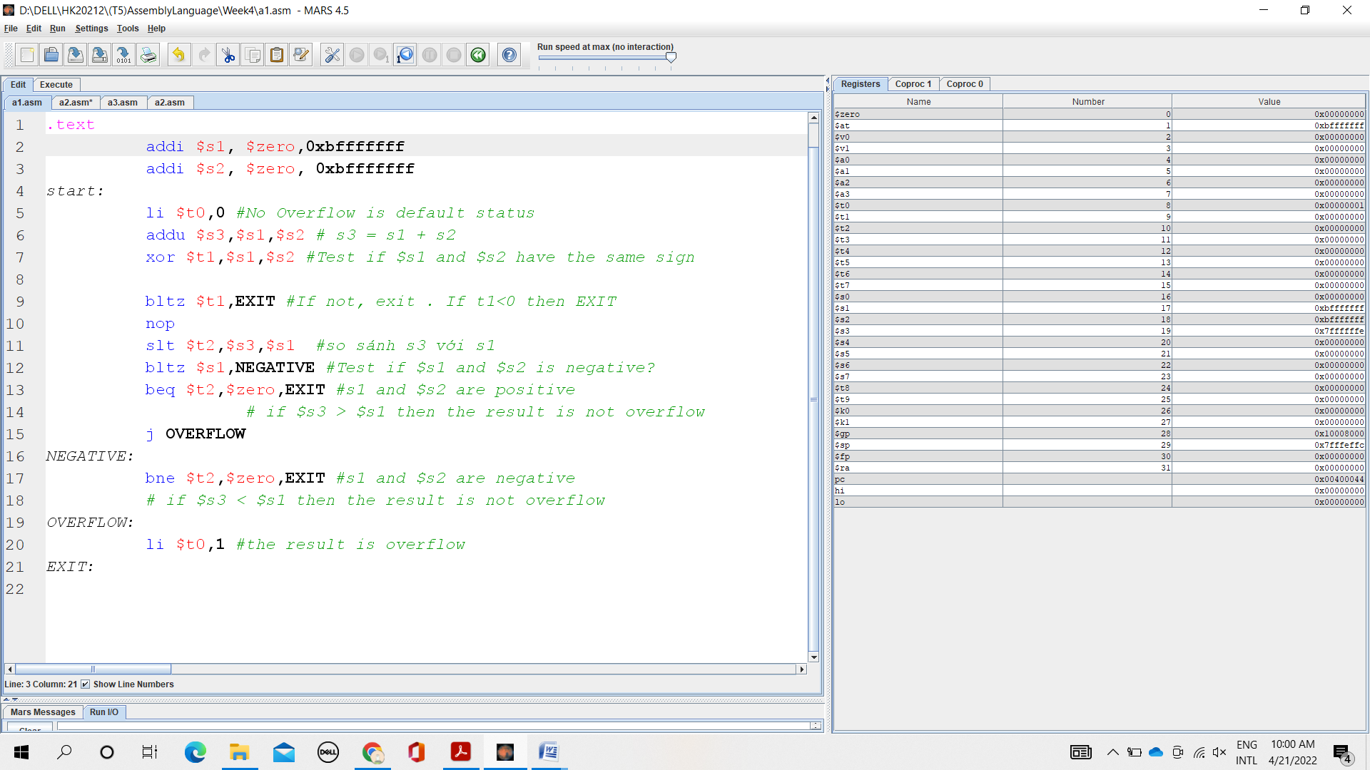

When we assign s1 = 0xbfffffff, s2 = 0xbfffffff ( s1 and s2 are negative) . After addu construction,we see:

s3= 0x7ffffffe < s1 +s2 .

And t0 =1

Then overflow has occurred.

* Case 2: Operands of the different sign.

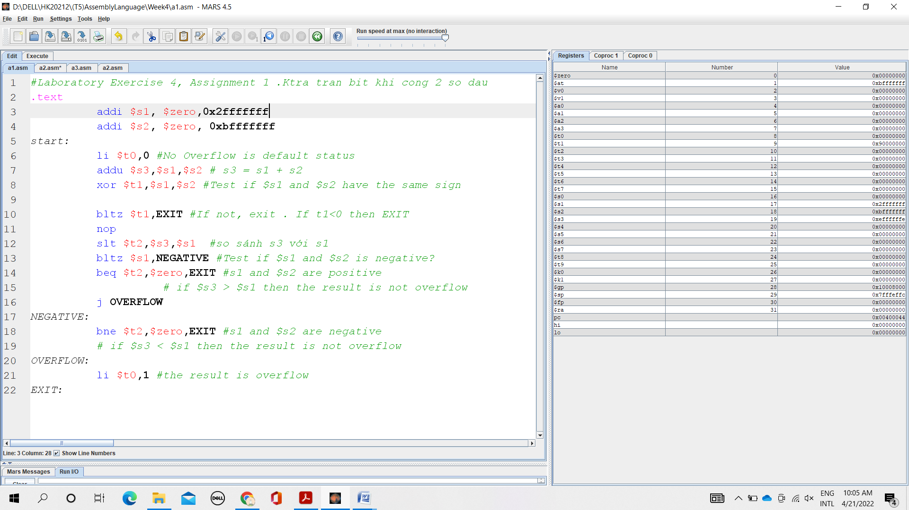

When we assign s1 = 0x2fffffff ( Positive), s2 = 0xbfffffff ( Negative) .

Finally we get t0 =0

Then overflow has not occurred.

ASSIGNMENT 2:

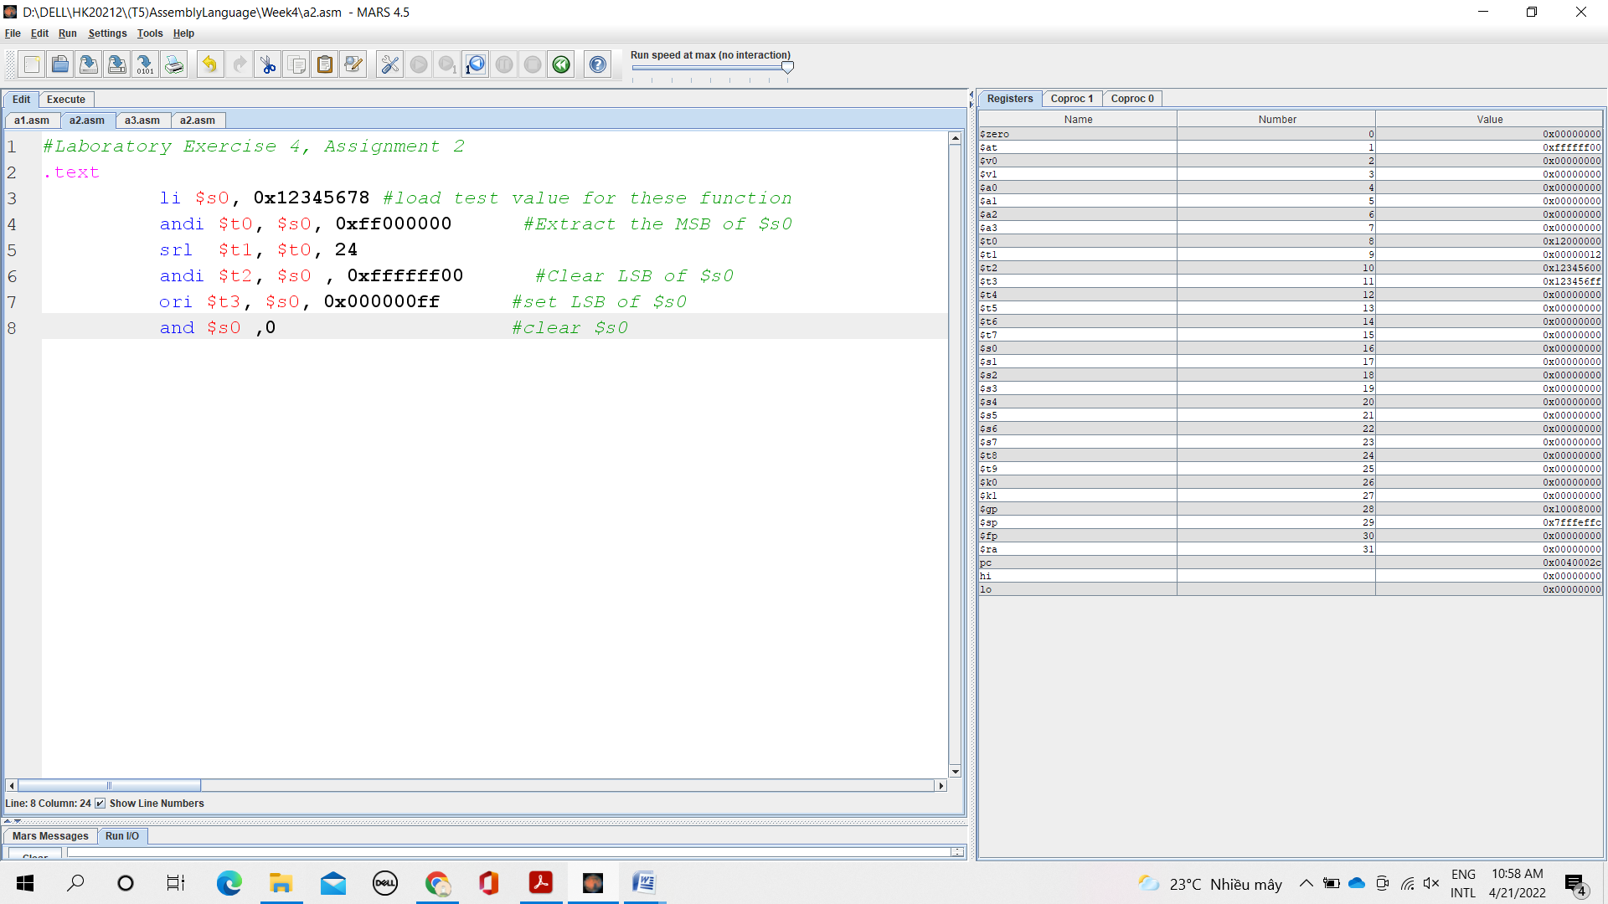

ASSIGNMENT 3:

1. abs s0, s1

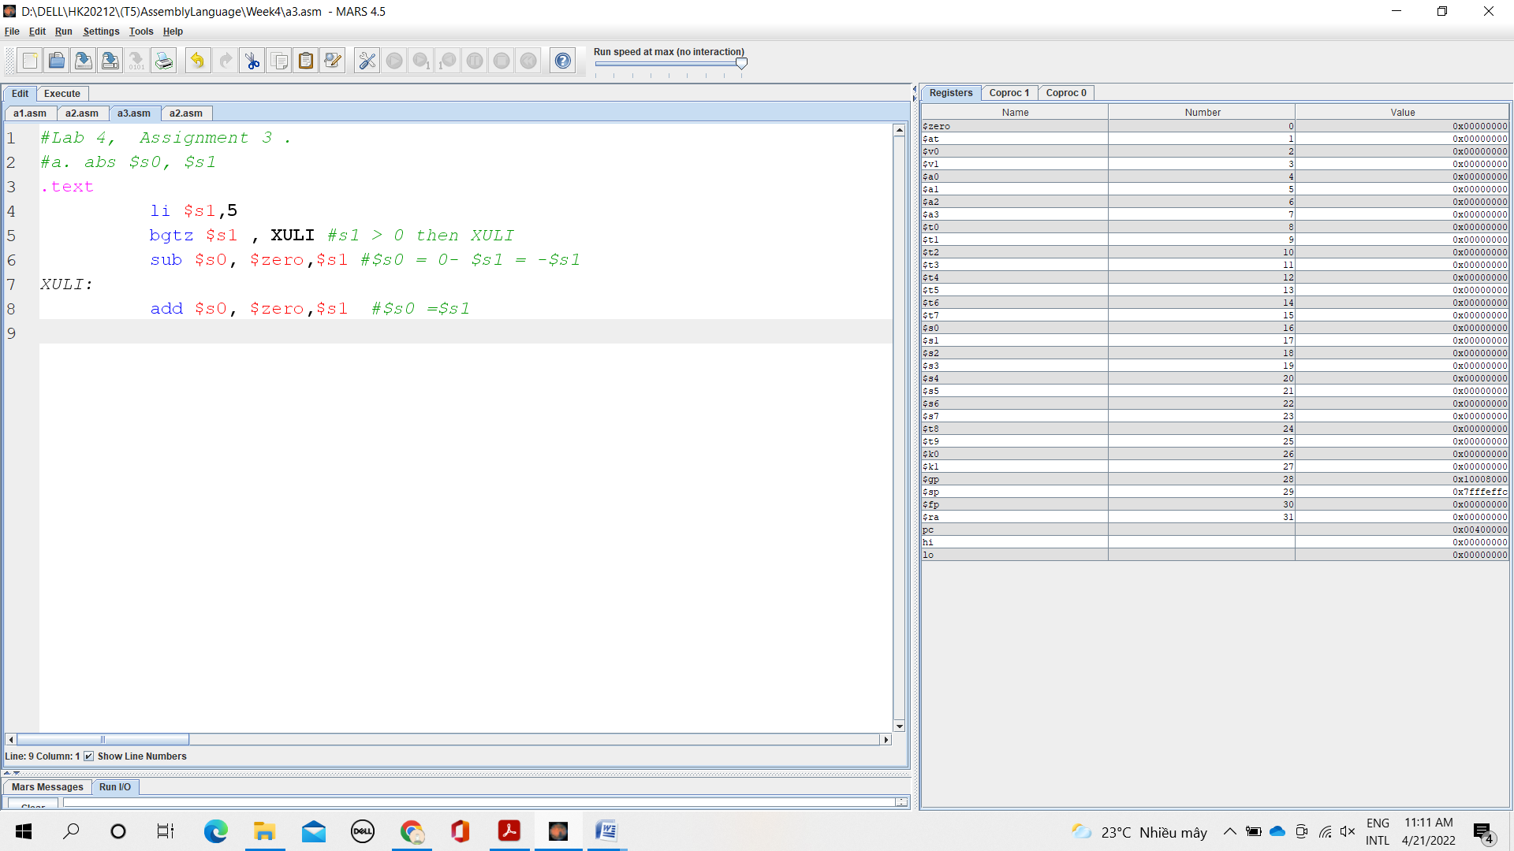

1. move s0 , s1

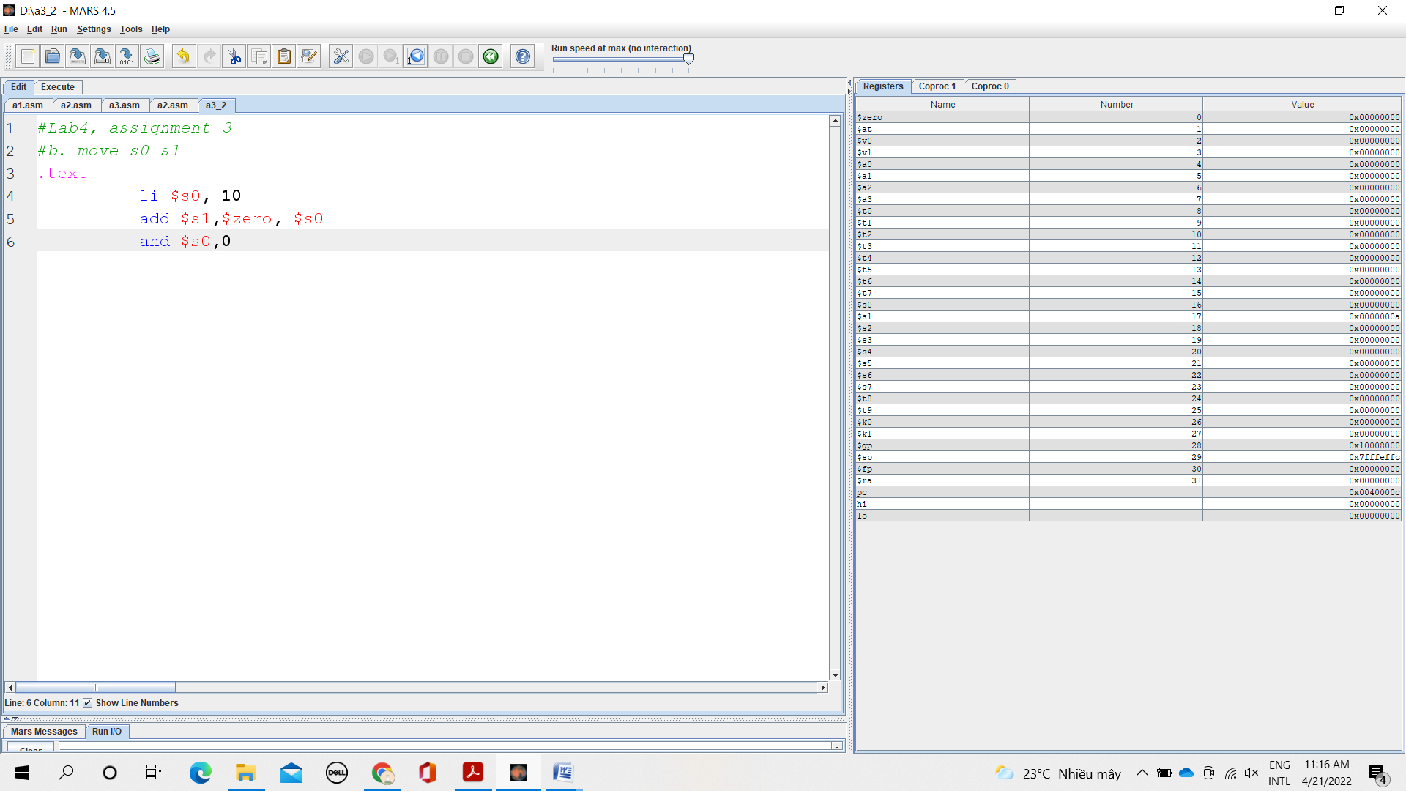

1. not s0

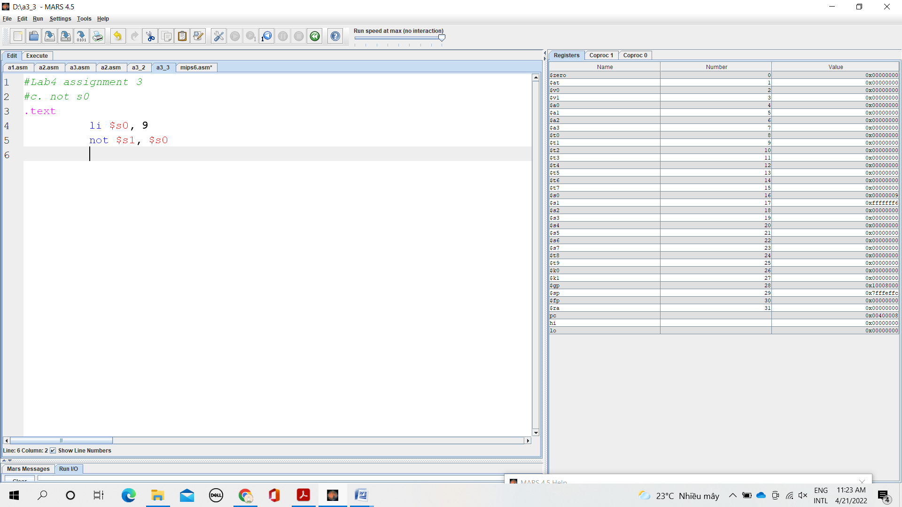

1. ble s1,s2,L

if (s1 <= $s2)

s3 =L

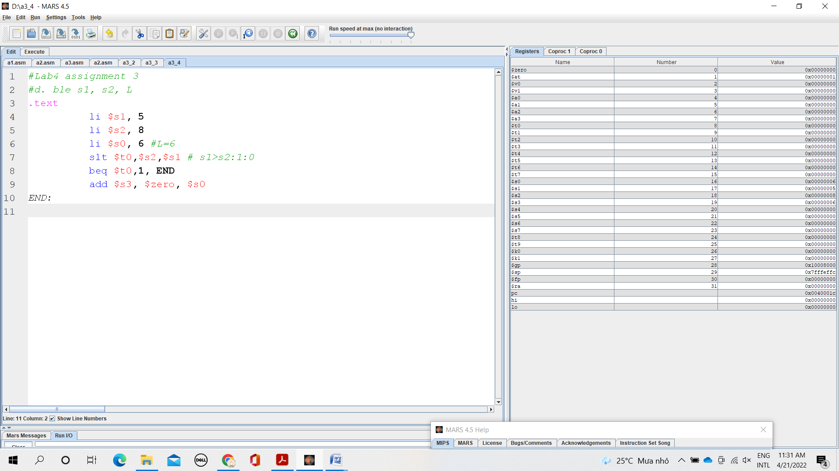

ASSIGNMENT 4:

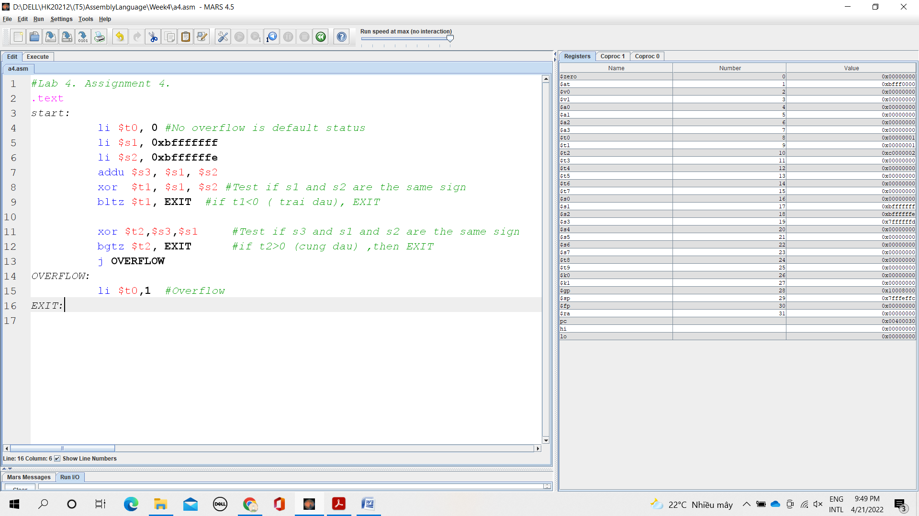

When s1 = 0xbfffffff and s2= 0xbffffffe ( 2 negative )

Then finally, we get t0=1

* It’s overflow

ASSIGNMENT 5:

