Assignment 1:

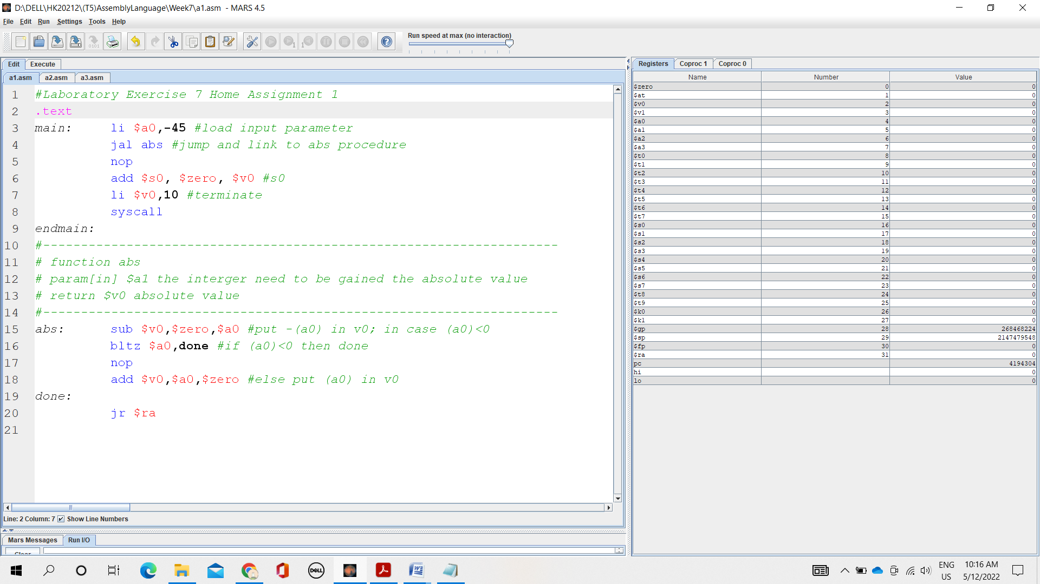

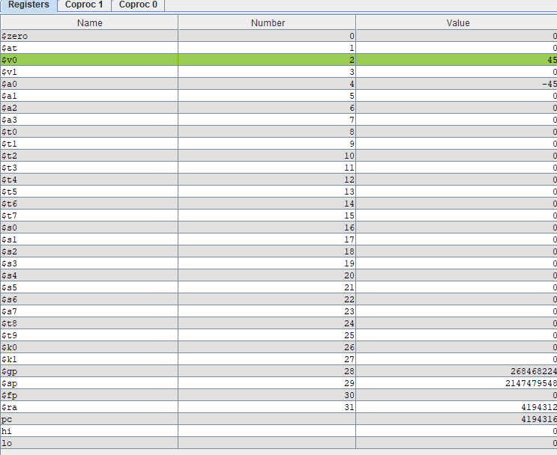

* The program will jump down to the (abs) after executing the (jal abs) statement. $a0 < 0 so the program jumps to (done) and returns to (main) to assign the absolute value to $s0 with the value 45

Assignment 2:

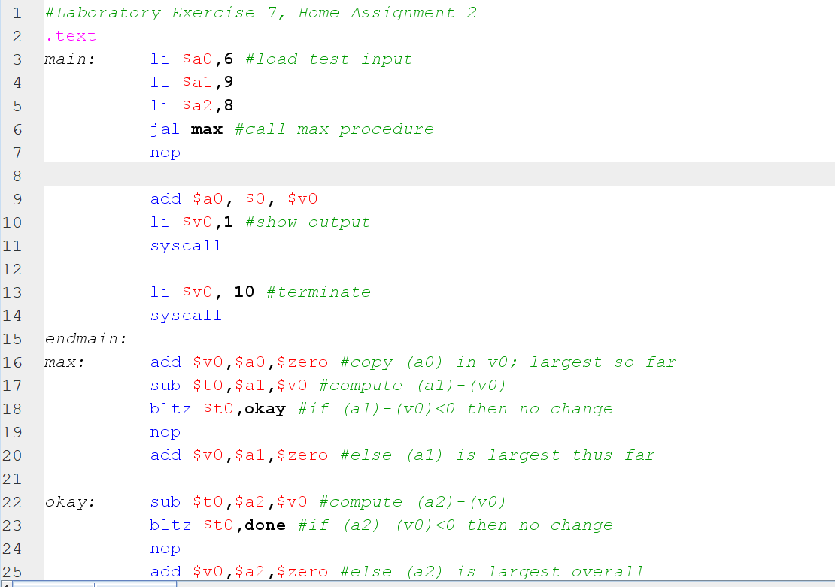

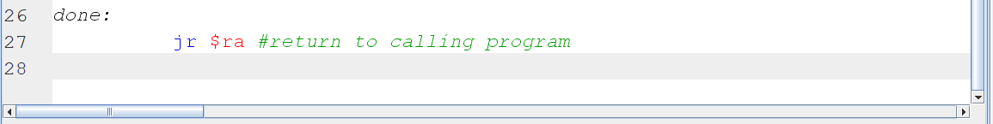

Result:

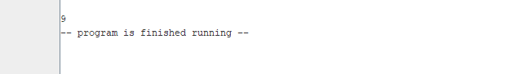

Assignment 3:

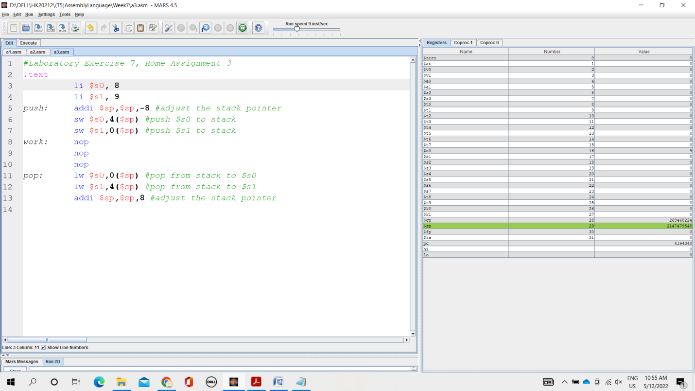

\*After running Push function, two values are pushed onto the stack



\*After running Pop function, two values are popped out in reverse order of push

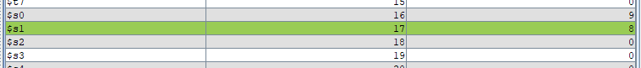

Assignment 4:

