CS545 Midterm Exam

**Professor Rujuan Xing**

**Student Id: _______________________ Name: __________________________**

The exam takes 2.5 hours. Total score is 60.

|  |  |  |  |  |  |  |  |  |  |  |  |  |
| --- | --- | --- | --- | --- | --- | --- | --- | --- | --- | --- | --- | --- |
| 1  (3) | 2  (3) | 3  (2) | 4  (2) | 5  (2) | 6  (1) | 7  (2) | 8  (2) | 9  (5) | 10  (3) | 11  (33) | 12  (2) | Total  (60) |
|  |  |  |  |  |  |  |  |  |  |  |  |  |

Please read the exam policy before you start the exam.

Exam Policy:

There is no tolerance policy for exams. **You will be asked to leave the exam room immediately without a warning** once you do the following things which mean you’ll get **NC**.

1. You are caught cheating or trying to cheat.
2. Answers should be written with a Pen or Pencil, but if you want to use a pencil please bring your own eraser and sharpener. You’re not allowed to borrow from other students or proctors during exam.
3. All mobile phones should be turned off and submitted along with your luggage at the beginning of the exam.
4. You’re not allowed to go out room for water.
5. You’re not allowed to ask/get extra papers from other students or proctors. All your notes must be written on the exam paper provided. Use the back side if you need to draft.

**Please write down your answer clearly. If I cannot read your answer, you’ll not get credit.**

Good luck!

## PART I (25 points): Short Answer Questions

1. (3 points) What is a N-tier architecture. Describe the 3 types in details(such as features, pros).

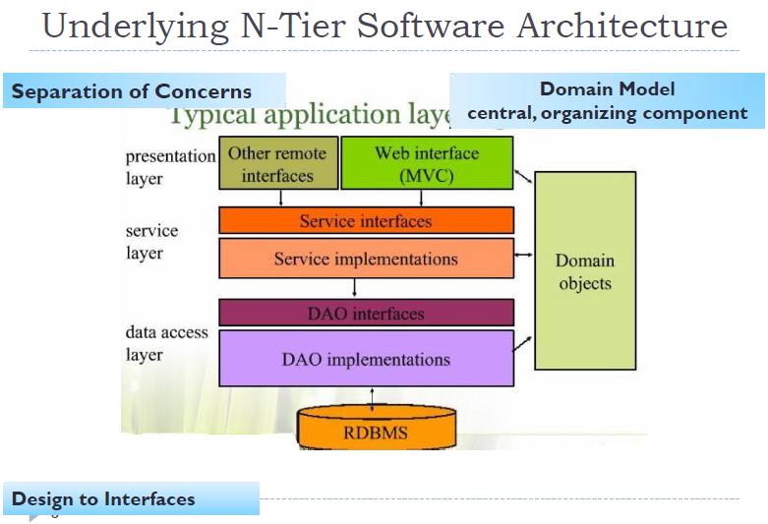

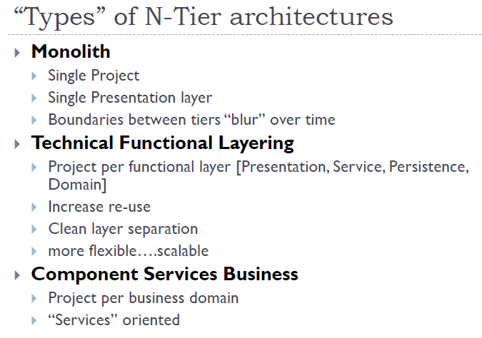

1. (3 points) Explain Data Binding. What is its value? What data does it handle? What data does it not handle?

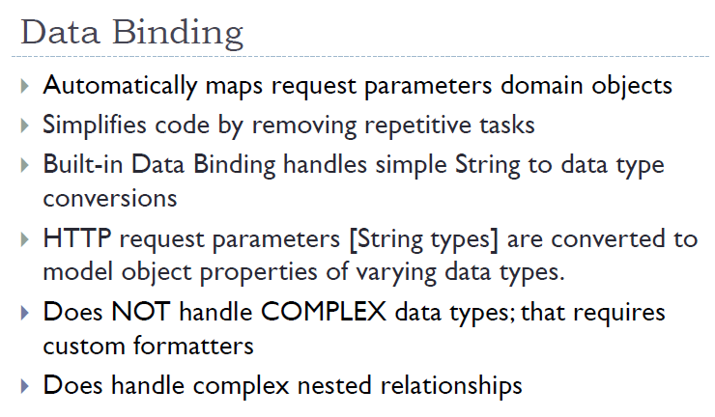

1. (2 points) What does <mvc:annotation-driven /> do ?

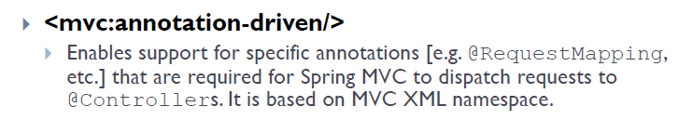

1. (2 points) What does <context:component-scan base-package="edu.mum" /> do ?

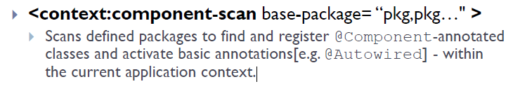

1. (2 points) What is the Formatter interface used for? Give an example.

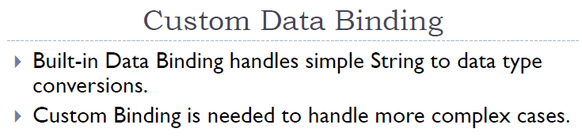

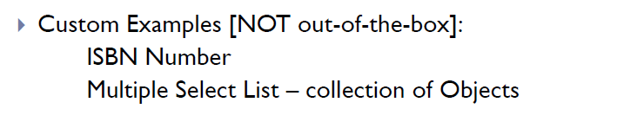

1. (1 points) What is Front Controller Pattern?

**A Controller that handles all requests for a web site.**

1. (2 points) Describe the two ways to apply the @ModelAttribute annotation. What’s the difference between them?

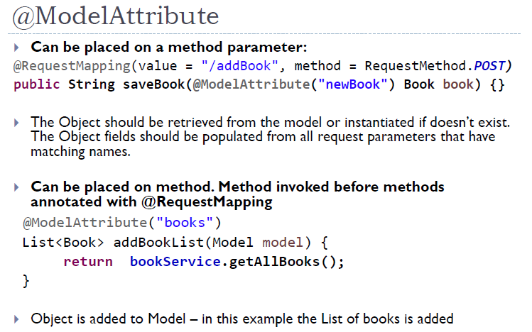

1. (2 points) Why is there a need for a Custom Validator? Give an example.

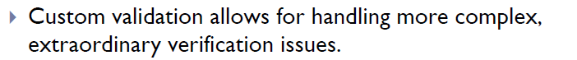The out of box validation like Bean validation cannot handle all cases. For example, the requirement is to validate if ProductId existing in DB while adding a new Product. There’s no bean validation annotation which can handle this case, so we need a Custom Validator.

1. (5 points) What are the 5 major interfaces in Spring MVC? Explain in details about Spring MVC Flow which means when a request comes, how Spring MVC handles this request with the help of the 5 major interfaces. **You must describe the flow in details. No credit if you only show a diagram.**

**DispatherServlet, HandlerMapping, Controller, ViewResolver, View**

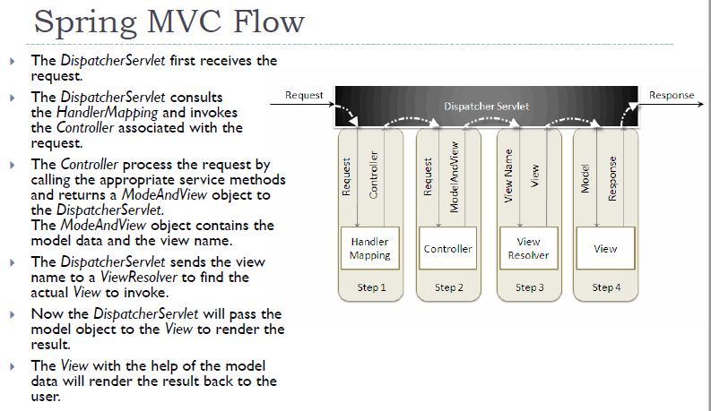

1. (3 Points) Read the source code below and find out the value of EL expression in product.jsp. The URL to init the request is:

<http://localhost:8080/Exam11017/product>

**NOTE: For this question, you MUST explain your answer. No explanation No credit.**

@Controller

@SessionAttributes({"phone"})

**public** **class** ProductController {

@RequestMapping("/product")

**public** String populateProduct(Model model, HttpSession session) {

model.addAttribute("phone", "iPhone 8");//see first time, then refresh>> remove

session.setAttribute("tablet", "iPad");

model.addAttribute("company", "Apple");//request scope

**return** "redirect:/display";

}

@RequestMapping("/display")

**public** String displayProduct(Model model, SessionStatus status) {

status.setComplete();

**return** "product";

}

}

**product.jsp**

<p>

Q1. What's the value being displayed below?

${phone }

Q2. What's the value being displayed below?

${tablet }

Q3. What's the value being displayed below?

${company }

Q4. Submit and refresh, what gonna happen?

${company }

</p>

Your answers: (**YOU MUST EXPLAIN**)

Q1: iPhone 8 or null, depends on the reason

Q2: null

Q3: Apple

## PART II (33 points): Programming Questions

1. Complete the Registration Form using Spring Form Tag Library, PRG pattern and Bean Validation to reflect the following relationship & screenshots. **The relative URL for the controller mapping is the same for both the GET form method and the POST method.** To determine Request Mapping URLs, refer URLs in Browser Bar according to screenshots. Upon completion of the save method, the success.jsp page should be displayed. Use Best Practices [naming conventions, PRG]. The name of this project is Exam11117.
2. **You MUST use Spring Form Tag Library. NO credit if HTML form used**
3. **You MUST use PRG pattern in Controller. NO credit if not used.**

**userForm.jsp**

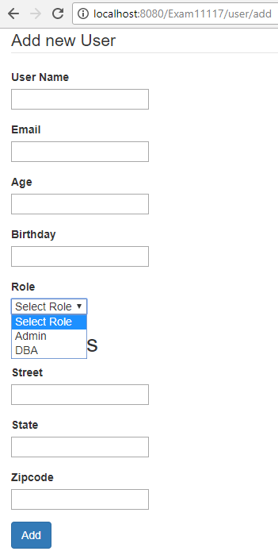

**userForm.jsp with** validation errors

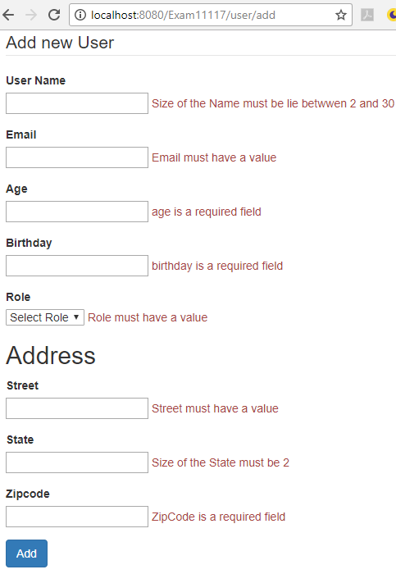 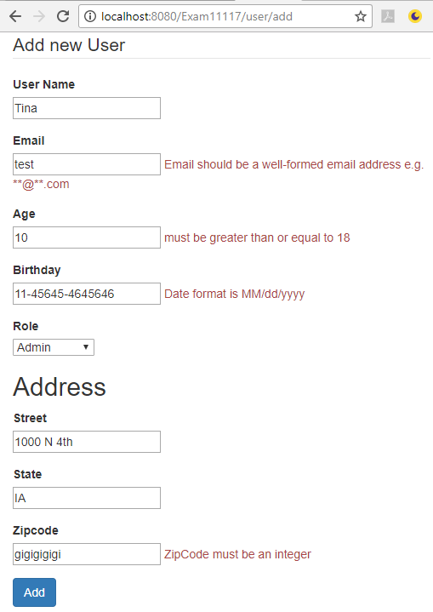

**success.jsp**

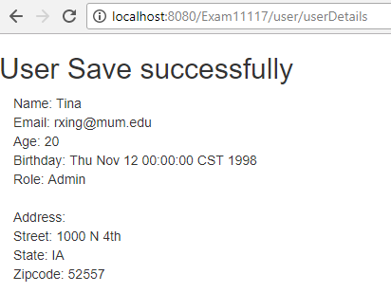

Add Bean validation annotation to implement functionalities as the screenshots display in **User.java** and **Address.java**. **The Error Message of validation must be configured in message.properties file, no credit if directly added on Bean validation annotation**.

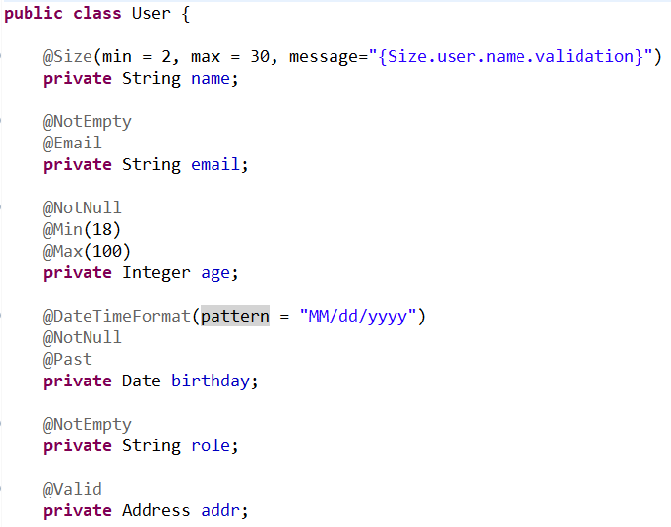

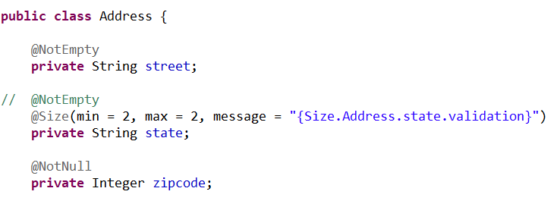

**UserController.java** - Add annotation and code necessary to implement the functionality as the screenshots display. Use PRG pattern.

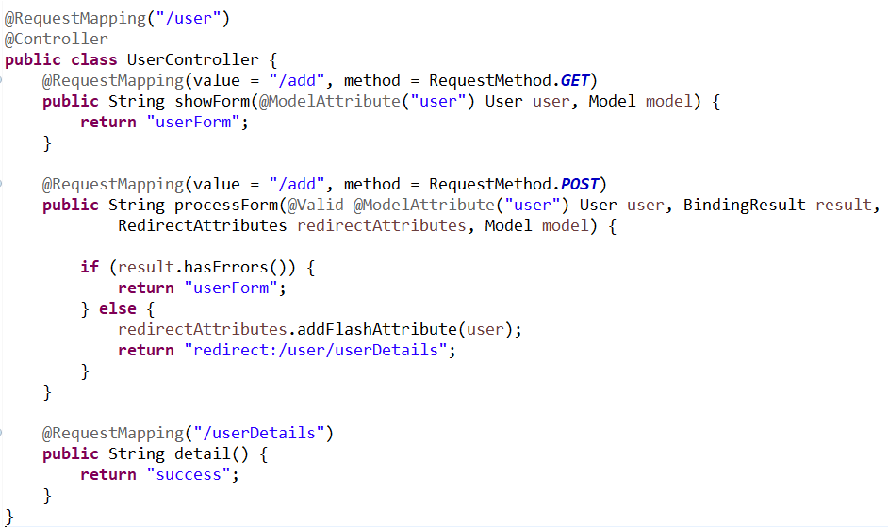

**userForm.jsp**

(You must use **Spring Form** to implement this JSP page, **No Credit for HTML form Tag**.)

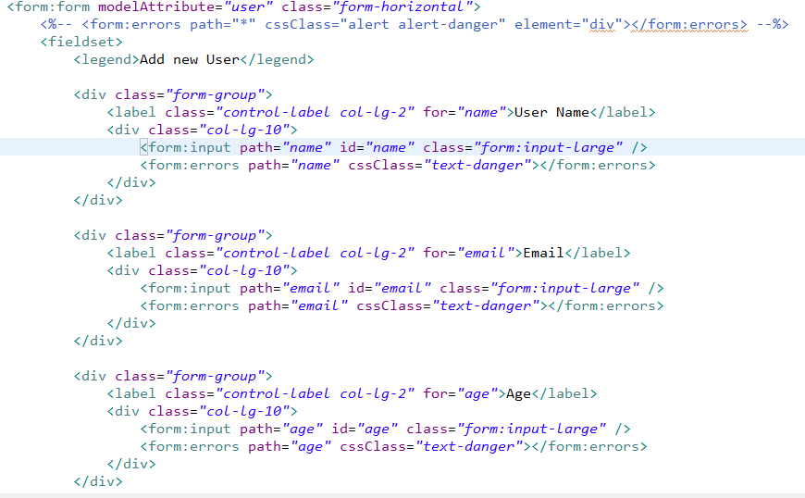

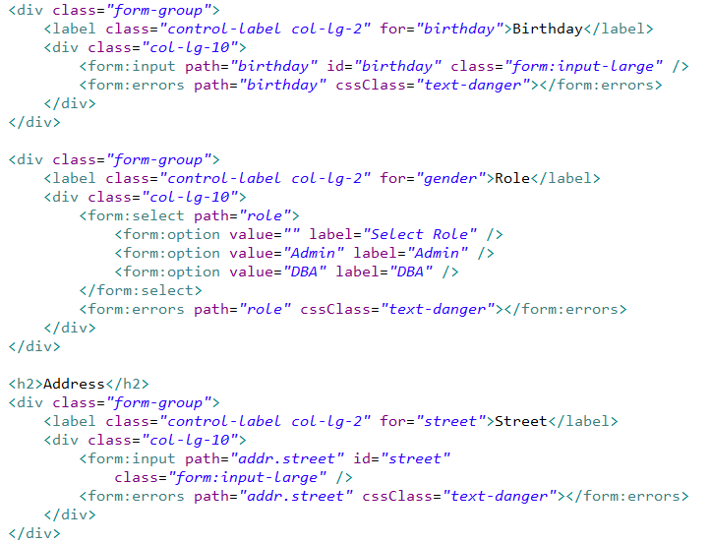

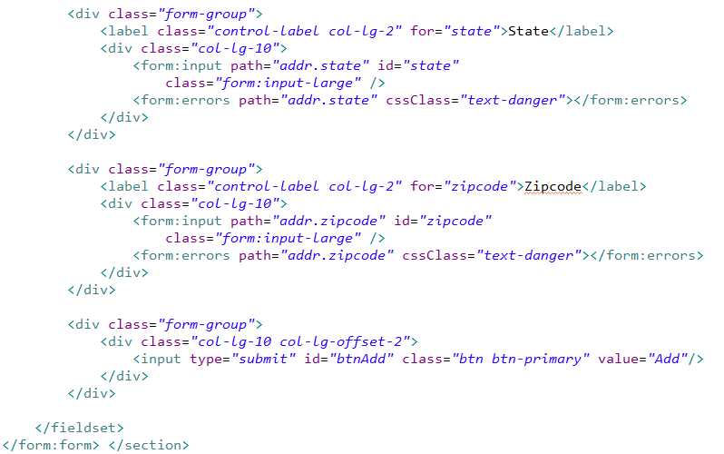

**success.jsp**

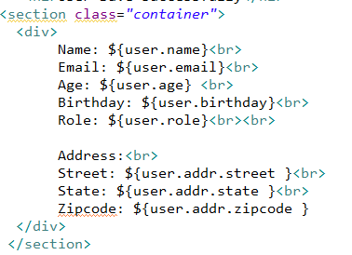

**errorMessages.properties**

#Add error message code in this file as necessary

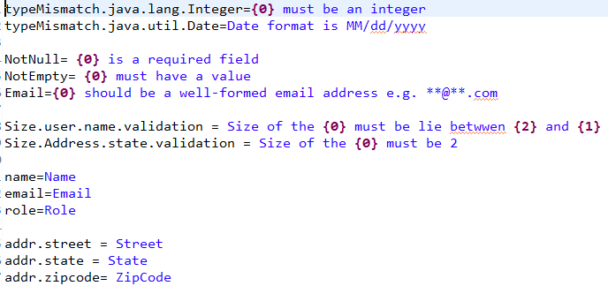

1. (2 Points) Write **two paragraphs** relating “Reflection API” to a principle from SCI. (No Credit if copy from main points chart. You have to use your own words).