Web Design and Development

4COSC011W

Report

Author:

Student ID:

Group Number:

Student Role:

Link(s) to Websites URL:

Content 2

1. Introduction 3

2. Technical Discussion 3

• Presentation Page 3

• Main Page 3

• Font size change 3

• Comments Form 3

• Buy products 3

• Quiz 3

• View images and change text/background colour 3

3. Discussion of UI and application of UX principles 3

3.1 Information architecture 3

a. Design 3

b. Code to achieve good Information architecture 4

3.2 Colour balance/composition/graphics/consistency 4

a. Design 4

b. Code to achieve good colour balance & ensure consistency 4

c. Colour contrast test results 4

3.3 Typography / consistency 4

a. Design 4

b. Code to achieve good typography / consistency 5

3.4 Gestalt principles grouping 5

3.5 Accessibility (graphics/forms) 7

a. Graphical elements - Design/Code 7

b. Form completion - Design/Code 7

3.6 Error prevention and recovery 7

a. Design 7

b. Code to address error prevention and recovery 8

4 Janet 8

5 Conclusions 8

References 8

Appendices 8

Appendix A: Code 8

Appendix B: Screenshots 8

Appendix C: Individual Statement 8

# Introduction

In this group project. We created a website with our understanding of HTML, CSS and JavaScript. In one group there will four parts for four students which is already allocated in course work details. And we discussed and choose one part for each member and created the web pages with good coding and UI principals.

In our group:

* D
* D
* D
* D

And In the following report I discussed how I implemented them and what principals that I followed and my conclusion about this group project.

# Technical Discussion

*Max 1000 words*

My part of this project is implementing student 4’s functionalities into the website. Creating site map by SVG, view images and changes text/ background colour.

**Changing the text color and background color**

My first part overview is creating a site map using svg and on mouse click navigate the user to the respective links.

**Creating the Site map using SVG**

The following code is the basic code, by repeating this I created the site map.

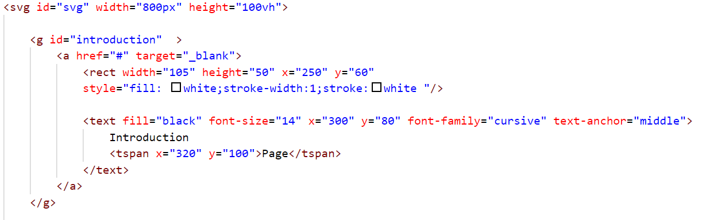

* In the above code is used to create the one single rectangle with text and one straight line.

* I created all rectangle and texts inside the <g></g> SVG group element, It’s working as div for SVG elements. Adding inside the grouping elements is useful we can just add a event listener. We can use java script easily.
* I used rectangle shape and lines which are already predefined in SVG

<rect width="105" height="50" x="250" y="60"

       style="fill: white;stroke-width:1;stroke:white "/>

In the code

* + width = rectangle’s width
  + height = rectangle’s height
  + x = position in horizontal axis
  + y = position in vertical axis
  + fill = background-color
  + stroke-width = border’s width
  + stroke = border’s color

<text fill="black" font-size="14" x="300" y="80" font-family="cursive" text-anchor="middle">

Introduction

<tspan x="320" y="100">Page</tspan>

</text>

In the code

* font-size = text-size
* fill = background- color
* x = position in horizontal axis
* y = position in vertical axis
* font-family = font-design
* text-anchor = to align the text
* tspan = for multiple lines



* So, I could create one like this(above picture). Then I continued to create the full site map with SVG

**Changing the text color/ background color and showing more info**

My second part overview is creating a web page which should have drop down menus and when user click the menu items my web page text/background color should change. And web page should have five thumbnail pictures and when the user clicked it should show more info related to the picture.

**Creating the drop-down list and setting them visible**

The codes that I used for changing background color in html

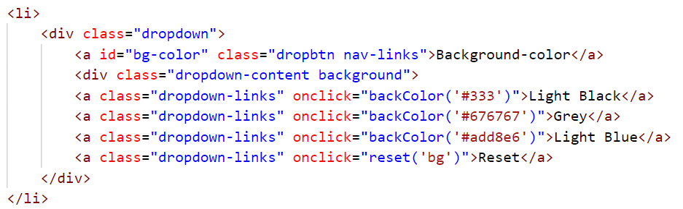

The codes that I used to create the drop-down list for changing text color in html

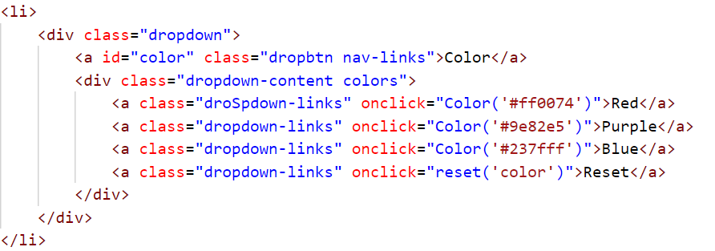

* The above both screen shots have codes/elements that I used to create drop down menus in HTML.
* In the above elements ( <a id="bg-color" class="dropbtn nav-links">) is going to works as menu and <div class="dropdown-content background"> is going to works as drop-down list container.
* I used these HTML elements and the following CSS to make fully functioning drop-down menus.

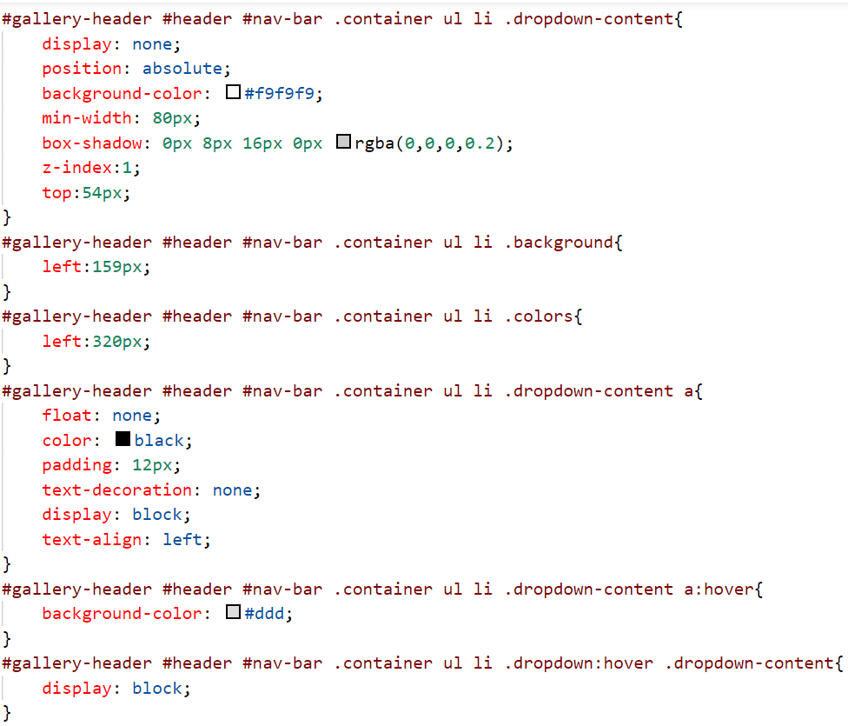

* In CSS we are going to make the drop-down list container visible when user hover over the parent element .
* In the above code I set the drop-down list container’s display property to none. So, it will not visible when we load / reload the page. But when the bring mouse over/ hover the specific link , we have to make it visible. So, by the following code I made it visible.

#gallery-header #header #nav-bar .container ul li .dropdown:hover .dropdown-content{

    display: block;}

* #gallery-header #header #nav-bar .container ul li .dropdown:hover this line of CSS code used because we need to show the drop-down list when the user hover over this element (<div class="dropdown">) . And .dropdown-content line used for to set style for this element (<div class="dropdown-content background">) When user hover over the previous element (<div class="dropdown">).
* So, we can set style to (<div class="dropdown">) element . And we only needed to make them visible, so I set the display property to block.

**Adding onclick attribute and setting functions**

**Following code written for changing the background color:**

<a class="links" onclick="backColor('#ebeb00')">Yellow</a>

**Following code written for changing the text color:**

<a class="links" onclick="Color('#9e82e5')">Purple</a>

* I used onclick attributes on the drop-down menu items (<a class="links" >). So, when the user clicked a menu item it will automatically call the function which inside the java script file.
* I gave string parameter to the function. It is a hexadecimal color code. When the user clicked the menu item, it will be call the function which inside java script and use the passed color code to change the text color/ background color into passed parameter color. Which is very help full and easy to avoid code duplications.

**Following codes are changing the text color and background color functions:**

function groupColor(navColor,headingColor){

    var links = document.getElementsByTagName('a');

    for(var i =0; i<links.length; i++  ){

        links[i].style.color= navColor;

    }

    var headIngs = document.getElementsByClassName('links-heading');

    for(var i =0; i<headIngs.length; i++  ){

        headIngs[i].style.color= headingColor;

    }

}

* The above function is used to avoid code duplication. When the user clicked the menu item (<a class="links">), it will call a function which call the above function to loop through all links and headings which have 'links-heading' as class name in that webpage and change their color to what color I passed as parameter in onclick function. This also very help full to avoid code duplication

var btn = document.getElementById('images-btn');

function backColor(bgcolor){

    document.body.style.backgroundColor = bgcolor;

}

function Color(color){

    document.body.style.color = color;

    gruopColor(color,color);

}

function reset(value){

    if(value==='bg'){

        document.body.style.background = "white";

    }else if(value==='color'){

        document.body.style.color = "black";

        gruopColor('white','white')

        btn.style.color="black";

    }

}

* The above functions (backColor, Color) are used to change colors and background colors. Inside these functions I used DOM to change the background color/ color for the web page.

* In backColor function I’m using DOM to change the body background color.

In Color function I changed the links color to user clicked / choosed color by gruopColor(navColor,headingColor) function and DOM to change the body text color.

* reset function used to reset to default color/ background color. Iam using previously define functions and DOM to change the body background and text color .

**Showing more info on mouse click**

Adding images into html and adding onlcick , onmouseover and onmouseout attributes.

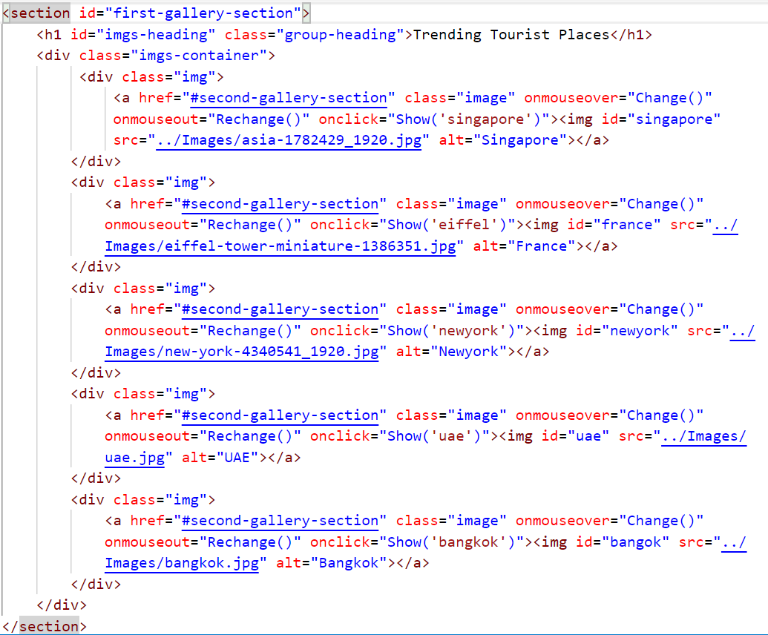

d

--------------------------------------------------------------------------------------------------------------------------

# Discussion of UI and application of UX principles

*Max 1000 words*

Section guidelines:

* Explain how you met the following UX principles to achieve a good aesthetical result, appealing to the target audience of the web site, with good visual balance between all the UI elements (background, header, footer, text, borders, graphics etc.), making content legible, clear and discoverable.
* Illustrate each of your discussion with screenshots and code samples.

---------------------------------------------------------------------------------------------------------------------------

## 3.1 Information architecture

### a. Design

Section guidelines:

* Explain how you structured the web site (the organization of the web site folders) and how you designed the web site navigation to ensure that content is discoverable, that users are aware at any time of their position (use of breadcrumb or breadcrumb trail) on the web site and they can easily (with the minimum number of steps) jump to different sections of the web site. Did you consider how you can assist the users to search for content?
* How did you implement the web site navigation system? Provide relevant HTML & CSS code.
* How do you structure each page to direct the user to content (when multiple pages use the same style you need to explain only the template that those pages follow)? Do you differentiate the importance of content (e.g. primary, footnotes)?

--------------------------------------------------------------------------------------------------------------------------

### b. Code to achieve good Information architecture

Section guidelines: E.g., the template created for your individual pages and for navigation.

## 3.2 Colour balance/composition/graphics/consistency

### a. Design

Section guidelines:

* Explain the colour combination, the composition (visual structural elements) and graphics (images, logo, icons) you used to ensure the proposed web site is appealing for its purpose, it reveals its’ identify and complies with the brand.
* Good aesthetical result such as good visual balance between all the UI elements (background, header, footer, text, borders etc.) and also ensure good legibility of the web site.

--------------------------------------------------------------------------------------------------------------------------

### b. Code to achieve good colour balance & ensure consistency

Section guidelines:

* What CSS did you write to ensure good and consistent colour balance.
* What HTML code you wrote to structure your we site in order to ensure good and consistent composition
* Did you write any CSS to consistently format the appearance of graphics?

--------------------------------------------------------------------------------------------------------------------------

### c. Colour contrast test results

Section guidelines: Text vs background colour contrast. Include screen shot of test results from a colour contrast checking tool such as: <https://snook.ca/technical/colour_contrast/colour.html#fg=FFFFFE,bg=000000>

## Typography / consistency

### a. Design

Section guidelines: Explain the fonts, font sizes, colours and styles you used to ensure the proposed web site is appealing and suitable for its purpose and at the same time legible. Explain how you ensured content relevance and consistency (e.g. paragraph titles, subtitles, text, small font).

### b. Code to achieve good typography / consistency

Section guidelines:

* What CSS you created to modify text.
* Did you use any of the online tools to test the legibility of your web site? What were the test results?
* How did you write the CSS to ensure consistency?

---------------------------------------------------------------------------------------------------------------------------

## Gestalt principles grouping

Section guidelines:

* How did you apply the Gestalt principles of grouping to reveal the purpose of the content, to direct the user to content and to increase the legibility of your web site? Use screenshots of your page to better support your justification.
* E.g. for the example below you could write something like that:

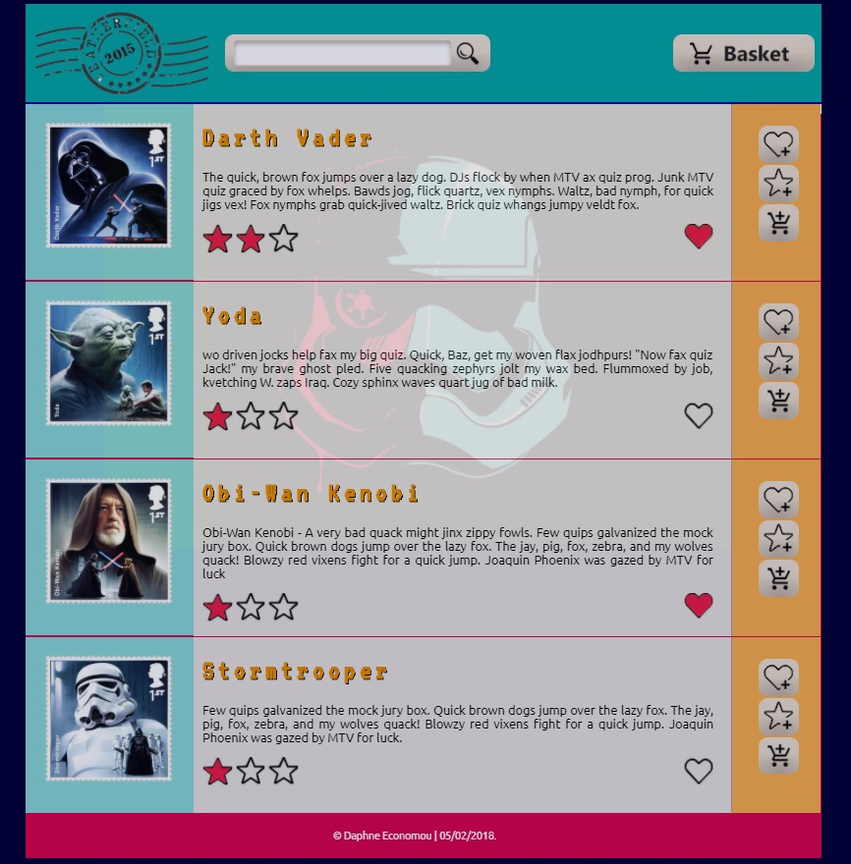

* In the above example **proximity** that states that "objects or shapes that are close to one another appear to form groups” has been applied in the following elements:
  + aligning the title, textual description for each stamp and rating star graphics close to each other creates a group, aligning this group of elements next to the stamp graphic creates a relation of the description to the stamp. Similarly aligning the favourite, rating and add to basket icons close to each other makes them a group. Aligning the stamp (blue box), the description (grey box), and icons (orange box) next to each other creates a relevance between those elements.
  + leaving space vertically between each stamp, description and icons box separates the stamps, their description and the icons to interact with each stamp respectively.
* In addition, **closure** is applied by drawing a line between stamps makes those groups more explicit. Placing the stamp inside a blue box, the description in a grey box, and icons in the orange box is another way of applying closure to make more explicit that this content belongs in the same group.
* Closure is also applied by drawing a line after the header and by using different colours in the header, footer and the main part of the page (container) to make the type of content more explicit and to enhance legibility and discoverability.
* **Continuation** users "tend to continue shapes beyond their ending points". The box that contain the stamp thumbnail, the stamp description related icons and buttons, appear in discrete boxes with different colour, however we tend to perceive that those boxes are enclosed in a wider box.
* **Similarity** stands for the things which share visual characteristics such as shape, size, colour, texture, or value will be seen as belonging together in the viewer’s mind. In this example this principle is applied by repeating the same style to the boxes that contain the stamp thumbnail, the stamp description and related icons and buttons indicate that enclosed content is of similar type.

--------------------------------------------------------------------------------------------------------------------------

## 3.5 Accessibility (graphics/forms)

### a. Graphical elements - Design/Code

Section guidelines: Explain how you addressed accessibility on the design of the web site. E.g., for the following graphical elements what accessibility tags have been used in order to make sure that in case that the graphics cannot be displayed the users would still get the required information and would still be able to interact with buttons and icons.



### b. Form completion - Design/Code

Section guidelines: State how you ensure good accessibility, for example in form completion. Explain the tags you used.

## 3.6 Error prevention and recovery

### a. Design

Section guidelines:

* In cases of form completing how did you assist the user to complete all the required field, to enter the information correctly and eliminate error and how did you address error recovery? E.g., did you use any instructions for completing the form? Did you provide any meaningful error messages in case the users did not completed the form correctly to help them correct their mistakes?
* How have you addressed accessibility in the design. E.g., instructions for form completion, inclusion of images for descriptive or decorative purposes, or system response and error messages.
* Illustrate your discussion with screenshots.

--------------------------------------------------------------------------------------------------------------------------

### b. Code to address error prevention and recovery

Section guidelines: Provide the code you used to address accessibility, e.g. for form completion, graphics, or system response and error messages.

# Janet

Section guidelines: Explain how your web site complied with Janet Regulations, [Janet Policies and Legal Requirements](https://community.jisc.ac.uk/library/janet-services-documentation/janet-policies-and-legal-requirements). Max 200 words

# Conclusions

Section guidelines: This should include reflection on the work carried out, how you worked as a team, problems encountered as part of your technical development, lessons learnt and suggested improvements.

# References

Provide references to resources you have used.

# Appendices

## Appendix A: Code

Provide a full listing of your files, with well indented and commented code in the following format:

Filename

Code

## Appendix B: Screenshots

Provide a screenshot of all your web pages, in the following format:

Filename

Screenshot(s)

## Appendix C: Individual Statement

|  |  |  |  |
| --- | --- | --- | --- |
| Student Name: |  | Student Id: |  |
| State what tasks you carried out in the project. | | | |
|  | | | |
| State what you enjoyed and did not enjoy about teamwork. | | | |
|  | | | |
| State what you learnt about teamwork. | | | |
|  | | | |
| State what skills you gained/learnt from undertaking the project. | | | |
|  | | | |
| State any strengths about yourself that emerged whilst undertaking the project. | | | |
|  | | | |
| State any weaknesses about yourself that emerged whilst undertaking the project. | | | |
|  | | | |
| State how you would do things better if you were to undertake the project again. | | | |
|  | | | |
| Additional general or project specific comments: | | | |
|  | | | |
| Student Signature: |  | Date: |  |