Lab 07: Data Modeling

# Entity-Relationship Diagram

# Logical Data Model

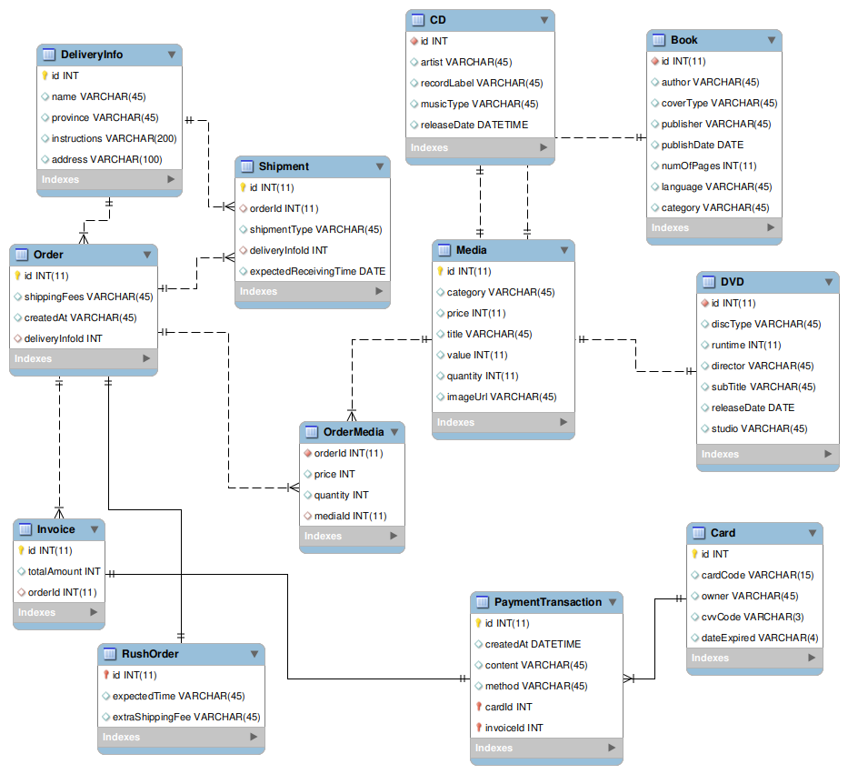

# Physical Data Model

- **Media**

|  |  |  |  |  |  |  |
| --- | --- | --- | --- | --- | --- | --- |
| **#** | **PK** | **FK** | **Column Name** | **Data type** | **Mandatory** | **Description** |
| **1.** | x |  | id | Integer | Yes | ID, auto increment |
| **2.** |  |  | category | VARCHAR(45) | Yes | Media type, e.g., CD, DVD |
| **3.** |  |  | price | Integer | Yes | Current price |
| **4.** |  |  | quantity | Integer | Yes | Number of products |
| **5.** |  |  | title | VARCHAR(45) | Yes | Product name |
| **6.** |  |  | value | Integer | Yes | Value of the product |
| **7.** |  |  | imageUrl | VARCHAR(45) | Yes | Product image path |
| **8** |  |  | supportRushOrder | Integer | Yes | To check if the media supports rush order or not |

* **CD**

|  |  |  |  |  |  |  |
| --- | --- | --- | --- | --- | --- | --- |
| **#** | **PK** | **FK** | **Column Name** | **Data type** | **Mandatory** | **Description** |
| **1.** |  | x | id | Integer | Yes | ID, same as ID of Media of which type is CD |
| **2.** |  |  | artist | VARCHAR(45) | Yes | Artist's name |
| **3.** |  |  | recordLabel | VARCHAR(45) | Yes | Record label |
| **4.** |  |  | musicType | VARCHAR(45) | Yes | Music genres |
| **5.** |  |  | releasedDate | DATE | No | Release date |

* **Book**

|  |  |  |  |  |  |  |
| --- | --- | --- | --- | --- | --- | --- |
| **#** | **PK** | **FK** | **Column Name** | **Data type** | **Mandatory** | **Description** |
| **1.** |  | x | id | Integer | Yes | ID, same as ID of Media of which type is Book |
| **2.** |  |  | author | VARCHAR(45) | Yes | Author |
| **3.** |  |  | coverType | VARCHAR(45) | Yes | Cover type |
| **4.** |  |  | Publisher | VARCHAR(45) | Yes | Publishing house |
| **5.** |  |  | publishDate | DATETIME | Yes | Date of publishing |
| **6.** |  |  | numOfPages | Integer | Yes | Page number |
| **7.** |  |  | language | VARCHAR(45) | Yes | Language |
| **8.** |  |  | bookCategory | VARCHAR(45) | Yes | Book category |

* **DVD**

|  |  |  |  |  |  |  |
| --- | --- | --- | --- | --- | --- | --- |
| **#** | **PK** | **FK** | **Column Name** | **Data type** | **Mandatory** | **Description** |
| **1.** |  | x | id | Integer | Yes | ID, same as ID of Media of which type is DVD |
| **2.** |  |  | discType | VARCHAR(45) | Yes | Disc type |
| **3.** |  |  | director | VARCHAR(45) | Yes | Director |
| **4.** |  |  | runtime | Integer | Yes | Duration |
| **5.** |  |  | studio | VARCHAR(45) | Yes | Manufacturer |
| **6.** |  |  | subtitle | VARCHAR(45) | Yes | Subtitles |
| **7.** |  |  | releasedDate | DATETIME | Yes | Release date |
| **8.** |  |  | filmType | VARCHAR(45) | Yes | Genres |

* **Card**

|  |  |  |  |  |  |  |
| --- | --- | --- | --- | --- | --- | --- |
| **#** | **PK** | **FK** | **Column Name** | **Data type** | **Mandatory** | **Description** |
| **1.** | x |  | id | Integer | Yes | ID, auto increment |
| **2.** |  |  | cardCode | VARCHAR(45) | Yes | Card code |
| **3.** |  |  | owner | VARCHAR(45) | Yes | Cardholders |
| **4.** |  |  | cvvCode | VARCHAR(3) | Yes | CVV code |
| **5.** |  |  | dateExpired | VARCHAR(4) | Yes | Expiration date |

* **DeliveryInfo**

|  |  |  |  |  |  |  |
| --- | --- | --- | --- | --- | --- | --- |
| **#** | **PK** | **FK** | **Column Name** | **Data type** | **Mandatory** | **Description** |
| **1.** | X |  | id | Integer | Yes | ID, auto increment |
| **2.** |  |  | name | VARCHAR(45) | Yes | Receiver name |
| **3.** |  |  | province | VARCHAR(45) | Yes | Provinces |
| **4.** |  |  | instructions | VARCHAR(200) | No | Delivery instructions |
| **5.** |  |  | address | VARCHAR(100) | Yes | Delivery address |

* **Order**

|  |  |  |  |  |  |  |
| --- | --- | --- | --- | --- | --- | --- |
| **#** | **PK** | **FK** | **Column Name** | **Data type** | **Mandatory** | **Description** |
| **1.** | X |  | id | Integer | Yes | ID |
| **2.** |  |  | shippingFees | VARCHAR(45) | Yes | Shipping fee |
| **3.** |  | X | deliveryInfoId | Integer | Yes | Delivery Info ID |
| **4** |  |  | isRushOrder | Integer | Yes | Check if the order is a rush order or not |

* **OrderMedia**

|  |  |  |  |  |  |  |
| --- | --- | --- | --- | --- | --- | --- |
| **#** | **PK** | **FK** | **Column Name** | **Data type** | **Mandatory** | **Description** |
| **1.** |  | X | mediaID | Integer | Yes | Media ID |
| **2.** |  | X | orderID | Integer | Yes | Order ID |
| **3.** |  |  | price | Integer | Yes | Selling price |
| **4.** |  |  | quantity | Integer | Yes | Number |

* **Invoice**

|  |  |  |  |  |  |  |
| --- | --- | --- | --- | --- | --- | --- |
| **#** | **PK** | **FK** | **Column Name** | **Data type** | **Mandatory** | **Description** |
| **1.** | x |  | id | Integer | Yes | ID |
| **2.** |  |  | totalAmount | Integer | Yes | Total |
| **3.** |  | x | orderId | Integer | Yes | Order ID |

* **PaymentTransaction**

|  |  |  |  |  |  |  |
| --- | --- | --- | --- | --- | --- | --- |
| **#** | **PK** | **FK** | **Column Name** | **Data type** | **Mandatory** | **Description** |
| **1.** | x |  | id | Integer | Yes | ID |
| **2.** |  |  | createAt | DATETIME | Yes | Date of creation |
| **3.** |  |  | content | VARCHAR(45) | Yes | Transaction contents |
| **4.** |  |  | method | VARCHAR(45) | Yes | Payment methods |
| **5.** |  | x | cardId | Integer | Yes | ID of used card |
| **6.** |  | x | invoiceId | Integer | Yes | Invoice ID |

* **RushOrder**

|  |  |  |  |  |  |  |
| --- | --- | --- | --- | --- | --- | --- |
| **#** | **PK** | **FK** | **Column Name** | **Data type** | **Mandatory** | **Description** |
| **1.** |  | x | id | Integer | Yes | ID |
| **2.** |  |  | expected  ReceivingTime | DATE | Yes | Time to expect receiving rush order |
| **3.** |  |  | extraShippingFee | VARCHAR(45) | Yes | Extra shipping fee for rush order |

* **Shipment**

|  |  |  |  |  |  |  |
| --- | --- | --- | --- | --- | --- | --- |
| **#** | **PK** | **FK** | **Column Name** | **Data type** | **Mandatory** | **Description** |
| **1.** | x |  | id | Integer | Yes | ID |
| **2.** |  |  | expected  ReceivingTime | DATE | No | Time to expect receiving rush order |
| **3.** |  | x | orderId | INT(11) | Yes | The order that shipment belongs to |
| **4.** |  | x | deliveryInfoId | INT(11) | Yes | The delivery information of the shipment |
| **5.** |  |  | shipmentType | VARCHAR(45) | Yes | The type of the shipment |

-- MySQL Script generated by MySQL Workbench

-- Thứ ba, 16 Tháng 11 Năm 2021 13:17:25 +07

-- Model: New Model Version: 1.0

-- MySQL Workbench Forward Engineering

SET @OLD_UNIQUE_CHECKS=@@UNIQUE_CHECKS, UNIQUE_CHECKS=0;

SET @OLD_FOREIGN_KEY_CHECKS=@@FOREIGN_KEY_CHECKS, FOREIGN_KEY_CHECKS=0;

SET @OLD_SQL_MODE=@@SQL_MODE, SQL_MODE='ONLY_FULL_GROUP_BY,STRICT_TRANS_TABLES,NO_ZERO_IN_DATE,NO_ZERO_DATE,ERROR_FOR_DIVISION_BY_ZERO,NO_ENGINE_SUBSTITUTION';

-- -----------------------------------------------------

-- Schema mydb

-- -----------------------------------------------------

-- -----------------------------------------------------

-- Schema mydb

-- -----------------------------------------------------

CREATE SCHEMA IF NOT EXISTS `mydb` DEFAULT CHARACTER SET utf8 ;

USE `mydb` ;

-- -----------------------------------------------------

-- Table `mydb`.`DeliveryInfo`

-- -----------------------------------------------------

CREATE TABLE IF NOT EXISTS `mydb`.`DeliveryInfo` (

`id` INT NOT NULL,

`name` VARCHAR(45) NULL,

`province` VARCHAR(45) NULL,

`instructions` VARCHAR(200) NULL COMMENT '\n',

`address` VARCHAR(100) NULL,

PRIMARY KEY (`id`))

ENGINE = InnoDB;

-- -----------------------------------------------------

-- Table `mydb`.`Media`

-- -----------------------------------------------------

CREATE TABLE IF NOT EXISTS `mydb`.`Media` (

`id` INT(11) NOT NULL,

`category` VARCHAR(45) NULL,

`price` INT(11) NULL,

`title` VARCHAR(45) NULL DEFAULT CURRENT_TIMESTAMP,

`value` INT(11) NULL,

`quantity` INT(11) NULL,

`imageUrl` VARCHAR(45) NULL,

PRIMARY KEY (`id`))

ENGINE = InnoDB;

-- -----------------------------------------------------

-- Table `mydb`.`CD`

-- -----------------------------------------------------

CREATE TABLE IF NOT EXISTS `mydb`.`CD` (

`id` INT NOT NULL,

`artist` VARCHAR(45) NULL,

`recordLabel` VARCHAR(45) NULL,

`musicType` VARCHAR(45) NULL DEFAULT CURRENT_TIMESTAMP,

`releaseDate` DATETIME NULL,

INDEX `fk_CD_1_idx` (`id` ASC) VISIBLE,

CONSTRAINT `fk_CD_1`

FOREIGN KEY (`id`)

REFERENCES `mydb`.`Media` (`id`)

ON DELETE NO ACTION

ON UPDATE NO ACTION)

ENGINE = InnoDB;

-- -----------------------------------------------------

-- Table `mydb`.`Book`

-- -----------------------------------------------------

CREATE TABLE IF NOT EXISTS `mydb`.`Book` (

`id` INT(11) NOT NULL,

`author` VARCHAR(45) NULL,

`coverType` VARCHAR(45) NULL,

`publisher` VARCHAR(45) NULL,

`publishDate` DATE NULL,

`numOfPages` INT(11) NULL,

`language` VARCHAR(45) NULL,

`category` VARCHAR(45) NULL,

INDEX `fk_Book_1_idx` (`id` ASC) VISIBLE,

CONSTRAINT `fk_Book_1`

FOREIGN KEY (`id`)

REFERENCES `mydb`.`Media` (`id`)

ON DELETE NO ACTION

ON UPDATE NO ACTION)

ENGINE = InnoDB;

-- -----------------------------------------------------

-- Table `mydb`.`Order`

-- -----------------------------------------------------

CREATE TABLE IF NOT EXISTS `mydb`.`Order` (

`id` INT(11) NOT NULL,

`shippingFees` VARCHAR(45) NULL,

`createdAt` VARCHAR(45) NULL,

`deliveryInfoId` INT NULL,

PRIMARY KEY (`id`),

INDEX `fk_Order_1_idx` (`deliveryInfoId` ASC) VISIBLE,

CONSTRAINT `fk_Order_1`

FOREIGN KEY (`deliveryInfoId`)

REFERENCES `mydb`.`DeliveryInfo` (`id`)

ON DELETE NO ACTION

ON UPDATE NO ACTION)

ENGINE = InnoDB;

-- -----------------------------------------------------

-- Table `mydb`.`DVD`

-- -----------------------------------------------------

CREATE TABLE IF NOT EXISTS `mydb`.`DVD` (

`id` INT(11) NOT NULL,

`discType` VARCHAR(45) NULL,

`runtime` INT(11) NULL,

`director` VARCHAR(45) NULL DEFAULT CURRENT_TIMESTAMP,

`subTitle` VARCHAR(45) NULL,

`releaseDate` DATE NULL,

`studio` VARCHAR(45) NULL,

UNIQUE INDEX `id_UNIQUE` (`id` ASC),

CONSTRAINT `fk_DVD_1`

FOREIGN KEY (`id`)

REFERENCES `mydb`.`Media` (`id`)

ON DELETE NO ACTION

ON UPDATE NO ACTION)

ENGINE = InnoDB;

-- -----------------------------------------------------

-- Table `mydb`.`Invoice`

-- -----------------------------------------------------

CREATE TABLE IF NOT EXISTS `mydb`.`Invoice` (

`id` INT(11) NOT NULL,

`totalAmount` INT NULL,

`orderId` INT(11) NULL,

PRIMARY KEY (`id`),

INDEX `fk_Invoice_1_idx` (`orderId` ASC) VISIBLE,

CONSTRAINT `fk_Invoice_1`

FOREIGN KEY (`orderId`)

REFERENCES `mydb`.`Order` (`id`)

ON DELETE NO ACTION

ON UPDATE NO ACTION)

ENGINE = InnoDB;

-- -----------------------------------------------------

-- Table `mydb`.`OrderMedia`

-- -----------------------------------------------------

CREATE TABLE IF NOT EXISTS `mydb`.`OrderMedia` (

`orderId` INT(11) NOT NULL,

`price` INT NULL,

`quantity` INT NULL,

`mediaId` INT(11) NULL,

INDEX `index1` () VISIBLE,

INDEX `fk_OrderMedia_2_idx` (`mediaId` ASC) VISIBLE,

INDEX `fk_OrderMedia_1_idx` (`orderId` ASC) VISIBLE,

CONSTRAINT `fk_OrderMedia_1`

FOREIGN KEY (`orderId`)

REFERENCES `mydb`.`Order` (`id`)

ON DELETE NO ACTION

ON UPDATE NO ACTION,

CONSTRAINT `fk_OrderMedia_2`

FOREIGN KEY (`mediaId`)

REFERENCES `mydb`.`Media` (`id`)

ON DELETE NO ACTION

ON UPDATE NO ACTION)

ENGINE = InnoDB;

-- -----------------------------------------------------

-- Table `mydb`.`Card`

-- -----------------------------------------------------

CREATE TABLE IF NOT EXISTS `mydb`.`Card` (

`id` INT NOT NULL,

`cardCode` VARCHAR(15) NULL,

`owner` VARCHAR(45) NULL,

`cvvCode` VARCHAR(3) NULL,

`dateExpired` VARCHAR(4) NULL,

PRIMARY KEY (`id`))

ENGINE = InnoDB;

-- -----------------------------------------------------

-- Table `mydb`.`PaymentTransaction`

-- -----------------------------------------------------

CREATE TABLE IF NOT EXISTS `mydb`.`PaymentTransaction` (

`id` INT(11) NOT NULL,

`createdAt` DATETIME NULL,

`content` VARCHAR(45) NULL,

`method` VARCHAR(45) NULL,

`cardId` INT NOT NULL,

`invoiceId` INT NOT NULL,

PRIMARY KEY (`id`, `cardId`, `invoiceId`),

INDEX `fk_PaymentTransaction_1_idx` (`invoiceId` ASC) VISIBLE,

INDEX `fk_PaymentTransaction_2_idx` (`cardId` ASC) VISIBLE,

CONSTRAINT `fk_PaymentTransaction_1`

FOREIGN KEY (`invoiceId`)

REFERENCES `mydb`.`Invoice` (`id`)

ON DELETE NO ACTION

ON UPDATE NO ACTION,

CONSTRAINT `fk_PaymentTransaction_2`

FOREIGN KEY (`cardId`)

REFERENCES `mydb`.`Card` (`id`)

ON DELETE NO ACTION

ON UPDATE NO ACTION)

ENGINE = InnoDB;

-- -----------------------------------------------------

-- Table `mydb`.`RushOrder`

-- -----------------------------------------------------

CREATE TABLE IF NOT EXISTS `mydb`.`RushOrder` (

`id` INT(11) NOT NULL,

`expectedTime` VARCHAR(45) NULL,

`extraShippingFee` VARCHAR(45) NULL,

INDEX `fk_RushOrder_1_idx` (`id` ASC) VISIBLE,

PRIMARY KEY (`id`),

CONSTRAINT `fk_RushOrder_1`

FOREIGN KEY (`id`)

REFERENCES `mydb`.`Order` (`id`)

ON DELETE NO ACTION

ON UPDATE NO ACTION)

ENGINE = InnoDB;

-- -----------------------------------------------------

-- Table `mydb`.`Shipment`

-- -----------------------------------------------------

CREATE TABLE IF NOT EXISTS `mydb`.`Shipment` (

`id` INT(11) NOT NULL,

`orderId` INT(11) NULL,

`shipmentType` VARCHAR(45) NULL,

`deliveryInfoId` INT NULL,

`expectedReceivingTime` DATE NULL,

PRIMARY KEY (`id`),

INDEX `fk_Shipment_1_idx` (`orderId` ASC) VISIBLE,

INDEX `fk_Shipment_2_idx` (`deliveryInfoId` ASC) VISIBLE,

CONSTRAINT `fk_Shipment_1`

FOREIGN KEY (`orderId`)

REFERENCES `mydb`.`Order` (`id`)

ON DELETE NO ACTION

ON UPDATE NO ACTION,

CONSTRAINT `fk_Shipment_2`

FOREIGN KEY (`deliveryInfoId`)

REFERENCES `mydb`.`DeliveryInfo` (`id`)

ON DELETE NO ACTION

ON UPDATE NO ACTION)

ENGINE = InnoDB;

SET SQL_MODE=@OLD_SQL_MODE;

SET FOREIGN_KEY_CHECKS=@OLD_FOREIGN_KEY_CHECKS;

SET UNIQUE_CHECKS=@OLD_UNIQUE_CHECKS;