Report
Computer Graphic Group 8
Simulate Horse Racing Chess

Team member
 | Full Name | Student ID | E-mail
 | Đồng Xuân Thủy (Leader) | 10020347 | thuydx_55@vnu.edu.vn
 | Chu Việt Anh | 10020002 | anhcv_550@vnu.edu.vn
 | Đặng Trần Thái | 10020325 | thaidt_55@vnu.edu.vn
 | Nguyễn Thế Tùng | 10020417 | tungnt_55@vnu.edu.vn
 | Trịnh Văn Tú (Designer) | 10020427 | tunv_55@vnu.edu.vn

Describe Project
Simulate a board for 2-4 players
Simulate moving pieces and attack pieces
Change the viewport arbitrary

Project github source
https://github.com/thuydx55/CoCaNgua

Project Plan
From 11/3
 | Week | Content | Work | Member
 | 1 | Prepare | Plan, find idea, assign work | All members
 | 2 | Display Model in 3D view  Display temporary models and textures | Load Model from *.obj file  Load texture  Create temporary models in 3ds max  Draw model and texture in 3D view | Đồng Xuân Thủy
 | 3 | Classify object Library for 3D objects | Class Model, Piece, Die, Board, Rock  Function get/set position, get/set Anchor Point, … | Đồng Xuân Thủy
 | 4 | Light & Camera, matlib  Mouse clicking  Move Piece  Player turn  Game Logic | Create class Light and Camera  Add matlib library  Mouse click to objects  Piece move and jump  Next turn if current player can’t move  Specify type of move: start, attack, start and attack, move home from road, move inside home, can’t move | Đồng Xuân Thủy  Nguyễn Thế Tùng  Chu Việt Anh
 | 5 | Die Model  Rotate Die  Game Logic (continue)  Input Manager | Final Die Model  Throw Die (rotate die randomly) and get the number  Game Logic according rules  Manage Key press, mouse click in specify scene | Đồng Xuân Thủy  Chu Việt Anh  Trịnh Văn Tú
 | 6 | Shadow & Highlight  Library for 2D scenes  Game Logic (continue) | Create shadow for object  Class Sprite2D, Button, ToggleButton, RadioGroup ProgressTimerSprite2D  Identify winner | Đặng Trần Thái  Đồng Xuân Thủy  Chu Việt Anh  Trịnh Văn Tú
 | 7 | Specify Scenes  Integrate UI  Visual effects  Camera  (continue)  Sound | Scenes: Loading, Main Menu, Option, About, Select Players, Game  Add final textures  Visual effect: slow time, direction of pieces…  Camera auto rotate  Integrate sound | Đồng Xuân Thủy  Trịnh Văn Tú  Đặng Trần Thái  Nguyễn Thế Tùng
 | 8 | Test and Debug  Comments | Testing  Debugging  Comments  Final Optimization. | All members

Part of game has been completed

Model Class
- Load data from obj file and store it in memory.
  - Vector of vertices.
  - Vector of meshes – each mesh is a triangle; contains indexes of 3 vertices in vector vertices.
  - Vector of materials – each mesh contains ambient light, diffuse light, specular light, shininess, alpha, name of texture.
- Draw model with texture.
- Change color of material by changing ambient and diffuse light.

Camera
- Using Spherical Coordinates.
- Zoom, Rotate Camera.

Game Scene
- Initialize all model used in game.
- Draw scene and die.
- After die is thrown, we get the number appear on top face of die. Each Piece will predict what type of moving is and which field it’s will be in. Highlight all Pieces can move.
- Identify which Pieces is clicked, then move it to predict position.
- Control die appearing.
- Players turn.

Die Class
- Die also use spherical coordinates. φ (phi) & θ (theta).
- When call rollDie() function, new φ and new θ is randomly generated. Each frame, current φ and θ are interpolated (linear interpolation).

Piece Class (child class of Model)
- At the corner of road, piece will move 90⁰ to the left or right. So we divide the road from current position to target position to separate parts. Each part is a line, so points between start and end point are easily interpolated.
- Height of piece when jumping is calculate by formula:

Mouse clicking in 3D
- Game is currently used glFrustum.
- When user clicks, it will calculate the x, y coordinate in zNear plane.
- The pick vector is (x, y, -zNear), pick origin is (0, 0, 0). But it’s using eye coordinate. To transform this eye coordinate pick ray into object coordinates, multiply it by the inverse of the ModelView matrix in use when the scene was rendered.
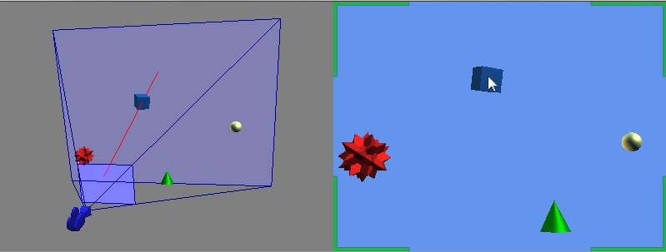
- Identify piece has been clicked by checking intersection of ray and piece’s bounding box.

Dispatches user input event.

Game Scene
- Left click: roll die, choose specify piece for moving.
- Right click: rotate camera, look around the board.
- Keyboard mapping:

S | Save screenshot
1 to 6 | Cheating: get a specific number after roll die from 1 to 6
D | Hide/Display die
~ | Toggle between full screen and windowed

Other Scenes
- Left click: click to buttons.

Addition Library

Math library (matlib, collision)
- Contain Math, Vector2, Vector3, Vector4, Matrix3, Matrix4, Matrix Stack and some functions like plus, minus, multiple, division, determinant, convert from degree to radian and reverse.
- Some type of bounding: bounding box, bounding sphere, bounding volume; Plane, Frustum, Ray and intersection function.

Simple OpenGL Image Library (SOIL)
- A tiny C library used primarily for uploading textures into OpenGL. SOIL can also be used to save and load images in a variety of formats (useful for loading height maps, non-OpenGL applications, etc.)

Game Screenshot

Loading Scene
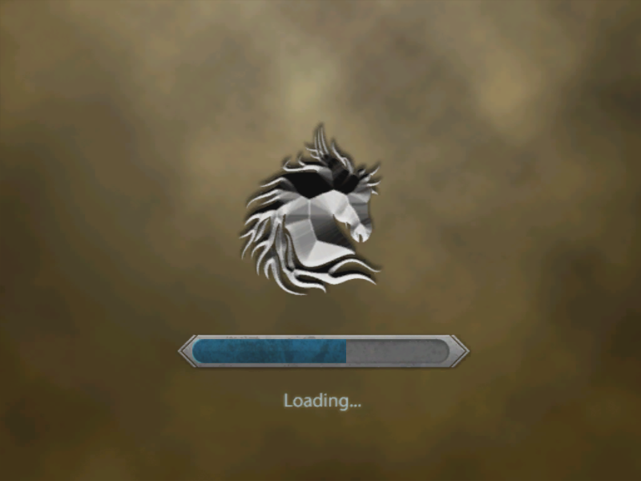

Main Menu Scene
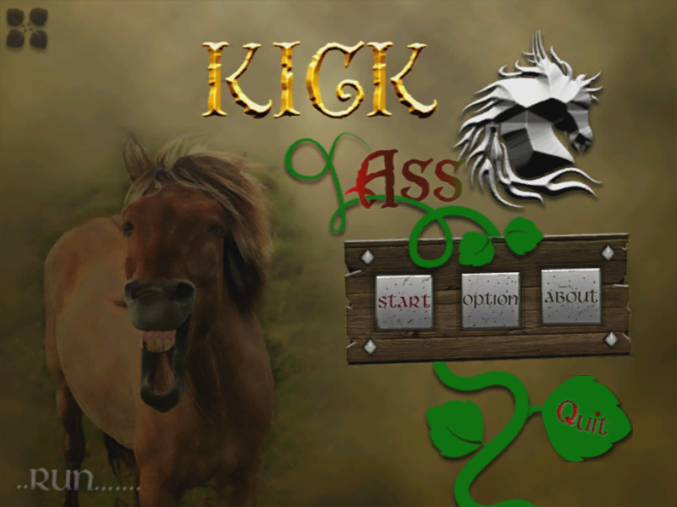

Select Player Scene

Option Scene
Not complete

About Scene
Not complete

Game Scene
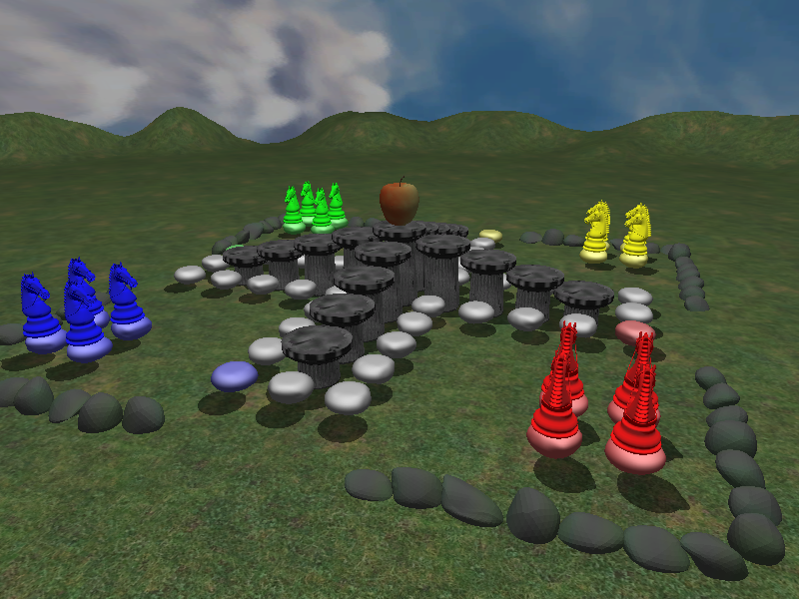

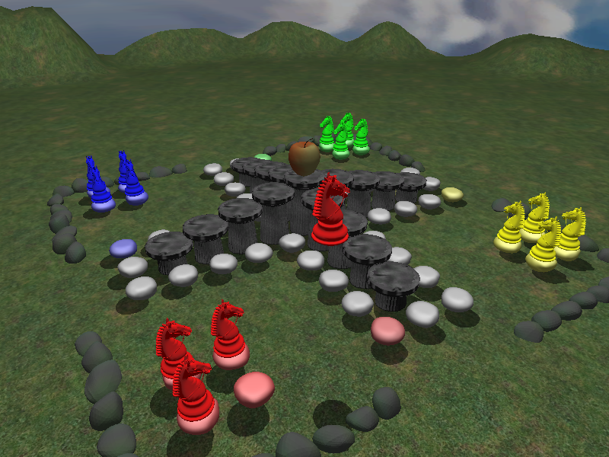
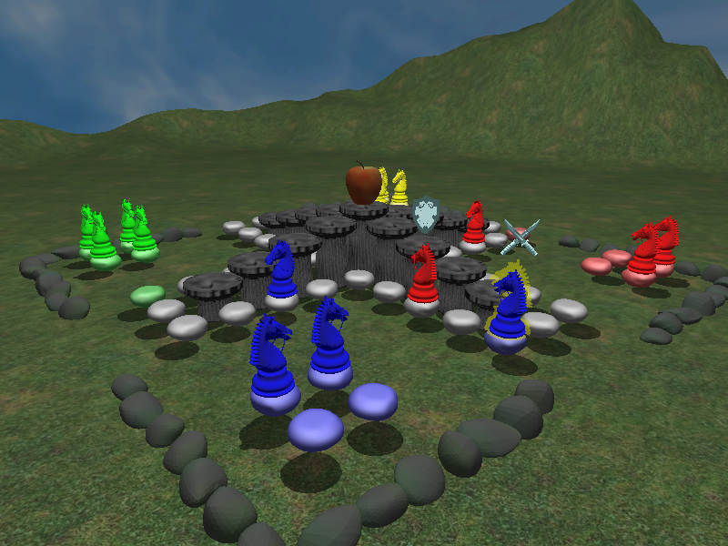

Classes Overview

Math Library Classes
File: mathlib.h, mathlib.cpp
- Math: performing some common math operations such as convert from degree to radian and reverse, linear interpolation …
- Vector2, Vector3, Vector4: A 2, 3, 4-component vector class that represents a row vector and some operations.
- Matrix3, Matrix4: A row-major 3x3, 4x4 matrix class and some operations.

Collision Library Classes
- BoundingBox: A minimum box that contains the object inside it.
- BoundingSphere: A minimum sphere that contains the object inside it.
- Plane: performing a plane with a vector (a, b, c) and a number d
a*x + b*y + c*z + d = 0
- Ray: an origin point and a direction vector. This class contains some intersection functions with BoundingBox, BoundingSphere…

Objects Classes
- ModelOBJ: parent of all classes in this group. Read data from obj and mtl file, process data and store it in memory.
- Model: child of ModelOBJ. This class contains function to get data from memory and draw object on screen with some parameter such as object’s position, anchor point…
- Piece: Piece object and Piece function. There are some addition features of piece: shadow, highlight…
- Die: Die object, draw and roll die function.
- Board: Board object.
- Rock: Rocks create the road that Piece move on it.
- Sky: simulate the sky by drawing a sphere and add texture on it.
- Sword & Shield: Visual effect of piece’s attacking.

2D UI Classes
- Sprite2D: Store 2D texture and draw it in a rectangle in 2D or 3D view.
- Button: A button with 4 states: normal, hover, press, disable.
- ToggleButton: Toggle button with 3 states: on, off, disable.
- RadioGroup: A group of toggle button that if one button is on, others will be off.
- ProgressTimerSprite2D: Another type of Sprite2D, allow to draw only a part of texture on screen with specific percent.

Scene Classes
- Scene: Interface class. All other scenes inherit this class.
- LoadingScene: This scene displays the progress of loading data to memory.
- MainMenuScene: A menu scene, 4 buttons: Start, Option, About, Quits.
- SelectPlayerScene: Choose number of player, type of players in game (Human, Computer)
- OptionScene: Some options in game. (Not complete)
- AboutScene: Game’s information, creator’s information. (Not complete)
- GameScene: Game scene, user play game in this scene.

Future Work
- Complete option scene, about scene.
- Add Pause button in Game, a tiny menu appear after press pause button, allow quitting current game without shutting down the application.
- AI for game, players can play with computer.
- Update the sound.
- Add Vietnamese rules.
- Add more Pieces’ model.
- Model animation.

