*Hi,*

*This is guidance for check my project. The project is built with Maven, TestNg.*

Download project from github: <https://github.com/thuyenh1081/OpenWeatherMap>

**To view the test report:**

+ Please open file *SearchWeatherInYourCity_TestReport.xlsx* under root project

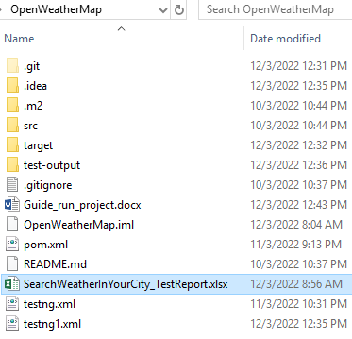

**To run project:**

**You need:**

1. Install Jdk 8, Maven
2. Set the path of Maven, JDK in environment Variables and add %JAVA_HOME%\bin, %JAVA_HOME%\bin in to Path variable

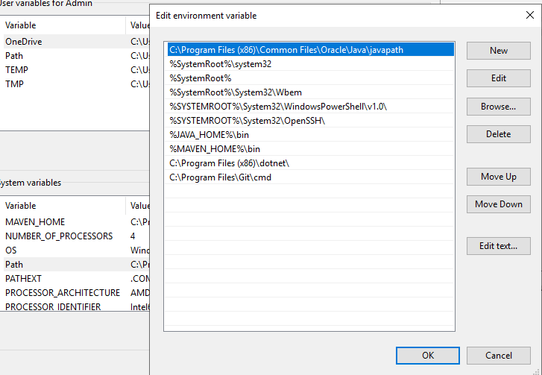

1. Your computer need have hight configuration to avoid error exception when running multi different browser in parallel
2. Install Intelji/Eclipse to open and run it. ( I used Intelji)
3. I put chromeDriver and GeokoDriver under \src\test\resources\driver. You need check them for make sure the drivers is suitable for your browsers (Chrome, Firefox). If there is not suitable, you need download new ones and put them under \src\test\resources\driver
4. Set respository: In your IDE, Ex: Intelji, open Setting/ “Build, Execution, Deployment/ Build Tool/Maven” , check “Override” for Local repository and browser to .m2 folder in this project ( refer below image)
5. Reload maven for make sure that we could build project successfully

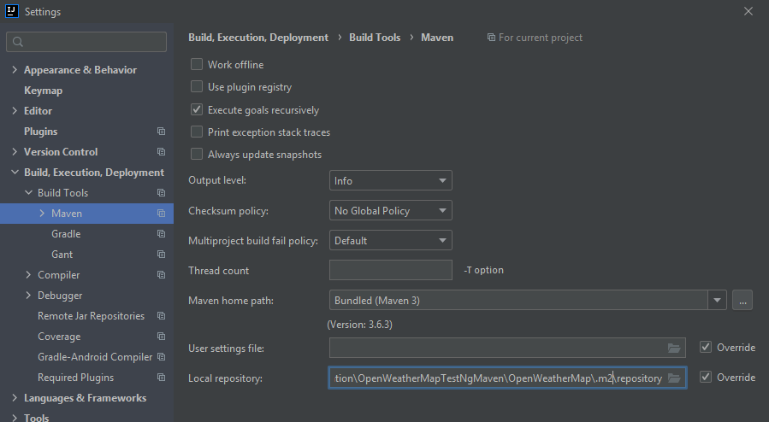

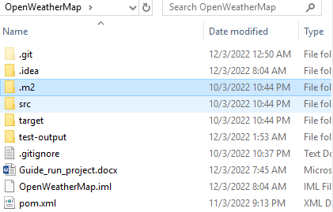

**Run by testng.xml:**

+ right click on testng.xml in the project and choose Run. You need check on “Use Default Reporter” to see report after running. With this way, open {root folder}\test-output\index.html to view the report

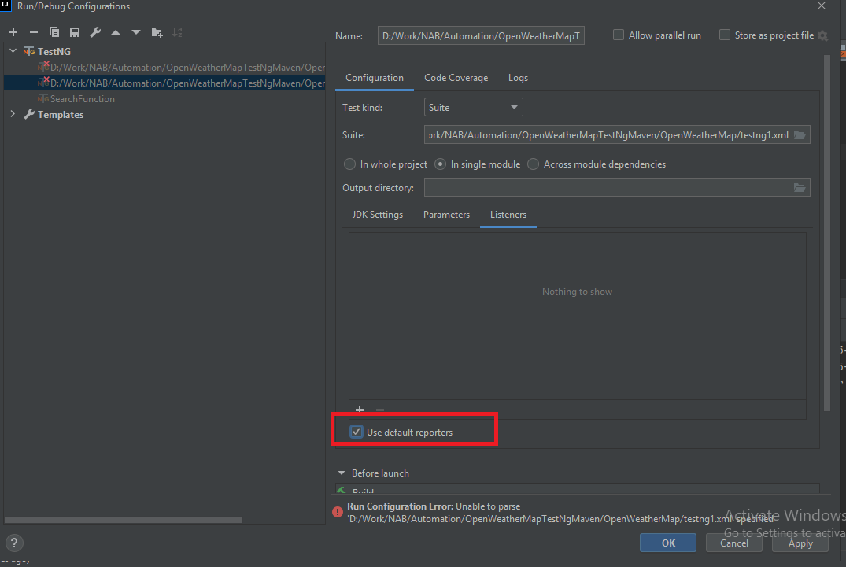

**Run by maven command:**

1. Open cmd, go to the root project
2. Run this command: mvn clean verify test -Dmaven.repo.local=".m2/repository"
3. With this way, open {root folder}\target\surefire-reports\index.html to view the report



Beside report file, you could see the picture that is captured after running a test case:

