Week 2 Day 3 Lab – Closure and Module Pattern
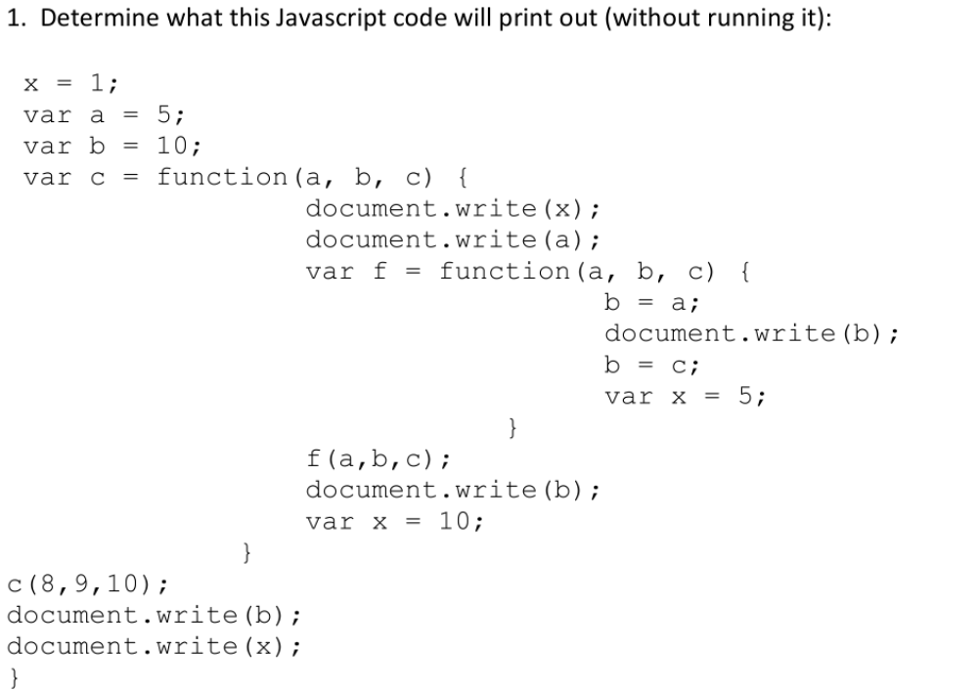
Ans: undefined889101
Ans: Any variable declared outside of a function or assigned value without declare belongs to the global scope, and is therefore accessible from anywhere in your code.
Each function has its own scope (local scope), and any variable declared within that function is only accessible from that function and any nested functions.
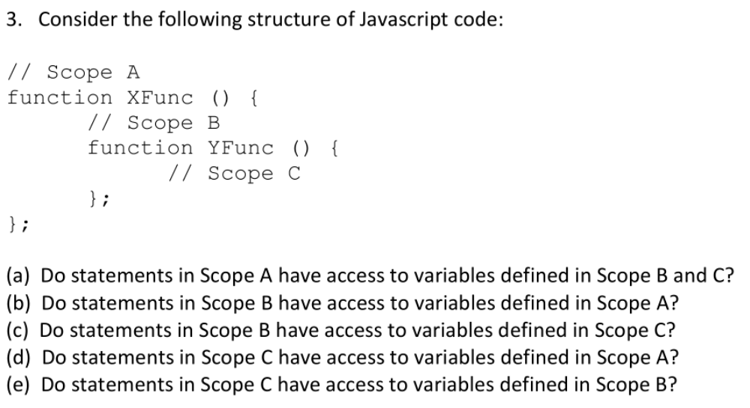
Ans: B, D, E
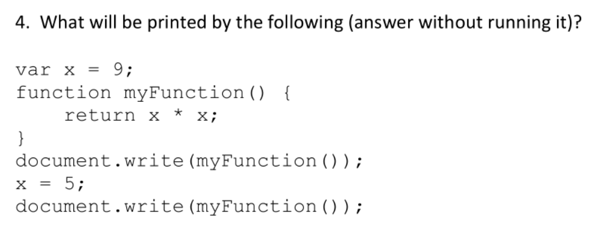
Ans: 8181
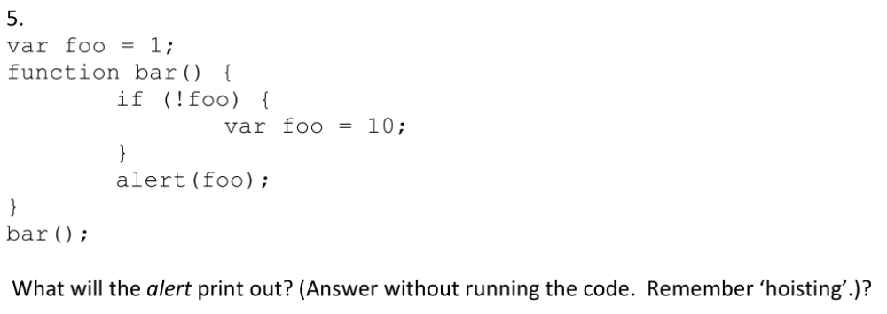
Ans: 10
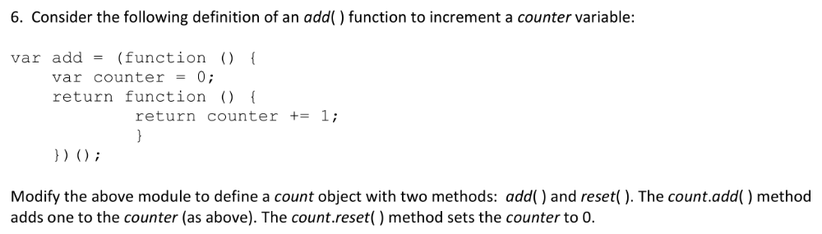
Ans:

function test_Lab6_6() {
var method = (function(){
var myCount = 0;
function changeBy(val) {
myCount += val;
};
return {
add: function () {
changeBy(1);
console.log("test");
},
reset: function () {
return 0;
},
value: function () {
return myCount;
}
}
})();
method.add();
console.log(method.value());
method.reset();
console.log(method.value());
}

Ans: Free variable is variable which it is declared on enclosing class

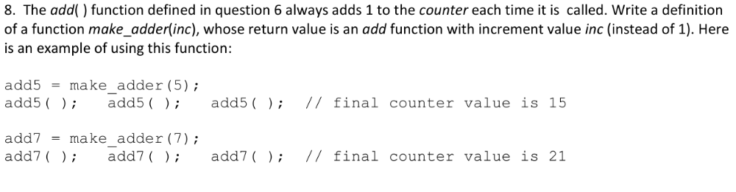
Ans:

function test_Lab6_8() {
function make_add(val) {
var privateCounter = 0;
const myVal = val;
return function changeBy() {
privateCounter += myVal;
return privateCounter;
}
}
var add5 = make_add(5);
add5();
add5(); //add5;
console.log(add5());
var add7 = make_add(7);
add7();
add7();// add7;
console.log(add7());
}

Add all code to the function. After function finished, function and variable declaration on that function will be destroyed. (Apply module partern)

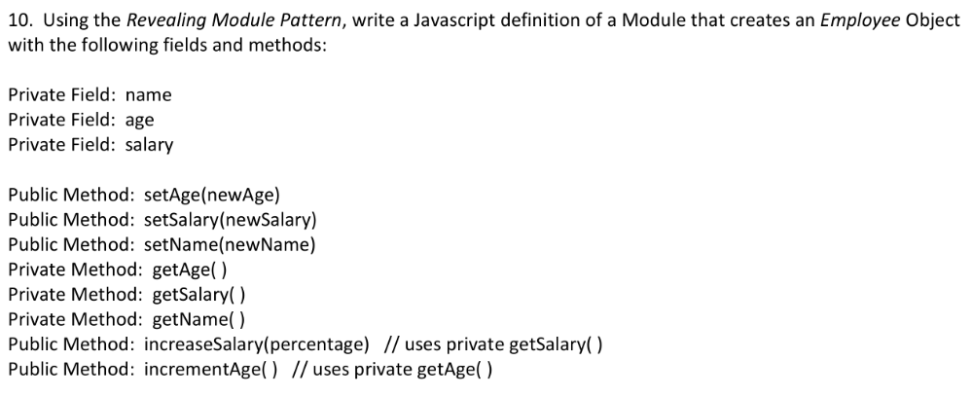
Ans:

function test_lab6_10_revealingPartern() {
var employee = (function () {
var name = "";
var age = 0;
var salary = 0;
function getName() {
return name;
}
function getAge() {
return age;
}
function getSalary() {
return salary;
}
function setAge(newAge) {
age = newAge;
}
function setName(newName) {
name = newName;
}
function setSalary(newSalary) {
salary = newSalary;
}
function increaseSalary(percentage) {
salary += getSalary()*percentage;
}
function increaseAge() {
age = getAge() + 1;
}
return {
age : setAge,
setName : setName,
// getName : getName,
setSalary : setSalary,
increaseSalary: increaseSalary,
increaseAge : increaseAge
}
})();
}

Ans:
function test_lab6_11_revealingPartern() {
var employee = (function () {
var name = "";
var age = 0;
var salary = 0;
var address = "";
function getName() {
return name;
}
function getAge() {
return age;
}
function getSalary() {
return salary;
}
function setAge(newAge) {
age = newAge;
}
function setName(newName) {
name = newName;
}
function setSalary(newSalary) {
salary = newSalary;
}
function increaseSalary(percentage) {
salary += getSalary()*percentage;
}
function increaseAge() {
age = getAge() + 1;
}
function setAddress(newAddress) {
address = newAddress;
}
function getAddress() {
return address;
}
return {
age : setAge,
setName : setName,
setSalary : setSalary,
increaseSalary: increaseSalary,
increaseAge : increaseAge,
getAddress: getAddress,
setAddress: setAddress
}
})();
employee.setAddress("test");
console.log(employee.getAddress());
}

