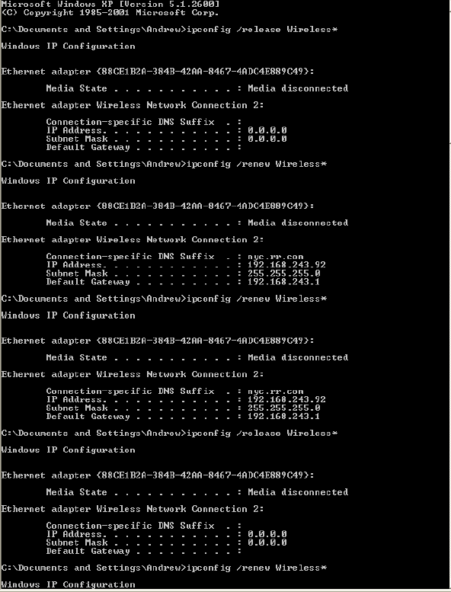1.

2. I am not clear. Wait lab solution.

3.

Frame 1 (342 bytes on wire, 342 bytes captured)

Ethernet II, Src: 192.168.243.92 (00:90:4b:69:dd:34), Dst: Broadcast

(ff:ff:ff:ff:ff:ff)

Destination: Broadcast (ff:ff:ff:ff:ff:ff)

Source: 192.168.243.92 (00:90:4b:69:dd:34)

Type: IP (0x0800)

Internet Protocol, Src: 0.0.0.0 (0.0.0.0), Dst: 255.255.255.255 (255.255.255.255)

User Datagram Protocol, Src Port: bootpc (68), Dst Port: bootps (67)

Bootstrap Protocol

4. The values which differentiate the Discover message from the Request message are in “Option 53: DHCP Message Type”.

5. The value of the Transaction ID is 0xe6746a7d. The second Transaction ID is 0xe4eff25f.

6. The DHCP client and server both use 255.255.255.255 as the destination address. The client uses source IP address 0.0.0.0, while the server uses its actual IP address as the source.

7. The IP address of the DHCP server is 192.168.243.1.

8. The DHCP server offered the IP address 192.168.243.92 to my client machine. The DHCP message with “DHCP Message Type = DHCP Offer” contained the offered IP.

9. The “Relay agent IP address” is 0.0.0.0, which indicates that there is no DHCP Relay used.

10.

The router line indicates to the client what its default gateway should be.

The subnet mask line tells the client which subnet mask it should use.

11. The host requests the offered IP address in the DHCP Request message.

12. The lease time is 3 days.

13. DHCP Release message to cancel its lease on the IP address given to it by the DHCP server.

14. Yes. The DHCP server issues an ARP request for the offered IP to make sure the IP address is not already in use by another workstation.