1.IP: 192.168.1.102 port number: 1161

2.IP: 128.119.245.12 port number: 80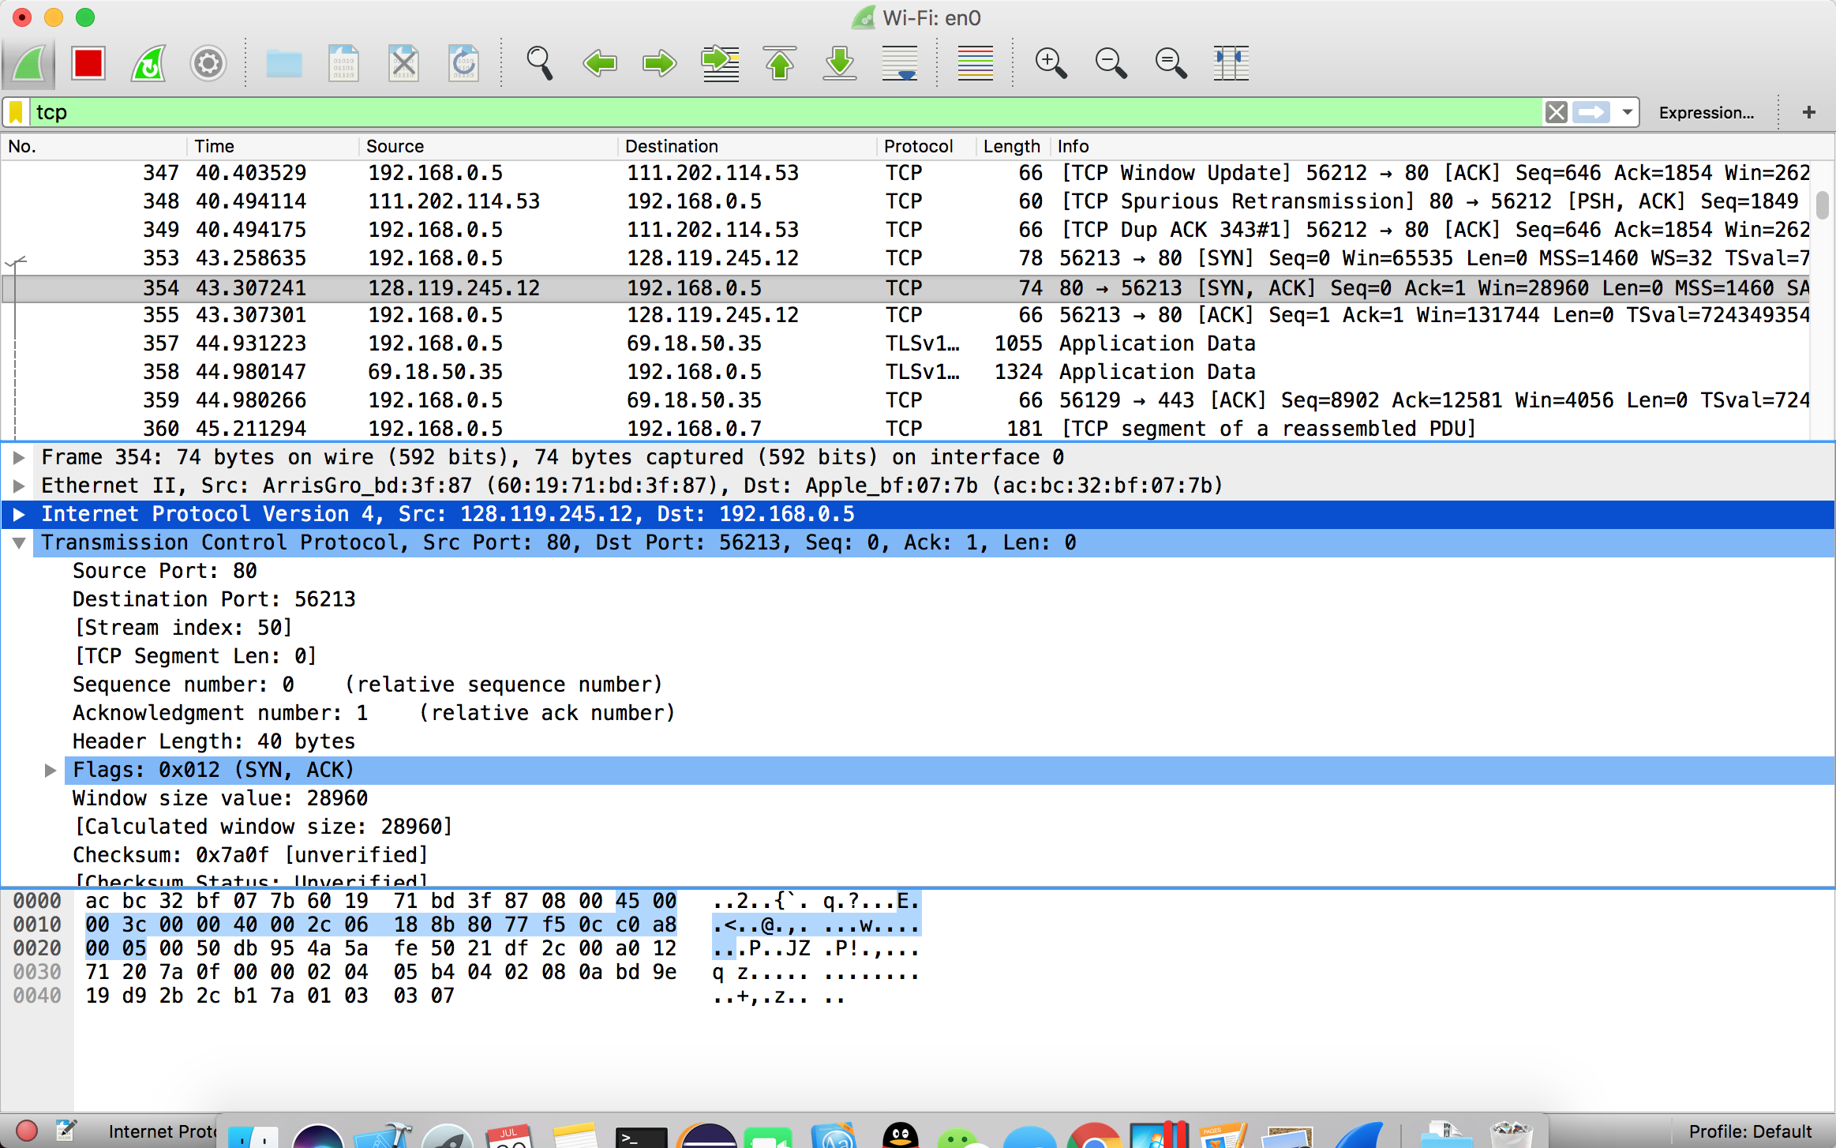

3.1.IP: 192.168.0.5 port number: 56213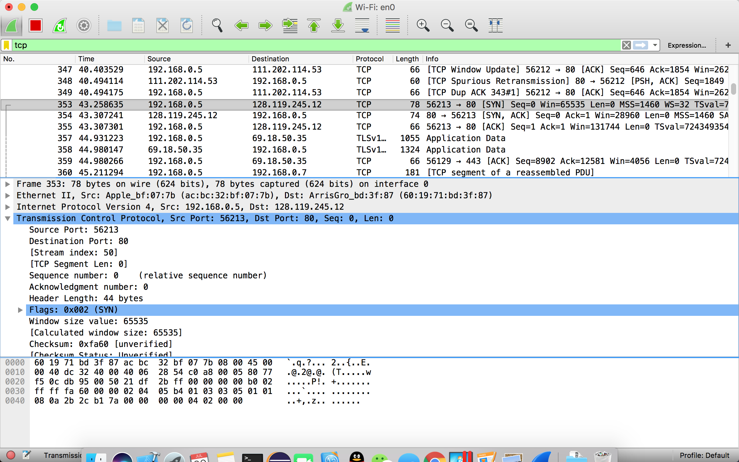

4.The sequence number of the TCP SYN segment is 0

SYN flag is set to 1 which indicates that this segment is a SYN segment.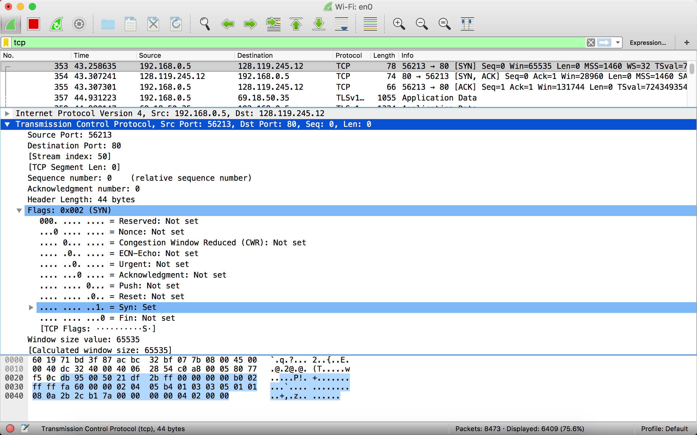

5. the sequence number of the SYN_ACK segment sent by gaia.cs.umass.edu to the client computer in reply to the SYN is 0. The value of the acknowledgement field in the SYN_ACK segment is determined by the server gaia.cs.umass.edu. The server adds 1 to the initial sequence number of the SYN segment from the client computer. For this case, the initial sequence number of the SYN segment from the client computer is 0, thus the value of the acknowledgement field in the SYN_ACK segment is 1. A segment will be identified as a SYN_ACK segment if both SYN flag and ACKnowledgement flag in the segment are set to 1.

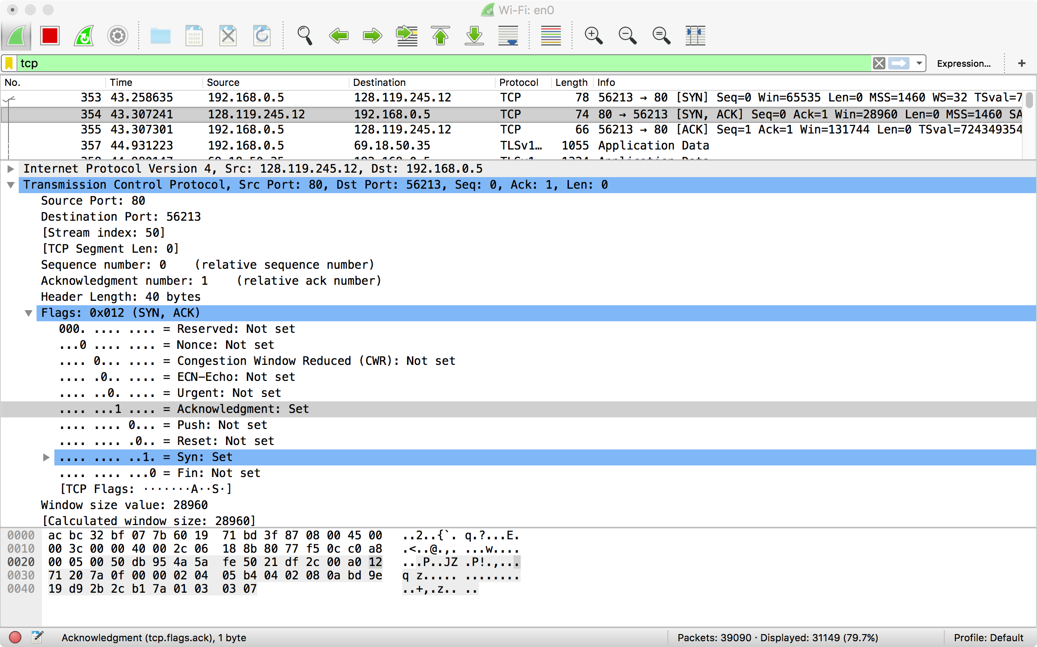

6.The sequence number of the TCP segment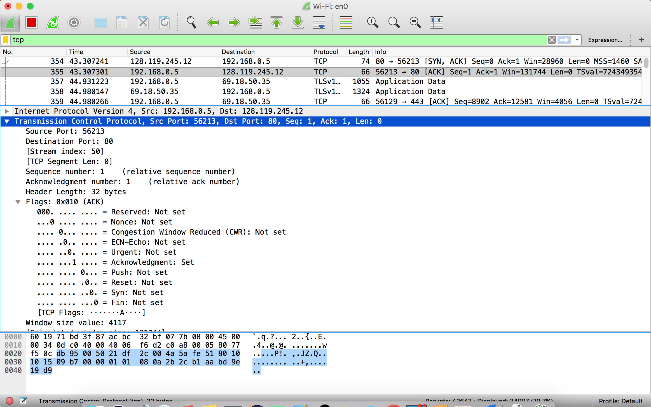 containing the HTTP Post command is 1.

7

**Segment Packet Number Sequence Time Sent received RTT**

1 38 1 1.738554 2.026105 0.287551

2 43 1401 2.026161 2.311435 0.285274

3 44 2801 2.026174 2.311435 0.285261

4 45 4201 2.026180 2.311549 0.285369

5 49 5601 2.311505 2.311681 0.000176

6 50 7001 2.311512 2.597809 0.286297

8.The length of each of the first 6 TCP segments is 1400 bytes.

**Segment Packet Number Sequence Length Time Sent received RTT**

1 38 1 1400 1.738554 2.026105 0.287551

2 43 1401 1400 2.026161 2.311435 0.285274

3 44 2801 1400 2.026174 2.311435 0.285261

4 45 4201 1400 2.026180 2.311549 0.285369

5 49 5601 1400 2.311505 2.311681 0.000176

6 50 7001 1400 2.311512 2.597809 0.286297

9.The minimum amount of available buffer space advertised at the received is 17536 bytes.

**Segment** **Available Buffer Space Advertised At The Received**

1 17536

2 20480

3 23424

4 26368

5 29312

6 32128

10: There is no retransmitted segments. Because the sequence number is successive.This can be explained by packets with same sequence number at different time is not found.

11. the ACK numbers increase in the sequence of 1401, 2801, 4201, and so on. The ACK numbers increases by 1400 each time, indicating that the receiver is acknowledging 1400 bytes.

12:From the trace , we know that the last number of ACK is 152987.

The duration of the http is 5.058767 - 4.381002 = 0.677765

So the throughput is 152987 / 0.677765 = 225722 bytes/second;

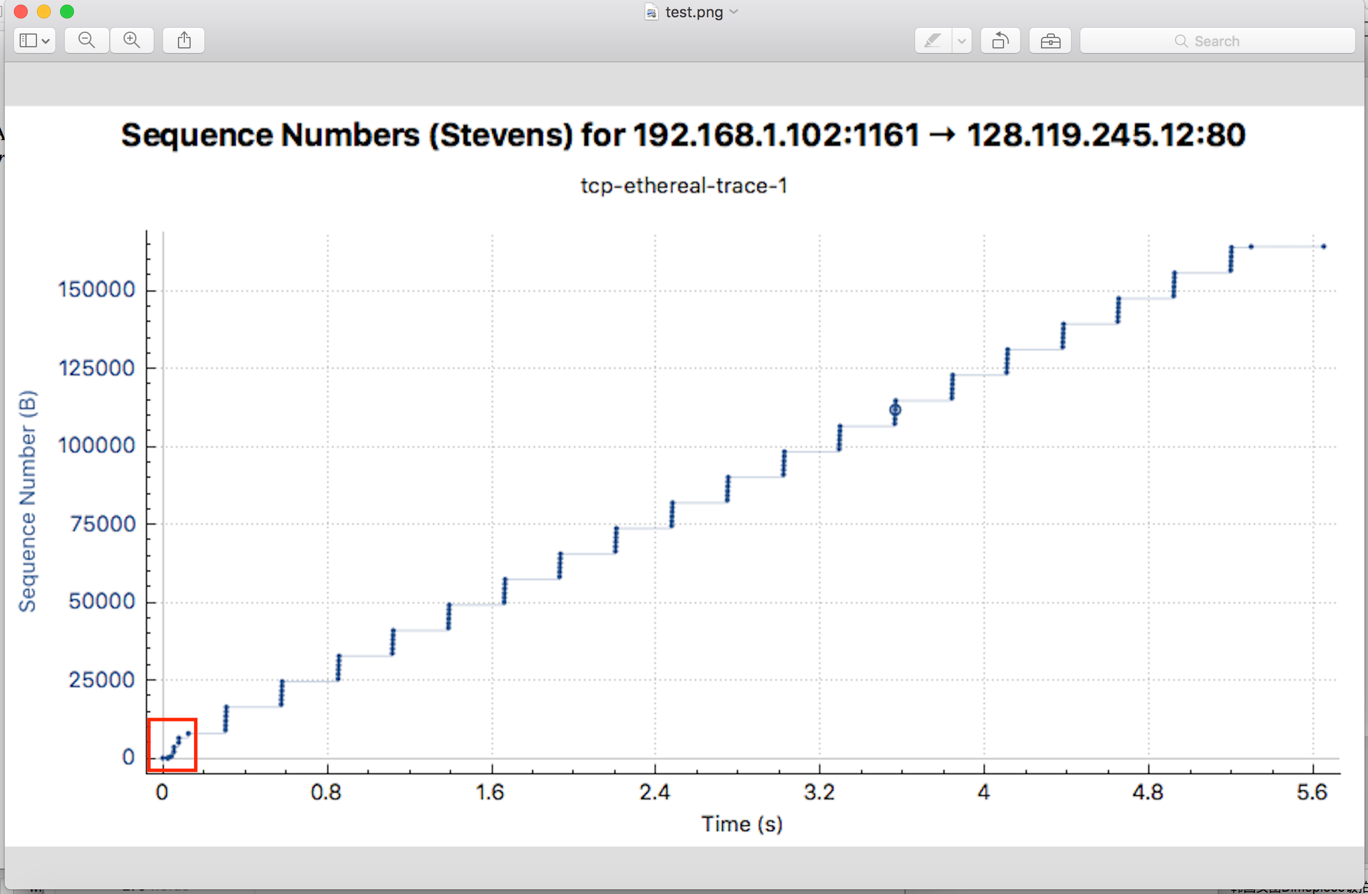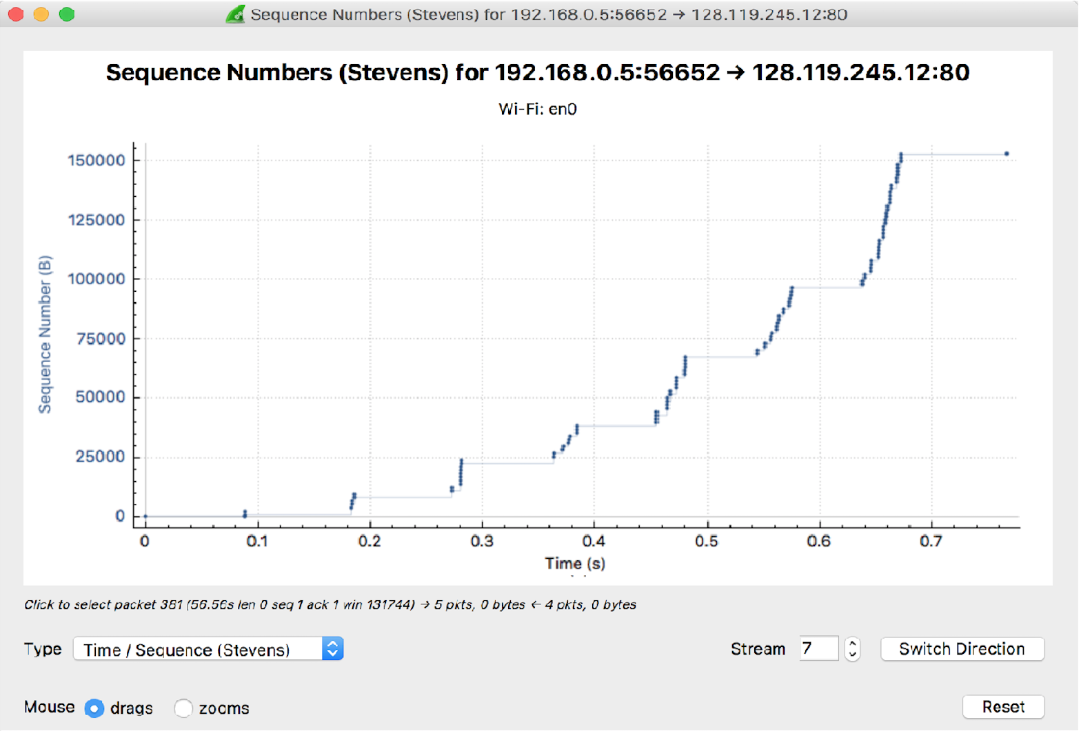

14:According to my trace , we can see the window size till increase. So we can’t see the low star end.