1. List 3 different protocols: TCP, UDP, DNS
2. How long did it take from when the HTTP GET message was sent until the HTTP OK reply was received?
→ 0.065981721 seconds
3. What is the Internet address of the gaia.cs.umass.edu?
→ 128.119.245.12
What is the Internet address of your computer?
→ 192.168.0.16

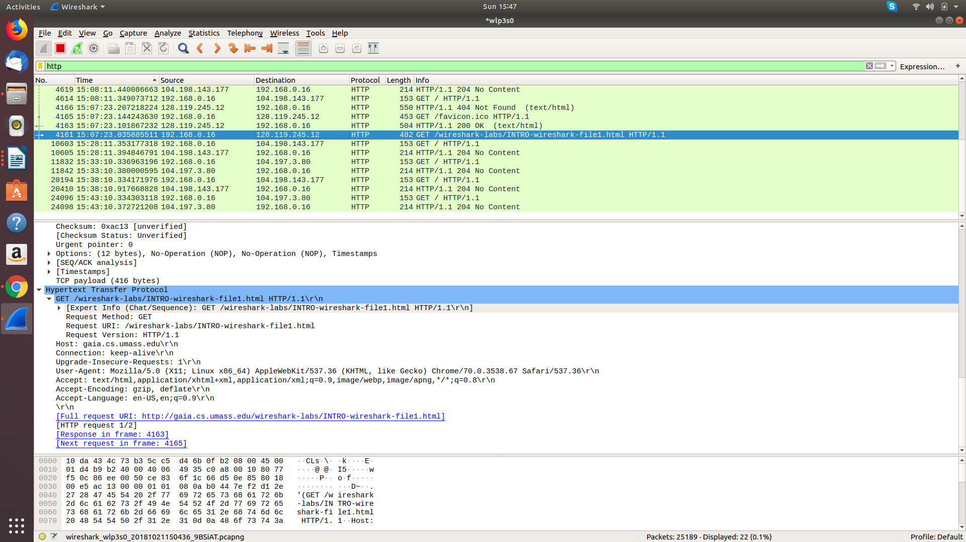
I hereby declare that this submission is my own original work and to the best of my knowledge it contains no materials previously published or written by another person.

