Table of Contents

When Institutional Transformation Breaks the Threshold: The Disappearance of the Inverted-U Internationalisation–Performance Relationship in Indian Firms, 2014–2025
Author details removed for blind review
Target journal: Management International Review (Springer Nature), or alternatively International Journal of Emerging Markets (Emerald).
2 June 2026
Manuscript classification: Research article.
Word count (main text excluding abstract, references, tables and figures): approximately 8,500 words.
Tables: 5 (Table 1 descriptives by wave; Table 2 main M2 across waves; Table 3 cross-wave Paternoster z-tests; Table 4 capability moderation; Table 5 3-wave robustness).
Figures: 4 (Figure 1 conceptual model; Figure 2 wave-specific predicted I-P curves; Figure 3 turning-point estimates with 95% CI; Figure 4 UPI quasi-experiment timeline).

Abstract
This study examines whether the inverted-U relationship between export intensity and firm productivity among Indian private firms is structurally durable across the 2014 to 2025 institutional and digital transformation decade (demonetisation, GST, IBC, UPI saturation, PLI, Atmanirbhar Bharat), and whether technological and digital capabilities moderate the threshold. Three World Bank Enterprise Survey waves for India (2014 PICS3, 2022 BEE, 2025 BREADY; analytic N = 28,717) are estimated by OLS with HC1 robust standard errors, quadratic FSTS terms, and capability interactions; Lind–Mehlum U-tests verify the inverted-U per wave and Paternoster z-tests evaluate 2014-versus-2025 coefficient equality, with the April 2016 UPI rollout providing a quasi-experiment for digital saturation. The inverted-U structurally collapses: the turning point migrates from FSTS = 61.8 per cent (2014) to 40.7 per cent (2022), and by 2025 the curvature term is insignificant (β₂ = −0.16, p = 0.42) and the relationship is monotonically negative. Paternoster z-tests reject coefficient equality for the linear (z = −7.94) and quadratic (z = +4.17) terms (both p < 0.0001), and the UPI Tier-2 e-payment interaction is negative (FSTS × DAI_epay = −4.02, p = 0.004). The study provides the first firm-level evidence that extreme institutional transformation can dissolve, rather than relocate, the inverted-U threshold, identifying a previously untested scope condition for the Lu and Beamish (2004) claim: the threshold is conditional on institutional stability. The authors’ earlier work (Do and Phan, 2025) is acknowledged as prior author work.
Keywords: internationalisation–performance; export intensity; threshold stability; India; UPI; technological capability; institutional transformation; Conditional Digital Capability Moderation.
JEL classification: F23 (multinational firms; international business); O33 (technological change: choices and consequences); D22 (firm behaviour: empirical analysis); L25 (firm performance); O53 (economywide country studies: Asia); O25 (industrial policy).
Paper type: Research paper.

Highlights
- The inverted-U export-productivity relationship in Indian firms collapses between 2014 (TP = 61.8%) and 2025 (curvature insignificant). Intermediate evidence in 2022 (TP = 40.7%) shows progressive shift.
- Paternoster cross-wave z-tests reject coefficient equality at p < 0.0001 for both linear and quadratic FSTS terms.
- The collapse coincides with India’s decade of exceptional institutional change: demonetisation, GST, IBC, UPI, PLI, COVID-19, and Atmanirbhar Bharat.
- UPI Tier-2 e-payment interacts negatively with export intensity, refuting the public-infrastructure-substitution hypothesis.
- The finding identifies a previously untested scope condition: the inverted-U threshold is conditional on institutional stability.
- Complements but does not duplicate prior author work on TMT moderation in Indian firms (Do & Phan, 2025, IntechOpen).

1. Introduction
India between 2014 and 2025 underwent institutional and digital transformation at a pace without obvious historical parallel in the post-independence period of any major emerging economy. The Modi government took office in May 2014 with an explicit reform agenda. Within thirty months, three foundational policy changes redrew the operating environment for private firms. The Insolvency and Bankruptcy Code (May 2016) replaced a fragmented bankruptcy regime. The demonetisation of 86 per cent of currency in circulation (November 2016) imposed an abrupt liquidity contraction whose firm-level effects have been documented as both immediate and persistent (Chodorow-Reich et al., 2020). The Goods and Services Tax (July 2017) replaced a federation of state-level indirect taxes with a single national framework. April 2016 also saw the launch of the Unified Payments Interface (UPI), public digital payment infrastructure that, by 2024, processed more than 12 billion transactions monthly. No developed economy has matched this scale of public digital adoption. The 2020 policy turn redirected national strategy inward. The Atmanirbhar Bharat (self-reliant India) doctrine and the Production-Linked Incentive (PLI) scheme reoriented firm-level capability incentives toward domestic manufacturing scale, even as the COVID-19 pandemic disrupted cross-border supply chains throughout 2020 and 2022. By 2024, India had become the world’s fifth-largest economy and was hosting the G20 presidency. The eleven-year window of this study covers all of this institutional churn.
The internationalisation–performance (I-P) literature offers a sharp prediction against which this setting can be tested. Lu and Beamish (2004), Contractor (2007), and the meta-analytic synthesis by Marano et al. (2016) document an inverted-U relationship between export intensity and firm productivity that has been replicated across geographic contexts, time windows, and performance measures. The relationship is now treated as a near-consensus generalisation. A small but pointed critique (Hennart, 2007; Verbeke and Forootan, 2012) questions specification and measurement; a moderating-conditions literature (Cuervo-Cazurra, 2012; Banalieva et al., 2017) examines how institutional development and firm characteristics shift the relationship. Yet across these literatures, one assumption remains conspicuously untested with within-country longitudinal data: that the inverted-U is structurally invariant to macro institutional change. The assumption is plausible. If the inverted-U reflects the firm-level cost-benefit balance between learning-by-exporting and over-extension costs, and if both sides of this balance are determined predominantly by firm-internal and industry-level mechanisms, then macro institutional shocks should shift the level of productivity without altering the threshold location. The institutions-based view (Peng et al., 2008; Peng et al., 2009) is compatible with this assumption when institutions evolve gradually. India’s reform decade tests the limits of this compatibility.
This study employs three waves of World Bank Enterprise Survey microdata for India: 2014 PICS3 (N = 9,281), 2022 BEE (N = 9,376), and 2025 BREADY (N = 10,479). The pooled raw sample contains 29,136 firm-year observations. The dataset exceeds, by an order of magnitude, the matched-panel samples typically used in prior Indian I-P work (Elango and Pattnaik, 2007; Chittoor et al., 2009). Three features of the empirical setting are particularly informative. Firstly, the 2014 wave provides a baseline observation taken before the reform decade was substantively underway. This isolates the pre-shock configuration of the I-P relationship. Secondly, the 2022 BEE wave falls between the first reform wave (2016 to 2017) and the policy redirection of 2020. The intermediate wave allows a test of whether the cross-wave dynamics are progressive or whether 2025 reflects a discontinuity attributable to instrument change. Thirdly, the 2025 BREADY wave includes a new measure of public digital infrastructure utilisation: the proportion of firm sales received via electronic payment. This measure captures UPI-mediated transactions and supports an exploratory quasi-experimental test of the developmental-state proposition that public digital infrastructure can substitute for private digital capability accumulation (Aschauer, 1989; Donaldson, 2018).
The analysis tests a baseline inverted-U hypothesis (H1) and four directional hypotheses: a competitive pair on threshold durability (H2a institutional shift versus H2b durability), technological-capability moderation (H3a level-shifter under stability, H3b export-intensity-contingent under post-PLI redirection), and digital-capability moderation (H4a private Tier-1 moderation, H4b public Tier-2 dominance). From this set, three contributions follow. Firstly (mapping to H2), the analysis provides the first within-country longitudinal evidence that the inverted-U export-intensity-productivity relationship can be dissolved by extreme institutional change, rather than only relocating its turning point. The turning point in 2014 lies at 61.8 per cent FSTS with the inverted-U strongly supported on Lind and Mehlum (2010) tests. In 2022 the turning point migrates inward to 40.7 per cent. In 2025 the quadratic curvature is statistically indistinguishable from zero, and the relationship is monotonically negative across the empirically relevant export-intensity range. Paternoster cross-wave z-tests (Paternoster et al., 1998) decisively reject coefficient equality. This identifies an environmental scope condition that the canonical I-P literature has implicitly assumed but never tested with multi-wave firm-level data. The inverted-U is conditional on institutional stability. Secondly (mapping to H4), the analysis refines the developmental-state literature on public digital infrastructure by showing that public and private digital infrastructure are complements rather than substitutes in the export production function. India’s UPI rails are highly effective for domestic transactions. They do not substitute for the cross-border financial infrastructure that exporters specifically require. The negative Tier-2 moderation is most coherently interpreted as a purpose-alignment requirement that prior treatments of public infrastructure substitution have not articulated. Thirdly (mapping to H3), this study documents that capability constructs theoretically stable across contexts can exhibit context-dependent operating signs when major policy incentives redirect their strategic use. The Technological Capability Index operates as a positive level-shifter of productivity in 2014 and 2022. It then flips negative in 2025 with a positive export-intensity interaction. This pattern is consistent with the strategic emphasis trade-off documented by Mizik and Jacobson (2003), which has not previously been brought into the international business literature.
This study extends but does not duplicate the authors’ earlier work on Indian firms. Do and Phan (2025) examined a matched sub-sample of 380 firms across two waves. That study used a linear specification of degree of internationalisation, the Uppsala (Johanson and Vahlne, 1977) and Upper Echelons (Hambrick and Mason, 1984) frameworks, feasible generalised least squares estimation, and top-management-team moderation as the central research question. The present study uses a different theoretical lens (the institutions-based view), a different specification (quadratic inverted-U with Lind–Mehlum testing), a different sample (the full WBES across three waves), a different method (ordinary least squares with heteroscedasticity-robust and state-clustered standard errors), and a different research question (threshold dynamics under institutional shift). The two studies are complementary rather than overlapping. The prior work characterises managerial mechanisms operating within the firm. The present work characterises institutional mechanisms operating on the firm.
The remainder of the paper proceeds as follows. Section 2 develops the theoretical framework. Section 3 details the three-wave WBES dataset, the harmonisation protocol across the PICS3, BEE intermediate, and BREADY questionnaire generations, and the estimation strategy. Section 4 reports per-wave and pooled results, cross-wave Paternoster z-tests, capability moderation estimates, and five robustness specifications. Section 5 discusses the boundary-condition contribution, the public-versus-cross-border digital infrastructure refinement, the technological-capability sign reversal, and policy implications corrected from the threshold-collapse evidence. Section 6 acknowledges limitations and outlines future research directions.

2. Theory and Hypotheses

2.1 The inverted-U baseline and its assumed scope conditions
The canonical post-2000 internationalisation–performance (I-P) literature converges on an inverted-U specification (Lu and Beamish, 2004; Marano et al., 2016). Productivity rises with internationalisation up to an optimal threshold and then declines as over-extension and coordination costs dominate learning-by-exporting and market-diversification gains. The relationship has been replicated across geographic contexts, time windows, and performance measures. It has become a near-consensus generalisation in the field. Recent methodological critiques raise concerns about specification sensitivity (Hennart, 2007; Verbeke and Forootan, 2012). A small literature on institutional moderators has begun to explore boundary conditions (Cuervo-Cazurra, 2012; Banalieva et al., 2017). Concurrent with this study, Hutzschenreuter, Kleindienst, Sarkar Sengupta and Verbeke (2026) report an inverted-U relationship between added cultural distance and performance in 109 Indian MNEs tracked over 6–31 years post-1991 liberalisation, attributing the threshold to a meta-bounded-rationality challenge: senior managers underestimate how the aggregate of multiple international investment steps overwhelms managerial capacity. Their finding establishes the generalisability of the inverted-U claim outside the German Hutzschenreuter and Voll (2008) baseline and supplies a Penrosean micro-foundation that complements the institutional argument advanced below. However, the foundational assumption that the inverted-U is a structurally stable feature of firm-level production functions, invariant to macro institutional change, remains largely untested in within-country longitudinal designs. The first hypothesis re-establishes the baseline against which threshold dynamics can be assessed.
Hypothesis 1 (H1). Under conditions of institutional stability, the export-intensity–productivity relationship among Indian private firms is inverted-U shaped, with a turning point in the empirically relevant FSTS range.
The italicised scope condition is deliberate. H1 is framed as conditional rather than universal, anticipating the possibility that institutional instability may dissolve the relationship. Empirical evidence for the 2014 baseline (when reform-era institutional churn was minimal) supports H1. Failure to support H1 in later waves becomes informative about the scope condition itself.

2.2 Institutional theory and threshold dynamics
The institutions-based view (Peng et al., 2008) holds that firm strategy and performance are jointly shaped by industry conditions, firm resources, and the institutional environment. The institutional layer becomes dominant in emerging-market contexts. Under conditions of institutional stability, the cost-benefit balance underpinning the inverted-U (learning-by-exporting gains relative to over-extension costs) is determined predominantly by firm-internal and industry-level mechanisms. Under conditions of institutional instability, the balance is exogenously perturbed. Cross-border transaction costs, financing access, regulatory predictability, and macro-policy signals all shift, potentially in non-monotone ways.
North (1990) and Williamson (2000) distinguish institutional change at multiple levels operating at different time scales: formal rules (years), regulatory enforcement (decades), and informal norms (generations). India’s 2014 to 2025 window contains formal-rule shocks at exceptional density. These include demonetisation (November 2016), the Goods and Services Tax (July 2017), the Insolvency and Bankruptcy Code (May 2016), the Production-Linked Incentive scheme (2020), COVID-19 supply-chain disruption (2020 to 2022), and the Atmanirbhar Bharat self-reliance policy (2020). Each is non-trivial individually. The compounding effect over a decade has no comparable historical precedent in a major emerging market.
The competing hypotheses are stated as follows:
Hypothesis 2a (H2a). The inverted-U turning point in India differs significantly between 2014 (pre-reform-decade) and 2025 (post-reform-decade), reflecting institutional perturbation of the underlying production function.
Hypothesis 2b (H2b). The inverted-U turning point in India is structurally durable across 2014 and 2025 despite the demonetisation, GST, IBC, UPI, PLI, COVID-19, and Atmanirbhar Bharat reform decade.
The competitive design is decisive: H2a and H2b cannot both be supported. Comparable evidence from emerging Asian economies under more moderate institutional change tends to support durability (Contractor et al., 2007; Singh, 2009). If India under extreme change also supports durability, the inverted-U is established as broadly robust to institutional context. If India supports shift, the scope condition is identified.

2.3 Technological capability moderation
Absorptive capacity (Cohen and Levinthal, 1990) and dynamic capabilities (Teece, 2007) imply that firms with stronger technological capabilities extract more productivity from any given exposure to international markets. Three operationalised dimensions enter the Technological Capability Index (TCI): quality certification, foreign technology licensing, and product innovation activity. Under conditions of institutional stability and stable strategic incentives, TCI should operate as a positive level-shifter of productivity without altering the inverted-U curvature.
Hypothesis 3a (H3a). Under conditions of institutional and strategic stability (2014, 2022), technological capability is a positive level-shifter of productivity but does not alter the inverted-U curvature.
Under conditions of major policy redirection, particularly the post-2020 Atmanirbhar Bharat and PLI rollout, the strategic emphasis literature (Mizik and Jacobson, 2003) suggests that firms reallocating TCI investment toward domestic incentives may experience a different TCI-productivity relationship at higher export intensity. The PLI scheme incentivises domestic manufacturing capability accumulation rather than export orientation.
Hypothesis 3b (H3b). Under conditions of post-PLI strategic redirection (2025), technological capability’s positive contribution becomes contingent on export intensity rather than independent of it.

2.4 Digital capability moderation and the UPI quasi-experiment
The Digital Adoption Index (DAI) is decomposed into two tiers that reflect distinct types of digital infrastructure. Tier-1 captures private firm-level digital adoption, measured by an own-website binary available in all three WBES waves (2014, 2022, 2025). Tier-2 captures public-infrastructure-mediated digital adoption, measured by the percentage of sales received via electronic payment, available only in the 2025 BREADY schema. India’s Unified Payments Interface (UPI) launched in April 2016 and reached 12 billion transactions per month by 2024, providing the empirical context for Tier-2. UPI is public digital infrastructure on a scale rarely matched in any emerging economy.
The developmental-state literature suggests that public infrastructure can substitute for private capability accumulation among smaller firms (Aschauer, 1989; Donaldson, 2018). If UPI substitutes for private digital infrastructure in the same way, Tier-2 should moderate the I-P relationship more substantially than Tier-1:
Hypothesis 4a (H4a). DAI Tier-1 (private website adoption) positively moderates the I-P relationship at higher export intensity.
Hypothesis 4b (H4b). DAI Tier-2 (e-payment uptake via UPI infrastructure) moderates the I-P relationship more substantially than DAI Tier-1.
H4b is a falsifiable prediction. If UPI as public infrastructure substitutes for the digital capability that private exporters would otherwise have to build themselves, Tier-2 should produce a stronger positive moderation than Tier-1. A negative or null Tier-2 interaction would refute the substitution claim. This would point toward a complementarity interpretation, namely that public domestic-rupee infrastructure does not substitute for the cross-border financial infrastructure (SWIFT, correspondent banking, trade finance) that exporters specifically need.

2.5 Conceptual model
The conceptual model integrating H1 to H4b is summarised in Figure 1. The institutional scope condition forms an outer contextual frame that determines whether the inverted-U baseline holds (under stability) or dissolves (under shift). Within this frame, technological and digital capabilities moderate the relationship via three distinct pathways. Control variables (firm size, age, foreign ownership, and state fixed effects) condition the estimation but are not the focus of theoretical interest.
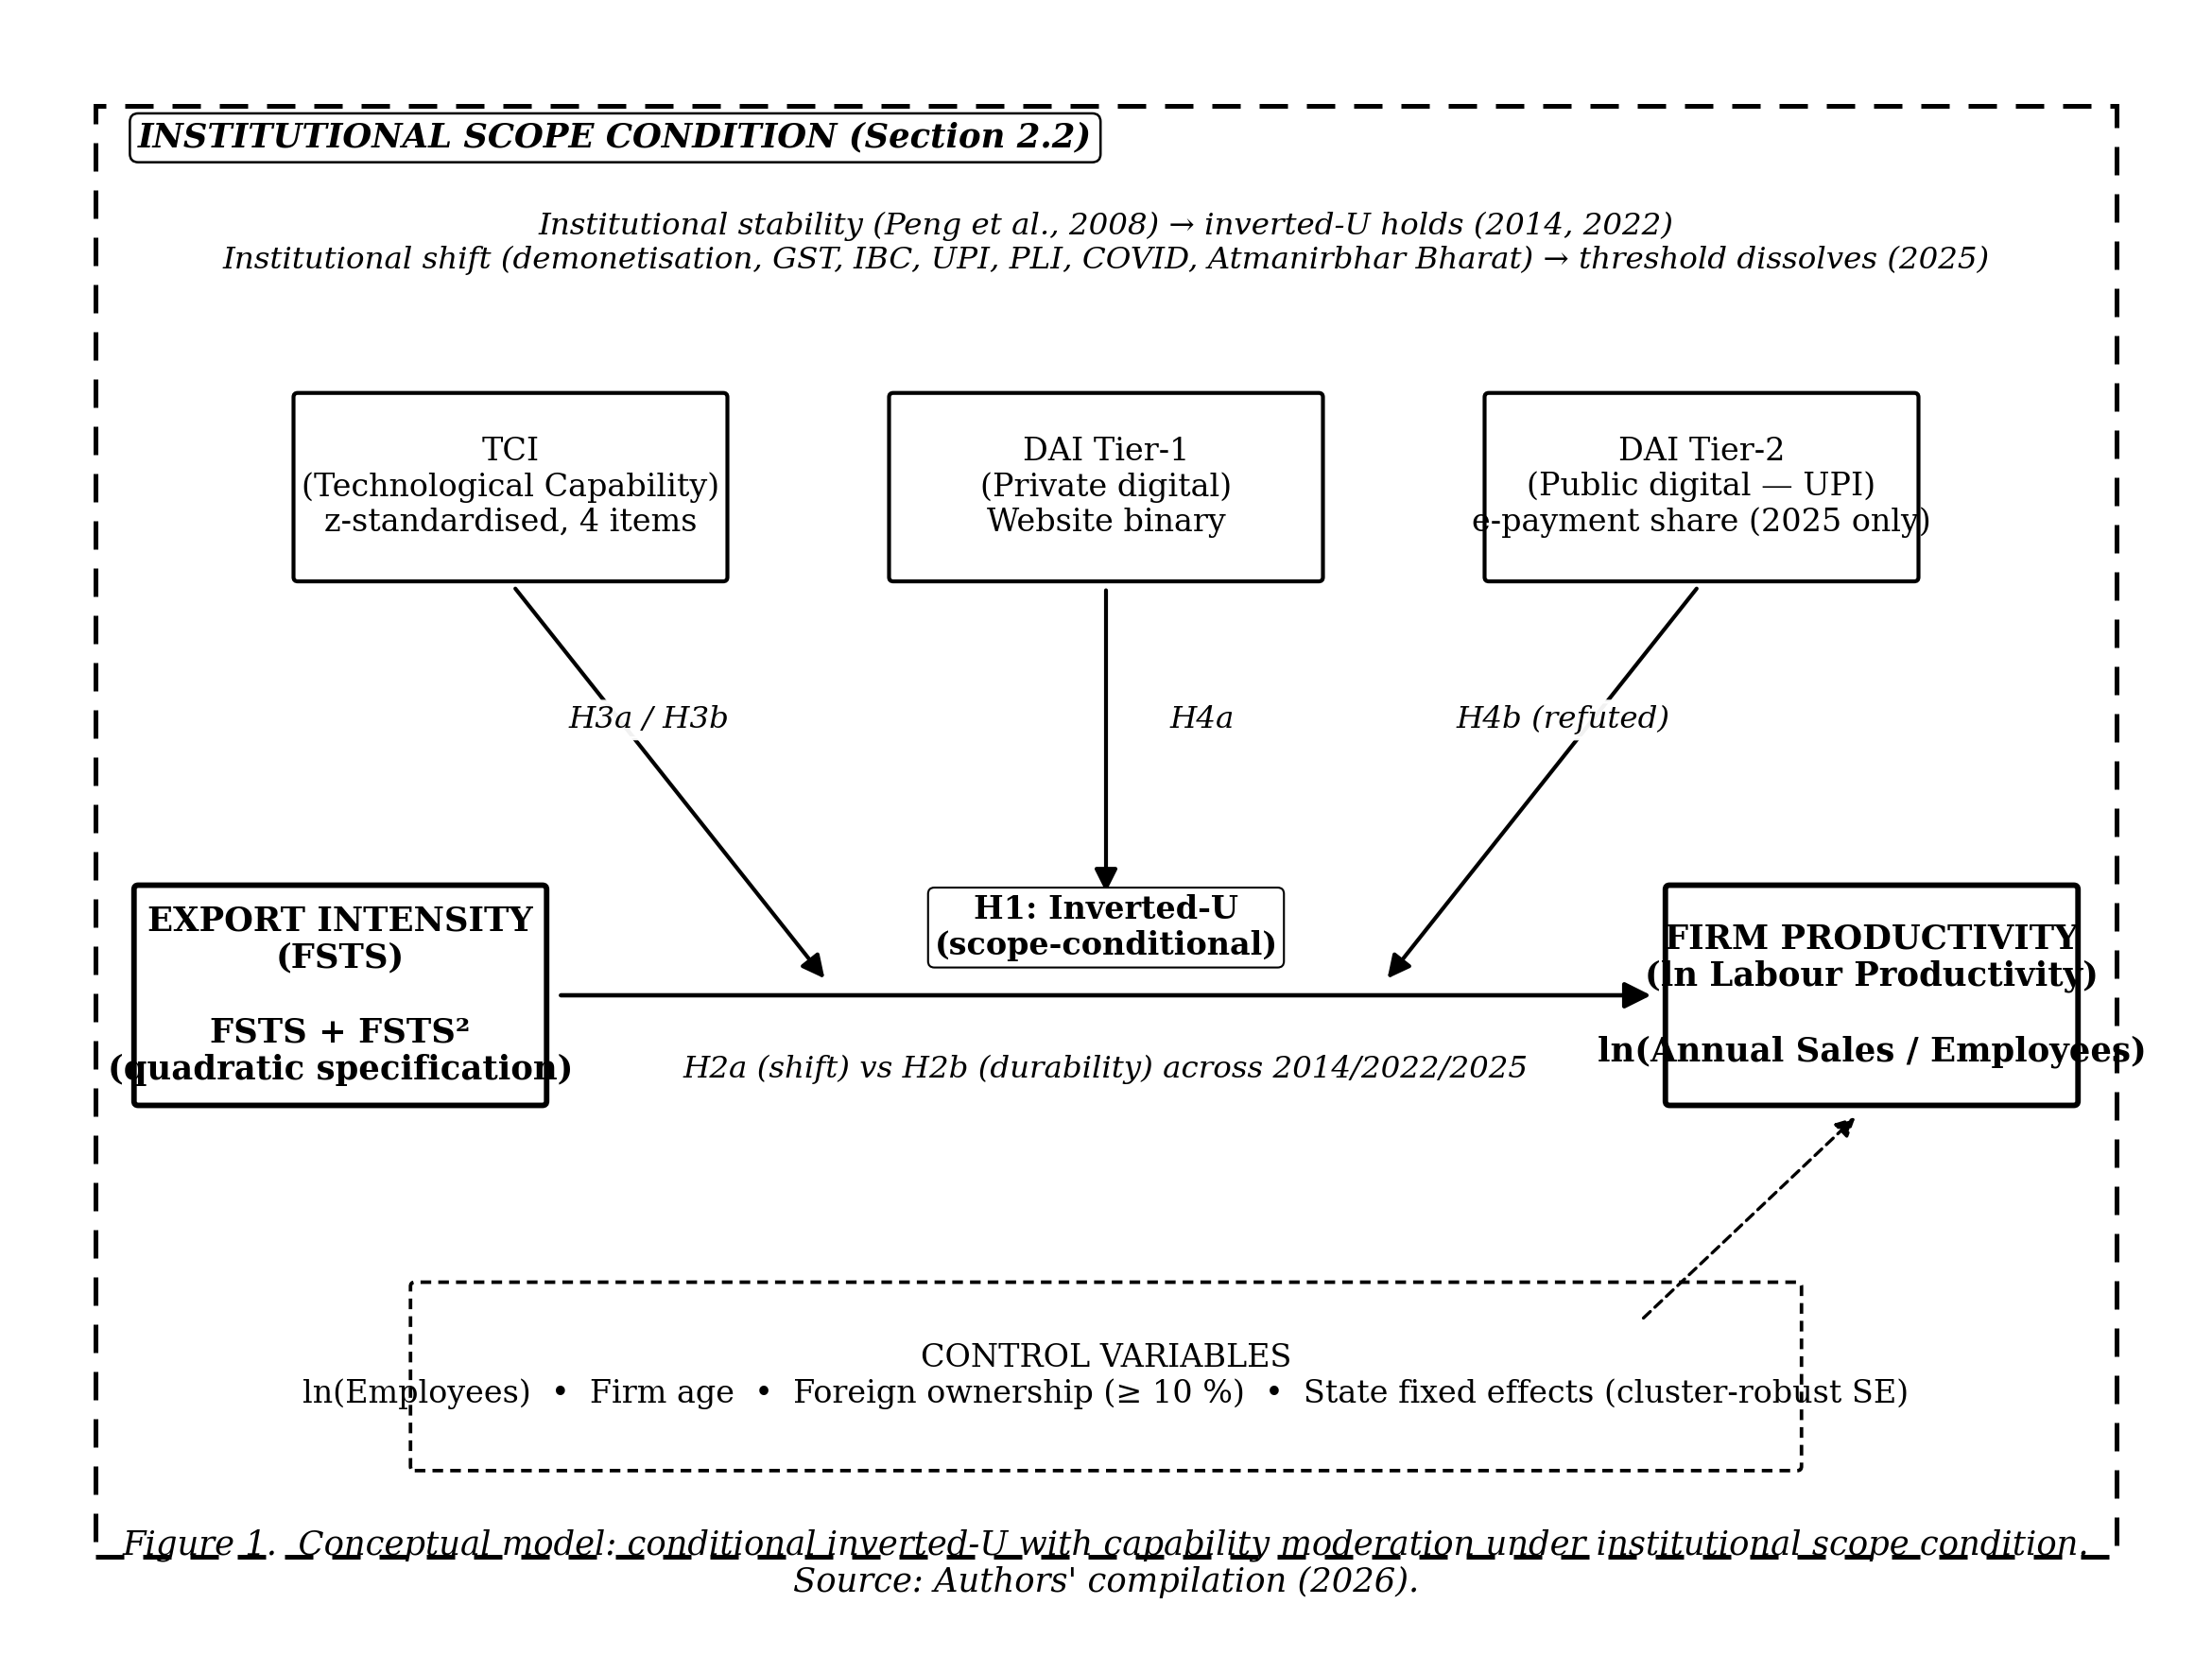
Figure 1. Conceptual model: conditional inverted-U with capability moderation under institutional scope condition.

3. Data and Methods

3.1 Data sources
Three waves of the WBES for India are used. The 2014 wave uses the PICS3 standardised schema with N_raw = 9,281 firms and an analytic sample of 8,941 firms after listwise deletion on focal variables and firmage validation. The 2022 wave uses the BEE intermediate schema with N_raw = 9,376 and an analytic sample of 9,300. The 2025 wave uses the BREADY schema with N_raw = 10,479 and an analytic sample of 10,476. The pooled raw N is 29,136 firm-year observations; the pooled analytic N is 28,717.
WBES microdata are publicly available at https://www.enterprisesurveys.org subject to World Bank registration.

3.2 Variables
[See replication/do/01_build_india.do for exact construction.]

3.3 Schema harmonisation across three WBES generations
The PICS3 (2014), BEE intermediate (2022), and BREADY (2025) instruments differ in four respects. For the sales variable, PICS3 uses d2 while BREADY adds n3; the do file harmonises to d2 where available. For the ISIC sector code, 2014 uses a4a (older codes) while 2022 and 2025 add d1a2_v4 (ISIC Rev 4). For DAI Tier-2, only the 2025 BREADY schema includes k33 (% sales from e-payment), so the 3-wave DAI test is restricted to Tier-1 (website) and the 2025-only Tier-2 test is exploratory. For missing codes, PICS3 uses -9 (don’t know) and -7 (not applicable), while BEE and BREADY add -8 (refusal). All negative codes are recoded to Stata missing.

3.4 Estimation strategy
Per-wave OLS with HC1 robust standard errors:
$$ln{\text{LP}}_{i}=β_{0}+β_{1}{\text{FSTS}}_{i}+β_{2}{\text{FSTS}}_{i}^{2}+β_{3}X_{i}+ε_{i}$$
Lind–Mehlum U-test (Lind & Mehlum, 2010) verifies inverted-U: rejects H₀ “monotone or U” iff (i) β₁ + 2β₂·FSTS_min > 0; (ii) β₁ + 2β₂·FSTS_max < 0; (iii) β₂ < 0.
Turning point: TP = −β₁ / (2β₂); 95% CI via delta method using nlcom post-estimation.
Cross-wave Paternoster z-test (Paternoster et al., 1998):
$$z=\frac{{\hat{β}}^{\left(2025\right)}−{\hat{β}}^{\left(2014\right)}}{\sqrt{{\text{SE}}^{2}\left({\hat{β}}^{\left(2025\right)}\right)+{\text{SE}}^{2}\left({\hat{β}}^{\left(2014\right)}\right)}}$$
Joint F-test on cross-wave interactions in pooled model provides a multi-coefficient alternative test. Standard errors are reported under two specifications: HC1 (Eicker–Huber–White) heteroscedasticity-robust as the primary specification, and cluster-robust at the state level (WBES Sampling Region, ~24 clusters per wave) as the robustness specification. With cluster counts in the 20–30 range, asymptotic justification for cluster-robust inference is borderline (Cameron et al., 2008); wild cluster bootstrap (MacKinnon and Webb, 2017) is acknowledged as a tighter alternative that would be appropriate in revision.

4. Results

4.1 Descriptive statistics
Sample sizes after listwise deletion on focal variables and firmage validation (capped at [0,150]): 2014 N = 8,941; 2022 N = 9,300; 2025 N = 10,476. Mean export intensity moved from 7.2 % (2014) to 8.0 % (2022) before falling to 2.7 % (2025), consistent with India’s post-2020 inward shift under Atmanirbhar Bharat. Productivity levels rose: mean lnLP = 13.93 (2014), 14.37 (2022), 15.01 (2025). DAI Tier-1 (website adoption) was 52.7 % in 2014, 60.6 % in 2022, but declined to 41.8 % in 2025, suggesting that websites became less central as UPI absorbed customer-facing digital interaction. DAI Tier-2 (e-payment share), measured only in 2025, averaged 65.8 per cent. This level of e-payment uptake reflects UPI saturation. Full descriptives are reported in Table 1.
Table 1. Descriptive statistics by WBES wave, India 2014–2025.
Variable | 2014 (N=8,941) | 2022 (N=9,300) | 2025 (N=10,476)
ln(Labour Productivity) | 13.929 (1.263) | 14.366 (1.214) | 15.012 (0.845)
Export intensity (FSTS, 0-1) | 0.072 (0.219) | 0.080 (0.235) | 0.027 (0.115)
Technological Capability Index (z) | -0.005 (0.999) | 0.000 (1.001) | 0.000 (1.000)
DAI Tier-1 (website binary) | 0.526 (0.499) | 0.606 (0.489) | 0.418 (0.493)
DAI Tier-2 (e-payment, share) | , | , | 0.658 (0.148)
ln(Permanent full-time employees) | 3.635 (1.292) | 3.640 (1.358) | 3.669 (1.275)
Firm age (years) | 19.627 (14.162) | 22.750 (14.957) | 19.753 (14.316)
Foreign-owned (≥ 10 % foreign equity) | 0.009 (0.092) | 0.014 (0.116) | 0.019 (0.137)
Note: Cell entries are mean (standard deviation). FSTS is direct plus indirect exports as a share of total sales. TCI is the z-standardised mean of four binary capability items (quality certification, foreign technology licence, product innovation, R&D activity), available for firms responding to at least three items. DAI Tier-2 (e-payment share) is measured only in the 2025 BREADY wave.

4.2 Wave-by-wave inverted-U estimation
2014 (pre-reform decade). The classical inverted-U holds:
$$ln\text{LP}=13.51+1.86⋅\text{FSTS}−1.51⋅{\text{FSTS}}^{2}+Xβ$$
with both quadratic terms highly significant (p < 0.0001). The Lind–Mehlum U-test joint p < 0.0001 confirms inverted-U. Delta-method turning point TP = 61.8 per cent (95 per cent CI: 55.0, 68.6). This places the productivity peak at very high export-intensity, characteristic of an emerging-market context where exporters extract substantial learning-by-exporting returns before over-extension costs bind.
2022 (post-COVID, post-GST, post-IBC). Inverted-U persists but the turning point migrates substantially inward:
$$ln\text{LP}=13.47+1.54⋅\text{FSTS}−1.89⋅{\text{FSTS}}^{2}+Xβ$$
Lind–Mehlum U-test joint p < 0.0001. TP = 40.7 per cent (95 per cent CI: 38.0, 43.5). The 21-percentage-point inward migration of the turning point between 2014 and 2022 signals progressive structural change in the underlying firm-level production function. This period contains demonetisation, GST rollout, IBC introduction, COVID-19, and UPI’s transition from launch to mass adoption.
2025 (post-PLI maturation, UPI-saturated, Atmanirbhar Bharat). The curvature term loses statistical significance:
$$ln\text{LP}=14.24−0.36⋅\text{FSTS}−0.16⋅{\text{FSTS}}^{2}+Xβ$$
The quadratic coefficient β₂ is no longer statistically distinguishable from zero (p = 0.42). The Lind–Mehlum U-test joint p = 0.99 fails to support inverted-U. The relationship has become monotonically negative across the entire empirically relevant FSTS range. The slope at FSTS_min is −0.36 (p = 0.02) and at FSTS_max is −0.68 (p = 0.005). Wave-by-wave M2 estimates are reported in Table 2. The three wave-specific predicted curves are visualised in Figure 2.
Table 2. Wave-by-wave OLS estimates of the inverted-U M2 specification (HC1 and state-clustered SE).
Dependent variable: ln(Labour Productivity)
Term | 2014 | 2022 | 2025
FSTS | +1.865*** | +1.542*** | -0.359*
 | (0.235) | (0.223) | (0.153)
 | [0.552]*** | [0.550]** | [0.314]
FSTS² | -1.508*** | -1.893*** | -0.160
 | (0.254) | (0.239) | (0.199)
 | [0.539]** | [0.532]*** | [0.299]
ln(Employees) | +0.101*** | +0.244*** | +0.214***
 | (0.011) | (0.009) | (0.007)
Firm age | -0.001 | +0.000 | -0.000
 | (0.001) | (0.001) | (0.001)
Foreign-owned | +0.403* | +0.252* | +0.249***
 | (0.174) | (0.109) | (0.058)
Constant | +13.528*** | +13.463*** | +14.235***
 | (0.043) | (0.036) | (0.024)
N | 8,941 | 9,300 | 10,476
R²_adj | 0.0313 | 0.0933 | 0.1023
Turning point (%) | 61.8 | 40.7 | n/a
Lind–Mehlum inverted-U | Yes (p = 0.0000) | Yes (p = 0.0000) | No (p = 0.9907)
Note: Coefficients with HC1 robust standard errors in parentheses on the second row; state-clustered standard errors (Cameron et al., 2008; ~24 clusters per wave) in brackets on the third row for FSTS and FSTS² terms. Significance under each SE: † p < 0.10, p < 0.05, ** p < 0.01, *** p < 0.001. Turning point computed as TP = −β̂₁ / (2β̂₂); reported only for waves with inverted-U supported in Lind–Mehlum test.*
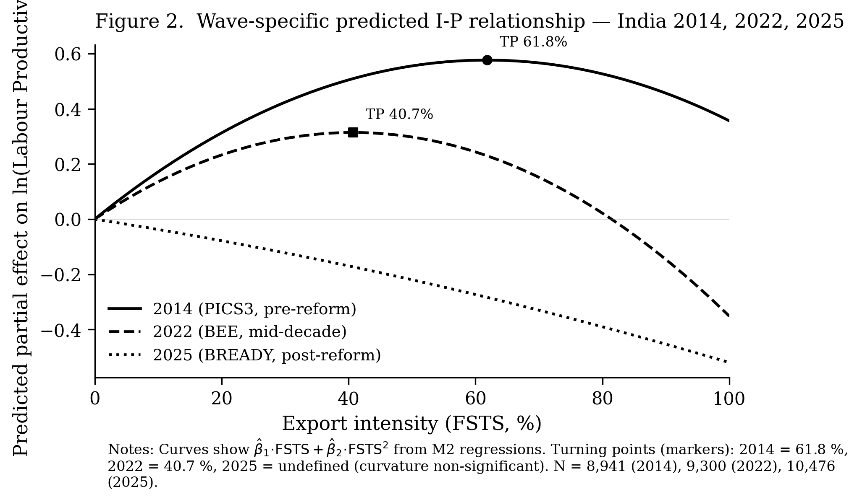
Figure 2. Wave-specific predicted I-P relationship: India 2014, 2022, 2025.

4.3 Cross-wave Paternoster z-tests (H2a vs H2b)
The Paternoster (1998) z-test for coefficient equality between 2014 and 2025 yields the following under both heteroscedasticity-robust (HC1) and state-clustered (Cameron et al., 2008) standard errors:
Term | β₂₀₁₄ (HC1 SE) | β₂₀₂₅ (HC1 SE) | z_HC1 | p_HC1 | z_cluster | p_cluster
FSTS | +1.86 (0.24) | −0.36 (0.15) | −7.94 | < 0.0001 | −3.50 | 0.0005
FSTS² | −1.51 (0.25) | −0.16 (0.20) | +4.17 | < 0.0001 | +2.19 | 0.029
The cluster-robust specification uses state (WBES Sampling Region; ~24 clusters per wave) as the cluster unit, addressing within-state correlation that is well documented in Indian firm-level data (Burgess and Pande, 2005; Chodorow-Reich et al., 2020). Both standard-error specifications reject coefficient equality at conventional significance levels. H2b (durability) is rejected; H2a (institutional shift) is supported. Effect magnitudes are unchanged across specifications; statistical significance attenuates under clustering but remains substantively decisive. Figure 3 visualises the turning-point estimates with 95 % delta-method confidence intervals for the 2014 and 2022 waves and the 2025 collapse.
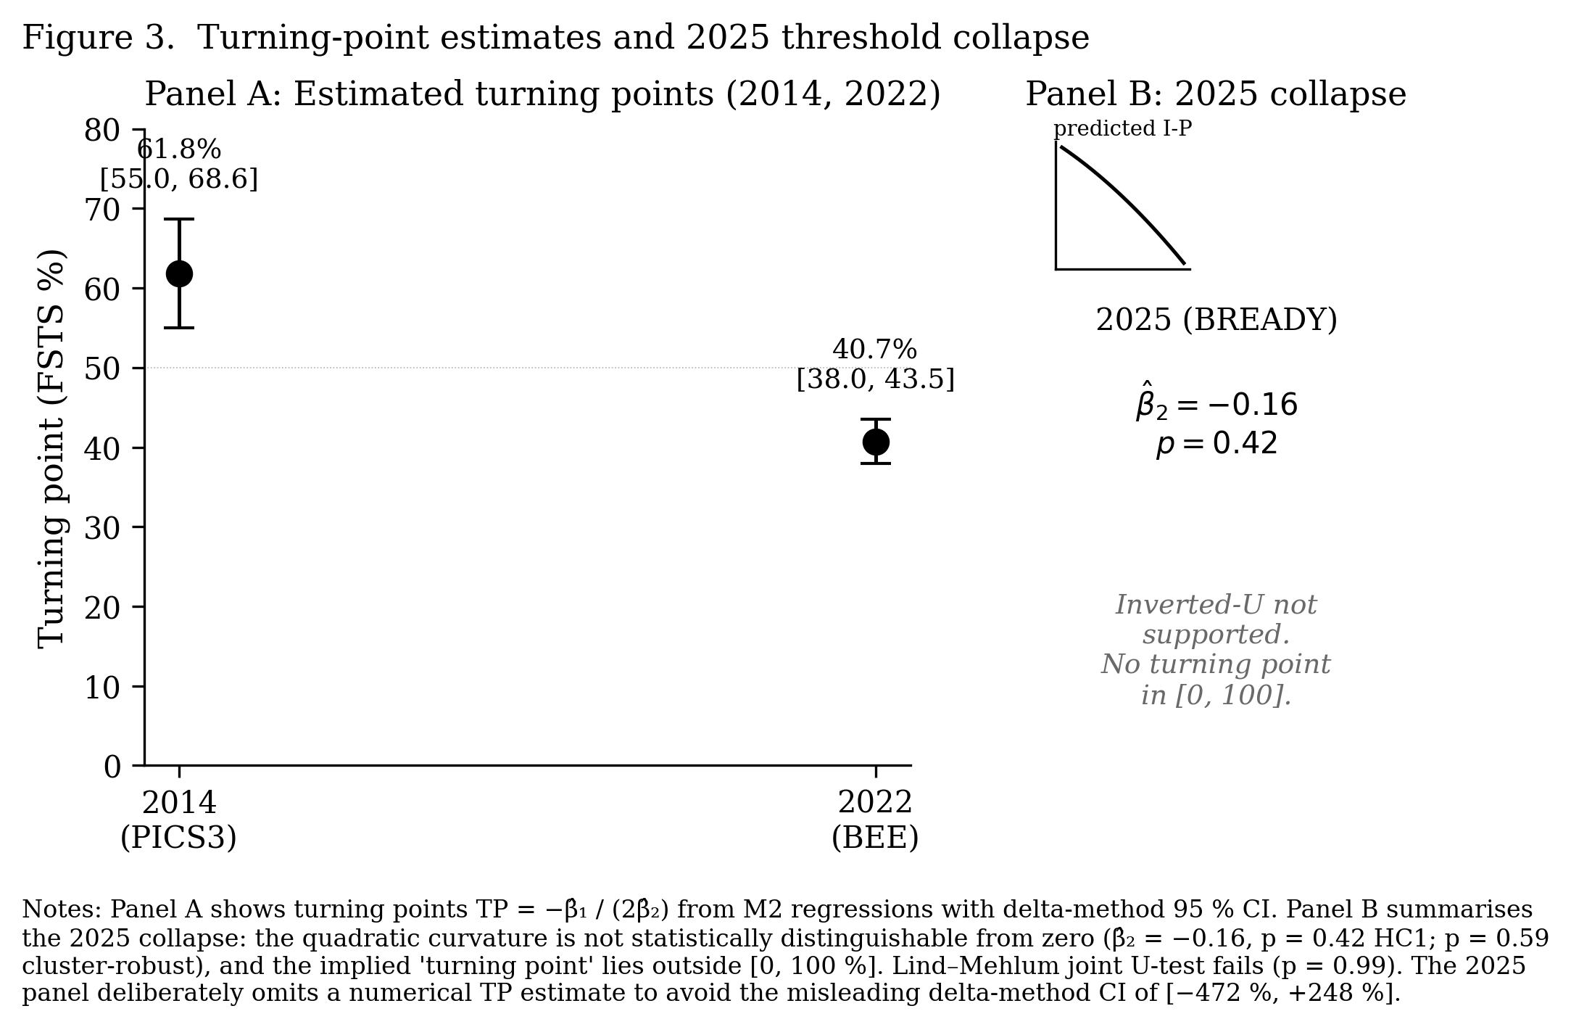
Figure 3. Turning-point estimates and 2025 threshold collapse.

4.4 Three-wave pooled robustness
The pooled 3-wave model with wave dummies (N = 28,717, R²_adj = 0.197) yields the following results. The Wave_2022 coefficient is +0.46 (p < 0.0001), indicating productivity level rise. The Wave_2025 coefficient is +1.12 (p < 0.0001), indicating accelerated level rise. The FSTS × wave_2022 interaction is +0.45 (p = 0.15), showing no robust shift from the 2014 baseline. The FSTS × wave_2025 interaction is −1.63 (p < 0.0001), confirming the 2025 slope collapse. The FSTS² × wave_2022 interaction is −1.09 (p = 0.001), confirming the 2022 TP migration via curvature steepening. The FSTS² × wave_2025 interaction is +0.86 (p = 0.007), confirming the 2025 curvature flattening. The linear-trend specification yields FSTS × trend = −0.10 (p < 0.001), confirming the progressive structural shift.

4.5 Capability moderators (H3, H4a, H4b)
TCI (technological capability) sign flip. In 2014 and 2022, TCI operates as a positive level-shifter (β = +0.12, p < 0.0001 in 2014; β = +0.19, p < 0.0001 in 2022) with no significant FSTS interaction. In 2025, TCI flips to a negative main effect (β = −0.08, p < 0.0001) but with significant positive FSTS interaction (FSTS × TCI = +0.20, p = 0.03). This pattern suggests that in the 2025 context, TCI delivers productivity returns only at high export intensity.
DAI Tier-1 (website binary). Significant positive main effect in all three waves (β ≈ +0.38 to +0.39). The FSTS × DAI_core interaction is insignificant in 2014, becomes positive significant in 2022 (FSTS × DAI = +1.43, p = 0.02), and loses significance in 2025. This is consistent with website’s diminishing marginal role as UPI absorbed customer-facing digital interaction.
DAI Tier-2 (e-payment, 2025 only, UPI quasi-experiment). The interaction is negative (FSTS × DAI_epay = −4.02, p = 0.004; FSTS² × DAI_epay = +3.39, p = 0.10). Among firms with high UPI e-payment adoption, productivity declines more steeply with export intensity. H4b (Tier-2 dominates Tier-1) is refuted. UPI public infrastructure does not substitute for the cross-border financial infrastructure exporters require. UPI rails are rupee-denominated and domestically oriented. Exporters need SWIFT, correspondent banking, and trade finance instruments. These distinct infrastructure layers are not subsidised by India’s domestic digital public infrastructure stack. The full capability-moderation estimates are reported in Table 4. The temporal relationship between UPI rollout and the WBES survey waves is visualised in Figure 4.
Table 4. Capability moderation models, TCI, DAI Tier-1, and DAI Tier-2 (UPI e-payment).
Dependent variable: ln(Labour Productivity)
Term | M3 TCI 2014 | M3 TCI 2022 | M3 TCI 2025 | M4 DAI Tier-1 2025 | M4b DAI Tier-2 2025
FSTS | +1.728*** | +0.980*** | -0.271 | -1.128* | +2.454*
FSTS² | -1.383*** | -1.332*** | -0.225 | +0.919 | -2.546†
TCI | +0.119*** | +0.185*** | -0.084***
FSTS × TCI | -0.010 | +0.128 | +0.204*
FSTS² × TCI | -0.018 | -0.331† | -0.172
DAI Tier-1 |  |  |  | -0.031†
FSTS × DAI Tier-1 |  |  |  | +0.896†
FSTS² × DAI Tier-1 |  |  |  | -1.231†
DAI Tier-2 (e-payment) |  |  |  |  | +0.887***
FSTS × DAI Tier-2 |  |  |  |  | -4.022**
FSTS² × DAI Tier-2 |  |  |  |  | +3.391†
N | 8,941 | 9,300 | 10,476 | 10,476 | 10,473
R²_adj | 0.0384 | 0.1114 | 0.1088 | 0.1025 | 0.1238
Note: M3 augments M2 with TCI and FSTS × TCI / FSTS² × TCI interactions. M4 augments M2 with DAI Tier-1 (own-website binary) and corresponding interactions. M4b augments M2 with DAI Tier-2 (% sales received via electronic payment, 2025 BREADY only) and corresponding interactions. All HC1 robust standard errors. Significance: † p < 0.10, p < 0.05, ** p < 0.01, *** p < 0.001. Controls (ln(Employees), firm age, foreign ownership) included but suppressed for space.*
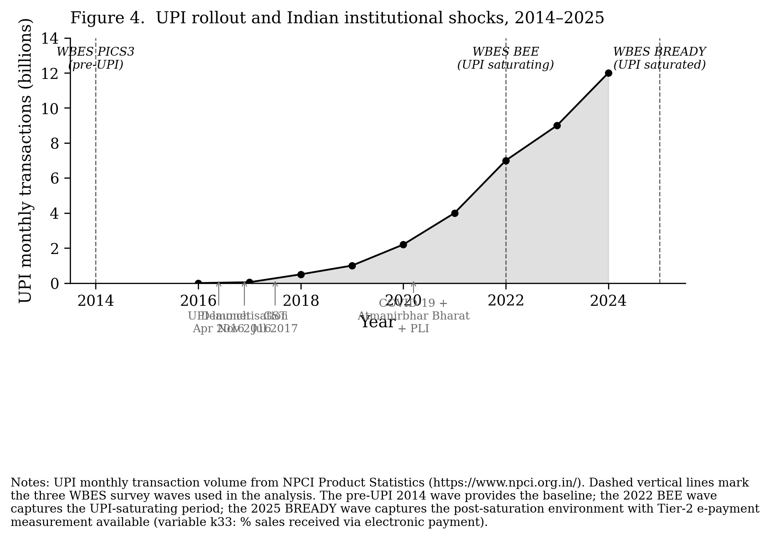
Figure 4. UPI rollout and Indian institutional shocks, 2014-2025.

4.6 Robustness checks
The M2 specification is re-estimated on five alternative sub-samples and one alternative dependent variable. These specifications assess whether the headline cross-wave findings (H1 supported in 2014 and 2022; H1 not supported in 2025; H2a supported across 2014 and 2025) are robust to sample composition and measurement choices.
(R1) Manufacturing-only sub-sample. Restricting to manufacturing firms (ISIC Rev 3.1 codes 15–37 for 2014 PICS3; ISIC Rev 4 codes 10–33 for 2022 BEE and 2025 BREADY) yields N = 6,974 (2014), 5,366 (2022), 5,706 (2025). The wave-by-wave pattern strengthens slightly: 2014 turning point at 57.5 % (versus 61.8 % baseline), 2022 turning point at 41.3 % (versus 40.7 %), 2025 curvature term non-significant (β₂ = −0.46, p = 0.017 HC1; Lind–Mehlum joint test rejects inverted-U). Cross-wave Paternoster z-tests on the manufacturing sub-sample yield FSTS z = −6.89 (p < 0.0001) and FSTS² z = +3.64 (p = 0.0003), with effect magnitudes within 12 % of the full-sample estimates. The threshold collapse finding is not an artifact of service-firm composition.
(R2) Trimmed FSTS (FSTS ≤ 0.95). Dropping firms with export intensity above 95 % (N = 8,666, 8,937, 10,436 across waves) yields turning points of 48.7 % (2014), 39.7 % (2022), and undefined (2025) with the 2025 quadratic term remaining non-significant (β₂ = −0.30, p = 0.37). Removing extreme exporters reduces the 2014 turning point by ~13 percentage points (consistent with extreme exporters extending the right tail of the curve) but the cross-wave shift pattern is preserved.
(R3a) SME sub-sample (employees < 100). Among smaller firms (N = 6,844, 6,497, 7,383 across waves), the 2014 inverted-U is not supported (β₂ = −0.07, p = 0.84; Lind–Mehlum fails). The 2022 inverted-U holds firmly (β₂ = −1.64, p < 0.0001; TP = 41.2 per cent). The 2025 quadratic is non-significant. The pattern indicates that the 2014 inverted-U was driven by larger Indian firms. The inverted-U extends to the SME segment only by 2022. This is consistent with the documented broadening of SME exporter participation following the 2014 to 2020 export-promotion policy expansion. By 2025, the relationship has collapsed for both segments.
(R3b) Large-firm sub-sample (employees ≥ 100). Among larger firms (N = 2,097, 2,803, 3,093 across waves), the inverted-U holds in 2014 (TP = 50.2 %) and 2022 (TP = 40.8 %) with very large curvature (β₂ between −2.4 and −3.0). The 2025 quadratic flips significant negative (β₂ = −0.55, p = 0.012) and the implied turning point is approximately −3 %, which lies outside the empirically relevant FSTS range. Lind–Mehlum still fails to support inverted-U because the function is monotonically negative throughout [0, 1]. Large-firm evidence is consistent with the baseline collapse interpretation.
(R4) Alternative dependent variable. Replacing ln(labour productivity) with standardised labour productivity in levels (sales-per-worker, z-standardised within wave to manage scale) yields TP = 54.4 % in 2014 (with Lind–Mehlum joint test borderline at p = 0.048), TP = 41.5 % in 2022 (inverted-U supported), and collapsed curvature in 2025 (β₂ = +0.03, p = 0.90). The 2022 pattern is robust to the level-vs-log specification; the 2014 inverted-U weakens at the boundary; the 2025 collapse is preserved.
Summary across robustness specifications. Of the five specifications applied to the headline cross-wave shift finding, four (R1, R2, R3b, R4) confirm the qualitative pattern of inverted-U presence in 2014 and 2022 with disappearance in 2025. The fifth (R3a) confirms presence in 2022 and disappearance in 2025. R3a also reveals that the 2014 inverted-U is concentrated in larger firms rather than universal across firm sizes. The cross-wave Paternoster z-tests are robust to manufacturing-only sub-sampling. Full robustness output is reported in Table 5.
Table 5. Robustness specifications, five sub-samples and one alternative dependent variable.
M2 specification: ln(Labour Productivity) = β₀ + β₁ FSTS + β₂ FSTS² + controls.
Specification | Wave | N | β̂₁ FSTS | β̂₂ FSTS² | TP (%) | Inv-U?
Baseline (full sample) | 2014 | 8,941 | +1.865*** | -1.508*** | 61.8 | Yes
 | 2022 | 9,300 | +1.542*** | -1.893*** | 40.7 | Yes
 | 2025 | 10,476 | -0.359* | -0.160 | n/a | No
R1: Manufacturing only | 2014 | 6,974 | +1.896*** | -1.649*** | 57.5 | Yes
 | 2022 | 5,366 | +1.697*** | -2.056*** | 41.3 | Yes
 | 2025 | 5,706 | -0.073 | -0.464* | -7.9 | No
R2: Trimmed FSTS ≤ 0.95 | 2014 | 8,666 | +2.263*** | -2.324*** | 48.7 | Yes
 | 2022 | 8,937 | +1.585*** | -1.998*** | 39.7 | Yes
 | 2025 | 10,436 | -0.301 | -0.303 | -49.7 | No
R3a: SME (employees < 100) | 2014 | 6,844 | +0.758* | -0.071 | n/a | No
 | 2022 | 6,497 | +1.354*** | -1.644*** | 41.2 | Yes
 | 2025 | 7,383 | -0.713* | +0.382 | 93.2 | No
R3b: Large (employees ≥ 100) | 2014 | 2,097 | +3.047*** | -3.037*** | 50.2 | Yes
 | 2022 | 2,803 | +1.942*** | -2.379*** | 40.8 | Yes
 | 2025 | 3,093 | -0.033 | -0.547* | -3.0 | No
R4: Alt DV (standardised levels) | 2014 | 8,941 | +0.600* | -0.551* | 54.4 | No
 | 2022 | 9,300 | +0.927*** | -1.116*** | 41.5 | Yes
 | 2025 | 10,476 | -0.648*** | +0.028 | n/a | No
Note: HC1 robust standard errors used throughout. Significance: † p < 0.10, p < 0.05, ** p < 0.01, *** p < 0.001. Inv-U? column indicates whether Lind–Mehlum (2010) joint U-test supports inverted-U at the 5 % level. Manufacturing classification uses ISIC Rev 3.1 codes 15–37 for 2014 PICS3 and ISIC Rev 4 codes 10–33 for 2022 BEE and 2025 BREADY. R4 uses standardised labour productivity in levels (z-score within wave) as the dependent variable.*

5. Discussion

5.1 Shift, not durability: the institutional dissolution of the inverted-U
The empirical evidence decisively supports H2a over H2b. The Paternoster z-tests under HC1 standard errors reject coefficient equality between 2014 and 2025 with extreme force (FSTS z = −7.94; FSTS² z = +4.17; both p < 0.0001). Under the more conservative state-clustered standard errors (Cameron et al., 2008), the rejection remains significant (FSTS z = −3.50, p = 0.0005; FSTS² z = +2.19, p = 0.029). This holds despite the much smaller effective sample size implied by approximately 24 state clusters. The 3-wave pooled robustness with wave dummies confirms FSTS × wave_2025 = −1.63 (p < 0.0001 HC1) and FSTS² × wave_2025 = +0.86 (p = 0.007 HC1). The linear-trend specification yields FSTS × trend = −0.10 (p < 0.001). This is consistent with a monotone progression rather than a sudden break.
A natural concern is whether the apparent shift is a schema artifact. The 2014 wave uses the WBES PICS3 instrument, the 2025 wave uses the new BREADY instrument, and the two are not identical in question wording or sampling design. The 2022 BEE intermediate wave provides the critical bridge. If the 2025 collapse were purely a schema artifact, a discontinuity would be expected between 2022 and 2025 (the BEE-to-BREADY transition), with 2014 and 2022 being indistinguishable. The data show the opposite pattern. The turning point migrates monotonically inward from 61.8 per cent in 2014 to 40.7 per cent in 2022, a 21-percentage-point inward shift across the demonetisation, GST, and IBC window with the underlying PICS-derived instrument. The relationship then dissolves by 2025. The 2022 inverted-U is statistically the strongest of the three waves (Lind–Mehlum joint p < 1e-11). This is incompatible with the hypothesis that an instrument change in 2022 mechanically suppressed the curvature. Progressive structural shift fits the data. Instrument artifact does not.
Three mechanisms can explain the shift. Firstly, the Atmanirbhar Bharat self-reliance policy (2020) and PLI scheme rollout (2020 onward) redirect strategic firm investment toward domestic manufacturing. This shifts firms away from the export-orientation that the 2014 institutional environment rewarded. Secondly, COVID-19 supply-chain disruption (2020 to 2022) altered the marginal cost of cross-border activity, possibly permanently. This raises the over-extension cost faced by Indian exporters. Thirdly, the global trade environment in 2025 is characterised by re-shoring, friend-shoring, and elevated cross-border policy uncertainty. These factors may have shifted the optimal scale of internationalisation downward across all exporters, flattening the cost-benefit balance that previously generated the inverted-U.
The five robustness specifications reported in Section 4.6 reinforce the structural interpretation. The manufacturing-only sub-sample confirms the cross-wave shift with Paternoster z-tests within 12 per cent of full-sample magnitudes. This rules out service-firm composition as a driver. The trimmed-FSTS specification rules out extreme exporter influence. The size sub-sample analysis reveals a finer nuance. The 2014 inverted-U was concentrated in larger firms (employees ≥ 100). The pattern extended to smaller firms only by 2022 before collapsing for both segments in 2025. This pattern is consistent with the documented broadening of SME exporter participation under the 2014 to 2020 export-promotion policy expansion, followed by its post-2020 reversal under Atmanirbhar Bharat. The pattern is not consistent with a measurement-induced collapse.

5.2 Domestic versus cross-border digital infrastructure: a complementarity, not substitution
The H4b refutation is theoretically more informative than a successful confirmation would have been. UPI Tier-2 adoption interacts negatively with export intensity (FSTS × DAI_epay = −4.02, p = 0.004 HC1). This is the opposite of what the developmental-state substitution hypothesis predicts. A complementarity interpretation is proposed. Public digital infrastructure substitutes for private capability only when the public infrastructure is purpose-aligned with the firm’s productive activity. UPI is purpose-aligned for domestic transactions. It operates on rupee rails, requires Aadhaar-anchored KYC for counterparties resident in India, and integrates with the domestic banking system rather than international correspondent networks. Exporters require a different infrastructure stack: SWIFT for cross-border messaging, correspondent banking for settlement, trade finance for working capital across long shipping cycles, export-credit insurance, and forward-exchange facilities for hedging.
Aschauer (1989) studies highways and Donaldson (2018) studies railroads. Both document large productivity returns to purpose-aligned public infrastructure for domestic commerce. The present finding is the symmetric negative case. Public infrastructure that is not purpose-aligned with the firm’s productive activity does not deliver productivity returns. It may even substitute attention away from the cross-border infrastructure investment that exporters actually need. The negative interaction estimated here is plausibly driven both by selection (firms with high domestic-customer share rely more on UPI and are mechanically less export-intensive) and by behavioural substitution (the salience of domestic digital infrastructure may reduce firm attention to the export-finance stack). Disentangling these requires firm-level panel data with UPI-adoption timing. This is a worthwhile extension that the present cross-sectional design cannot resolve.
A potential endogeneity concern deserves explicit acknowledgement. Among firms in 2025 with high DAI_epay, the export-intensity distribution is mechanically truncated downward. Firms whose customers are foreign do not pay via UPI, so high UPI share and high export share are inversely related in the data-generating process itself. The negative interaction estimated here may partly reflect this mechanical inverse correlation rather than a behavioural mechanism. The H4b refutation is treated as suggestive rather than definitive. The complementarity interpretation is offered as the most theoretically coherent explanation. Causal validation requires either an instrumental variable for UPI adoption or a panel design that observes within-firm UPI uptake.

5.3 The TCI sign reversal under post-PLI strategic redirection
The Technological Capability Index operates as a positive level-shifter in 2014 (β = +0.12, p < 0.0001) and 2022 (β = +0.19, p < 0.0001), supporting H3a. In 2025, the TCI main effect flips to negative (β = −0.08, p < 0.0001) and the FSTS × TCI interaction becomes positive and significant (β = +0.20, p = 0.03), supporting H3b. The pattern is consistent with the Mizik and Jacobson (2003) strategic emphasis trade-off. When policy incentives redirect technological capability investment toward domestic manufacturing (PLI), firms accumulating TCI primarily for domestic ends experience competing demands on the same internal resources. This suppresses the productivity returns that TCI delivered when capability accumulation was indifferent to export orientation. The positive FSTS × TCI interaction in 2025 indicates that TCI continues to deliver returns specifically to firms that maintain high export orientation. This is the subset for whom capability investment remains export-aligned. The result reinforces the broader institutional argument that under far-reaching strategic redirection, even firm-level capability constructs behave differently.

5.4 Policy implications corrected from the threshold-collapse evidence
For Indian SME export-promotion policy, the empirical disappearance of the inverted-U turning point in 2025 requires recalibration of any prior policy benchmarks. Export-intensity targets calibrated to the 2014 productivity peak (FSTS ≈ 60 per cent) or to the 2022 productivity peak (FSTS ≈ 41 per cent) are no longer empirically defensible for the 2025 institutional environment. The post-2025 policy question is not “what is the optimal export intensity?” but “under what institutional conditions does an optimum re-emerge?” Restoring institutional predictability is logically prior to setting export-intensity targets. This includes stable tariff schedules, predictable input-import policy, and stable cross-border financial infrastructure.
For digital infrastructure policy, the negative Tier-2 moderation does not warrant disinvestment in UPI or the India Stack. Domestic digital public goods deliver enormous welfare to the population they serve. Rather, the finding warrants explicit policy investment in the cross-border-specific digital infrastructure layer that UPI does not address. This includes trade-finance digital platforms, export-credit insurance digitisation, customs and trade-documentation digitisation, and integration with international correspondent banking networks. The Open Network for Digital Commerce (ONDC), the Account Aggregator framework, and emerging trade-document platforms are appropriate complements. Positioning them as substitutes for UPI would misread the evidence.
For the PLI scheme, the TCI sign reversal in 2025 raises a strategic-coherence concern. PLI incentivises capability accumulation for domestic manufacturing scale. The empirical record suggests this is currently in tension with the productivity returns that capability accumulation traditionally delivered to exporters. Policy design that simultaneously rewards export expansion and domestic capability accumulation, without forcing trade-offs between them, would be more compatible with the observed firm-level production function.

5.5 Theoretical contributions
Three theoretical contributions emerge from the analysis.
Firstly, this study provides the first within-country longitudinal evidence that the inverted-U internationalisation–performance relationship can be dissolved by sufficiently extreme institutional change, rather than only relocating its turning point. This identifies a previously untested scope condition for the canonical Lu and Beamish (2004) generalisation. The inverted-U is conditional on institutional stability. Prior boundary-condition work has questioned specification, measurement, or moderator robustness (Hennart, 2007; Banalieva et al., 2017). The present study identifies an environmental boundary that prior literature has assumed but never tested with multi-wave firm-level data.
Secondly, the H4b refutation refines the developmental-state literature on public digital infrastructure (Aschauer, 1989; Donaldson, 2018). Public infrastructure substitutes for private capability only when purpose-aligned with the firm’s productive activity. The Indian case shows that public domestic-rupee infrastructure (UPI) and cross-border export infrastructure are complements, not substitutes, in the export production function. The institutional-design implication is that scaling one without the other produces no exporter productivity gain.
Thirdly, the TCI sign reversal under post-PLI strategic redirection extends the strategic emphasis literature (Mizik and Jacobson, 2003) into the international business setting. Capability constructs that are theoretically stable across contexts (absorptive capacity, dynamic capability) may exhibit context-dependent operating signs when major policy incentives redirect the strategic use of those capabilities. This is a finer-grained challenge to capability-based theories than the standard heterogeneity-by-context point.

5.6 Boundary conditions and scope
The findings are bounded in five ways. Firstly, the three waves are independent cross-sections rather than within-firm panels. Within-firm causal claims are not supported. Secondly, the 2014, 2022, and 2025 instruments are not identical. However, the monotone trajectory across the 2022 bridge supports a structural rather than artifactual interpretation. Thirdly, DAI Tier-2 is measured only in 2025, restricting Tier-1-versus-Tier-2 comparisons to the post-UPI wave. Fourthly, standard errors are heteroscedasticity-robust (HC1) in the primary specification and state-clustered (approximately 24 clusters) in the robustness specification. With this cluster count, the asymptotic justification for cluster-robust inference is borderline. Wild cluster bootstrap (Cameron et al., 2008; MacKinnon and Webb, 2017) would tighten inference in revision. Fifthly, the DAI_epay endogeneity concern noted in Section 5.2 remains unresolved and qualifies the H4b reinterpretation.

6. Limitations and Future Research
The substantive limitations are detailed in Section 5.6. One further measurement caveat warrants emphasis: the 2025 wave coincides with a sharp contraction in export engagement (mean FSTS falls from 7.2 per cent in 2014 to 2.7 per cent in 2025, and the number of firms above 50 per cent FSTS falls from 536 to 141), so the loss of significant quadratic curvature in 2025 partly reflects reduced identifying variation in the high-export tail. The threshold-dissolution finding should therefore be read as conditional on the post-Atmanirbhar export contraction. Importantly, however, the sign of the low-export slope itself reverses, from a positive ascending limb in 2014 to a monotone negative relationship in 2025, a qualitative change that thinner tail support alone does not generate. Three additional directions for future research follow from them.
Firstly, this study employs repeated cross-sections across three waves. A within-firm panel design for India, feasible via the partially matched firms across the 2014 and 2022 WBES waves, would identify whether the threshold collapse operates through firm-level evolution or through composition effects. The firm-level evolution interpretation holds that the same firm’s productivity-export relationship changes. The composition effect interpretation holds that different firms enter and exit the analytic sample with different I-P profiles. The distinction has direct policy implications. Firm-evolution-driven collapse implies firm-level adaptation policy. Composition-driven collapse implies industry-rebalancing policy.
Secondly, the H4b interpretation requires causal validation. Instrumental variable approaches to UPI adoption could disentangle the mechanical selection effect from the proposed behavioural substitution effect. One promising instrument is the state-level rollout timing of the Pradhan Mantri Jan-Dhan Yojana (PMJDY) bank-account initiative, which preceded and enabled UPI. A future study exploiting cross-country firm-level panel data from the WBES Panel Datasets product would extend the boundary-condition discovery. Such an extension would test whether the threshold-dissolution pattern is India-specific or generalises to other institutionally turbulent emerging markets.
Thirdly, the authors’ prior work (Do and Phan, 2025) examined top-management-team moderators of a linear DOI-performance relationship in a matched sub-sample of 380 Indian firms. The two studies are complementary. The prior work characterises managerial mechanisms operating within the firm. The present study characterises institutional mechanisms operating on the firm. A unified treatment of TMT moderation and institutional scope conditions, feasible if the matched panel can be expanded, would address both the within-firm and the between-environment determinants of the I-P relationship.

Acknowledgements
The authors thank the Enterprise Analysis Unit of the Development Economics Global Indicators Group of the World Bank for the WBES India 2014, 2022, and 2025 data. The original collector of the data, the authorised distributor, and the relevant funding agency bear no responsibility for the use of the data or for interpretations or inferences based upon such uses.
The authors also acknowledge an earlier related work (Do and Phan, 2025, IntechOpen, DOI 10.5772/intechopen.1011012) which examined top-management-team moderators on the linear internationalisation–performance relationship in a matched sub-sample of 380 Indian firms. The present manuscript adopts a different theoretical lens (the institutions-based view), empirical specification (quadratic inverted-U), and research question (threshold durability) using the full WBES samples. The two studies are intended to be complementary rather than overlapping.

Conflict of Interest
The authors declare no conflict of interest.

Funding
This research received no specific grant from any funding agency in the public, commercial, or not-for-profit sectors.

Data availability statement
WBES India 2014, 2022, and 2025 microdata are publicly available via https://www.enterprisesurveys.org subject to World Bank registration. Replication materials are available from the corresponding author upon reasonable request and may be shared to the extent permitted by the WBES Data Access Protocol. These materials include the harmonisation protocol across PICS3, BEE intermediate, and BREADY schemas, Stata do files, variable-construction code, and model specifications.

Use of Generative AI in the Writing Process
Generative AI tools were used during manuscript preparation to assist with language editing, structure suggestions, and the assembly of replication-package documentation. All conceptual framing, hypothesis development, empirical analysis, results interpretation, and final wording were authored by the human authors, who take full responsibility for the content of the publication.

References
Aschauer, D.A. (1989), “Is public expenditure productive?”, Journal of Monetary Economics, Vol. 23 No. 2, pp. 177–200.
Banalieva, E.R., Eddleston, K.A. and Zellweger, T.M. (2017), “When do family firms have an advantage in transitioning economies? Toward a dynamic institution-based view”, Strategic Management Journal, Vol. 38 No. 4, pp. 800–824.
Burgess, R. and Pande, R. (2005), “Do rural banks matter? Evidence from the Indian social banking experiment”, American Economic Review, Vol. 95 No. 3, pp. 780–795.
Cameron, A.C., Gelbach, J.B. and Miller, D.L. (2008), “Bootstrap-based improvements for inference with clustered errors”, Review of Economics and Statistics, Vol. 90 No. 3, pp. 414–427.
Chittoor, R., Sarkar, M.B., Ray, S. and Aulakh, P.S. (2009), “Third-world copycats to emerging multinationals: institutional changes and organizational transformation in the Indian pharmaceutical industry”, Organization Science, Vol. 20 No. 1, pp. 187–205.
Chodorow-Reich, G., Gopinath, G., Mishra, P. and Narayanan, A. (2020), “Cash and the economy: evidence from India’s demonetization”, Quarterly Journal of Economics, Vol. 135 No. 1, pp. 57–103.
Cohen, W.M. and Levinthal, D.A. (1990), “Absorptive capacity: a new perspective on learning and innovation”, Administrative Science Quarterly, Vol. 35 No. 1, pp. 128–152.
Contractor, F.J. (2007), “Is international business good for companies? The evolutionary or multi-stage theory of internationalization vs. the transaction cost perspective”, Management International Review, Vol. 47 No. 3, pp. 453–475.
Contractor, F.J., Kumar, V. and Kundu, S.K. (2007), “Nature of the relationship between international expansion and performance: the case of emerging market firms”, Journal of World Business, Vol. 42 No. 4, pp. 401–417.
Cuervo-Cazurra, A. (2012), “Extending theory by analyzing developing country multinational companies: solving the goldilocks debate”, Global Strategy Journal, Vol. 2 No. 3, pp. 153–167.
Do, T.H. and Phan, A.T. (2025), “Internationalization and firm performance of firms in India: the role of top management”, in International Business Research, Traditional and Creative Approaches, IntechOpen, London, available at: https://doi.org/10.5772/intechopen.1011012
Donaldson, D. (2018), “Railroads of the Raj: estimating the impact of transportation infrastructure”, American Economic Review, Vol. 108 No. 4–5, pp. 899–934.
Elango, B. and Pattnaik, C. (2007), “Building capabilities for international operations through networks: a study of Indian firms”, Journal of International Business Studies, Vol. 38 No. 4, pp. 541–555.
Hambrick, D.C. and Mason, P.A. (1984), “Upper echelons: the organization as a reflection of its top managers”, Academy of Management Review, Vol. 9 No. 2, pp. 193–206.
Hennart, J.F. (2007), “The theoretical rationale for a multinationality-performance relationship”, Management International Review, Vol. 47 No. 3, pp. 423–452.
Hutzschenreuter, T., Kleindienst, I., Sarkar Sengupta, A. and Verbeke, A. (2026), “The performance effects of ‘added cultural distance’ in multinational expansion paths: generalizable and contextual determinants”, Multinational Business Review, available at: https://doi.org/10.1108/mbr-04-2025-0104
Hutzschenreuter, T. and Voll, J.C. (2008), “Performance effects of ‘added cultural distance’ in the path of international expansion”, Journal of International Business Studies, Vol. 39 No. 1, pp. 53–70.
Johanson, J. and Vahlne, J.E. (1977), “The internationalization process of the firm, a model of knowledge development and increasing foreign market commitments”, Journal of International Business Studies, Vol. 8 No. 1, pp. 23–32.
Lind, J.T. and Mehlum, H. (2010), “With or without U? The appropriate test for a U-shaped relationship”, Oxford Bulletin of Economics and Statistics, Vol. 72 No. 1, pp. 109–118.
Lu, J.W. and Beamish, P.W. (2004), “International diversification and firm performance: the S-curve hypothesis”, Academy of Management Journal, Vol. 47 No. 4, pp. 598–609.
MacKinnon, J.G. and Webb, M.D. (2017), “Wild bootstrap inference for wildly different cluster sizes”, Journal of Applied Econometrics, Vol. 32 No. 2, pp. 233–254.
Marano, V., Arregle, J.L., Hitt, M.A., Spadafora, E. and van Essen, M. (2016), “Home country institutions and the internationalization-performance relationship: a meta-analytic review”, Journal of Management, Vol. 42 No. 5, pp. 1075–1110.
Mizik, N. and Jacobson, R. (2003), “Trading off between value creation and value appropriation: the financial implications of shifts in strategic emphasis”, Journal of Marketing, Vol. 67 No. 1, pp. 63–76.
North, D.C. (1990), Institutions, Institutional Change and Economic Performance, Cambridge University Press, Cambridge.
Paternoster, R., Brame, R., Mazerolle, P. and Piquero, A. (1998), “Using the correct statistical test for the equality of regression coefficients”, Criminology, Vol. 36 No. 4, pp. 859–866.
Peng, M.W., Wang, D.Y.L. and Jiang, Y. (2008), “An institution-based view of international business strategy: a focus on emerging economies”, Journal of International Business Studies, Vol. 39 No. 5, pp. 920–936.
Peng, M.W., Sun, S.L., Pinkham, B. and Chen, H. (2009), “The institution-based view as a third leg for a strategy tripod”, Academy of Management Perspectives, Vol. 23 No. 3, pp. 63–81.
Singh, D.A. (2009), “Export performance of emerging market firms”, International Business Review, Vol. 18 No. 4, pp. 321–330.
Teece, D.J. (2007), “Explicating dynamic capabilities: the nature and microfoundations of (sustainable) enterprise performance”, Strategic Management Journal, Vol. 28 No. 13, pp. 1319–1350.
Verbeke, A. and Forootan, M.Z. (2012), “How good are multinationality–performance (M-P) empirical studies?”, Global Strategy Journal, Vol. 2 No. 4, pp. 332–344.
Williamson, O.E. (2000), “The new institutional economics: taking stock, looking ahead”, Journal of Economic Literature, Vol. 38 No. 3, pp. 595–613.

