AUTHOR INFORMATION
Article Title: Firm Performance Heterogeneity in Emerging Asia: Evidence from World Bank Enterprise Surveys
Authors: Do Thuy Huong (MSc/PhD candidate)
Research stream: Internationalization Strategy
Affiliations: School of Economics, Can Tho University, Vietnam
Phone: 0987.962.542
Email: thuyhuongctu@gmail.com
Address: Tan Loc, Can Tho city, Vietnam

Phan Anh Tu, PhD (Corresponding author)
Research stream: Internationalization Strategy, Corruption in LDCs.
Affiliations: School of Economics, Can Tho University, Vietnam
Phone: 0988.263.778
Email: patu@ctu.edu.vn
Address: Tân An, Can Tho city, Vietnam
Declaration: We certify that this manuscript is original, has not been published elsewhere, and is not under consideration by any other journal. We take full responsibility for the accuracy of the data and citations.

FIRM PERFORMANCE HETEROGENEITY IN EMERGING ASIA:
EVIDENCE FROM WORLD BANK ENTERPRISE SURVEYS
Abstract. This study investigates firm-level performance heterogeneity across 17 emerging Asian economies using World Bank Enterprise Survey data comprising 40,633 firm observations collected between 2009 and 2024. Drawing on the Resource-Based View and Institutional Theory, the analysis examines regional productivity disparities, the role of firm capabilities, and the constraining effects of business obstacles on labor productivity. The results reveal pronounced regional productivity hierarchies: firms located in Greater China exhibit the highest average labor productivity (USD 167,139 PPP per worker), representing an 87% premium over ASEAN economies and a 37% premium relative to South Asia. Firm capabilities play a central role in shaping performance outcomes. Technology adoption is associated with a substantial productivity gain of approximately 50%, while international quality certification confers an additional productivity premium of nearly 38%. Conversely, business obstacles exert a statistically significant negative effect on productivity. Importantly, technology adoption moderates this relationship, mitigating the adverse impact of business obstacles by approximately 83%. Further analysis indicates considerable regional variation in productivity gaps between small and medium-sized enterprises and large firms, ranging from minimal differences in Greater China to substantial disparities in South Asia. Overall, the findings underscore the importance of capability-building strategies and institutional reforms in enhancing firm productivity and reducing performance inequalities across emerging Asian markets.
Keywords: firm performance; labor productivity; emerging Asian economies; technology adoption; business obstacles; SMEs; World Bank Enterprise Survey

1. Introduction
The remarkable economic transformation witnessed in Asia over the past four decades stands as one of the most pivotal developments in the history of the global economy. Commencing with Japan's post-war economic miracle, extending through the emergence of the Asian Tigers, and culminating in China's recent extraordinary growth trajectory, the region has definitively established itself as the foremost engine of worldwide economic expansion. The International Monetary Fund posits that Asian economies shall contribute approximately two-thirds of global growth throughout the forthcoming decade, thereby underscoring the enduring centrality of the region to the world economy (IMF, 2024). Notwithstanding this aggregate narrative of success, a substantial heterogeneity in economic performance is veiled both across and within Asian economies, which consequently raises fundamental inquiries concerning the genesis and determinants of firm-level productivity differentials, bearing significant implications for Theory, policy formulation, and managerial practice.
The comprehension of patterns and primary drivers characterizing firm performance heterogeneity within Asian emerging markets is paramount, attributable to several interconnected rationales. Primarily, from a theoretical vantage point, these heterogeneous economies present an authentic natural laboratory for the investigation of the joint manner in which corporate capabilities and institutional milieus co-determine productivity results. The region incorporates economies residing at vastly divergent developmental stages, accompanied by varied institutional attributes and industrial compositions, thus allowing researchers to precisely isolate the relative contribution of factors pertaining to the firm-level and the country-level towards the observed variability in performance (Hsieh & Klenow, 2009). Secondly, pertaining to the policy dimension, the meticulous identification of the cardinal determinants underlying productivity disparities can provide guidance for evidence-based interventions purposed to foster inclusive growth and sustainable economic progression, a concern which maintains paramount importance for governmental bodies throughout the region. Tertiary, for seasoned business practitioners and discerning international investors, attaining clarity regarding regional productivity patterns is requisite for judicious strategic formulation concerning market entry, the assignment of resources, and the securing of competitive positioning within these dynamic markets of increasing significance.
Despite the importance of this topic, existing research suffers from several limitations that constrain our understanding of firm performance heterogeneity in emerging Asian markets. Much of the extant literature focuses on individual countries, particularly China and India, given their economic significance, which limits the generalizability of findings across the broader Asian context (Bloom and colleagues, 2013; Hsieh & Klenow, 2009). Cross-country studies often rely on aggregate macroeconomic data that cannot capture the rich heterogeneity at the firm level or utilize datasets with limited geographic coverage that preclude comprehensive regional comparisons. Furthermore, while separate literatures examine the effects of firm capabilities and institutional environments on performance outcomes, relatively few studies explicitly investigate how these factors interact to shape productivity. This gap is significant given theoretical predictions that firm capabilities may serve as substitutes for or complements to institutional quality in emerging market contexts, with significant implications for both theory development and practical recommendations (Khanna & Palepu, 2010).
Notwithstanding the crucial nature of this subject, currently existing research exhibits several constraints that impede a thorough understanding of firm performance heterogeneity within emerging Asian markets. A substantial portion of the extant literature concentrates primarily upon individual nations, specifically China and India, due to their profound economic significance, thereby unduly restricting the generalizability of resulting observations across the wider Asian theatre (Bloom and colleagues, 2013; Hsieh & Klenow, 2009). Analyses spanning multiple countries frequently depend upon aggregate macroeconomic data, which prove inadequate for capturing the profound heterogeneity extant at the firm level, or they employ datasets characterized by constrained geographic reach that effectively preclude expansive regional comparative analysis. Moreover, although independent bodies of literature scrutinize the impacts of firm capabilities and institutional environments upon performance outcomes, a comparatively meagre number of studies explicitly inquire into the interactive dynamics of these elements in shaping productivity. This deficiency is particularly salient given theoretical postulations suggesting that corporate capabilities may function either as substitutes for, or complements to, the quality of institutions in emerging market milieus, thereby yielding momentous implications for both the advancement of theory and the formulation of pragmatic recommendations (Khanna & Palepu, 2010).
This present study endeavors to bridge these identified deficiencies through the provision of a comprehensive, multi-country analysis elucidating the determinants of firm performance spanning 17 Asian emerging economies. We employ data sourced from the World Bank Enterprise Survey (WBES), encompassing 40,633 firm observations meticulously gathered between the years 2009 and 2024; this sample represents one of the largest and most geographically extensive utilized within this scholarly domain. Our subsequent analysis is delineated across three principal Asian regions that exhibit profound differences in their respective levels of economic progression, institutional settings, and industrial compositions: Greater China (incorporating mainland China, Hong Kong SAR, and Taiwan, constituting 5,251 firm observations), ASEAN (eight constituent member nations, yielding 12,068 firms), and South Asia (six constituent economies, comprising 23,314 firms). We address three intrinsically interrelated research inquiries: (1) In what manner do firm productivity levels diverge across these defined regions? (2) What is the function served by firm-level capabilities in accounting for productivity variation? (3) How do extant business environment obstacles detrimentally influence firm performance, and is it demonstrable that firm capabilities possess the capacity to mitigate these adverse consequences?
Our empirical analysis furnishes several significant findings contributing fundamentally to both theoretical comprehension and practical implementation. Primarily, we delineate substantial and statistically compelling productivity hierarchies spanning the Asian regions, whereby firms within Greater China attain a mean labor productivity of USD 167,139 PPP per worker—a value 87% superior to that recorded in ASEAN and 37% higher than that in South Asia. Secondly, the adoption of technology manifests as a potent catalyst for productivity, correlated with a 50.5% augmentation in productivity, while the attainment of quality certification yields an incremental premium of 38.0%. Tertiary, impediments within the business environment significantly obstruct firm performance; however, critically, our results reveal that technology adoption actively mitigates this adverse effect, thereby postulating that the refinement of capability affords a degree of insulation against extant institutional limitations. Finally, we substantiate a pronounced variation in productivity disparities between SMEs and large firms across regions, observing a considerably reduced discrepancy in Greater China (6.9%) relative to South Asia (33.3%), yielding salient implications for finely calibrated policy interventions.

2. Literature Review and Hypotheses Development

2.1. Regional Productivity Differences in Asia
The differences observed in productivity across distinct economies have, for an extended duration, represented a core preoccupation of economic inquiry, accompanied by foundational scholarly contributions evidencing that income disparities across countries are primarily accounted for by divergences in total factor productivity (TFP), rather than merely through the accumulation of factors (Hall & Jones, 1999; Caselli, 2005). The fundamental inquiry concerning the disproportionate wealth of certain nations relative to others has fueled voluminous theoretical and empirical efforts aimed at discerning the underlying origins of productivity variability. Hsieh and Klenow (2009), within their highly influential study employing plant-level data, rigorously substantiated that manufacturing TFP in China and India would appreciate by 30-50% if both capital and labor were systematically reallocated such that marginal products across disparate operational plants were fully equalized to the degree noted within the United States context, thereby suggesting a considerable misallocation of resources relative to the established efficiency frontier.
Several interconnected factors contribute to regional differences in productivity across Asia. First, historical development trajectories and initial conditions have fundamentally shaped industrial structures, technological capabilities, and human capital endowments across the region. Greater China, particularly mainland China, has benefited from massive infrastructure investments exceeding $500 billion annually in recent decades, extensive technology transfers through foreign direct investment and joint ventures with multinational corporations, and deep integration into global value chains as the world's factory (Brandt & Rawski, 2008). The development of special economic zones, industrial clusters, and export processing zones has created agglomeration economies that enhance firm productivity through knowledge spillovers, specialized labor pools, and supplier networks (World Bank, 2020).
Second, institutional quality varies substantially across Asian regions, creating differential transaction costs and incentive structures for firms. Weak institutions increase the costs of doing business through unreliable infrastructure, bureaucratic delays, corruption, and uncertain property rights (Acemoglu & Johnson, 2005; North, 1990). The World Governance Indicators reveal substantial variation in regulatory quality, rule of law, and government effectiveness across Asian economies, with implications for firm investment decisions and operational efficiency. Third, human capital endowments and the quality of educational systems differ markedly across the region, affecting firms' ability to adopt and utilize technologies effectively (World Bank, 2018). Countries with stronger educational foundations can more readily absorb and adapt foreign technologies, creating virtuous cycles of productivity improvement.
Hypothesis 1: Labor productivity is highest in Greater China, followed by South Asia and ASEAN.

2.2. Firm Capabilities and the Resource-Based View
The Resource-Based View (RBV) of the firm, originating in the work of Penrose (1959) and formalized by Barney (1991), posits that sustained competitive advantage derives from valuable, rare, inimitable, and non-substitutable (VRIN) resources and capabilities. In the context of emerging markets characterized by underdeveloped factor markets, weak institutions, and rapid environmental change, firm capabilities assume heightened importance as sources of competitive differentiation and drivers of productivity. The RBV suggests that firms possessing superior capabilities can achieve higher performance outcomes regardless of external environmental conditions, though the magnitude of capability effects may vary across institutional contexts.
Technology adoption represents a particularly critical capability dimension in emerging market contexts. Technological capabilities enable firms to improve operational efficiency through process automation and optimization, access global knowledge networks and best practices, enhance product quality and innovation, and respond more effectively to market demands (Bloom and colleagues, 2012). In the digital era, even basic technologies such as email communication, website presence, and enterprise software can fundamentally transform how firms interact with customers, suppliers, and government agencies. The productivity benefits of technology adoption may be particularly pronounced in emerging markets where traditional information channels are less developed and digital technologies can leapfrog legacy systems.
Quality certification represents another important dimension of firm capabilities that signals process standardization, management competence, and commitment to quality. International quality certifications such as ISO 9001 serve multiple functions: they provide a credible signal to potential customers and partners about the firm's quality management systems, they drive internal process improvements through the certification requirements, and they facilitate access to global value chains and export markets that increasingly require demonstrated quality capabilities (Terlaak & King, 2006). Empirical studies generally find positive associations between quality certification and firm performance, though the mechanisms underlying this relationship remain debated (Levine & Toffel, 2010). Quality certification may also serve as a coordination mechanism that helps firms overcome information asymmetries in markets characterized by weak institutional frameworks.
Hypothesis 2: Technology adoption is positively associated with firm labor productivity.
Hypothesis 2a: Quality certification is positively associated with firm labor productivity.

2.3. Institutional Environment and Business Obstacles
Institutional Theory, grounded in the seminal work of North (1990), emphasizes that the formal and informal rules of the game governing economic activity fundamentally shape firm behaviour, strategies, and performance outcomes. Institutions define the incentive structures facing economic actors and determine the transaction costs of productive activity. In emerging markets, where formal institutions are often underdeveloped, unreliable, or captured by vested interests, firms face substantial obstacles that can significantly impede growth and productivity. The institutional environment shapes not only the costs of doing business but also the types of strategies firms can profitably pursue.
The World Bank Enterprise Surveys systematically document the business obstacles faced by firms across over 140 developing and emerging economies (World Bank, 2024). Common obstacles include unreliable electricity supply that disrupts production processes and requires costly backup generators, inadequate transportation infrastructure that increases logistics costs and delivery times, burdensome customs and trade regulations that impede international trade, telecommunications deficiencies that limit connectivity and information access, and inefficient courts that undermine contract enforcement and property rights. Dollar and colleagues (2005) showed that investment climate factors explain a substantial portion of TFP variation across countries, with infrastructure and regulatory obstacles having powerful adverse effects. These obstacles create direct costs through production disruptions and indirect costs through resource misallocation as firms divert resources to coping mechanisms.
Hypothesis 3: Business environment obstacles are negatively associated with firm labor productivity.

2.4. SME Productivity Gap and Capability-Environment Interaction
Small and medium enterprises (SMEs) constitute the backbone of Asian economies, accounting for over 90% of all enterprises and more than 50% of total employment across the region (ADB, 2020). SMEs play critical roles in job creation, innovation, and economic diversification, yet they typically exhibit lower productivity than their larger counterparts due to several interrelated constraints. These include limited access to finance that constrains investment in productivity-enhancing equipment and technologies, weak bargaining power with suppliers and customers that compresses margins, constrained managerial capabilities that limit strategic planning and operational optimization, and limited resources for research, development, and innovation activities (Beck & Demirguc-Kunt, 2006).
The magnitude of SME productivity gaps varies substantially across countries depending on the effectiveness of SME support ecosystems. China has implemented pervasive SME support programs, including preferential financing through dedicated SME banks and credit guarantee schemes, technology assistance through industrial parks and extension services, simplified administrative procedures through one-stop registration and licensing, and tax incentives, including reduced rates and accelerated depreciation (Huang, 2008). A central theoretical question concerns how firm capabilities and institutional environments interact. The substitution view, articulated by Khanna and Palepu (2010), suggests that firm capabilities can compensate for weak institutions by creating workarounds and self-providing missing market functions.
Hypothesis 4: The SME-large firm productivity gap varies across regions, with Greater China exhibiting a smaller gap than South Asia.
Hypothesis 5: Technology adoption moderates the adverse effect of business obstacles on productivity, such that the obstacle-productivity relationship is weaker for technology-adopting firms.

3. Research Methodology

3.1. Data Source and Sample
We use data from the World Bank Enterprise Surveys (WBES), which provide standardized, firm-level information on the business environment, operations, and performance of private-sector establishments across developing and emerging economies worldwide. The World Bank implements the WBES in partnership with regional development banks. It has collected data from over 175,000 firms in more than 140 countries since 2006, making it the most comprehensive source of cross-country comparable firm-level data for developing economies (World Bank, 2024). The WBES employs a stratified random sampling methodology based on firm size, business sector, and geographic location to ensure representative coverage of the formal non-agricultural private sector within each country.
Our analysis draws on WBES data from 17 Asian economies surveyed between 2009 and 2024. The sample comprises three regional groupings reflecting distinct development trajectories and institutional configurations: Greater China (mainland China surveyed in 2012 and 2024, Hong Kong SAR in 2023, Taiwan in 2024: 5,251 firms), ASEAN (Vietnam, Indonesia, Malaysia, Thailand, Cambodia, Lao PDR, Singapore, Timor-Leste: 12,068 firms), and South Asia (India, Bangladesh, Pakistan, Nepal, Sri Lanka, Bhutan: 23,314 firms). We exclude observations with missing values on key variables, including sales, employment, and capability indicators. To reduce the influence of extreme outliers that may reflect measurement error, we winsorize productivity measures at the 1st and 99th percentiles. The final analytical sample comprises 40,633 firm observations, representing a diverse cross-section of Asian emerging-market enterprises.

3.2. Variable Measurement
The dependent variable is labor productivity, measured as total annual sales divided by the number of permanent full-time employees. This measure captures the output generated per worker and is widely used in firm-level productivity research due to its straightforward interpretation and data availability. Sales values are converted to USD using Purchasing Power Parity (PPP) conversion factors to enable meaningful cross-country comparisons that account for differences in price levels. In regression analysis, we use the natural logarithm of productivity to address the right-skewed distribution typical of firm-level productivity data and to facilitate interpretation of coefficients as approximate percentage effects.
Independent variables include three main categories. First, technology adoption is measured using a binary indicator for whether the firm uses email to communicate with clients and suppliers (WBES variable c22b). While this measure captures only one dimension of technological capability, it serves as a valuable proxy for broader digital adoption patterns and is consistently available across survey waves and countries. Second, quality certification is measured using a binary indicator of whether the firm holds an internationally recognized quality certification, such as ISO 9001 (WBES variable b8). Third, the business obstacle index is constructed as the arithmetic mean of five obstacle indicators, each measured on a 0-4 scale where higher values indicate greater severity: electricity (c30a), telecommunications (c30b), transportation (d30b), customs and trade regulations (d30e), and courts (j30f). Control variables include firm size (log employment), SME status (<100 employees), export intensity, and survey year fixed effects.

3.3. Analytical Strategy
We employ ordinary least squares (OLS) regression with heteroskedasticity-robust standard errors using the HC3 estimator as recommended by Long and Ervin (2000) for samples of this size. The baseline model estimates: ln(Productivity)ᵢ = α + β₁Greater_Chinaᵢ + β₂South_Asiaᵢ + β₃Capabilitiesᵢ + β₄Obstaclesᵢ + β₅Controlsᵢ + εᵢ. To test the moderation effects specified in Hypotheses 4 and 5, we include interaction terms between technology adoption and the obstacle index, and between SME status and regional dummy variables. We employ a progressive model-building approach, starting with regional indicators alone (Model 1), sequentially adding capability variables (Model 2), obstacle measures (Model 3), SME-region interactions (Model 4), and capability-obstacle interactions (Model 5).

4. Results and Discussion

4.1. Descriptive Statistics
Table 1 presents descriptive statistics for key variables by region. Substantial variation in labor productivity is evident across the three Asian regional groupings. Greater China exhibits the highest mean productivity at $167,139 USD PPP per worker, followed by South Asia at $122,267 and ASEAN at $89,220. The productivity premium of Greater China over ASEAN is 87%, while South Asia exceeds ASEAN by 37%. Median productivity values follow a similar rank ordering. However, they are substantially lower than the means of $86,580 for Greater China, $52,175 for South Asia, and $30,488 for ASEAN, indicating right-skewed distributions typical of firm-level productivity data.
Firm characteristics also vary meaningfully across regions. Greater China firms are substantially larger on average (109.7 employees) compared to ASEAN (69.7) and South Asia (83.9). Technology adoption rates range from 46.2% in ASEAN to 62.0% in Greater China. Quality certification rates range from 17.1% in ASEAN to 49.3% in Greater China. Business environment obstacles are most severe in South Asia (mean index = 1.32 on a 0-4 scale), followed by ASEAN (0.80) and Greater China (0.37). One-way ANOVA confirms significant regional differences (F = 1149.28, p < 0.001), with region explaining 5.4% of productivity variance (η² = 0.054).
Table 1: Descriptive Statistics by Region
Variable | Greater China | ASEAN | South Asia | Total
Productivity (USD PPP) | 167,139 | 89,220 | 122,267 | 118,251
Median Productivity | 86,580 | 30,488 | 52,175 | 47,893
Employment (mean) | 109.7 | 69.7 | 83.9 | 83.0
Technology adoption (%) | 62.0 | 46.2 | 52.5 | 51.9
Quality certification (%) | 49.3 | 17.1 | 30.6 | 29.0
Obstacle index (0-4) | 0.37 | 0.80 | 1.32 | 1.04
N | 5,251 | 12,068 | 23,314 | 40,633
Source: World Bank Enterprise Surveys 2009-2024
Figure 1: Regional Labor Productivity Comparison in Emerging Asia
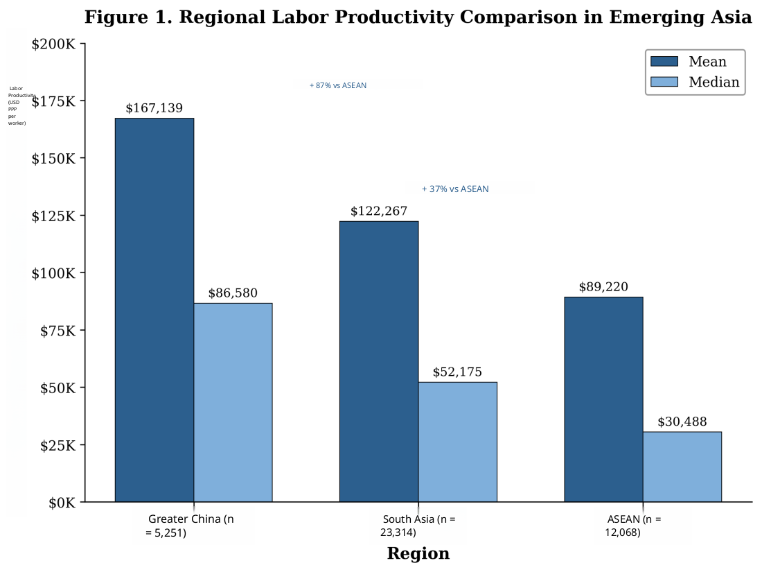
Source: Author's calculations from WBES data

4.2. Regression Results
Table 2 presents OLS regression results for the determinants of firm labor productivity. Model 1 includes only regional indicator variables. Relative to ASEAN, Greater China firms exhibit substantially higher productivity (β = 0.990, p < 0.001), implying approximately 169.1% higher productivity. South Asian firms also exceed ASEAN productivity (β = 0.506, p < 0.001), corresponding to 65.9% premium. Regional indicators alone explain 5.4% of productivity variance (R² = 0.054), supporting Hypothesis 1.
Model 2 adds firm capability variables. Technology adoption is strongly and positively associated with productivity (β = 0.409, p < 0.001), indicating approximately 50.5% higher productivity among firms that use email for business communication, supporting Hypothesis 2. Quality certification shows a similarly positive effect (β = 0.322, p < 0.001), corresponding to a 38.0% increase in productivity, supporting Hypothesis 2a. R² increases from .054 to .105 with capability variables, nearly doubling explanatory power.
Model 3 introduces the business obstacle index. Obstacles are negatively and significantly associated with productivity (β = -0.076, p < 0.001), implying that each one-unit increase reduces productivity by approximately 7.3%, supporting Hypothesis 3. Model 4 tests regional heterogeneity in SME gaps, revealing that South Asia shows substantial SME disadvantage (interaction β = -0.390, p < 0.001) while Greater China shows minimal gap (β = 0.043, n.s.), supporting Hypothesis 4.
Model 5 tests the capability-environment interaction hypothesis. The interaction coefficient is positive and highly significant (β = 0.110, p < 0.001), indicating that technology adoption attenuates the adverse effect of business obstacles. This supports Hypothesis 5 and the substitution view. Technology adoption reduces the productivity penalty from obstacles by approximately 83%: for non-adopters, each additional unit of obstacles reduces productivity by 12.5%; for adopters, the net penalty is only 2.3%. Figure 2 illustrates this moderation effect.
Table 2: OLS Regression Results
Variable | Model 1 | Model 2 | Model 3 | Model 4 | Model 5
Greater China | 0.990*** | 0.780*** | 0.745*** | 0.761*** | 0.769***
South Asia | 0.506*** | 0.407*** | 0.445*** | 0.770*** | 0.459***
Technology adoption |  | 0.409*** | 0.409*** | 0.426*** | 0.297***
Quality certification |  | 0.322*** | 0.322*** | 0.357*** | 0.323***
Log employment |  | 0.046*** | 0.046*** |  | 0.068***
Obstacle index |  |  | -0.076*** | -0.074*** | -0.133***
SME × South Asia |  |  |  | -0.390***
Obstacle × Technology |  |  |  |  | 0.110***
R² | 0.054 | 0.105 | 0.107 | 0.113 | 0.113
N | 40,633 | 40,633 | 40,633 | 40,633 | 40,633
Note. ***p < 0.001. Reference category: ASEAN. Robust standard errors (HC3). Controls include export intensity and survey year.
Source: Author's calculations from WBES data
Figure 2: Moderation Effect - Technology Adoption Buffers Negative Impact of Business Obstacles
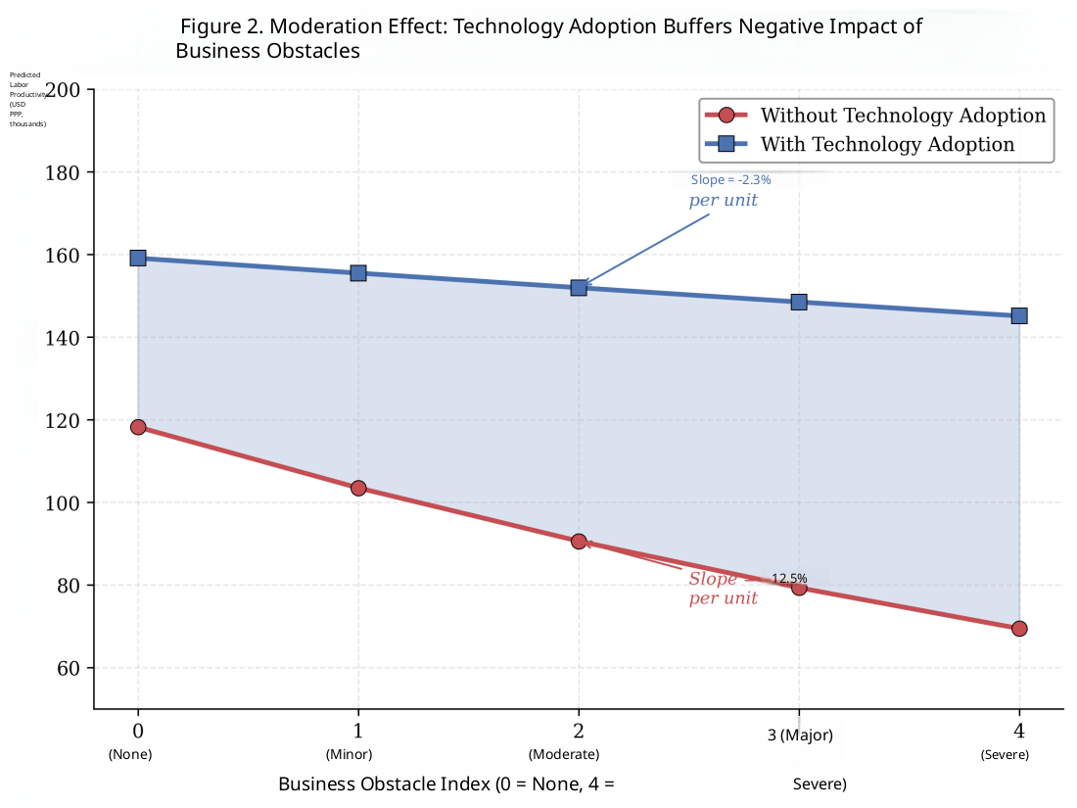
Source: Author's calculations from WBES data

4.3. Discussion of Findings
Our findings provide large-scale, multi-country empirical support for the Resource-Based View in emerging market contexts. The strong positive effects of technology adoption (β = 0.409) and quality certification (β = 0.322) demonstrate that internal capabilities generate meaningful and economically significant performance advantages even in environments characterized by substantial institutional voids. These results align with RBV predictions that valuable, difficult-to-imitate capabilities can serve as sources of competitive advantage and extend this logic to the emerging-market context, where the relative importance of firm-level versus environment-level factors has been debated.
The capability-environment moderation effect (interaction β = 0.110, p < 0.001) provides firm support for the substitution view articulated by Khanna and Palepu (2010). As shown in Figure 2, technology adoption enables firms to partially compensate for institutional weaknesses through multiple mechanisms: digital communication tools help firms cope with deficiencies in telecommunications infrastructure, online platforms help overcome information asymmetries in markets with weak contract enforcement, and digital documentation systems facilitate navigation of complex regulatory requirements. The 83% reduction in obstacle penalty for technology adopters represents a substantial buffering effect with important practical implications for firm strategy in challenging institutional environments.
The marked variation in SME-large firm productivity gaps across regions (Figure 3) contributes novel insights to understanding how ecosystem factors shape competitive dynamics. Greater China's remarkably narrow gap (6.9%, not statistically significant) compared to South Asia's substantial gap (33.3%, p < 0.001) suggests that China's extensive SME support infrastructure has enabled smaller firms to achieve competitive productivity levels. This finding has important policy implications for other emerging markets seeking to promote inclusive growth and reduce the competitive disadvantages facing smaller enterprises.
Figure 3: SME-Large Firm Productivity Gap Across Asian Regions
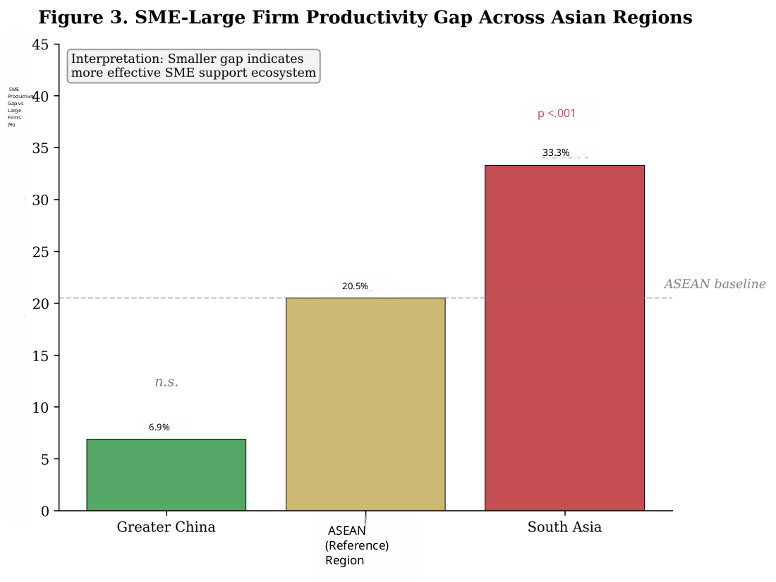
Source: Author's calculations from WBES data

5. Policy Recommendations
Our findings have several important practical implications for policymakers, firm managers, and international development organizations seeking to promote productivity growth in Asian emerging markets. For policymakers, the results highlight the importance of dual-track strategies that simultaneously address both firm capabilities and institutional constraints. Neither capability building alone nor institutional reform alone is sufficient; instead, the interaction between these factors suggests that coordinated interventions targeting both dimensions can generate multiplicative benefits.
First, programs that facilitate technology adoption can yield substantial productivity gains, with our estimates indicating 50% higher productivity for technology-adopting firms. Specific policy interventions include: digital literacy training programs for entrepreneurs and workers to build foundational skills, broadband infrastructure investment to improve connectivity, especially in rural and underserved areas where access remains limited, e-government services enabling digital interaction with regulatory authorities to reduce compliance costs, and financial incentives for ICT investment, such as accelerated depreciation allowances or tax credits for technology purchases. The moderation effect documented in our study suggests such programs are particularly valuable in contexts with weak institutional environments where technology provides a buffer against obstacles.
Second, institutional investments in infrastructure reliability, regulatory streamlining, and judicial efficiency can directly boost productivity. Our estimates indicate that reducing business obstacles by one unit would increase productivity by approximately 7.3%. Given that South Asia's obstacle index (1.32) is nearly four times higher than Greater China's (0.37), there is substantial room for improvement through infrastructure development, regulatory reform, and governance improvements. Priority areas include electricity grid reliability and renewable energy investment; transportation network development and logistics efficiency; customs modernization and trade facilitation; and judicial reform to strengthen contract enforcement.
Third, the substantial regional variation in SME productivity gaps points to the potential effectiveness of comprehensive SME support programs. China's experience suggests that combining multiple support mechanisms can substantially narrow the gap between small and large firms. Key elements include: dedicated SME financing through specialized banks, credit guarantee schemes, and venture capital funds; technology assistance through industrial parks, incubators, and extension services; regulatory simplification through streamlined licensing and one-stop service centres; and training programs for entrepreneurship development and management skill building. South Asian economies may benefit from adapting similar comprehensive support approaches tailored to local contexts.
For firm managers in emerging Asian markets, findings underscore the strategic importance of capability development, particularly technology adoption. The substantial direct productivity benefits (50% higher productivity) and the buffering effect against institutional obstacles make technology investment an attractive strategic priority. Managers should view technology adoption not merely as an operational improvement but as a strategic resource that enhances resilience and competitive positioning. Quality certification investments can similarly yield meaningful competitive advantages, particularly for firms seeking export market access or participation in global value chains.

6. Conclusion
This study provides comprehensive empirical evidence on firm performance heterogeneity across 17 Asian emerging economies using World Bank Enterprise Survey data from 40,633 firms collected between 2009 and 2024. By integrating insights from the Resource-Based View and Institutional Theory, we developed and tested a theoretical framework examining how internal firm capabilities and external institutional constraints jointly shape productivity outcomes. Our multi-country, multi-region design enables systematic comparisons across diverse institutional contexts while leveraging the WBES's standardized measurement approach to ensure cross-country comparability.
Key findings include: First, significant regional productivity hierarchies exist across Asia, with Greater China achieving a mean productivity of $167,139 USD PPP per worker-87% above ASEAN and 37% above South Asia, supporting Hypothesis 1. Second, technology adoption emerges as a powerful productivity driver, associated with 50.5% higher productivity, while quality certification contributes a 38.0% premium, supporting Hypotheses 2 and 2a. Third, business obstacles negatively affect productivity (β = -0.076, p < 0.001), supporting Hypothesis 3. Fourth, technology adoption moderates the adverse effects of business obstacles (interaction β = 0.110, p < 0.001), reducing the productivity penalty by approximately 83%, supporting Hypothesis 5 and the substitution view. Fifth, SME-large firm productivity disparities vary significantly-6.9% in Greater China versus 33.3% in South Asia-supporting Hypothesis 4.
Study limitations include the cross-sectional design, which limits causal inference; the basic technology measure, which captures only email use; and reliance on managers' subjective perceptions of obstacles. Specifically, the technology adoption variable (email usage for business communication) may not fully reflect the actual degree of digitalization and technological capability of firms. More advanced technologies, such as enterprise resource planning (ERP) systems, cloud computing, and big data analytics, may have differential impacts on productivity that our measures cannot capture. Furthermore, the correlational nature of the analysis does not allow us to establish causal relationships between technology adoption and productivity-it is possible that higher-productivity firms are more likely to invest in technology rather than technology driving productivity gains (reverse causality or endogeneity concerns). Future research should examine more comprehensive technology measures, use panel data to identify causal effects, employ instrumental variable approaches to address endogeneity, and complement perception-based measures with objective institutional indicators. Despite these limitations, our findings provide robust empirical evidence supporting policies targeting technology adoption, institutional reform, and SME development in emerging Asian markets. As Asian emerging markets continue to drive global economic growth, understanding the sources of firm performance heterogeneity remains crucial for scholars, policymakers, and practitioners alike.
Acknowledgement
We thank the Enterprise Analysis Unit of the World Bank's Development Economics Global Indicators Group for the data. Source: World Bank Enterprise Surveys, www.enterprisesurveys.org

References
1. Acemoglu, D., and Johnson, S. (2005), Unbundling institutions, Journal of Political Economy, 113(5), pp. 949-995;
2. Asian Development Bank (2020), Asia Small and Medium-Sized Enterprise Monitor 2020, ADB;
3. Barney, J. B. (1991), Firm resources and sustained competitive advantage, Journal of Management, 17(1), pp. 99-120;
4. Beck, T., and Demirguc-Kunt, A. (2006), Small and medium-size enterprises: Access to finance as a growth constraint, Journal of Banking & Finance, 30(11), pp. 2931-2943;
5. Bloom, N., Sadun, R., and Van Reenen, J. (2012), Americans do IT better, American Economic Review, 102(1), pp. 167-201;
6. Bloom, N., Sadun, R., and Van Reenen, J. (2013), Management as a technology?, NBER Working Paper No. 22327;
7. Brandt, L., and Rawski, T. G. (2008), China's remarkable economic transformation, Cambridge University Press;
8. Caselli, F. (2005), Accounting for cross-country income differences, Handbook of Economic Growth, Vol. 1, pp. 679-741;
9. Dollar, D., Hallward-Driemeier, M., and Mengistae, T. (2005), Investment climate and firm performance, Economic Development and Cultural Change, 54(1), pp. 1-31;
10. Hall, R. E., and Jones, C. I. (1999), Why do some countries produce so much more output per worker? Quarterly Journal of Economics, 114(1), pp. 83-116;
11. Hsieh, C.-T., and Klenow, P. J. (2009), Misallocation and manufacturing TFP in China and India, Quarterly Journal of Economics, 124(4), pp. 1403-1448;
12. Huang, Y. (2008), Capitalism with Chinese characteristics, Cambridge University Press;
13. International Monetary Fund (2024), World economic outlook: April 2024, IMF;
14. Khanna, T., and Palepu, K. G. (2010), Winning in emerging markets, Harvard Business Press;
15. Levine, D. I., and Toffel, M. W. (2010), Quality management and job quality, Management Science, 56(6), pp. 978-996;
16. Long, J. S., and Ervin, L. H. (2000), Using heteroscedasticity consistent standard errors, American Statistician, 54(3), pp. 217-224;
17. North, D. C. (1990), Institutions, institutional change and economic performance, Cambridge University Press;
18. Penrose, E. T. (1959), The Theory of the growth of the firm, John Wiley & Sons;
19. Terlaak, A., and King, A. A. (2006), The effect of certification with ISO 9000, Journal of Economic Behaviour & Organisation, 60(4), pp. 579-602;
20. World Bank (2018), World development report 2018: Learning to realize education's promise, World Bank;
21. World Bank (2020), World development report 2020: Trading for development, World Bank;
22. World Bank (2024), Enterprise Surveys, www.enterprisesurveys.org.

