**Unit 1**

**Write a description (100 - 120 words) about an IT item you like basing on the suggested questions**

**1. What is your favorite IT item?**

**2. Why do you like?**

**3. How long have you had it?**

**4. What is it like? (color, size, shape, materials)**

**5. What are its functions and applications?**

Now I will tell you about an IT item I like very much. And the device I like most is the smartphone. I got this phone from my dad for my birthday. I like my phone very much because it is a great tool to help bring knowledge, understanding, and relaxation after a tiring day with engaging videos. I have had it for 2 years. This phone is black and this is my favorite color. It is rectangular and compact in the palm of my hand. The screen size is 6.5 inches and It’s made of metal. I can find all the information I want with this phone. I usually use it for studying, surfing the internet and sometimes chatting with my friends.

**Unit 2**

**It person**

The person I admire is Sergey Brin. He is 48 years old. He is from Russia and now he lives in America. Normally I can only see him through newspapers or news channels and I hope to see him in real life. He is a Technical Director of Google company. He is so handsome. He is creative and intelligent. What he influences me is that he is an example of overcoming all circumstances. I admire him very much because he inspires me to study better and become an IT engineer.

**Write a brief introduction (100-120 words) about a company you know. Write your answer in the notebook.**

**Suggested questions:**

1. What is the name of the company?
2. When was it founded?
3. Where is its headquarters located?
4. What does it specialize in?
5. How many employees does it have?
6. Do you want to work for that company after graduation? Why?

My favorite company is Hewlett-Packard (HP). It is an information technology corporation. It’s located in American. The company was founded on january 1, 1939 and the founder of it is William Redington Hewlett and David Packard. Its headquarters located in Palo Alto, California, U.S. It has 30000 employees. The company specialize in HP software product, printers, cameras, scanners, personal desktops, business notebooks, pocket computers, mobile phones, tablet computers and so on. After graduating, I really want to work at the company because everybody wants to start their career with the best company and as a fresher and it is the fastest growing company in the industry and if I join it will be a great opportunity for increasing my knowledge and upgrading my experience and my skills.

**Unit 4**

**Talk about the problem(s) of an IT device that you have just bought.**

**Suggested questions:**

1. What IT device did you buy?
2. What problem did you have?
3. How long have you got the problem?
4. What did you do first when you had the problem?
5. What do you ask the seller to solve the problem?

Dear FPT Shop,

Last year, I got this phone from my dad for my birthday. Just a few days ago, my phone got wet, it was because I dropped it when running in the rain in the park near my house. First, I quickly take the phone out of water, turn it off and shake my phone gently to let the water out. At that time, I felt very worried, scared, and nervous because I restarted my phone but it did not respond when I touched it. I think the phone needs a screen replacement and help me see if the phone is damaged anywhere else and fix it. Thank you for giving the matter your attention and I hope to hear your reply soon.

Your faithfully,

Thúy

**Unit 6**

**Write a paragraph (100-120 words) about one invention (in IT field) you like best**

***Suggested questions:***

1. What is the invention you like best?

2. When was it invented?

2. By whom was it invented?

4. What is it used for?

5. Why do you like this invention?

Today, I will write about my favorite invention, that is telephone. It was invented in 1876 by Alexander Graham Bell. The telephone is used to talk to somebody else over long distances, search information, play games, ... Now, the phone is more and more compact, with many smart features, becoming an indispensable thing for everyone. I like my phone very much because it is a great tool to help bring knowledge, understanding, and relaxation after a tiring day with engaging videos. That’s my favorite invention. Thanks for your reading.

**Unit 7**

**Write a paragraph (100-120 words) to describe the components of computer basing on suggested questions**

**Suggested questions:**

1. What kind of computer do you have?
2. What is its color, size, materials and brand?
3. What basic components does your computer have? (name at least 5 components)
4. What are the functions of each component?
5. What is the storage capacity / clock speed of your computer?

Today I will write about my favorite device, which is my laptop. I bought this laptop when I passed the entrance examination. I like it so much. It is an ASUS laptop with a copper gold color. It has a screen size of 15.6 inches and is made of aluminum and plastic materials. It has a lot of components such as: monitor, RAM, motherboard ,… monitor is used to work a video card ,show information, images on the screen, RAM is used to store data when it is processed and lose the data when the power is turned off; motherboard is used to connect all the components inside the system. My laptop has 256 GB, 8GB RAM and comes with an Intel core i7 processor running at 3 GHz. The laptop is very useful and is an indispensable part of my life. That is my laptop.

**Unit 8 1**

**Write about IT security and safety rules at workplace (100 - 120 words) based on given suggestions:**

1. Computer
2. Password
3. Email
4. Security measure (firewall, antivirus software)
5. Others

Today, I will write about IT security and safety rules at the workplace. First, I always switch off my computer after work. And second, I don’t use personal email for work. More importantly, I must change my password at least twice a month and include letters and numbers in my password. Third, I don’t use illegally copied antivirus software and back up data at least twice a month. Finally, I use a secure channel to discuss work. That’s any security and safety rules at my workplace. Thanks for reading.

**Unit 8 2**

**Write simple safety instructions of an IT product (100 - 120 words) based on suggested questions**

**Suggested questions:**

*1. What IT device do you have?*

*2. What security measures do you have to protect it?*

*3. What threats can those measures protect your device from?*

*4. What do you avoid doing to protect it?*

*5. What is the condition of your IT device now?*

I will write about an IT device I have: my laptop. I bought it 2 years ago when I passed the university exam. To protect it, first, I install a firewall and use the latest version of the operating system, which is Windows 10. Besides, I install an antivirus program: BKAV and update it regularly to secure it from hackers, viruses and worms. More importantly, I also change my password at least six times a month and include letters and numbers in my password, so a hacker can’t gain unauthorized access to my computer. I never use illegally copied programs as my computer might get infected with spyware. Now my computer is still running well like when I first bought it.

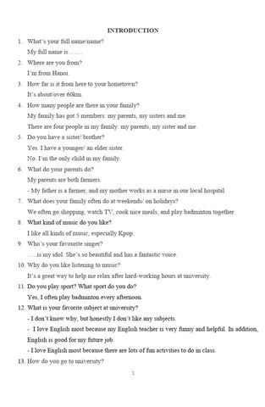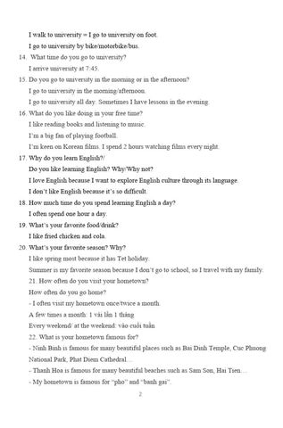

What do you often do on your weekends?

I mostly spend time resting and entertaining on weekends. Such things as taking more time for my sleep, reading my favorite books, going shopping, or meet friends at coffee shops