**REVISION**

**(SPEAKING)**

**I. UNIT 1: APPROACHING TO INFORMATION TECHNOLOGY**

**Card 1A (Student A):** Make conversation to exchange information about an IT person

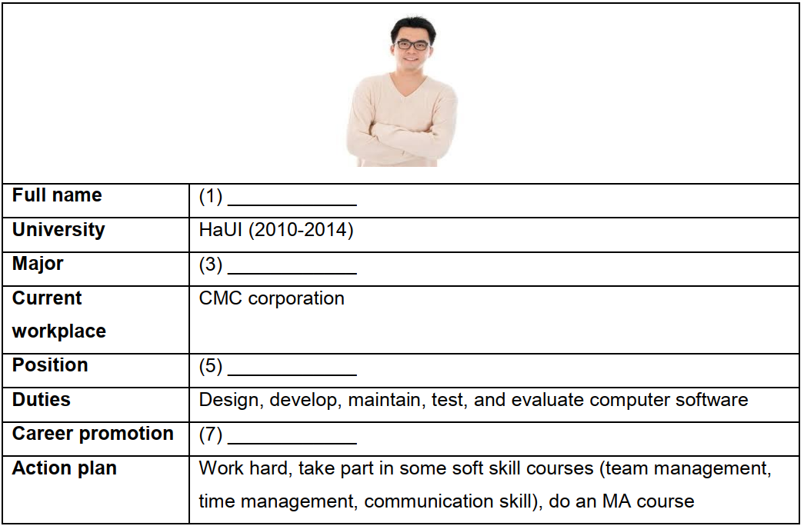

**Card 1B (Student B):** Make conversation to exchange information about an IT person

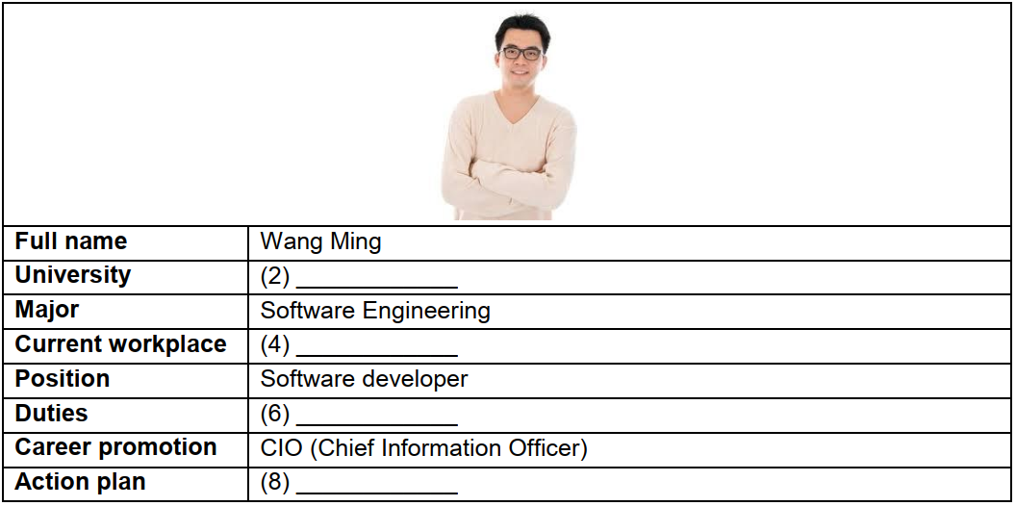

**Suggested answer:**

A: Can we share a little about this man?

B: Yes, sure.

A: (1) What is his full name?

B: His full name is Wang Ming. (2) Where did he study?

A: He studied at HaUI. (3) What is his major?/ What major did he study?

B: His major is Software engineering/ He studied Software engineering. (4) Where does he work?

A: He works in CMC corporation. (5) What is his job?

B: He is a software developer. (6) What are his job duties?

A: He develops, maintains, tests, and evaluates computer software. (7) What career promotion does he want to get in the future?

B: He wants to become a CIO. (8) What are his future plans?

A: He will work hard, take part in some soft skill courses such as team management, time management, communication skill, and do an MA course.

**Topic 1: Write/ Talk about your IT major**

Suggested questions:

*1. What is your major?*

*2. What do you study in your major?*

*3. What kinds of job can you do after graduation?*

*4. What are your job duties?*

*5. Do you like your major? Why/ Why not?*

**Short version:**

Now, I’m studying Information System at HaUI. In my major, I learn about software engineering, network programming & security, software and hardware installation,…This major provides me a wide range of career choices such as web designer, system analyst, database administrator, network administrator, tester,… After graduation, I want to become a web designer. I’ll be responsible for programming the websites using HTML, CSS and JavaScript. Additionally, I also need to keep the website up-to-date. I love this major because it helps me earn a lot of money to support my family. In a nutshell, Information Technology is a great major and I have no regrets of my choice.

**Vocabulary:**

(Be) fascinated by + Noun … bị thu hút bởi…

Network programming and security (n) lập trình và an ninh mạng

Software and hardware installation (n) cài đặt, lắp đặt phần mềm và phần cứng

Operation and maintenance (n) vận hành và bảo dưỡng

Data structure and algorithms (n) Cấu trúc dữ liệu và giải thuật

Web designer (n) người thiết kế web

System analyst (n) nhà phân tích hệ thống

Database administrator (n) người quản trị cơ sở dữ liệu

Network administrator (n) người quản trị mạng

Tester (n) nhân viên kiểm thử

Application (n) ứng dụng

Fix error (v) sửa lỗi

Keep + noun + adj: giữ .. (keep the website up to date: giữ cho trang web cập nhật)

Because of + noun, S + (V) + …: Bởi vì

In-demand (adj) có nhu cầu

High-paying (adj) được trả lương cao

**II. UNIT 2: INSIDE THE COMPUTER**

**Card 2A (Student A):** ﻿You are at an electrical shop and looking for a new Dell computer. Ask the

shop assistant for some more information about its memory features and their functions.

**Card 2B (Student B):** ﻿You are the shop assistant. Answer the customer some questions about the computer that the customer is looking for.

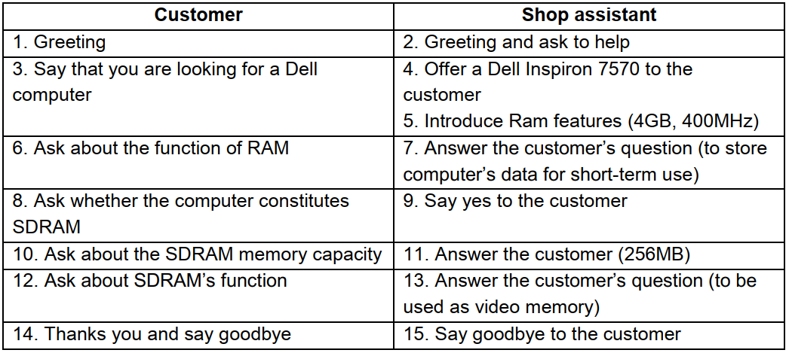

**Suggested answer:**

A: Good morning!

B: Good morning! How can I help you?

A: Well, I’m looking for a Dell computer.

B: Let’s have a look at this Dell inspiron 7375. It has 4GB of RAM and can be expanded to 32GB.

A: So what’s the function of RAM?

B: It’s used to store computer’s data for short-term use.

A: Does this computer constitute SDRAM?

B: Yes.

A: What’s the storage capacity of SDRAM?

B: It’s 256MB.

A: What’s the function of the SDRAM?

B: It can be used as video memory.

A: Thank you…

**Topic 2: Describe the components inside the system**

Suggested questions:

1. *What kind of computer do you have?*
2. *What are its color, screen size, materials and brand?*
3. *What are key components of a computer? (at least 3 components)*
4. *What are the function of each component?*
5. *What is the processor speed/ hard drive capacity/ memory size of your computer?*

**Short version:**

I have a laptop computer, it comes from HP. This year, I got this latop from my dad for my birthday. It is black and made of metal with the screen size of 15 inches. It has a lot of components such as CPU, main memory, motherboard, … and each component has different functions. The motherboard is used to connect all the components inside the system. Hard drive is used to store data for long-term use instead of RAM only used to store data for short-term use. The main memory contains instructions and data processed by the CPU. The laptop can hold 16GB of Ram, 2TB of hard drive space and processor speed runs at 3.2GHz, which makes the computer run very fast and smoothly.

**Vocabulary:**

Manufacture (v) sản xuất

Component (n) bộ phận, phần

Perform (v) thực hiện

Back-bone (n) cột sống

When + V-ing, S + (V) …: Khi …

Execute (v) thực hiện

Program instructions (n) câu lệnh chương trình

Coordinate (v) phối kết hợp

Process (v) xử lý

Hold (v) lưu, giữ

Superior capability (n) khả năng vượt trội

Indispensible (adj) không thể thiếu

**Topic: Describe the funtions of the CPU**

The computer needs various important components to work properly and efficiently. One of the core parts of computer is the CPU. CPU stands for central processing unit which is considered the “brain” of computer. This is built into a single **chip** which executes program instructions and coordinates the activities of all the other units. There are many such parts of a computer CPU, but the central processing unit consists of three main components known as Arithmetic logic unit, Control unit and registers. **The arithmetic logic unit (ALU)** performs mathematical calculations and logical operations. **The control unit** directs the operation of the processor. **The registers** are high-speed units of memory used to store and control data. All the three parts are very important and the CPU cannot run without one of them.

**III. UNIT 3: INPUT AND OUTPUT DEVICES**

**Card 3A (Student A):** ﻿Make a conversation to ask and answer about the specifications and features of a printer

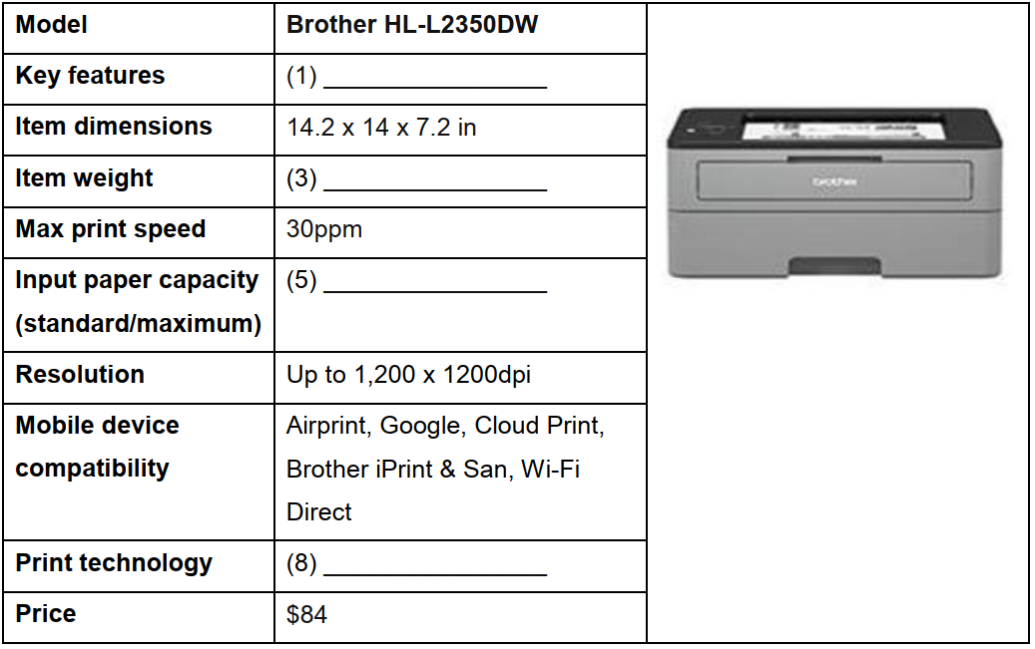

**Card 3B (Student B):** ﻿Make a conversation to ask and answer about the specifications and features of a printer

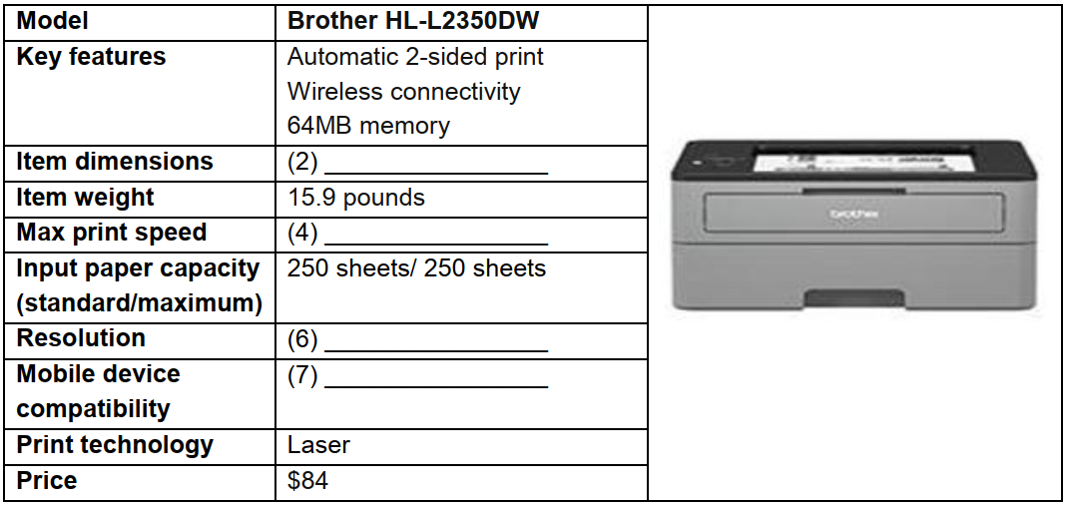

**Suggested answer:**

A: Hello David. Do you know anything about this Brother HL-L2350DW printer?

B: Yes, a littile. Can we share some information about it to each other?

A: Sure. (1) What are the key features of this printer?

B: Well, it features automatic 2-sided printing which can seriously reduce the cost of each print job. Besides, it offers wireless connectivity allowing users printing from compatible mobile devices. And its memory is up to 64GB so it can store a lot of data. (2) What are its dimensions (for each item)?

A: It’s 14.2 inches long by 14 inches wide by 7.2 inches high. (3) How much does it weigh?  
B: It weighs 15.9 pounds.

B: (4) What is its maximum print speed?

A: It can print up to 30 pages per minute. (5) What is its maximum input paper capacity?  
B: It provides the input paper capacity of 250 sheets. (6) So, What is its resolution?  
A: Well, it has a resolution of 1,200 by 1,200 dots per inch. (7) What mobile device is it compatible with?

B: It’s compatible with Airprint, Google, Cloud Print, Brother iPrint & San and Wi-Fi Direct. (8) What print technology does it use?

A: It uses laser technology*.*

B:…

**Topic 3: Write/ Talk about your favorite input output device**

**Suggested questions:**

*1. What is the name of your favorite output device? (model, brand)*

*2. What is its shape? What is it made of? (size, shape, materials)*

*3. What are its specifications, functions and key features? (dimensions, weight, resolution, OS compatibility, component, capability,…)*

*4. What are its advantages and disadvantages?*

*5. Why do you like it? (compared to other products)*

**Sample:**

The USB (Universal Serial Bus) which is both input and output device. My USB’s brand is HP and this brand is also known as a big famous company about electronic devices such as laptop, smartphone, graphic tablet. Most of USB made of plastic or metal but each USB has a unique shape and always small like a finger. In spite of it’ dinky appearance, the function of USB will make us surprise. It can storage a large amount of data and use for storaging, backing up data also transfering files between devices. Because of my major, I need to have a USB for my learning so it become an indispensable part of mine.

**Vocabulary:**

Have/ has a screen resolution of …: có độ phân giải màn hình là …

Anti-glare screen (n) màn hình chống chói

Connectivity (n) kết nối

Vivid color (n) màu sắc sống động

Prevent eyestrain and fatigue (v) ngăn cản mỏi mắt

**IV. UNIT 4: STORAGE DEVICES**

**Card 4A (Student A):** ﻿Make a conversation to ask and answer about the specifications of an SSD

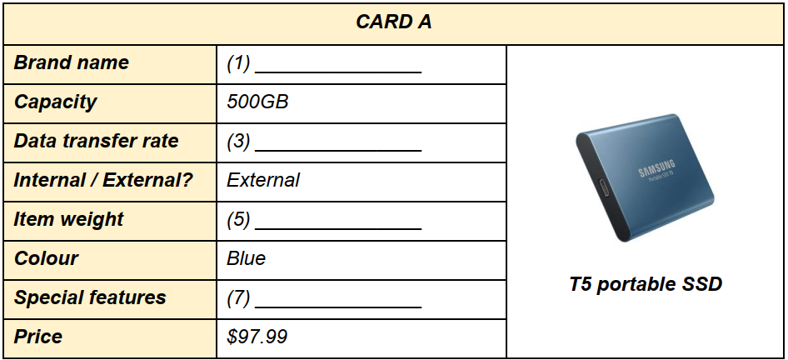

**Card 4B (Student):** ﻿Make a conversation to ask and answer about the specifications of an SSD

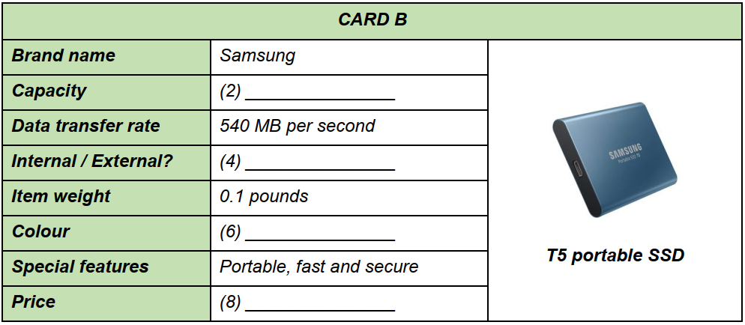

**Suggested answer:**

A: Hello, Linh. Do you know anything about this SSD?

B: Yes, a little. Can we share some information about it to each other?

A: Sure. I’ll ask you first. (1) What is its brand name?

B: It is Samsung. (2) What is its storage capacity?

A: It can store 500GB of data. (3) What is its data transfer rate?/How much data can it transfer per second?

B: It can transfer 540MB per second. (4) Is it an internal or external SSD?  
A: It is an external SSD. (5) What is its weight? / How heavy is it?/ How much does it wegh?  
B: It weighs 0.1 pounds. (6) What is its color?

A: It is blue. (7) What special features does it have?

B: It is portable, fast and has secure external storage. (8) How much is it?/ How much does it cost?

A: It is $97.99

A: Thank you for your information.

B: You’re welcome.

**Topic 4: Write/ Talk about your favorite storage device**

Suggested questions:

*1. What kinds of storage device do you have?  
2. What storage device do you like most?  
3. How much memory does it have?  
4. What are its advantages and disadvantages?  
5. Why do you like it (compare with other storage devices)?*

**Short version:**

The storage device I like most is USB. USB is both input and output device. My USB is made of plastic and has a rectangular shape and small like a finger. In spite of it’s dinky apperance, it can hold up to 100 GB in memory. Besides, the Universal Serial Bus also uses for transfering data between devices. I prefer to USB because it’s convenience and the large capacity. Because of my major, I always need to have a USB for my learning so it become an indispensable part of my life.

**Structures:**

1. Rather than + V-ing, S + (V) + …: Hơn là … (làm gì đó), thì …

2. Because/As S + (V) + …, S + (V) + …: Bởi vì …

3. S + (be) + adj-er (short adj) + (than) + N + …: Ai đó/ cái gì đó … hơn …

more + adj (long adj)

4. Another disadvantage of Noun + (be) + Noun: Một bất lợi khác của … là …

5. It’s likely that + S + (V) + …: Có khả năng là …

**New words:**

Advantages = good points = benefits = pros: lợi ích

Disadvantages = bad points = drawbacks = cons = shortcomings = limitations: điểm bất lợi

As = Because: Bởi vì

So = Thus = Therefore: Vì vậy

Cutting-edge (adj): vượt trội, độc đáo

High data access speed (noun phrase): tốc độ truyền dữ liệu cao

Platter (noun): đĩa từ

Spindle motor (noun): trục quay

Read/write head (noun): đầu đọc, ghi

NAND flash memory (noun): bộ nhớ NAND flash (NAND = Not And/ Negative And)

Have lower power consumption (verb phrase): có lượng tiêu thụ điện ít hơn

Generate less heat (verb phrase): tạo ra ít hơi nóng hơn

Conventional drives (noun): các loại ổ đĩa/ ổ lưu trữ truyền thống = traditional drives

Improve (verb): cải thiện

Replace (verb): thay thế

**V. UNIT 5: SYSTEM SOFTWARE**

**Card 5.1**

**Card 5A (Student A):** You are a salesperson at a computer shop. Make a conversation with the customer, and provide support.

**Card 5B (Student B):** You are looking for a new laptop. Make conversation with the salesperson to ask for help.

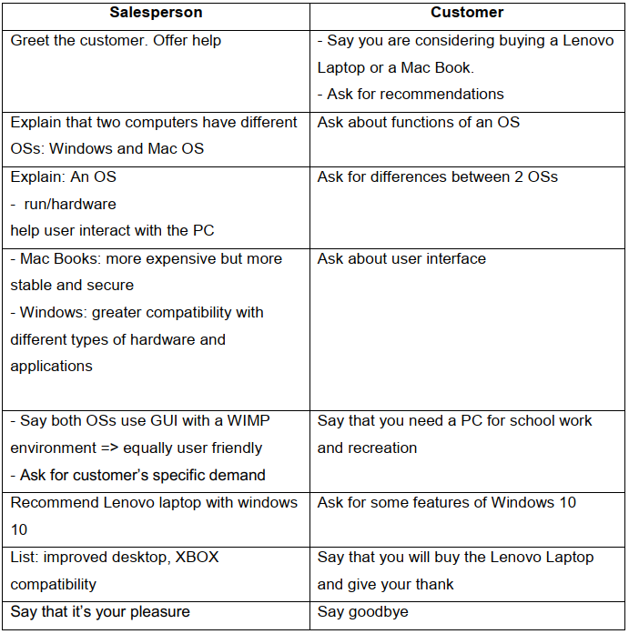

**Card 5.2**

**Card 5A: Look at card A, ask student B questions about Window and then answer student B’s questions.**

|  |  |
| --- | --- |
| **Operating systems** | **Windows** |
| **Developed by** | (1) _______ |
| **Year released** | 1985 |
| **Mostly used for** | (3) ________ |
| **Market share (2018)** | 83% |
| **User interface** | (5) _______ |
| **Popular applications** | Microsoft office, Microsoft To-do, OneNote |
| **Latest version** | (7) _______ |
| **New features** | Cortana voice assistant, virtual desktop, Xbox live integration |
| **Advantages** | (9) _______ |
| **Disadvantages** | Greater risk of virus attack |

**Card 5B: Look at card B, answer student A’s questions about Windows and then ask student A questions about Windows.**

|  |  |
| --- | --- |
| **Operating systems** | **Windows** |
| **Developed by** | Microsoft |
| **Year released** | (2) _______ |
| **Used for** | Traditional PCs (92% of all computers) |
| **Market share (2018)** | (4) _______ |
| **User interface** | GUI with Wimp environment |
| **Popular applications** | (6) _______ |
| **Latest version** | Windows 10 (July 29, 2015) |
| **New features** | (8) _______ |
| **Advantages** | Compatibility with most hardware and application software |
| **Disadvantages** | (10)_______ |

**Suggested answer:**

A: (1) Which company developed Windows?

B: It was Microsoft. (2) When was it released?

A: In 1985. (3) What is it used for?

B: It is used for traditional PCs (92% of all computers). (4) What is its market share in

2018? / What market share did it have in 2018?

A: It had 83 % market share./ It had a market share of 83%. (5) What is its user interface?/What user interface does it have?

B: It is GUI with Wimp environment. (6) Can you tell me some of its popular software programs? / What are its popular applications?

A: They are Microsoft office, Microsoft To-do, and OneNote. (7) What is its latest version?  
B: Windows 10. It was launched/ released on July 29th, 2015. (8) What are its features?  
A: It has Cortana voice assistant, virtual desktop, and Xbox live integration. (9) What are its advantages?/ What advantages does it have?

B: It is compatible with most hardware and application software. (10) What about disadvantages?

A: It has greater risk of virus attack.

**Topic 6: Write/Talk about an Operating System you know well**

Suggested questions:

*1. Which company developed it?*

*2. When was it first released?*

*3. Which platform was it most used for? (mobile, home computer, server network)*

*4. What are its advantages and disadvantages?*

*5. What is its recommended use?*

**Sample:**

Among various kinds of Operating Systems, the one I like most is definitely Microsoft Windows. Windows was first launched on November 20th, 1985. It is used for home and office computers, tablets, smartphones, etc. Like other operating systems, it runs the computer hardware and help users interact with the PC. As a dominant operating system, Windows brings users a lot of advantages. First of all, it supports for most hardware and software. As Windows OS is used by 95% of users, most of the developers make drivers, utilities and software which are compatible with Windows. Second, it is easy to use. All versions of Microsoft Windows have something common in its interface, which makes users easy to shift from one version to another. Despite some good points, Windows also has some drawbacks. Compared to other operating systems, Microsoft security is weak. Windows computers are more likely to be hacked and used to distribute everything from spam to hate mail. In addition, source code of Microsoft Windows is closed, which means they are only debugged by Microsoft itself. To sum up, in spite of some limitations, Windows is still one of the best operating systems running on PCs.

**Short version:**

Among many kinds of Operating Systems, the one I like most is definitely Microsoft Windows. Windows was first launched on November 20th, 1985. It is used for home and office computers, tablets, smartphones, etc. Windows brings users a lot of advantages. First, it’s compatible with most hardware and software. Second, Windows is a GUI operating system so it is very easy to use. Despite some good points, Windows also has some drawbacks. Compared to other operating systems, Microsoft security is weak. Therefore, it’s more likely to be hacked. In addition, source code of Microsoft Windows is closed, which means they are only debugged by Microsoft itself. To sum up, in spite of some limitations, Windows is still one of the best operating systems running on PCs.

**Structures:**

1. S + (be) + Pii + …: Cái gì đó được …

2. S + V + …, which + (Vs) + …: Ai đó/ cái gì đó… , việc mà khiến … (Nếu câu trước là nguyên nhân của câu sau => thường dùng đại từ QH ‘which’ để thay thế cho cả câu)

Ex: All versions of Microsoft Windows have something common in its interface (1). This makes users easy to shift from one version to another.

(Tất cả các phiên bản của Windows đều có 1 vài điểm chung ở giao diện của nó. Điều này khiến người dùng dễ dàng chuyển đổi từ phiên bản này sang phiên bản khác)

* This và cả câu số 1 là một. Để ghép 2 câu này lại với nhau dùng ĐTQH ‘which’ để thay thế cho cả mệnh đề trước nó.
* All versions of Microsoft Windows have something common in its interface, which makes users easy to shift from one version to another. (Đằng trước chỉ có 1 mệnh đề, 1 nguyên nhân nên động từ ‘make’ chia theo S số ít => makes)

3. Despite + Noun, S + (V) + …: Mặc dù …, …

= In spite of + Noun, S + (V) + …

4. Compared to + Noun, S + (V) + …: So sánh với … thì …

5. S + (be) + likely + to + V(inf) + …: … dễ có khả năng …

Windows computers are more likely to be hijacked and used to distribute everything

so sánh hơn bị động của ‘to V’

from spam to hate mail.

(Máy tính cài HĐH windows dễ có khả năng bị tấn công hơn và được dùng để phát tán mọi thứ từ spam đến thư rác.)

6. Present participle (phân từ hiện tại)

Windows is still **one of the best operating systems**. **It** runs on PCs.

* Windows is still one of the best operating systems which runs on PCs.
* Windows is still one of the best operating systems running on PCs.

(Câu đằng sau ‘It runs on PCs’ là câu chủ động, nên có thể ghép 2 câu lại bằng cách chuyển động từ của câu sau sang ‘V-ing’, vậy một cách khác khi viết câu là ngoài việc dùng ĐTQH, ta có thể dùng theo cách này để các cấu trúc câu linh hoạt hơn)

**Vocabulary:**

Definitely (adv): hoàn toàn

Launch (v): giới thiệu, phát hành, đưa ra (cho m.ng biết)

Dominant (adj): thống trị

Support (v): hỗ trợ

Drivers (n): phần mềm điều hành

Utility (n): tiện ích

(Be) compatible with (adj): tương thích với

Interface (n): giao diện

Shift (v): thay đổi, chuyển đổi

Security (n): tính bảo mật

Distribute (v): phát tán, phân phát

Source code (n): mã nguồn

Dubug (v) gỡ lỗi, sửa lỗi

**VI. UNIT 6: PROGRAMMING SOFTWARE**

**Card 6A (Student A):** ﻿Make a conversation to ask and answer about computer languages

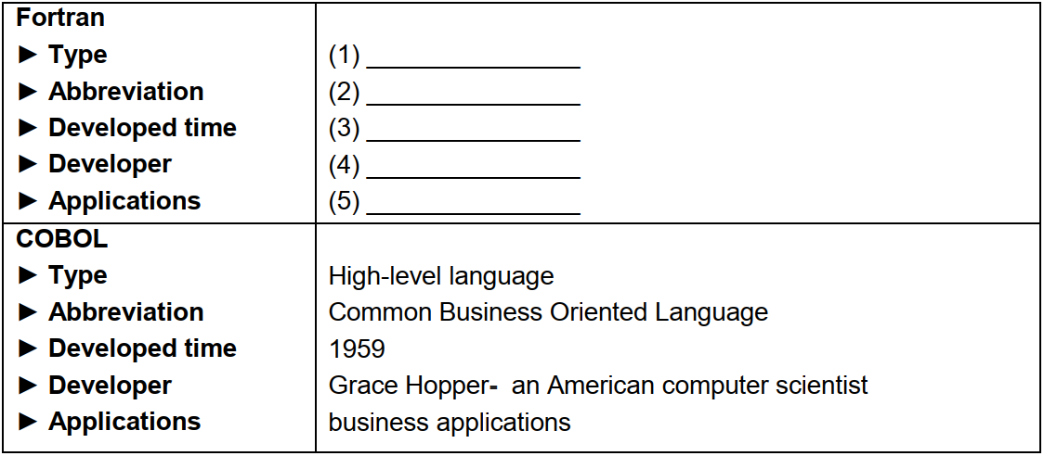

**Card 6B (Student B):** Make a conversation to ask and answer about computer languages

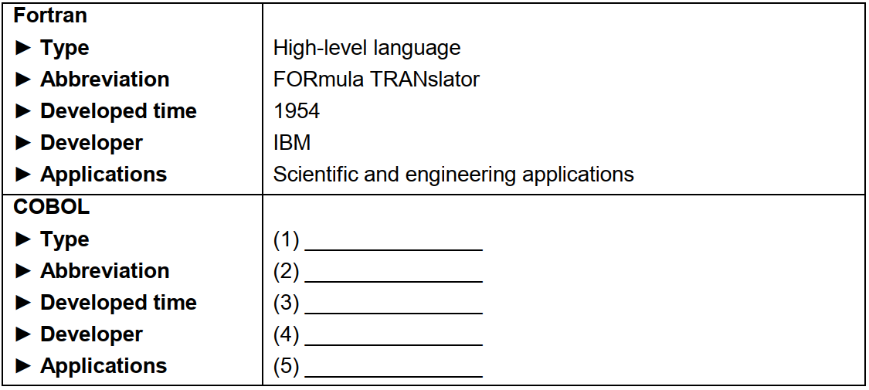

**Suggested answer:**

|  |  |
| --- | --- |
| 1. What is the type of Fortran language? | It’s a high-level language. |
| 2. What is the abbreviation of Fortran?/ What does Fortran stand for? | It is FORmula TRANslator. |
| 3. When was it developed? | It was developed in 1954. |
| 4. By whom was it developed? /Who developed it? | It was developed by IBM/ IBM did. |
| 5. What is it used for? | It is used for Scientific and engineering applications. |
| It’s a high-level language. | 1. What is the type of COBOL language? |
| It is Common Business Oriented Language. | 2. What is the abbreviation of COBOL?/ What does COBOL stand for? |
| It was developed in 1959. | 3. When was it developed? |
| It was developed by Grace Hopper -  an American [computer scientist](https://en.wikipedia.org/wiki/Computer_scientist). | 4. By whom was it developed? / Who developed it? |
| It’s used for scientific and engineering applications. | 5. What is it used for? |

**Topic 7 (Unit 6): Write/Talk about a computer language you know**

**Suggested questions:**

*1. How many types of computer languages are there?*

*2. What computer language do you know best?*

*3. By whom was it developed?*

*4. When was it developed?*

*5. What is it used for?*

**Sample:**

There are two main kinds of computer languages which are low-level language and high-level language. C++ is a high-level programming language that was developed by Bjarne Stroustrup in December, 2017. It can be used to develop games, desktop apps, operating systems, browsers, networking, device drivers, etc. It runs on a variety of platforms, such as Windows, Mac OS, and various versions of UNIX. C++ has many advantages when it comes to computer programming. Compared to the previous languages, C++ is more powerful, efficient and faster. Besides, C++ is an object-oriented programming language which includes concepts like classes, inheritance, … allowing code to be reused and making a program more reliable. Additionally, **C++ offers the feature** of portability which lets users run the same program on different operating systems or interfaces. However, this language has less security and is quite complex in a very high level program. In conclusion, despite some drawbacks, C++ is always an awesome programming language to learn and use.

**Short version:**

There are two main kinds of computer languages which are low-level language and high-level language. C++ is a high-level programming language that was developed by Bjarne Stroustrup in December, 2017. It can be used to develop games, operating systems, browsers, networking, device drivers, etc. C++ has many advantages. Compared to the previous languages, C++ is more powerful, efficient and faster. Additionally, **C++ offers the feature** of portability which lets users run the same program on different operating systems or interfaces. However, this language has less security and is quite complex in a very high level program. In conclusion, despite some drawbacks, C++ is always a great programming language to learn and use.

**Structures & Vocabulary:**

S + can be + Pii + …: Cái gì/ Ai đó có thể được …

Low-level language: ngôn ngữ bậc thấp

High-level language: ngôn ngữ bậc cao

Develop (v) phát triển

Browser (n) trình duyệt

Device driver (n) phần mềm điều hành

A variety of = a lot of = many: nhiều, một loạt

Platform (n) nền hệ thống, nền tảng

Powerful (adj) mạnh

Efficient (adj) hiệu quả

Object-oriented programming language (n) ngôn ngữ lập trình hướng đối tượng

Concept (n) khái niệm

Class (n) lớp

Inheritance (n) tính kế thừa

Allow sth to be + pii (bị động của động từ allow): cho phép … được …

Make sth + adj: khiến … như thế nào…

Reliable (adj) đáng tin cậy

Offer = provide (v) đưa ra, cung cấp

Portibility (n) tính di động (portable (adj))

Let sb + V(inf) + … = allow sb to V(inf) = enable sb to V(inf): cho phép ai đó làm gì…

Interface (n) giao diện

Complex (adj) phức tạp

**VII. UNIT 7: NETWORKING**

**Card 7A (Student A):** Make conversation to ask and answer about a type of network

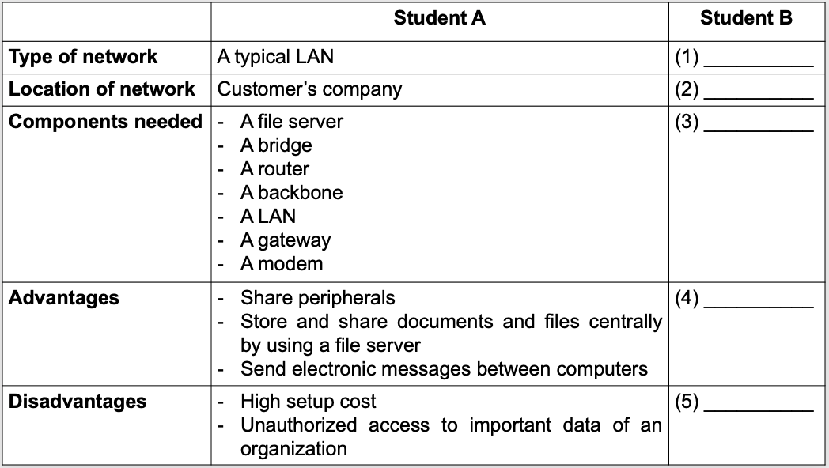

**Card 7B (Student):** Make conversation to ask and answer about a type of network

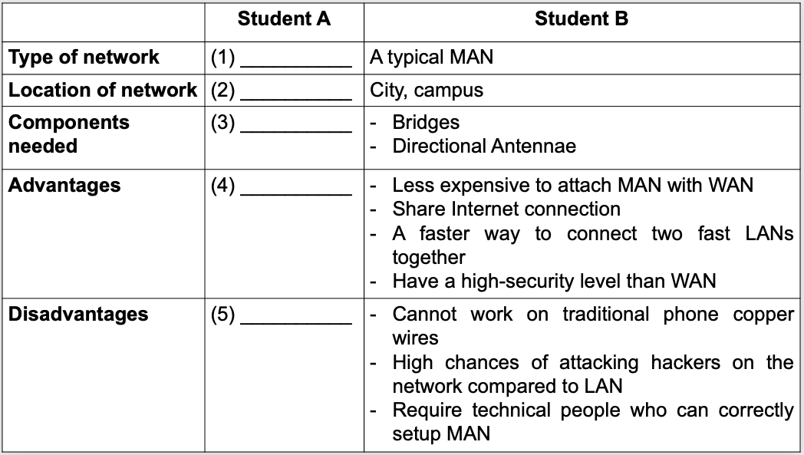

**Topic 8: Write/Talk about the type of network you’re using at home**

**Suggested questions:**

*1. What type of network are you using at home?*

*2. What do you use the network for?*

*3. How do you access the network?*

*4. Why do you use it?*

*5. How fast is it?*

**Sample:**

There are various types of computer networks such as LAN, PAN, MAN, WAN, etc. At home, I’m using Local Area Network (LAN). I use LAN to communicate with my relatives and friends by chat or email. To access the network, I need to set it up with components such as cables, access points, switches, routers, and other components. I choose to use this type of network because it has a lot of advantages. First, it’s very fast. It has a bandwidth speed of 10Mbps, several times faster than an average WAN. Second, because it is available in one small region, it is easy to control and manage. Furthermore, compared to WAN, LAN connection is relatively inexpensive to set up and maintain. In conclusion, with the benefit it offers, LAN is an ideal choice for users like me and my family.

**Structures and Vocabulary:**

Mbps (Megabits per second)

Use sth to V(inf) …: dùng cài gì để làm việc gì…

Communicate (with) (v) giao tiếp với…

Relative (n) họ hàng

Access (v) truy cập

Cable (n) dây cáp

Access point (n) thiết bị kết nối, điểm truy cập

Switch (n) thiết bị dịch chuyển mạng

Router (n) bộ định tuyến

Enable sb/sth to + V-inf…: khiến … làm gì …

Server (n) mày chủ

Bandwidth (n) băng thông

Several times faster than …: nhanh hơn vài lần (chú ý đặt số lần trước tính từ so sánh)

Average (adj) trung bình

Control (v) điểu khiển

Manage (v) quản lý

Relatively (adv) khá

Maintain (v) bảo trì, bảo dưỡng

**Topic 9: Advantages and disadvantages of network**

A computer network is defined as a group of computers that are interconnected for sharing data. There are many advantages of network. Firstly, it is very easy to communicate through a network. People can communicate together efficiently using a network via emails, messages, video conferencing, chat rooms, etc. Secondly, thanks to networking, people can find and share information and data. This is beneficial for large organizations to maintain their data in an organized manner and facilitate access for desired people. Another important advantage of networking is the ability to share hardware and software. For an example, a printer can be shared among the users in a network so that there’s no need to have individual printers for every computer in the company. However, computer networks are not always secure. Hackers can infect computer networks with malicious software such as viruses, spyware, worms, trojans, etc. In conclusion, despite some drawbacks, computer network is always a fast and convenient means of sharing information that people can’t live without.

**Short version:**

Network has both advantages and disadvantages. In terms of advantages, first, it is very easy to communicate through a network. People can communicate together efficiently using a network via emails, messages, video conferencing, chat rooms, etc. Secondly, thanks to networking, people can find and share information and data easily without spending time on travelling. However, computer networks are not always secure. Hackers can infect computer networks with viruses, spyware, worms, trojans,… and our personal information or money can be easily stolen if we are not careful. In conclusion, despite some drawbacks, computer network is always a fast and convenient means of sharing information that people can’t live without.

**VIII. UNIT 8: TECHNICAL REPORTS**

**Card 8A (Student A):** You are an office staff. You have a problem with your computer display screen.

Make a telephone conversation with the IT technician to ask for advice on that problem

based on the given information in the card.

**Card 8B (Student B):** You are an IT technician of ABC Company. You get a phone call from an office

staff talking about her/ his problem. Make a telephone conversation with the office staff

based on given clues in the cards.

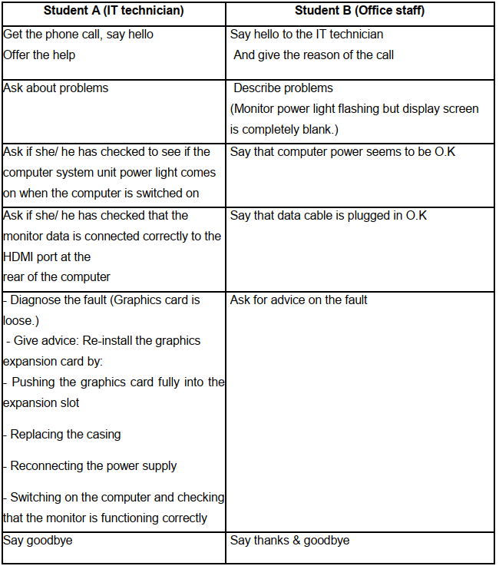

**Suggested answer:**

A: Hello, this is IT service division. David speaking. How can I help you?  
B: Hello, this is Peter from Marketing Department. I’m phoning about my problem with the display screen.

A: So can you give me the detailed problem? / Can you describe what exactly the problem is?  
B: Well, I see the monitor power light flashing but the display screen is completely blank.  
A: Have you checked to see if the computer system unit power light comes on when the computer is switched on?

B: Yes. I have. But the computer power seems to be O.K.

A: Have you checked that the monitor data is connected correctly to the HDMI port at the rear of the computer?

B: Let me see. Well, the data cable is plugged in O.K.

A: It sounds as if the graphics card is loose.

B: What should I do now? / Can you give me some advice?

A: All right. You should re-install the graphics expansion card by: pushing the graphics card fully into the expansion slot, replacing the casing, reconnecting the power supply, then switching on the computer to check that the monitor is functioning correctly.

B: Thanks a lot. Good bye.

A: You’re welcome. Bye.

**Card 9A (Student A): ﻿**You are a Chief Information Officer. Make a conversation with student B

(the leader of IT supervisor group) to complete the card.

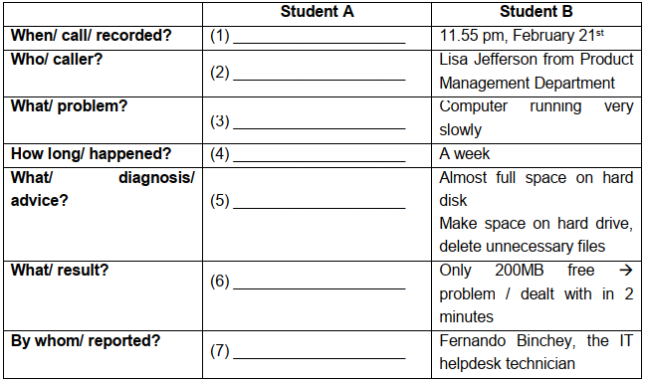

﻿**Card 9B (Student B):** You are a Chief Information Officer. Make a conversation with student A

(the leader of the IT supervisor group) to complete the card.

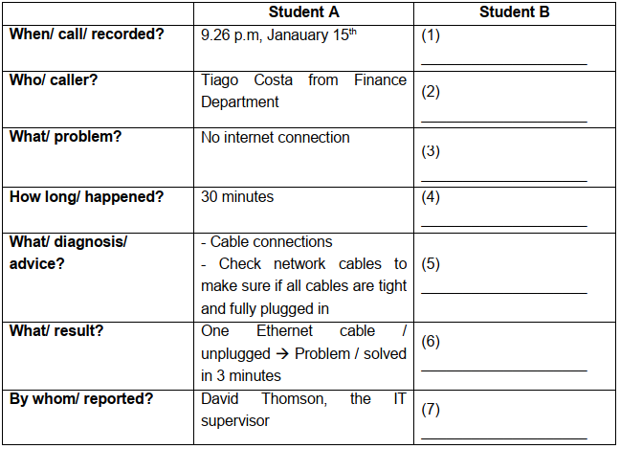

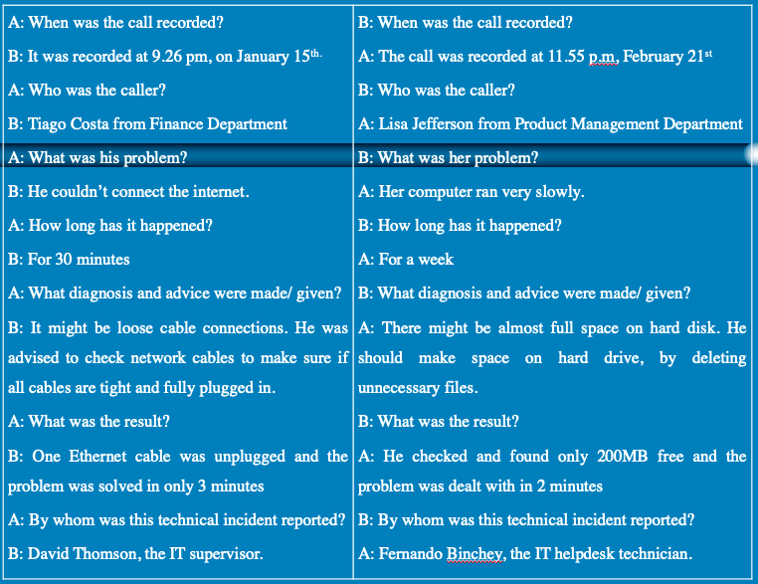

**Card 10A (Student A):** You have an IT problem. Make a phone call to the helpdesk technician (Student B) to ask for help.

**Card 10B (Student B):** ﻿You are a telephone help desk technician. Make a conversation with the customer (Student A) to provide help.

|  |  |
| --- | --- |
| **Student A** | **Student B** |
| ﻿Say Hello, give your name and the name of  your department | ﻿Answer the phone and offer help |
| ﻿Say your problem: computer running very  slowly | ﻿Ask how many programs are opened |
| ﻿Answer the question (only mail and word  processor) | ﻿Ask if she/ her has checked space on hard  disk |
| ﻿Say No | ﻿Give fault diagnosis (almost full space on  hard disk) |
| ﻿Ask for advice | ﻿Give advice (make space on hard drive,delete unnecessary applications) |
| ﻿Say you will do that immediately | ﻿Say if the problem stills happens, call you again |
| ﻿Say thanks and end the conversation | ﻿Say thanks and end the conversation |

**Suggested answer:**

A: Hello, I’m Linda Smith from Accounting Department.

B: Hello Ms. Smith. How can I help you?

A: Well, my computer is running very slowly. It takes me a lot of time to download something or open a file.

B: How many programs are opened on your computer?

A: Only mail and word processor.

B: Have you checked space on hard disk?

A: No, I haven’t.

B: It might be almost full space on hard disk.

A: What should I do now?/ Can you give me some advice?

B: Now, you should make space on hard drive and delete unnecessary applications.

A: OK, I’ll do that immediately.

B: If the problem still happens, call me again.

A: Great. Thank you so much.

B: You’re welcome. Goodbye!

**Topic 10: Write a report based on the following note:**

|  |  |
| --- | --- |
| **TECHNICAL REPORT** | |
| **Date of call** | 22/2/2018 |
| **Time commenced** | 4:50p.m |
| **Problem** | Not playing MIDI sound files |
| **Fault diagnosis** | Faulty sound driver |
| **Advice** | Reinstall the original sound drivers |

**Sample:**

I would like to make a detailed technical report to you. The call was recorded at 4:50 p.m on 22nd February, 2018. John Smith from Customer Service Department phoned to ask about a problem with his computer. It is not playing MIDI sound files. I think it sounds as if he probably has faulty sound drivers. He was advised to uninstall the original sound drivers and re-install the new one. As a result, her computer could play MIDI sound files, and it took me 10 minutes to deal with this problem.