**Assignment 1**

#Laboratory Exercise 5, Home Assignment 1

.data

 test: .asciiz "Hello World"

 .text

  li  $v0, 4

    la  $a0, test

      syscall

Kết quả sau khi chạy:

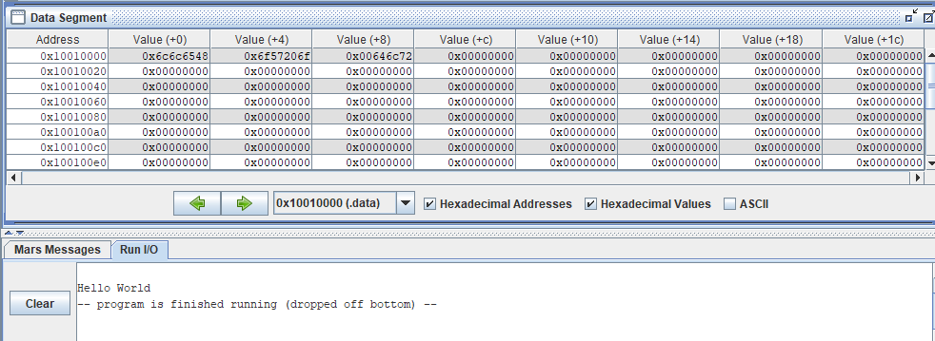

**Assignment 2**

#“The sum of (s0) and (s1) is (result)”

.data

message1 : .asciiz "The sum of "

message2 : .asciiz " and "

message3 : .asciiz " is "

.text

 li $s0, 10

 li $s1, 20

 #printf message1:

  li $v0,4

  la $a0, message1

  syscall

   #printf $s0:

  li $v0,1

  add $a0, $s0,$zero

  syscall

   #printf message2:

  li $v0,4

  la $a0, message2

  syscall

   #printf $s1:

  li $v0,1

  add $a0, $s1,$zero

  syscall

   #printf message3:

  li $v0,4

  la $a0, message3

  syscall

   #printf result:

  li $v0,1

  add $a0, $s0,$s1

  syscall

Kết quả :

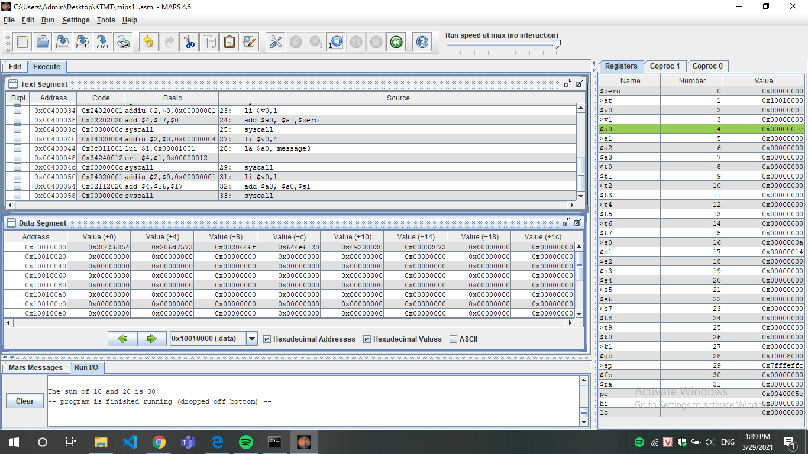

**Assignment 3**

#Laboratory Exercise 5, Assignment 2

.data

 x: .space 1000                     # destination string x, empty

 y: .asciiz "Bui Thu Thuy Linh"                 # source string y

.text

strcpy:

la  $a0,x

la  $a1,y

add $s0,$zero,$zero         #s0 = i=0

L1:

add $t1,$s0,$a1             #t1 = s0 + a1 = i + y[0]

  #   = address of y[i]

  lb $t2,0($t1)              #t2 = value at t1 = y[i]

  add $t3,$s0,$a0             #t3 = s0 + a0 = i + x[0]

  #   = address of x[i]

  sb $t2,0($t3)              #x[i]= t2 = y[i]

  beq $t2,$zero,end_of_strcpy #if y[i]==0, exit

  nop

   addi  $s0,$s0,1               #s0=s0 + 1 <-> i=i+1

  j L1                      #next character

   nop

end_of_strcpy:

Kết quả

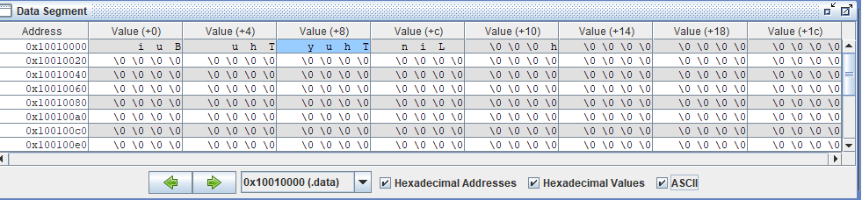

**Assignment 4**

.data

*string:* .space 50

*Message1:* .asciiz "Nhap xau:"

*Message2*: .asciiz "Do dai la "

.text

*main*:

*get_string*: *#TODO*

li $v0, 54

  la $a0, Message1

  la $a1, string

  la $a2, 100

  syscall

*get_length*: la $a0, string *# a0 = Address(string[0])*

*#xor $v0, $zero, $zero # v0 = length = 0*

  xor $t0, $zero, $zero *# t0 = i = 0*

*check_char*: add $t1, $a0, $t0 *# t1 = a0 + t0*

*#= Address(string[0]+i)*

lb $t2, 0($t1) *# t2 = string[i]*

  beq $t2,$zero,end_of_str *# Is null char?*

*#addi $v0, $v0, 1 # v0=v0+1->length=length+1*

  addi $t0, $t0, 1 *# t0=t0+1->i = i + 1*

  j check_char

*end_of_str*:

*end_of_get_length*:

*print_length*: *#TODO*

li $v0,56

la $a0,Message2

add $a1,$zero,$t0

syscall

Kết quả:

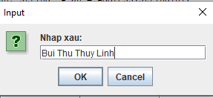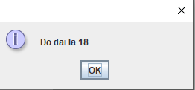

**Assignment 5**

.data

mes: .asciiz "\n reverse: "

string: .space 50

reverse: .space 50

.text

la $s0,string

xor $s1,$0,$s0

read_char:

li $v0,12

syscall

add $s1,$s0,$t0

addi $t0,$t0,1

beq $v0,10,end_read_char

sb $v0, 0($s1)

beq $t0, 20, end_read_char

j read_char

end_read_char:

get_length:

la $a0, string # a0 = Address(string[0])

#xor $v0, $zero, $zero  # v0 = length = 0

  xor $t0, $zero, $zero # t0 = i = 0

check_char:

add $t1, $a0, $t0 # t1 = a0 + t0

  #= Address(string[0]+i)

lb $t2, 0($t1) # t2 = string[i]

  beq $t2,$zero,end_of_str # Is null char?

  #addi $v0, $v0, 1 # v0=v0+1->length=length+1

  addi $t0, $t0, 1 # t0=t0+1->i = i + 1

  j check_char

end_of_str:

end_of_get_length:

print_reverse:

la $a0,string

la $a1,reverse

subi $s1,$t0,1

xor $s0,$0,$0

loop:

add $t1,$s1,$a0

lb $t2,0($t1)

add $t3,$s0,$a1

sb $t2,0($t3)

beq $s1,$0,exit

addi $s0,$s0,1

subi $s1,$s1,1

j loop

exit:

li $v0,4

la $a0,mes

syscall

li $v0,4

la $a0,reverse

syscall

Kết quả:

