**Laboratory Exercise 11**

**Họ và tên : Phạm Tuấn Dũng**

**MSSV : 20176728**

**Assignment 1**

1. Yêu cầu : Viết chương trình sử dụng ngôn ngữ Assembly để phát hiện phím được 16 phím nhấn (từ 0->F) trong Digi Lab Sim và in số phím vào bàn điều khiển.
2. Mã Nguồn

#------------------------------------------------------

# col 0x1 col 0x2 col 0x4 col 0x8

#

# row 0x1 0 1 2 3

# 0x11 0x21 0x41 0x81

#

# row 0x2 4 5 6 7

# 0x12 0x22 0x42 0x82

#

# row 0x4 8 9 a b

# 0x14 0x24 0x44 0x84

#

# row 0x8 c d e f

# 0x18 0x28 0x48 0x88

#

#------------------------------------------------------

# command row number of hexadecimal keyboard (bit 0 to 3)

# Eg. assign 0x1, to get key button 0,1,2,3

# assign 0x2, to get key button 4,5,6,7

# NOTE must reassign value for this address before reading,

# eventhough you only want to scan 1 row

.eqv IN_ADRESS_HEXA_KEYBOARD 0xFFFF0012

# receive row and column of the key pressed, 0 if not key pressed

# Eg. equal 0x11, means that key button 0 pressed.

# Eg. equal 0x28, means that key button D pressed.

.eqv OUT_ADRESS_HEXA_KEYBOARD 0xFFFF0014

.text

main: li $t1, IN_ADRESS_HEXA_KEYBOARD

li $t2, OUT_ADRESS_HEXA_KEYBOARD

li $t3, 0x1 # check row 1 with key 0,1,2,3

li $t4, 0x2 # check row 2 with key 4,5,6,7

li $t5, 0x4 # check row 3 with key 8,9,a,b

li $t6, 0x8 # check row 4 with key c,d,e,f

polling:

polling_row1:

sb $t3, 0($t1 ) # must reassign expected row

lb $a0, 0($t2) # read scan code of key button

bnez $a0, print

polling_row2:

sb $t4, 0($t1 ) # must reassign expected row

lb $a0, 0($t2) # read scan code of key button

bnez $a0, print

polling_row3:

sb $t5, 0($t1 ) # must reassign expected row

lb $a0, 0($t2) # read scan code of key button

bnez $a0, print

polling_row4:

sb $t6, 0($t1 ) # must reassign expected row

lb $a0, 0($t2) # read scan code of key button

bnez $a0, print

print: li $v0, 34 # print integer (hexa)

syscall

sleep: li $a0, 100 # sleep 100ms

li $v0, 32

syscall

back_to_polling:

j polling # continue polling

1. Kết quả

-Khi nhấn 1 phím hàng đầu :

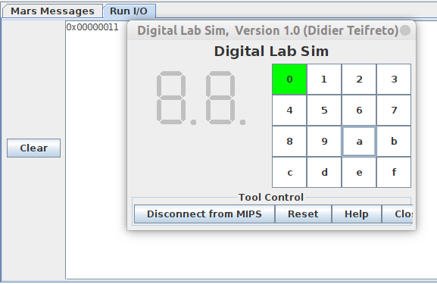

- Khi nhấn 1 phím ở hàng 2 :

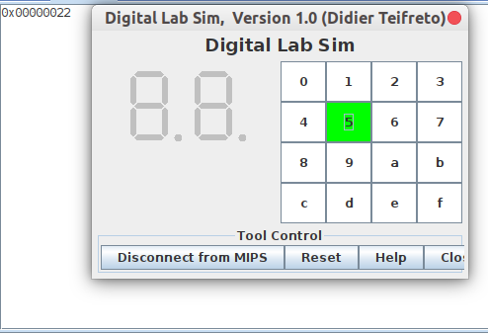

-Khi nhấn 1 phím ở hàng 3 :

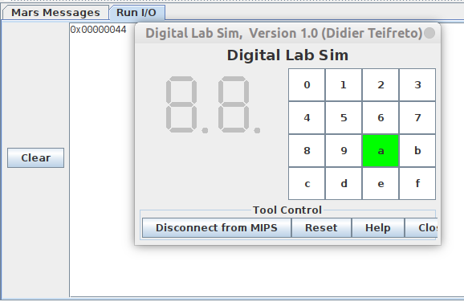  
-Khi nhấn 1 phím ở hàng 4 :

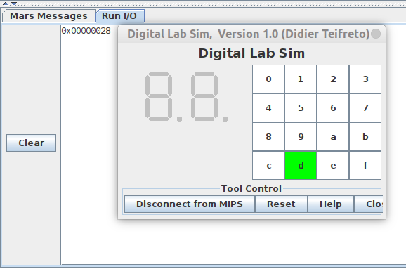

**Assignment 2**

1. Yêu cầu : Chờ một ma trận từ bàn phím và in ra tin nhắn đơn giản

2. Mã nguồn

.eqv IN_ADRESS_HEXA_KEYBOARD 0xFFFF0012

.data

Message: .asciiz "Oh my god. Someone's presed a button.\n"

#~~~~~~~~~~~~~~~~~~~~~~~~~~~~~~~~~~~~~~~~~~~~~~~~~~~~~~~~~~~~~~~~~

# MAIN Procedure

#~~~~~~~~~~~~~~~~~~~~~~~~~~~~~~~~~~~~~~~~~~~~~~~~~~~~~~~~~~~~~~~~~

.text

main:

#---------------------------------------------------------

# Enable interrupts you expect

#---------------------------------------------------------

# Enable the interrupt of Keyboard matrix 4x4 of Digital Lab Sim

li $t1, IN_ADRESS_HEXA_KEYBOARD

li $t3, 0x80 # bit 7 of = 1 to enable interrupt

sb $t3, 0($t1)

#---------------------------------------------------------

# No-end loop, main program, to demo the effective of interrupt

#---------------------------------------------------------

Loop: nop

nop

nop

nop

b Loop # Wait for interrupt

end_main:

#~~~~~~~~~~~~~~~~~~~~~~~~~~~~~~ ~~~~~~~~~~~~~~~~~~~~~~~~~~~~~~~~~~~

# GENERAL INTERRUPT SERVED ROUTINE for all interrupts

#~~~~~~~~~~~~~~~~~~~~~~~~~~~~~~~~~~~~~~~~~~~~~~~~~~~~~~~~~~~~~~~~~

.ktext 0x80000180

#--------------------------------------------------------

# Processing

#--------------------------------------------------------

IntSR: addi $v0, $zero, 4 # show message

la $a0, Message

syscall

#--------------------------------------------------------

# Evaluate the return address of main routine

# epc <= epc + 4

#--------------------------------------------------------

next_pc:mfc0 $at, $14 # $at <= Coproc0.$14 = Coproc0.epc

addi $at, $at, 4 # $at = $at + 4 (next instruction)

mtc0 $at, $14 # Coproc0.$14 = Coproc0.epc <= $at

return: eret # Return from exception

3. Kết quả

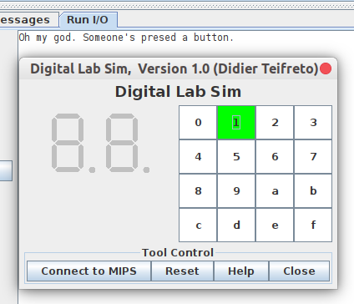

**Assignment 3**

1. Yêu cầu :

- Chương trình chính cho phép 1 ngắt: từ ma trận khóa trong Data Lab Sim

- Chương trình chính chỉ in số thứ tự lên bàn điều khiển

- Kết nối Sim phòng thí nghiệm dữ liệu. Bất cứ khi nào người dùng nhấn nút phím C, D, E Assignment 3hoặc F, một tăng gián đoạn và in mã quét mã khóa lên bàn điều khiển

1. Mã nguồn :

.eqv IN_ADRESS_HEXA_KEYBOARD 0xFFFF0012

.eqv OUT_ADRESS_HEXA_KEYBOARD 0xFFFF0014

.data

Message: .asciiz "Key scan code "

#~~~~~~~~~~~~~~~~~~~~~~~~~~~~~~~~~~~~~~~~~~~~~~~~~~~~~~~~~~~~~~~~~

# MAIN Procedure

#~~~~~~~~~~~~~~~~~~~~~~~~~~~~~~~~~~~~~~~~~~~~~~~~~~~~~~~~~~~~~~~~~

.text

main:

#---------------------------------------------------------

# Enable interrupts you expect

#---------------------------------------------------------

# Enable the interrupt of Keyboard matrix 4x4 of Digital Lab Sim

li $t1, IN_ADRESS_HEXA_KEYBOARD

li $t3, 0x80 # bit 7 = 1 to enable

sb $t3, 0($t1)

#---------------------------------------------------------

# Loop an print sequence numbers

#---------------------------------------------------------

xor $s0, $s0, $s0 # count = $s0 = 0

Loop: addi $s0, $s0, 1 # count = count + 1

prn_seq:addi $v0,$zero,1

add $a0,$s0,$zero # print auto sequence number

syscall

prn_eol:addi $v0,$zero,11

li $a0,'\n' # print endofline

syscall

sleep: addi $v0,$zero,32

li $a0,300 # sleep 300 ms

syscall

nop # WARNING: nop is mandatory here.

b Loop # Loop

end_main:

#~~~~~~~~~~~~~~~~~~~~~~~~~~~~~~~~~~~~~~~~~~~~~~~~~~~~~~~~~~~~~~~~~

# GENERAL INTERRUPT SERVED ROUTINE for all interrupts

#~~~~~~~~~~~~~~~~~~~~~~~~~~~~~~~~~~~~~~~~~~~~~~~~~~~~~~~~~~~~~~~~~

.ktext 0x80000180

#-------------------------------------------------------

# SAVE the current REG FILE to stack

#-------------------------------------------------------

IntSR: addi $sp,$sp,4 # Save $ra because we may change it later

sw $ra,0($sp)

addi $sp,$sp,4 # Save $at because we may change it later

sw $at,0($sp)

addi $sp,$sp,4 # Save $sp because we may change it later

sw $v0,0($sp)

addi $sp,$sp,4 # Save $a0 because we may change it later

sw $a0,0($sp)

addi $sp,$sp,4 # Save $t1 because we may change it later

sw $t1,0($sp)

addi $sp,$sp,4 # Save $t3 because we may change it later

sw $t3,0($sp)

#--------------------------------------------------------

# Processing

#--------------------------------------------------------

prn_msg:addi $v0, $zero, 4

la $a0, Message

syscall

li $t6, 0x1

li $t3, 0x81 # check row 4 and re-enable bit 7

get_cod:li $t1, IN_ADRESS_HEXA_KEYBOARD

bgt $t3, 0x88, reset_getcod # check row 4 and re-enable bit 7

sb $t3, 0($t1) # must reassign expected row

li $t1, OUT_ADRESS_HEXA_KEYBOARD

lb $a0, 0($t1)

bnez $a0, prn_cod

mul $t6, $t6, 2

add $t3, $t6, 0x80

j get_cod

prn_cod:li $v0,34

syscall

li $v0,11

li $a0,'\n' # print endofline

syscall

#--------------------------------------------------------

# Evaluate the return address of main routine

# epc <= epc + 4

#--------------------------------------------------------

next_pc:mfc0 $at, $14 # $at <= Coproc0.$14 = Coproc0.epc

addi $at, $at, 4 # $at = $at + 4 (next instruction)

mtc0 $at, $14 # Coproc0.$14 = Coproc0.epc <= $at

#--------------------------------------------------------

# RESTORE the REG FILE from STACK

#--------------------------------------------------------

restore:lw $t3, 0($sp) # Restore the registers from stack

addi $sp,$sp,-4

lw $t1, 0($sp) # Restore the registers from stack

addi $sp,$sp,-4

lw $a0, 0($sp) # Restore the registers from stack

addi $sp,$sp,-4

lw $v0, 0($sp) # Restore the registers from stack

addi $sp,$sp,-4

lw $ra, 0($sp) # Restore the registers from stack

addi $sp,$sp,-4

lw $ra, 0($sp) # Restore the registers from stack

addi $sp,$sp,-4

return: eret # Return from exception

reset_getcod:

li $t3, 0x81

li $t6, 0x1

j get_cod

1. Kết quả :

* Khi nhấn nút ở hàng 1 :

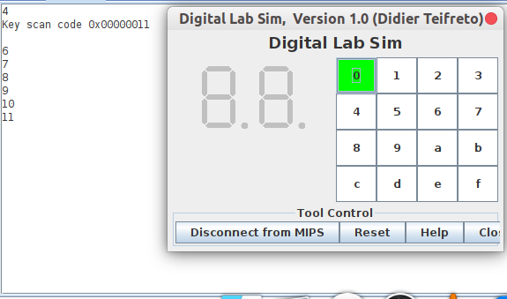

* Khi nhấn nút ở hàng 2 :

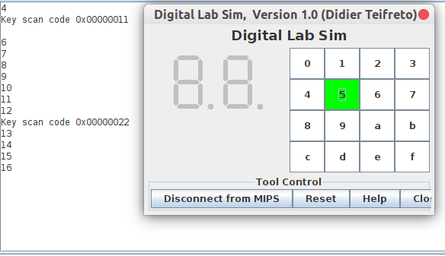

* Khi nhấn nút ở hàng 3 :

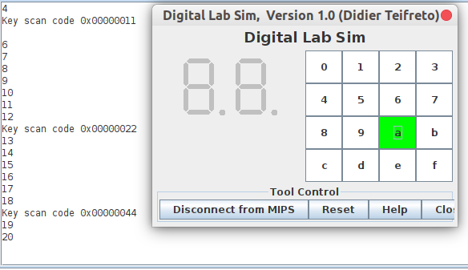

* Khi nhấn nút ở hàng 4 :

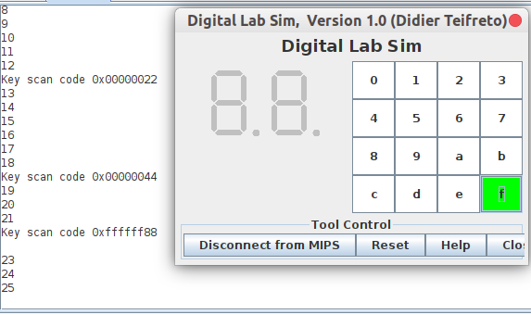

**Assignment 4**

1. Yêu cầu :

- Chương trình chính cho phép đồng thời 2 ngắt: từ ma trận khóa và bộ đếm thời gian trong Data Lab Sim.

- Chương trình chính không làm gì với deadloop

- Kết nối Data Lab Sim. Cứ mỗi lần user press any key hoặc time interval reachs, một ngắt tăng và in mã quét mã khóa lên bàn điều khiển

2. Mã nguồn

.eqv IN_ADRESS_HEXA_KEYBOARD 0xFFFF0012

.eqv COUNTER 0xFFFF0013 # Time Counter

.eqv MASK_CAUSE_COUNTER 0x00000400 # Bit 10: Counter interrupt

.eqv MASK_CAUSE_KEYMATRIX 0x00000800 # Bit 11: Key matrix interrupt

.data

msg_keypress: .asciiz "Someone has pressed a key!\n"

msg_counter: .asciiz "Time inteval!\n"

#~~~~~~~~~~~~~~~~~~~~~~~~~~~~~~~~~~~~~~~~~~~~~~~~~~~~~~~~~~~~~~~~~

# MAIN Procedure

#~~~~~~~~~~~~~~~~~~~~~~~~~~~~~~~~~~~~~~~~~~~~~~~~~~~~~~~~~~~~~~~~~

.text

main:

#---------------------------------------------------------

# Enable interrupts you expect

#---------------------------------------------------------

# Enable the interrupt of Keyboard matrix 4x4 of Digital Lab Sim

li $t1, IN_ADRESS_HEXA_KEYBOARD

li $t3, 0x80 #

sb $t3, 0($t1)

# Enable the interrupt of TimeCounter of Digital Lab Sim

li $t1, COUNTER

sb $t1, 0($t1)

#---------------------------------------------------------

# Loop an print sequence numbers

#---------------------------------------------------------

Loop: nop

nop

nop

sleep: addi $v0,$zero,32 # BUG: must sleep to wait for Time Counter

li $a0,200 # sleep 300 ms

syscall

nop # WARNING: nop is mandatory here.

b Loop

end_main:

#~~~~~~~~~~~~~~~~~~~~~~~~~~~~~~~~~~~~~~~~~~~~~~~~~~~~~~~~~~~~~~~~~

# GENERAL INTERRUPT SERVED ROUTINE for all interrupts

#~~~~~~~~~~~~~~~~~~~~~~~~~~~~~~~~~~~~~~~~~~~~~~~~~~~~~~~~~~~~~~~~~

.ktext 0x80000180

IntSR: #--------------------------------------------------------

# Temporary disable interrupt

#--------------------------------------------------------

dis_int:li $t1, COUNTER # BUG: must disable with Time Counter

sb $zero, 0($t1)

# no need to disable keyboard matrix interrupt

#--------------------------------------------------------

# Processing

#--------------------------------------------------------

get_caus: mfc0 $t1, $13 # $t1 = Coproc0.cause

IsCount: li $t2, MASK_CAUSE_COUNTER# if Cause value confirm Counter..

and $at, $t1,$t2

beq $at,$t2, Counter_Intr

IsKeyMa: li $t2, MASK_CAUSE_KEYMATRIX # if Cause value confirm Key..

and $at, $t1,$t2

beq $at,$t2, Keymatrix_Intr

others: j end_process # other cases

Keymatrix_Intr: li $v0, 4 # Processing Key Matrix Interrupt

la $a0, msg_keypress

syscall

j end_process

Counter_Intr: li $v0, 4 # Processing Counter Interrupt

la $a0, msg_counter

syscall

j end_process

end_process:

mtc0 $zero, $13 # Must clear cause reg

en_int: #--------------------------------------------------------

# Re-enable interrupt

#--------------------------------------------------------

li $t1, COUNTER

sb $t1, 0($t1)

#--------------------------------------------------------

# Evaluate the return address of main routine

# epc <= epc + 4

#--------------------------------------------------------

next_pc:mfc0 $at, $14 # $at <= Coproc0.$14 = Coproc0.epc

addi $at, $at, 4 # $at = $at + 4 (next instruction)

mtc0 $at, $14 # Coproc0.$14 = Coproc0.epc <= $at

return: eret # Return from exception

3. Kết quả

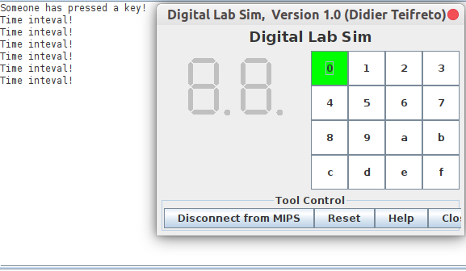

**Assignment 5**

1. Yêu cầu

Thiết bị Keyboard không tự động tạo ra ngắt khi có một phím được bấm,

mà người lập trình phải tự tạo ngắt mềm.

1. Mã nguồn

.eqv KEY_CODE 0xFFFF0004 # ASCII code from keyboard, 1 byte

.eqv KEY_READY 0xFFFF0000 # =1 if has a new keycode ?

# Auto clear after lw

.eqv DISPLAY_CODE 0xFFFF000C # ASCII code to show, 1 byte

.eqv DISPLAY_READY 0xFFFF0008 # =1 if the display has already to do

# Auto clear after sw

.eqv MASK_CAUSE_KEYBOARD 0x0000034 # Keyboard Cause

.text

li $k0, KEY_CODE

li $k1, KEY_READY

li $s0, DISPLAY_CODE

li $s1, DISPLAY_READY

loop: nop

WaitForKey: lw $t1, 0($k1) # $t1 = [$k1] = KEY_READY

beq $t1, $zero, WaitForKey # if $t1 == 0 then Polling

MakeIntR: teqi $t1, 1 # if $t0 = 1 then raise an Interrupt

j loop

#---------------------------------------------------------------

# Interrupt subroutine

#---------------------------------------------------------------

.ktext 0x80000180

get_caus: mfc0 $t1, $13 # $t1 = Coproc0.cause

IsCount: li $t2, MASK_CAUSE_KEYBOARD# if Cause value confirm Keyboard..

and $at, $t1,$t2

beq $at,$t2, Counter_Keyboard

j end_process

Counter_Keyboard:

ReadKey: lw $t0, 0($k0) # $t0 = [$k0] = KEY_CODE

WaitForDis: lw $t2, 0($s1) # $t2 = [$s1] = DISPLAY_READY

beq $t2, $zero, WaitForDis # if $t2 == 0 then Polling

Encrypt: addi $t0, $t0, 1 # change input key

ShowKey: sw $t0, 0($s0) # show key

nop

end_process:

next_pc: mfc0 $at, $14 # $at <= Coproc0.$14 = Coproc0.epc

addi $at, $at, 4 # $at = $at + 4 (next instruction)

mtc0 $at, $14 # Coproc0.$14 = Coproc0.epc <= $at

return: eret # Return from exception