Group members:

Mai Hồ An Thúy 18110052

Nguyễn Tấn Thành 18110046

Hà Văn Cường 18110003

|  |  |
| --- | --- |
| **Register / Sign in the application** | |
| Actors | Nutrition App User, Nutrition App System |
| Description | A user may register the application to Nutrition App System collecting the customers database. The information shown includes name, sex, age, weight, height and summary of their daily food. |
| Data | Users’ personal information, diet summary |
| Stimulus | User command issued by application system |
| Response | Confirmation that the application has been updated |
| Comments | The application owners must have certain security permissions to access users information. |

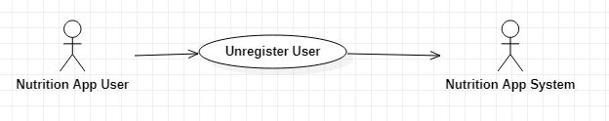

|  |  |
| --- | --- |
| **Unregister user** | |
| Actors | Nutrition App User, Nutrition App System |
| Description | A user may unregister the application to Nutrition App System collecting the customers database. |
| Data | Users who are not loged in personal information |
| Stimulus | User command issued by application system |
| Response | Confirmation that the application has been updated |
| Comments | The application owners must have certain security permissions to access the information of users not logging in. |

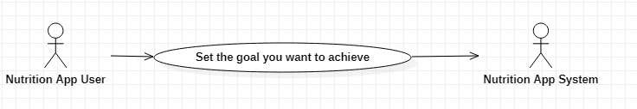

|  |  |
| --- | --- |
| **Set the goal you want to achieve** | |
| Actors | Nutrition App User, Nutrition App System |
| Description | A user may set their own goal: to track eating habits, track physical activities or lose weight. |
| Data | Users’ goals of diet |
| Stimulus | User command issued by application system |
| Response | Confirmation that the application has been updated |
| Comments | The application owners must have certain security permissions to access users’ goals, from that, help them achieve that. |

|  |  |
| --- | --- |
| **Set a reminder schedule** | |
| Actors | Nutrition App User, Nutrition App System |
| Description | A user may set a reminder schedule about eating or starting a workout. |
| Data | Users’ meal reminders |
| Stimulus | User command issued by application system |
| Response | Confirmation that the application has been updated |
| Comments | The application owners must have certain security permissions to access each user’s diet schedules. |

|  |  |
| --- | --- |
| **Manage User Information** | |
| Actors | Nutrition App System |
| Description | The app system may manage user information and collect the customers database. The information shown includes name, sex, age, weight, height and summary of their daily food. |
| Data | Users’ personal information, diet summary |
| Stimulus | User command issued by application system |
| Response | Confirmation that the application has been updated |
| Comments | The application owners must have certain security permissions to access users information. |

|  |  |
| --- | --- |
| Add data | |
| Actors | User |
| Description | Users add food consumed and activities during the day, the system will calculate the total kcal intake and consumption in the day. |
| Data | The data will be picked up from the user |
| Stimulus | The interface to choose activities user do during the day |
| Response | The total kcal of each activity |
| Comments | List all the activities they do during the day. Show the correct activities |

|  |  |
| --- | --- |
| Eliminate unwantes foods | |
| Actors | User, system |
| Description | Lists foods and activities the user has to eliminate during the process |
| Data | The list from the system |
| Stimulus | List of excluded activities and foods, not good for the user |
| Response | The list of things we should avoid |
| Comments | Do not eat and operate the things listed on the list |

|  |  |
| --- | --- |
| Warn the user when performing the wrong purpose | |
| Actors | User, System |
| Description | If the amount of kcal is less than or exceeds the target, the system will notify the user |
| Data | A notification from the system |
| Stimulus | Notifications that remind users to eat and stay on schedule |
| Response | Notifications are sent when a user is eating and drinking not on schedule |
| Comments | Read the notice and comply with the request |

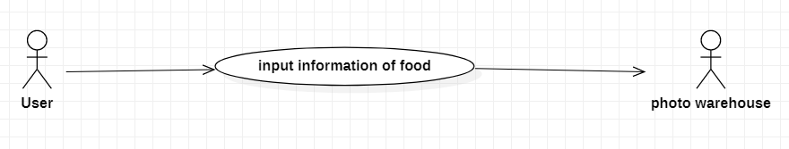

|  |  |
| --- | --- |
| **input information of food** | |
| Actors | System |
| Description | Provide and synchronize images in the system and help improve user satisfaction, help users distinguish foods |
| Data | photos that the system supports |
| Respone | increase the accessibility of users and help the system become complete |
| Comments | the Images need regular updating and diversification of options |

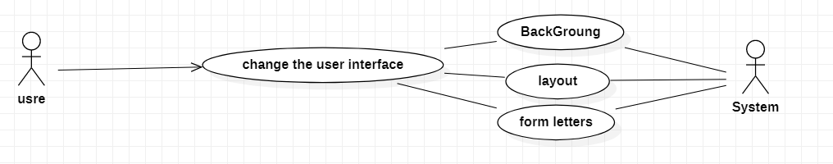

|  |  |
| --- | --- |
| **input information of food** | |
| Actors | System |
| Description | Creates diverse user options to drive downloads and optimize usage |
| Data | Pre-configured options in the app |
| Respone | Pre-configured options in the app |

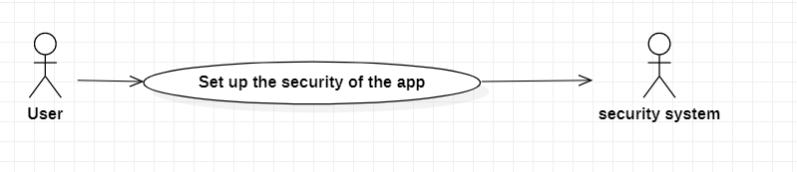

|  |  |
| --- | --- |
| **Set up the security of the app** | |
| Actors | system and user information |
| Description | it is an essential element of every app and helps increase the app's security to drive downloads |
| Data | passwords and login names of different users |
| Stimulus | user privacy |
| Respone | The result is to ensure the privacy of each user. If there is use of many different users and then need a password and username to use. |
| Comments | Recommended to use |
|  |  |

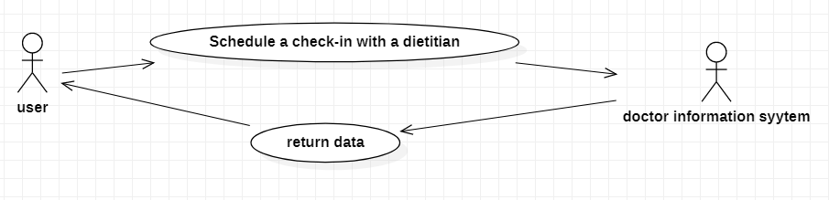

|  |  |
| --- | --- |
| **Schedule a check-in with a dietian** | |
| Actors | System, user , nutritionist |
| Description | As part of the system that helps to systematically maintain the food chain, improve the efficiency of health monitoring and understand user health. |
| Data | user information on contact information |
| Stimulus | is the give the a khuyên mang tính thuyết phục |
| Respone | The results help to improve nutritional cycle age and monitor health status |
| Comments | It is necessary to set up this feature to contribute to the correct implementation of the original purpose |