

Department of Computer Science

CSC 4103: Operating Systems
Prof. Aisha Ali-Gombe

Programming Assignment # 3: A Simple Filesystem
Due Date: on or before December 5th @ Class Time

Work with your PA Buddy
Submission after December 5th will not be accepted

The Mission

In this assignment you will implement a simple filesystem from scratch in a file name filesystem.c. I will provide the implementation of a persistent "raw" software disk (available in softwaredisk.h and softwaredisk.c), which supports reads and writes of fixed-sized blocks (numbered 0..software_disk_size() - 1). This component simulates a hard drive.

Your goal is to wrap a higher-level filesystem interface around the software disk implementation. It is your responsibility to implement –
- an API for reading, writing…. and all other file operations (see below in filesystem.h)
- track files that are created
- allocate blocks for file allocation
- the directory structure
- file data

Requirements:

- Obviously you must store all data persistently on the software disk and use only the software disk API. You may not use standard filesystem operations like fopen(), etc. at all—you are implementing the filesystem from scratch, above a block-oriented storage device.
- You must provide a file system initialization program called formatfs.c which initializes your file system
- You must use a bitmap for tracking free disk blocks and inodes.
- Your filesystem will provide a flat namespace. There is only a single root directory and no subdirectories.
- You must use an inode-based block allocation strategy for files. Use 13 16-bit direct block numbers and a single indirect block number in the inode. You do not have to implement double and triple indirect blocks in the inode.
- Your filesystem must gracefully handle out of space errors (e.g., operations which overflow the capacity of the software disk) and set appropriate error conditions.
- Your filesystem must support filenames of at least 256 characters in length. These are nul-terminated strings composed of printable ASCII characters.
- Your implementation does not have to be thread-safe for full credit, but it's not a bad idea to make it thread-safe if you have time—it's good experience. To see how to use the pthreads library to do this, examine the code for prioque.c, which you used in the last assignment.
- Pay very special attention to the error conditions outlined in the FSError definition below! For example, you must catch attempts to open a file that is already open, to delete a file that is currently open, etc.
- Your filesystem must provide the following filesystem interface. This is the interface expected by the sample applications—if your code deviates from this interface, it it is incorrect and applications will break:

filesystem.h:

#if ! defined(__FILESYSTEM_4103_H__)
#define __FILESYSTEM_4103_H__

// private
struct FileInternals;

// file type used by user code
typedef struct FileInternals* File;

// access mode for open_file()
typedef enum {
READ_ONLY, READ_WRITE
} FileMode;

// error codes set in global 'fserror' by filesystem functions
typedef enum {
FS_NONE,
FS_OUT_OF_SPACE, // the operation caused the software disk to fill up
FS_FILE_NOT_OPEN, // attempted read/write/close/etc. on file that isn't open
FS_FILE_OPEN, // file is already open. Concurrent opens are not
// supported and neither is deleting a file that is open.
FS_FILE_NOT_FOUND, // attempted open or delete of file that doesn’t exist
FS_FILE_READ_ONLY, // attempted write to file opened for READ_ONLY
FS_FILE_ALREADY_EXISTS, // attempted creation of file with existing name
FS_EXCEEDS_MAX_FILE_SIZE,// seek or write would exceed max file size
FS_ILLEGAL_FILENAME, // filename begins with a null character
FS_IO_ERROR // something really bad happened
} FSError;

// function prototypes for filesystem API

// open existing file with pathname 'name' and access mode 'mode'.
// Current file position is set to byte 0. Returns NULL on
// error. Always sets 'fserror' global.
File open_file(char *name, FileMode mode);

// create and open new file with pathname 'name' and (implied) access
// mode READ_WRITE. Current file position is set to byte 0. Returns
// NULL on error. Always sets 'fserror' global.
File create_file(char *name);

// close 'file'. Always sets 'fserror' global.
void close_file(File file);

// read at most 'numbytes' of data from 'file' into 'buf', starting at the
// current file position. Returns the number of bytes read. If end of file is reached,
// then a return value less than 'numbytes' signals this condition. Always sets
// 'fserror' global.
unsigned long read_file(File file, void *buf, unsigned long numbytes);

// write 'numbytes' of data from 'buf' into 'file' at the current file
// position. Returns the number of bytes written. On an out of space
// error, the return value may be less than 'numbytes'. Always sets
// 'fserror' global.
unsigned long write_file(File file, void *buf, unsigned long numbytes);

// sets current position in file to 'bytepos', always relative to the
// beginning of file. Seeks past the current end of file should
// extend the file. Returns 1 on success and 0 on failure. Always
// sets 'fserror' global.
int seek_file(File file, unsigned long bytepos);

// returns the current length of the file in bytes. Always sets
// 'fserror' global.
unsigned long file_length(File file);

// deletes the file named 'name', if it exists. Returns 1 on success,
// 0 on failure. Always sets 'fserror' global.
int delete_file(char *name);

// determines if a file with 'name' exists and returns 1 if it exists, otherwise 0.
// Always sets 'fserror' global.
int file_exists(char *name);

// describe current filesystem error code by printing a descriptive
// message to standard error.
void fs_print_error(void);

// extra function to make sure structure alignment, data structure
// sizes, etc. on target platform are correct. Should return 1 on
// success, 0 on failure. This should be used in disk initialization
// to ensure that everything will work correctly.
int check_structure_alignment(void);

// filesystem error code set (set by each filesystem function)
extern FSError fserror;

#endif

What Do I Get?

An implementation of the software disk is provided. Do not implement this yourself and do not make modifications. The code for softwaredisk.h, softwaredisk.c, filesystem.h and testfs0.c and testfs4a.c (as test cases) are available from Moodle. The program exercisesoftwaredisk.c (available in the same place) tests the functionality of the software disk and illiustrates how to use the software disk API.

The software disk uses the following API, defined in:

softwaredisk.h:

#if ! defined(SOFTWARE_DISK_BLOCK_SIZE)
#define SOFTWARE_DISK_BLOCK_SIZE 4096

// software disk error codes
typedef enum {
SD_NONE,
SD_NOT_INIT, // software disk not initialized
SD_ILLEGAL_BLOCK_NUMBER, // specified block number exceeds size of software disk
SD_INTERNAL_ERROR // the software disk has failed
} SDError;

// function prototypes for software disk API

// initializes the software disk to all zeros, destroying any existing
// data. Returns 1 on success, otherwise 0. Always sets global 'sderror'.
int init_software_disk();

// returns the size of the SoftwareDisk in multiples of SOFTWARE_DISK_BLOCK_SIZE
unsigned long software_disk_size();

// writes a block of data from 'buf' at location 'blocknum'. Blocks are numbered
// from 0. The buffer 'buf' must be of size SOFTWARE_DISK_BLOCK_SIZE. Returns 1
// on success or 0 on failure. Always sets global 'sderror'.
int write_sd_block(void *buf, unsigned long blocknum);

// reads a block of data into 'buf' from location 'blocknum'. Blocks are numbered
// from 0. The buffer 'buf' must be of size SOFTWARE_DISK_BLOCK_SIZE. Returns 1
// on success or 0 on failure. Always sets global 'sderror'.
int read_sd_block(void *buf, unsigned long blocknum);

// describe current software disk error code by printing a descriptive message to
// standard error.
void sd_print_error(void);

// software disk error code set (set by each software disk function).
extern SDError sderror;
#endif

Using the API

Compile the test cases (to perform file operations like reading, writing, deleting etc) like this:

$ gcc -g -o testfs0 testfs0.c filesystem.c softwaredisk.c

Filesystem Implementation Cheatsheet

Your software disk has 4096 block, each block has 4096 bytes. See screenshot below for block apportionment in the filesystem.c implementation.

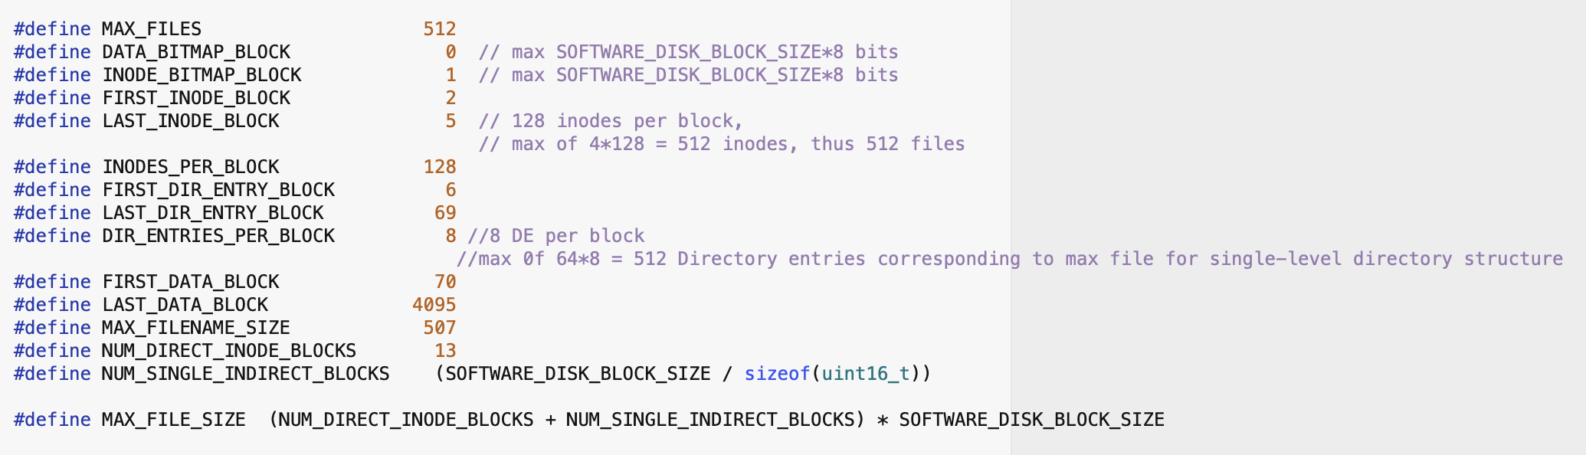

Submission/Grading

In addition to your implementation in (filesystem.h, filesystem.c, formatfs.c), you must submit a concise, typed design document that describes the physical layout of your filesystem on the software disk. This should include a description of which blocks are used to track metadata such as the bitmaps, inodes, et al, how the directory structure is maintained, etc. You should also document any implementation-specific limits (such as limits on the size of filenames, maximum number of files, etc.). Please name your design document filesystem_design.pdf and include it with your submission to classes.csc.lsu.edu.

A good grade on this assignment depends on a proper design for your filesystem, your filesystem working flawlessly, and on high-quality, well-designed code.

