**Criminal Evidence Management System**

The project attached to this book is called the Criminal Evidence Management System. It is an application used to manage police criminal evidence for various cases. It is a proof-of-concept application inspired by the CSI series, so it cannot be used as a real application.

The following describes what this little project provides.

1. A user should have a secured account to access the application. The following are the types of accounts

– **VIEWER**: The user can query the evidence database to retrieve information.

– **DETECTIVE**: The user that can submit evidence, retrieve it for analysis, or return it to the evidence locker.

– **ADMIN**: An account with special privileges that can manage other users’ activities on the evidence system.

2. Evidence has to be linked to a case

3. A case usually has multiple evidence items linked to it

4. Every time a piece of evidence is submitted, retrieved for analysis or returned, a track entry is created that contains the detective accessing the evidence and the reason for him/her to do so

5. A detective can be a lead on a case investigation, but can also be an investigator for another case. Thus, a detective can work on multiple cases at once

6. A detective can have different ranks

– TRAINEE: No access to the evidence system

– JUNIOR: Read access to the evidence system

– SENIOR: Write access to the evidence system

– INSPECTOR: Write access to the evidence system and read access to personnel system.

– CHIEF_INSPECTOR: Write access to the evidence system and personnel system.

7. Cases can be classified based on their severity as follows.

– INFRACTION: The smallest of crimes, punishable with community service and/or a fine.

– MISDEMEANOR: A crime punishable with incarceration for one year or less.

– FELONY: The most serious crimes.

8. Cases can be classified by the investigation status as follows.

– SUBMITTED: Recently introduced into the system.

– UNDER_INVESTIGATION: The evidence is being collected; the investigation is in process.

– IN_COURT: All evidence is submitted, conclusions have been drawn, people have been arrested, and now the lawyers are doing their thing in court.

– CLOSED: All evidence is archived; the case has been solved; people have been sentenced.

– DISMISSED: An invalid case that required no investigation.

– COLD: A case that was in UNDER_INVESTIGATION state for more than 10 years.

9. When a case is closed, all evidence is archived

10. Evidence is stored in different storage locations

The core classes of the application and the relationship between them are depicted in Figure

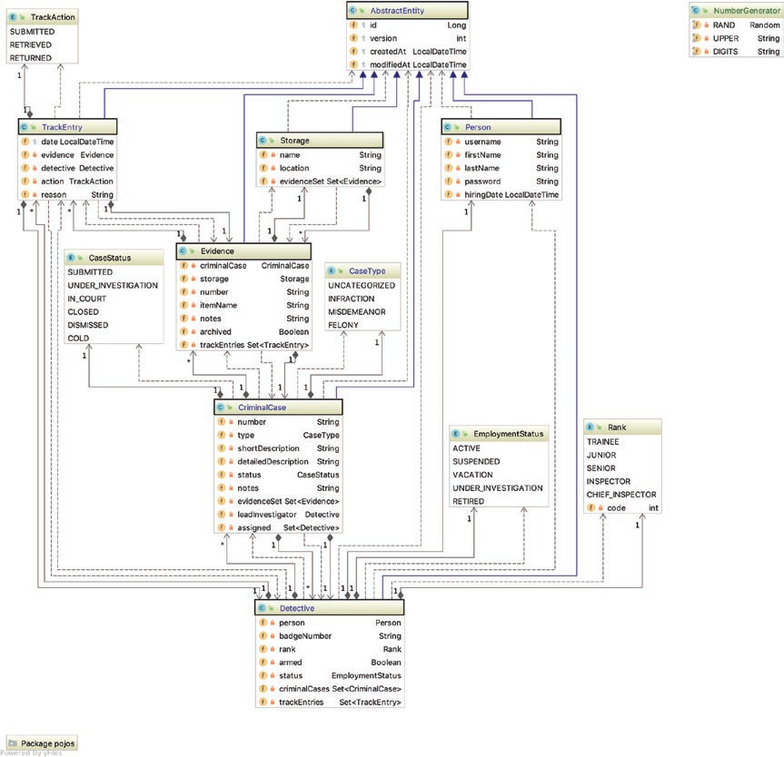

The classes that are wrapped in dark rectangles in Figure are the entity classes and they map to tables in the database. The entities have common fields used by hibernate to identify uniquely each entity instance (id) and fields used to audit each entity instance (createdAt and modifiedAt) and keep track of how many times an entity was modified (version). These fields have been grouped in the AbstractEntity class to avoid having duplicated code. Other classes are enumerations used to define different types of objects and other utility classes (for conversion and serialization)

The database structure and the foreign keys are depicted in Figure

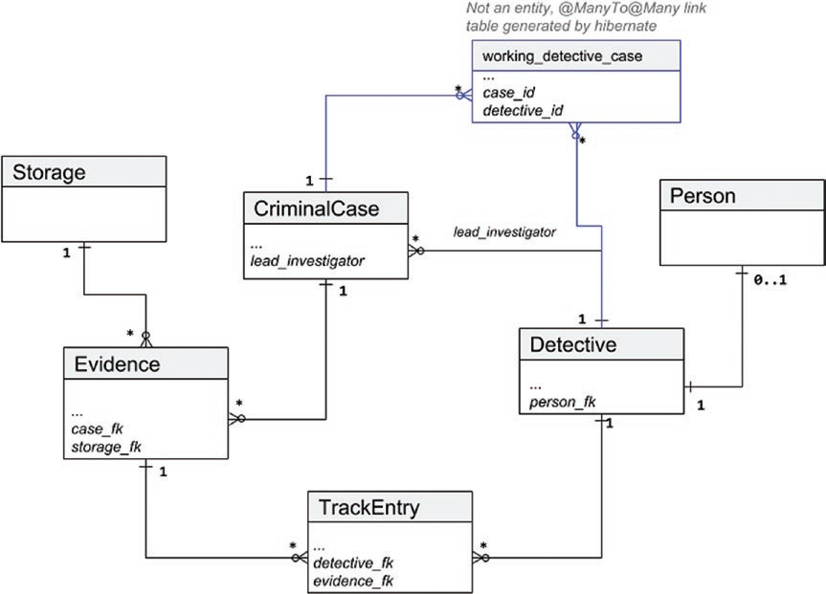

The Criminal Evidence Management System was designed with the multitier architecture in mind. The abstract internal layer structure is depicted in Figure

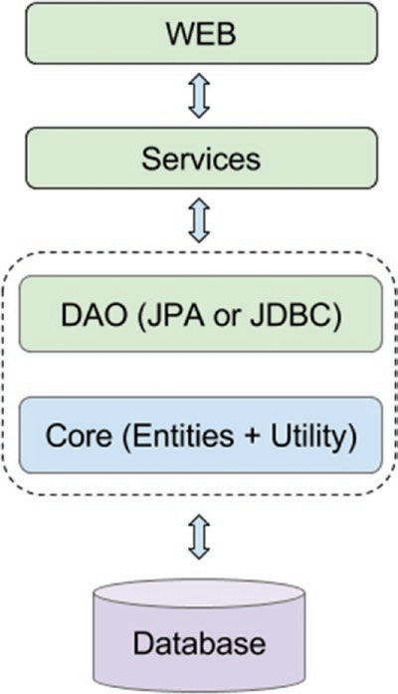

Questions:

1. Build endpoints CRUD for a Criminal Case Entity
2. Build endpoints CRUD for an Evidence Entity
3. Build endpoints CRUD for a Detective Entity
4. Build an endpoint to list of criminal cases with the specified case status (ONLY use for usernames with Rank: CHIEF_INSPECTOR)
5. Build an endpoint to list of evidences of the specified criminal number (ONLY use for usernames with Rank: SENIOR)
6. Build an endpoint to list of criminal cases of the specified username (ONLY use for usernames with Rank: INSPECTOR)

Note: Write unit tests for all endpoints