**HOMEWORK** : 17/3/2025

**NAME** : Võ Thị Thúy Sang - 22IT248

**CLASS** : Lập trình web nâng cao (1)

**Lap1: SQL Server Database Connection in C# Using ADO.NET**

**Bài 1:**

1. using System.Data;
2. using System.Data.SqlClient;
3. namespace ConnectToSQL
4. {
5. public partial class Form1 : Form
6. {
7. public Form1()
8. {
9. InitializeComponent();
10. }
11. SqlConnection conn = null;
12. string strconn = "Data Source=THUYSANG\\MSSQLSERVER02;Initial Catalog=STUDENT_MANAGEMENT;Integrated Security=True;Connect Timeout=30;Encrypt=True;Trust Server Certificate=True";
13. private void btnConnect_Click(object sender, EventArgs e)
14. {
15. try
16. {
17. conn = new SqlConnection(strconn);
18. conn.Open();
19. MessageBox.Show("Successful connection!");
20. }
21. catch (Exception ex)
22. {
23. MessageBox.Show("Failed to connect to server \n" + ex.Message);
24. }
25. }
26. private void btnDisconnect_Click(object sender, EventArgs e)
27. {
28. if (conn != null && conn.State == ConnectionState.Open)
29. {
30. conn.Close();
31. MessageBox.Show("Successful Disconnection");
32. }
33. }
34. }
35. }

**Bài 2:**

1. using System.Data;
2. using System.Data.SqlClient;
3. namespace DataQuery
4. {
5. public partial class Form1 : Form
6. {
7. public Form1()
8. {
9. InitializeComponent();
10. }
11. string stringconn = "Data Source=THUYSANG\\MSSQLSERVER02;Initial Catalog=STUDENT_MANAGEMENT;Integrated Security=True";
12. SqlConnection conn = null;
13. private void btnCalculate_Click_Click(object sender, EventArgs e)
14. {
15. if (conn == null)
16. conn = new SqlConnection(stringconn);
17. if (conn.State == ConnectionState.Closed)
18. conn.Open();
19. SqlCommand command = new SqlCommand($"Select count(*) from STUDENT Where ClassID = '{txtClassID.Text}'", conn);
20. //Execute the sql command to return a value
21. int result = (int)command.ExecuteScalar();
22. txtNumber.Text = result.ToString();
23. conn.Close();
24. }
25. }
26. }

**Bài 3:**

1. using System.Data;
2. using System.Data.SqlClient;
3. namespace Data_View
4. {
5. public partial class Form1 : Form
6. {
7. public Form1()
8. {
9. InitializeComponent();
10. }
11. string stringconn = "Data Source=THUYSANG\\MSSQLSERVER02;Initial Catalog=STUDENT_MANAGEMENT;Integrated Security=True";
12. SqlConnection conn = null;
13. private void label1_Click(object sender, EventArgs e)
14. {
15. }
16. private void btnViewClass_Click(object sender, EventArgs e)
17. {
18. txtClassID.Text = "";
19. txtClassName.Text = "";
20. txtYear.Text = "";
21. if (conn == null)
22. conn = new SqlConnection(stringconn);
23. if (conn.State == ConnectionState.Closed)
24. conn.Open();
25. SqlCommand command = new SqlCommand();
26. command.CommandType = CommandType.Text;
27. command.CommandText = $"select * from Class where ClassID='{txtEnterClassID.Text}'";
28. command.Connection = conn;
29. SqlDataReader reader = command.ExecuteReader();
30. if (reader.Read())
31. {
32. txtClassID.Text = reader.GetString(0);
33. txtClassName.Text = reader.GetString(1);
34. txtYear.Text = reader.GetInt32(2).ToString();
35. }
36. conn.Close();
37. }
38. private void btnViewStudent_Click(object sender, EventArgs e)
39. {
40. lsvStudent.Items.Clear();
41. if (conn == null) conn = new SqlConnection(stringconn);
42. if (conn.State == ConnectionState.Closed) conn.Open();
43. SqlCommand command = new SqlCommand($"select * from Student where ClassID='{txtEnterClassID.Text}'", conn);
44. SqlDataReader reader = command.ExecuteReader();
45. while (reader.Read())
46. {
47. string studentID = reader.GetString(0);
48. string name = reader.GetString(1);
49. string classID = reader.GetString(2);
50. ListViewItem item = new ListViewItem(studentID);
51. item.SubItems.Add(name);
52. item.SubItems.Add(classID);
53. lsvStudent.Items.Add(item);
54. }
55. conn.Close();
56. }
57. private void lsvStudent_SelectedIndexChanged(object sender, EventArgs e)
58. {
59. }
60. }
61. }

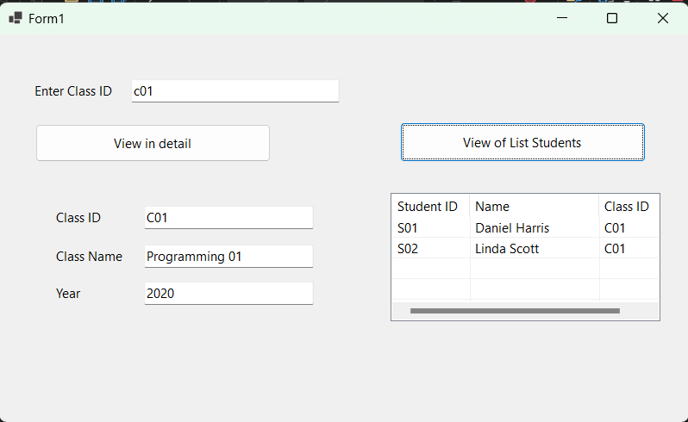

**Bài 4:**

1. using System.Data;
2. using System.Data.SqlClient;
3. namespace Data_List
4. {
5. public partial class Form1 : Form
6. {
7. public Form1()
8. {
9. InitializeComponent();
10. }
11. string stringconn = "Data Source=THUYSANG\\MSSQLSERVER02;Initial Catalog=STUDENT_MANAGEMENT;Integrated Security=True";
12. SqlConnection conn = null;
13. private void Form1_Load(object sender, EventArgs e)
14. {
15. if (conn == null) conn = new SqlConnection(stringconn);
16. if (conn.State == ConnectionState.Closed) conn.Open();
17. SqlCommand command = new SqlCommand("Select * from Class", conn);
18. // Execute SQL Command
19. lsbClass.ClearSelected();
20. SqlDataReader reader = command.ExecuteReader(); // Execute SQL Command
21. while (reader.Read())
22. {
23. string classID = reader.GetString(0);
24. string className = reader.GetString(1);
25. int year = reader.GetInt32(2);
26. string line = classID + "-" + className + "-" + year.ToString();
27. lsbClass.Items.Add(line);
28. }
29. conn.Close();
30. }
31. private void lbsClass_SelectedIndexChanged(object sender, EventArgs e)
32. {
33. lsvStudent.Items.Clear();
34. if (lsbClass.SelectedIndex == -1) return;
35. string line = lsbClass.SelectedItem.ToString();
36. string[] array = line.Split('-');
37. string classID = array[0];
38. if (conn == null) conn = new SqlConnection(stringconn);
39. if (conn.State == ConnectionState.Closed) conn.Open();
40. SqlCommand command = new SqlCommand($"Select * from Student where = ClassID = '{classID}'", conn);
41. SqlDataReader reader = command.ExecuteReader();
42. while (reader.Read())
43. {
44. string studentID = reader.GetString(0);
45. string name = reader.GetString(1);
46. string classIDRow = reader.GetString(2);
47. ListViewItem item = lsvStudent.Items.Add(studentID);
48. item.SubItems.Add(name);
49. item.SubItems.Add(classIDRow);
50. lsvStudent.Items.Add(item);
51. }
52. conn.Close();
53. }
54. }
55. }

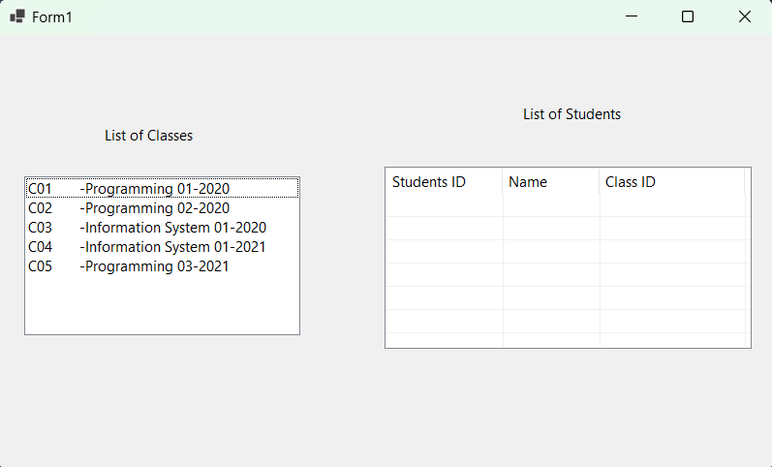

**Bài 5:**

1. using System.Data;
2. using System.Data.SqlClient;
3. namespace Data_StudentInfor
4. {
5. public partial class Form1 : Form
6. {
7. public Form1()
8. {
9. InitializeComponent();
10. }
11. SqlConnection conn;
12. string stringconn = "Data Source=THUYSANG\\MSSQLSERVER02;Initial Catalog=STUDENT_MANAGEMENT;Integrated Security=True;";
13. private void Form1_Load(object sender, EventArgs e)
14. {
15. Data_StudentInfor();
16. }
17. private void Data_StudentInfor()
18. {
19. lvwStudent.Items.Clear();
20. if (conn == null) conn = new SqlConnection(stringconn);
21. if (conn.State == ConnectionState.Closed) conn.Open();
22. SqlCommand command = new SqlCommand("Select * from Student", conn);
23. SqlDataReader reader = command.ExecuteReader();
24. while (reader.Read())
25. {
26. string masv = reader.GetString(0);
27. string hoten = reader.GetString(1);
28. string malop = reader.GetString(2);
29. ListViewItem item = lvwStudent.Items.Add(masv);
30. item.SubItems.Add(hoten);
31. item.SubItems.Add(malop);
32. }
33. conn.Close();
34. }
35. int result = -1;
36. private void btnInsert_Click(object sender, EventArgs e)
37. {
38. if (conn == null) conn = new SqlConnection(stringconn);
39. if (conn.State == ConnectionState.Closed) conn.Open();
40. SqlCommand command = new SqlCommand();
41. command.CommandType = CommandType.Text;
42. command.Connection = conn;
43. command.CommandText = "insert into Student (StudentID, Name, ClassID)" +
44. "values (@StudentID, @Name, @ClassID)";
45. SqlParameter parameter1 = new SqlParameter("@StudentID", txtStudentID.Text);
46. command.Parameters.Add(parameter1);
47. SqlParameter parameter2 = new SqlParameter("@Name", txtName.Text);
48. command.Parameters.Add(parameter2);
49. SqlParameter parameter3 = new SqlParameter("ClassID", txtClassID.Text);
50. command.Parameters.Add(parameter3);
51. try
52. {
53. result = command.ExecuteNonQuery();
54. //using ExecuteNonQuery if SQL command-insert, update or delete
55. }
56. catch (Exception ex)
57. {
58. MessageBox.Show(ex.Message + "\nInsert a record failed!!!!!!");
59. }
60. if (result > 0)
61. {
62. Data_StudentInfor();
63. }
64. }
65. private void lvwStudent_SelectedIndexChanged(object sender, EventArgs e)
66. {
67. if (lvwStudent.SelectedItems.Count > 0)
68. {
69. txtStudentID.Text = lvwStudent.SelectedItems[0].SubItems[0].Text;
70. txtName.Text = lvwStudent.SelectedItems[0].SubItems[1].Text;
71. txtClassID.Text = lvwStudent.SelectedItems[0].SubItems[2].Text;
72. }
73. }
74. private void btnUpdate_Click(object sender, EventArgs e)
75. {
76. if (conn == null) conn = new SqlConnection(stringconn);
77. if (conn.State == ConnectionState.Closed) conn.Open();
78. SqlCommand command = new SqlCommand($"update Student set Name = '{txtName.Text}', ClassID='{txtClassID.Text}' where StudentID = '{txtStudentID.Text}'", conn);
79. try
80. {
81. result = command.ExecuteNonQuery();
82. }
83. catch (Exception ex)
84. {
85. MessageBox.Show(ex.Message + "\n Update failed!!!!!");
86. }
87. if (result > 0)
88. {
89. Data_StudentInfor();
90. }
91. }
92. private void btnDelete_Click(object sender, EventArgs e)
93. {
94. if (conn == null) conn = new SqlConnection(stringconn);
95. if (conn.State == ConnectionState.Closed) conn.Open();
96. SqlCommand command = new SqlCommand($"delede from Student where StudentID = '{txtStudentID.Text}'", conn);
98. try
99. {
100. result = command.ExecuteNonQuery();
101. }
102. catch (Exception ex)
103. {
104. MessageBox.Show(ex.Message + "\n Update failed!!!!!");
105. }
106. if (result > 0)
107. {
108. Data_StudentInfor();
109. txtStudentID.Text = "";
110. txtName.Text = "";
111. txtClassID.Text = "";
112. }
113. }
114. }
115. }

