**Flashing Large Mammals**

Does white LED flashes in camera traps  
affect detection rates of target species?

**Torgeir Holmgard Valle**



Thesis submitted for the degree of  
Master in Bioscience: Ecology and Evolution  
60 Credits

Department of Biosciences  
Faculty of Mathematics and Natural Sciences

UNIVERSITY OF OSLO  
April 2021

**Flashing Large Mammals**

Does white LED flashes in camera traps  
affect detection rates of target species?

**Torgeir Holmgard Valle**

## Abstract

Camera trapping is a rapidly improving survey method that is largely targeted towards large mammals, and especially large carnivores. Nonetheless, the cameras are triggered by all large and medium-sized animal species in the area, and thus gathers valuable data on the whole ecological community. White light flashes are sometimes utilized to get more detailed photos allowing for capture-recapture based population estimates for naturally marked species, like the Eurasian lynx (*Lynx lynx*).

However, the white light could function as a stressor or attractant for different species, which would affect density estimates. There are evidence of behavioural change in several mammal species, when exposed to a white flash, but quantifications on the detection rate of species are still lacking.

Therefore, I investigated whether introducing an additional white LED camera trap (CT) at established CT sites affected the detection rates of the most common wild mammal species in the area.

I predicted that the detection rate of nocturnal and crepuscular species would be altered as a response to the white light stimuli, and that the extent of the effect would depend on the species’ visual sensitivity.

I found a minimal effect of white LED, suggesting short term avoidance, which did not lead to longer term avoidance of the sites.

An explanation could be...

*Keywords:* camera trap; camera trap shyness; monitoring bias; night-time photography; diel activity; density estimation;

# Introduction

Estimating the number of animals is central in population ecology, and census methods have always been under development in order to get accurate, reliable ways of conducting surveys (Morellet et al. 2011). Direct observations are prone to undercounting, as many species are elusive and dwindling concentration by observers over time. Telemetry studies can provide very detailed knowledge, but studies are usually limited in extent, as they are costly and invasive in nature (Ikeda et al. 2016). Distribution of medium sized and large mammals are therefore often based on proxy data such as harvest statistics, but such methods tend to be quite unreliable due to variable hunter effort. In particular for large carnivores, harvest may also be low or absent for periods where management targets are not obtained (Morellet et al. 2011).

In recent years, automated camera traps (CT) have been developing fast, and become quite affordable (Burton et al. 2015). CTs offer a consistent, standardised sampling method, and provide information about the presence, demography and behaviour of multiple species with a high temporal resolution (Rovero et al. 2016) CTs are traditionally used to study a single species in a specific study site, but they are increasingly seen as a tool for investigating multiple sympatric species, their interactions and diel patterns (Ikeda et al. 2016). The underlying assumption is that CTs are unselective in which species they capture, or that biases in capture rates can be corrected for by using covariates in a statistical framework (Rovero et al. 2013).

In general, terrestrial mammalian diel patterns can be categorized into diurnal, nocturnal, crepuscular (active at twilight), and cathemeral (active throughout the day) (Ikeda et al. 2016). However, even within species, these patterns vary along with seasons, geographic distribution and human disturbance (Kamler, Jedrzejewska, and Jedrzejewski 2007; Gaynor et al. 2018). Lacking quantitative data on the activity patterns of sympatric mammal species, camera traps provide a perfe studies(Ikeda et al. 2016).

Camera traps have been considered non-invasive, but can affect animal behaviour in several ways (Meek et al. 2014), for example through detecting sounds from triggering camera, scents from human operators, the unfamiliar shape of the camera itself or the flash used in night-time (Meek et al. 2014; Burton et al. 2015; Beddari 2019).

During night time, CTs normally use infra-red (IR) light from an array of light-emitting diodes (LED) to photo capture animals, which is invisible to most human eyes, but has been shown to be visible to several other mammals (Meek et al. 2014, 2016). However, the lack of sharpness and detail from IR photos limit the information we can retrieve from them, as for example individual variation in coat patterns (e.g. tigers (*Panthera tigris*), jaguars (*Panthera onca*) and lynx) which can be used in capture-mark-recapture models to accurately estimate population numbers (Meek et al. 2014; Rovero et al. 2013).

The need for more photographic detail has brought back interest in the original white xenon flashes, as well as white LED flashes (Rovero et al. 2013). Xenon provides the sharpest photos due to a more powerful light (Rovero et al. 2013), but has the disadvantage of requiring long cool downs after each photo (Henrich et al. 2020). The white light could also increase the chance of causing flash blindness in the passing animal (Dryja et al. 2005).

Naturally, white light is highly visible to all land dwelling mammals, and can therefore increase the number of CT aware animals (Glen et al. 2013). That could be detrimental, as studies using indices and capture-mark-recapture estimators must avoid altering animal behaviour during or between monitoring sessions, not to affect their detectability (Meek et al. 2014). Therefore, there is a need to determine which species are influenced, and to what extent their detection rates are altered in comparison to IR flash CTs. A CT’s flash is used whenever natural light gets scarce. The darker it is, the stronger the white flash stimulus will be (because of dark habituated eyes). Thus, white and IR flash CTs should in theory only differ in effect during night, and animal responses will depend on the species activity patterns (see below).

White light affects all photoreceptors in an animals retina (Dryja et al. 2005), whereas IR flash only would affect those that are sensitive to IR wavelengths. A white flash can therefore increase the total number of CT aware animals. The white light could be associated to human presence in the form of artificial light at night, and could trigger a response depending on the animal’s relationship to humans. Scavengers could be attracted to the light in search for garbage (food). High conflict species, like the grey wolf (*Canis lupus*), could be scared off, as high hunting pressure could select for shy and elusive individuals.

However, a quantification of the effects white flash CTs have on species detectability is still lacking, to the best of my knowledge.

As the saying goes, eyes are the window to the soul. It turns out this statement also holds for animals, as nocturnal vertebrates have different eye morphology than diurnal ones (Schmitz and Motani 2010). Most mammals have less variation in eye morphology than other amniotes (birds and reptiles) (Schmitz and Motani 2010; Hall, Kamilar, and Christopher Kirk 2012), but they have other adaptations to increase light sensitivity(Ollivier et al. 2004; Solovei et al. 2009).

Eye characteristics governing nocturnal behaviour could also affect a species’ response to the white flash. More light sensitive eyes will react stronger to the white flash, especially considering that rod cells (low-light sensitivity) take longer to depolarize than cone cells (visual acuity and color distinction) (Dryja et al. 2005), and thus nocturnal mammals could experience glare or flash blindness. Flash blindness can cause spatial disorientation or loss of situation awareness in humans (Nakagawara and Montgomery 2001), but as most mammals rely less on optical senses than humans, they might not react as strongly.

In this study, I will quantify how the usage of white LED flash affects the detection rate of the most common large mammal species in an area in Southeastern Norway. White LED CTs have similar recovery speeds to that of regular IR CTs, as both utilize LED flashes, which makes them well fit for meaningful comparison. A subgoal is to quantify the species’ activity patterns, providing data on nine sympatric mammalian species at high northern latitudes, and how their diel patters change along the seasons. I have restricted the analysis to all wild species observed at least 50 independent times during my survey, which totaled nine species. There were three cervids (roe deer (*Capreolus capreolus*), moose (*Alces alces*) and red deer (*Cervus elaphus*)), four carnivores, of which two were mustelids (badger (*Meles meles*), European pine marten (*Martes martes*)), one was canid (red fox (*Vulpes vulpes*)), one was felid (lynx), and two were members of the clade Glires; one rodent (red squirrel (*Sqiurus vulgaris*)), and one lagomorph (mountain hare (*Lepus timidus*)). The species will be grouped by taxonomic relationships in results and discussion, assuming closely related species to have similar sensory anatomy and therefore similar experiences of being exposed to a white flash during night time. Squirrels and hares are more distantly related than the two other groupings I’ve presented, and as such should be expected to have larger differences in their sensory anatomy. Relative visual acuity is correlated with visual importance, and has been used in previous studies as a way to compare animals of disparate size (Hall, Kamilar, and Christopher Kirk 2012). I will use data from the supplementary material of Hall et al. (2012) to discuss the relevance visual acuity can have on mammals reaction to white flashes.

I predict usage of white LED flash will alter the detection rate of nocturnal and crepuscular species.

# Method and materials

## Study area

The study area (59.36-60.45° N, 9.31-11.13° E) extends over much of the southeastern parts of Norway in municipalities Flå, Krødsherad, Sigdal, Ringerike, Modum, Hole, Lier, Øvre Eiker, Asker, Oslo, Enebakk, Indre Østfold, Våler, Råde, Moss, Frogn and Vestby in Oslo and Viken counties. The climate has a continental character due to rain shadows of the mountain ridges from the west.

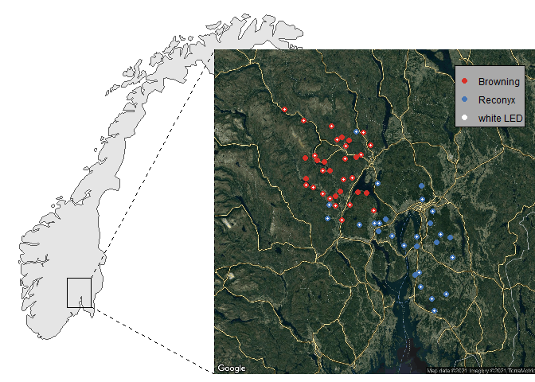

Figure 1: Map of study area 60 sites in Southeastern Norway were included in the survey. Point colouration represents camera brand, and white dots represent sites that had periods with an additional white LED camera trap.

The mean annual temperatures ranges from 2-6 , precipitation lies between 700-1500mm and growing season length lies between 170-190 days (Moen 1999). Topography is predominantly flat towards the south, and more rugged and elevated towards the north. The landscape is a mosaic of forest and agricultural areas, divided with a wide network of gravel roads. The area is situated in the southern boreal and boreonemoral zones. Norway spruce (*Picea abies*) and Scots pine (*Pinus sylvestris*) make up the dominating boreal coniferous forests, with frequent presence of silver birch (*Betula pendula*) and downy birch (*Betula pubescens*), then aspen (*Populous tremula*), alder (*Alnus incana*) and black alder (*Alnus glutinosa*).

## Study design

In northern areas, like Norway, counting animal tracks on snow has been a popular method (Linnell et al. 2007). Snow track counts have the benefit of visible tracks, and provide a somewhat accurate dating of the tracks to the last snowfall, when old tracks fade. However, lately the snow season in southern Norway has been variable, which makes snow track counts unpredictable and difficult to conduct at a consistent time of year (Odden 2015). Therefore, the Norwegian Institute of Nature Research (NINA) started with camera trap (CT) surveys in 2010, as an additional method to monitor family groups of Eurasian lynx (*Lynx lynx*) in southeastern Norway (Odden 2015). The surveys are integrated in a coordinated Scandinavian science project on lynx, called Scandlynx.

I was given access to CTs used in the Scandlynx project, and chose 60 sites to get a substantial amount of data. For logistical reasons, I chose the sites closest to Oslo which weren’t already equipped with white LED flashes. Instead, these CTs were equipped with infra-red flashes, and I will refer to them as the *IR CTs*.

The IR CTs had been installed on trees 1-3 m from wildlife, human or tractor paths, 20-160 cm above ground level, 100-3000 m from closest house (median 495 m). They were set up and handled by people from NINA, and in some places by local volunteers. The installation of the cameras did not follow a strict protocol, nor were their locations chosen randomly. The overall placement was systematic as decided by NINA. Then there was a deliberately-biased placement of the CTs put up in areas where the NINA employees or local volunteers deemed it most likely to photograph lynx, and hence, based on a combination of site accessibility and expectations of animal occurrence.

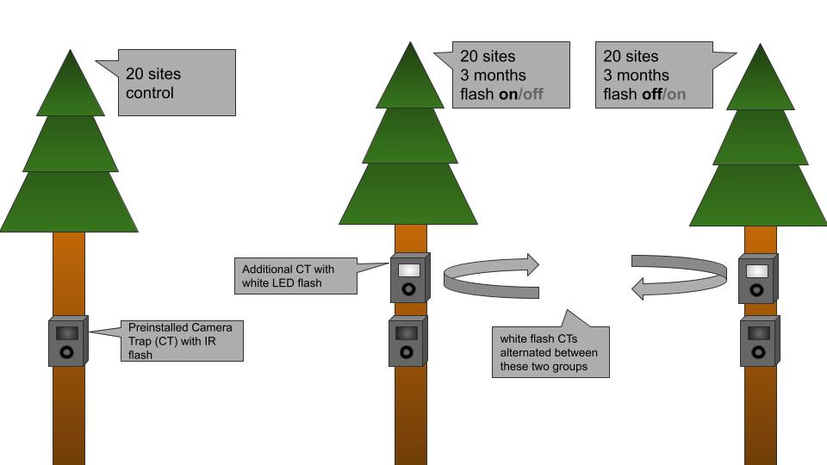

Figure 2: The experimental setup. 60 sites with preinstalled Infrared Camera Traps (IR CTs) that was divided into three groups, where the first group remained unchanged (control group), and the two other alternated on having additional white LED CTs present or not (treatment groups).

I divided the sites randomly into three groups of 20 sites. The first group remained unchanged as a control, and the other two groups (hereby referred to as the *treatment groups*) were equipped with an additional white LED camera (hereby referred to as the *white LED CTs*) in alternating 3 month-periods, as illustrated in figure[fig:exp_set].

Periods when an additional white LED CT was present (and operational), I will refer to as *white LED periods*. Periods when the white LED was absent (or inactive), I will refer to as *IR periods*. All periods from the control group, I will refer to as *control periods*. Note that control periods also are periods that only had IR CTs present, but they differ from the IR periods in that there never was a white LED present at these sites.

I up all white LED CTs above the IR CTs already in place (installation examples in figure 3.3). Using an electric drill, I mounted the CTs with metal cases that remained locked between visits. I used short logs to adjust the angle of the white LED CTs, aligning them to match the corresponding IR CT’s field of view. Vegetation obstructing the view of any camera was removed at setup, or when noticed during a later visitation (e.g. tall grass during summer). At one site the IR camera had been installed so far above ground level that I chose to position the white LED CT below the IR CT. The metal cases containing the white LED CTs remained at each site until the end of the survey. Note that the second treatment group had no additional metal case before the start of their first white LED period in May 2019.

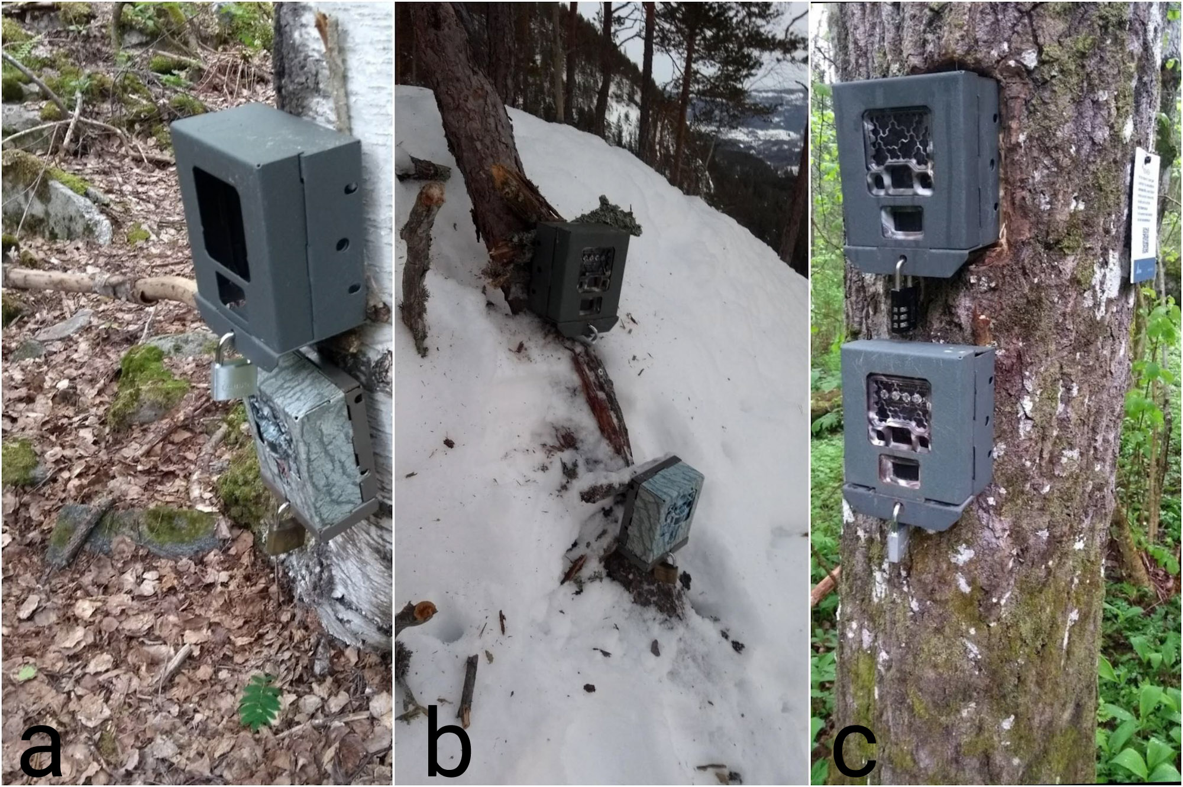

Figure 3: Examples of camera installations. The preinstalled IR cameras varied in the way they were set up. Lower cameras had Infra-Red flash, upper cameras had white LED flash. Additional CT boxes remained during IR periods, as seen in picture a.

I visited sites of the treatment groups at least once every three months in order to move the white LED cameras. For logistical reasons I visited sites of the control group less often. However, as all cameras were part of other, ongoing projects, they were occasionally visited by workers from NINA to retreive the Secure Digital memory cards (hereby SD Cards) for data. This was mostly the case for sites close to, and south of, Oslo, or rather, the cameras not normally operated by local volunteers.

## Data Collection

Five different models of Reconyx (address: 3828 Creekside Ln, Ste 2, Holmen, WI 54636, USA, www.reconyx.com) cameras were used, and one model of Browning (address: One Browning Place, Morgan, UT 84050, USA, www.browningtrailcameras.com). Model names and flash types are presented in table 3.1. As seen in the map in figure 3.1, there was a correlation between latitude and camera brand. Since all Reconyx models were from the same series, they were practically identical in all aspects except for the type of flash. Differences in features and settings between the Reconyx an the Browning CTs are presented in table 3.2. For my analyses, I assumed all IR CTs to be practically identical.

Cameras were operating 24 hours per day. All were set to take photos as quickly as possible with the *rapidfire* and *no delay* settings. The two brands differed slightly in their trigger recovery speed, as shown in table 3.2. However, the difference was not large enough to affect the results. More important for the result would be differences in detection area due to my placement of the white LED CTs. Differences in horizontal angle between IR and white LED CTs could cause the white LED to trigger first, and sometimes scare the passing animal away before entering the IR CT’s field of view. Browning CTs had a slightly wider detection angle than the Reconyx CTs, which could be beneficial in minimizing the times a white LED was triggered first. Both brands had passive infrared (PIR) motion detectors[1] with ranges that far exceeded the expected travelling route. The largest functional difference between the two brands was in the number of photos taken per trigger. While Reconyx CTs were set to take 3 photos per trigger, the Browning CTs were set to 8 photos per trigger. In turn, Browning CTs tended to fill their memory cards faster in areas with sheep or cattle, and due to triggering by vegetation. Consequently, they tended to have less active days than the Reconyx, as CTs stop taking pictures when their memory cards are full. Adding insult to injury, the Browning CTs did not have a time lapse function, confounding the number of active days. To approach the true number of active CT days, I assumed all Browning cameras to be functional every day, unless the camera was inactive when I visited it. In that case, I considered the camera inactive since the day of its last photo. On the other hand, Reconyx cameras were set to take one time lapse photo per day, making it easy to verify which days they were operational.

Camera models included in the survey.  
The Reconyx cameras were from the same series, and differed mainly in type of flash. The white LED CTs were also from the same series of Reconyx cameras.

|  |  |  |
| --- | --- | --- |
| Brand | Model name | Flash type |
| Browning | Spec Ops: Extreme | No-glow IR |
| Reconyx | HC500 Semi-Covert IR | Red-glow IR |
| (HyperFire | HC600 High-Output Covert IR | No-glow IR |
| Series) | PC800 Professional Semi-Covert IR | Red-glow IR |
|  | PC900 Professional Covert IR | No-glow IR |
|  | PC850 Professional White Flash LED | White LED |

Overview of camera feature and settings.  
One model of Browning and five models of Reconyx cameras were used (see Table 2.1). Camera specifications were gathered from product reviews (www.trailcampro.com).

|  |  |  |
| --- | --- | --- |
|  | Browning | Reconyx |
| Number of (IR) cameras | 33 | 27 |
| PIR Sensor Range | 24 m | 18 m |
| Trigger speed | 0.43 s | 0.28 s |
| Recovery speed | 0.8 s | 0.9 s |
| Photos per trigger | 8 | 3 |
| Detection angle | 45.5 | 42 |
| Field of view | 40.6 | 42 |
| Quiet period | No delay | No delay |
| Trigger interval | *rapidfire* | *rapidfire* |
| Time lapse | No | Yes |

## Data processing

All SD cards were delivered to NINA for data processing. The white LED CTs were considered as external flashes, and so, *only the pictures from the preinstalled IR CTs* (mounted underneath the white LED cameras) were sorted for species identification. First, a facial recognition algorithm (FRA) was used to identify species on all pictures. Second, a human sorter reviewed the software’s output, confirming all the correct identifications and rectifying the wrong ones. Consequently, the rate of correctly identified species has increased as the FRA sometimes detect animals that aren’t easily noticed by human sorters (John Odden personal communication). NINA’s goal is for the FRA to automatically and reliably delete pictures of humans, which has been requested from The Norwegian Data Protection Authority (Datatilsynet) (John Odden personal communication).

Third, NINA provided me with a data frame containing time stamps for every triggering of each IR CT, including all metadata from the CTs, coupled with predicted species (FRA output, with a confidence number), verified species (by human sorters), number of animals and distance from camera. Thus, if a moose ruminated in front of a camera for 30 minutes, the data frame would include an entry for each time the moose triggered the IR CT.

Finally, I extracted metadata from all pictures taken by the white LED CTs, and used that to define the duration of each white LED period.

Four times a site’s white LED CT stopped working (eg. due to full SD card or empty batteries) before the day I came to relocate it, which can be seen as the dark blue lines transitioning to light blue outside of a field work period in figure 3.4. Time lapse photos from the white LED CTs made dating of these stops in treatment accurate, keeping the transition to IR periods reliable. Whenever an IR CT stopped working during a white LED period, the rest of the period represented a data gap even if the white LED CT was functioning.[2] Nevertheless, inhabitant animals would still be exposed to the white flash up until the start of the following IR period. I never experienced that both the IR and white LED CTs of a site had stopped working at the same time.

In order to remove autocorrelation in the observations, I defined an event to be any sighting of a species that occurred more than 20 minutes after the previous sighting of the same species. Number of individuals was not taken into account. Ergo, I counted the number of independent times a species was observed, not the number of individuals. My predictor variable of interest was the three different types of periods, namely IR, white LED and control periods, and how they interacted with time since deployment (ie. time since the start of each period).

When modelling the detection rates, periods of similar lengths were required. White LED and IR periods were clearly defined, but control periods lacked a common definition for period splits, as I visited control sites less frequently than the treatment sites. Therefore, I divided the control sites into four periods of similar lengths to that of the IR- and white LED-periods (see figure 3.4).

Before the analysis, four sites were removed due to technical faults, or alike. One site was removed from the control group, as the CT turned out to have a white LED flash, contrary to what was logged in NINA’s documents. Three sites were removed from the treatment groups, because of large or frequent gaps in the data due to technical errors, and at one site, ineffective placement of the additional white LED camera.

## Statistical analysis

To test for effects of the white LED flash I used the R programming language (R Core Team 2021), in the RStudio IDE (RStudio Team 2020), adopting large parts of the tidyverse (Wickham et al. 2019) and the easystats (Makowski, Ben-Shachar, and Lüdecke 2020) frameworks along the way. Ensuring that all species were modelled equally (and reducing workload), I wrote code in an RMarkdown-file, using the R package knitr (Xie 2015), which iteratively (re)ran all processes on subsets for each species, and stored updated plots and tables to include in the final manuscript. Dates were handled using the R package lubridate (Spinu, Grolemund, and Wickham 2021), and for the plots of diel patterns, I defined winter as December - February, spring as March - May, and so on. Plots were produced using the R packages ggplot2 (Wickham 2016) and sjPlot (Lüdecke 2021).

### Exploring the effect of LED flash on detection rates

I used Generalised Linear Mixed Models (GLMM) with the glmer function from the R package lme4 (Bates et al. 2020). I fitted separate models for each species to avoid overly complicated models. Locations that had 0 observations of the modelled species were filtered out before the modelling, but for all locations that had observed the species, all periods were included. The dependent variable was count data (number of observations per day), and I therefore assumed the error term followed a Poisson distribution ().

Although there were differences between the Browning and Reconyx IR CTs, I didn’t include them as variables in my models, because they correlated with spatial and microhabitat-variables. Instead, I included location ID and week of the year as random effects to account for differences between camera sites and seasonal changes during the year of study. 95% Confidence Intervals (CIs) and p-values were computed using the Wald approximation.

The main term of interest was time since deployment (continuous) interacting with type of flash period (categorical; formula: n.obs time.deploy flash). For the sites that were equipped with an additional white LED camera, time since deployment starts from the day I visited the camera, and set up or took down the white LED. For the sites that started with an IR period, time since deployment started at the first day of field work, or when I visited them. The control group’s “day 0” of time since deployment were set at points reflecting the onset of field work each time, in order to obtain periods of similar lengths to that of the white LED-locations.

I trimmed the period lengths down to a reduced maximum length, based on the median length of the IR and white LED periods, to enhance meaningful comparison (Figure 2.5). Finally, due to large eigenvalues in the fixed effects, the model failed to converge, and an error message prompted me to rescale variables. Therefore I divided the time since deployment-variable by ten, which solved the convergence issue. Consequently, the time parameter estimates represent the change in detection rates per 10 days.

If there were any effect of the white LED, the IR period should show a regression to the norm, ie. counteracting the trend during the white LED periods. Thus, if the white LED had a negative slope along the time axis, the IR should have a positive slope. Further, the detection rate at the start of each period, should correspond somewhat to the detection rate at the end of the previous period. Still, that pattern could be skewed to some extent due to my visitation of each location at the start of all IR and white LED periods.

Using the R package performance (Lüdecke, Makowski, Waggoner, et al. 2021) I checked the model for overdispersion, zero-inflation and singularity, which held up in every model.

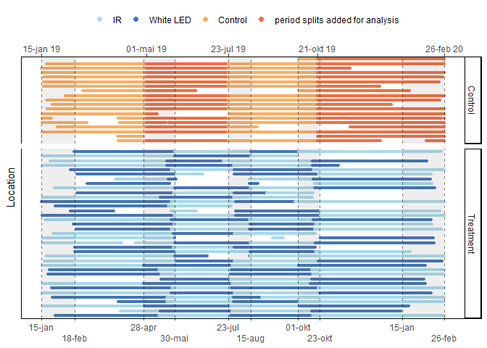

Figure 4: An overview of active camera days for each camera throughout the whole study period. Colours indicate the different periods for each site. White spaces indicate gaps where the IR CTs were inactive. Control camera periods were defined in similar lengths to that of the treatment group during analysis. As a result, the first day of control periods are often set at dates far from when I actually visited a site. Shaded areas represent my field work periods.

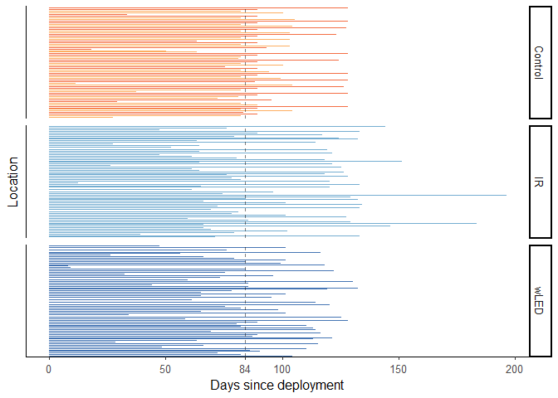

Figure 5: Period lengths for each camera. Vertical line represents the median IR period length, which was shorter than the median of the other groups. Data superseding the median were trimmed away for the GLMM.

### Equivalence test and Second Generation P-Values

I used the standard significance level of , and performed an equivalence test on my model outputs, using the function equivalence_test from the R package parameters (Lüdecke, Makowski, Ben-Shachar, et al. 2021). In an equivalence test, model parameters are tested against a Region of Practical Equivalence (ROPE) as opposed to merely one single mean value which is done in a standard Null Hypothesis Significance Test (NHST). Thus, rather than saying that a parameter’s effect was significantly different (or not) from 0, the *effect size* is also considered. If the parameter estimate and confidence interval (CI) lies outside the ROPE, the effect is significantly and practically different from 0, and the null hypothesis is rejected. However, if the CI is inside the ROPE, H0 is accepted, no matter if a NHST would have deemed it significantly different, because the difference is so small that there is practically no effect.

The percentage of the CI inside the ROPE is identical to the Second Generation P-Value (SGPV), which was proposed as a way to account for all the empirical data supporting null hypotheses.

Inside the function equivalence_test I used the Two One-Sided Tests (TOST) rule, where the CI is set to . In my case that gave a CI of 0.90.[3] For models from count data, the residual variance is often used to define the ROPE range. However, the description of the rope_range function from the package bayestestR (R-bayestestR) states this threshold as "rather experimental" and that the range is probably often similar to the default [-0.1, 0.1] of a standardized parameter. Hence, I used the default ROPE range which corresponds to a negligible effect size according to Cohen, 1988.

# Results

There were a total of active camera trapping days, which were unevenly distributed between the different period types (see figure 4.1b). Filtering out time lapses and photos of nothing, there were triggers of the CTs. Of the nine most common wild species, there were a total of 5 844 independent events. Figure 4.1a shows the total events of each species, and how the trimming of the data affected the count.

The type of CT flash had an overall minor effect on detection rates. The three least common species (lynx, pine marten and red deer) had the most variation explained by type of period and time since deployment (ie. highest marginal R2), as shown in table 4.1. Most of the explained variation in detection rate was due to seasonal changes and variation between the different camera sites captured in the random terms. For most species, the control periods (which never had white flashes) had a somewhat lower detection rate than the IR and white LED periods. Diel patterns were consistent between all three types of periods.

I here present detailed results of all the nine mammalian species included in my analyses, grouped by taxonomic relationship.

Each species is presented with a photo taken by a white LED CT, a figure showing seasonal varitation in activity across time of day, a plot of the marginal means of the fixed effects in the GLMM model, showing the detection rates of all three types of periods (Control, IR and white LED) along a time axis, and effect sizes in an equivalence test,

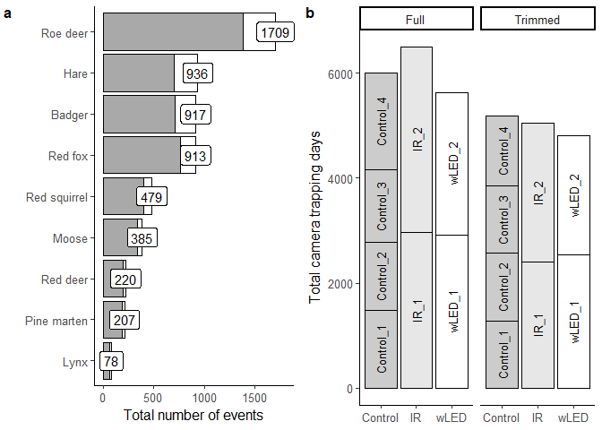

Figure 6: Trapping days and events, before and after trimming the data. a) Total number of events per species. Grey area marks the number of events that were included in the modelling. b) Total number of active camera days per period type. Trimming the data evened out the disproportions between period types.

Performance of species specific models  
Conditional R2 is a measure of how much variation was explained by both random and fixed effects, ranging from 0 to 1. Marginal R2 is for the fixed effects alone, and somewhere between 0.10 and 0.01 is considered good. Week of the year and site ID were used as random effects. The larger their standard deviations, the more variation in the data they can explain. Only sites that observed a species at least once were included in the model of said species.

|  |  |  |  |  |  |
| --- | --- | --- | --- | --- | --- |
|  | **Explained variation** |  | **Standard deviations of random effects** |  |  |
| Species | R2 (marg.) | R2 (cond.) | Week of the year | Site ID | N sites |
| Lynx | 0.060 | 0.18 | 0.52 | 0.68 | 22 |
| Pine marten | 0.052 | 0.22 | 0.72 | 0.74 | 42 |
| Red deer | 0.011 | 0.20 | 0.51 | 0.85 | 26 |
| Red squirrel | 0.010 | 0.30 | 0.81 | 1.03 | 37 |
| Badger | 0.006 | 0.39 | 1.27 | 1.01 | 48 |
| Moose | 0.004 | 0.19 | 0.73 | 0.63 | 41 |
| Roe deer | 0.003 | 0.38 | 0.56 | 1.29 | 47 |
| Mountain hare | 0.003 | 0.33 | 0.70 | 1.15 | 45 |
| Red fox | 0.001 | 0.19 | 0.27 | 0.87 | 53 |

Results of Poisson mixed effects models on detection rate of species at 56 different locations in southeastern Norway, with three different treatment levels interacting with time since deployment (Time); periods from control sites (Intercept), periods with only IR camera (IR), periods with an additional white LED camera (wLED). Second Generation P-Values (SGPV) is identical to the proportion of a parameter that is inside the ROPE in an equivalence test. Random effects were location ID and week of year.

|  |  |  |  |  |  |  |  |
| --- | --- | --- | --- | --- | --- | --- | --- |
| Species | Parameter | Coefficient | SE | 95% CI | z | p | SGPV |
| Roe deer | Intercept | -2.85 | 0.38 | (-3.58, -2.11) | -7.57 | .001 | 0.00 |
|  | Time | -0.05 | 0.02 | (-0.09, -0.01) | -2.24 | 0.025 | 1.00 |
|  | IR | -0.26 | 0.44 | (-1.12, 0.60) | -0.59 | 0.557 | 0.14 |
|  | wLED | -0.13 | 0.44 | (-0.99, 0.73) | -0.30 | 0.761 | 0.14 |
|  | Time * IR | 0.02 | 0.03 | (-0.04, 0.08) | 0.71 | 0.476 | 1.00 |
|  | Time * wLED | 3.37e-03 | 0.03 | (-0.05, 0.06) | 0.12 | 0.901 | 1.00 |
| Moose | Intercept | -4.15 | 0.30 | (-4.75, -3.56) | -13.75 | .001 | 0.00 |
|  | Time | 6.30e-03 | 0.05 | (-0.08, 0.10) | 0.14 | 0.890 | 1.00 |
|  | IR | -0.08 | 0.35 | (-0.77, 0.60) | -0.23 | 0.814 | 0.17 |
|  | wLED | 0.30 | 0.34 | (-0.36, 0.97) | 0.89 | 0.373 | 0.18 |
|  | Time * IR | 0.05 | 0.06 | (-0.06, 0.17) | 0.86 | 0.389 | 0.75 |
|  | Time * wLED | -6.98e-03 | 0.06 | (-0.12, 0.10) | -0.12 | 0.902 | 1.00 |
| Red deer | Intercept | -3.89 | 0.41 | (-4.69, -3.09) | -9.55 | .001 | 0.00 |
|  | Time | -0.09 | 0.06 | (-0.21, 0.02) | -1.63 | 0.104 | 0.53 |
|  | IR | -9.87e-03 | 0.50 | (-0.99, 0.97) | -0.02 | 0.984 | 0.12 |
|  | wLED | -0.69 | 0.53 | (-1.72, 0.35) | -1.30 | 0.192 | 0.12 |
|  | Time * IR | 0.06 | 0.08 | (-0.09, 0.21) | 0.81 | 0.421 | 0.65 |
|  | Time * wLED | 0.23 | 0.08 | ( 0.08, 0.38) | 2.96 | 0.003 | 0.00 |
| Badger | Intercept | -4.49 | 0.37 | (-5.22, -3.76) | -12.12 | .001 | 0.00 |
|  | Time | 0.06 | 0.03 | ( 0.00, 0.13) | 1.85 | 0.064 | 0.82 |
|  | IR | 0.17 | 0.39 | (-0.59, 0.93) | 0.44 | 0.657 | 0.16 |
|  | wLED | 0.24 | 0.38 | (-0.51, 0.99) | 0.64 | 0.523 | 0.16 |
|  | Time * IR | 0.01 | 0.04 | (-0.07, 0.09) | 0.27 | 0.784 | 1.00 |
|  | Time * wLED | 4.35e-03 | 0.04 | (-0.07, 0.08) | 0.11 | 0.914 | 1.00 |
| Pine Marten | Intercept | -5.95 | 0.54 | (-7.02, -4.89) | -10.95 | .001 | 0.00 |
|  | Time | 0.09 | 0.09 | (-0.09, 0.28) | 0.97 | 0.331 | 0.52 |
|  | IR | 1.69 | 0.58 | ( 0.55, 2.82) | 2.92 | 0.004 | 0.00 |
|  | wLED | 0.76 | 0.61 | (-0.43, 1.95) | 1.25 | 0.210 | 0.10 |
|  | Time * IR | -0.11 | 0.11 | (-0.32, 0.09) | -1.07 | 0.286 | 0.46 |
|  | Time * wLED | 0.03 | 0.11 | (-0.18, 0.24) | 0.30 | 0.768 | 0.56 |
| Red fox | Intercept | -3.44 | 0.26 | (-3.94, -2.94) | -13.40 | .001 | 0.00 |
|  | Time | -5.47e-04 | 0.03 | (-0.06, 0.05) | -0.02 | 0.985 | 1.00 |
|  | IR | 0.03 | 0.32 | (-0.59, 0.65) | 0.09 | 0.926 | 0.19 |
|  | wLED | 0.18 | 0.31 | (-0.44, 0.79) | 0.56 | 0.574 | 0.19 |
|  | Time * IR | -2.41e-03 | 0.04 | (-0.08, 0.07) | -0.06 | 0.949 | 1.00 |
|  | Time * wLED | -0.01 | 0.04 | (-0.08, 0.06) | -0.30 | 0.763 | 1.00 |
| Lynx | Intercept | -4.82 | 0.58 | (-5.96, -3.67) | -8.24 | .001 | 0.00 |
|  | Time | -0.22 | 0.14 | (-0.49, 0.05) | -1.58 | 0.113 | 0.24 |
|  | IR | -0.20 | 0.72 | (-1.61, 1.21) | -0.28 | 0.781 | 0.08 |
|  | wLED | 0.15 | 0.72 | (-1.26, 1.55) | 0.20 | 0.839 | 0.08 |
|  | Time * IR | 0.25 | 0.16 | (-0.07, 0.57) | 1.53 | 0.127 | 0.22 |
|  | Time * wLED | 0.26 | 0.16 | (-0.06, 0.58) | 1.59 | 0.112 | 0.20 |
| Hare | Intercept | -3.91 | 0.36 | (-4.61, -3.21) | -10.94 | .001 | 0.00 |
|  | Time | 0.04 | 0.03 | (-0.03, 0.10) | 1.12 | 0.263 | 1.00 |
|  | IR | 0.38 | 0.42 | (-0.44, 1.21) | 0.91 | 0.363 | 0.14 |
|  | wLED | 0.25 | 0.42 | (-0.58, 1.08) | 0.59 | 0.555 | 0.14 |
|  | Time * IR | -0.05 | 0.04 | (-0.13, 0.03) | -1.26 | 0.209 | 0.88 |
|  | Time * wLED | 1.27e-03 | 0.04 | (-0.08, 0.08) | 0.03 | 0.975 | 1.00 |
| Red squirrel | Intercept | -4.82 | 0.41 | (-5.63, -4.00) | -11.63 | .001 | 0.00 |
|  | Time | 0.08 | 0.05 | (-0.01, 0.18) | 1.67 | 0.095 | 0.62 |
|  | IR | 0.91 | 0.47 | (-0.02, 1.83) | 1.93 | 0.054 | 0.00 |
|  | wLED | 0.61 | 0.48 | (-0.32, 1.54) | 1.28 | 0.201 | 0.13 |
|  | Time * IR | -0.17 | 0.06 | (-0.29, -0.05) | -2.85 | 0.004 | 0.13 |
|  | Time * wLED | -0.02 | 0.06 | (-0.13, 0.10) | -0.29 | 0.771 | 0.92 |

## Cervidae

Three species of the family Cervidae, namely roe deer, moose and red deer, were detected. All three cervids were detected throughout the day, but had pronounced bimodal peaks around the twilight hours. However, during winter, roe deer shifted towards a more diurnal pattern, as seen in figure 4.2a. On the other hand, moose (figure 4.3) and red deer (figure 4.4) showed a crepuscular pattern throughout the year. Consequently, all cervids were subject to the white flash during twilight and night.

Roe deer had the highest detection rates in the study. Moose and red deer had similar detection rates at the sites where they were present, but moose were detected at more sites. Only the red deer had a significant response to any model parameters in a standard null hypothesis significance test (NHST). During white LED periods there was a significant increase in detection rates along the time axis (p = 0.003). However, white LED periods weren’t significantly different from IR periods, as they had a large overlap of confidence intervals.

For roe deer, the trend along the time axis for both IR periods and white LED periods, were considered practically equivalent to the control group, which also had no trend along the time axis. The moose also had no trend along the time axis during control periods, but although the Second Generation P Value (SGPV) for Time * wLED were 100%, the equivalence test failed to decide on the parameter’s practical equivalence. In other words, the equivalence tests accepted the null hypothesis of no effect on the roe deer detection rates.

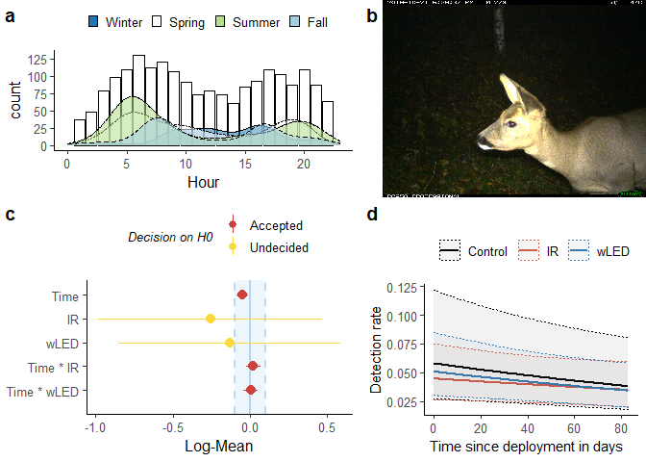

a) Bars represent the raw count of total roe deer detections per hour of the day, and density curves show the diel pattern for each season. b) LED-CT photograph of a roe deer. This deer passed the camera repeatedly and often stopped in front of the flashing light. c) Equivalence test of model parameters. 90% confidence intervals are tested against the Region of Practical Equivalence (set to 0.1 Log-Mean). d) The predicted detection rate of roe deer for each period type. 95% confidence intervals are represented by dotted lines.

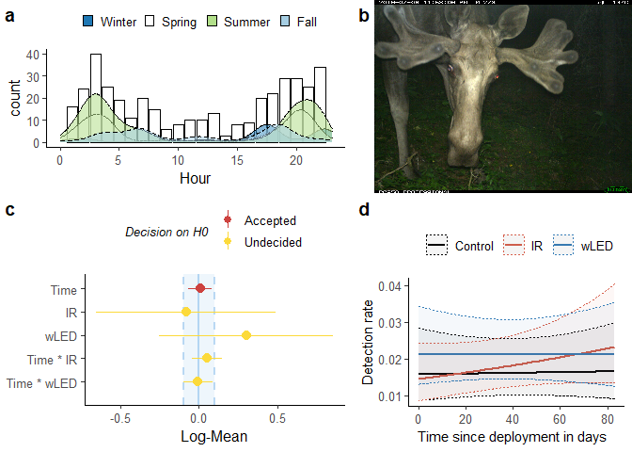

a) Bars represent the raw count of total moose detections per hour of the day, and density curves show the diel pattern for each season. b) LED-CT photograph of a moose. This bull foraged in front of the flash for a minute. c) Equivalence test of model parameters. 90% confidence intervals are tested against the Region of Practical Equivalence (set to 0.1 Log-Mean). d) The predicted detection rate of moose for each period type. 95% confidence intervals are represented by dotted lines.

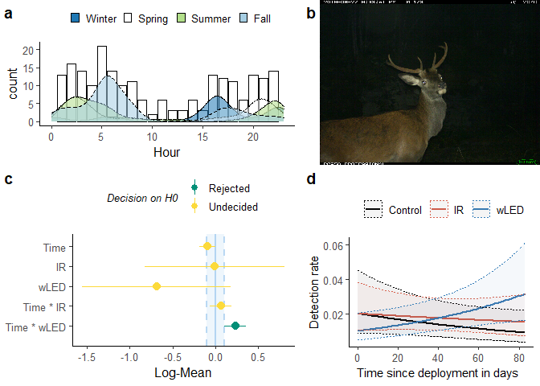

a) Bars represent the raw count of total red deer detections per hour of the day, and density curves show the diel pattern for each season. b) LED-CT photograph of a red deer. This stag stopped in front of the flash for a minute, observing the CTs intently, before moving on. Red deer were subsequently redetected several times during the same period. c) Equivalence test of model parameters. 90% confidence intervals are tested against the Region of Practical Equivalence (set to 0.1 Log-Mean). d) The predicted detection rate of red deer for each period type. 95% confidence intervals are represented by dotted lines.

## Carnivora

Four of the most commonly detected species were from the order Carnivora, split by the three families Mustelidae, Canidae and Felidae. Badgers showed a clear nocturnal activity pattern, and was most active during spring, as seen in figure 4.5a. The other three species showed a crepuscular pattern, having activity peaks around the twilight hours. Both foxes (figure 4.7) and pine martens (figure 4.6) had clear peaks at dusk. Martens were increasingly active during the summer, whilst foxes remained almost identical in activity the whole year through. In fact, foxes had the lowest variation in seasonal pattern overall, which is represented by the low standard deviation in week of the year in table 3.1. The lynx was the least common of the nine species included in my analyses, with 78 events on 22 of the 56 sites. Accordingly, the density curves in figure 4.8a were quite rugged. Nevertheless, all peaks coincided well with the twilight hours of the respective seasons, and the summer had fewest total detections. All carnivores were subject to the white LED during twilight and night time.

Badgers and red foxes had third and fourth highest detection rates, whilst pine marten and lynx had the lowest detection rates. Pine marten was the only carnivore with a significant parameter in a standard NHST. During IR periods the pine marten detection rates were significantly higher than that of control periods, but the difference between IR and white LED periods were non-significant. For both badger and red fox, the treatment groups’ trends along the time axis were practically identical to that of the control periods. Hence, the equivalence tests accepted the null hypothesis of no effect for those two species.

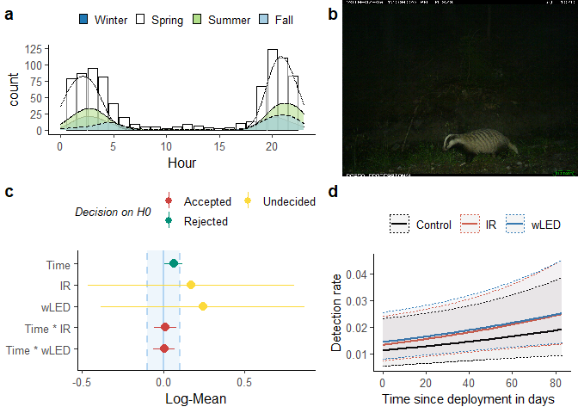

a) Bars represent the raw count of total badger detections per hour of the day, and density curves show the diel pattern for each season. b) LED-CT photograph of a badger. This badger was foraging during rain weather, and showed no reaction to the white flash. c) Equivalence test of model parameters. 90% confidence intervals are tested against the Region of Practical Equivalence (set to 0.1 Log-Mean). d) The predicted detection rate of badgers for each period type. 95% confidence intervals are represented by dotted lines.

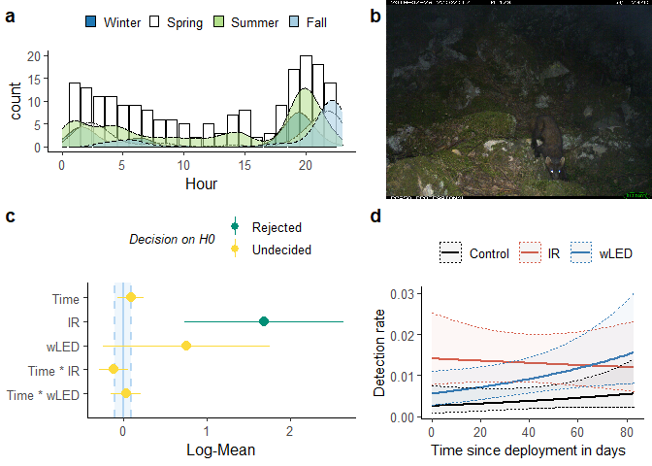

a) Bars represent the raw count of total pine marten detections per hour of the day, and density curves show the diel pattern for each season. b) LED-CT photograph of a pine marten. This marten defecated while observing the camera traps, then went on inspecting the area. c) Equivalence test of model parameters. 90% confidence intervals are tested against the Region of Practical Equivalence (set to 0.1 Log-Mean). d) The predicted detection rate of martens for each period type. 95% confidence intervals are represented by dotted lines.

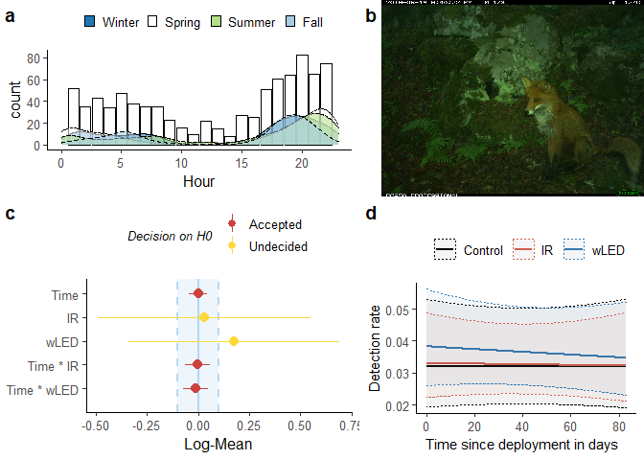

a) Bars represent the raw count of total fox detections per hour of the day, and density curves show the diel pattern for each season. b) LED-CT photograph of a red fox. This fox stopped in front of the flashing camera and scratched its ear, before moving on. A second fox followed right behind. c) Equivalence test of model parameters. 90% confidence intervals are tested against the Region of Practical Equivalence (set to 0.1 Log-Mean). d) The predicted detection rate of foxes for each period type. 95% confidence intervals are represented by dotted lines.

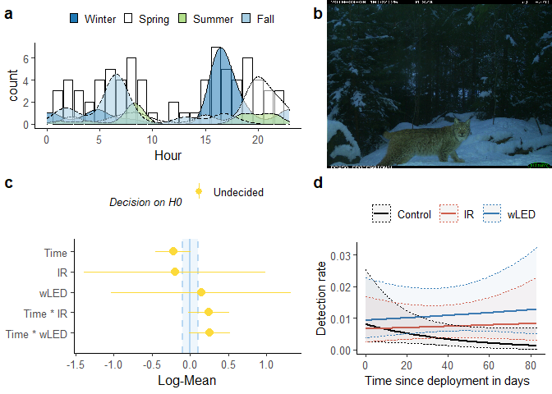

a) Bars represent the raw count of total lynx detections per hour of the day, and density curves show the diel pattern for each season. b) LED-CT photograph of a lynx. This lynx stopped to observe the CTs, before moving on. c) Equivalence test of model parameters. 90% confidence intervals are tested against the Region of Practical Equivalence (set to 0.1 Log-Mean). d) The predicted detection rate of lynx for each period type. 95% confidence intervals are represented by dotted lines.

## Glires

The final two species in study both belong to the clade Glires, which consists of the two orders Rodentia (red squirrel) and lagomorphs (mountain hare). The two Glires species were polar opposites in their diel patterns. Hares showed a nocturnal to crepuscular pattern, whereas squirrels were diurnal, and were never observed around midnight. Like badgers, mountain hares were markedly more active during during the spring. On the other hand, red squirrels were least detected during spring, and primarily from dawn untill midday. Long summer days allowed them to spread their activity between more sunlit hours, and peak detectability was during fall and winter. Therefore, out of these two species, only the hare was subject to white light during night, although squirrels sometimes passed a white LED CT during dawn.

Mountain hares had the second highest detection rates in the study, whilst red squirrels had similar detection rates to that of moose. Nevertheless, the squirrel was the only Glires species that had any significant parameters in the standard NHST. IR periods had a significantly negative slope along the time axis than that of the control periods (p = 0.003), but they were not significantly different from the white LED periods. The same was true for the equivalence test. Although IR periods were rejected as practically identical to the control periods, they weren’t significantly different from white LED periods. In other words, for squirrels, there seems to have been differences between the control sites and the treatment sites, but there were no significant differences between white LED and IR periods.

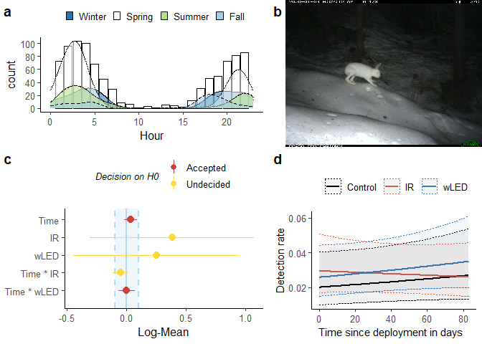

a) Bars represent the raw count of total hare detections per hour of the day, and density curves show the diel pattern for each season. b) LED-CT photograph of a mountain hare in winter coat. This camera had repeated hare detections at night. c) Equivalence test of model parameters. 90% confidence intervals are tested against the Region of Practical Equivalence (set to 0.1 Log-Mean). d) The predicted detection rate of hares for each period type. 95% confidence intervals are represented by dotted lines.

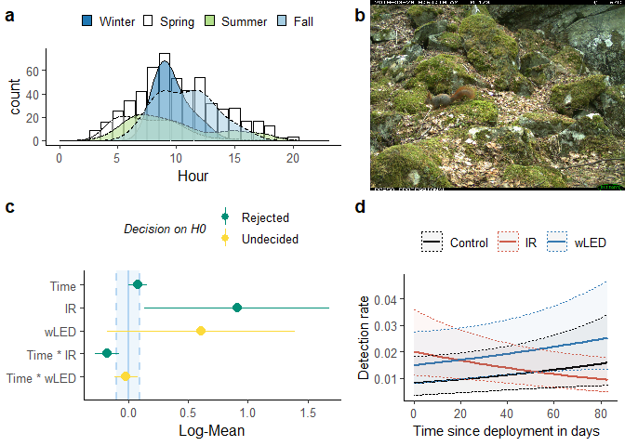

a) Bars represent the raw count of total squirrel detections per hour of the day, and density curves show the diel pattern for each season. b) LED-CT photograph of a squirrel. Squirrels were seen at this site often, and the pine marten in figure 4.6 was seen sniffing around repeatedly during the same period. c) Equivalence test of model parameters. 90% confidence intervals are tested against the Region of Practical Equivalence (set to 0.1 Log-Mean). d) The predicted detection rate of squirrels for each period type. 95% confidence intervals are represented by dotted lines.

# Discussion

This study examined the detection rates of nine sympatric mammal species during periods with and without white LED camera traps present. Animals can detect CTs using IR flash, both by hearing, smelling and seeing it (Meek et al. 2014), but to a varying degree, as their surroundings are filled with distractions. However, a white light emitting CT is noticeable for any land dwelling mammal during night, and does startle some individuals (Meek et al. 2014; Rovero et al. 2013; Glen et al. 2013). Nevertheless, I found no clear cut evidence that capture rates of any species were significantly impacted by the usage of white LED.

There were examples of individual foxes, roe deer, pine marten and one badger turning around and fleeing, when flashed by a white LED CT, but more examples of species merely observing the CTs. Most animals seemed indifferent when passing the white LED CTs, and individuals from all species of cervids were observed ruminating for up to several minutes, while being repeatedly flashed. The latter is also supported by my results. Nevertheless, the overall effect of white LED was minimal, suggesting these responses were short term avoidance behaviour and did not lead to longer term avoidance of the sites. As shown in the density plots (figure 3.2-3.10 a), CTs successfully recorded daily activity patterns for all species, revealing seasonal variation in roe deer, badgers, pine martens, hares and red squirrels. Red squirrel was the only diurnal species. Mountain hare and badger showed nocturnal patterns, whereas the rest had crepuscular activity patterns.

## The effect of CT flashes on carnivores

I expected to find detection rates of foxes at least slightly lowered, due to examples of frightened individuals. Surprisingly, the mean detection rates were highest during white LED periods, although the difference was non-significant. Red fox was the fourth most common species, and so the frightened individuals could represent a small minority that avoided white LED sites. To find out whether the frightened individuals were less likely to be redetected, one would need to recognize individuals. In a recent study, Taggart, Peacock, and Fancourt (2020) did just that, studying feral cats’ (*Felis catus*) responses to white and IR flash, by using a capture-mark-recapture design. They found no evidence for white LED CTs affecting redetection, nor that flash type affected behavioural responses to CTs. Beddari (2019) found lynx and wolves’ reactions to CTs to vary with flash type, although she did not quantify the effect on detection rates. Lynx were more dependant on visual cues to detect the camera traps, substantiating their dependence on sight (Beddari 2019). However, just like Taggart, Peacock, and Fancourt (2020), I found no effect of white LED on the detection rates of felids.

Whenever the white LED CTs were absent, there was an empty metal case above the IR CT that often were filled with snails and some sort of dropping. The empty metal case can have acted as a hiding place and food source for (perhaps) birds, and at that, could represent either an attractant or a repellant based on whatever occupied or marked the case. Could this explain the attractant effect IR periods had on pine marten?

Badgers seemed completely unfazed by the white LED, having almost entirely parallel slopes of detection rates for all three types of periods.

Nevertheless, the overall effect of white LED was minimal, suggesting these responses were short term avoidance behaviour and did not lead to longer term avoidance of the sites.

## The effect of CT flashes on cervids

Henrich et al. (2020) studied roe deer and red deer’s responses to no-glow IR, red-glow IR and white flash, and found no change in trapping rates over time for any flash type or species. However, they used a xenon white flash, which had a cool down of minimum 22 seconds. The discrepancy in picture frequency between the white xenon and the other two flash types hindered any meaningful comparisons of deer detection rates with white light flashes. The latter is also supported by my results. In my study, cervid detection rates were similar between all periods, and no species showed signs of white LED negatively impacting redetections, supporting the findings of Henrich et al. (2020). Although white LED periods saw a significantly positive trend in red deer detection rates, the difference was non-significant compared to the IR periods from the same sites. As red deer only were present at 26 of the 56 sites, seasonal changes not accounted for by the model random effects could explain the differences between the period types. Henrich et al. (2020) found red deer to be more wary of CTs than roe deer in general, supporting the notion that larger animals react stronger than small ones, to human disturbance (Gaynor et al. 2018). Although the two larger cervids varied more in detection rates than the smaller roe deer, I suspect these differences to be stochastic variation due to the lower densities of red deer and moose.

Similar to my findings, activity patterns of red deer in Europe have previously been reported as crepuscular, by studies carried out in areas where deer were heavily culled or hunted by humans, and where large carnivores were absent (Kamler, Jedrzejewska, and Jedrzejewski 2007). However, Kamler, Jedrzejewska, and Jedrzejewski (2007) found red deer to be cathemeral in the Bialowieza National Park, Poland, where human hunting was prohibited, and healthy populations of both lynx and wolves were present. As similar activity patterns had been reported on European bison (*Bison bonasus*) in the same forest, Kamler, Jedrzejewska, and Jedrzejewski (2007) suggested ungulates shifts towards nocturnality as a strategy to avoid humans. Indeed, the same nocturnal shift has been shown in mammals across diverse mammalian taxa and geographic distribution (Gaynor et al. 2018).

In my study, most cervids either reacted by passing the white LED CTs unflustered, or by stopping in front of the camera for a minute, inspecting the CTs and possibly scanning the area for other threats. Nevertheless, as with the carnivores, the overall effect of white LED was minimal, and did not lead to long term avoidance of the sites.

## The effect of CT flashes on Glires species

Pine martens are predators of squirrels, and squirrels may try to avoid pine martens. The negative trend for squirrels during IR periods could be a correlation with the positive trend for pine martens during the same periods. The picture of the squirrel in figure 4.10b, is taken at the same site as the picture of the pine marten in figure 4.6b.

Ikeda et al. (2016) reported mountain hare (in Japan) as being crepuscular during spring-summer, and nocturnal during autumn-winter, whilst Ogurtsov, Zheltukhin, and Kotlov (2018) found it to be nocturnal (in Russia). In my study, mountain hares were nocturnal throughout the year, supporting the building evidence on nocturnally shifting mammals in response to human disturbance (Gaynor et al. 2018).

Cont....

## Eye morphology

This contradicts my assumption that species with high relative acuity would react stronger to a white flash.

Assuming that cervids are true cathemeral species in their natural surroundings, their eyes would be adapted for a higher acuity than nocturnal species. Relative acuity of cervids calculated with the supplementary data from Hall et al. (2012), supports this notion. Cervids had a medium relative acuity (1.25 - 1.34) compared to the low value for badgers (1.05), and high values for lynx and martens (1.43).

However, I never observed any red deer fleeing from a white LED site, and only observed one young moose running past a CT. Roe deer expressed flight responses a few times that I saw, and not instantly, but after having been flashed a couple of times. Gaynor et al. (2018) mentioned some animals being more fearful of predators in lit areas, which could explain the sudden shift in behaviour of some roe deer. The white light might act as "splintering wood", making nearby animals aware of the photo captured individual, and the photo captured individual self aware/more wary of nearby sounds.

In their paper, Henrich et al. (2020) also reported habituance to novel CTs. As all the sites in my study were established well before the survey start, animals could have already habituated to their presence. The only novelty presented by additional white LED CTs was my hypothesized flash blindness, and more noise from two jointly triggering CTs.

Moreover, most sites were at human and tractor paths, which operates as "high roads" for travelling animals, attracting them to the CT site. Therefore, I am unable to conclude on the effect a white LED would have if put up on a site, and especially if put up at random sites, without any attractant stuff. As always, whether to use a white LED or not depends on the survey goal.

In the supplementary material, Hall, Kamilar, and Christopher Kirk (2012) provided data on the species they had analysed, with eye measurement data and classification of diel pattern. Three of the species in my study were represented in their dataset, whilst most other were represented by the same genus (except for roe deer), as seen in table 5.1. Hall, Kamilar, and Christopher Kirk (2012) defined cathemeral species as awake and active both during day and night.

However, in their CT study of seasonal and diel activity patterns, Ikeda et al. (2016) strictly defined a species as cathemeral when no differences were observed in the photographic frequencies among day, night and twilight. Since this also is a CT study, I will do the same. Therefore, I expect some contradictions with the species categorized as cathemeral in the supplementary material of Hall, Kamilar, and Christopher Kirk (2012).

As stated in Hall, Kamilar, and Christopher Kirk (2012): "The ratio of corneal diameter to axial length of the eye is a useful measure of relative sensitivity and relative visual acuity that has been used in previous studies as a way to compare animals of disparate size." Relative acuity is given in table 1.1 as axial length divided by corneal diameter. The higher the value of relative acuity, the higher the hypothetical importance of sight for each species.

Relative acuity from Hall, Kamilar, and Christopher Kirk (2012). Three of the species in my study were represented in the dataset. The other six have been paired with the closest relative of the dataset.

|  |  |  |  |
| --- | --- | --- | --- |
| Study | Closest relative in | Relative | Diel |
| species | Hall et al. 2012 | acuity | pattern |
| Lynx lynx | L. canadensis | 1.43 | Cathemeral |
| Martes martes | M. flavigula | 1.43 | Diurnal |
| Capreolus capreolus | Dama dama | 1.34 | Cathemeral |
| Sciurus vulgaris | S. carolinensis | 1.30 | Diurnal |
| Alces alces | - | 1.28 | Cathemeral |
| Vulpes vulpes | - | 1.26 | Nocturnal |
| Cervus elaphus | C. nippon | 1.25 | Cathemeral |
| Lepus timidus | L. californicus | 1.18 | Cathemeral |
| Meles meles | - | 1.05 | Nocturnal |
|  |  |  |  |

## Second Generation P-Values

The equivalence tests found the detection rate of roe deer, red foxes and badgers to be unaltered during any of the treatment periods. Those were also the three species with the most events included in the model (grey area of the bars in figure 4.1a). When trimming period lengths before the modelling, many mountain hare events were excluded from the model, and presumably most of them from IR periods. That could explain the negative slope for IR periods in 4.9d, and why the IR slope wasn’t accepted as practically equivalent to the control slope.

When interpreting a continuous variable, like the variable for time since deployment, it is worth considering the variable scale. I scaled my time variable to represent 10 day intervals, in order for the model to converge. That means the estimated effect of time since deployment is ten times larger than it would have been if it remained as 1 day intervals. Conversely, had I scaled it to represent the whole span of 84 days, the estimated effect and confidence interval would have been 8.4 times larger than what it is now, thus leaving all the equivalence tests undecided on the effect sizes of time since deployment. However, the standard null hypothesis significance test would be unaffected as parameters remain proportional around 0.

Seeing as capture-mark-recapture studies are set to short period lengths

much shorter than mine, it seems reasonable to aim for a time unit which would translate well to these more common lengths.

For example, Henrich et al. (2020) set up cameras for periods of  20 days, and could therefore not have detected any effects on a time scale of 84 days. In that sense, a scale of 84 days is meaningless.

# Conclusion

Camera trapping is an increasingly important tool in animal ecology and wildlife conservation. The underlying assumption for using CT in investigating multiple species are that CTs are unselective in which species they capture, or that biases in capture rates can be corrected for. An accurate interpretation of data from camera trap studies is dependent on understanding of how study design decisions such as the flash type may influence the trapping rates of the target animals. I found no evidence for that capture rates of any of the nine mammal species were significantly impacted by the usage of white LED. My findings suggest that white-flash cameras are suitable for capture-mark-recapture studies, and quantification of diel patterns. It is important to note that the probability of detecting a species with a camera trap is affected by several other factors operating on different scales ..

[app:sessinfo]

Bates, Douglas, Martin Maechler, Ben Bolker, and Steven Walker. 2020. *lme4: Linear Mixed-Effects Models using Eigen and S4*. <https://github.com/lme4/lme4/>.

Beddari, Benedicte Lissner. 2019. “Behavioral responses to camera traps : a study on two large carnivores in Norway.” *Master of Sciences in Natural Resource Management*, 52. <https://nmbu.brage.unit.no/nmbu-xmlui/handle/11250/2608534>.

Burton, A. Cole, Eric Neilson, Dario Moreira, Andrew Ladle, Robin Steenweg, Jason T. Fisher, Erin Bayne, and Stan Boutin. 2015. “Wildlife camera trapping: A review and recommendations for linking surveys to ecological processes.” *Journal of Applied Ecology* 52 (3): 675–85. <https://doi.org/10.1111/1365-2664.12432>.

Dryja, Thaddeus P., Terri L. McGee, Eliot L. Berson, Gerald A. Fishman, Michael A. Sandberg, Kenneth R. Alexander, Deborah J. Derlacki, and Aruna S. Rajagopalan. 2005. “Night blindness and abnormal cone electroretinogram ON responses in patients with mutations in the GRM6 gene encoding mGluR6.” *Proceedings of the National Academy of Sciences of the United States of America* 102 (13): 4884–89. <https://doi.org/10.1073/pnas.0501233102>.

Gaynor, Kaitlyn M., Cheryl E. Hojnowski, Neil H. Carter, and Justin S. Brashares. 2018. “The influence of human disturbance on wildlife nocturnality.” *Science* 360 (6394): 1232–35. <https://doi.org/10.1126/science.aar7121>.

Glen, Alistair S., Stuart Cockburn, Margaret Nichols, Jagath Ekanayake, and Bruce Warburton. 2013. “Optimising Camera Traps for Monitoring Small Mammals.” Edited by Tobias Deschner. *PLoS ONE* 8 (6): e67940. <https://doi.org/10.1371/journal.pone.0067940>.

Hall, Margaret I., Jason M. Kamilar, and E. Christopher Kirk. 2012. “Eye shape and the nocturnal bottleneck of mammals.” *Proceedings of the Royal Society B: Biological Sciences* 279 (1749): 4962–68. <https://doi.org/10.1098/rspb.2012.2258>.

Henrich, Maik, Sandra Niederlechner, Max Kröschel, Stefanie Thoma, Carsten F. Dormann, Florian Hartig, and Marco Heurich. 2020. “The influence of camera trap flash type on the behavioural reactions and trapping rates of red deer and roe deer.” *Remote Sensing in Ecology and Conservation* 6 (3): 399–410. <https://doi.org/10.1002/rse2.150>.

Ikeda, Takashi, Kenta Uchida, Yukiko Matsuura, Hiroshi Takahashi, Tsuyoshi Yoshida, Koichi Kaji, and Itsuro Koizumi. 2016. “Seasonal and diel activity patterns of eight sympatric mammals in northern Japan revealed by an intensive camera-trap survey.” *PLoS ONE* 11 (10): 1–16. <https://doi.org/10.1371/journal.pone.0163602>.

Kamler, Jan F., Bogumiła Jedrzejewska, and Włodzimierz Jedrzejewski. 2007. “Activity patterns of red deer in Białowieża National Park, Poland.” *Journal of Mammalogy* 88 (2): 508–14. <https://doi.org/10.1644/06-MAMM-A-169R.1>.

Lüdecke, Daniel. 2021. *sjPlot: Data Visualization for Statistics in Social Science*. <https://strengejacke.github.io/sjPlot/>.

Lüdecke, Daniel, Dominique Makowski, Mattan S Ben-Shachar, Indrajeet Patil, and Søren Højsgaard. 2021. *parameters: Processing of Model Parameters*. <https://easystats.github.io/parameters/>.

Lüdecke, Daniel, Dominique Makowski, Philip Waggoner, Indrajeet Patil, and Mattan S Ben-Shachar. 2021. “performance: Assessment of Regression Models Performance.” *CRAN*. <https://doi.org/10.5281/zenodo.3952174>.

Makowski, Dominique, Mattan S Ben-Shachar, and Daniel Lüdecke. 2020. “The easystats collection of R packages.” *GitHub*. <https://github.com/easystats/easystats>.

Meek, Paul D., Guy A. Ballard, Peter J. S. Fleming, Michael Schaefer, Warwick Williams, and Greg Falzon. 2014. “Camera traps can be heard and seen by animals.” *PLoS ONE* 9 (10). <https://doi.org/10.1371/journal.pone.0110832>.

Meek, Paul D., Guy Ballard, Peter Fleming, and Greg Falzon. 2016. “Are we getting the full picture? Animal responses to camera traps and implications for predator studies.” *Ecology and Evolution* 6 (10): 3216–25. <https://doi.org/10.1002/ece3.2111>.

Moen, Asbjørn. 1999. *National Atlas of Norway: Vegetation*. Edited by Arvid Lillethun. Hønefoss: Norwegian Mapping Authority. <https://www.nb.no/items/URN:NBN:no-nb{_}digibok{_}2010011503011>.

Morellet, Nicolas, François Klein, Erling Solberg, and Reidar Andersen. 2011. “The census and management of populations of ungulates in Europe.” In *Ungulate Management in Europe: Problems and Practices*, edited by Rory Putman, Marco Apollonio, and ReidarEditors Andersen, 106–43. Cambridge University Press. <https://doi.org/10.1017/CBO9780511974137.006>.

Nakagawara, Van B, and Ronald W Montgomery. 2001. “Laser Pointers: Their Potential Affects on Vision and Aviation Safety.” Oklahoma City: Federal Aviation Administration.

Odden, John. 2015. “Bruk av viltkamera i overvåking av gaupe - et pilotstudie i tre områder på Østlandet - NINA Rapport 1216.” Oslo, Norway: NINA. <https://brage.nina.no/nina-xmlui/handle/11250/2368722>.

Ogurtsov, Sergey S., Anatoliy S. Zheltukhin, and Ivan P. Kotlov. 2018. “Daily activity patterns of large and medium-sized mammals based on camera traps data in the central forest nature reserve, Valdai Upland, Russia.” *Nature Conservation Research* 3 (2): 68–88. <https://doi.org/10.24189/ncr.2018.031>.

Ollivier, F. J., D. A. Samuelson, D. E. Brooks, P. A. Lewis, M. E. Kallberg, and A. M. Komaromy. 2004. “Comparative morphology of the tapetum lucidum (among selected species).” *Veterinary Ophthalmology* 7 (1): 11–22. <https://doi.org/10.1111/j.1463-5224.2004.00318.x>.

R Core Team. 2021. *R: A Language and Environment for Statistical Computing*. Vienna, Austria: R Foundation for Statistical Computing. <https://www.r-project.org/>.

Rovero, Francesco, Fridolin Zimmermann, Duccio Berzi, and Paul Meek. 2013. “Which camera trap type and how many do I need? A review of camera features and study designs for a range of wildlife research applications.” *Hystrix, the Italian Journal of Mammalogy* 24 (2): 148–56. <https://doi.org/10.4404/hystrix-24.2-8789>.

RStudio Team. 2020. “RStudio: Integrated Development Environment for R.” Boston, MA: RStudio, PBC. <http://www.rstudio.com/>.

Schmitz, Lars, and Ryosuke Motani. 2010. “Morphological differences between the eyeballs of nocturnal and diurnal amniotes revisited from optical perspectives of visual environments.” *Vision Research* 50 (10): 936–46. <https://doi.org/10.1016/j.visres.2010.03.009>.

Solovei, Irina, Moritz Kreysing, Christian Lanctôt, Süleyman Kösem, Leo Peichl, Thomas Cremer, Jochen Guck, and Boris Joffe. 2009. “Nuclear Architecture of Rod Photoreceptor Cells Adapts to Vision in Mammalian Evolution.” *Cell* 137 (2): 356–68. <https://doi.org/10.1016/j.cell.2009.01.052>.

Spinu, Vitalie, Garrett Grolemund, and Hadley Wickham. 2021. *lubridate: Make Dealing with Dates a Little Easier*. <https://cran.r-project.org/package=lubridate>.

Taggart, Patrick L., David E. Peacock, and Bronwyn A. Fancourt. 2020. “Camera trap flash-type does not influence the behaviour of feral cats (Felis catus).” *Australian Mammalogy* 42 (2): 220. <https://doi.org/10.1071/AM18056>.

Wickham, Hadley. 2016. *ggplot2: Elegant Graphics for Data Analysis*. Springer-Verlag New York. <https://ggplot2.tidyverse.org>.

Wickham, Hadley, Mara Averick, Jennifer Bryan, Winston Chang, Lucy D’Agostino McGowan, Romain François, Garrett Grolemund, et al. 2019. “Welcome to the {tidyverse}.” *Journal of Open Source Software* 4 (43): 1686. <https://doi.org/10.21105/joss.01686>.

Xie, Yihui. 2015. *Dynamic Documents with {R} and knitr*. 2nd ed. Boca Raton, Florida: Chapman; Hall/CRC. <https://yihui.org/knitr/>.

1. PIR motion detectors work by detecting heat radiation (infrared light), and are triggered by moving objects that are warmer than their surroundings.
2. Remember that white LED CTs were considered as external flashes, and their pictures were left out of the analyses.
3. Therefore, a significant difference in a TOST differs slightly from a significant difference in a standard NHST, which is based on a CI of 0.95.