FPT Corporation Equity Research Initiation
Historical research simulation with FY2025 forecast post mortem
Company | FPT Corporation
Ticker | HOSE FPT
Historical rating | Conditional BUY
Valuation date | 31 October 2025
Information cutoff | 31 October 2025
Case study completed | 11 October 2026
Purpose
This report demonstrates a point-in-time equity research process: source-controlled forecasting, DCF and peer valuation, explicit monitoring triggers, and a post-cutoff test against audited FY2025 results.
Important
The rating and valuation are a historical simulation as of 31 October 2025. They are not a current investment recommendation and do not incorporate information available after that date except in the separately labelled forecast post mortem.

Investment conclusion
Historical decision
At the Clock A cutoff, the evidence supported a conditional BUY. The blended valuation was VND 126,218 per share, 22.7% above the VND 102,830 market price. The recommendation required staged exposure and a cash-conversion review because terminal value represented 76.8% of enterprise value and the thesis monitor was amber.
Market price | Blended value | Upside | Value range | Monitor
VND 102,830 | VND 126,218 | 22.7% | VND 109,203 to VND 141,409 | AMBER

Why the market offered upside
- The market price implied a 2026F P/E of 17.7x, below the 20.2x segment-mix multiple applied to model-derived FY2026E EPS of VND 5,794.
- The reverse DCF implied terminal growth of 1.4%, well below the 4.0% base assumption. That gap created upside if FPT sustained double-digit revenue growth and normalized investment intensity.
- Global IT demand indicators remained constructive: signed revenue and large-deal evidence supported the revenue path, while telecom provided a steadier earnings base.

Why the rating was conditional
- Nine-month post-capex cash conversion was 23.1%, below the 30% red threshold. Earnings growth had not yet converted into free cash flow at the preferred rate.
- The base case assumed EBIT margin expansion from 16.7% in FY2024 to 17.5% by FY2030 and capex normalization toward 5.0% of revenue. Both assumptions required operating evidence.
- The DCF depended materially on the terminal period. A 10.23% WACC and 4.0% terminal growth produced VND 132,527 per share, but the sensitivity range was wide.
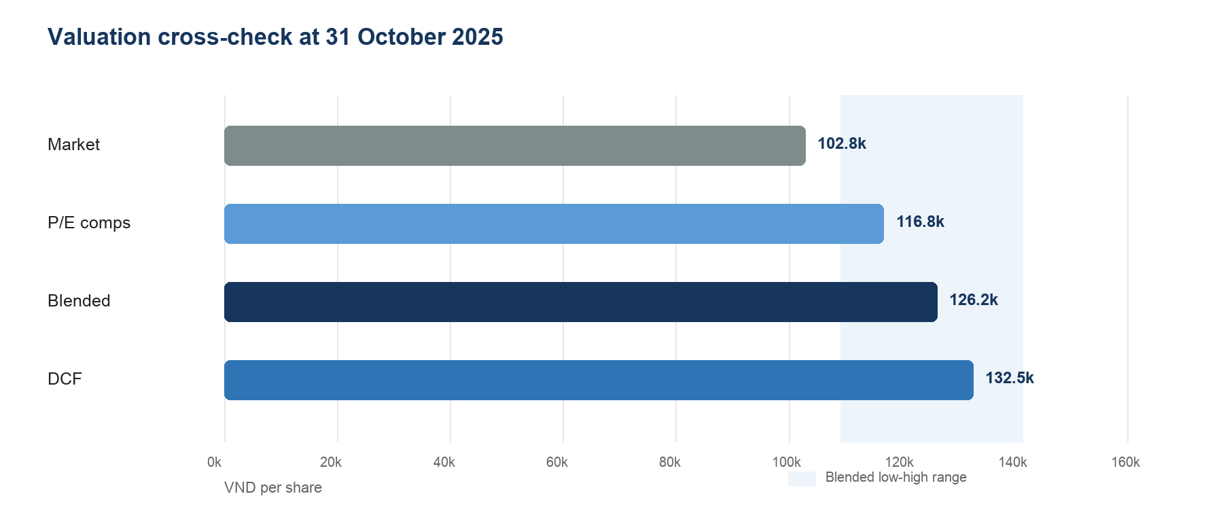
Figure 1 Market price and valuation methods at the Clock A cutoff

Business mix and research thesis
FPT combines global and domestic technology services, telecommunications, digital content, and education and investment activities. That mix requires a valuation architecture that reflects different growth, margin and reinvestment profiles rather than treating the group as a pure software company.

Central research question
How much of the market-implied value depended on Global IT revenue growth and steady-state margin, and did signed revenue, large-deal mix and productivity provide enough evidence to support those expectations?
Hypothesis | Evidence required | Falsification condition
Global IT drives value | Revenue CAGR and margin sensitivity dominate valuation | Telecom, other segments or WACC explain most valuation movement
Productivity matters | Revenue per delivery employee and service mix explain margin | A simple growth baseline performs as well
Backlog helps but is not enough | Signed revenue improves near-term visibility | Conversion timing adds no explanatory value
Telecom stabilizes downside | More stable growth, margin and cash generation | Capex or content costs create technology-like volatility
Per-share normalization matters | NCI and share-count bridge change attributable value | Adjustments have immaterial per-share effect

Forecast architecture
The model separates reported history, normalized operating drivers, free cash flow and valuation. Actual statements never depend on the scenario selector. Forecasts link to visible assumptions, and valuation checks read the model without feeding it. The explicit DCF starts in FY2026, so cash flows earned before 31 October 2025 are not counted twice.
Layer | Purpose
Reported history | Audited group, segment, balance-sheet and cash-flow data
Operating forecast | Segment revenue drivers and a selected Base or Downside case
Cash conversion | EBIT, tax, D&A, capex and working-capital bridge to FCFF
Valuation | DCF control total, reverse DCF, P/E cross-check and blended range
Governance | Source register, checks, monitor thresholds and frozen backtest snapshot

Earnings forecast and cash flow
The Clock A base case forecast group revenue of VND69.7tn in FY2025 and VND120.1tn in FY2030. Revenue growth decelerated from 12.3% in FY2026 to 10.4% in FY2030, while EBIT margin rose gradually to 17.5%. FCFF increased from VND9.7tn in FY2026 to VND16.1tn in FY2030.
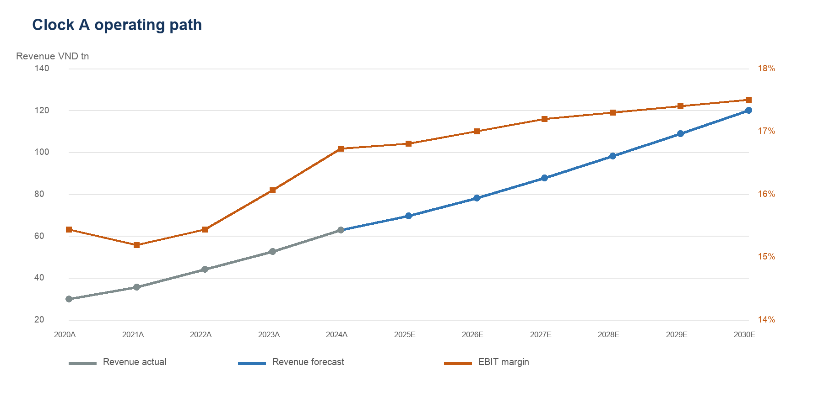
Figure 2 Reported history through FY2024 and the frozen Clock A forecast
Metric | 2025E | 2026E | 2027E | 2028E | 2029E | 2030E
Revenue VND bn | 69,666 | 78,237 | 87,786 | 98,110 | 108,803 | 120,126
Revenue growth | 10.8% | 12.3% | 12.2% | 11.8% | 10.9% | 10.4%
EBIT margin | 16.8% | 17.0% | 17.2% | 17.3% | 17.4% | 17.5%
FCFF VND bn | 8,430 | 9,659 | 11,251 | 12,860 | 14,587 | 16,096
FCFF margin | 12.1% | 12.3% | 12.8% | 13.1% | 13.4% | 13.4%
Capex to revenue | 6.0% | 5.8% | 5.5% | 5.2% | 5.0% | 5.0%

Assumptions that carry the thesis
- Global IT revenue growth remained the main growth engine at 15% in FY2026 and FY2027 before easing to 12% by FY2030.
- Telecom revenue growth started at 11% in FY2026 and declined to 9% by FY2030, providing a steadier but more capital-intensive contribution.
- Working-capital investment equaled 2% of incremental revenue. The FY2025 backtest later showed that this was too optimistic for the forecast year.
- The base case normalized capex toward 5% of revenue. This was a valuation-critical assumption, not a mechanical extrapolation from FY2024.

Valuation
The blended value was VND 126,218 per share. The model assigned 60% weight to the DCF and 40% to the P/E cross-check. The resulting 22.7% gap to market exceeded the 15% threshold required by the thesis monitor, but the valuation range remained broad.
Method | Low | Base | High | Role
DCF | VND 116,341 | VND 132,527 | VND 153,749 | Primary intrinsic value
P/E comparables | VND 98,496 | VND 116,754 | VND 122,899 | Market cross-check
Blended | VND 109,203 | VND 126,218 | VND 141,409 | Decision range
Market | VND 102,830 | VND 102,830 | VND 102,830 | Observed price

Discounted cash flow
A 10.23% WACC and 4.0% terminal growth produced enterprise value of VND211.4tn and equity value of VND225.8tn, equal to VND 132,527 per share. The equity bridge added cash, short-term investments, associates and other financial investments, then deducted debt and non-controlling interests.
Enterprise to equity bridge | VND bn | Treatment
Enterprise value | 211,426.5 | DCF output
Cash and equivalents | 9,853.5 | Add
Short-term investments | 27,125.6 | Add
Associates and joint ventures | 2,925.8 | Add
Net other financial investments | 1,056.2 | Add
Debt | -19,587.9 | Deduct
Non-controlling interests | -7,039.7 | Deduct
Equity value | 225,760.1 | Result

Comparable valuation
The comparable method applied a 20.2x 2026F P/E to model-derived EPS of VND 5,794. Segment peer medians were weighted by FPT's 9M2025 PBT mix, then reduced by 5% for group structure and imperfect comparability. The method produced VND 116,754 per share.
Segment | PBT weight | Peer 2026F P/E | Weighted P/E
Technology | 45.4% | 26.6x | 12.1x
Telecom | 33.8% | 16.5x | 5.6x
Education and other | 20.7% | 17.1x | 3.5x
Mix-adjusted median | 100.0% |  | 21.2x

Reverse DCF and sensitivity
At VND 102,830, the reverse DCF implied 1.4% perpetual growth when the explicit operating forecast and equity bridge were held constant. This was below the 4.0% base assumption, but the conclusion depended on margin, capex and working-capital normalization. Reverse DCF therefore framed the hurdle; it did not validate the base case by itself.
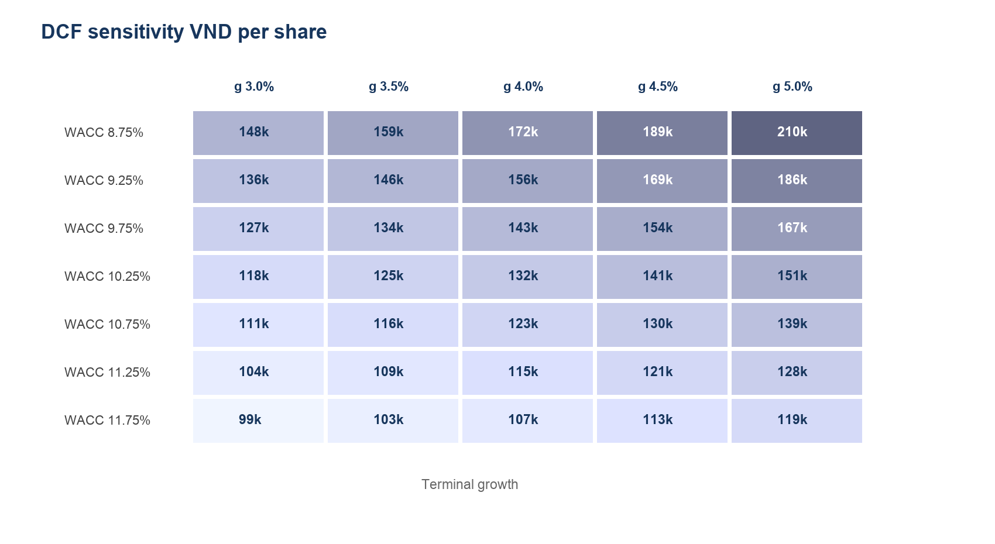
Figure 3 DCF sensitivity across WACC and terminal growth assumptions

Sensitivity interpretation
- The base case sat near the center of the sensitivity grid at approximately VND 132,527 per share.
- Terminal value contributed 76.8% of enterprise value. That dependence required a wider decision range and a monitoring rule for profitability and cash conversion.
- A lower cost of capital or higher terminal growth created substantial upside, but neither was treated as an operating thesis. The recommendation had to survive less favorable financing assumptions.
Question | Clock A evidence | Decision implication | Required update
Is growth priced aggressively | Market-implied g 1.4% | No, relative to base | Recheck after forecast revision
Is the DCF terminal-heavy | TV to EV 76.8% | Yes | Keep range wider than a single target
Does the peer method confirm upside | VND 116,754 per share | Moderate confirmation | Refresh peers and model EPS together
Is valuation sufficient alone | 22.7% blended gap | No | Require cash and margin evidence

Risk framework and thesis monitor
The monitor translated the investment thesis into twelve observable indicators across demand, geography, profitability, cash conversion and valuation. It did not change assumptions automatically. A breach identified which part of the model required review.
Indicator | Observed | Green | Red | Status
Global IT revenue growth | 12.8% | >=13.5% | <8.0% | AMBER
Signed revenue growth | 14.4% | >=15.0% | <10.0% | AMBER
Japan revenue growth | 26.3% | >=20.0% | <10.0% | GREEN
APAC revenue growth | -7.5% | >=0.0% | <-10.0% | AMBER
Operating cash flow to PAT | 73.2% | >=90.0% | <70.0% | AMBER
Post-capex cash conversion | 23.1% | >=60.0% | <30.0% | RED

Key risks
Risk | Transmission to value | Leading evidence | Model response
Global IT demand | Lower revenue CAGR and utilization | Signed revenue, large deals, geography | Cut segment growth and P/E
Margin execution | Lower EBIT and FCFF | Global IT PBT margin and productivity | Reduce margin path
Capital intensity | Lower near-term FCFF | Capex to revenue and data-center investment | Raise capex assumptions
Working capital | Cash conversion lags earnings | OCF to PAT and receivables | Raise NWC investment
Valuation duration | Higher sensitivity to WACC and g | TV to EV and reverse DCF | Widen range or require more upside
Per-share leakage | Lower value attributable to parent | NCI and share-count bridge | Refresh equity bridge

Decision rules
- Add exposure only when blended upside remains at least 15% and no two critical indicators are red.
- Re-underwrite the model if Global IT growth falls below 8%, Global IT PBT margin falls below 14.5%, or operating cash flow to PAT falls below 70%.
- Reduce or exit the historical position if the blended value falls below market, unless the discrepancy is caused by a documented one-off that does not affect long-run cash flow.

FY2025 forecast post mortem
FY2025 actuals were published after the information cutoff and were used only to test the frozen forecast. They did not overwrite the Clock A assumptions, forecast schedules or original valuation. The frozen workbook hash preserved the forecast evidence.
Metric | Forecast | Actual | Error | Tolerance | Result
Group revenue | VND69,665.5bn | VND70,112.8bn | 0.6% | 2.0% | PASS
EBIT margin | 16.8% | 15.7% | 1.1pp | 0.5pp | MISS
FCFF | VND8,429.7bn | VND6,029.8bn | 28.5% | 10.0% | MISS
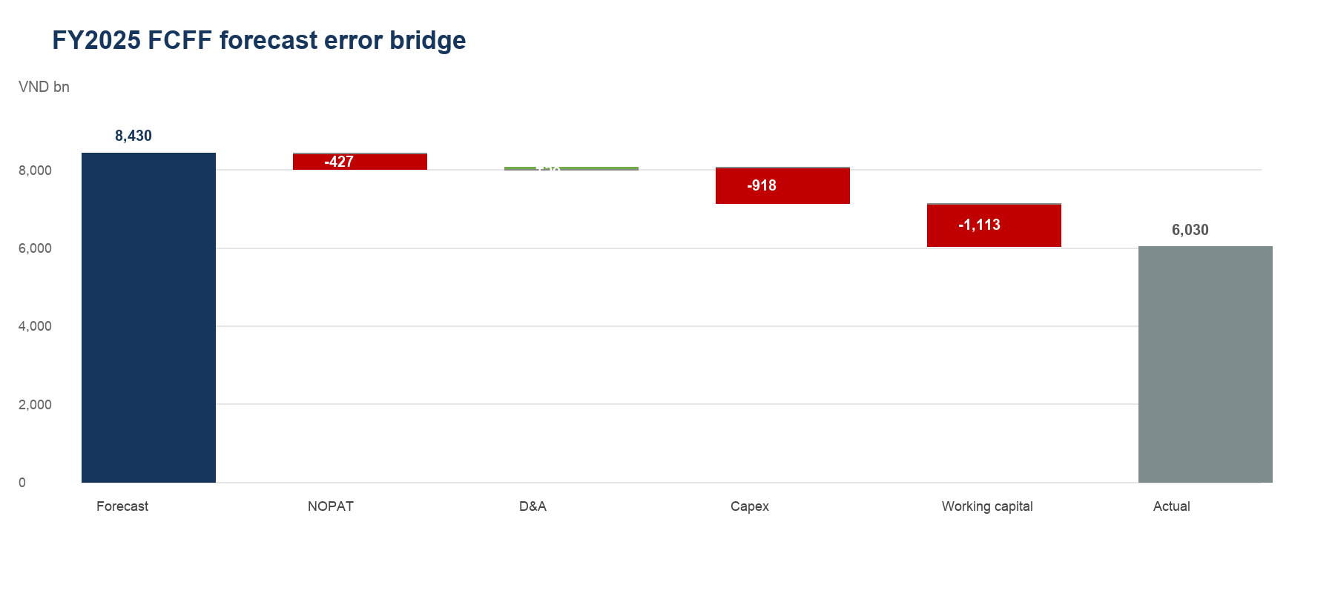
Figure 4 FY2025 FCFF miss by component

What the test changed
The result was mixed. The segment-driver structure estimated group revenue well and outperformed a repeat of FY2024 growth and management's 20% plan. The model nevertheless overestimated the conversion of revenue into operating profit and cash flow.
- NOPAT was VND427.1bn below forecast. The expected FY2025 margin expansion did not occur.
- Capex exceeded forecast by VND918.0bn and working-capital use exceeded forecast by VND1,112.7bn. These two items explained most of the FCFF miss.
- Full-year OCF to PAT recovered to 90.2%, while post-capex cash conversion improved to 44.9%. The nine-month warning improved from red to amber but did not fully clear.
- A revenue-only actual re-anchor changed DCF value by only 0.3%. The next model version must re-underwrite margin, capex and working capital rather than simply replacing revenue.

Research judgment after the backtest
Retain the revenue-driver architecture. Do not retain the old profitability and cash-conversion path without new evidence. Preserve Clock A as the audit trail and open a separate Clock B model for the live view.

Methodology and model governance

Free cash flow definition
FCFF equals EBIT before financial items after cash tax, plus depreciation and amortization, less capital expenditure and the change in working capital. Historical working capital is derived from reported cash-flow effects. Forecast working capital is tied to incremental revenue.

Research clocks
Clock | Purpose | Information set | Status
Clock A | Historical reconstruction and forecast test | Public by 31 October 2025 | Frozen and backtested
Clock B | Current research view | Latest official disclosures | Not yet opened

Controls
- Post-cutoff FY2025 actuals appear only in the actuals and validation layers.
- A SHA-256 hash identifies the frozen v0.6 forecast snapshot used in the backtest.
- Scenario changes do not alter reported history, market price, or the frozen forecast review.
- The workbook reconciles segment revenue, parent and non-controlling earnings, the share-count bridge, FCFF and valuation outputs.
- Peer observations remain visible, including high-multiple outliers. Segment medians, not averages, drive the applied multiple.
- Licensed broker tables are documented by source and date but are not committed as raw datasets.

Known limitations
- The model does not yet contain a common-basis historical diluted-share series for a long EPS trend.
- The historical multiple work is diagnostic rather than a formal point-in-time backtest because a complete monthly TTM EPS series is not available.
- The education peer set is an imperfect proxy because FPT reports education together with investment and other activities.
- The DCF does not apply a separate operating-lease adjustment beyond reported finance-lease borrowings.
- This report does not present a live 2026 recommendation. That requires a separate Clock B forecast and market-date refresh.

Sources
Operating facts and financial statements
FPT Annual Report 2024
https://fpt.com/-/media/project/fpt-corporation/fpt/ir/general-meetings-of-shareholders/fpt_annual_report_2024.pdf
FPT 9M2025 Earnings Report
https://fpt.com/-/media/project/fpt-corporation/fpt/ir/information-disclosures/year-report/2025/october/fpt_earnings-report-9m2025.pdf
FPT Q3 2025 Consolidated Financial Statements
https://file.fpts.com.vn/FileStore2/File/2025/10/24/20251023_-_FPT_-_BCTC_hop_nhat_Quy_3_2025.pdf
FPT Annual Report 2025 used only for post mortem
https://bctn2025.fpt.com/wp-content/uploads/2026/04/Annual-Report-2025.pdf
FPT FY2025 Results Release used only for post mortem
https://fpt.com/en/news/fpts-profit-before-tax-of-vnd-13039-billion-representing-yoy-growth-of-178
Market and valuation inputs
Vietnam State Securities Commission October 2025 market report
https://ssc.gov.vn/webcenter/portal/ssc/pages_r/l/chitit?dDocName=APPSSCGOVVN1620160814
Damodaran archived country risk data
https://pages.stern.nyu.edu/~adamodar/New_Home_Page/dataarchived.html
Vietcap FPT Report 22 October 2025
https://www.vietcap.com.vn/api/cms-api/uploads/file/202510/FPT-20251022-BUY.pdf
Vietcap FPT Report 14 August 2025
https://www.vietcap.com.vn/api/cms-api/uploads/file/202508/FPT-20250814-OP.pdf
KBSV FPT Update 11 September 2025
https://www.kbsec.com.vn/pic/Service/KBSV_FPT_2Q25Update_Eng.pdf
ACBS FPT Update 28 October 2025
https://acbs.com.vn/acbsmedia/2025/10/FPT-by-ACBS_Update_Oct-28th-2025.pdf

Analyst statement
This is an independent portfolio case study based on public information. It was prepared to demonstrate research process, model governance and decision discipline. It is not investment advice, does not represent an employer or broker, and should not be used as a current recommendation.

