FPT Corporation Equity Research Update
Clock B live underwriting after the 2026 reporting-basis change
Research item | Clock B snapshot
Company | FPT Corporation
Ticker | HOSE FPT
Valuation date | 9 October 2026
Market price | VND 57,900
Blended fair value | VND 94,498
Upside | 63.2%
Mechanical rating | BUY
Risk label | HIGH
Decision
Open or retain a measured position only if the mandate accepts high cash-conversion risk. The valuation gap is material, but the next increase in exposure should require FY2026 evidence that the H1 working-capital outflow reverses.
Important
This is independent portfolio research based on public information. It is not investment advice, a solicitation, or a broker recommendation.

Investment conclusion
Clock B produces a blended fair value of VND 94,498 per share, 63.2% above the observed VND 57,900 price. The primary SOTP value is VND 97,511; a 2027E P/E cross-check gives VND 89,978. The valuation supports a mechanical BUY, while the live evidence supports only measured sizing because cash conversion is red.
Market | SOTP | P/E | Blended | Monitor
VND 57,900 | VND 97,511 | VND 89,978 | VND 94,498 | AMBER
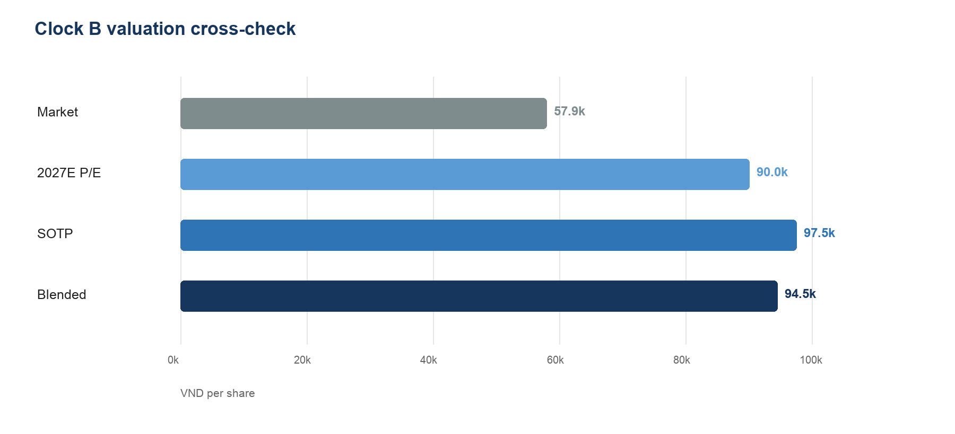
Figure 1 Market price and Clock B valuation methods

Why the market may be too pessimistic
- The market trades at approximately 10.9x trailing earnings while 8M2026 revenue and profit before tax grew 13.5% and 17.5%.
- H1 new signed revenue grew 32.3%; Japan revenue grew 24.4%; AI and data-analytics revenue grew 54%.
- The Base cross-check uses 15.0x 2027E earnings rather than requiring a return to Clock A's higher comparable multiple.

Why position size should remain measured
- H1 operating cash flow was negative VND1,145.7bn against parent net profit of VND5,055.0bn.
- The FY2025 post mortem already identified capex and working capital as the largest FCFF forecast errors.
- The change to equity-method accounting reduces comparability and raises the risk of misreading group growth and cash flow.

What changed from Clock A
Clock A valued the fully consolidated group at 31 October 2025. From 1 January 2026, FPT Telecom moved to the equity method following the governance change. Parent net profit and EPS were not affected by presentation, but group revenue, EBIT, cash flow, assets, debt and non-controlling interests became structurally non-comparable.
Item | Clock A | Clock B response
Reporting perimeter | FPT Telecom fully consolidated | Continuing operations plus associate line
Primary valuation | Whole-group FCFF DCF | Operating DCF plus capitalised associate earnings
Share count | Pre-2026 reference basis | 1,885.7m post-bonus shares
WACC | 10.2% | 10.9% Base
Starting margin | Old consolidated basis | 14.8% H1 anchor
Cross-check | 2025 peer snapshot | 15.0x 2027E analyst multiple

Clock B valuation architecture
Step | Calculation | Double-count control
1 | DCF continuing-operation FCFF | Excludes equity-accounted associates
2 | Capitalise 2027E associate profit | Do not add associate book value
3 | Add cash and short-term investments | Use 30 June 2026 reported balances
4 | Subtract debt and NCI | Use balances on the same reporting date
5 | Divide by post-bonus shares | Avoid stale per-share denominators

Interpretation boundary
Clock A and Clock B target values are not a clean price-target bridge because the reporting perimeter, market date, share count, WACC and forecast evidence changed simultaneously. The professionally defensible comparison is between research decisions and assumptions, not a single unexplained target-price delta.

Current evidence and operating forecast
Evidence | Reading | Status | Model implication
8M revenue growth | +13.5% | GREEN | Supports 2026 revenue anchor
8M PBT growth | +17.5% | GREEN | Earnings outpace revenue
H1 EBIT margin | 14.8% | GREEN | Sets conservative starting margin
H1 signed revenue | +32.3% | GREEN | Supports forward visibility
Japan revenue | +24.4% | GREEN | Leading market remains strong
AI and data analytics | +54.0% | GREEN | Potential mix improvement
H1 OCF / parent PAT | -22.7% | RED | Main thesis-confirmation risk
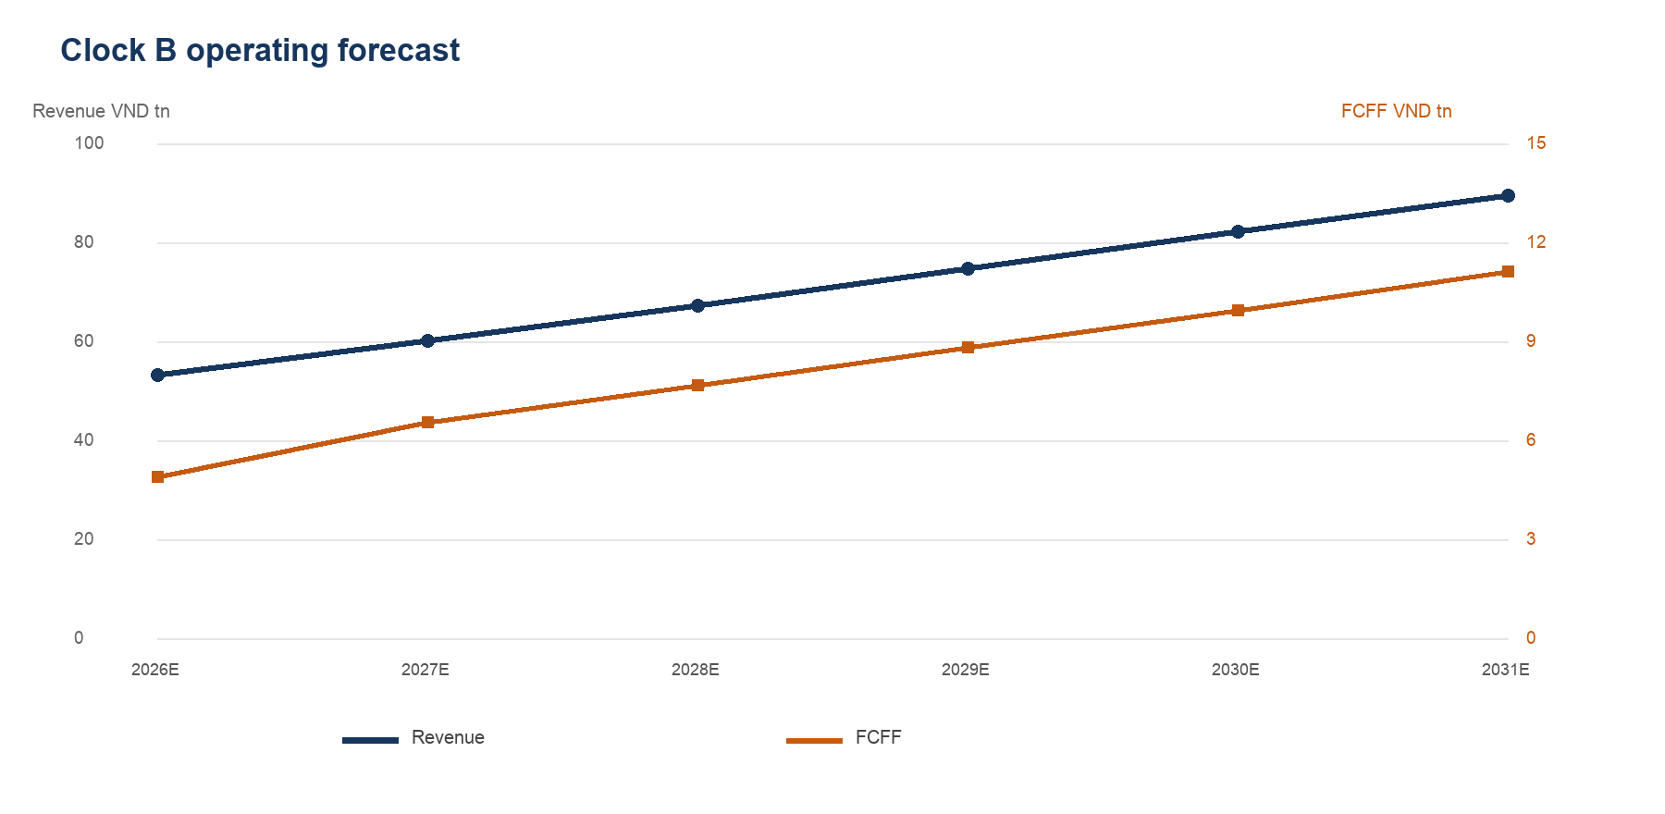
Figure 2 Base revenue and FCFF path
Metric | 2026E | 2027E | 2028E | 2029E | 2030E | 2031E
Revenue VND bn | 53,112 | 60,017 | 67,219 | 74,613 | 82,074 | 89,460
EBIT margin | 14.8% | 15.1% | 15.5% | 15.8% | 16.1% | 16.3%
FCFF VND bn | 4,893 | 6,549 | 7,666 | 8,811 | 9,942 | 11,121
EPS VND | 5,287 | 5,999 | 6,769 | 7,535 | 8,314 | 9,048

Base-case underwriting
The forecast is driver-based and deliberately explicit about the cash-flow assumptions most likely to fail. Revenue decelerates, margin recovers gradually, and reinvestment normalises only after the 2026 working-capital shock.
Driver | 2026E | 2031E | Underwriting logic
Revenue growth | 13.5% | 9.0% | 8M actual anchor then gradual fade
EBIT margin | 14.8% | 16.3% | Recovery below an abrupt snapback
D&A / revenue | 3.2% | 3.0% | Broadly stable asset intensity
Capex / revenue | 5.2% | 4.5% | Normalises after growth investment
NWC / incremental revenue | 15.0% | 5.0% | Front-loads current cash risk
Associate profit growth | — | 6.0% | 10% in 2027, then fades

Forecast logic
- 2026E revenue annualises official 8M revenue of VND35.4tn; 2026E margin uses H1 gross profit less selling and administration expense.
- FCFF equals EBIT after normalised tax plus D&A, less capex and change in working capital.
- Associate and JV profit is forecast separately, then capitalised in the SOTP; it is not included in operating FCFF.
- Parent earnings include operating EBIT, associate profit and net financial income, then apply an 88% parent PAT-to-PBT conversion.

Variant view versus market expectations
Question | Market reference | Clock B variant
Growth | Price decline implies sharper slowdown | Double-digit growth persists near term
Multiple | 10.9x trailing P/E | 15.0x on 2027E EPS if evidence holds
Cash | Market may discount earnings quality | No re-rating without FY2026 cash reversal
Accounting | New basis may obscure trend | Separate associate economics explicitly

Key analytical judgment
The thesis does not require heroic top-line growth or a return to Clock A's multiple. It does require cash conversion to recover. That makes FY2026 working capital the pivotal evidence item, not a secondary modelling detail.

Sum-of-parts valuation
Component | VND bn | Treatment
PV explicit FCFF | 32,745.8 | 2027E–2031E mid-year
PV terminal value | 97,914.3 | 31 December 2031 terminal
Operating enterprise value | 130,660.2 | Continuing operations
Capitalised associate earnings | 43,840.7 | 14.0x 2027E profit
Cash | 8,843.2 | Add
Short-term investments | 20,128.4 | Add
Debt | (18,449.5) | Subtract
Non-controlling interests | (1,144.2) | Subtract
Equity value | 183,878.6 | Result
SOTP per share | 97,511 | 1,885.7m shares

Cost of capital
Input | Base | Comment
Risk-free rate | 4.58% | Vietnam 10-year yield
Equity risk premium | 8.35% | Clock A comparable assumption
Levered beta | 0.90x | FPT-specific assumption
Pre-tax cost of debt | 4.25% | H1 annualised interest / debt
WACC | 10.89% | Market-value weights
Terminal growth | 4.00% | Below nominal long-run growth

Cross-check and weighting
The P/E cross-check applies 15.0x to 2027E EPS of VND 5,999, producing VND 89,978. The decision value weights SOTP at 60% and P/E at 40%, producing VND 94,498. The weighting prevents either terminal-value duration or a single earnings multiple from dominating the conclusion.

Scenario range and monitoring rules
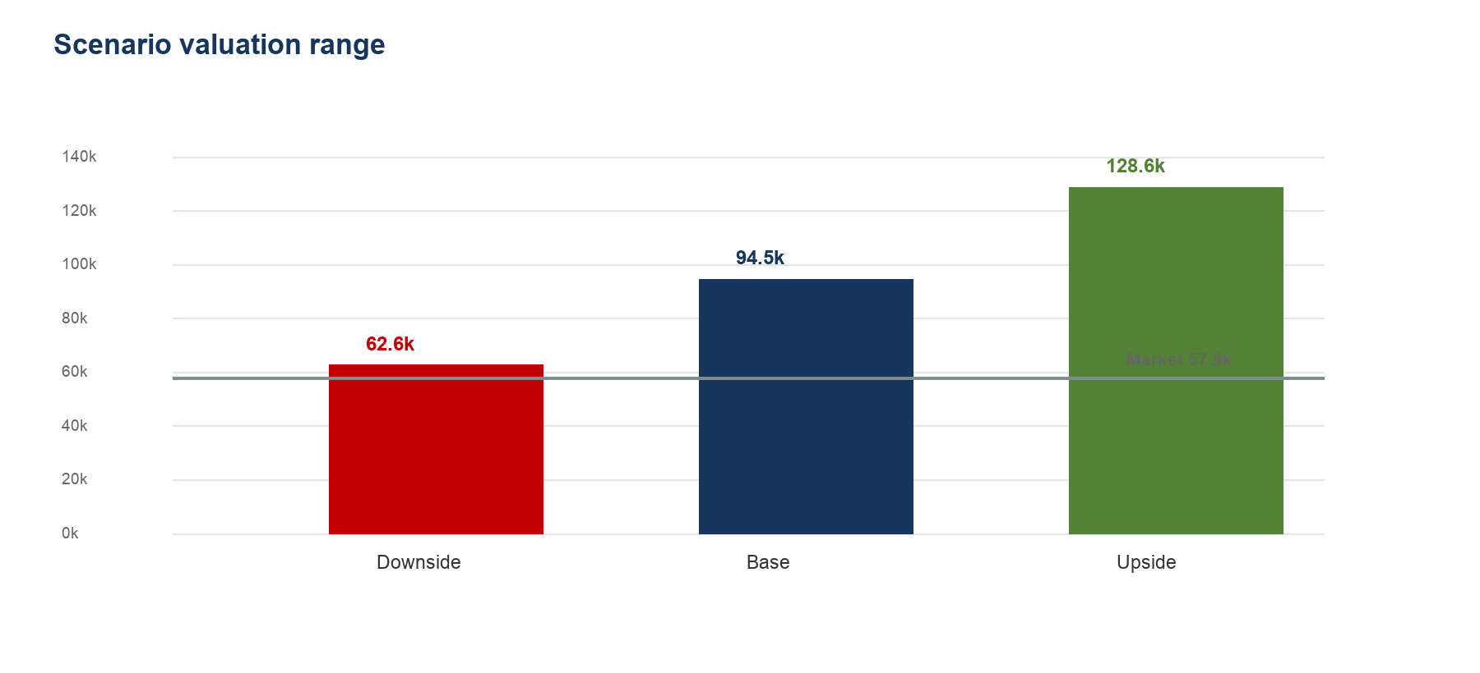
Figure 3 Blended value across operating and valuation scenarios
Case | WACC | g | Associate P/E | Cross-check P/E | Blended value
Downside | 11.89% | 3.0% | 11.0x | 12.0x | VND 62,635
Base | 10.89% | 4.0% | 14.0x | 15.0x | VND 94,498
Upside | 10.14% | 4.5% | 17.0x | 18.0x | VND 128,650

Live monitor
Indicator | Actual | Green | Red | Status
8M revenue growth | 13.5% | >=13.0% | <10.0% | GREEN
8M PBT growth | 17.5% | >=17.0% | <12.0% | GREEN
H1 EBIT margin | 14.8% | >=14.7% | <14.0% | GREEN
H1 OCF / parent PAT | -22.7% | >=70.0% | <30.0% | RED
H1 capex / revenue | 5.1% | <=5.5% | >6.5% | GREEN
Accounting basis | Equity method | Reconciled | Unreconciled | AMBER

Escalation rules
- Keep Base while revenue growth, EBIT margin and signed revenue remain at or above green thresholds.
- Re-underwrite if revenue growth falls below 10%, EBIT margin falls below 14%, or capex exceeds 6.5% of revenue.
- Reduce or exit if two or more live indicators are red or if refreshed blended value loses its required margin of safety.
- Do not add to the position before FY2026 operating cash flow shows a substantial second-half reversal.

Risks, next evidence and source basis
Risk | Transmission | Evidence | Model response
Cash conversion | FCFF below earnings | OCF, receivables, payables | Raise NWC intensity
Margin execution | Lower NOPAT and EPS | Segment margins and utilization | Cut recovery path
Demand | Lower revenue CAGR | Signed revenue conversion | Reduce growth
Capital intensity | Lower near-term FCFF | Maintenance vs growth capex | Raise capex ratio
Accounting basis | False trend comparisons | Common-basis disclosure | Maintain SOTP separation
Valuation duration | Sensitivity to WACC and g | Terminal-value share | Require wider margin of safety

Evidence required next
- FY2026 operating cash flow and the receivables, payables and deferred-expense bridge.
- FY2026 capex split between maintenance and growth projects.
- FPT Telecom revenue and profit contribution under the equity method.
- Conversion of H1 signed revenue into recognised Global IT revenue.
- Margin progression in Japan, domestic IT and AI-related work.

Primary sources
FPT information disclosures https://fpt.com/en/ir/information-disclosures
FPT H1 2026 results https://fpt.com/vi/tin-tuc/6-thang-dau-nam-2026-loi-nhuan-truoc-thue-cua-fpt-tang-truong-18-1
FPT 8M2026 operating update https://fpt.com/en/news/minister-of-science-and-technology-trust-and-credibility-have-driven-fpt-s-success-in-japan
Vietnam 10-year yield history https://www.investing.com/rates-bonds/vietnam-10-year-bond-yield-historical-data
Market snapshot https://taichinh.com/chung-khoan/fpt

Analyst statement
The valuation is a point-in-time analytical output, not a promise of realised value. Public facts, model assumptions and decision rules are separated throughout the workbook and reproducible Python implementation. Clock A remains frozen for backtest integrity; Clock B is the current view as of 9 October 2026.

