C -> F

Begin   
 Input C  
 F = (9*C)/5+32  
 Print F

End  
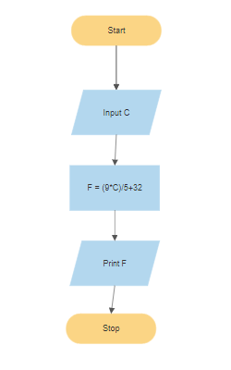

_______________________________

F -> C  
Begin

Input F  
 C = F-32/1,8

Print C  
End

