

TPV e-commerce

# WEBSITE E-COMMERCE

## Revision History

|  |  |  |  |
| --- | --- | --- | --- |
| **Date** | **Version** | **Description** | **Author** |
| <28/2/25> | <1.0> | SRS 1.0 | TPV e-commerce |
| <6/3/25> | <1.2> | SRS 1.2 | TPV e-commerce |
| <7/3/25> | <1.3> | SRS 1.3 | TPV e-commerce |

## Member

|  |  |
| --- | --- |
| **Name** | **Role** |
| Nguyễn Thanh Tâm | Nhóm trưởng |
| Trần Minh Pháp | Thành viên |
| Bùi Thanh Vương | Thành viên |

## Introduction

-In the context of modern technology growing, online shopping has become an indispensable part of today's life. E-commerce platforms such as Shopee, Lazada or Tiktok have changed the way consumers choose and shop for products, helping them access goods more easily, quickly and conveniently. Group K recognized the great potential of this online shopping market, so the group decided to develop an online sales website, aiming to bring the most modern, convenient and optimal shopping experience to customers.

## II. Main Features

### **i. Overall Use-case**

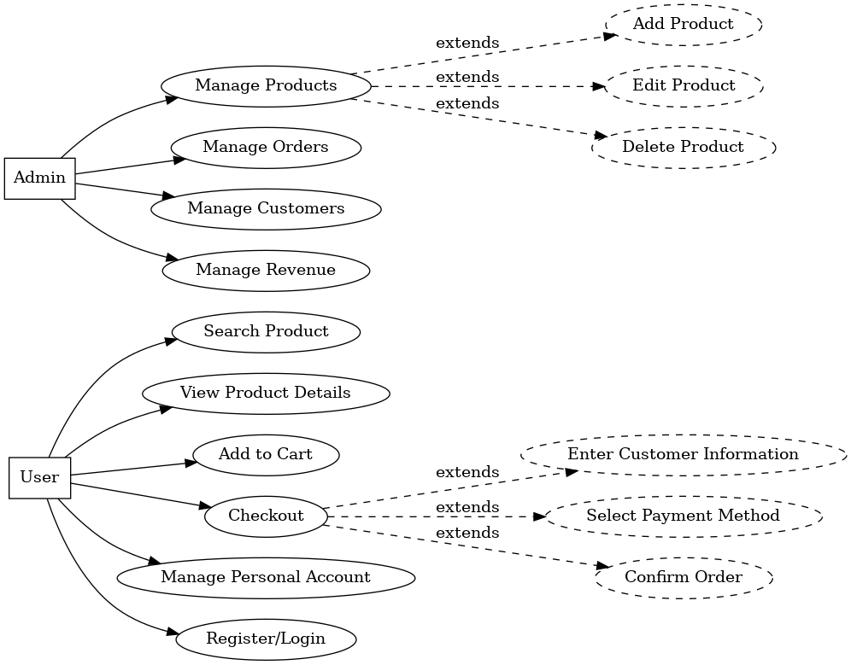

### Sơ đồ ERD:

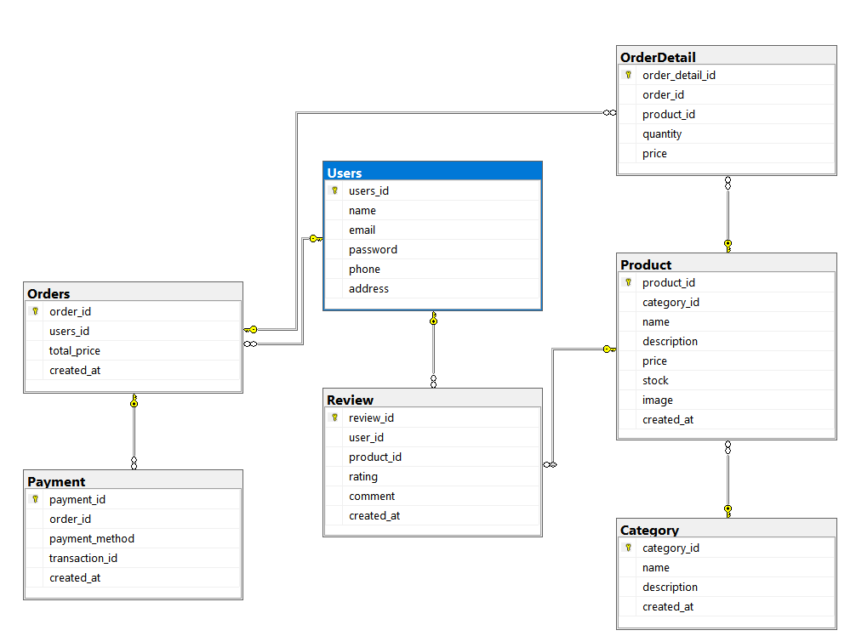

# Mô tả:

## Users

|  |  |  |  |
| --- | --- | --- | --- |
| STT | Field | Function | Constraint |
| 1 | users_id | Unique identifier for each user | Primary Key, Auto Increment |
| 2 | name | User's full name | NOT NULL |
| 3 | email | User's email address | Unique, NOT NULL |
| 4 | password | User's login password | NOT NULL |
| 5 | phone | User's contact number | Optional |
| 6 | address | User's home address | Optional |

## Category

|  |  |  |  |
| --- | --- | --- | --- |
| STT | Field | Function | Constraint |
| 1 | category_id | Unique identifier for each category | Primary Key, Auto Increment |
| 2 | name | Name of the category | NOT NULL |
| 3 | description | Details about the category | Optional |
| 4 | created_at | Timestamp of category creation | Default: GETDATE() |

## Product

|  |  |  |  |
| --- | --- | --- | --- |
| STT | Field | Function | Constraint |
| 1 | product_id | Unique identifier for each product | Primary Key, Auto Increment |
| 2 | category_id | Foreign key referencing Category | NOT NULL, ON DELETE CASCADE |
| 3 | name | Product name | NOT NULL |
| 4 | description | Details about the product | Optional |
| 5 | price | Price of the product | NOT NULL |
| 6 | stock | Available quantity in stock | NOT NULL |
| 7 | image | Image path of the product | Optional |
| 8 | created_at | Timestamp of product creation | Default: GETDATE() |

## Orders

|  |  |  |  |
| --- | --- | --- | --- |
| STT | Field | Function | Constraint |
| 1 | order_id | Unique identifier for each order | Primary Key, Auto Increment |
| 2 | users_id | Foreign key referencing Users | NOT NULL, ON DELETE CASCADE |
| 3 | total_price | Total amount of the order | NOT NULL |
| 4 | created_at | Timestamp of order creation | Default: GETDATE() |

## OrderDetail

|  |  |  |  |
| --- | --- | --- | --- |
| STT | Field | Function | Constraint |
| 1 | order_detail_id | Unique identifier for each order detail | Primary Key, Auto Increment |
| 2 | order_id | Foreign key referencing Orders | NOT NULL, ON DELETE CASCADE |
| 3 | product_id | Foreign key referencing Product | NOT NULL, ON DELETE CASCADE |
| 4 | quantity | Quantity of the product ordered | NOT NULL |
| 5 | price | Price per unit at the time of order | NOT NULL |

## Payment

|  |  |  |  |
| --- | --- | --- | --- |
| STT | Field | Function | Constraint |
| 1 | payment_id | Unique identifier for each payment | Primary Key, Auto Increment |
| 2 | order_id | Foreign key referencing Orders | NOT NULL, ON DELETE CASCADE |
| 3 | payment_method | Method of payment | NOT NULL |
| 4 | transaction_id | Unique transaction identifier | Unique, NOT NULL |
| 5 | created_at | Timestamp of payment processing | Default: GETDATE() |

## Review

|  |  |  |  |
| --- | --- | --- | --- |
| STT | Field | Function | Constraint |
| 1 | review_id | Unique identifier for each review | Primary Key, Auto Increment |
| 2 | user_id | Foreign key referencing Users | NOT NULL, ON DELETE CASCADE |
| 3 | product_id | Foreign key referencing Product | NOT NULL, ON DELETE CASCADE |
| 4 | rating | Rating given to the product | 1-5 (CHECK CONSTRAINT) |
| 5 | comment | User's review comments | Optional |
| 6 | created_at | Timestamp of review submission | Default: GETDATE() |

### **Specifically Functional Requirements**

## 2. Home (Vuong)

### 2.1 Workflows

**Step 1:** User accesses the homepage.

**Step 2:** The system displays a search bar, banner ads, product categories, featured products, and discount information.

**Step 3:** User interacts with any element (search, view categories, click on products, etc.).

**Step 4:** The system processes the request and navigates accordingly.

### 2.2 Contains

|  |  |  |  |  |  |
| --- | --- | --- | --- | --- | --- |
| Field Name | Control Type | Required | Data Type | Default Value | Description |
| Search Bar | Text Input | Yes | String | Empty | Product search bar |
| Banner Ads | Image Slider | No | Image URL | Default Ads | Displays advertisements and promotions |
| Product Categories | List/Grid View | Yes | Array | N/A | Displays product categories |
| Featured Products | Card/Grid Layout | No | Array | Auto-fetch | Displays featured, best-selling, and new products |
| Discount Info | Text/Label | No | String | Empty | Displays discount and promotional information |

### 2.3 Description

**Home:**

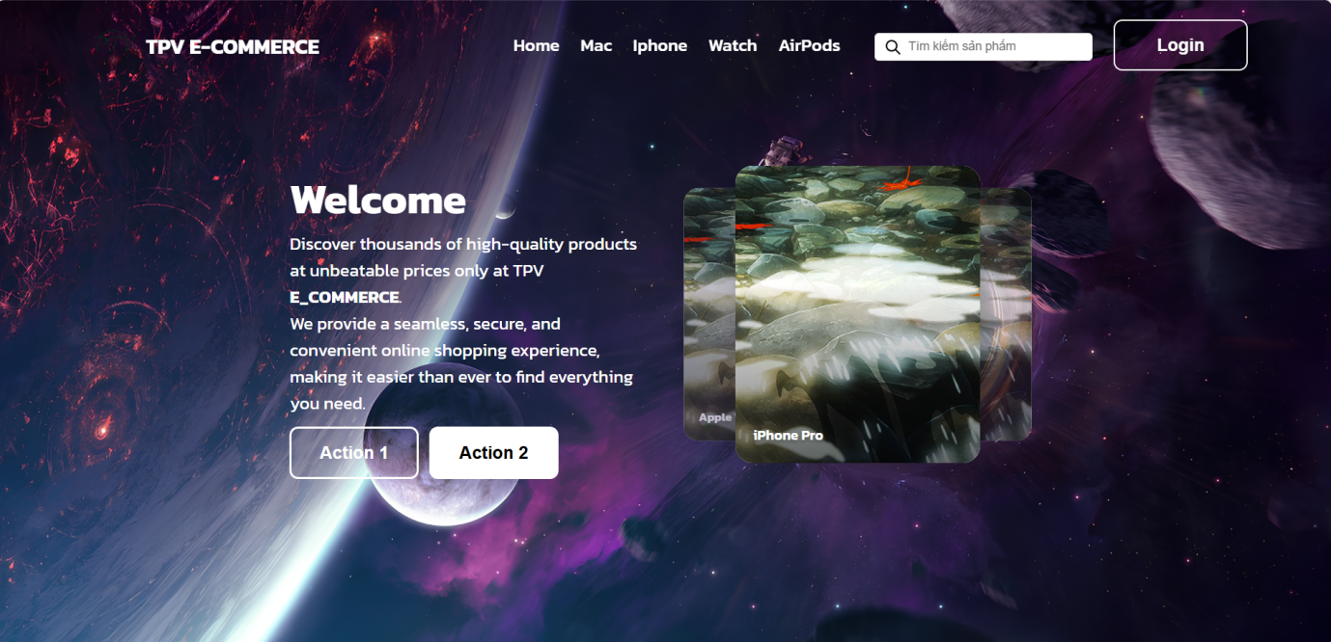

**Product search bar**: Users will be able to find products that match their interests and needs.

**Advertising banners, promotions**: Promotions and offers are offered by the website to attract customers, helping customers experience shopping at a lower price than the original price, the banner contains information about discounted products, best-selling products.

**Featured, best-selling, latest products**: Products with the highest sales will be listed on the banner, and the latest products will be listed and labeled new.

**Discount and offer information**: Discounted products will have information on the product, the discount will be calculated by % or shipping fee... For offers, users will be able to buy discounted products at the original price.

## 3. Product list ()

### 3.1 Workflows

**Step 1:** User selects a product category from the homepage.

**Step 2:** The system displays the product list with filtering and sorting options.

**Step 3:** User applies filters (e.g., price, brand, rating) or sorting options.

**Step 4:** The system updates the displayed products accordingly.

**Step 5:** User clicks on a product to view details.

### 3.2 Contains

|  |  |  |  |  |  |
| --- | --- | --- | --- | --- | --- |
| Field Name | Control Type | Required | Data Type | Default Value | Description |
| Product Name | Text Label | Yes | String | N/A | Displays the name of the product |
| Price | Text Label | Yes | Float | N/A | Displays the price of the product |
| Image | Image Display | Yes | Image URL | Default Image | Displays the product image |
| Filter Options | Dropdown/List | No | Array | N/A | Allows users to filter products by category, price, brand, etc. |
| Sort Options | Dropdown/List | No | String | N/A | Allows sorting by price, popularity, newest, etc. |

### 3.3 Description

**Product list():** Users will hover over items on the navbar, and the product list will appear wherever the user hovers.

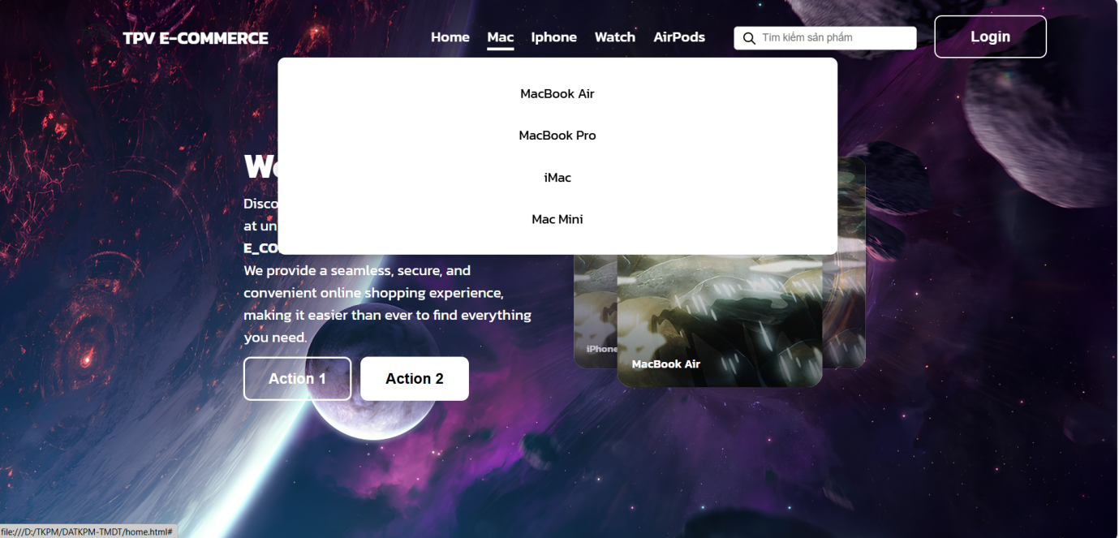

**List of products by category**: For products of the same type such as USB, when users search, only USB products will appear and no other products will appear.

**Filter (price, brand, rating, popularity):** When users select a price range from 500,000 VND - 1,000,000 VND, products with prices in this range will appear. Users will be able to select famous brands such as Apple, Samsung, ...., Rating will allow users to choose a number of stars from 1-5 depending on the level of satisfaction with the product. The products that are most purchased or added to the cart by users are popular products

**Sort products (newest, high/low price):** When users select the newest product, newly updated products will appear first, and for product prices, users can choose prices from high to low and vice versa.

## 4. Shopping cart (Vuong)

### 4.2 Workflows

**Step 1:** User adds products to the cart from the product details page.

**Step 2:** The system updates the shopping cart and displays selected items.

**Step 3:** User reviews the cart, modifies quantity, or removes items.

**Step 4:** The system recalculates the total price.

**Step 5:** User proceeds to checkout.

### 4.3 Contains

|  |  |  |  |  |  |
| --- | --- | --- | --- | --- | --- |
| Field Name | Control Type | Required | Data Type | Default Value | Description |
| Product List | Table/Grid | Yes | Array | Empty | Displays all products added to the cart |
| Quantity | Number Input | Yes | Integer | 1 | Allows users to change the quantity of products |
| Remove Item | Button | Yes | Action | N/A | Allows users to remove an item from the cart |
| Total Price | Text Label | Yes | Float | 0.00 | Displays the total price of the items |
| Checkout | Button | Yes | Action | N/A | Proceeds to the payment process |
|  |  |  |  |  |  |

### 4.3 Description

**Product photos, detailed description**: Each product will have a photo corresponding to that product, when the user clicks on the product, all information of that product will appear.

**Price, promotion**: Each product will have a separate price and promotion. For example: 499,000 - 399,000, 399,000 is the promotional price, 499,000 is the product price

**Customer reviews and comments**: Customer reviews of the product from customers who have purchased will appear below the product.

**Add to cart, buy now button**: When customers like the product but do not want to buy it or for many other reasons, customers can add it to the cart, the products in the cart will not be lost but only when the user deletes it. When clicking buy now, the user will be directed to the payment page.

## 5. Login, Register (Vuong)

### 5.1 Workflows

**Step 1:** User selects the login/register option.

**Step 2:** The system displays a login form for existing users and a registration form for new users.

**Step 3:** User enters credentials and submits the form.

**Step 4:** The system verifies the information:

* If valid, the user is logged in.
* If invalid, an error message is displayed.

**Step 5:** Registered users can now access their account and proceed with shopping.

### 5.2 Contains

|  |  |  |  |  |  |
| --- | --- | --- | --- | --- | --- |
| Field Name | Control Type | Required | Data Type | Default Value | Description |
| Email | Text Input | Yes | String | Empty | User's email for login/register |
| Password | Password Input | Yes | String | Empty | User's password |
| Confirm Password | Password Input | Yes | String | Empty | Only required for registration |
| Login Button | Button | Yes | Action | N/A | Submits login form |
| Register Button | Button | Yes | Action | N/A | Submits registration form |

### 5.3 Description

**register:**

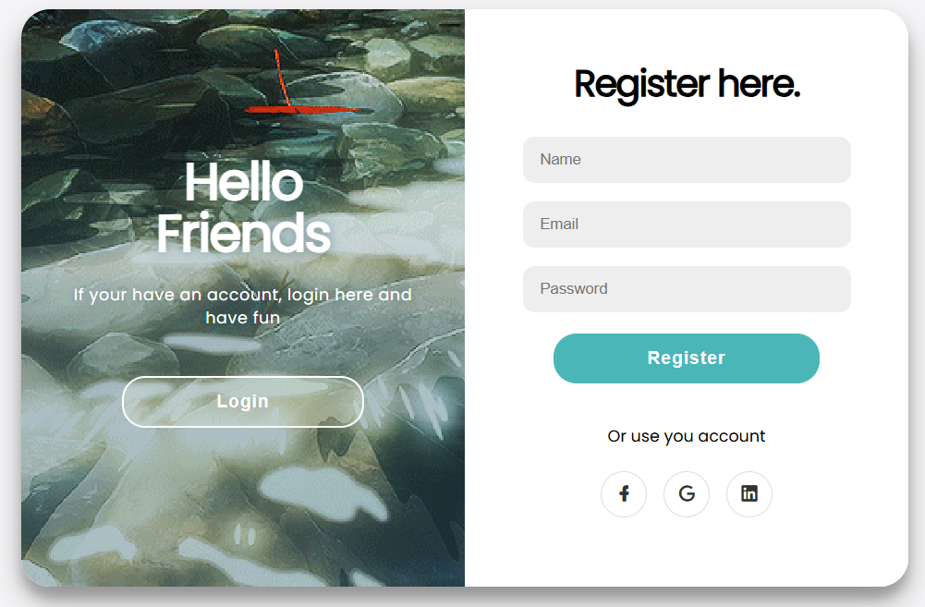

The Registration Function allows users to sign up using their email and phone number. It includes the following key features:

* Input Validation: Ensures that the email and phone number are in the correct format.
* Duplicate Check: Prevents registration with an already registered email or phone number.
* OTP Verification (Optional): Sends a one-time password (OTP) to the email or phone for verification.
* Database Storage: Saves the email and phone number securely in the system’s database.
* User Feedback: Displays success or error messages based on the registration outcome.

**Login:**



The Login Function allows users to access their accounts using their email or phone number. It includes the following key features:

* Credential Input: Users enter their registered email or phone number along with their password or OTP (if applicable).
* Input Validation: Ensures correct format for email or phone number.
* Authentication Check: Verifies the provided credentials against stored user data.
* OTP Verification (Optional): Sends a one-time password (OTP) to the email or phone for additional security.
* Session Management: Creates a secure session for authenticated users.
* Error Handling: Displays messages for incorrect credentials or unregistered accounts.

## 6. Pay ()

### 6.1 Workflows

**Step 1:** User proceeds to checkout from the shopping cart.

**Step 2:** The system displays a form to enter shipping and billing details.

**Step 3:** User selects a payment method (e.g., Credit Card, COD, PayPal).

**Step 4:** The system processes the payment:

* If successful, the order is confirmed.
* If failed, an error message is displayed.

**Step 5:** User receives an order confirmation with a summary and estimated delivery date.

### 6.2 Contains

|  |  |  |  |  |  |
| --- | --- | --- | --- | --- | --- |
| Field Name | Control Type | Required | Data Type | Default Value | Description |
| Payment Method | Dropdown/List | Yes | String | Empty | Selects payment method (COD, Credit Card, etc.) |
| Card Number | Text Input | No | String | Empty | Required if credit card is selected |
| Billing Address | Text Input | Yes | String | Empty | User's billing address |
| Total Amount | Text Label | Yes | Float | Calculated | Displays the total order amount |
| Confirm Payment | Button | Yes | Action | N/A | Finalizes the purchase |

### 6.3 Description

**Enter customer information (address, phone number):** Customers will enter their accommodation information so that the seller can bring the product to the user.

**Select payment method**: When the user clicks on Payment, there will be options such as Cash on delivery, QR, Bank...

**Confirm payment**: money will be deducted based on the options in the payment method, the deducted amount will be the total amount.

## 7. Manager ()

### 7.1 Workflows

**Step 1:** Admin logs into the management dashboard.

**Step 2:** The system displays options to manage products, orders, customers, and revenue reports.

**Step 3:** Admin selects a management option:

* Add/Edit/Delete products.
* View/Process orders.
* Manage customer accounts.
* View revenue reports.

**Step 4:** The system processes the admin’s request and updates data accordingly.

**Step 5:** Admin logs out after completing tasks.

### 7.2 Contains

|  |  |  |  |  |  |
| --- | --- | --- | --- | --- | --- |
| Field Name | Control Type | Required | Data Type | Default Value | Description |
| Manage Products | Button | Yes | Action | N/A | Allows admin to add, edit, or delete products |
| Manage Orders | Button | Yes | Action | N/A | Allows admin to view and process orders |
| Manage Users | Button | Yes | Action | N/A | Allows admin to manage customer accounts |
| Revenue Reports | Button | Yes | Action | N/A | Displays sales and revenue data |
| System Settings | Button | No | Action | N/A | Allows admin to configure website settings |

### 7.3 Description

**Product management**: For products on the web, the admin will manage the product updates on the web, this can only be done with the admin account.

**Order management**: Orders that users have placed will appear in the admin's order management section, authorized people will prepare the goods and deliver them to users in the fastest and most optimal way.

**Account management**: For customer information accounts will be kept confidential, and personal information can only be viewed by that user, avoiding customer information disclosure.

**Revenue management**: Revenue will be totaled for the day, calculated by the total number of invoices sold.

## 8. Product Details (Tam)

### 8.1 Workflows

### 8.2 Contains

### 8.3 Description

## 9. User Account (Tam)

### 9.1 Workflows

### 9.2 Contains

### 9.3 Description