Game★Mite
User Manual
Revision 1.0.0
by Tom Williams, Mick Gulovsen & Bill McKinley

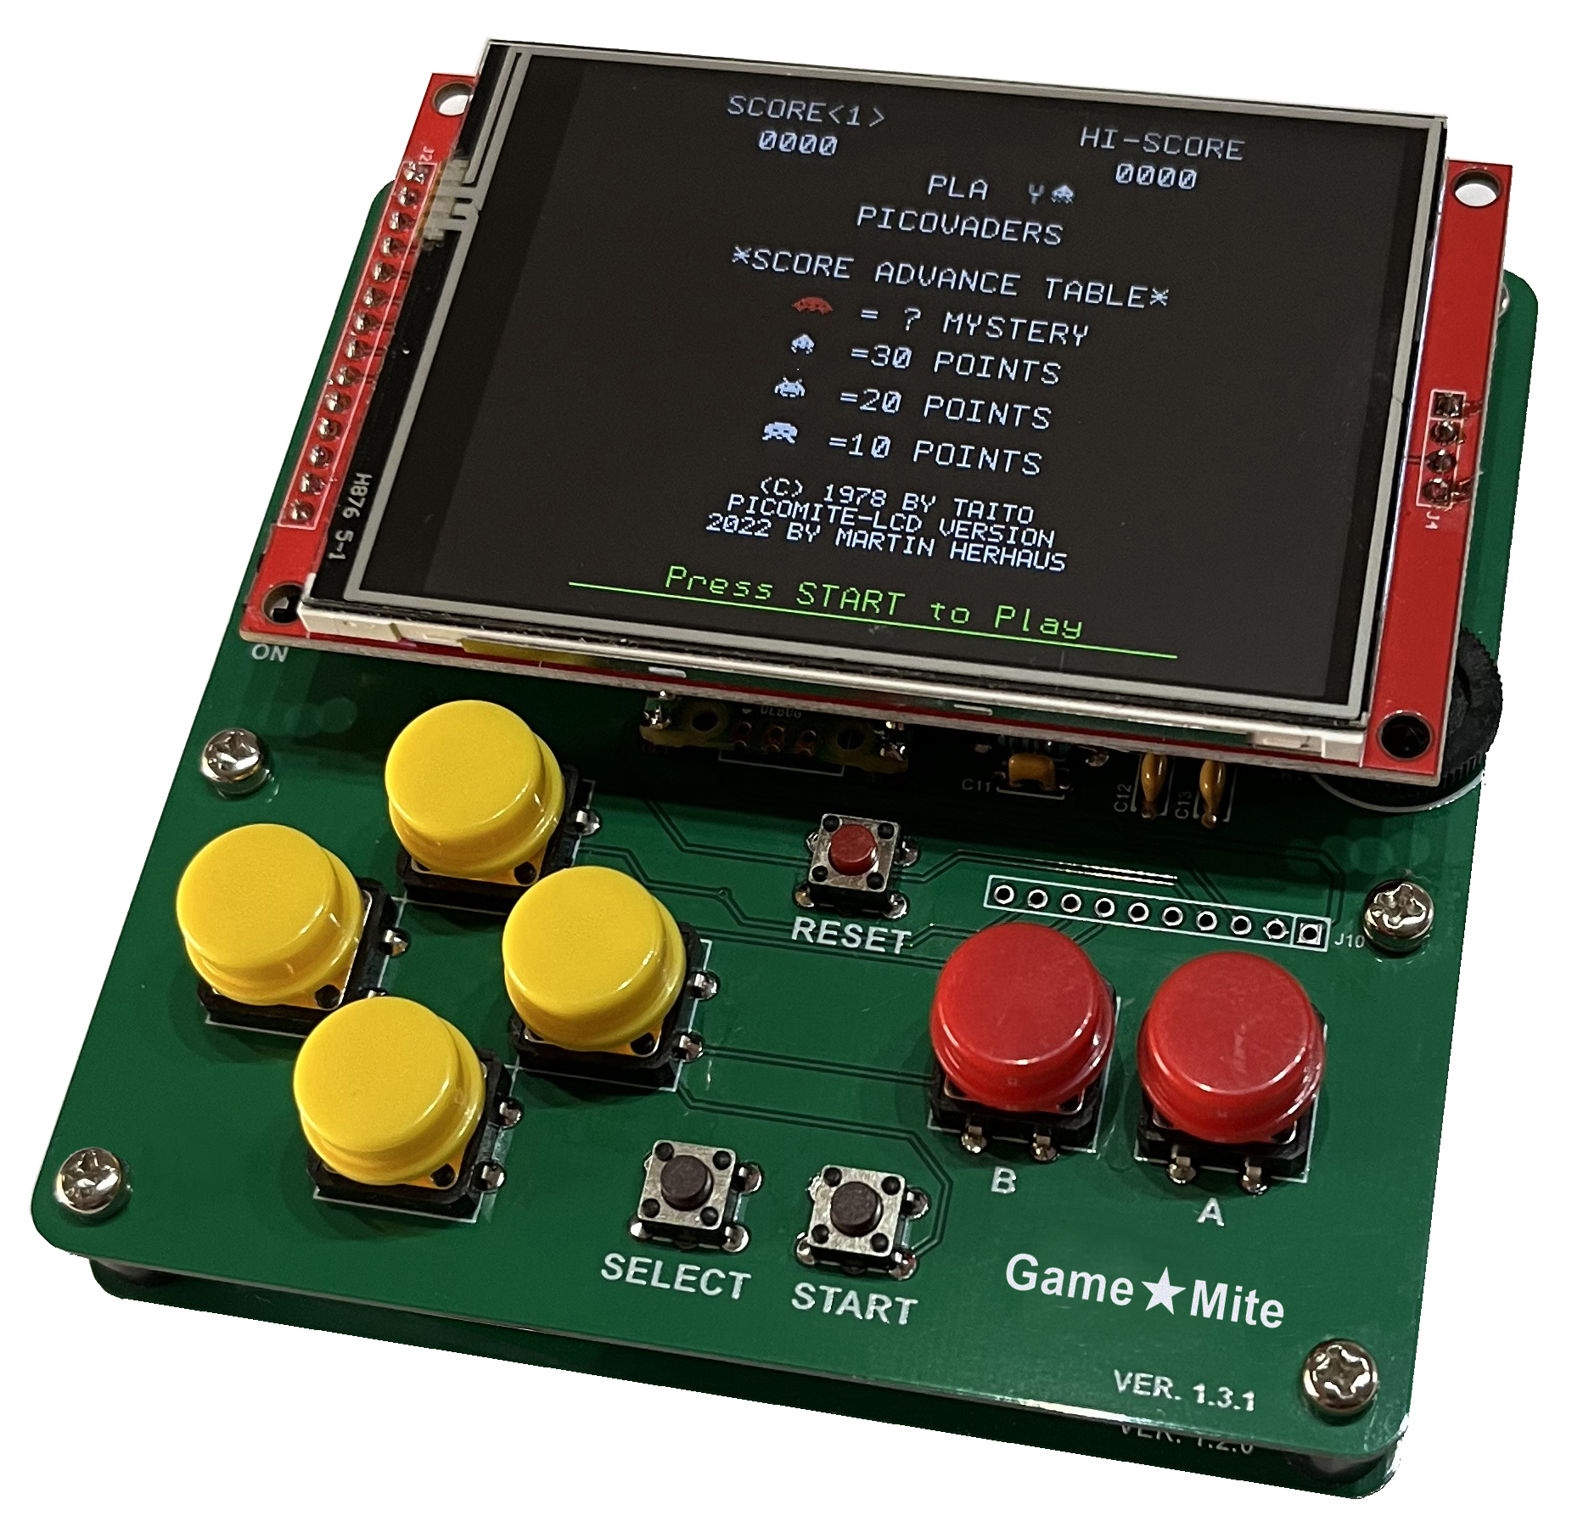

Table of Contents
Table of Contents 2
Copyright and Acknowledgements 3
1. Introduction 4
Features 4
Support 4
2. Building the GameMite 5
A note about the modules 5
The male pins 6
Resistors and capacitors 7
Connecting the speaker (J5) and battery (J8) 7
Finalising the build 8
Charging the battery 8
3. Installing the GameMite software 8
4. Programming the GameMite 10
Reading the controller 10
Appendix A - Schematic 11
Appendix B - Bill of materials 12
Appendix C - Differences from the standard PicoMite firmware 15
Customised serial console banner 15
Automatically sets default GameMite OPTIONs 15
Does not clear OPTION AUTORUN on “sigbus” error 15
Uncaught errors displayed on TFT panel 15
New MM.INFO sub-functions 15
Appendix D - Alternative software installation instructions 16
Loading the firmware 16
Virtual serial port 17
Terminal emulator 17
The console 17
Installing the MMBasic programs 18
Appendix E - Miscellanea 19
Audio circuit 19
Adjusting the trimpot on the PAM8302A module 19
Battery charging circuit 20
TFT display brightness 20
TFT 3v3 regulator 20
SD card troubleshooting 20
TFT SPI screen layout 21

Revision History
1.0.0 | Initial release for GameMite firmware/software v1.0.x and PCB v1.3.x.

Copyright and Acknowledgements
GameMite hardware © 2023 Thomas Hugo Williams (@thwill):
- Original concept and prototype by Thomas Hugo Williams based on the “PicoMite Backpack” by Mick Ames (@Mixtel90).
- PCB designed by Mick Gulovsen (@bigmik) hindered by Thomas Hugo Williams and Bill McKinley (@Turbo46).
- Published under the CC BY 4.0 license.
- https://www.sockpuppetstudios.com
GameMite MMBasic program suite by Thomas Hugo Williams and friends:
- See individual programs for copyright and licensing specifics.
GameMite User Manual © 2023 Thomas Hugo Williams, Mick Gulovsen and Bill McKinley
- Published under the CC BY 4.0 license.
- The instructions for loading the firmware and attaching a terminal emulator were adapted with permission from the PicoMite User Manual: https://geoffg.net/Downloads/picomite/PicoMite_User_Manual.pdf.
PicoMite/MMBasic firmware:
- https://geoffg.net/picomite.html
- Copyright 2011-2023 Geoff Graham
- Copyright 2016-2023 Peter Mather
- Customisations for GameMite by Thomas Hugo Williams https://github.com/thwill1000/picomite-firmware/tree/gamemite.
Special thanks to @Martin H, @Mozzie, @Volhout and our other friends from “The Back Shed” forum: https://www.thebackshed.com/forum/Microcontrollers.

1. Introduction
The GameMite is a “build it yourself” handheld game console based on the Raspberry Pi Pico microcontroller running a customised version of the PicoMite firmware.

Features
- Raspberry Pi Pico Microcontroller
- 320x240 ILI9341 SPI TFT display + integrated SD card reader
- NES style game controller (very clicky)
- Mono audio via PWM capable of playing 4 notes simultaneously
- 3v7 LiPo battery with charging and protection circuit
- MMBasic programming language

Support
Support questions should be raised on “The Back Shed” forum (https://www.thebackshed.com/forum/Microcontrollers) where the developers of the GameMite and the PicoMite firmware and many other MMBasic users are regulars.

2. Building the GameMite
Construction of the GameMite is fairly straightforward and can be completed by those who have a basic knowledge of soldering through hole components, there are no surface mounted components to worry about.
That aside there are a few areas that can be a bit tricky, but if done in the order set out here you shouldn’t have any real problems to complete the build.
Of course, the usual safety precautions should always be adhered to; wear glasses when trimming wires, and whilst soldering, and be careful handling the hot soldering iron.
See the bill of materials (Appendix B) and the overlay image below, for component orientation and values.
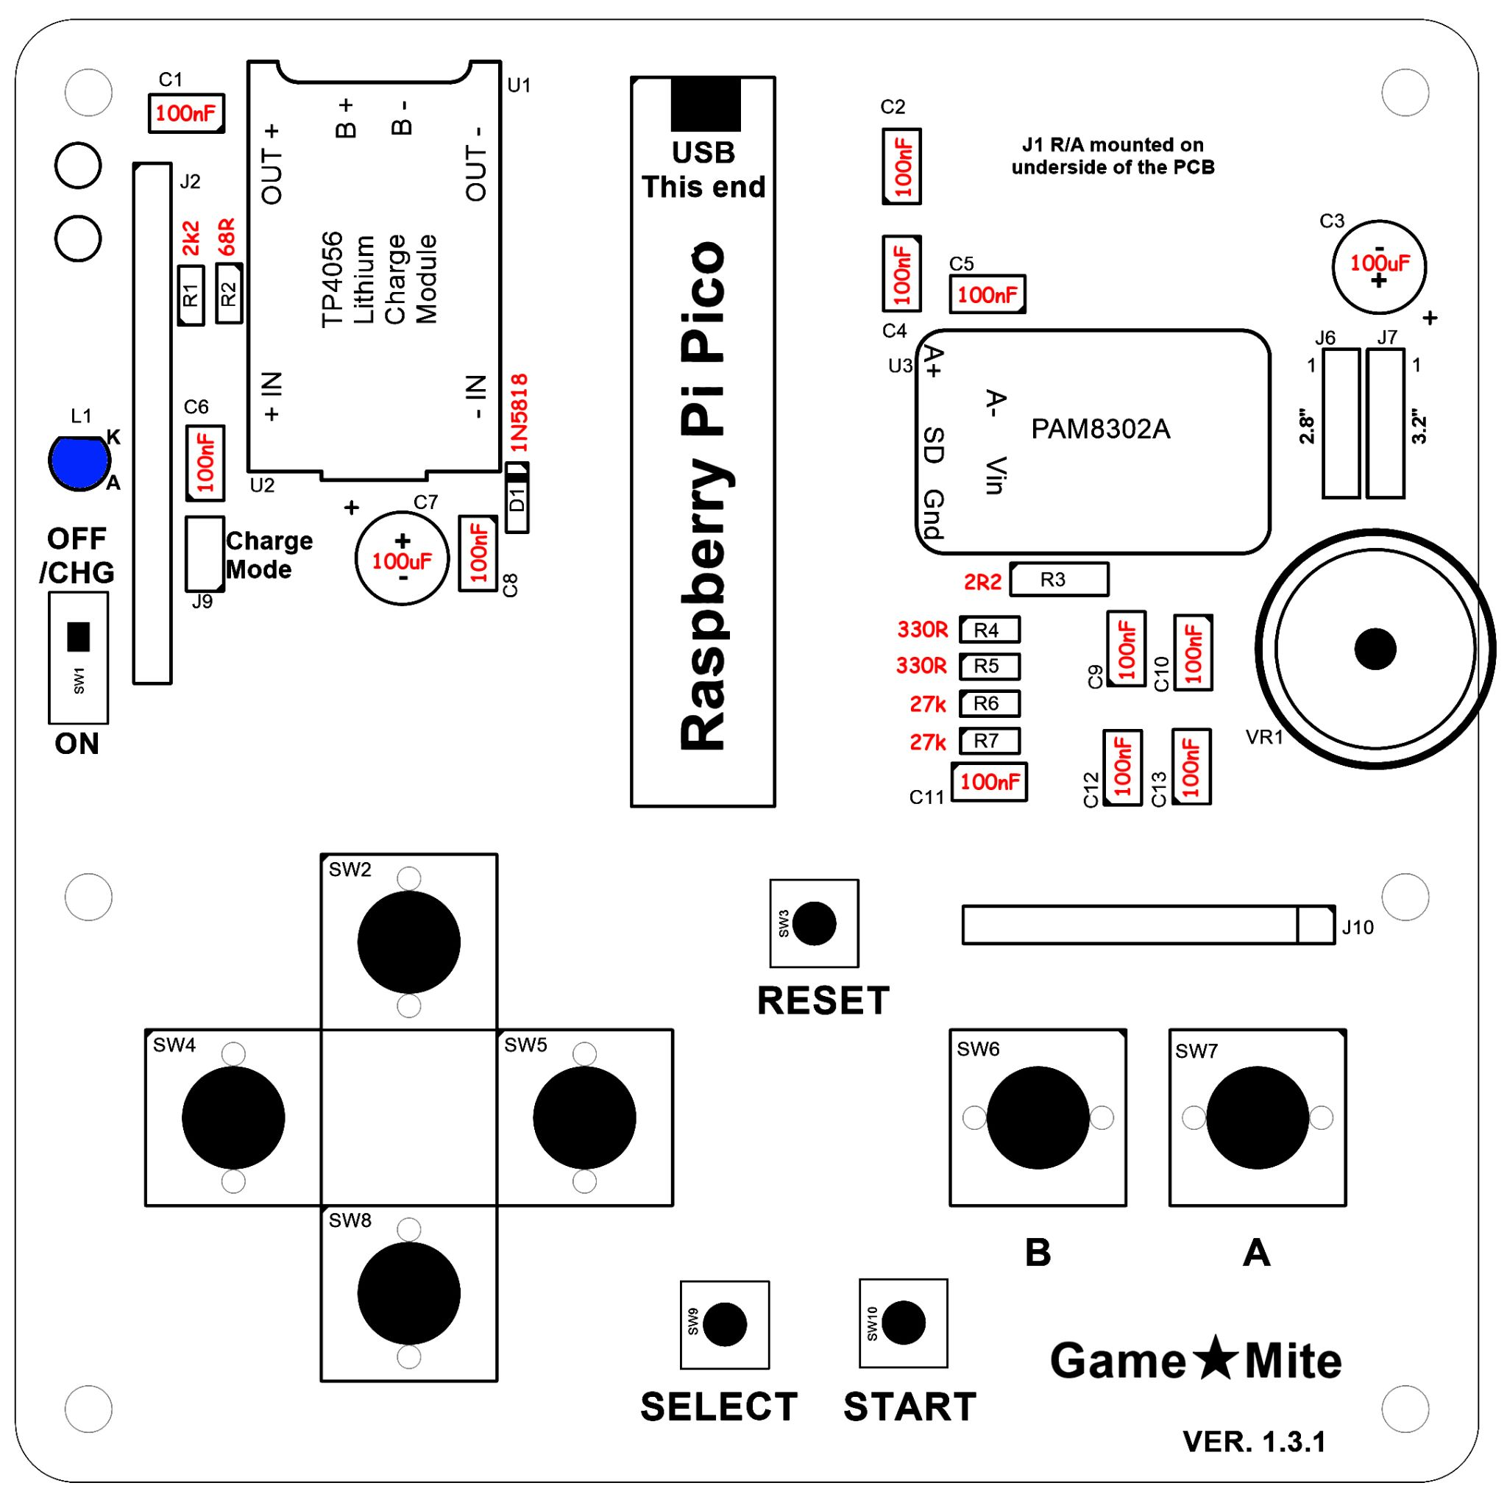
IMPORTANT: Two copies of the PCB are used in construction; the top one has the components soldered to it, the bottom one serves as a baseplate and somewhere to attach the speaker and battery. If you bought your GameMite as a kit then it is possible that the PCB supplied for use as the baseplate is an older revision. Check the version number (lower right hand corner) of both PCBs and ensure that you only solder components to the one with the higher version.

A note about the modules
If you don’t read any further, make sure you read this paragraph!
The GameMite uses 3 modules as part of its build, namely: The Raspberry Pi Pico, TP4056 lithium manager and a PAM8302A amplifier. It is strongly recommended that all three modules should be spaced off the PCB by soldering them onto standard male header pins.
- DO NOT socket the modules as there is insufficient room under the TFT.
- DO NOT directly solder the Pico to the PCB using its castellated pads as you then won’t be able to insert a micro USB cable.

The male pins
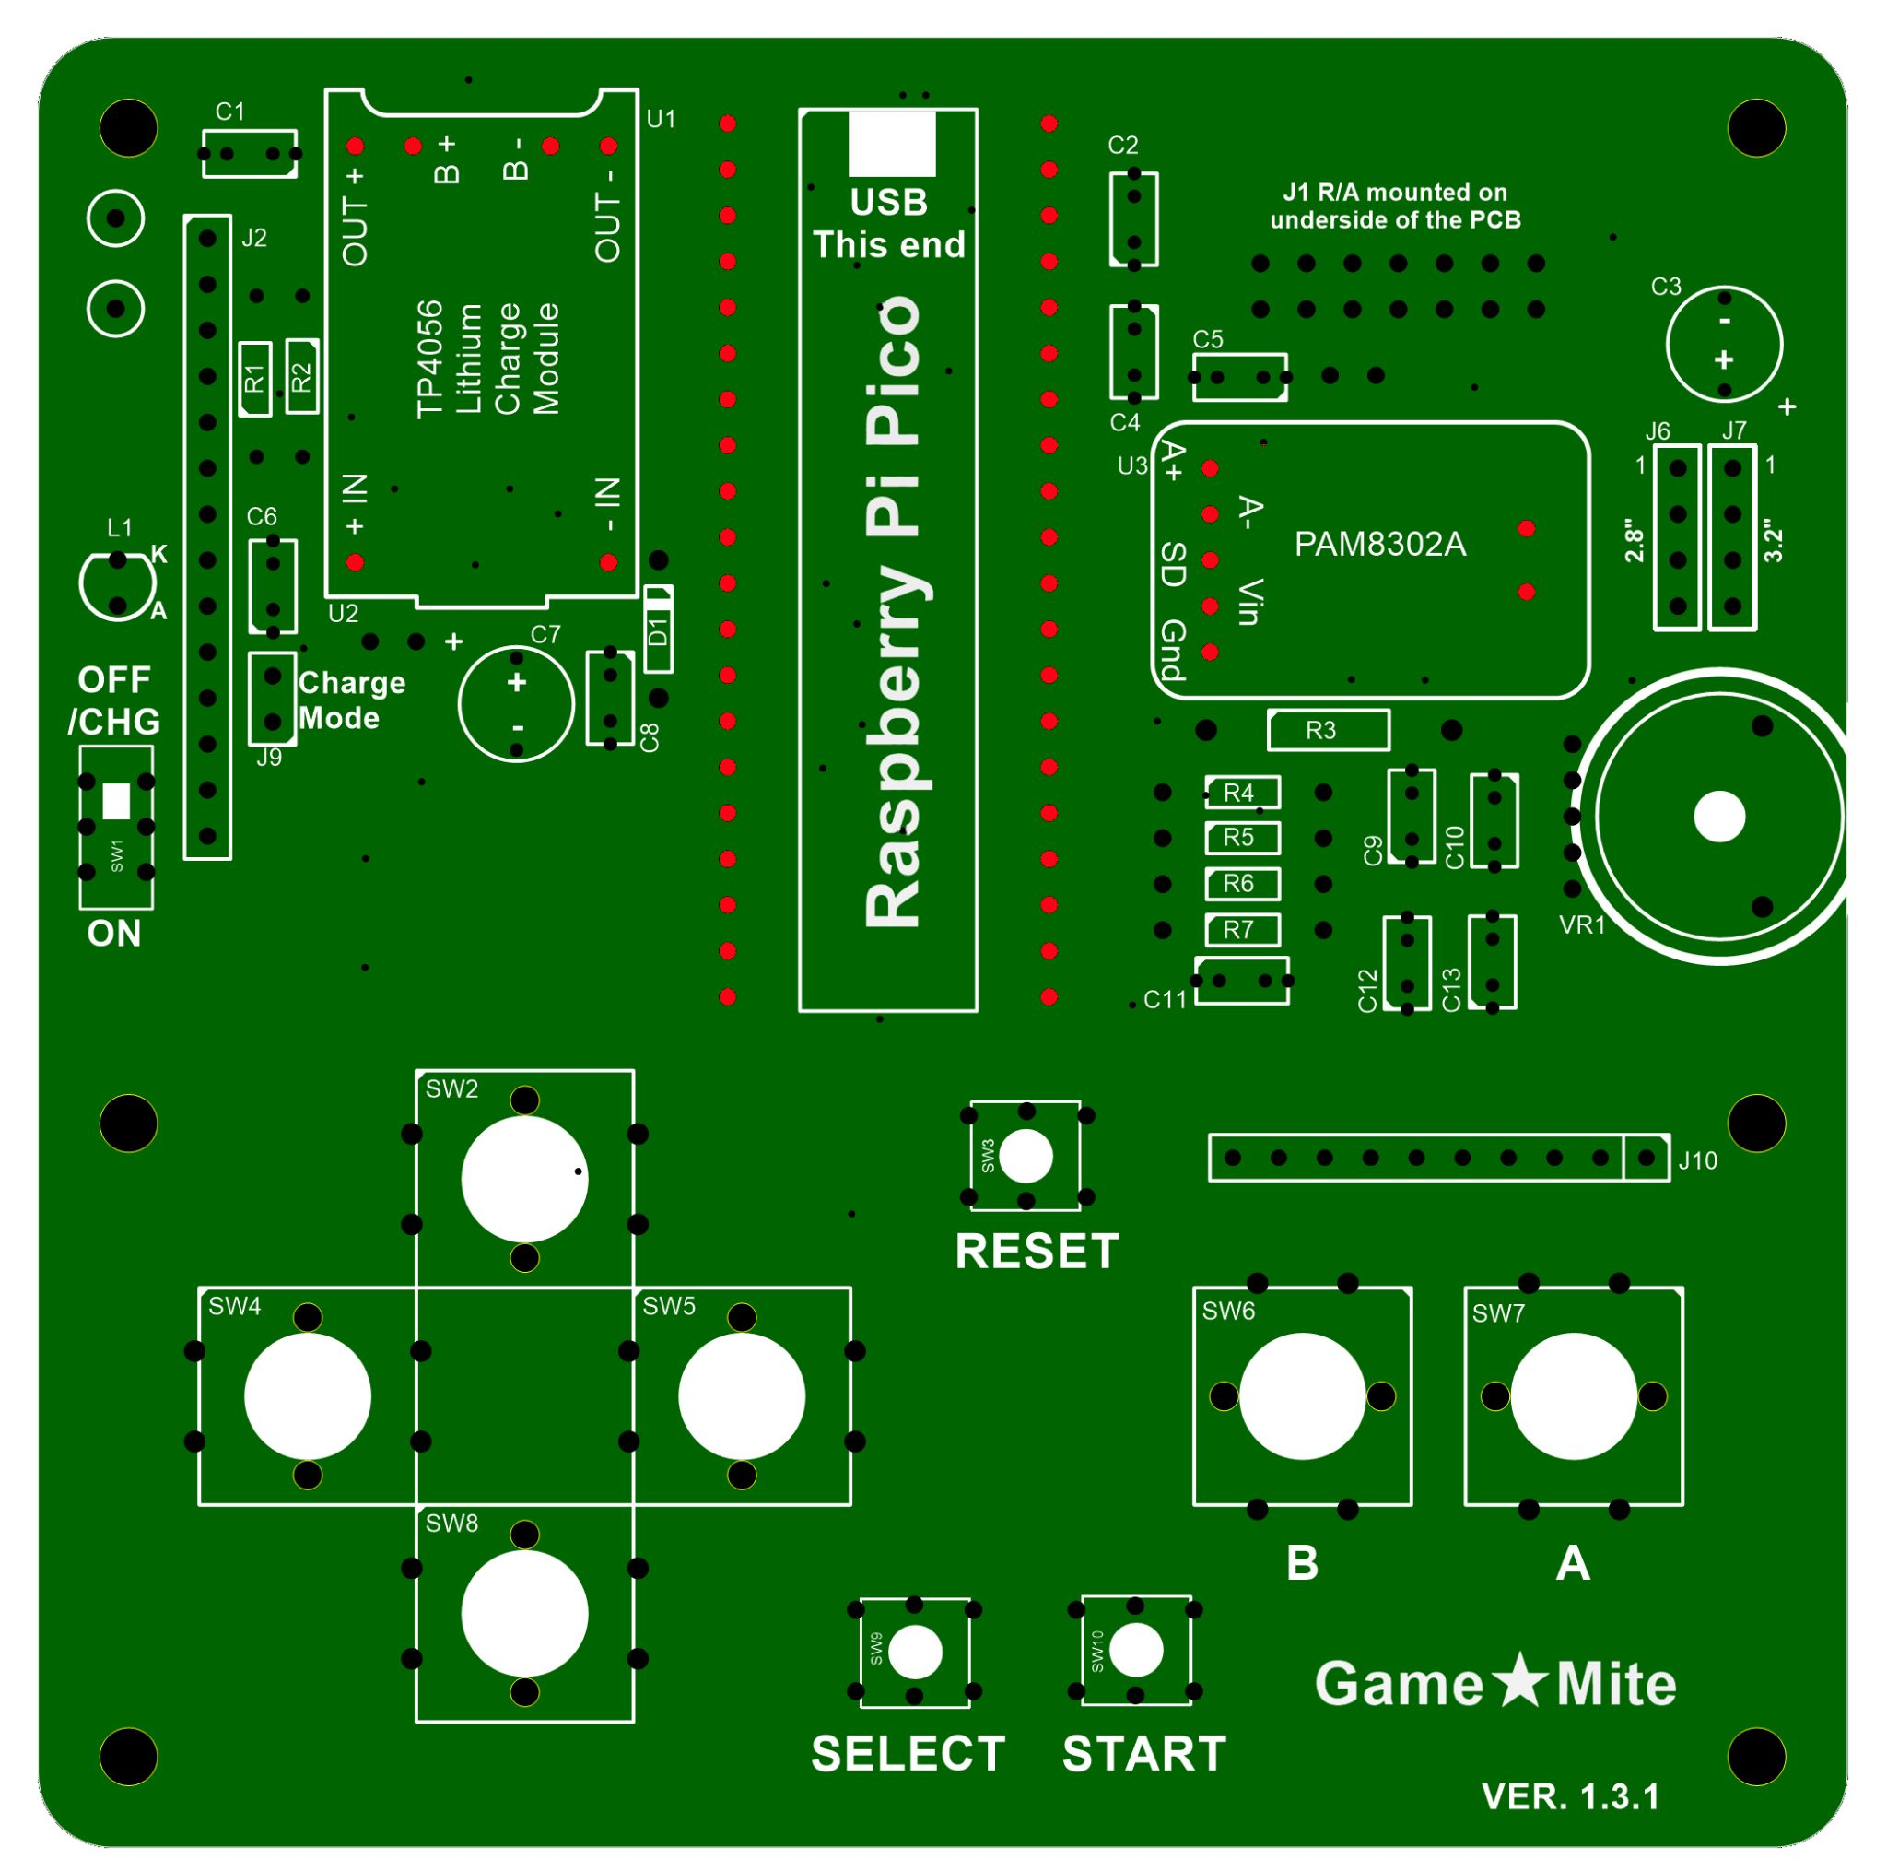
Normally, construction would begin with the passive components (resistors, capacitors etc.) but several components are on their own modules with pin spacings that are not all 2.54mm (0.1”). As a result individual pins have to be cut from strips and soldered onto the PCB, getting them all aligned perfectly square can be a bit awkward.
One way to achieve this is to use a second PCB as a jig:
- Insert male pins into the PCB you are assembling, long side down from the top, in the locations shown in RED .
- Place a second PCB over the top of the short side of these pins sandwiching them between the two PCBs.
- Use small clamps, clothes pegs, or elastic bands to hold the assembly together.
- Flip the assembly over and solder the pins to the underside of the first PCB.
- Once soldered, carefully snip off the excess pin length from the underside of the first PCB.
- Remove the second PCB.
- You should be left with the pins, marked in RED, with their short side facing UP. You will solder the modules to these later in the build.
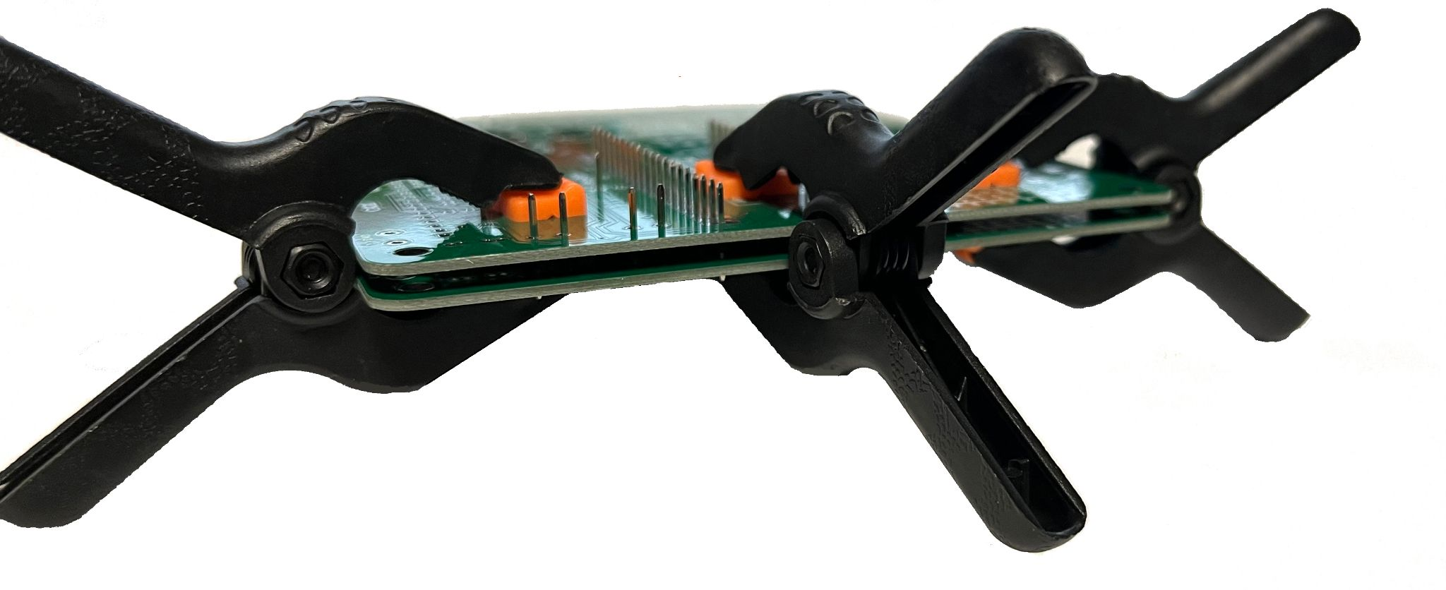
Solder side of the latest version PCB (currently 1.3.1) with long pins protruding

Second PCB to help
locate the pins for soldering

Resistors and capacitors
Refer to the bill of materials (Appendix B) and the overlay for the value of each component and solder them to the GameMite, using the placement that is silk screen printed onto the PCB.
Fit the resistors, 100nF capacitors (the PCB caters for both 2.54mm/0.1" and 5.08mm/0.2'' spacing) and the 1N5818 diode (D1).
DO NOT fit the 2 electrolytic capacitors (C3 & C7) at this time. This is because they can make it more difficult to fit the speaker (J5) and battery (J8) sockets, see next section.
Fit the volume control (thumbwheel trimpot VR1), charging-indicator LED (L1, observe the polarity; the anode is the longer leg and the cathode has a small flat on the edge) and all of the switches (SW1-10).
Fit J9, the “Charge mode” jumper.
Fit J2 and then depending on your TFT module size fit J6 (for 2.8” TFT) or J7 (for 3.2” TFT); only one of these is required but it won't hurt to install both.
Optionally, for test purposes, fit a small half loop of bare wire connecting the two GND test points at the top left of the PCB to provide an attachment point for a crocodile clip.
DO NOT fit anything in the J10 position as this is for a possible future keyboard expansion and the header may interfere with the fire buttons if installed.
Fit the modules: TP4056 (with the USB, which is unused, pointing towards the bottom of the PCB), Raspberry Pi Pico (with the USB pointing towards the top of the PCB) and the PAM8302A into their respective locations and solder them in place.
Use a screwdriver with a small flat blade to carefully turn the miniature trimpot on the PAM8302A module fully clockwise (maximum resistance). WARNING! Do not use a Phillips / cross-head screwdriver; despite appearances to the contrary the screw is not of that type and you will possibly chew up the head. See Appendix E for more details.
Optionally, fit the expansion connector J1 onto the underside of the PCB.

Connecting the speaker (J5) and battery (J8)
The battery and speaker are connected to the underside of the top PCB by flying leads. When attaching them:
- BE CAREFUL to correctly observe the polarity of the battery.
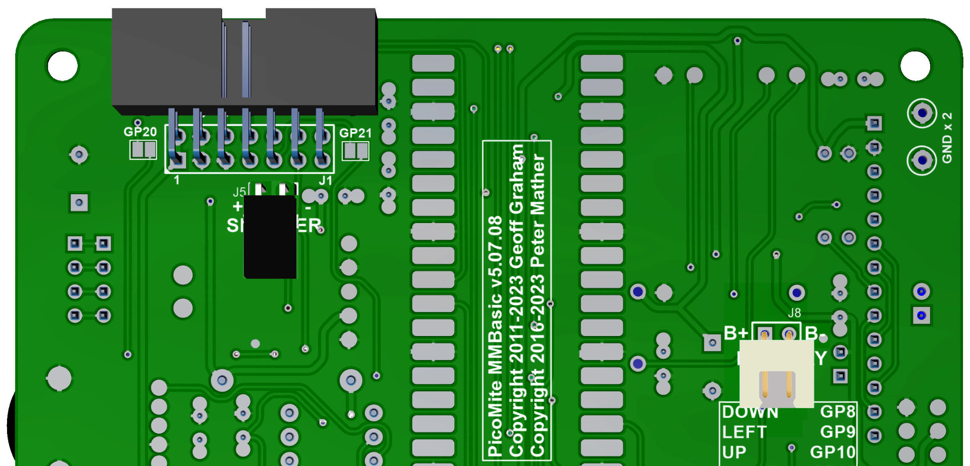
- DO NOT short the battery leads.
- DO NOT swap the speaker and battery.
For the battery we recommend that a polarised connector is used, e.g. on the PCB a right-angle 2-pin JST-XH socket.
For the speaker an unpolarised connector is sufficient, e.g. on the PCB a right-angle female 2-pin 2.54mm pitch standard header.
The flying leads for the battery and speaker will then need the appropriate mates spliced to them with heat shrink tubing or insulation tape applied.
Other connection methods are possible: the pin spacing for both connectors is 2.54mm and will accept standard right-angle male or female headers or small screw terminal blocks; at a pinch you could even directly solder the leads to the PCB.

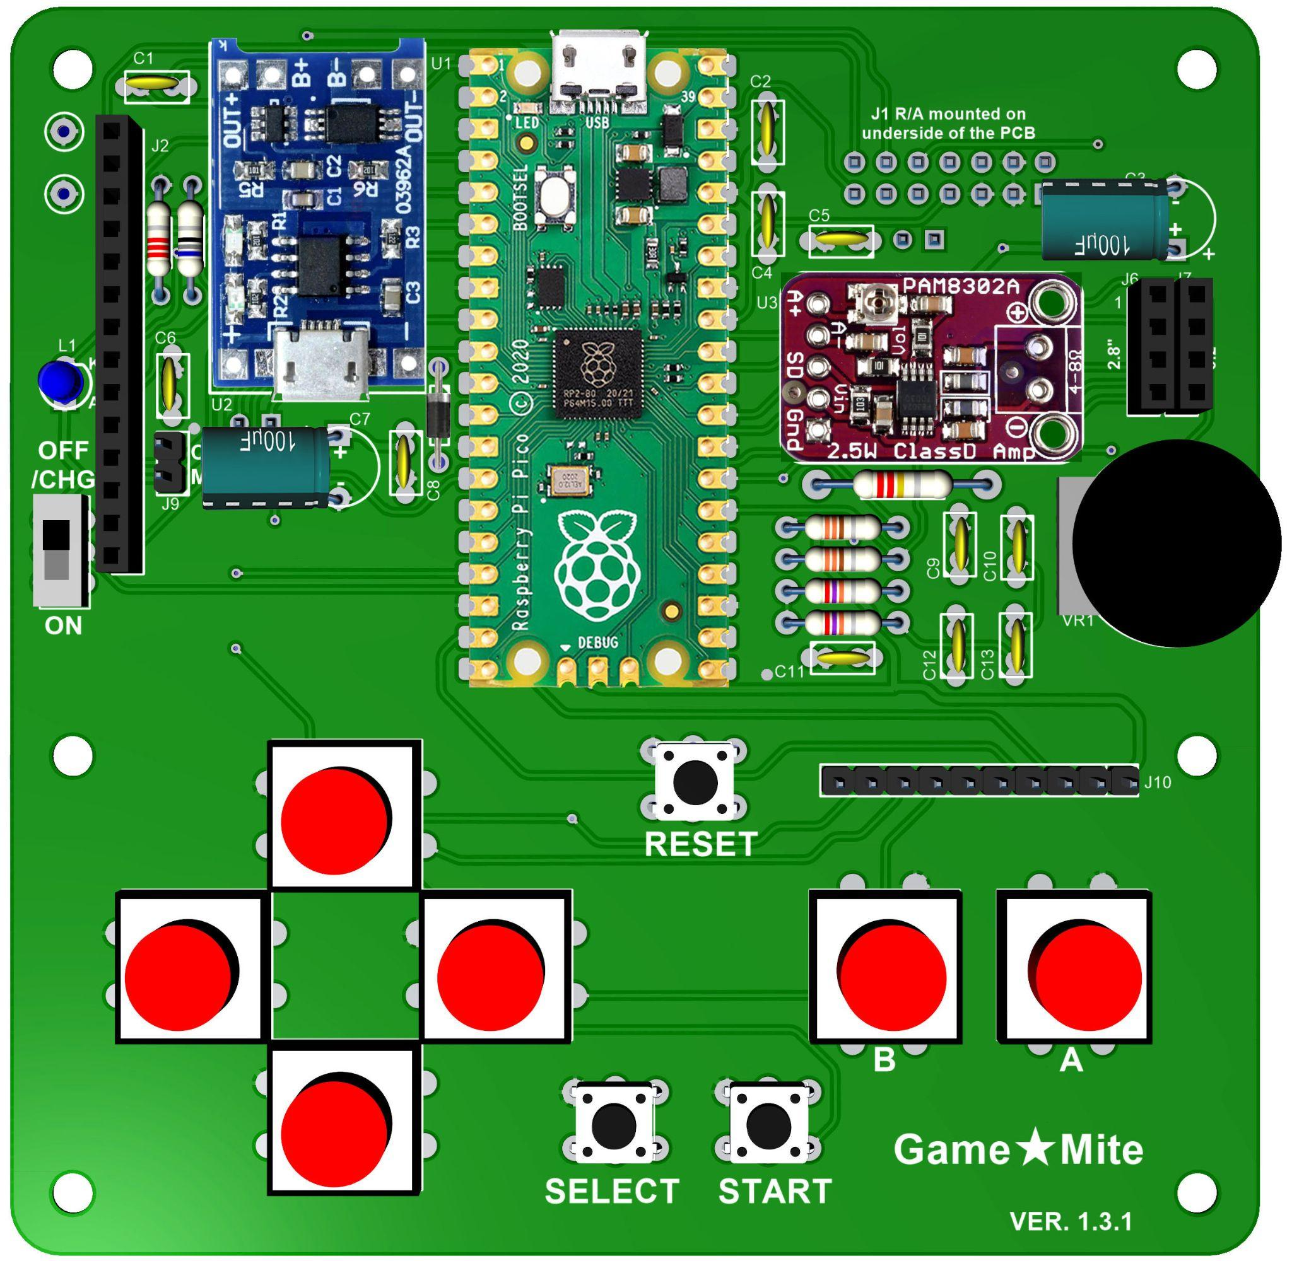
Finalising the build
Fit the 2 electrolytic capacitors (C3 & C7). Observe the polarity and mount them rocked over on their side (see photo of constructed board) to clear the TFT screen when it is fitted (there is 11mm clearance under the TFT).
Fit keycaps onto the 12mm switches then connect the battery, speaker and choice of 2.8” or 3.2” ILI9341 TFT SPI display.
Secure battery and speaker to the top surface of the baseplate PCB, using double sided foam tape or other suitable mounting mechanism.
WARNING! Be very careful to ensure that the pins on the underside of the board are sufficiently trimmed and that the battery will not be pierced by any of them!
Finally mount the main PCB to the baseplate PCVB using 6 x 10-13mm (0.4-0.5”) standoffs (fitting just the 4 corners should be sufficient).

Charging the battery
With SW1 up (OFF/CHG) plug a USB power source into the Raspberry Pi Pico. The 3mm blue LED (L1) will light to indicate that the GameMite is in charge mode; note that this stays lit even when the battery is fully charged. In addition there is a small red LED on the TP4056 which will light whilst the battery charging, once it is fully charged this will be replaced by a small blue LED.
Optionally, if a link is fitted to the “Charge mode” jumper (J9) then the battery will charge irrespective of the position of SW1 provided a USB power source is attached. See Appendix E for more details.
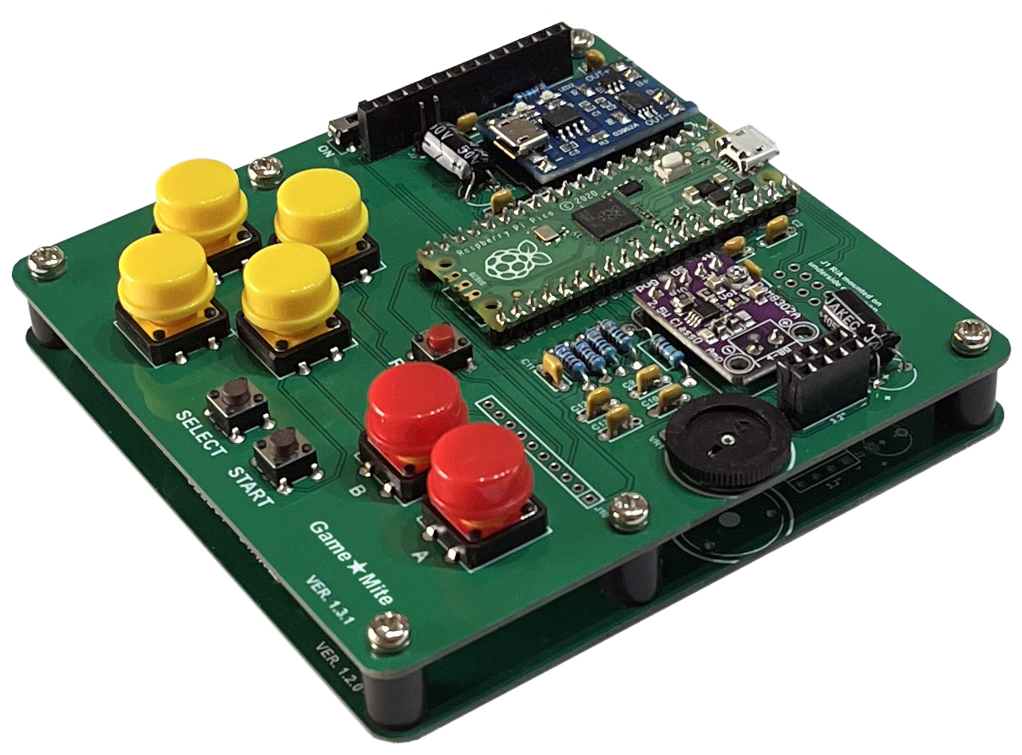
Once the battery has been charged for the first time see Chapter 3 to install the software.

3. Installing the GameMite software
WARNING! The installation process described here will replace the entire contents of the Raspberry Pi Pico’s flash memory erasing any existing content.
The simplest way to install the GameMite software uses a single file image containing both the GameMite’s customised version of the PicoMite firmware and also its MMBasic program suite consisting of a boot menu, tools and games.
Note: see Appendix D for an alternative installation process that allows the firmware and MMBasic program suite to be installed and updated independently of each other.
To install:
- Follow the links from https://github.com/thwill1000/mmbasic-gamemite to download “GameMite-<version>-full.zip”.
- Extract the “GameMite-<version>-full.uf2” file.
- Using a USB cable, plug the Raspberry Pi Pico into your computer (Windows, Linux or Mac) while holding down the white BOOTSEL button on the Raspberry Pi Pico (you will need to remove the TFT display to do this).
- The Raspberry Pi Pico should connect to your computer and create a virtual drive (the same as if you had plugged in a USB memory stick) called “RPI-RP2”. This drive will contain two files which you can ignore.
- Copy the “GameMite-<version>-full.uf2” file to this virtual drive.
- When the copy has completed, the Raspberry Pi Pico will restart and create a virtual serial port on your computer. The LED on the Raspberry Pi Pico will blink slowly indicating that the firmware with MMBasic is now running.
If the LED does not start blinking, then it is possible that the Raspberry Pi Pico’s flash memory was in a previously corrupted state. To fix this install the file https://github.com/thwill1000/mmbasic-gamemite/raw/main/download/flash_nuke.uf2 following the same instructions. This should reset the Raspberry Pi Pico to its factory fresh state from where you can try installing “GameMite-<version>-full.uf2” again.
- The GameMite software should now be set up. If RESET is pressed or the device is power-cycled it should reboot to show the version and copyright message before displaying the boot menu.

4. Programming the GameMite
From a programming aspect the GameMite hardware is just a standard PicoMite with an ILI9341 TFT display attached to it. As such, those who wish to write their own programs for it are directed to the excellent PicoMite User Manual (https://geoffg.net/Downloads/picomite/PicoMite_User_Manual.pdf).
The one non-standard (because there is no PicoMite standard) part of the hardware is the controller layout and how to read this is demonstrated below.

Reading the controller
' simple_ctrl.bas

Cls

' Initialise GP8-GP15 as digital inputs with PullUp resistors
For i% = 8 To 15
SetPin Mm.Info(PinNo "GP" + Str$(i%)), Din, PullUp
Next

Do
' Read digital inputs into the bits of a single integer.
' When a button is pressed the corresponding bit will be set.
' If multiple buttons are pressed simultaneously then multiple
' bits will be set.
x% = Port(GP8, 8) Xor &h7FFF

' Display buttons currently pressed
s$ = ""
If x% And &h01 Then Cat s$, "DOWN "
If x% And &h02 Then Cat s$, "LEFT "
If x% And &h04 Then Cat s$, "UP "
If x% And &h08 Then Cat s$, "RIGHT "
If x% And &h10 Then Cat s$, "SELECT "
If x% And &h20 Then Cat s$, "START "
If x% And &h40 Then Cat s$, "B "
If x% And &h80 Then Cat s$, "A "
If s$ = "" Then s$ = "-- NONE --"
If Len(s$) < 40 Then Cat s$, Space$(40 - Len(s$))
Text 0, 0, s$
Loop

Note: for consistency between GameMite programs it is recommended that the START button is used to start/pause programs and the SELECT button is used to select an item highlighted in a menu. In some instances it might make sense for the A button to start/pause a program or select an item, but this should be in addition to, not instead of the the START and SELECT buttons.

Appendix A - Schematic
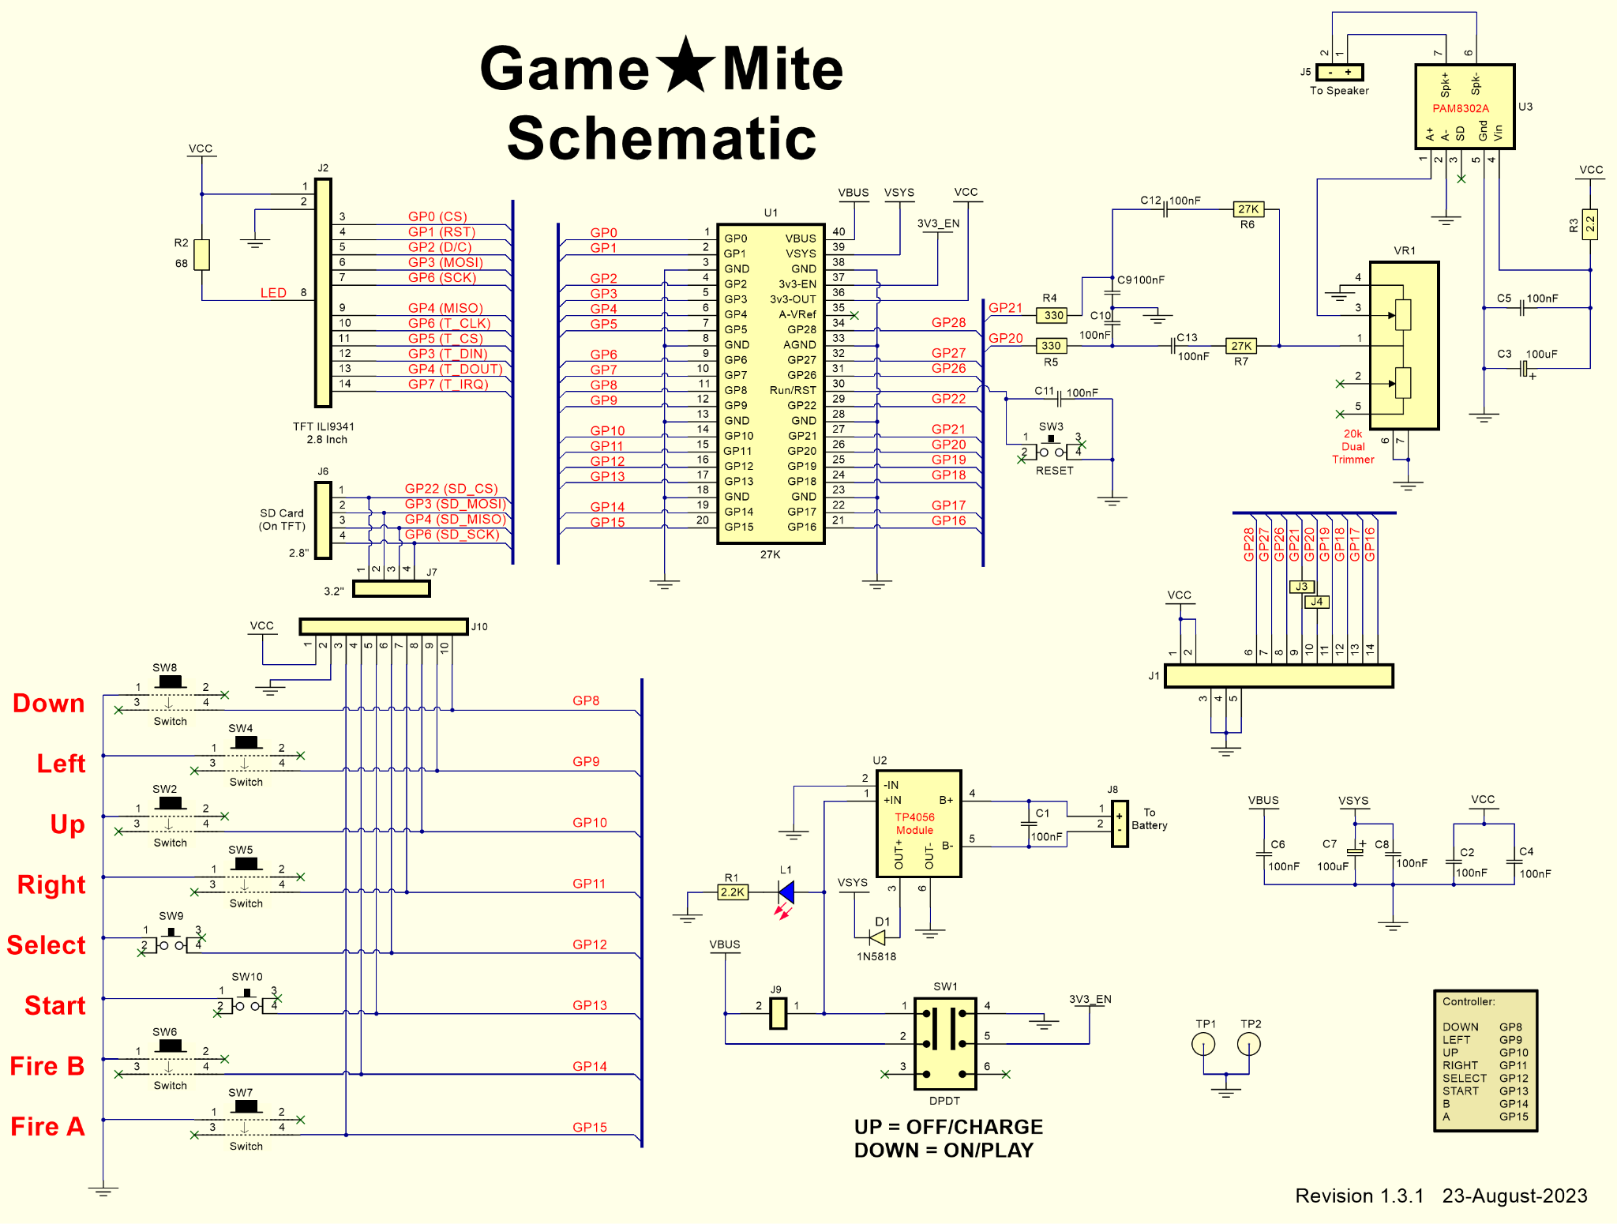

Appendix B - Bill of materials
Because searching the internet based on a component description alone may point to an incorrect part we have included pictures below for some items. Items not matching the illustrations may not be compatible.
Count | Reference | Value | Comment
2 | Game★Mite PCB | - | Two copies of the PCB are used in construction; the top one has the components soldered to it, the bottom one serves as a baseplate and somewhere to attach the speaker and battery.  If you bought your GameMite as a kit then it is possible that the PCB supplied for use as the baseplate is an older revision. Check the version number (lower right hand corner) of both PCBs and ensure that you only solder components to the one with the higher version.
11 | C1,C2,C4,C5,C6,C8,  C9,C10,C11,C12,C13 | 100nF | Mounting holes suit 0.1” or 0.2” spacing
2 | C3,C7 | 100uF 10V | Mounting holes suits 0.2” spacing
1 | D1 | 1N5818 | Schottky diode
1 | J1 | 14-pin Male right-angle header | Optional expansion header exposing GP16-21,26-28
1 | J2 | Header 14x1F | Cut from larger strip
2 | J3, J4 | - | Solder short pads, close with a blob of solder to make GP20 + 21 available from J1
1 | J5 | 2-pin Female right-angle header | Speaker “socket” soldered on PCB
1 | - | Header 2x1M | Speaker “plug” on lead to match J5.  Cut from a larger strip.
1 | J6 | Header 4x1F | For 2.8” display. Cut from larger strip
1 | J7 | Header 4x1F | For 3.2” display. Cut from larger strip
1 | - | Header 4x1M | Install on the display; they usually have a 14 pin male header pre-installed but their 4 pin header is optional.  Cut from larger strip
1 | J8 | 2-pin R/A JST-XH socket | Battery socket soldered on PCB
1 | - | 2-pin JST-XH plug | Battery plug on lead to match J8
1 | J9 | Header 2x1M | Cut from larger strip
1 | J10 | Header 10x1M | Cut from larger strip
1 | L1 | Blue 3mm LED
1 | R1 | 2K2 | ¼ watt.  Note: if the blue charge-indicator LED (L1) is too bright then replace this with a higher resistance value.
1 | R2 | 68R | ¼ watt
1 | R3 | 2R2 | ½ watt - HALF WATT
2 | R4, R5 | 330R | ¼ watt
2 | R6, R7 | 27K | ¼ watt
1 | SW1 | DPDT slide switch | 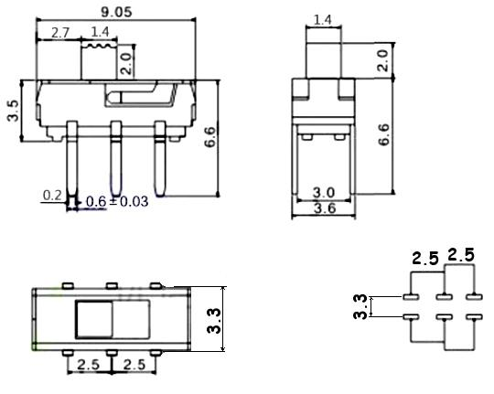  AliExpress/eBay search: “6 pin slide switch dpdt”  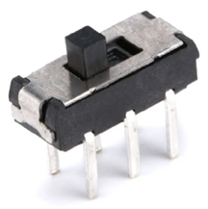
6 | SW8,SW4,SW2  SW5,SW6,SW7 | 12mm push button | AliExpress/eBay search: “push button switch 12x12x7.3mm”  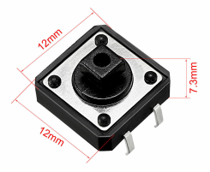
6 | - | - | Switch caps for the above
3 | SW3, SW9, SW10 | 6mm push button | AliExpress/eBay search: “4-pin push button switch 6x6x5mm”  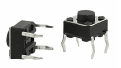
2 | TP1,TP2 | - | GND test points, optionally connect with half-loop of wire
1 | U1 | Raspberry Pi Pico | Programmed with the customised GameMite version of the PicoMite firmware, see Chapter 3.
1 | U2 | PAM8302A - Mono 2.5W Class D Audio Amplifier | AliExpress/eBay search: “pam8302a amplifier module”  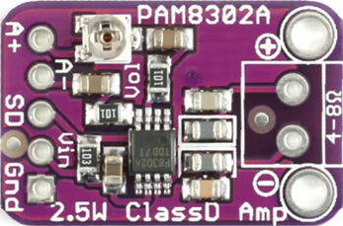
1 | U3 | TP4056 - Lithium Battery Charger | AliExpress/eBay search: “tp4056 lithium battery charger module”  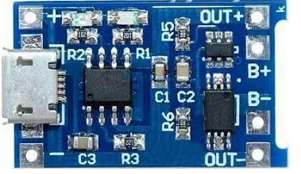
1 | VR1 | 20K  Dual-Trimmer | This is a Linear (B-type) potentiometer.  AliExpress/eBay search: “double gear tuning potentiometer B203”  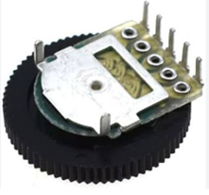
1 | TFT display  with SD card reader | 3.2” or 2.8”  320x240 pixel  ILI9341 with touch | AliExpress/eBay search: “3.2 inch tft ili3941”  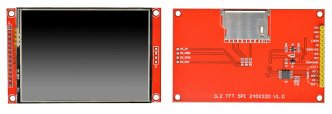
1 | LiPo battery | 3v7, 1000 mAh  4x40x50mm | Sizes 404050, 523450, 503450 are suitable - avoid anything beginning with a 10, they are too “fat” (10mm). AliExpress/eBay search: “3v7 lithium polymer battery 1000mAh”  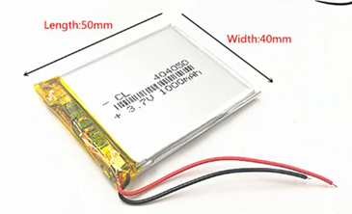
1 | Speaker | 8R, 2W | AliExpress/eBay search: “8 ohm 2 watt laptop speaker square”  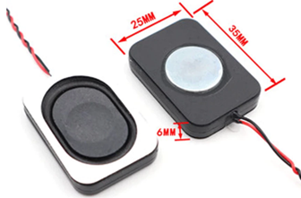
8 | Threaded screws | M3, 5mm long | Screws and spacers are only required at the corners of the PCB.
4 | Tapped plastic or nylon spacers | M3, 10-12mm long

Appendix C - Differences from the standard PicoMite firmware
The GameMite firmware is derived from the standard PicoMite firmware (https://geoffg.net/picomite.html) with the following minor customisations:

Customised serial console banner
To help identify the customised version of the PicoMite firmware the copyright message written to the banner has an identifying suffix appended to it:
PicoMite MMBasic Version 5.07.08b11 - Game*Mite
Copyright 2011-2023 Geoff Graham
Copyright 2016-2023 Peter Mather

Automatically sets default GameMite OPTIONs
When a new (or nuked) Pico is first booted with the customised PicoMite firmware it automatically has the following OPTIONs set:
OPTION CPUSPEED 252000
OPTION SYSTEM SPI GP6,GP3,GP4
OPTION TOUCH GP5,GP7
OPTION SDCARD GP22
OPTION AUDIO GP20,GP21
OPTION LCDPANEL ILI9341,RLANDSCAPE,GP2,GP1,GP0

Does not clear OPTION AUTORUN on “sigbus” error
The standard PicoMite clears OPTION AUTORUN when a “sigbus” error occurs in order to prevent the Pico going into an unbreakable restart cycle should the program being AUTORUN throw such an error; the simple GameMite "startup.bas" is hopefully error free.
Without this change any “sigbus” error thrown will cause the GameMite to reboot to a blank display that can only be restored by attaching a serial console and re-enabling OPTION AUTORUN as described in Software below.

Uncaught errors displayed on TFT panel
If OPTION LCDPANEL CONSOLE is not set (the default) then the GameMite will display any uncaught error on the TFT panel as well as the serial console.
Without this change any uncaught error will cause the GameMite to appear to have hung; the fact that an error had occurred would only be visible on the serial console.

New MM.INFO sub-functions
MM.INFO(VERSION X)
Returns the GameMite firmware version as an INTEGER = major * 10000 + minor * 100 + micro, e.g. version 1.2.3 would return 10203.
MM.INFO(VERSION) without the X will return the PicoMite version number as a FLOAT.
MM.INFO(DEVICE X)
Returns the STRING “GameMite”.
MM.INFO(DEVICE) without the X will return the STRING “PicoMite”.
Note that the X suffixes are accepted but ignored by the standard PicoMite firmware.

Appendix D - Alternative software installation instructions
Chapter 3 describes the simplest way of installing the GameMite’s firmware and suite of MMBasic programs, however this has the disadvantage of replacing/erasing the entire contents of the Raspberry Pi Pico’s flash memory.
For those who want to just install the firmware, just install the MMBasic programs, or just like to live dangerously, this appendix describes an alternative more manual process.

Loading the firmware
The Raspberry Pi Pico that underlies the GameMite comes with its own built-in firmware loader that is easy to use. Just follow these steps:
- Follow the links from https://github.com/thwill1000/mmbasic-gamemite to download “GameMite-<version>-appendix-d.zip”.
- Extract the firmware file “GameMite-<version>-fw-only.uf2”.
- Using a USB cable, plug the Raspberry Pi Pico into your computer (Windows, Linux or Mac) while holding down the white BOOTSEL button on the Raspberry Pi Pico (you will need to remove the TFT display to do this).
- The Raspberry Pi Pico should connect to your computer and create a virtual drive (the same as if you had plugged in a USB memory stick) called “RPI-RP2”. This drive will contain two files which you can ignore.
- Copy the “GameMite-<version>-fw-only.uf2” file to this virtual drive.
- When the copy has completed, the Raspberry Pi Pico will restart and create a virtual serial port on your computer. The LED on the Raspberry Pi Pico will blink slowly indicating that the firmware with MMBasic is now running.
If the LED does not start blinking, then it is possible that the Raspberry Pi Pico’s flash memory was in a previously corrupted state. To fix this install the file https://github.com/thwill1000/mmbasic-gamemite/raw/main/download/flash_nuke.uf2 following the same instructions. This should reset the Raspberry Pi Pico to its factory fresh state from where you can try installing “GameMite-<version>-fw-only.uf2” again.
Whilst the virtual drive created by the Raspberry Pi Pico looks like a USB memory stick it is not; the firmware file will vanish once copied and if you try copying any other type of file it will be ignored.
Loading the firmware will erase the flash memory including the current program, any programs saved in flash memory slots and all saved variables. So make sure that you backup this data if you ever upgrade the firmware.
The next step of the installation requires connecting a desktop computer to the Raspberry Pi Pico using a USB cable and then running a terminal emulator program on the desktop computer.

Virtual serial port
The virtual serial port created by the firmware acts like a normal serial port but it operates over USB.
Windows: Windows 10 + 11 include a driver for this virtual serial port. Once connected you should note the COM port assigned by the computer to the new connection. This can be done by starting Device Manager and checking the "Ports (COM & LPT)" entry for a new COM port as shown on the right.
Linux: A modern Linux distribution should present the Raspberry Pi Pico as an ACM device, e.g. /dev/ttyACM0 without requiring any additional driver. Note: you will need to be a member of the “dialout” group to access it.

Terminal emulator
You will need a terminal emulator program on your desktop computer. This program acts like an old fashioned computer terminal where it will display text received from a remote computer and any key presses will be sent to the remote computer over the serial link. The terminal emulator that you use should support VT100 emulation as that is what the editor built into the GameMite expects.
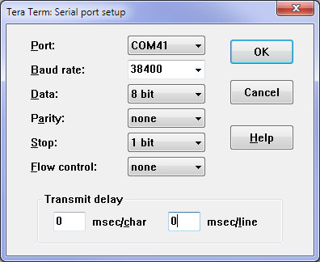
Windows:
Tera Term (https://tera-term.en.lo4d.com) is recommended for Windows users as this has a good VT100 emulator and is known to work with the XModem protocol which you can use to transfer programs to and from the GameMite.
The screen shot on the right shows the setup for Tera Term:
- The "Port:" setting will vary depending on which USB port your Raspberry Pi Pico was plugged into.
- The GameMite ignores the baud rate setting so it can be set to any speed (other than 1200 baud which puts the Raspberry Pi Pico into firmware upgrade mode).
Linux:
The standard screen command can be used to connect, e.g.
screen /dev/ttyACM0

The console
Once you have identified the virtual serial port and have connected your terminal emulator to it you should be able to press return on your keyboard and see the MMBasic prompt, which is the greater than symbol (e.g. “>”).
This is the console and is the most fundamental way to interact with the standard PicoMite. For the GameMite we just require it to install the suite of MMBasic programs that comprises the GameMite boot menu, tools and games.
If you wish to find out more then please see the PicoMite User Manual: https://geoffg.net/Downloads/picomite/PicoMite_User_Manual.pdf.

Installing the MMBasic programs
Though it is possible to run the GameMite software directly from the SD card (B:/) it is recommended that it is copied onto the GameMite internal flash drive (A:/) as described here:
- Open the “GameMite-<version>-appendix-d.zip” file and copy/extract the “GameMite” directory to the root of a FAT32 formatted SD card.
Once extracted the SD card should contain the following:
/
GameMite/
install-a.bas
menu.bas
startup.bas
...
Note: the SD card may have other pre-existing content, but only the "GameMite/" directory is relevant to these installation instructions.
- Connect to the GameMite from a terminal emulator as described above.
- Insert the SD card into the GameMite.
- Run the following command at the console to copy the software to the A:/ drive:
RUN "B:/GameMite/install-a.bas"
- When this has completed RUN the following commands to complete setup:
FLASH ERASE 1
LOAD "A:/GameMite/startup.bas"
FLASH SAVE 1
OPTION AUTORUN 1
Note: FLASH ERASE 1 will report a harmless error if flash slot 1 is already empty.
- The GameMite software should now be set up. If RESET is pressed or the device is power-cycled it should reboot to show the version and copyright message before displaying the boot menu.

Appendix E - Miscellanea
A collection of gritty details that you will hopefully never need to know.
WARNING! Before making any potentially damaging modifications to the ILI9341 TFT module please consider posting a question on “The Back Shed” forum: https://www.thebackshed.com/forum/Microcontrollers.

Audio circuit
The GameMite uses pins GP20 and GP21 for the PWM sound output. These outputs are each fed to low pass filter circuits comprising R4/C9 and R5/C10 which convert the PWM signals to audio. The roll off frequency of these filters begins at approximately 4800Hz. Capacitors C12 and C13 AC couple the audio signal to resistors R6 and R7 which are used to set the approximate maximum gain. Increasing their value will decrease the maximum gain and vice versa.
Resistors R6 and R7 both connect to the volume control pot (VR1) and so will combine the two sound outputs into one mono signal. The output of the volume control is fed to the digital amplifier module (PAM8302A) and from there to the speaker. The PAM8302A operates at around 250KHz and the output is not further filtered beyond what is present on the module, but fed straight to the speaker as is.
The components R3, C3 and C5 decouple the power supply for the PAM8302A to reduce noise generated by the PicoMite’s power supply.

Adjusting the trimpot on the PAM8302A module
In addition to the main volume control pot (VR1) the PAM8302A module has a miniature 10K trimpot on it which can be adjusted to set the maximum volume using a screwdriver with a small flat blade.
WARNING! Do not use a Phillips/cross-head screwdriver; despite appearances to the contrary the screw is not of that type and you will possibly chew up the head.
This is easiest done after the software has been installed by following this procedure:
- With the power off, carefully remove the TFT display module.
- Attach the GameMite to your desktop computer via USB.
- Switch the power on.
- Connect to the GameMite via a terminal emulator as described in Appendix D.
- If the GameMite boot menu is not shown in the terminal emulator:
  - Press Ctrl-C
  - The prompt “>” should be displayed
  - Type RUN
- Navigate to the “Sound Test” program.
- Navigate to “Play Music”.
- Play “Spring (Vivaldi)”.
- Set the GameMite thumbwheel pot to maximum volume - fully anti-clockwise.
- Adjust the miniature trimpot on the PAM8302A to the desired maximum volume.

Battery charging circuit
The GameMite’s LiPo battery is charged by connecting the Raspberry Pi Pico to an active USB power source. Charging and overcharge protection are managed by the TP4056 module powered from the Raspberry Pi Pico’s VBus pin.
The charge behaviour depends on whether the “Charge mode” link (J9) is fitted:
- If it is not fitted then the LiPo will only charge when the GameMite is OFF, i.e. SW1 is in the up (OFF/CHG) position.
- If it is fitted then the LiPo will charge irrespective of whether the GameMite is ON or OFF. Note that with the link fitted if SW1 is in the ON position then the GameMite will be powered from the USB, not the battery, i.e. even in this state the battery will not be driving a load at the same time it is charging.
The 3mm blue charging-indicator LED (L1) will be lit if USB power is being applied to the TP4056 module (from the Raspberry Pi Pico’s VBus pin). Note: this LED doesn’t show the actual state of the charge and will remain illuminated even if the battery is fully charged.
In addition the TP4056 module has two onboard surface mount LEDs, one blue (or green) and the other red. The red LED will be illuminated whilst charging and the blue once full charge has been reached. If the red LED is flashing then the battery is faulty, or not attached. Note: these LEDs will be partially hidden under the TFT.
Note: the USB connector on the TP4056 module can be ignored, it shouldn’t be possible to connect it because of other components in the way, and if you did succeed it should not represent a problem.

TFT display brightness
On some, older, ILI9341 TFT modules the brightness of the display can be controlled by decreasing (brighter) or increasing (dimmer) the value of R2 (default 68R). More recent modules supply the power to the backlight via a transistor (Q1 on the module) and for these displays R2 does not control the brightness. See picture overleaf.

TFT 3v3 regulator
The ILI9341 TFT module has an onboard 3v3 regulator (U1 on the module) so that they can be used from a 5V supply. The GameMite only supplies 3v3 so after the regulator dropout the module will be working at < 3v3. In practice this has not proved to be a problem (the ILI9341 will work at 2v8 and possibly below). If power to the TFT seems to be a problem then the regulator can be shorted out with a solder blob between the pins of J1 on the module. See picture overleaf.
WARNING! After shorting out the regulator the TFT module should not be connected to a 5V supply for fear of releasing the “magic smoke”.

SD card troubleshooting
The SD card reader on the ILI9341 TFT modules includes 1K resistors in series on its data lines. Shorting out these resistors (or replacing them with 0R) has been suggested as a fix for SD card reliability problems. In practice we have not seen this issue with the GameMite and in any case the quality of the SD card is probably more important. See picture overleaf.

TFT SPI screen layout
Q1 used to control backlight
1k Resistors in series with the SD card lines. on modern displays,
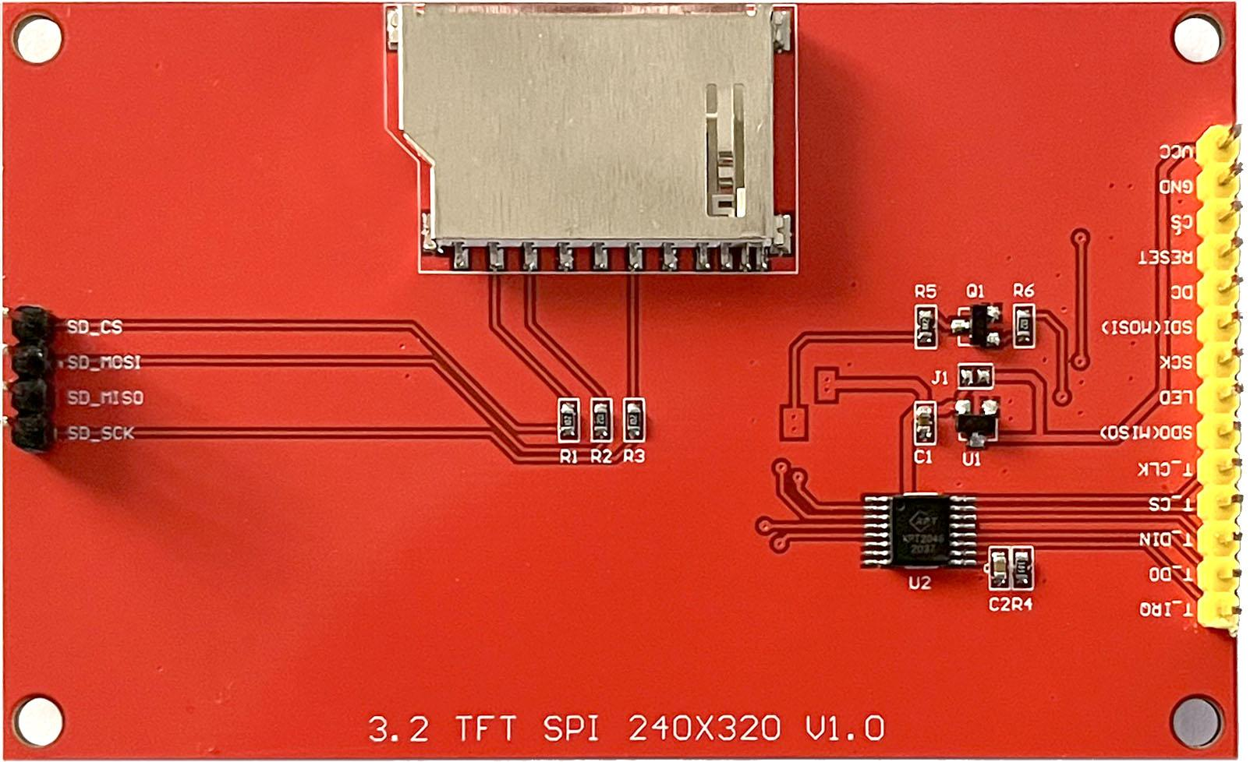
3v3 Regulator, U1, and bypass jumper J1.

In reality these are the original installation instructions before it was discovered it was possible to just use a single .uf2 file. They are maintained because they may prove useful if and when there is upgraded firmware or MMBasic programs to install.
Depending on the terminal font / code page the characters displayed for the menu border may be wrong, it doesn’t matter.

