**Online book**

[**Neural Networks and Deep Learning**](http://neuralnetworksanddeeplearning.com/index.html)

1. The architecture of neural networks and **sigmoid** neurons

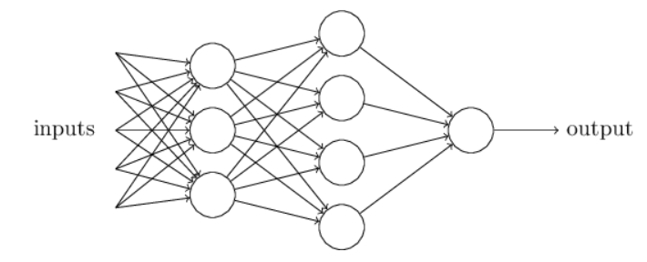

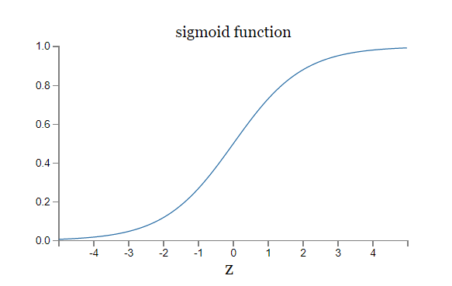

Other models of artificial neuron

**Tanh neuron:**

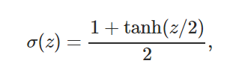

**Rectified linear neuron:**

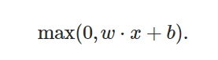

1. Learning with gradient descent
   1. Cost function

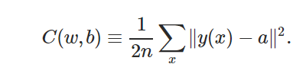

* 1. Use **backpropagation** algorithm to calculate the gradients of the cost function
  2. Train the nets with **stochastic gradient descent**

1. Improving the way neural networks learn
   1. The learning slowdown problem
      1. Cross-entropy cost function (sigmoid)
      2. log-likelihood cost function (softmax)
   2. Overfitting and regularization
      1. Regularization
         * L2
         * L1
      2. Dropout
      3. Artificially expanding the training data
   3. Weight initialization

W ~ Z( 0 , (1/nin)^0.5)

* 1. Use validation data set to choose hyper-parameters

1. Deep neural networks

Unstable gradients in deep neural nets

1. Convolutional neural networks

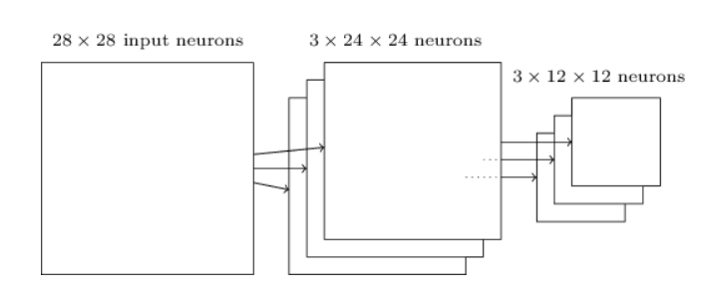

* 1. Local receptive fields
  2. Shared weights
  3. pooling

## [The 2012 LRMD paper:](med-DL/38115.pdf)

LRMD was names after the last names of the first authors. The 2011 ImageNet data that they used included 16 million full color images, in 20 thousand categories. LRMD's network obtained a respectable 15.8 percent accuracy for correctly classifying ImageNet images. That may not sound impressive, but it was a huge improvement over the previous best result of 9.3 percent accuracy. That jump suggested that neural networks might offer a powerful approach to very challenging image recognition tasks, such as ImageNet.

## [The 2012 KSH paper:](med-DL/imagenet.pdf)

The KSH network has 7 layers of hidden neurons. The first 5hidden layers are convolutional layers (some with max-pooling), while the next 2 layers are fully-connected layers. The output layer is a 1,000-unit softmax layer, corresponding to the 1,000 image classes.

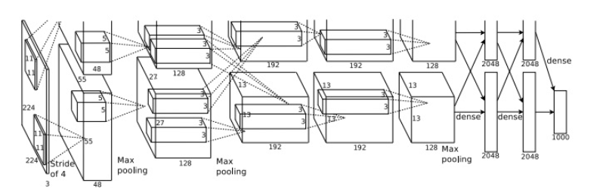

## [The 2014 ILSVRC competition:](med-DL/1409.4842.pdf)

The winning team, based primarily at Google, used a deep convolutional network with 22layers of neurons. They called their network GoogLeNet, as a homage to LeNet-5. GoogLeNet achieved a top-5 accuracy of 93.33 percent, a giant improvement over the 2013 winner (Clarifai, with 88.3 percent), and the 2012 winner (KSH, with 84.7 percent).