新疆理工学院

2020-2021第一学期

JavaEE程序设计课程项目报告

专业及班级： 计算机18-1班

学生学号： 20183451011

学生姓名： 邓世强

任课老师： 黄洪

提交时间： 2020年11月13日

一、目的
《JavaEE程序设计》是一门理论与实践紧密结合的课程，课程主要讲授使用Struts、Hiberbnate、Spring框架，结合JSP和Servlet技术开发Web应用程序的方法和技术。本次课程项目采用MySQL作为数据库管理系统，Tomcat为Web服务器和应用服务器，Eclipse为集成开发工具，综合运用SSH框架，完成Web应用开发的基本环节。
二、项目内容
运用SSH框架开发一个Web网站的用户管理模块，具体功能包括用户注册、用户登录、密码修改、用户查询（列出所有注册用户）、删除指定用户。数据库管理系统使用MySQL，Web服务器和应用服务器使用Tomcat，开发工具使用Eclipse for JavaEE。具体包括：
1) 基本开发环境构建和新建项目
描述用到的软件及其版本，包括JDK、Tomcat、Eclipse、MySQL，给出完整的安装过程描述。（10分）
2) 数据库设计与操作
创建数据库bookstore，数据库用户名为test，密码123456；创建用户表usertable，包括用户名，密码，性别，昵称，电子邮件等字段，用户名为主码；给出完成上述工作的SQL命令。（10分）
3) 页面设计
完成相关视图的JSP页面设计，如：注册页面，登录页面，修改口令页面，用户查询页面，和相关相应页面的设计，要求使用Struts标签实现结果数据的展示。设计一个主页index.jsp，该主页提供所有功能的链接入口。报告中提供所有页面的代码。（20分）
4) 基于Hibernate的持久化实现
设计持久化类User，包括注解的使用，Hibernate配置文件。给出持久化类的源代码和Hibernate配置文件的完整代码。（10分）
5) 基于Hibernate的业务模型类的设计和实现
设计业务模型的JavaBean，包含使用Hibernate框架对数据库bookstore中的usertable表进行增删改查的方法。（20分）
6) 基于Struts的控制功能实现
设计实现响应用户请求的Action类，并进行配置，给出相应的struts.xml配置文件和web.xml文件的代码。（20分）
7) 发布运行
将开发调试好的应用发布到Tomcat，给出应用的完整目录结构，画图说明各种组件及配置文件的位置（也可以截图），并给出应用的运行截图（10分）。
说明：usertable中，应包含admin用户，其密码为123456，还应包括以自己姓名为用户名的数据，应用系统中admin用户的数据无法删除。
实验内容中涉及的包名必须以自己姓名的拼音开头；
三、项目实施过程
1) 基本开发环境构建和新建项目
描述用到的软件及其版本，包括JDK、Tomcat、Eclipse、MySQL，给出完整的安装过程描述。（10分）
JDK 1.8.0_241 下载
双击安装 几乎是一路下一步
重要的是要配置环境变量， 配置方法如下：
- 复制安装路径 例如我的：D:\app\jdk\bin
- 找到我的电脑（此电脑）右键属性
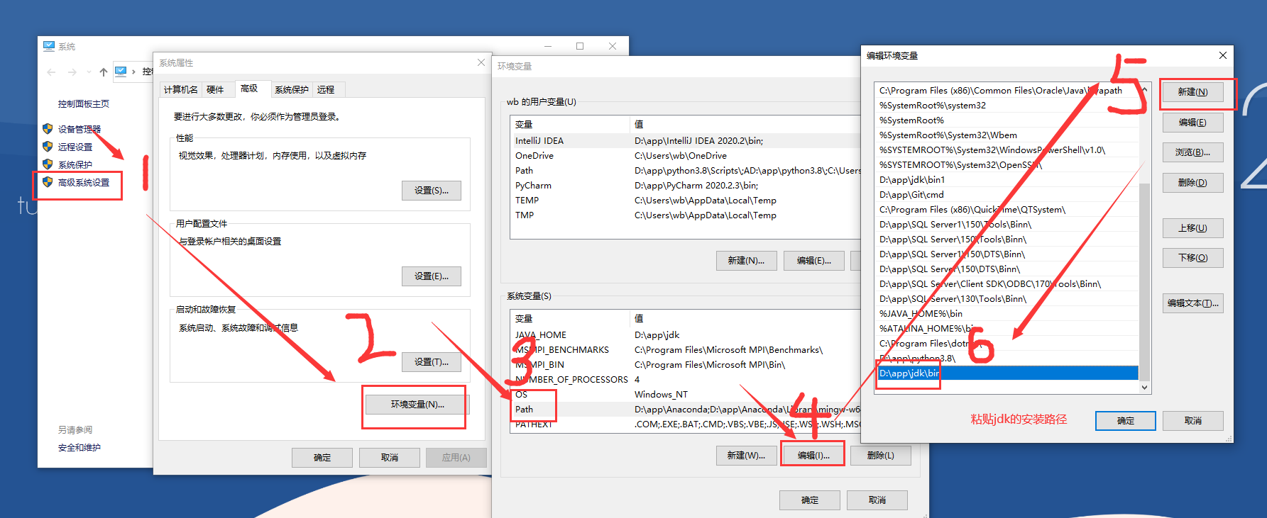
再三次确定，此时jdk安装完毕
Tomcat 9.0
Tomcat安装 下载下来解压到一个目录里面就行了
Eclipse 2019-03 (4.11.0)
下载下来 同样是一路下一步就可以安装完毕，只不过安装时间长一些
Mysql-8.0.22.0
下载下来之后 双击安装，在安装过程中，需要配置一些：比如登录mysql用户、密码，初始是root用户，要为root用户设置密码，Mysql,默认是开机启动的，不用再去配置什么
2) 数据库设计与操作
创建数据库bookstore，数据库用户名为test，密码123456；创建用户表usertable，包括用户名，密码，性别，昵称，电子邮件等字段，用户名为主码；给出完成上述工作的SQL命令。（10分）
create database bookstroe;

create table usertable(
userId int primary key not null unique auto_increment,
username varchar(20) unique not null,
pwd varchar(32) not null,
sex char(2) not null,
aliasname varchar(20),
email varchar(20),
picture varchar(50)
);
-- 修改表的编码集
ALTER TABLE usertable CONVERT TO CHARACTER SET utf8 COLLATE utf8_general_ci;
insert into usertable (
username, pwd, sex, aliasname, email, picture
)
values(
'thylove','123456','男','thylove','93787944@qq.com','img/p21.png'
);
创建一个test登录名 密码为123456
CREATE USER 'test'@'localhost' IDENTIFIED BY '123456';
授权 把bookstore.user权限授权给test用户
GRANT ALL ON bookstore.user TO 'test'@'localhost';
刷新
flush privileges;3) 页面设计
完成相关视图的JSP页面设计，如：注册页面，登录页面，修改口令页面，用户查询页面，和相关相应页面的设计，要求使用Struts标签实现结果数据的展示。设计一个主页index.jsp，该主页提供所有功能的链接入口。报告中提供所有页面的代码。（20分）
index.jsp
<%@ page language="java" contentType="text/html; charset=UTF-8" pageEncoding="UTF-8"%>
<%@ include file="pre.jsp"%>
<!DOCTYPE html>
<html>
<head>
<meta charset="UTF-8">
<title>首页</title>

</head>
<body>
<div class = "souye">
<span><a href="register.jsp" target="_blank">注册</a></span><span><a href="login.jsp" target="_blank">登录</a></span><span><a href="alterPwdLogin.jsp" target="_blank">修改密码</a></span><span><a href="searchUser.jsp" target="_blank">用户查询</a></span>
</div>
<s:actionmessage/>

<%@ include file="footer.jsp"%>
<script >
if($(".actionMessage li span").text() == "登录成功") {
alert($(".actionMessage li span").text());
$(".actionMessage li span").html("0");
} else if($(".actionMessage li span").text() == "注册成功") {
alert($(".actionMessage li span").text());
$(".actionMessage li span").html("0");
} else if($(".actionMessage li span").text() == "修改密码成功") {
alert($(".actionMessage li span").text());
$(".actionMessage li span").html("0");
} else if($(".actionMessage li span").text() == "删除成功") {
alert($(".actionMessage li span").text());
$(".actionMessage li span").html("0");
}
</script>

</body>
</html>

registe.jsp
<%@ page language="java" contentType="text/html; charset=UTF-8" pageEncoding="UTF-8"%>
<%@ taglib prefix="s" uri="/struts-tags" %>
<%@ include file="pre.jsp"%>
<!DOCTYPE html>
<html>
<head>
<meta charset="UTF-8">
<title>欢迎注册！</title>
</head>
<body style = "background:url(img/bg-register.png); background-size: 100%;">
<form action="register" method = "get" class = "registerForm" >
<table >
<caption class = "title">欢迎注册vip会员</caption>
<tr>
<td>用户名:</td>
<td><input type="text" name = "register.username" class = "registerusername"/></td>
</tr>
<tr>
<td>密码:</td>
<td><input type="password" name= "register.pwd" class = "registerPwd"/></td>
</tr>
<tr>
<td>确认密码:</td>
<td><input type="password" class = "registerrepwd"/></td>
</tr>
<tr>
<td>昵称:</td>
<td><input type="text" name = "register.aliasname" class = "registeraliasname"/></td>
</tr>
<tr>
<td><s:radio name="register.sex" list="#{1 : '男', 0 : '女'}" label ="性别"/></td>
</tr>
<tr>
<td>email:</td>
<td><input type="email" name = "register.email" class = "registeremail" /></td>
</tr>
<tr class = "btn">
<td colspan = "2"><p><input type="submit" value = "Register" class = "registerBtn"/>&emsp;<input type="reset" value = "Reset" /></p></td>
</tr>
</table>
</form>
<%@ include file="footer.jsp"%>
</body>
</html>
alterPwdLogin.jsp
<%@page import="java.net.URLDecoder"%>
<%@ page language="java" contentType="text/html; charset=UTF-8" pageEncoding="UTF-8"%>
<%@ include file="pre.jsp"%>
<!DOCTYPE html>
<html>
<head>
<meta charset="UTF-8">
<title>修改密码</title>
</head>
<body>
<%
String userName = null;
Cookie [] cookies = null;
cookies = request.getCookies();
if(cookies != null) {
for(Cookie cookie:cookies) {
if(cookie.getName().equals("userName")){
userName = URLDecoder.decode(cookie.getValue(),"utf-8");
}
}
}
%>

<span class="title">登录</span>
<br>
<div class="content" id = "cont">
<form action="alterPwd" method = "post">
用户名：<input type="text" name="alterPwdLogin.username" class="l" value="<%=userName==null ? "": userName%>"> <br>
密&emsp;码：<input type="password" name="alterPwdLogin.pwd" class="l" value = "123456"><br>
<div class="c">
<span>验证码：</span>
<input type ="text" class="check shu" >
<canvas id="myCanvas">
Your browser does not support the HTML5 canvas tag.
</canvas>
</div>
<p class="error">
<%
String erro = (String)session.getAttribute("uaperror");
if(erro != null)
out.println(erro);
%>
</p>
<input type="button" value="login" class="btn">
</form>
</div>
<%@ include file="footer.jsp"%>
</body>
</html>
alterPwd.jsp
<%@page import="java.net.URLDecoder"%>
<%@ page language="java" contentType="text/html; charset=UTF-8" pageEncoding="UTF-8"%>
<%@ include file="pre.jsp"%>
<!DOCTYPE html>
<html>
<head>
<meta charset="UTF-8">
<title>修改密码</title>
</head>
<body>
<form action="modifyPwd" method = "POST" class = "modifyPwd">
密&emsp;&emsp;码：<input type="password" name = "alterPwd" class = "alterPwd" placeholder="请输入新的密码"/> <br />确认密码：<input type="password" class = "repwd" placeholder="请输入确认密码" /> <br />
<input type="hidden" value = '<s:property value = "uid"/>' name = "uid" />
<br />
<p class = "modifyBtnt"><input type="submit" value = "Submit" class = "repwdbtn" />&emsp;&emsp; <input type="reset" value = "Reset" /></p>
</form>
<%@ include file = "footer.jsp" %>
</body>
</html>
searchUser.jsp
<%@ page language="java" contentType="text/html; charset=UTF-8" pageEncoding="UTF-8"%>
<%@ include file="pre.jsp"%>
<!DOCTYPE html>
<html>
<head>
<meta charset="UTF-8">
<title>查询用户</title>
</head>
<body>
<form action="searchUser" method = "get" class = "searchForm">
<input type="search" name = "keyWord" class = "searchKeyWord" placeholder="请输入用户名或昵称"/><input type="submit" value = "搜索" class = "searchSubmit"/>
</form>
<%@ include file="footer.jsp"%>
</body>
</html>
searchResult.jsp
<%@ page language="java" contentType="text/html; charset=UTF-8" pageEncoding="UTF-8"%>
<%@ include file="pre.jsp"%>
<!DOCTYPE html>
<html>
<head>
<meta charset="UTF-8">
<title>查询用户</title>
</head>
<body>
<s:if test="userlist.size">
<table border="1" cellpadding="1" cellspacing = "0" class = "reUser">
<caption style = "font-size: 50px; font-weight: bold;padding:20px; ">查询结果</caption>
<thead>
<tr>
<th>头像</th>
<th>用户名</th>
<th>密码</th>
<th>性别</th>
<th>昵称</th>
<th>电子邮件</th>
<th>操作</th>
</tr>
</thead>
<tbody>
<s:iterator value = "userlist" status="index">
<s:if test="#index.odd != true">
<tr align = "center" style="background-color:#cccccc">
<td class = "userimg"><p><img src='<s:property value = "picture" /> ' alt="" /></p></td>
<td class = "username" id = "uname"><s:property value = "username" /></td>
<td class = "pwd"><s:property value = "pwd" /></td>
<td class = "sex"><s:property value = "sex" /></td>
<td class = "username"><s:property value = "aliasname" /></td>
<td class = "pwd"><s:property value = "email" /></a></td>
<s:if test='<s:property value = "username" /> != admin'>
<td class = "sex"><a href='deleteUser?uid=<s:property value = "userId" />'>删除</a></td>
</s:if>
<s:else>
<td class = "sex"><a href='#' class = "nodel">删除</a></td>
</s:else>
</tr>
</s:if>
<s:else>
<tr align = "center">
<td class = "userimg"><p><img src='<s:property value = "picture" /> ' alt="" /></p></td>
<td class = "username" id = "uname"><s:property value = "username" /></td>
<td class = "pwd"><s:property value = "pwd" /></td>
<td class = "sex"><s:property value = "sex" /></td>
<td class = "username"><s:property value = "aliasname" /></td>
<td class = "pwd"><s:property value = "email" /></a></td>
<s:if test='<s:property value = "username" /> == admin'>
<td class = "sex"><a href='deleteUser?uid=<s:property value = "userId" />' >删除</a></td>
</s:if>
<s:else>
<td class = "sex"><a href='#' class = "nodel">删除</a></td>
</s:else>
</tr>
</s:else>
</s:iterator>
<tr><td colspan = "7" align = "center"><a href="searchUser.jsp" class = "with">重新搜索</a></td></tr>
</tbody>
</table>
</s:if>
<s:else>
<p >对不起！没有查到, 请<a href="searchUser.jsp" class = "with">重新搜索</a></p>
</s:else>
<%@ include file="footer.jsp"%>
</body>
</html>
error.jsp
<%@ page language="java" contentType="text/html; charset=UTF-8" pageEncoding="UTF-8"%>
<%@ taglib prefix="s" uri="/struts-tags" %>
<!DOCTYPE html>
<html>
<head>
<meta charset="UTF-8">
<title>失败！</title>
</head>
<body>
<s:actionmessage/>
</body>
</html>
pre.jsp
<%@ page language="java" contentType="text/html; charset=UTF-8" pageEncoding="UTF-8"%>
<%@ taglib prefix="s" uri="/struts-tags" %>
<link rel="stylesheet" href="JSandCSS/base.css" />
footer.jsp
<%@ page language="java" contentType="text/html; charset=UTF-8"
pageEncoding="UTF-8"%>
<script src = "JSandCSS/jquery-3.4.1.min.js"></script>
<script src="JSandCSS/check.js"></script>
<script src = "JSandCSS/MyJs.js"></script>
check.js(生成验证码)
var arr = [0,1,2,3,4,5,6,7,8,9];
for(var i = 65; i < 122; i ++) {
if(i > 90 && i < 97) {
continue;
}
arr.push(String.fromCharCode(i));
}
var value;
function createCanvas() {
var canvasStr = '';
value = '';
for(var i = 0; i < 4; i ++) {
var a = arr[Math.floor(Math.random() * arr.length)];
canvasStr += a + ' ';
value += a;
}
var myCanvas = document.getElementById('myCanvas');
var ctx = myCanvas.getContext('2d');
var oImg = new Image();
oImg.src = 'img/bg.png';
oImg.onload = function() {
var pattern = ctx.createPattern(oImg, 'repeat');
ctx.fillStyle = pattern;
ctx.fillRect(0, 0, myCanvas.width, myCanvas.height);
ctx.textAlign = 'center';
ctx.fillStyle = '#ccc';
ctx.font = '50px Roboto Slab';
ctx.setTransform(1, -0.12, 0.3, 1, -5, 45);
ctx.fillText(canvasStr, myCanvas.width/2, 60);
}
}
createCanvas();

$('.check').blur(function(){
showResule();
});
$('#myCanvas').on('click', function() {
createCanvas();
});
function showResule() {
var inputValues = $('.c input').val().toLowerCase();
if(value.toLowerCase() != inputValues) {
$('.btn').attr('type', 'button');
$('.check').html('');
$('.error').html('验证码错误，请重新输入!');
createCanvas();
}else{
$('.btn').attr('type', 'submit');
$('.error').html('');
createCanvas();
}
}
MyJs.js
// 这里生成rgb的颜色值
function rgb(a) {
var r = Math.floor(Math.random() * 255);
var rr = 255 - r;
var g = Math.floor(Math.random() * 255);
var rg = 255 - g;
var b = Math.floor(Math.random() * 255);
var rb = 255 - b;
if(a == 0)
return "rgb(" + r +"," + g + "," + b +")";
else
return "rgb(" + rr +"," + rg + "," + rb +")";

}
for(var i = 0; i < $(".souye span").length; i ++) {
$(".souye span a")[i].style.backgroundColor=rgb(0);
$(".souye span a")[i].style.color=rgb(1);
}

$(".registerrepwd").blur(function () {
if($(".registerrepwd").val() != $(".registerpwd").val()){
alert("密码和确认密码不一致！");
}
})
$(".registerBtn").click(function() {
if($(".registerusername").val() == "") {
alert("请输入用户名！");
return false;
} else if($(".registerPwd").val() == ""){
alert("请输入密码！");
return false;
} else if($(".registeraliasname").val() == ""){
alert("请输入昵称！");
return false;
} else if($(".registeremail").val() == ""){
alert("请输入电子邮件！");
return false;
} else if($(".registerrepwd").val() != $(".registerpwd").val()){
alert("密码和确认密码不一致！");
$(".registerrepwd")[0].focus();
return false;
}
return true;
})

$(".repwd").blur(function () {
if($(".repwd").val() != $(".repwd").val()){
alert("密码和确认密码不一致！");
}
})

$(".repwdbtn").click(function() {
if($(".alterPwd").val() == ""){
alert("请输入密码！");
return false;
} else if($(".repwd").val() != $(".alterPwd").val()){
alert("密码和确认密码不一致！");
$(".repwd")[0].focus();
return false;
}
return true;
})
$(".nodel").click(function(){
alert("不能删除管理员！");
});

base.css
@charset "UTF-8";

* {
margin:0;
padding: 0;
font: 12px/1.5 tahoma,arial;
text-decoration: none;
list-style:none;
}
html, body{
width: 100%;
height: 100%;
display: flex;
justify-content:center;
align-items: center;
flex-direction: column;
}
.souye {
width: 600px;
height: 500px;
}
.souye span {
display:inline-block;
width: 200px;
height: 80px;
margin: 80px 49px;
}
.souye span a {
display: inline-block;
width: 100%;
height: 100%;
background-color: #ccc;
line-height: 80px;
text-align: center;
font-size: 24px;
}

/*********登录******************/
.title {
margin-bottom: 20px;
font-size:24px;
}
.content {
width: 500px;
height: 300px;
margin-bottom: 260px;
background-color: #fff;
-webkit-box-shadow: 0 0 14px rgba(0,0,0,.1);
-moz-box-shadow: 0 0 14px rgba(0,0,0,.1);
box-shadow: 0 0 14px rgba(0,0,0,.2);
}
#cont {

}
.content form {
width: 100%;
height: 100%;
text-align: center;
padding-top: 10px;
}
.content input {
height: 30px;
width: 250px;
margin: 15px auto;
font-size:18px;
padding: 5px;
border-top-right-radius: 6px;
border-bottom-right-radius: 6px;
outline: none;
border: 1px solid #333;
}

.content .c {
width: 327px;
height: 40px

}
.c {
margin: 15px auto 8px;
}
.c span {
float:left;
line-height: 40px;
}
.content input.check {
width: 120px;
float: left;
margin: 0
}
.content canvas {
border-radius: 5px;
width: 100px;
height: 40px;
float: right;
cursor: pointer;
}
.error {
color: #f00;
font-size: 12px;
height: 16px;
width: 200px;
margin: 0 auto 7px;
text-align: left;
}
.content input.btn {
width: 100px;
height: 40px;
line-height: 40px;
background-color: #00bb00;
padding: 0;
outline: none;
border: 1px solid transparent;
border-radius: 5px;
cursor: pointer;
color: #fff;
margin-top: 0px;
}
.content input.btn:active {
transform: scale(1.01);
}
#myCanvas {
background-color: #ccc;
}

/**************ul***************/
ul.actionMessage {
display: none;
}

/*****************register*****************/

.registerForm {
padding: 50px;
}
.registerForm table tr td:first-child {
text-align: right;
}
.registerForm tr td {
margin: 20px;
font-size: 20px;
}
.registerForm tr td label {
font-size: 20px;

}
.registerForm tr td.tdInput label {
font-size: 20px;
vertical-align: 12px;
}
.registerForm tr td.tdInput input {
width: 20px;
}
.registerForm tr td input {
margin:5px 10px;
width: 250px;
height: 40px;
font-size: 20px;
line-height: 40px;
border: 1px solid #000;
padding: 5px 10px;
}
.registerForm tr.btn p {
text-align: center;
}
.registerForm tr.btn input {
padding: 0;
width: 100px;
height: 45px;
border-radius: 46px;
background-color: #fff;
outline: none;

}
.registerForm tr.btn input:hover {
background-color: #CCC;
cursor: pointer;
}

/****************修改密码*********************/
.modifyPwd {
margin-top: -50px;
font-size: 20px;
}
.modifyPwd input {
width: 250px;
height: 40px;
margin: 10px 0;
font-size: 20px;
padding: 5px 10px;
border: 2px solid #000;
outline: none;
}
.modifyPwd p {
text-align: center;
}
.modifyPwd p input{
width: 120px;
height: 50px;
border-radius: 25px;
background-color: #fff;
}
.modifyPwd p input:hover{
background-color: #99b37a;
}

/************用户搜索*****************/
.searchForm {
padding: 0px 50px 165px;
}

.searchForm input {
outline: none;
border: 2px solid #f40;
height: 50px;
float: left;
}
.searchForm .searchKeyWord {
width: 300px;
border-bottom-left-radius: 25px;
border-top-left-radius: 25px;
border-right: none;
padding: 10px 20px;
line-height: 40px;
font-size: 18px;

}
.searchForm .searchSubmit {
width: 80px;
border-bottom-right-radius: 25px;
border-top-right-radius: 25px;
background-color: #87e9ff;
font-size: 20px;
}
.reUser tr td {
font-size: 18px;
padding: 0 10px;

}
.reUser tr th {
font-size: 18px;
padding: 5 10px;
font-weight: bolder;

}
.reUser .userimg p{
display: flex;
justify-content:center;
align-items: center;
flex-direction: column;
width: 100px;
height: 100px;
border-radius: 50%;
overflow: hidden;
margin: 5px;

}
.reUser .userimg p img{
width: 150%;
}
.reUser tr td.username {
width: 150px;
}
.reUser tr td.pwd {
width: 200px;
}
.reUser tr td.sex {
width: 100px;
}
.reUser tr td.sex a{
font-size: 18px;
}

.with {
font-size: 18px;
padding: 10px;
display: inline-block;
}

4) 基于Hibernate的持久化实现
设计持久化类User，包括注解的使用，Hibernate配置文件。给出持久化类的源代码和Hibernate配置文件的完整代码。（10分）
get()
load()
find()
瞬态
持久化
new()
save()
saveOrUpdate()
delete()
脱管
evict()
close()
clear()
update()
saveOrUpdate()
lock()
垃圾回收
垃圾回收

User.java
package cn.thylove.bean;
public class User {
private int userId;
private String username;
private String pwd;
private String sex;
private String aliasname;
private String email;
private String picture;
public int getUserId() {
return userId;
}
public void setUserId(int userId) {
this.userId = userId;
}
public String getUsername() {
return username;
}
public void setUsername(String username) {
this.username = username;
}
public String getPwd() {
return pwd;
}
public void setPwd(String pwd) {
this.pwd = pwd;
}
public String getSex() {
return sex;
}
public void setSex(String sex) {
this.sex = sex;
}
public String getAliasname() {
return aliasname;
}
public void setAliasname(String aliasname) {
this.aliasname = aliasname;
}
public String getEmail() {
return email;
}
public void setEmail(String email) {
this.email = email;
}
public String getPicture() {
return picture;
}
public void setPicture(String picture) {
this.picture = picture;
}
@Override
public String toString() {
return "User [userId=" + userId + ", username=" + username + ", pwd=" + pwd + ", sex=" + sex + ", aliasname="
+ aliasname + ", email=" + email + ", picture=" + picture + "]";
}

}
User.hbm.xml
<?xml version="1.0" encoding="UTF-8"?>

<!DOCTYPE hibernate-mapping PUBLIC
"-//Hibernate/Hibernate Mapping DTD 3.0//EN"
"http://www.hibernate.org/dtd/hibernate-mapping-3.0.dtd">

<hibernate-mapping>
<!--
1.配置类和表对应
class 标签
name属性：实体类的全路径
table属性：数据库表的名称
-->
<class name="cn.thylove.bean.User" table="User">
<!--
2. 配置实体类的id和表的id对应
hibernate 要求实体类有一个属性唯一值
hibernate 要求表有字段作为唯一值
-->
<!--
id标签
name属性，实体类里面id属性名称
column属性
-->
<id name = "userId" column = "userId">

<!--
设置数据库表userid增长策略
native就是表明userid就是主键自动增长
-->

<generator class="native"></generator>
</id>
<!--
配置其他属性和表字段对应
name实体类属性名称
column属性：生成表字段名称
-->
<property name="username" column="username"></property>
<property name="pwd" column="pwd"></property>
<property name="sex" column="sex"></property>
<property name="aliasname" column="aliasname"></property>
<property name="email" column="email"></property>
<property name="picture" column="picture"></property>

</class>

</hibernate-mapping>

hibernate.cfg.xml
<?xml version="1.0" encoding="UTF-8"?>
<!DOCTYPE hibernate-configuration PUBLIC
"-//Hibernate/Hibernate Configuration DTD 3.0//EN"
"http://www.hibernate.org/dtd/hibernate-configuration-3.0.dtd">
<hibernate-configuration>
<session-factory>
<!-- 1.配置数据库信息 -->
<property name="hibernate.connection.driver_class">com.mysql.cj.jdbc.Driver</property>
<property name="hibernate.connection.url">jdbc:mysql:///bookstore?useUnicode=true &amp;characterEncoding=UTF-8 &amp;useJDBCCompliantTimezoneShift=true &amp;useLegacyDatetimeCode=false &amp;serverTimezone=UTC</property>
<property name="hibernate.connection.username">root</property>
<property name="hibernate.connection.password"></property>
<!-- 2.配置hibernate信息[可选] -->
<!-- 输出底层sql语句 -->
<property name="hibernate.show_sql">true</property>
<!-- 输出底层sql语句格式 -->
<property name="hibernate.format_sql">true</property>
<!-- hibernate帮创建表，需要配置之后
update: 如果已经有表，更新，如果没有表，创建 -->
<property name="hibernate.hbm2ddl.auto">update</property>
<!-- 配置数据库方言
在mysql里面实现分页 关键字limit，只能使用在mysql里面
在oracle数据库，实现分页rownum
让hibernate框架识别不同数据库的自己特有的语句

org.hibernate.dialect.MySQL5InnoDBDialect
org.hibernate.dialect.MySQL5Dialect
-->
<property name="hibernate.dialect">org.hibernate.dialect.MySQL5InnoDBDialect</property>
<!-- 3.把映射文件放到核心配置文件中 必须的 -->
<mapping resource="cn/thylove/bean/User.hbm.xml"/>
</session-factory>

</hibernate-configuration>
5) 基于Hibernate的业务模型类的设计和实现
设计业务模型的JavaBean，包含使用Hibernate框架对数据库bookstore中的usertable表进行增删改查的方法。（20分）
UserDao.java
package cn.thylove.dao;

import java.util.List;

import org.hibernate.Session;
import org.hibernate.Transaction;
import org.hibernate.query.Query;

import cn.thylove.bean.User;
import cn.thylove.utils.HibernateUtils;

public class UserDao {
private static final String User = null;
public User userLogin(String username, String pwd) {
User singleResult = null;
// 获得Hibernate Session
Session session = HibernateUtils.currentSession();
// 开始事务
Transaction tx = session.beginTransaction();
String strSQL = "FROM User where username =? and pwd = ?";
try {
Query createQuery = session.createQuery(strSQL, User.class).setParameter(0, username).setParameter(1, pwd);
tx.commit();
singleResult = (User)createQuery.getSingleResult();
HibernateUtils.closeSession();
return singleResult;

} catch(Exception ex) {
return singleResult;
}
}
public boolean userAdd(User u) {
// 获得Hibernate Session
Session session = HibernateUtils.currentSession();
// 开始事务
try {
Transaction tx = session.beginTransaction();
session.save(u);
HibernateUtils.closeSession();
return true;
} catch(Exception ex) {
System.out.println(ex.getMessage());
return false;
}
}
public boolean modifyPwd(String uid, String alterPwd) {
// 获得Hibernate Session
Session session = HibernateUtils.currentSession();
// 开始事务
try {
Transaction tx = session.beginTransaction();
User user = session.get(User.class, Integer.parseInt(uid));
user.setPwd(alterPwd);
session.update(user);
session.flush();
HibernateUtils.closeSession();
return true;
} catch(Exception ex) {
System.out.println(ex.getMessage());
return false;
}
}
public List<User> queryByKeyWord(String keyWord) {
List<User> userlist = null;
// 获得Hibernate Session
Session session = HibernateUtils.currentSession();
Transaction tx = session.beginTransaction();
String strSQL = "FROM User where username like ? or pwd like ?";
try {
Query createQuery = session.createQuery(strSQL, User.class).setParameter(0,"%" + keyWord + "%").setParameter(1, "%" + keyWord + "%");
tx.commit();
userlist = createQuery.list();
HibernateUtils.closeSession();
return userlist;

} catch(Exception ex) {
return userlist;
}
}
public boolean deleteUserById(String uid) {
// 获得Hibernate Session
Session session = HibernateUtils.currentSession();
// 开始事务
try {
Transaction tx = session.beginTransaction();
User user = session.get(User.class, Integer.parseInt(uid));
session.delete(user);
session.flush();
HibernateUtils.closeSession();
return true;
} catch(Exception ex) {
System.out.println(ex.getMessage());
return false;
}
}
}
HibernateUtils.java
package cn.thylove.utils;

import org.hibernate.HibernateException;
import org.hibernate.Session;
import org.hibernate.SessionFactory;
import org.hibernate.cfg.Configuration;

public class HibernateUtils {
public static final SessionFactory sessionFactory;

static
{
try
{
// 使用默认的hibernate.cfg.xml配置文件创建Configuration实例
Configuration cfg = new Configuration()
.configure();
// 以Configuration实例来创建SessionFactory实例
sessionFactory = cfg.buildSessionFactory();
}
catch (Throwable ex)
{
System.err.println("Initial SessionFactory creation failed." + ex);
throw new ExceptionInInitializerError(ex);
}
}

// ThreadLocal可以隔离多个线程的数据共享，因此不再需要对线程同步
public static final ThreadLocal<Session> session
= new ThreadLocal<Session>();

public static Session currentSession()
throws HibernateException
{
Session s = session.get();
// 如果该线程还没有Session,则创建一个新的Session
if (s == null)
{
s = sessionFactory.openSession();
// 将获得的Session变量存储在ThreadLocal变量session里
session.set(s);
}
return s;
}

public static void closeSession()
throws HibernateException
{
Session s = session.get();
if (s != null)
s.close();
session.set(null);
}}
6) 基于Struts的控制功能实现
设计实现响应用户请求的Action类，并进行配置，给出相应的struts.xml配置文件和web.xml文件的代码。（20分）
Struts请求响应图
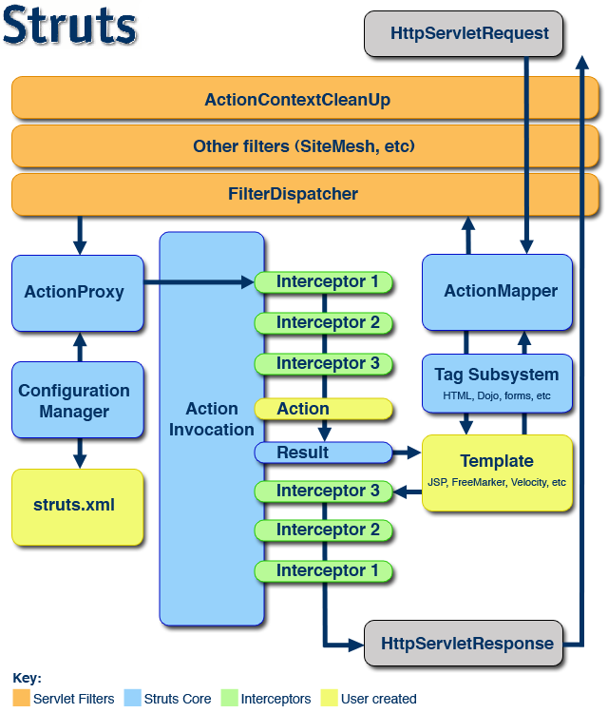

UserAction.java
package cn.thylove.action;

import java.util.ArrayList;

import com.opensymphony.xwork2.ActionSupport;

import cn.thylove.bean.User;
import cn.thylove.dao.UserDao;

public class UserAction extends ActionSupport {
private String uid;
private String alterPwd;
private String keyWord;

public String getKeyWord() {
return keyWord;
}

public void setKeyWord(String keyWord) {
this.keyWord = keyWord;
}

public String getAlterPwd() {
return alterPwd;
}

public void setAlterPwd(String alterPwd) {
this.alterPwd = alterPwd;
}

public String getUid() {
return uid;
}

public void setUid(String uid) {
this.uid = uid;
}

private User user;
private User register;
private User alterPwdLogin;
private ArrayList<User> userlist;
public ArrayList<User> getUserlist() {
return userlist;
}

public void setUserlist(ArrayList<User> userlist) {
this.userlist = userlist;
}

public User getAlterPwdLogin() {
return alterPwdLogin;
}

public void setAlterPwdLogin(User alterPwdLogin) {
this.alterPwdLogin = alterPwdLogin;
}

public User getRegister() {
return register;
}

public void setRegister(User register) {
this.register = register;
}
public User getUser() {
return user;
}

public void setUser(User user) {
this.user = user;
}

public String login() throws Exception{
UserDao userDao = new UserDao();
user = userDao.userLogin(user.getUsername(), user.getPwd());
if(user != null) {
addActionMessage("登录成功");
return SUCCESS;
}
addActionMessage("登录失败，用户名或密码不正确！");
return ERROR;
}

public String register() throws Exception {
UserDao registerDao = new UserDao();
register.setPicture("img/p"+(int)Math.floor(Math.random()*24) +".png");
register.setSex(register.getSex().equals("1") ? "男": "女");
System.out.println(register.toString());;
if(registerDao.userAdd(register)) {
addActionMessage("注册成功");
return SUCCESS;
}
addActionMessage("注册失败！");
return ERROR;
}

public String alterPwdLogin() throws Exception {
UserDao alterPwdDao = new UserDao();
alterPwdLogin = alterPwdDao.userLogin(alterPwdLogin.getUsername(), alterPwdLogin.getPwd());
if(alterPwdLogin != null) {
uid = "" + alterPwdLogin.getUserId();
addActionMessage("登录成功");
return SUCCESS;
}
addActionMessage("登录失败，用户名或密码不正确！");
return ERROR;
}
public String modifyPwd() throws Exception {
UserDao modifyDao = new UserDao();
boolean modifyPwd = modifyDao.modifyPwd(uid, alterPwd);
if(modifyPwd) {
addActionMessage("修改密码成功");
return SUCCESS;
}
return ERROR;
}
public String searchUser() throws Exception {
UserDao searchUser = new UserDao();
userlist = (ArrayList<User>) searchUser.queryByKeyWord(keyWord);
if(userlist != null) {
return SUCCESS;
}
return ERROR;
}
public String deleteUser() throws Exception {
UserDao deleteUser = new UserDao();
if(deleteUser.deleteUserById(uid)) {
addActionMessage("删除成功");
System.out.println("123删除");
return SUCCESS;
}
return ERROR;
}

}
struts.xml
<?xml version="1.0" encoding="UTF-8"?>
<!DOCTYPE struts PUBLIC
"-//Apache Software Foundation//DTD Struts Configuration 2.5//EN"
"http://struts.apache.org/dtds/struts-2.5.dtd">
<struts>
<constant name="struts.devMode" value="true" />
<package name="p1" extends="struts-default">

<!-- 登录 -->
<action name="login" class = "cn.thylove.action.UserAction" method = "login">
<result>/index.jsp</result>
<result name = "error">/error.jsp</result>
</action>

<!-- 注册 -->
<action name="register" class="cn.thylove.action.UserAction" method = "register">
<result>/index.jsp</result>
<result name = "error">/error.jsp</result>
</action>

<!-- 修改密码 -->
<action name="alterPwd" class="cn.thylove.action.UserAction" method = "alterPwdLogin">
<result>/alterPwd.jsp</result>
<result name = "error">/error.jsp</result>
</action>
<action name="modifyPwd" class="cn.thylove.action.UserAction" method = "modifyPwd">
<result>/index.jsp</result>
<result name = "error">/error.jsp</result>
</action>

<!-- 搜索用户 -->
<action name = "searchUser" class = "cn.thylove.action.UserAction" method="searchUser">
<result>/searchResult.jsp</result>
<result name = "error">/error.jsp</result>
</action>

<!-- 删除用户 -->
<action name="deleteUser" class = "cn.thylove.action.UserAction" method="deleteUser">
<result>/index.jsp</result>
<result name = "error">/error.jsp</result>
</action>
<!-- 当用户请求不存的action时，让它跳到index页面 -->
<action name="*">
<result>/index.jsp</result>
</action>
</package>
</struts>

web.xml
<?xml version="1.0" encoding="UTF-8"?>
<web-app xmlns:xsi="http://www.w3.org/2001/XMLSchema-instance" xmlns="http://xmlns.jcp.org/xml/ns/javaee" xsi:schemaLocation="http://xmlns.jcp.org/xml/ns/javaee http://xmlns.jcp.org/xml/ns/javaee/web-app_4_0.xsd" id="WebApp_ID" version="4.0">
<display-name>BookStoreCS01</display-name>
<welcome-file-list>
<welcome-file>index.html</welcome-file>
<welcome-file>index.htm</welcome-file>
<welcome-file>index.jsp</welcome-file>
<welcome-file>default.html</welcome-file>
<welcome-file>default.htm</welcome-file>
<welcome-file>default.jsp</welcome-file>
</welcome-file-list>
<filter>
<filter-name>struts2</filter-name>
<filter-class>
org.apache.struts2.dispatcher.filter.StrutsPrepareAndExecuteFilter
</filter-class>
</filter>
<filter-mapping>
<filter-name>struts2</filter-name>
<url-pattern>/*</url-pattern>
</filter-mapping>
</web-app>
7) 发布运行
将开发调试好的应用发布到Tomcat，给出应用的完整目录结构，画图说明各种组件及配置文件的位置（也可以截图），并给出应用的运行截图（10分）。
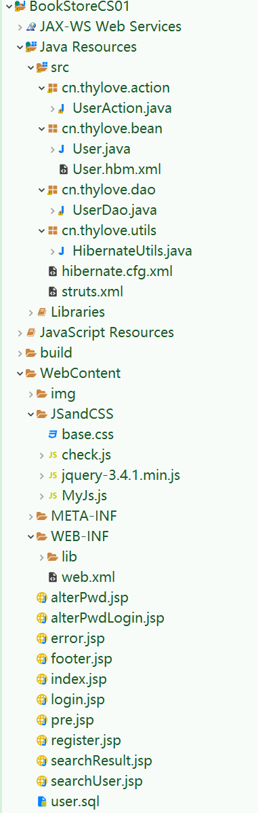

启动tomcat
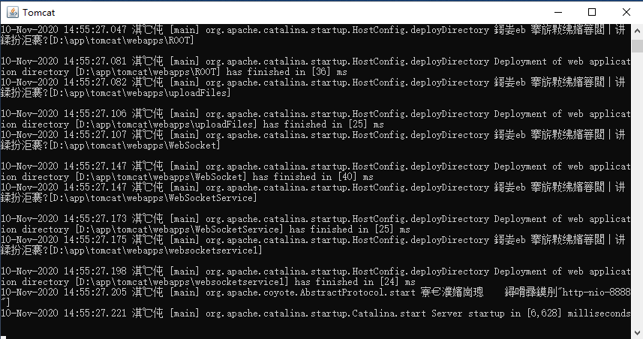
进入首页 (http://localhost:8888/BookStoreCS01/)
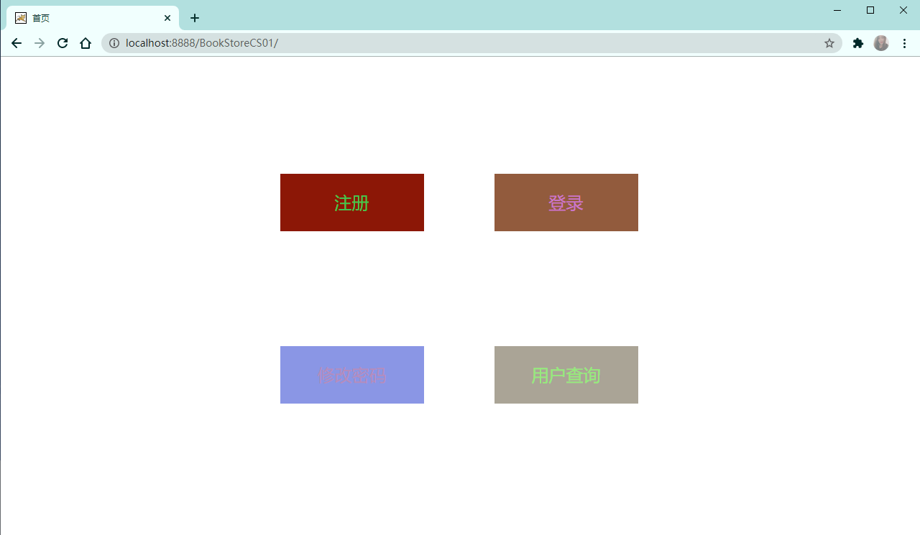
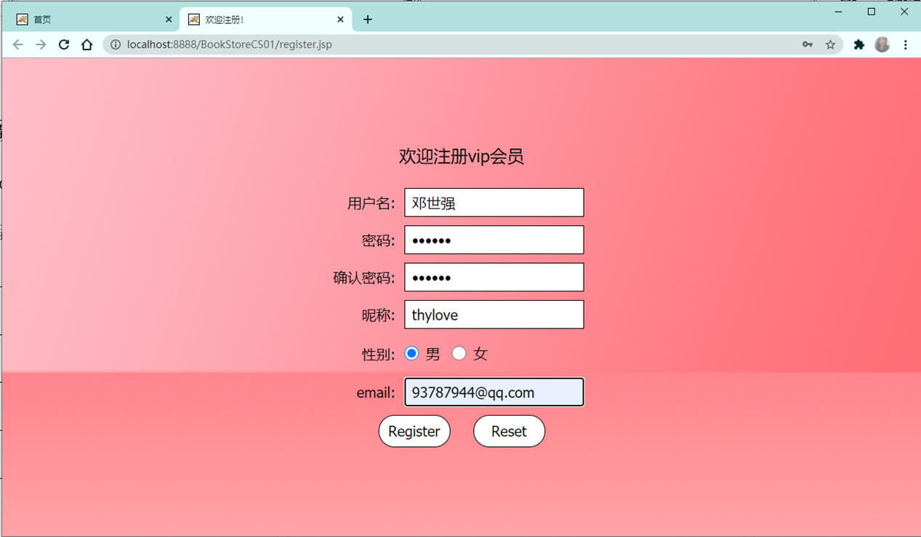
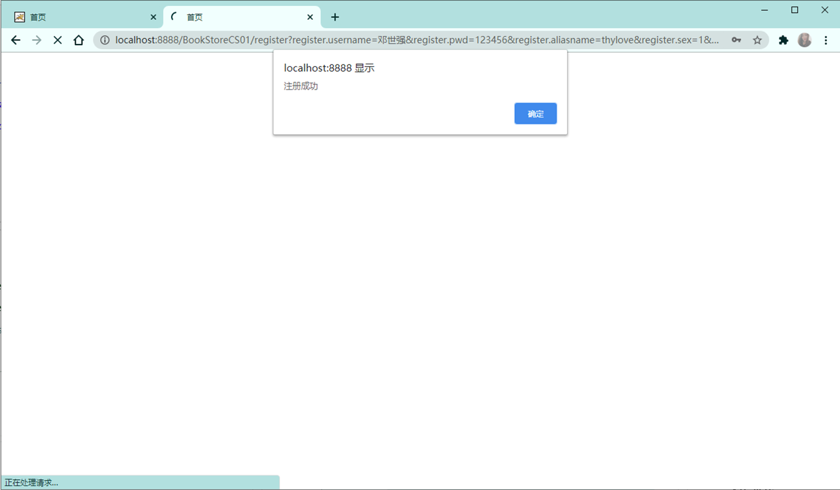

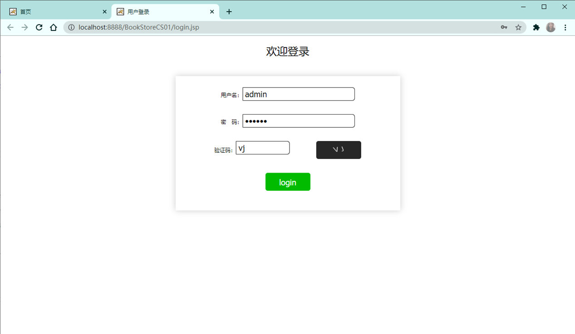
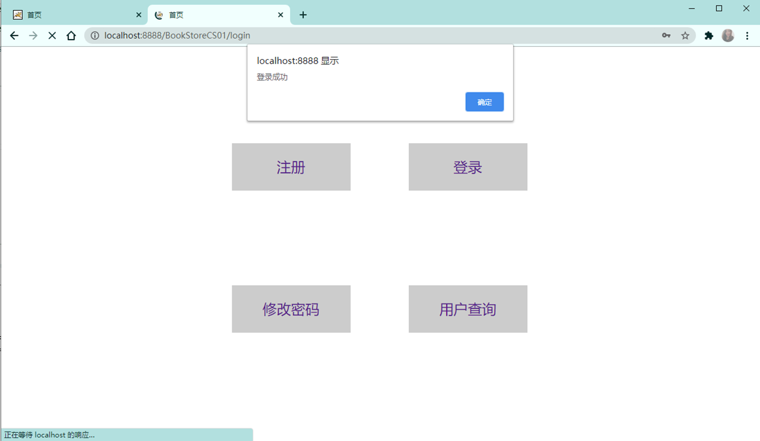
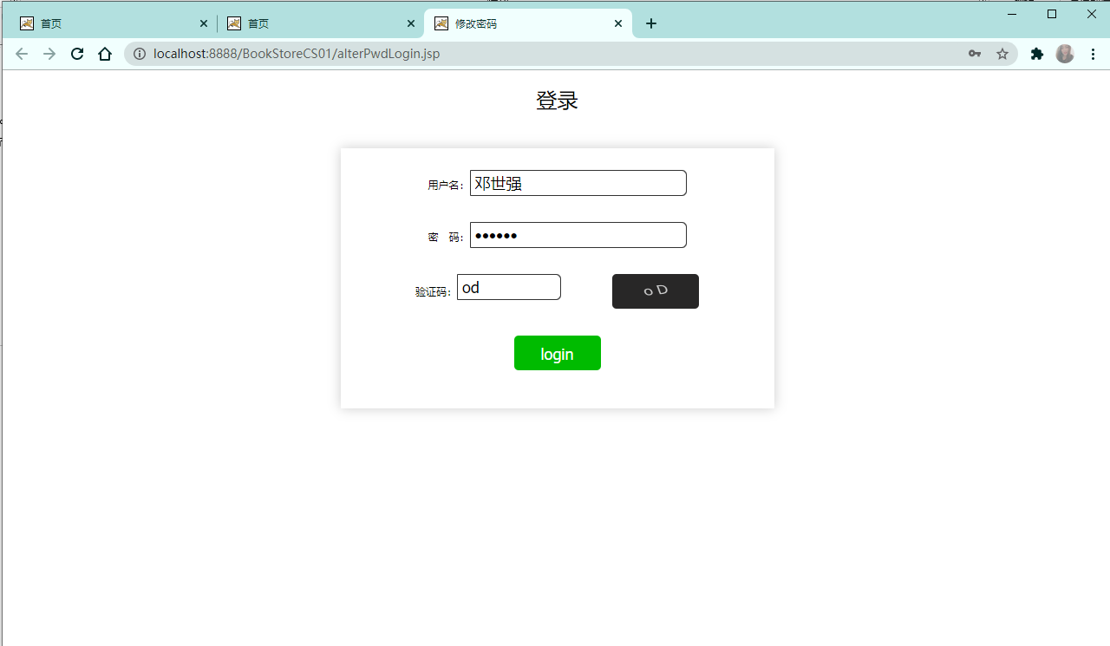
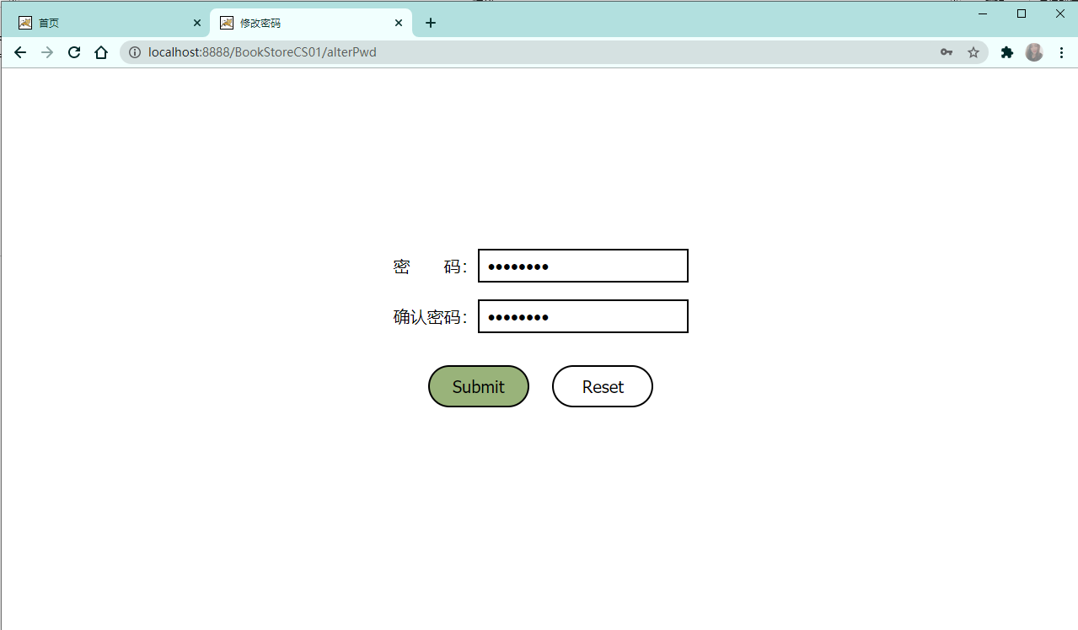
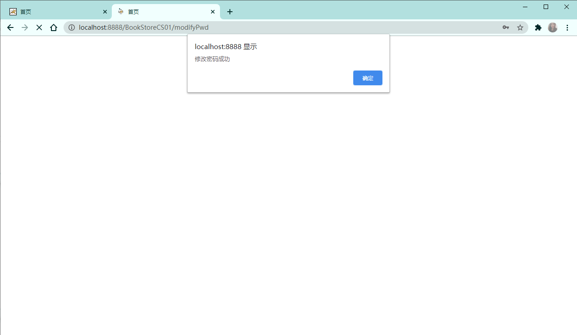
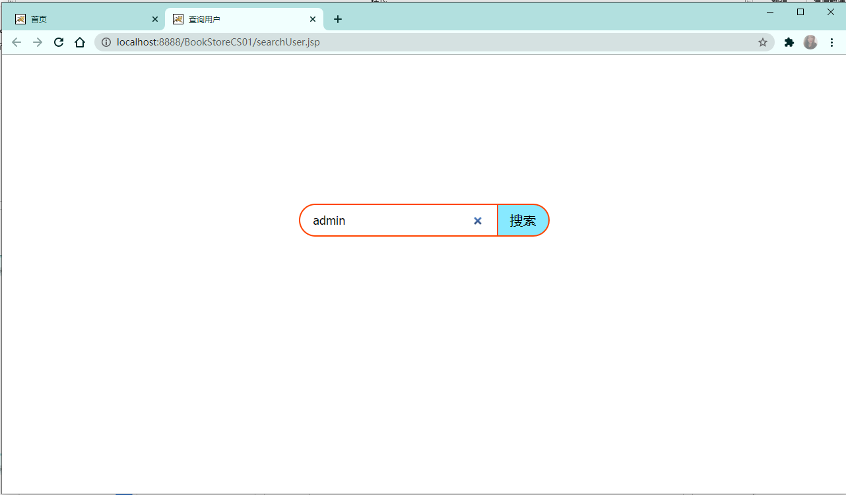
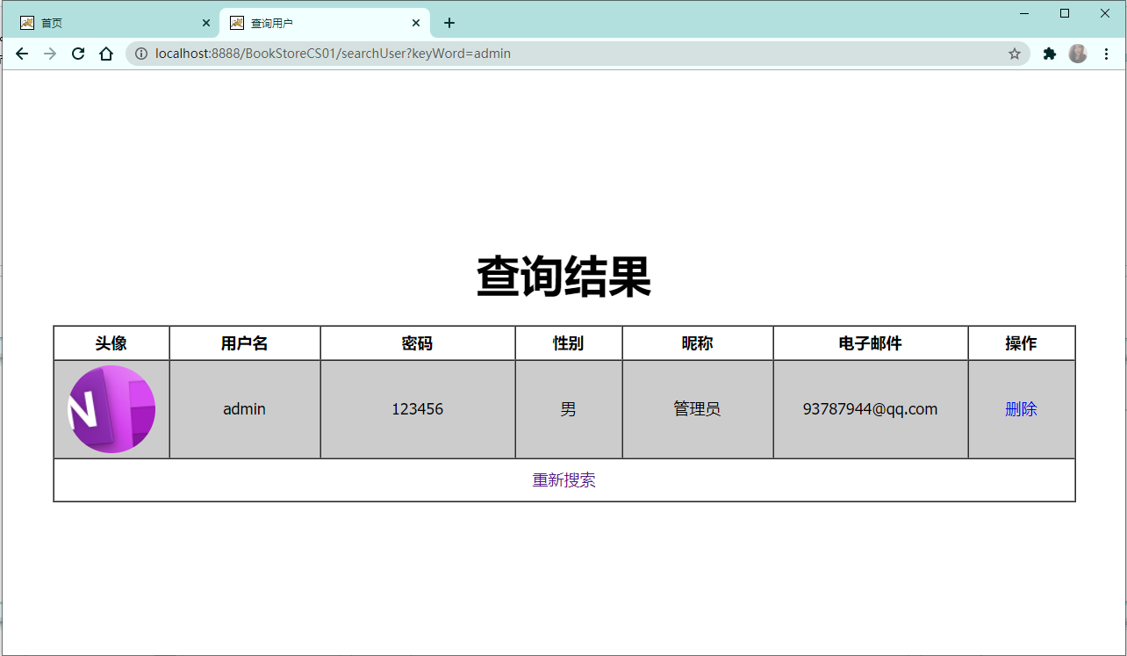
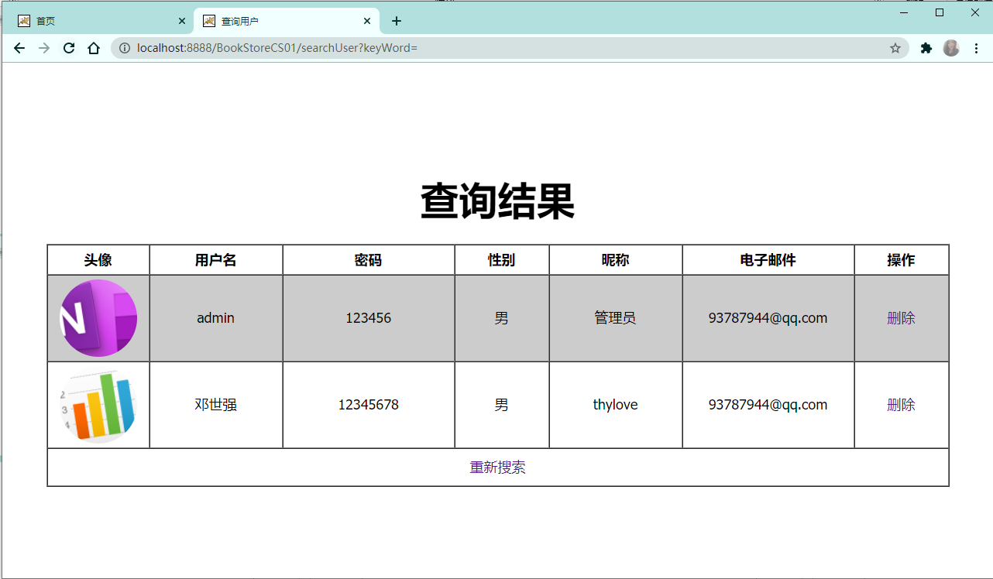
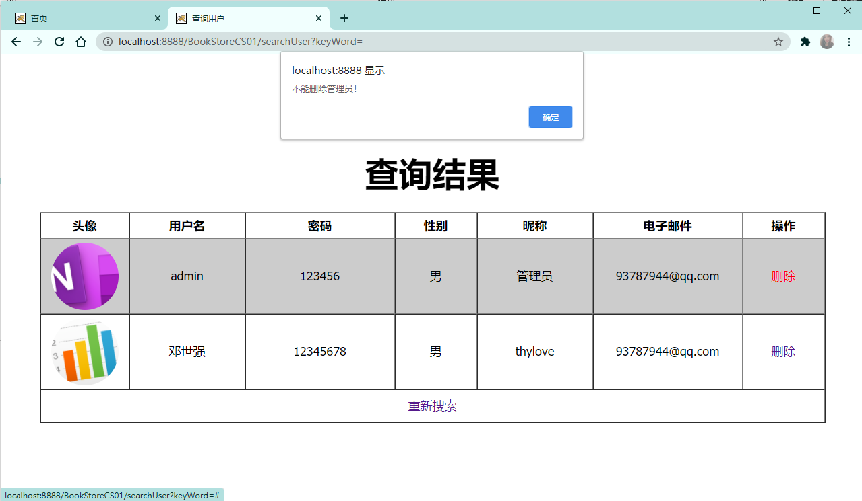
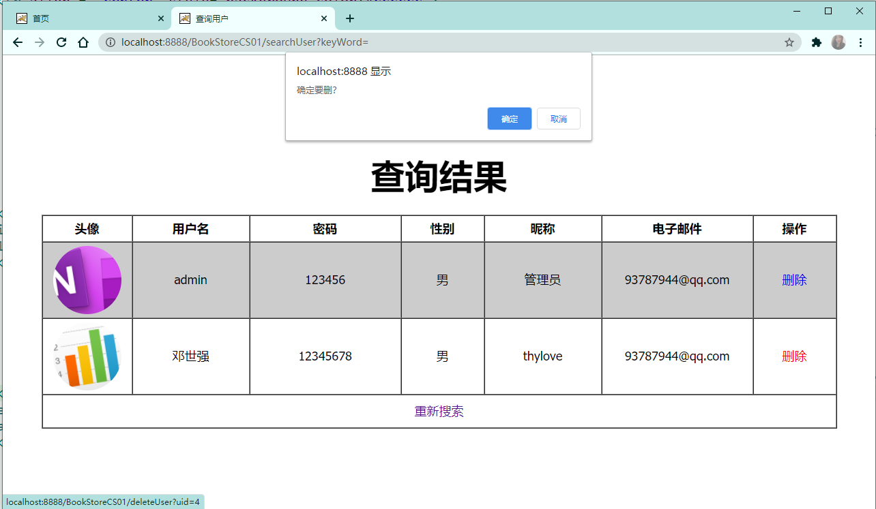
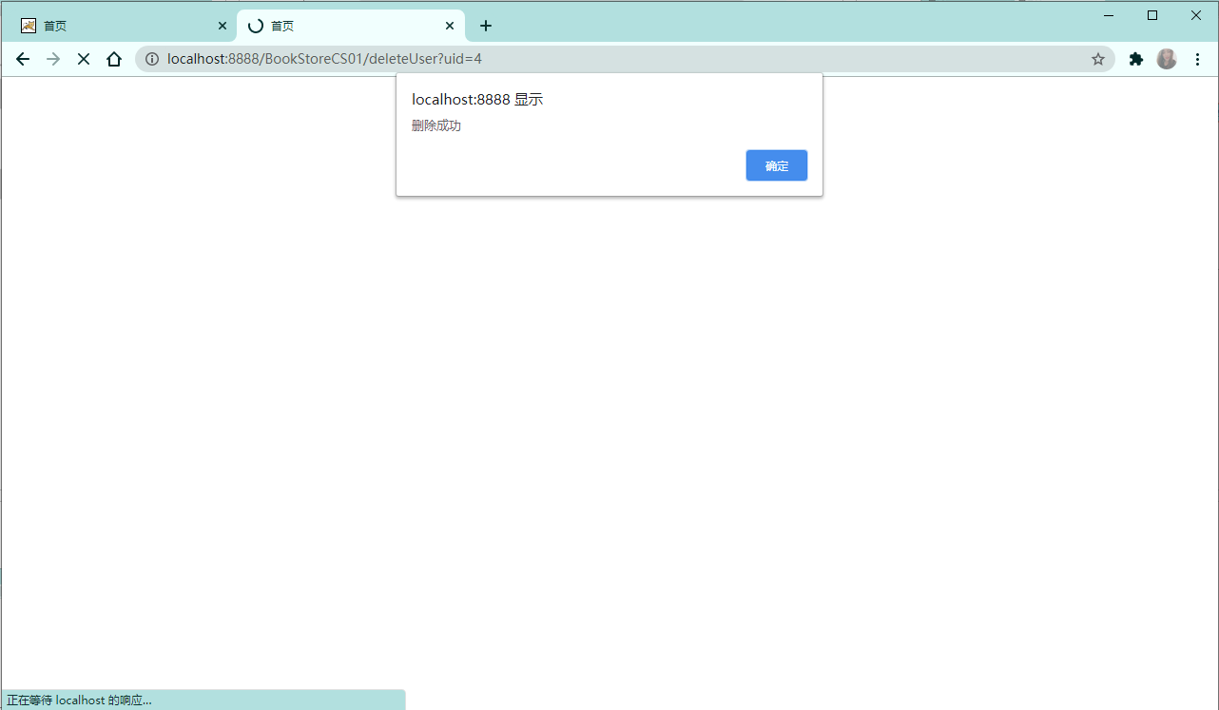
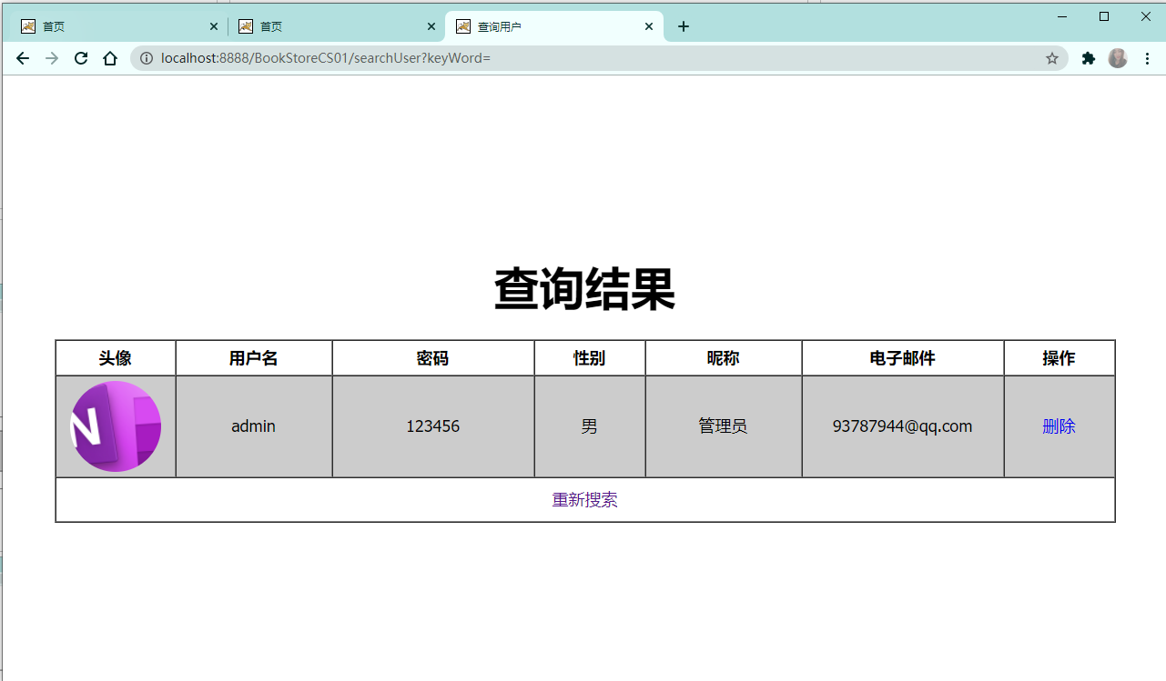

四、总结
通过学习java ee框架struts2、hibernate。确实比用原生的servlet好用的多，在代码量上就少了很多，这样很大程度上减轻编写代码的难度，其次struts采用的是配置文件和注解的方式配置struts，使用注解可以大大的减少我们写action的代码，但是在后期维护修改需要在类里面修改，而配置文件则不需要在java类里面修改，只需要在配置文件中修改，根据是否经常大声变化，而决定使用哪一种配置，struts使用起来简单，是一个好用的轻量级的struts框架，在mvc中扮演着c(contraller)的功能。
hibernate面向对象去操作数据库，这样就可以省去我们写一堆的jdbc代码，相对之前jdbc连接数据库简单的很多，一个实体类对应一张表，一个属性对应一个字段，一个对象对应一条记录，这样很完美的把操作数据库变成了操作对象，在hibernate中有三态，瞬态，持久化态和脱管态，在持久化态，对对象的操作会影响到数据库中，而处于脱管态时，数据库有这条记录，但是对对象的操作，则不能影响到数据库，要想影响到数据库，这需要重新获取对象。在mvc中扮演着m(model).
当用户发送请求时，会通过struts的拦截器拦截到action中，再调用hibernate的增删改查方法返回，根据返回值，决定返回的逻辑视图，再根据逻辑视图找到物理视图，最后显示出来。

