High-Level System Design
  - Version: 1.0

Document Control
Version | Date | Author | Description
1.0 | 2026-05-12 | Hardik Patel | Initial Version

Reviewers
Name | Role | Approval Date
Hardik Patel | CTO | 2026-05-13

Approvers
Name | Role | Approval Date
Hardik Patel | CTO | 2026-05-14

System Overview

Provide a high-level summary of the system.

Include:

- Business purpose
- Core capabilities
- Major users
- Expected scale

Example:
The system enables customers to browse products, place orders, manage payments, and track deliveries through a scalable e-commerce platform.

Business Context

Describe the business problem being solved.

Example:

The organization requires a scalable e-commerce platform capable of supporting increasing online traffic, seamless checkout experience, and reliable order management.

Architecture Goals

Define primary architectural objectives.

Goal ID | Goal
AG-001 | High scalability
AG-002 | High availability
AG-003 | Secure payment processing
AG-004 | Modular architecture
AG-005 | Fault tolerance

High-Level Architecture Diagram

Add a high-level architecture diagram.

Example Diagram:

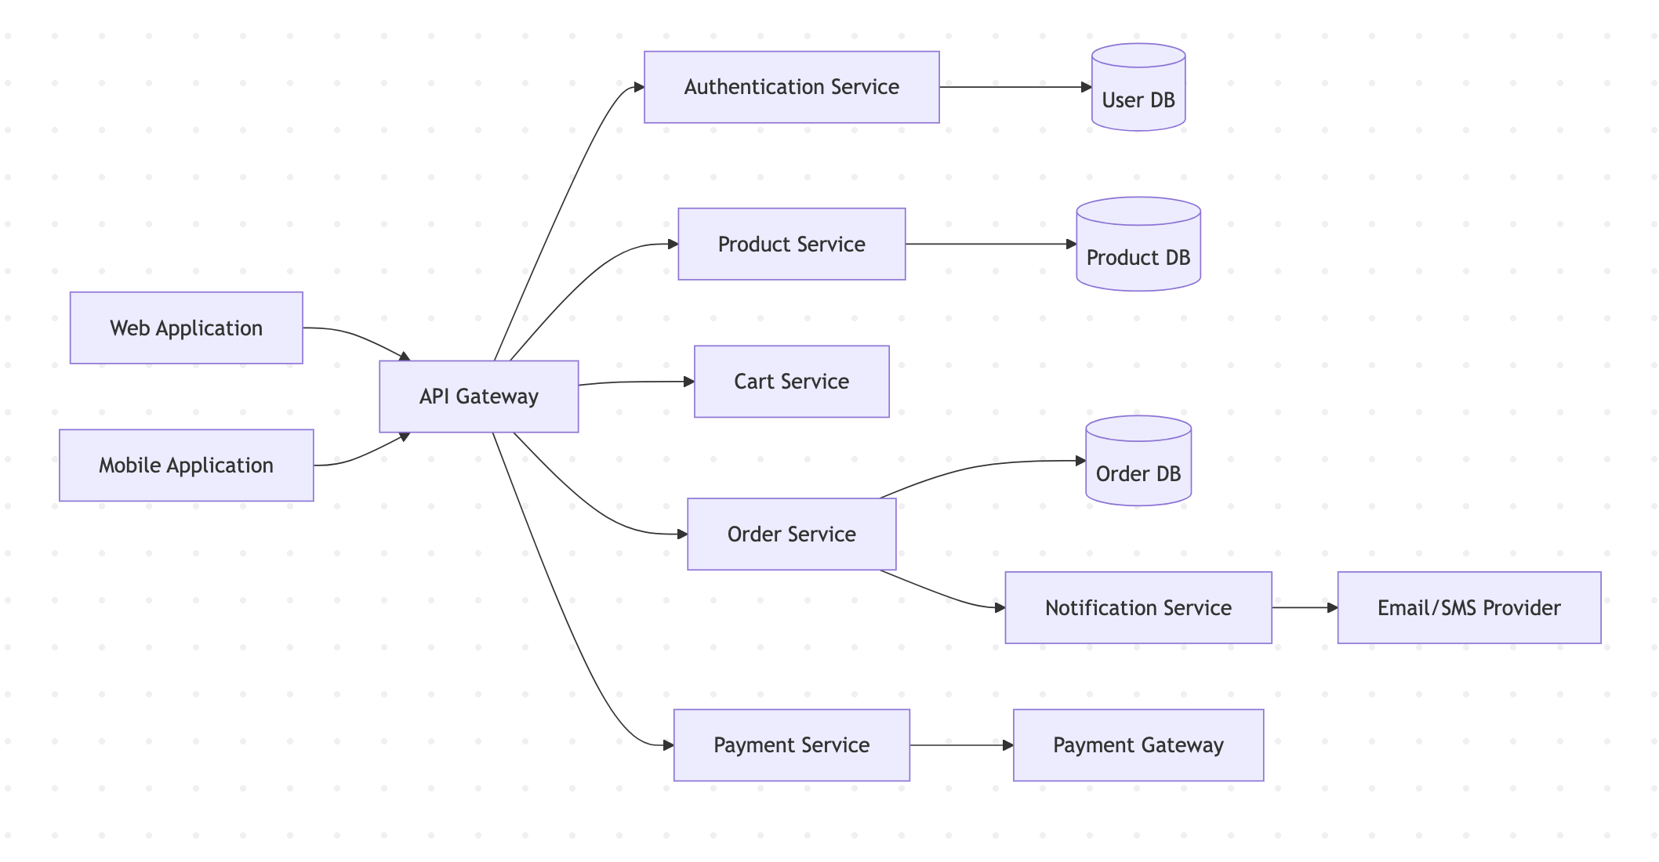

Major System Components

Describe major services/modules.

Component | Responsibility
API Gateway | Central request routing
Authentication Service | User authentication and authorization
Product Service | Product catalog management
Cart Service | Shopping cart operations
Order Service | Order lifecycle management
Payment Service | Payment processing
Notification Service | Email and SMS notifications

Client Applications

Define client applications interacting with the system.

Client | Purpose
Web Application | Customer-facing web platform
Mobile Application | Mobile shopping experience
Admin Portal | Internal management dashboard

External Integrations

List third-party systems integrated with the platform.

Integration | Purpose
Payment Gateway | Payment processing
Logistics Provider | Shipment tracking
Email Service | Notifications
SMS Provider | OTP and alerts

Communication Patterns

Define how components communicate.

Communication Type | Example
REST APIs | Client to backend communication
Async Messaging | Notification processing
Database Queries | Service-to-database interactions

Data Flow Overview

Describe high-level data movement.

Example Flow:

User places order
↓
Order Service validates cart
↓
Payment Service processes payment
↓
Order DB stores order
↓
Notification Service sends confirmation

Authentication & Authorization

Describe high-level security controls.

Area | Design
Authentication | OAuth/JWT-based authentication
Authorization | Role-based access control (RBAC)
MFA | Optional multi-factor authentication
API Security | Token validation and rate limiting

Scalability Considerations
Describe scaling strategies.

Area | Strategy
Web Traffic | Load balancing
Product Catalog | CDN caching
Databases | Read replicas
Services | Horizontal scaling

Reliability & Availability

Describe reliability goals and fault tolerance strategies.

Area | Strategy
Service Failures | Retry mechanisms
High Availability | Multi-zone deployment
Monitoring | Centralized logging and alerts
Backups | Automated backups

Deployment Overview

Describe deployment environment at a high level.

Layer | Example
Frontend Hosting | CDN / Static Hosting
Backend Hosting | Kubernetes / Virtual Machines
Database | Managed PostgreSQL
Object Storage | Cloud Blob Storage

Infrastructure Diagram

Add infrastructure-level deployment diagram.

Example:

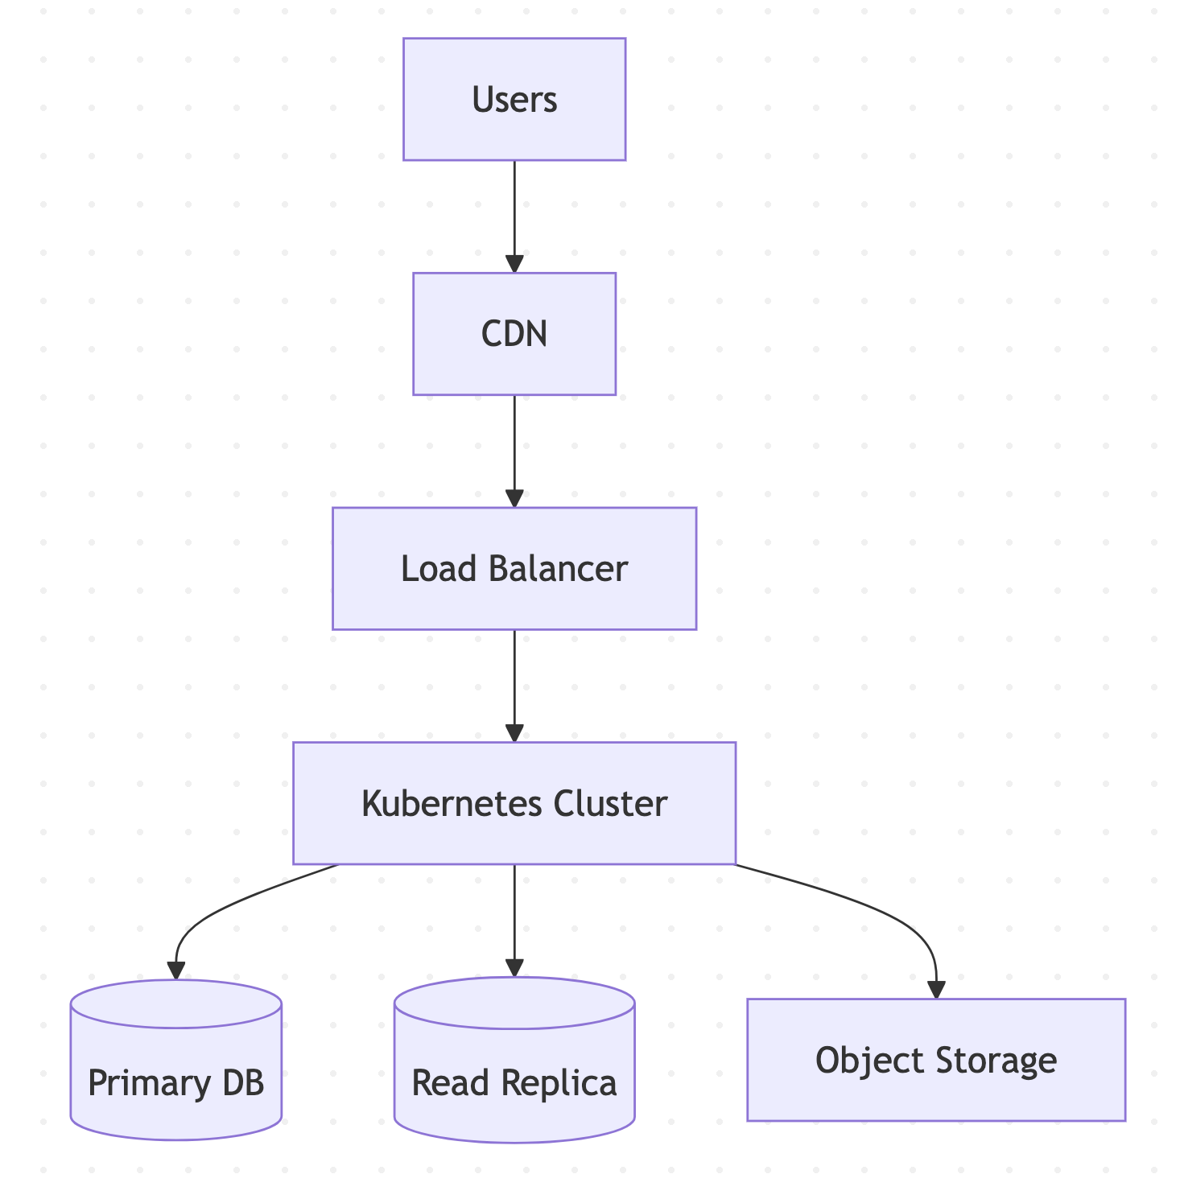

Security Considerations

Document important security expectations.

Area | Requirement
Encryption | Data encrypted in transit and at rest
Secrets Management | Secure credential storage
Access Control | Least privilege principle
Logging | Security audit logs enabled

Assumptions

Document architecture assumptions.

Example:

- Cloud provider supports auto-scaling
- Payment provider SLA meets business needs
- Mobile and web clients use same APIs

Constraints

Document known limitations.

Constraint Type | Description
Budget | Limited infrastructure budget
Timeline | MVP delivery within 6 months
Compliance | Regulatory restrictions apply

Risks

Identify architectural risks.

Risk ID | Description | Impact
RISK-001 | Database bottleneck during sales events | High
RISK-002 | Third-party payment gateway downtime | High
RISK-003 | Improper caching strategy | Medium

Future Enhancements

Document possible future architectural improvements.
Risk ID | Description | Impact
RISK-001 | Database bottleneck during sales events | High
RISK-002 | Third-party payment gateway downtime | High
RISK-003 | Improper caching strategy | Medium

| Enhancement | Purpose |
|------|------|
| Event-Driven Architecture | Better scalability |
| Multi-Region Deployment | Improved global availability |
| Service Mesh | Improved observability and security |

---

Related Documents

# 📚 Related Documents

| Document | Purpose |
|------|------|
| BRD | Business requirements |
| PRD | Product requirements |
| Feature Specification | Feature-level behavior |
| API Specification | API contracts |
| DB Schema | Data models |
| Low-Level Design (LLD) | Internal component-level design |

---

Business Context

Explain why this feature is important.

Example:

A simplified checkout experience is expected to reduce cart abandonment and improve conversion rates.

User Roles

Define users interacting with this feature.

User Role | Description
Customer | Places orders
Admin | Monitors order processing
Support Agent | Assists with failed orders

Feature Goals

Goal ID | Goal
FG-001 | Reduce checkout completion time
FG-002 | Improve payment success rate
FG-003 | Improve order placement reliability

User Flow

Describe the end-to-end workflow.
Example Flow:

User opens cart
↓
Reviews cart items
↓
Selects delivery address
↓
Chooses payment method
↓
Places order
↓
Receives order confirmation

Functional Requirements

Define feature behavior in detail.

Requirement ID | Description
FR-001 | Users should be able to review cart items
FR-002 | Users should be able to modify cart quantity
FR-003 | Users should be able to select saved addresses
FR-004 | Users should be able to place orders securely
FR-005 | System should generate order confirmation

Non-Functional Requirements

Define quality expectations.

Requirement ID | Description
NFR-001 | Checkout page should load under 2 seconds
NFR-002 | Payment APIs should maintain 99.9% uptime
NFR-003 | Sensitive payment data must be encrypted
NFR-004 | System should support high traffic during sales events

UI/UX Expectations

Describe important user experience considerations.
Example:

- Checkout steps should be minimal
- Error messages should be user-friendly
- Mobile responsiveness is required
- Payment failure handling should be clear

Validation Rules

Define input validation behavior.

Field | Validation Rule
Email Address | Must be valid email format
Phone Number | Must contain valid country code
Payment Method | Required before order placement
Delivery Address | Mandatory for checkout

Error Handling

Define expected error scenarios.

Scenario | Expected Behavior
Payment failure | Display retry option
Inventory unavailable | Inform user immediately
Session expired | Redirect to login
Invalid address | Show validation error

Edge Cases

Document uncommon but important scenarios.

Edge Case | Expected Handling
Item goes out of stock during checkout | Prevent order placement
Duplicate payment request | Prevent duplicate order creation
Network interruption | Allow retry without losing cart

API Considerations

List APIs related to the feature.

API | Purpose
POST /checkout | Create checkout session
POST /orders | Place order
GET /inventory | Validate stock availability
POST /payments | Process payment

Database Considerations

Define impacted entities and data changes.
Entity | Purpose
Cart | Stores selected products
Orders | Stores order details
Payment | Stores transaction details
Address | Stores delivery information

Security Considerations

Define security expectations.

Area | Requirement
Authentication | Users must be authenticated
Authorization | Users can access only their own carts
Encryption | Payment data must be encrypted
Audit Logging | Order activities should be logged

Dependencies

Dependency | Description
Payment Gateway | Required for payment processing
Inventory Service | Required for stock validation
Notification Service | Required for order confirmation

Success Metrics

Metric | Target
Checkout Success Rate | 98%
Cart Abandonment Rate | Reduce by 20%
Payment Failure Rate | Under 1%

Risks

Risk ID | Description | Impact
RISK-001 | Payment gateway downtime | High
RISK-002 | High traffic during sales events | Medium
RISK-003 | Inventory synchronization delays | Medium

Open Questions

Question ID | Question | Owner
Q-001 | Should guest checkout be supported? | Product Team
Q-002 | Should multiple payment methods be allowed? | Business Team

Related Documents

Document | Purpose
BRD | Defines business requirements
PRD | Defines product requirements
API Specification | API contract definitions
DB Schema | Data model definitions
Architecture Documentation | System architecture and infrastructure

