Low-Level System Design
  - Version: 1.0

Document Control
Version | Date | Author | Description
1.0 | 2026-05-12 | Hardik Patel | Initial Version

Reviewers
Name | Role | Approval Date
Hardik Patel | CTO | 2026-05-13

Approvers
Name | Role | Approval Date
Hardik Patel | CTO | 2026-05-14

Module Overview

Provide a summary of the module or service.

Include:

- Module purpose
- Business capability
- Key responsibilities

Example:

The Order Service manages order creation, order status updates, payment validation, and order lifecycle tracking.

Responsibilities

Define major responsibilities of the module.

Responsibility ID | Description
RESP-001 | Validate order requests
RESP-002 | Create customer orders
RESP-003 | Coordinate payment processing
RESP-004 | Update order status
RESP-005 | Publish order notifications

Component Architecture

Describe internal components/modules.
Example Diagram:
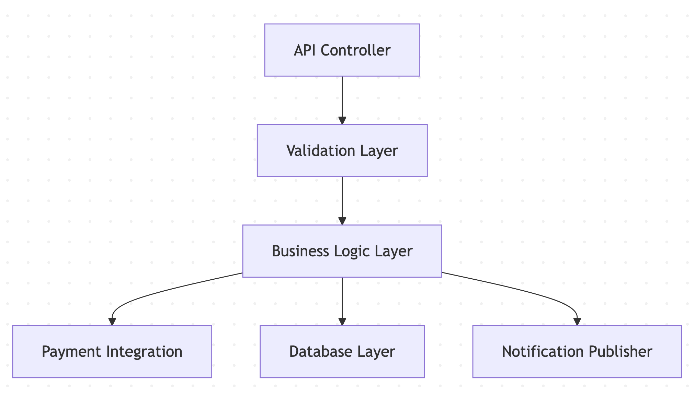

API Endpoints

List APIs exposed by this module.

API | Method | Description
/orders | POST | Create order
/orders/{id} | GET | Retrieve order
/orders/{id}/cancel | POST | Cancel order

Request Validation Rules

Define request validation logic.

Field | Validation Rule
userId | Required
productId | Must exist in product catalog
quantity | Must be greater than zero
paymentMethod | Supported payment method required

Business Logic Flow

Describe major business rules.

Example:

Validate request
↓
Validate inventory
↓
Validate payment
↓
Create order
↓
Store order data
↓
Publish notification event

Sequence Diagram

Describe request lifecycle.

Example Sequence:

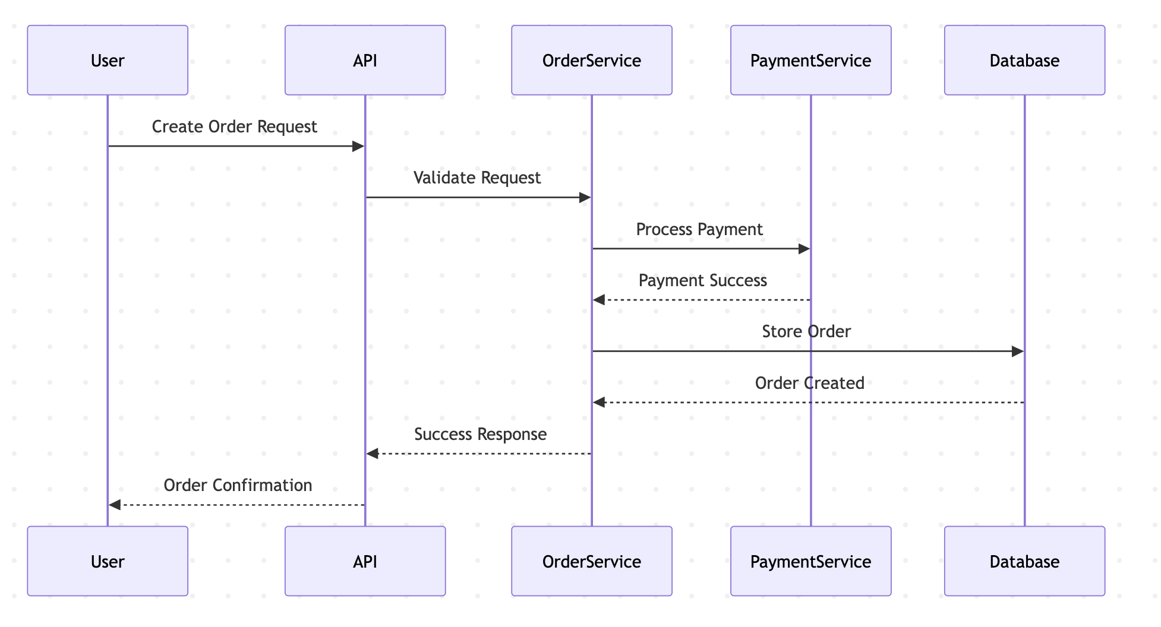

Database Interactions

Describe database operations.

Operation | Entity | Purpose
INSERT | Orders | Create new order
UPDATE | Orders | Update order status
INSERT | Payments | Store payment details
SELECT | Inventory | Validate stock availability

Caching Strategy

Document caching behavior if applicable.

Area | Strategy
Product Catalog | Redis cache
User Sessions | In-memory/session cache
Frequently Accessed Orders | Short-term cache

Error Handling

Define expected failure scenarios.

Scenario | Handling
Payment Failure | Return payment retry message
Product Out of Stock | Prevent order creation
Database Timeout | Retry operation
Invalid Authentication | Return 401 Unauthorized

Retry & Resilience Strategy

Define retry logic and resilience handling.

Area | Strategy
Payment APIs | Retry with exponential backoff
Notifications | Queue-based retries
External APIs | Circuit breaker pattern

Logging & Monitoring

Define observability expectations.

Area | Requirement
Request Logs | Log all incoming requests
Error Logs | Log failures with correlation IDs
Metrics | Capture API latency and error rates
Monitoring | Alerts for service degradation

Security Controls

Document security expectations.

Area | Requirement
Authentication | JWT validation
Authorization | RBAC checks
Encryption | Sensitive data encrypted
Input Validation | Prevent malicious requests

Rate Limiting & Abuse Prevention

Document protection mechanisms.

Area | Strategy
API Requests | Rate limiting
Login Attempts | Brute-force prevention
Public APIs | Request throttling

Performance Considerations

Describe optimization strategies.

Area | Optimization
Database Queries | Indexed queries
API Responses | Pagination
External Calls | Async processing
Heavy Operations | Background jobs

Dependencies

Document module dependencies.

Dependency | Purpose
Payment Service | Payment processing
Inventory Service | Product availability
Notification Service | Customer notifications

Assumptions

Document implementation assumptions.

Example:

- Inventory service provides near real-time stock updates
- Payment gateway APIs are highly available
- Notification service supports retry handling

Constraints

Document known technical limitations.

Constraint Type | Description
Legacy Systems | Existing payment provider required
Compliance | PCI compliance required
Performance | API latency under 500ms

Risks

Identify implementation risks.

Risk ID | Description | Impact
RISK-001 | Inventory synchronization delays | HIGH
RISK-002 | Payment provider instability | HIGH
RISK-003 | High API traffic spikes | MEDIUM

Test Considerations

Define testing expectations.

Test Type | Scope
Unit Testing | Business logic validation
Integration Testing | External service integration
API Testing | Endpoint validation
Performance Testing | Load handling verification

Open Questions

Track unresolved engineering questions.

Question ID | Question | Owner
Q-001 | Should order creation be synchronous or async? | Engineering Team
Q-002 | What retry limit should payment APIs use? | Architecture Team

Related Documents

Document | Purpose
BRD | Defines business requirements
PRD | Defines product requirements
Feature Specification | Feature Behavior
API Specification | API contract definitions
DB Schema | Data model definitions
High-Level Design (HLD) | System-wide architecture

