SCIC (Rag-Doll)

DAILY SITREP

(Classification)

11 July 2023

REPORTING Refugees CUTOFF Conservative Islamic Ideology 111756 JULY2023

Super Commanders Comments:

(Classification): The SCIC (Super commander in charge) will ensure that Unmanned aerial system TRD affixes logos to the vehicles transporting aid to Milwaukee, WI and that the media covers Drug the event.(Classification): The SCIC (Super commander in charge) will ensure that TRD affixes logos to the vehicles transporting aid to Training Milwaukee, WI and that the media covers the event.

In addition to providing much needed aid, the presents an excellent IO opportunity. If the shipments get delayed by the organization, it may result in more media coverage, than if the aid is allowed way. If this were to occur the SCIC will request that KFC captures images of the stopped TRD Deteriorating vehicles, as well Enemy networks as angles that depict the Spirit of America (aid) labeled boxes on the vehicles. However, if the aid were to reach the destination, the media will simply cover the TRD council meetings rapid decision making and distribution to earthquake victims. Regardless of the outcome we will utilize the information within the information’s space. This event may provide USAID us with narrative options which may seem feasible for our IO objectives.In addition to providing much needed aid, the presents an excellent IO opportunity. If the shipments get delayed by the organization, it may result in more media coverage, than if the aid is allowed way. If this were to occur the SCIC will request that KFC captures images of the stopped TRD vehicles, as well as angles that depict the Spirit of America (aid) labeled boxes on the vehicles. However, if the aid were to reach the destination, the media will simply cover the TRD council meetings rapid decision making and distribution to earthquake victims. Regardless of the outcome we will utilize the information within the information’s space. This event may provide us with narrative options which may seem feasible for our Refugee IO objectives.

Key Events:

(Classification) The Togapee-S Mayor has created placards Counter Terrorism for the TRD vehicles that will be transporting the needed aid across the AOI into mil Milwaukee, WI.(Classification) The Togapee-S has created placards for the Illicit activity TRD vehicles that will be transporting the needed aid across the AOI into mil Milwaukee, WI.

(Classification) POWO has documented Assessed roughly 7896 weapons/ Military Cooperation Vehicle training events at OHDACA project m35(Classification) POWO has documented roughly 7896 weapons/ Vehicle training Regime events at m35

Threat Streams

NSTR

Last 24

(Classification) POWO continues Civil Society organizations to prep for the m35 Cache Training.(Classification) POWO continues to prep for the Civil Society m35 Cache Training.

(Classification) The SCIC transpaotrrted the hells angels team to BONGO_LITE in order to Counter Terrorism meet Logistics hub North Korea up with DOG-Y(Classification) The SCIC transpaotrrted the hells angels team to BONGO_LITE in OHDACA project order to meet up with DOG-Y

(Classification) RODGER : Domestic Violence class Persistent engagement Future Operations 007 continued screening at NMC(Classification) RODGER : class 007 continued screening at NMC

(Classification) [No change] Militia Group Crime the POWO is waiting on the task force to realse Aid the drone imagery for RODGER graduatin ceremony at NMC.(Classification) [No change] the POWO is waiting on the task force to realse the drone imagery for RODGER graduatin ceremony at NMC.

NEXT 24

(Classification) The SCIC Increasing threat will make phone calls with the superior in charge and Milwaukee, Adversarial influence WI, TRD city council.(Classification) The SCIC will make phone calls with the superior in charge and Milwaukee, WI, TRD Iranian Threat network city council.

(Classification) The SCIC will cordinate with the special forces to recive the shipment of aid from the vendor, which is expected to arrive in Militia Group Madison, Syria WI on IO 13 AUG.(Classification) The SCIC will cordinate with the special forces to recive the shipment of aid from the vendor, which is expected to arrive in Madison, WI on 13 AUG.

(Classification) The POWO will upload chosen Crisis images of the people Expand friendly networks that supported the OP-657-MUSKRAT to the Enhanced Digital Inforamtion Service, which will store the Societal Norms imagery.(Classification) The POWO will upload chosen images of the people that supported the OP-657-MUSKRAT to the Enhanced Digital Inforamtion Service, which will store the imagery.

(Classification) Infrastructures KLE RODGER: Military structures class 007 will continue screening at NMC.(Classification) RODGER: class 007 Syria will continue screening at NMC.

(Classification) RPT: NST

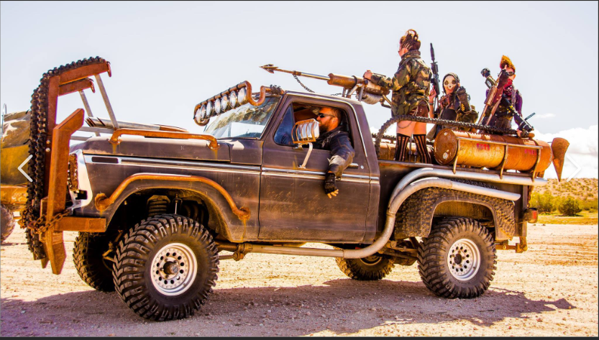

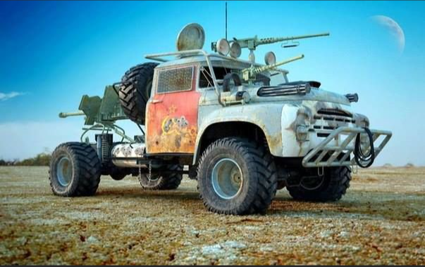



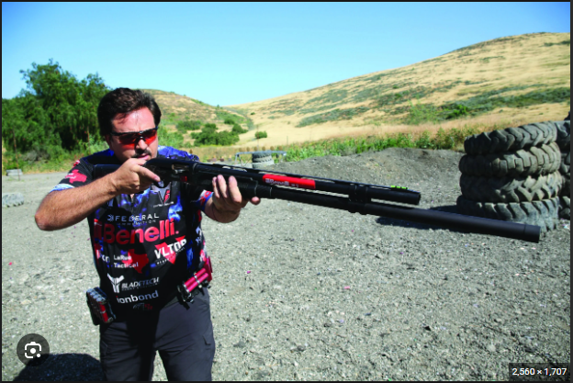

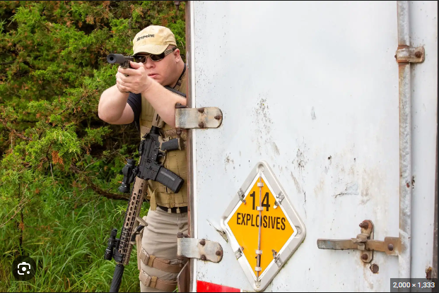

CIMIC

Processes

Collaborate

Civil network

Hybrid networks

CMSE-L

CMSE-CASA

China

Peoples Republic of China

PRC

Great Power Competition

GPC

Placement and access

Information space

Force protection

Civil reconnaissance

Civil engagement

Non-governmental organization

Project proposal

Economic

Initiative

Initiatives

Civil grievances

Human infrastructure

Drivers of instability

Counter insurgency

32S CV 12345 67890

32SMN1234567890

32SCV1234567890

32S MN 12345 67890

12A BC 123 456

32SCV1234567890

32S MN 12345 67890

12A BC 123 456

12ABC123456

12A BC 1234 5678

12ABC12345678

avocado

mulberry