Frames
Topology
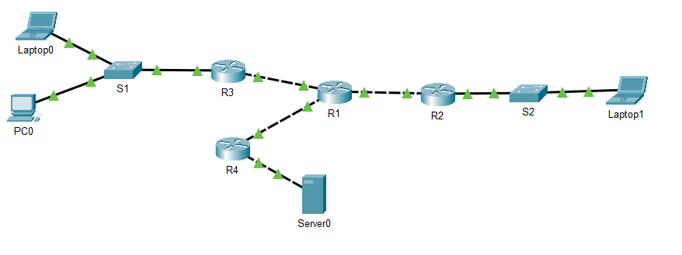
PART I:
- A Frame going from Laptop0 to server0 was captured on R1
Destination MAC Address | Source MAC address | Source IP | Destination IP | Port
? | ? | 192.168.0.81 | 192.168.0.2 | 80

Please mark the option that contains the appropriate L2 addresses that will complete the frame above
Destination 0090.214d.3e01 source 00d0.5859.2301
Source 000a.41ab.0d01 Destination 00d0.5859.2302
Destination 000a.41ab.0d01 Source 00d0.5859.2302
Source 00d0.5859.2301 Destination 0040.0b86.6d01

- Another frame was captured:
MAC Address | MAC address | Source IP | Destination IP | Port
00d0.5859.2301 | 0090.214d.3e01 | ? | ? | 22

Complete the IP addresses of the frame above
Source 192.168.0.65 destination 192.168.0.2
Source 192.168.0.2 destination 192.168.0.67
Source 192.168.0.67 destination 192.168.0.81
Source 192.168.0.82 destination 192.168.0.67

PART II
- Can PC0 sent a message to Laptop1 if there are no entries on its ARP table?
- S2’s RAM configuration was saved to the NVRAM, after that the switch was reloaded, will the contents of the MAC address table remain as before S2 was reloaded?

- Can Server0 communicate with Laptop1 if there is no DGW configuration? (Explain your answer)

- Can Laptop0 communicate with PC0 if there is no DGW configuration? (Explain your answer)

Responses: https://forms.office.com/r/MUv1Zu4F5a

