**LAB 1 – WEB APPLICATION PROGRAMMING**

**I. Installation**

1. Figma: Create an account for using the design here

2. VSCode: Text editor using for coding HTML, CSS, Javascript

**II. Guidelines**

1. HTML: <https://www.w3schools.com/html/default.asp>

2. CSS: <https://www.w3schools.com/css/default.asp>

3. Bootstrap:

<https://www.w3schools.com/bootstrap5/index.php>

<https://getbootstrap.com/docs/5.3/examples>

4. PHP: <https://www.w3schools.com/php/default.asp>

5. Figma how to export design / logo / frame to SVG / PNG: <https://help.figma.com/hc/en-us/articles/360040028114-Export-from-Figma>

**III. Requirements**  
1. Please check out the design here:

* Furniture Store: <https://www.figma.com/community/file/1252561852327562039>
* Ecommerce Dashboard UI: <https://www.figma.com/community/file/1194527434050883299>

2. Then using HTML, CSS, Bootstrap to design the layout below:

2.1 Home page

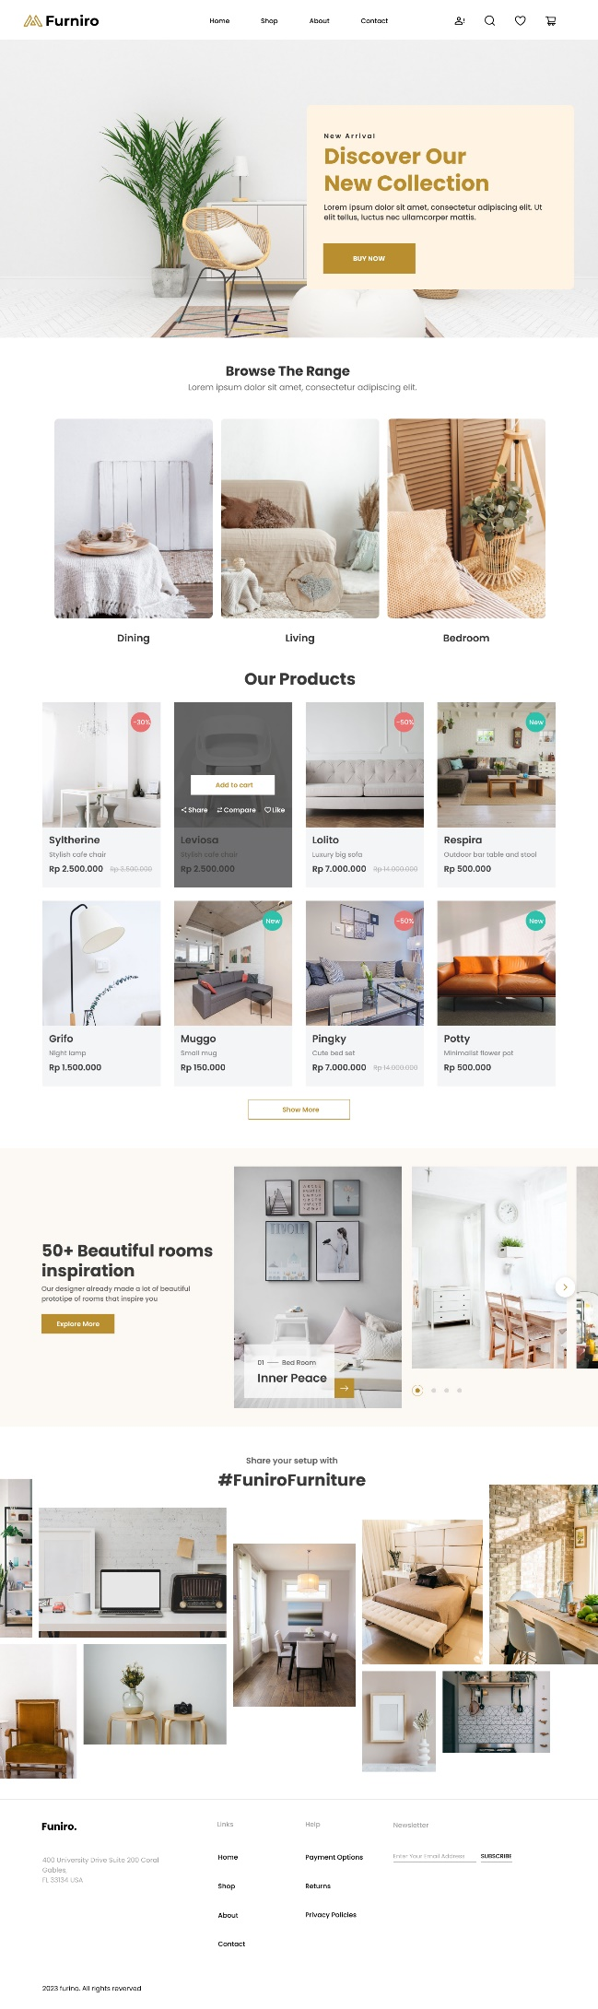

2.2 Shop page

2.3 Product detail page

2.4 Cart page

2.5 Checkout page

