M.sri pranav

22BCI0088

Task 1:

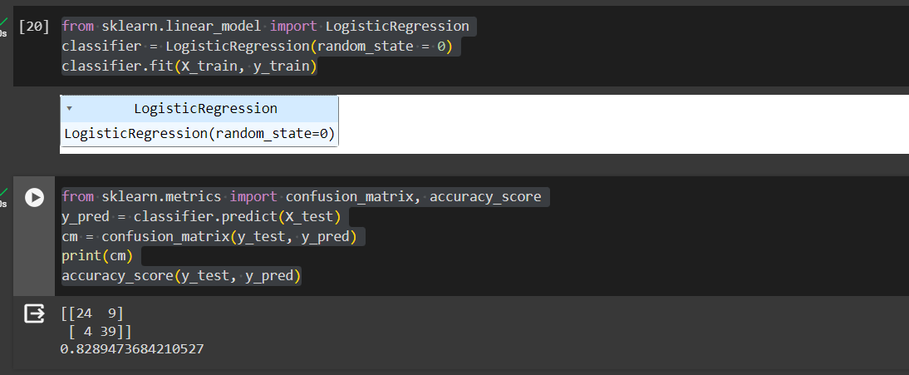

Task 2:

