Assignment – 8.2:

Let’s consider a hypothetical situation wherein you are employed by Arkansas- headquartered

Walmart, an American multinational retail corporation that owns a chain of grocery stores,

hypermarkets, and discount department stores. Founded by Sam Walton in 1962 and incorporated on October 31, 1969, the company also operates Sam's Club retail warehouses.

Your responsibility is to bring relevant insights out of the sales dataset, which incorporates data

about Revenue, Cost of items, Order ID, Order Date, Order Priority, etc.

Note: Please take the Screen shots of the work book for each problem and send it in a Doc file

along with the Packaged workbooks

Required Data Description:

• Country, Region: Geographical fields

• Order Date, Order ID, Order Priority: The date of order placed, the order id and the priority

with which it was placed

• Ship Channel, Ship date: Channel through which the order was shipped and the date on

which it was shipped

• Total Cost, Total Profit, Total Revenue: Cost, Profit, and Revenue calculated from the

entire order

• Unit Cost, Unit Price, Units Sold: Purchase cost, cost at which it was sold, and the total

number of units sold

Problem 1:

With the help of the forecasting tool, predict the revenue for the next 1 year with 90% accuracy

and without ignoring any last value. (Suggestion: Use Line chart and use the dates at monthly level)

Solution1:

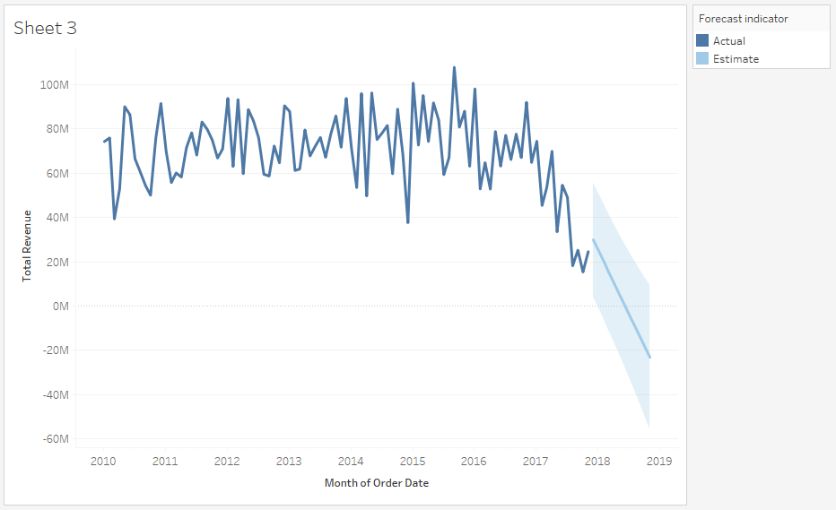

Problem 2:

With the help of Trend Lines, find the trends in the units sold over the available historical data at

a monthly level. (Suggestion: Use Line chart and use the dates at monthly level)

Solution2:

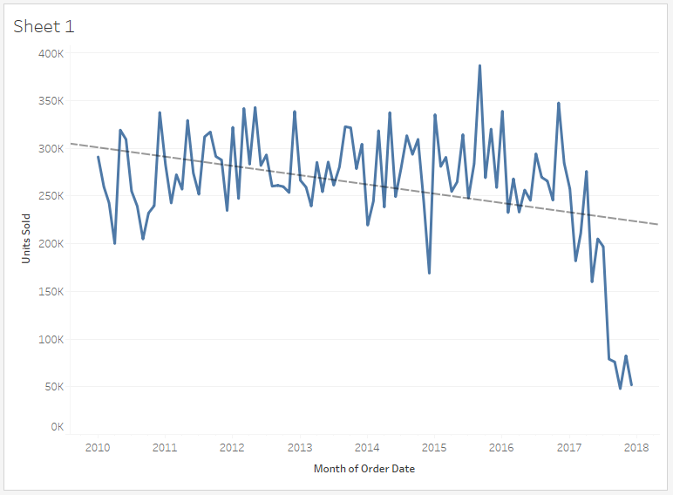

Problem 3:

Find the average profit across the regions using the Reference line. (Suggestion: Use Bar chart)

• Show a custom label over the Reference line as (AVG = <Value>)

• Fill the below of the average line with a lighter shade of grey (#e6e6e6)

Solution3:

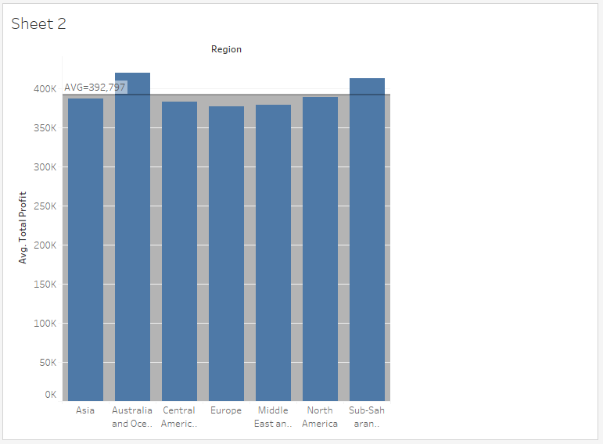

Problem 4:

Showcase the Number of Units Sold across the world using the geographic map.

• Mention the total profit in the tooltip as well

Solution4:

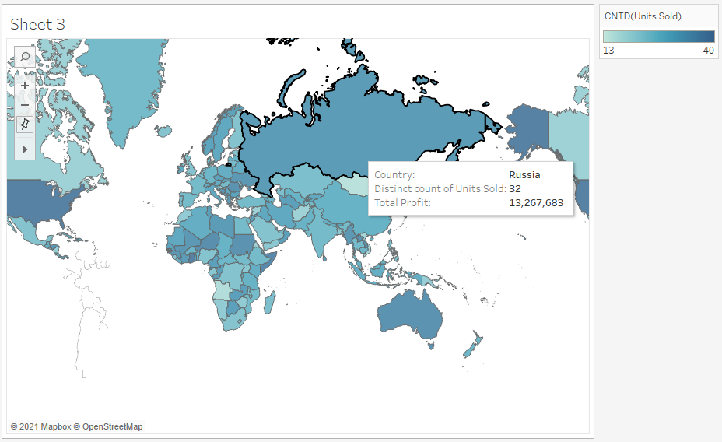

Problem 5:

Create a dashboard having all sheets from the above problems. Align the sheets in the dashboard as per your choice.

• Rename the worksheet title, as suitable. Try formatting the same as well.

• Provide the option to filter using the Country by clicking on the Countries present in the

worksheet created in problem 4. (Hint: Use Filter Actions)

Solution5:

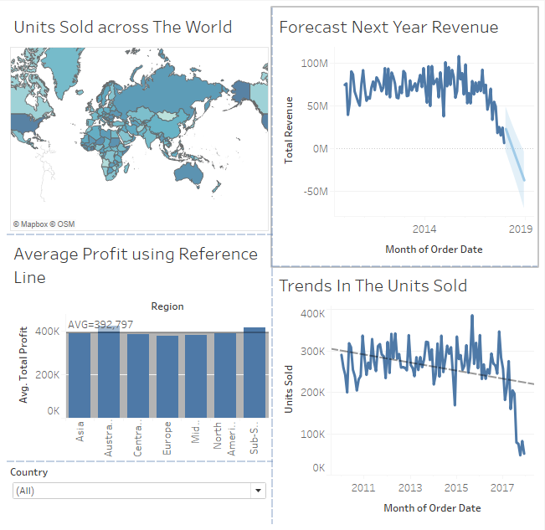

Problem 6:

Find the correlation between the Total Revenue & Units sold. (Hint: Use Scatter Plot)

• Distribute the data by the Order ID field

• Define different cluster of these Order ID based on the Total Revenue & Units Sold

Solution6:

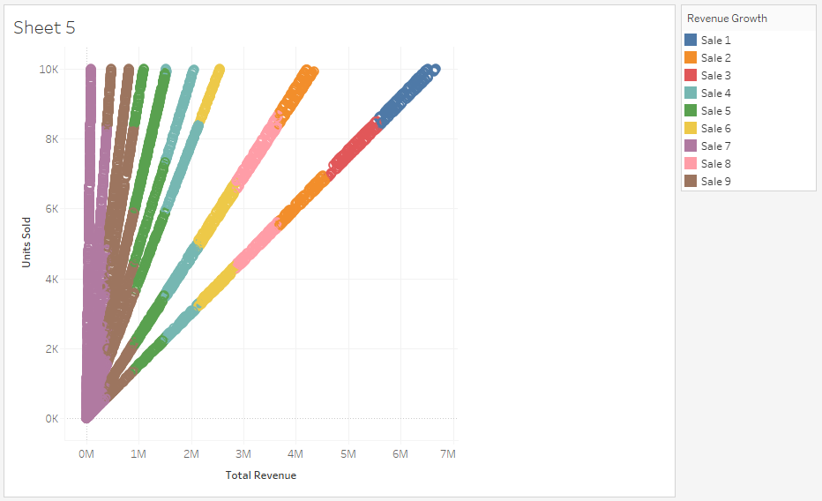

Problem 7:

Create a story having the sheets from Problem 1,2 & 3. Align the sheets in the dashboard as per your choice.

• Rename the story caption & title, as suitable.

Solution7:

