Q1 There are two tables named *test_orders* and *test_order_items*, in MYSQL database, perform the following operation:

1. Import the table *test_orders* into HDFS as a text file
2. Import the table *test_order_items* into HDFS as a text file
3. Import only those record from table *test_orders* where the order status is ‘delivered’
4. Import only those record from the table *test_order_items* where the product price is less than 200

Output Format: Paste the commands used to solve this problem in the text box below. Also, attach a screenshot(s) of the code.

Ans1 sqoop import --connect jdbc:mysql://dbserver.edu.cloudlab.com/labuser_database --username edu_labuser --password edureka --table test_orders -m 1 --as-textfile

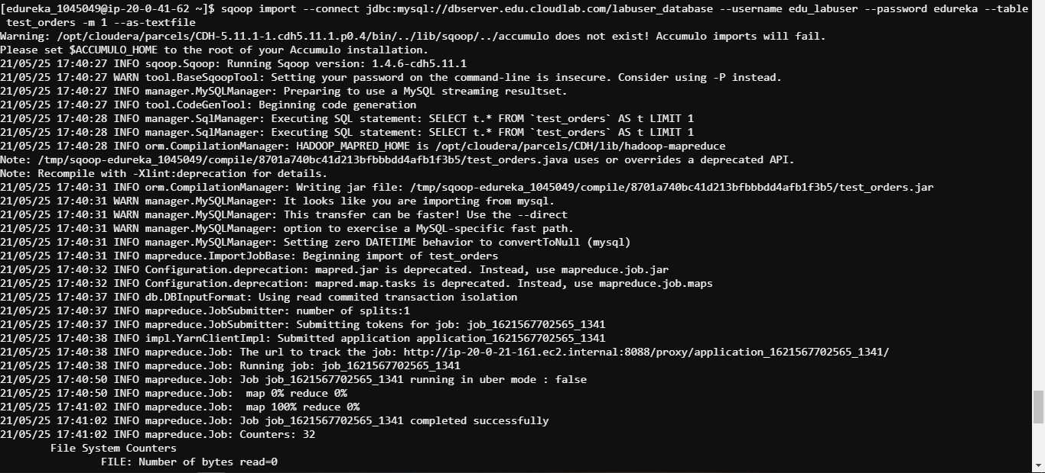

sqoop import --connect jdbc:mysql://dbserver.edu.cloudlab.com/labuser_database --username edu_labuser --password edureka --table test_order_items -m 1 --as-textfile

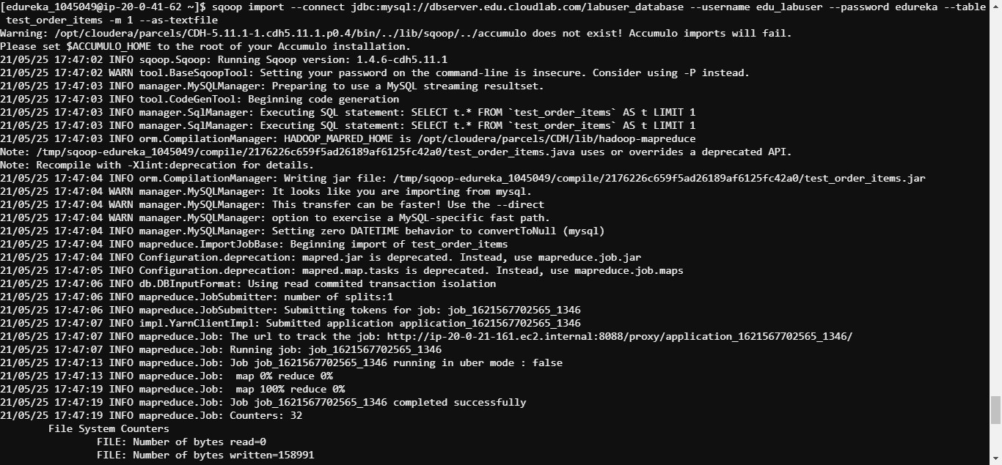

sqoop import --connect jdbc:mysql://dbserver.edu.cloudlab.com/labuser_database --username edu_labuser --password edureka --tabl

e test_orders -m 1 --where "order_status='delivered'" --target-dir /user/edureka_1045049/test_orders_demo

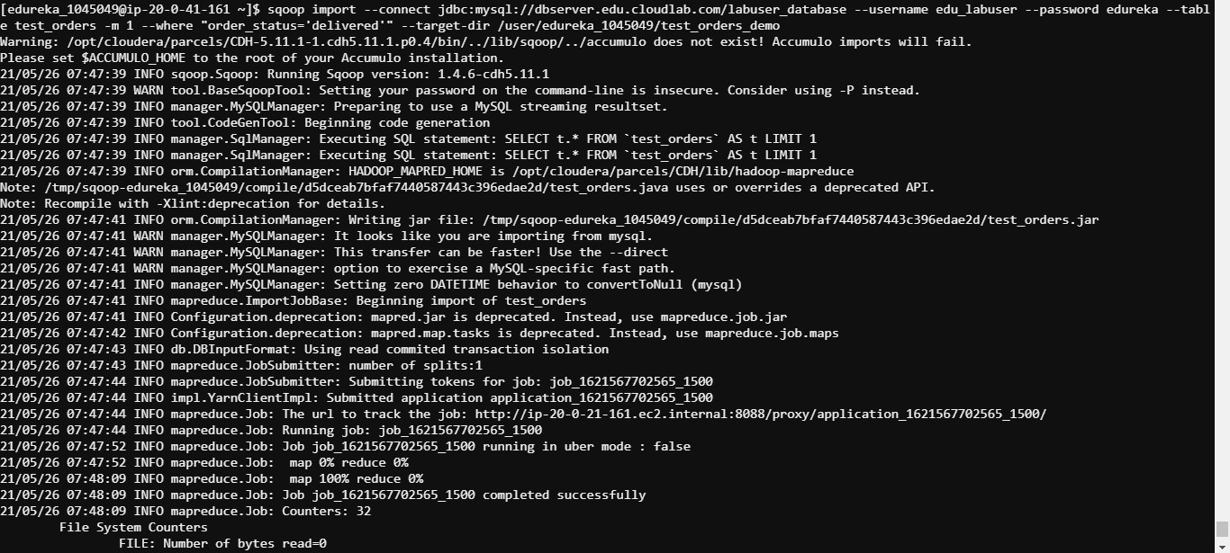

sqoop import --connect jdbc:mysql://dbserver.edu.cloudlab.com/labuser_database --username edu_labuser --password edureka --tabl

e test_order_items -m 1 --where "product_price<200" --target-dir /user/edureka_1045049/test_order_items_demo

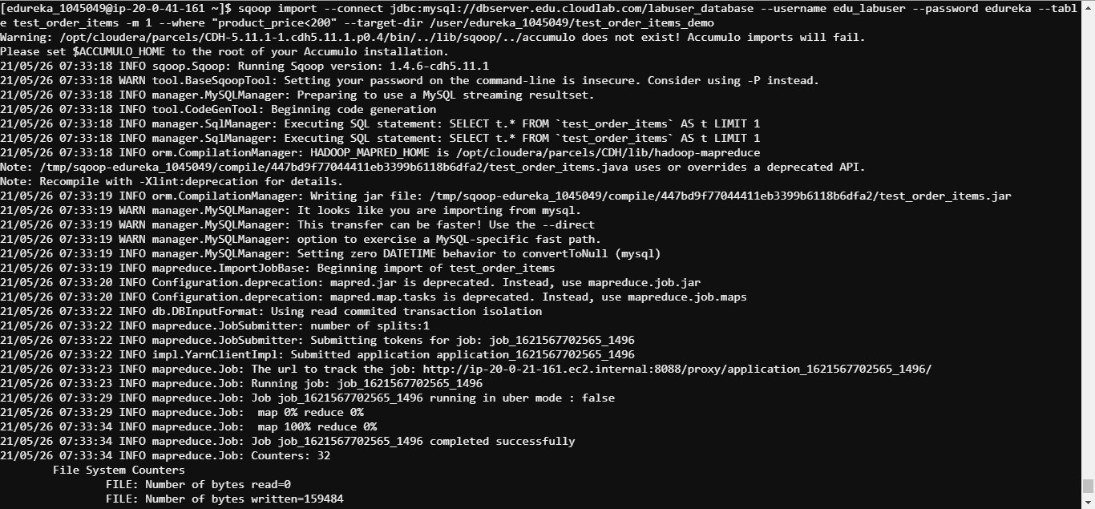

Q2 From the two tables mentioned in question 1, perform the following operations:

1. Write an import join statement, joining the tables *test_orders* and *test_order_items* on *order_id* and import the data in HDFS
2. Import the table *test_orders* in append mode in and with 4 mappers
3. Export the result obtained from step 2 into a table in MySQL

Output Format: Paste the commands used to solve this problem in the text box below. Also, attach a screenshot(s) of the code.

Ans2 sqoop import --connect jdbc:mysql://dbserver.edu.cloudlab.com/labuser_database --username edu_labuser --password edureka --quer

y "select test_orders.order_id, test_orders.order_date, test_orders.customer_id, test_orders.order_status, test_order_items.item_id, test_order_items.product_id, t

est_order_items.item_quantity, test_order_items.subtotal, test_order_items.product_price, test_order_items.address from test_orders join test_order_items on test_o

rders.order_id=test_order_items.order_id where \$CONDITIONS" --split-by test_orders.order_id --target-dir "/user/edureka_1045049/test_combined"

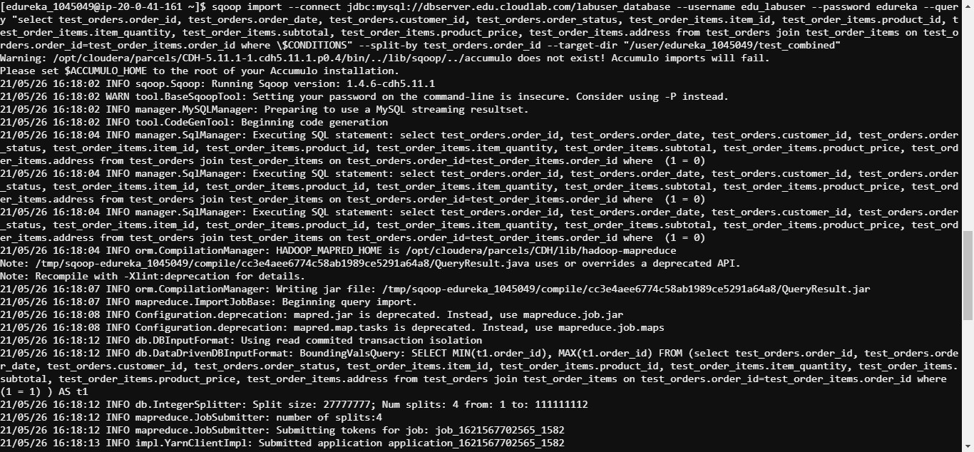

sqoop import --connect jdbc:mysql://dbserver.edu.cloudlab.com/labuser_database --username edu_labuser --password edureka --tabl

e test_orders --target-dir /user/edureka_1045049/test_orders_combined --check-column 'order_id' --incremental append --last-value 4 -m 1

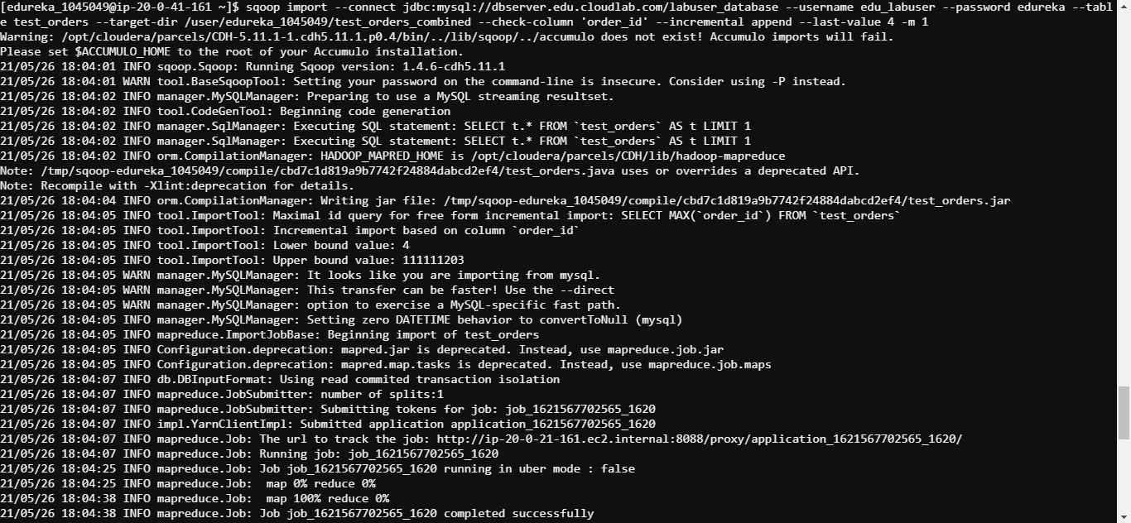

sqoop eval --connect jdbc:mysql://dbserver.edu.cloudlab.com/labuser_database --query "CREATE TABLE orders_append_test (order_id

int(11), order_date varchar(95), customer_id int(11), order_status varchar(50))" --username edu_labuser --password edureka

mysql -u edu_labuser -pedureka -h dbserver.edu.cloudlab.com

desc labuser_database.orders_append_test;

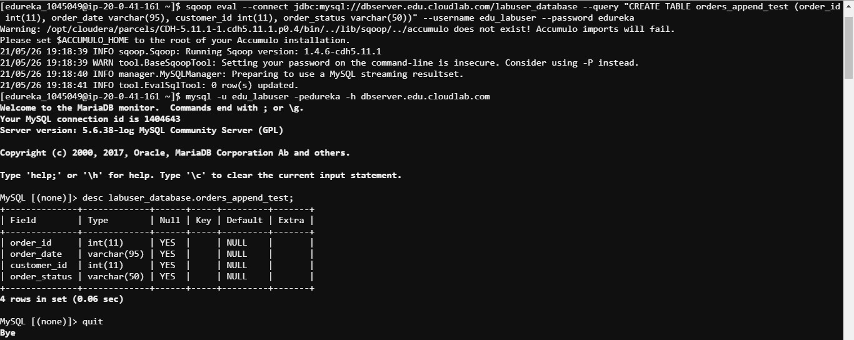

sqoop export --connect jdbc:mysql://dbserver.edu.cloudlab.com/labuser_database --username edu_labuser --password edureka --tabl

e orders_append_test --export-dir /user/edureka_1045049/test_orders_combined -m 1

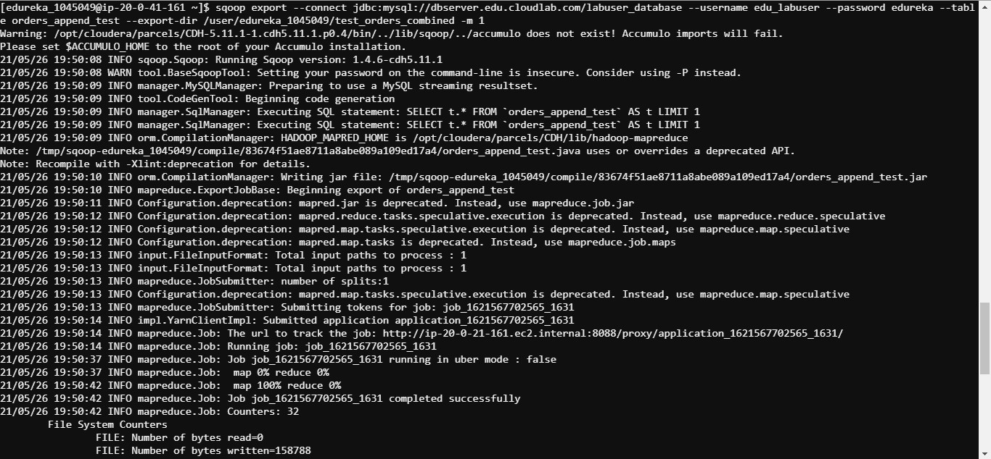

Q3 From the two tables mentioned in question 1, perform the following operations:

1. Add a few rows in both the tables *test_orders* and *test_order_items*, import these newly added rows in HDFS using the incremental append method
2. Create a hive table and import the table *test_orders* directly in this hive table using sqoop hive import

Output Format: Paste the commands used to solve this problem in the text box below. Also, attach a screenshot(s) of the code.

Ans3 insert into test_orders (order_id, order_date, customer_id, order_status) values (1328, '2021-05-27 17:05:09', 236791, 'pending');

insert into test_orders (order_id, order_date, customer_id, order_status) values (1329, '2021-05-27 17:15:09', 295891, 'delivered');

insert into test_orders (order_id, order_date, customer_id, order_status) values (1330, '2021-05-27 17:25:09', 156829, 'delayed');

insert into test_orders (order_id, order_date, customer_id, order_status) values (1331, '2021-05-27 17:35:09', 568349, 'cancelled');

insert into test_order_items (item_id, order_id, product_id, item_quantity, subtotal, product_price, address) values (56298, 1331, 832059

, 5, 177.5, 35.5, 'Chennai');

insert into test_order_items (item_id, order_id, product_id, item_quantity, subtotal, product_price, address) values (95208, 1330, 724186

, 3, 3000, 1000, 'Bengaluru');

insert into test_order_items (item_id, order_id, product_id, item_quantity, subtotal, product_price, address) values (32185, 1329, 423091

, 8, 2000, 250, 'Noida');

insert into test_order_items (item_id, order_id, product_id, item_quantity, subtotal, product_price, address) values (37802, 1328, 925106

, 100, 5060, 50.6, 'Mumbai');

sqoop import --connect jdbc:mysql://dbserver.edu.cloudlab.com/labuser_database --username edu_labuser --password edureka --table test_orders --target-dir /user/edureka_1045049/test_orders --check-column 'order_id' --incremental append --last-value 4 -m 1

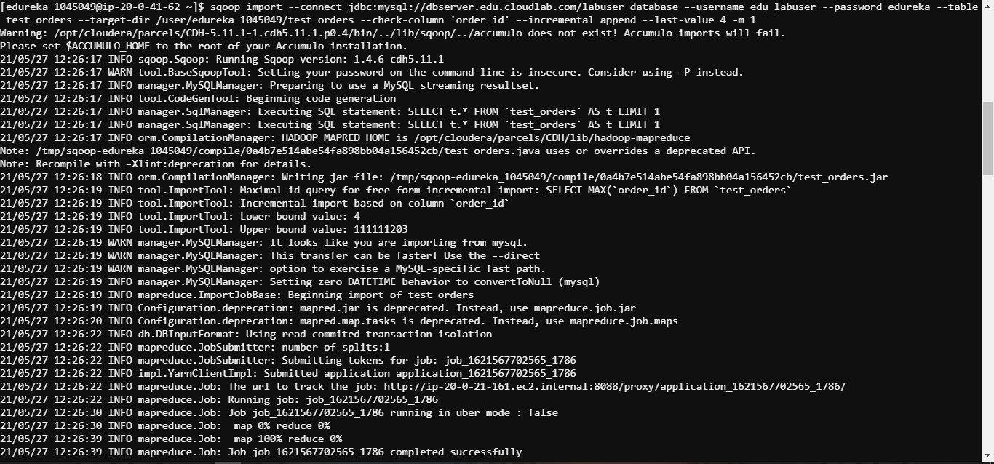

sqoop import --connect jdbc:mysql://dbserver.edu.cloudlab.com/labuser_database --username edu_labuser --password edureka --table test_order_items --target-dir /user/edureka_1045049/test_order_items --check-column 'order_id' --incremental append --last-value 4 -m 1

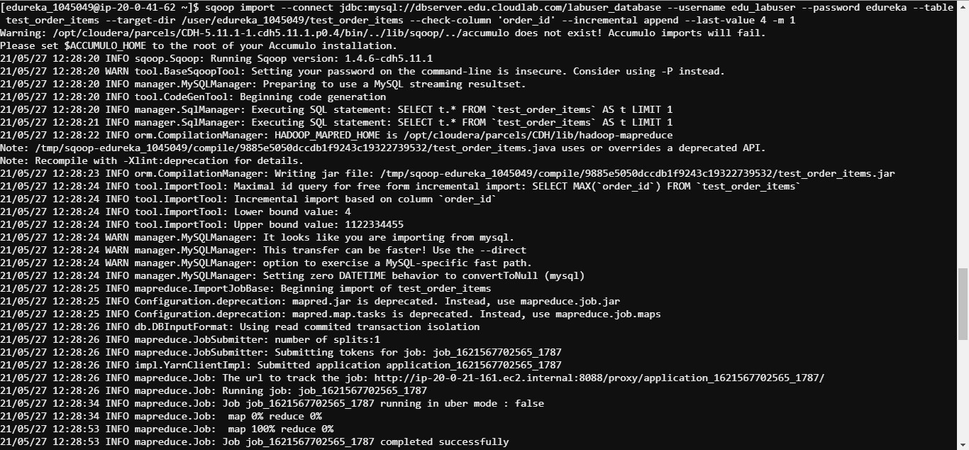

sqoop import --connect jdbc:mysql://dbserver.edu.cloudlab.com/labuser_database --username edu_labuser --password edureka --table

test_orders --target-dir /user/edureka_1045049/test_orders_hive --fields-terminated-by "," --hive-import --create-hive-table --hive-table test_sqoop.test_order

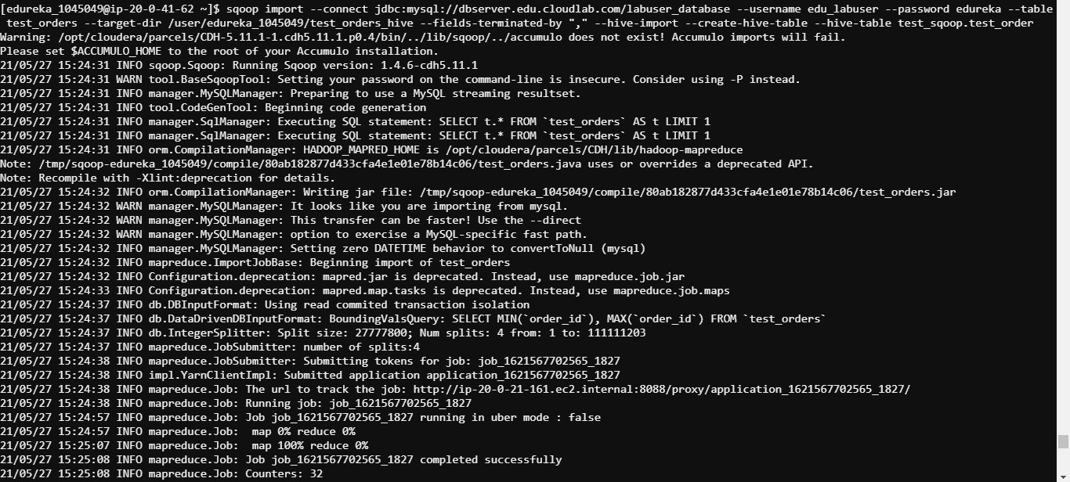

Q4 *Dataset: World_Bank_Indicators_noheader.csv*

Using the dataset present at the HDFS path

'hdfs:///bigdatads/common_folder/assignment2/World_Bank_Indicators_noheader.csv', perform the following activities on Hive:

1. Create a hive internal table named *world_bank_data* which is not partitioned
2. Create one more (internal) table named *world_bank_data_partitioned* partitioned on *Country_Name*
3. Insert the dataset given in table *world_bank_data*
4. Insert data in table *world_bank_data_partitioned* from table *world_bank_data* using dynamic partitioning

Output Format: Paste the commands used to solve this problem in the text box below. Also, attach a screenshot(s) of the code.

Ans4

create table world_bank_data(date1 string, transit_railways string, transit_passenger_cars string, business_mobile_phone_subscribers string, business_internet_users string, health_mortality_under_5 string,

health_expenditure_per_capita string, health_expenditure_total string, population_total string, population_urban string, population_birth_rate_crude string, health_life_expectancy_at_birth_female string, health_life_expectancy_at_birth_male string, health_life_expectancy_at_birth_total string, population_ages_0_14 string, population_ages_15_64 string, population_ages_65 string, finance_gdp string, finance_gdp_percapita string, country_name string) row format delimited fields terminated by ',';

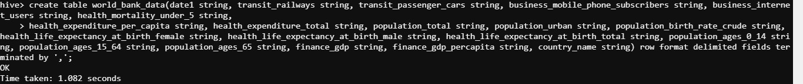

create table world_bank_data_partitioned(date1 string, transit_railways string, transit_passenger_cars string, business_mobile_phone_subscribers string, business_internet_users string, health_mortality_under_5 string,

health_expenditure_per_capita string, health_expenditure_total string, population_total string, population_urban string, population_birth_rate_crude string, health_life_expectancy_at_birth_female string, health_life_expectancy_at_birth_male string, health_life_expectancy_at_birth_total string, population_ages_0_14 string, population_ages_15_64 string, population_ages_65 string, finance_gdp string, finance_gdp_percapita string) partitioned by (Country_Name string) row format delimited fields terminated by ',';

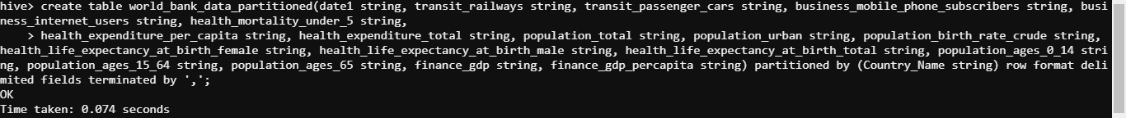

hadoop fs -cp /bigdatads/common_folder/assignment2/World_Bank_Indicators_noheader.csv /user/edureka_1045049

load data inpath '/user/edureka_1045049/World_Bank_Indicators_noheader.csv' into table ras_db.world_bank_data;

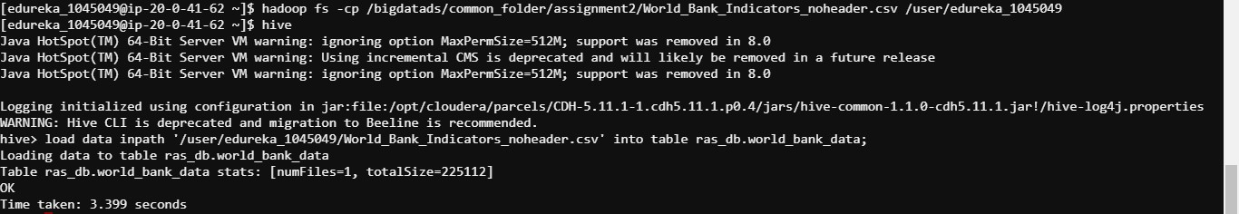

SET hive.exec.max.dynamic.partitions=100000;

SET hive.exec.max.dynamic.partitions.pernode=100000;

insert overwrite table ras_db.world_bank_data_partitioned partition (Country_Name) select date1 string, transit_railways string, transit_passenger_cars string, business_mobile_phone_subscribers string, business_internet_users string, health_mortality_under_5 string, health_expenditure_per_capita string, health_expenditure_total string, population_total string, population_urban string, population_birth_rate_crude string, health_life_expectancy_at_birth_female string, health_life_expectancy_at_birth_male string, health_life_expectancy_at_birth_total string, population_ages_0_14 string, population_ages_15_64 string, population_ages_65 string, finance_gdp string, finance_gdp_percapita string, country_name string from ras_db.world_bank_data;

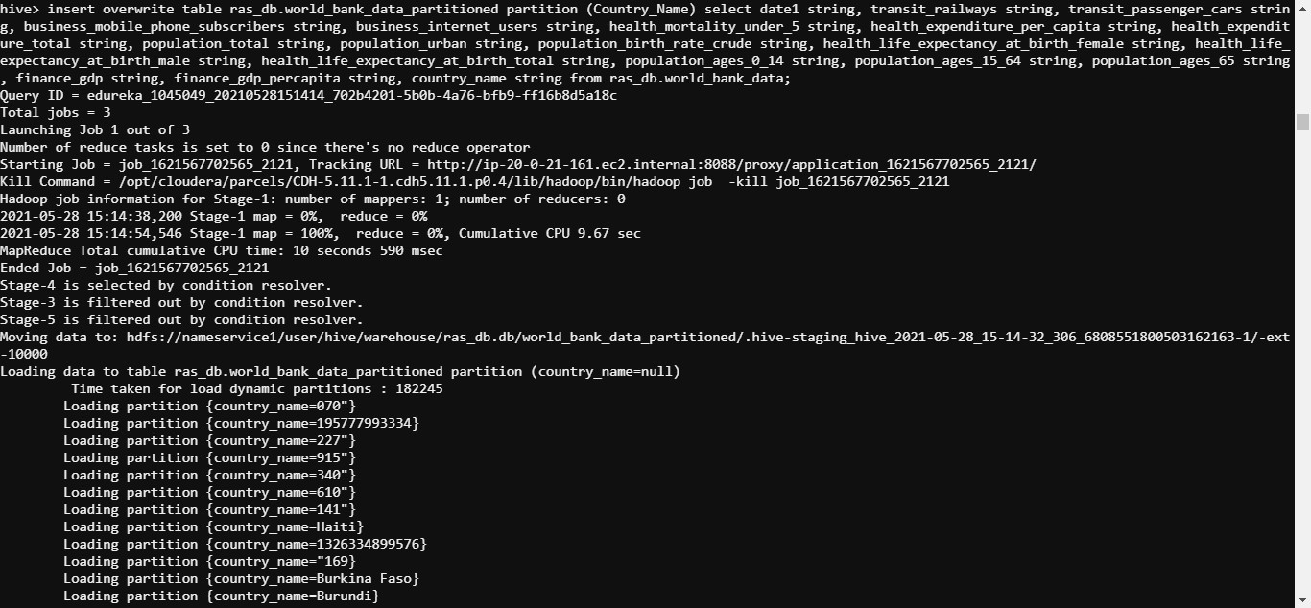

Q5 *Dataset: World_Bank_Indicators_noheader.csv*

From the two tables created in question 4, perform the following operations in Hive:

1. Find out the cumulative population of countries over the decade from the partitioned table
2. Find out the second most populous country from the partitioned table
3. Find out the population of the country Afghanistan from the table and compare the difference in timings taken by the query

Output Format: Paste the commands used to solve this problem in the text box below. Also, attach a screenshot(s) of the code.

Ans5 select country_name, sum(population_total) as cumulative_pop from ras_db.world_bank_data_partitioned group by country_name;

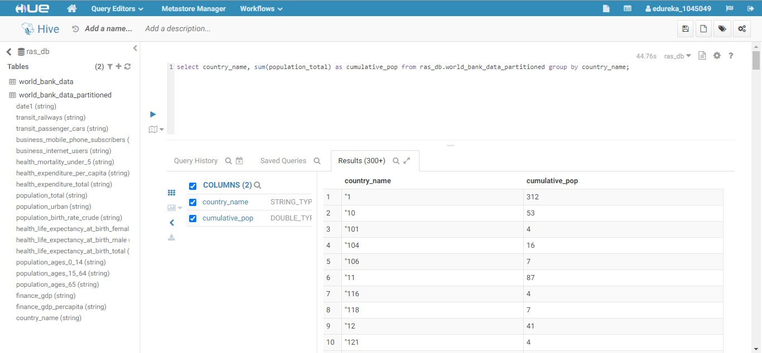

select country_name, sum(population_total) as cumulative_pop from ras_db.world_bank_data_partitioned group by country_name sort by cumulative_pop desc limit 2;

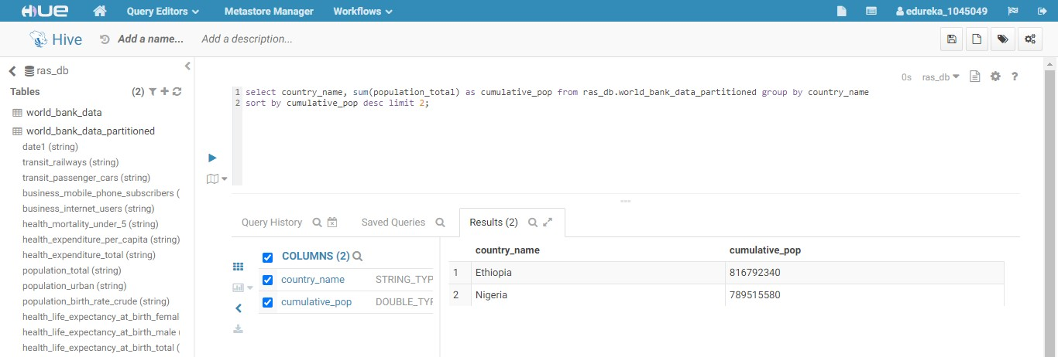

select country_name, population_total from ras_db.world_bank_data_partitioned where country_name = 'Afghanistan';

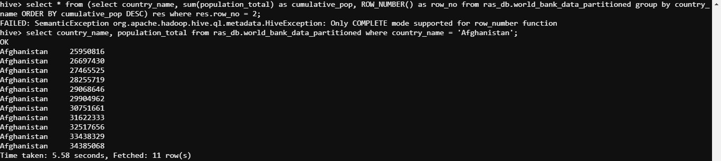

select country_name, population_total from ras_db.world_bank_data where country_name = 'Afghanistan';

