1. HDFS AND HIVE

Problem Statement 1

Census Analytics is a project where you need to collect the data of people along with their incomes. As the census data is usually in large volume, the analysis of the data will be a cumbersome task. To overcome this, we will be using the Hadoop Ecosystem.

As a first step, you need to load the data into HDFS and create a table in Hive that can be used for querying the data. You have to create different types of tables and execute queries, as mentioned below and compare the time required for execution for different types of tables.

1 Download the dataset named **censusdata.csv** that is provided in your LMS.

2 Load the downloaded data into HDFS.

Ans2 Loaded the data using HDFS browser

3 Create an internal table in Hive to store the data

1. Create the table structure

create schema test_tia13;

use test_tia13;

create table census_data(age int, workclass string, fnlwgt string, education string, education_num int, marital_status string,

occupation string, relationship string, race string, sex string, capital_gain int, capital_loss int, hours_per_week int, native_country string, income string) row format delimited fields terminated by ',';



1. Load the data from HDFS into the Hive table

load data inpath '/user/edureka_1045049/Project2/censusdata.csv' into table test_tia13.census_data;



4 Create an internal table in Hive with partitions

1. Create a Partition Table in Hive using “workclass” as the Partition Key

create table census_data_partitioned(age int, fnlwgt string, education string, education_num int, marital_status string,

occupation string, relationship string, race string, sex string, capital_gain int, capital_loss int, hours_per_week int, native_country string, income string) partitioned by (workclass string) row format delimited fields terminated by ',';



1. Load data from the staging table (Table created in Step 3) into this table

SET hive.exec.dynamic.partition=true;

SET hive.exec.dynamic.partition.mode=nonstrict;

INSERT OVERWRITE TABLE census_data_partitioned PARTITION (workclass) SELECT * FROM census_data;

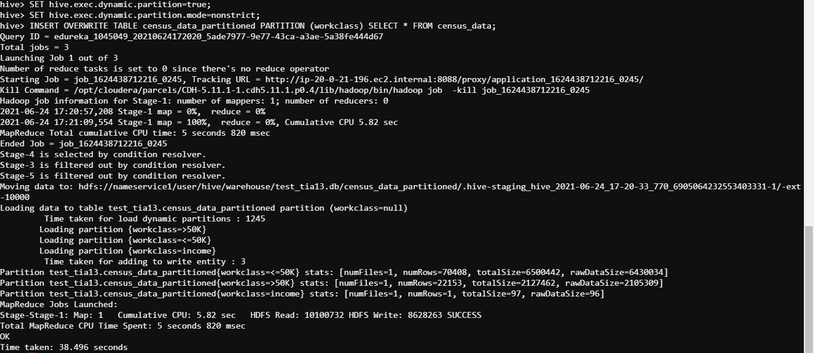

5 Create an external table in Hive to hold the same data stored in HDFS

Create external table census_data_ext(age int, workclass string, fnlwgt string, education string, education_num int, marital_status string, occupation string, relationship string, race string, sex string, capital_gain int, capital_loss int, hours_per_week int, native_country string, income string) row format delimited fields terminated by ',';



load data inpath '/user/edureka_1045049/Project2/censusdata.csv' into table test_tia13.census_data_ext;



6 Create an external table in Hive with partitions using “workclass” as Partition Key

create table census_data_ext_partitioned(age int, fnlwgt string, education string, education_num int, marital_status string,

occupation string, relationship string, race string, sex string, capital_gain int, capital_loss int, hours_per_week int, native_country string, income string) partitioned by (workclass string) row format delimited fields terminated by ',';



SET hive.exec.dynamic.partition=true;

SET hive.exec.dynamic.partition.mode=nonstrict;

INSERT OVERWRITE TABLE census_data_ext_partitioned PARTITION (workclass) SELECT * FROM census_data_ext;

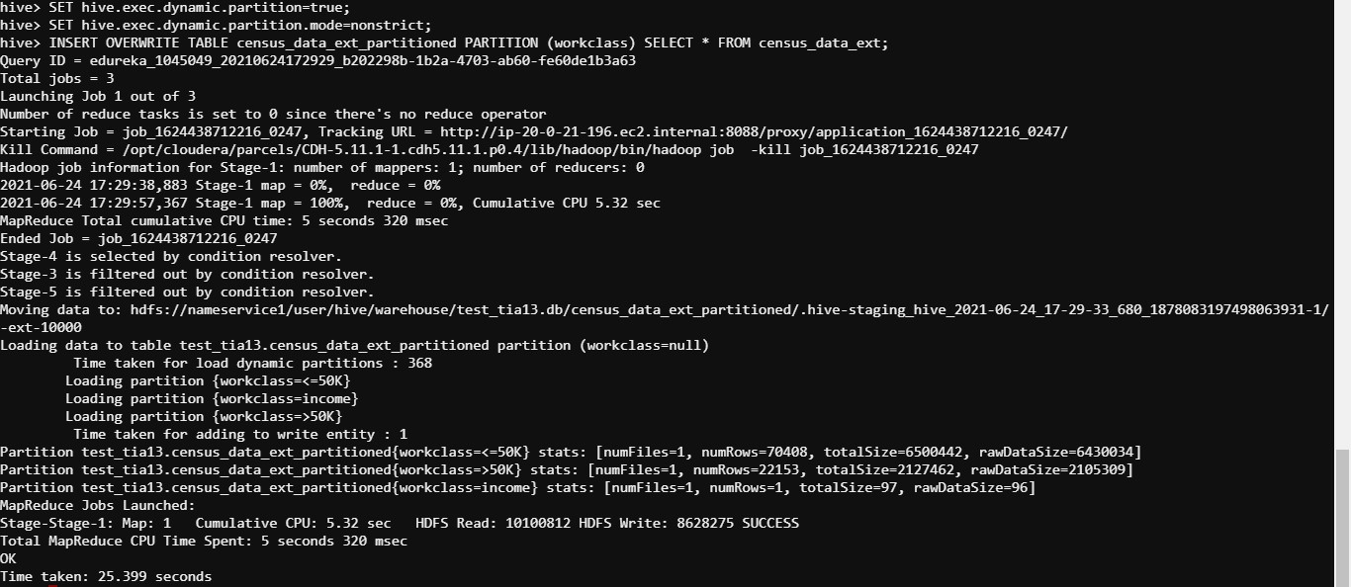

7 For each of the four tables created above, perform the following operations

1. Find out the number of adults based on income and gender. Note the time taken for getting the result

select count(age) as no_of_adults from test_tia13.census_data where age>=18 group by income, sex;

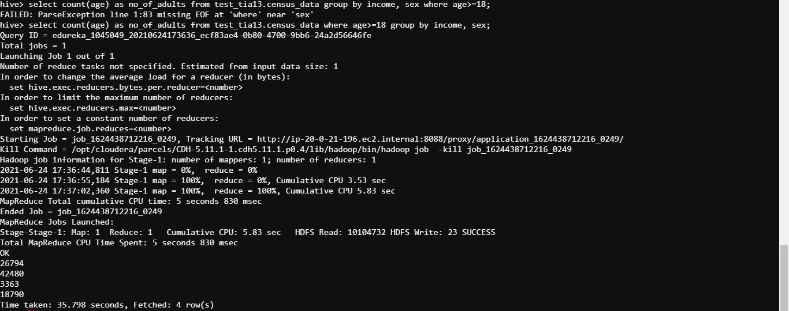

select count(age) as no_of_adults from test_tia13.census_data_partitioned where age>=18 group by income, sex;

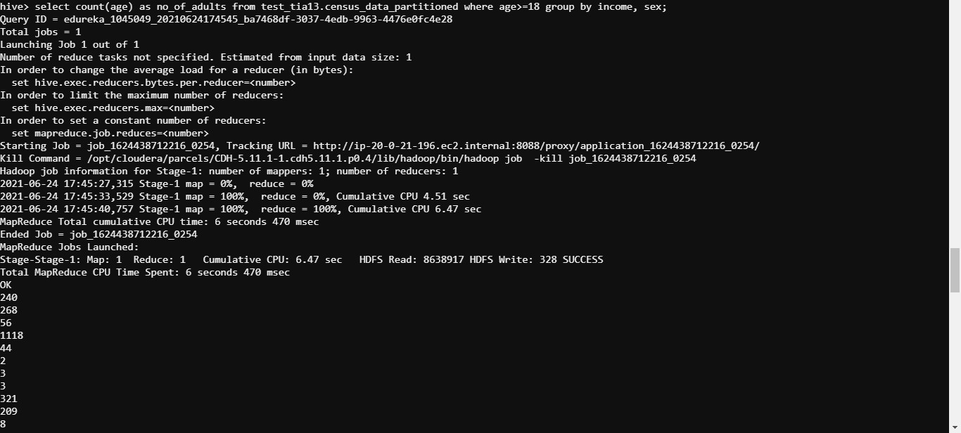

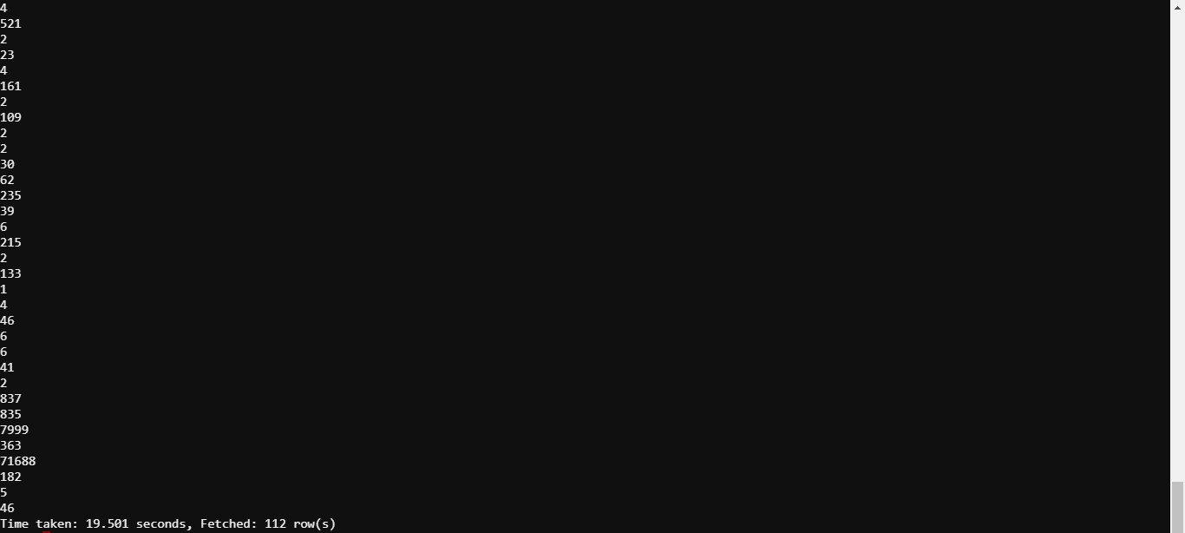

select count(age) as no_of_adults from test_tia13.census_data_ext where age>=18 group by income, sex;

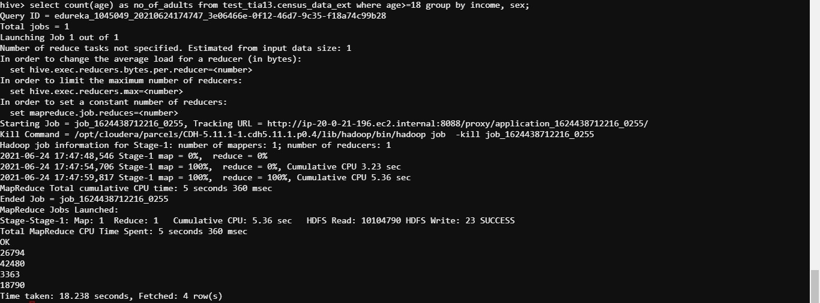

select count(age) as no_of_adults from test_tia13.census_data_ext_partitioned where age>=18 group by income, sex;

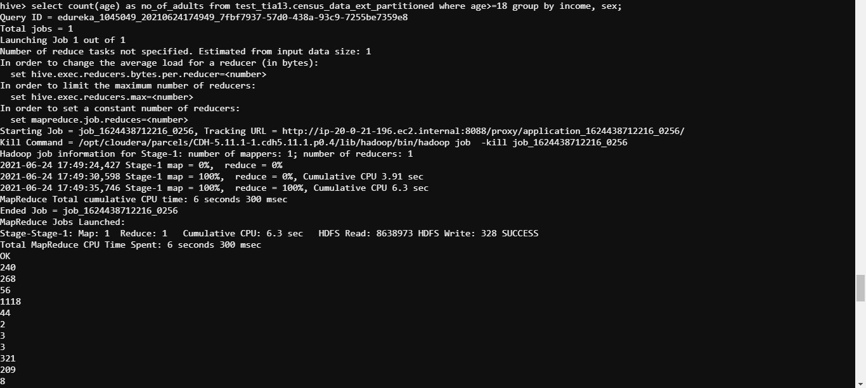

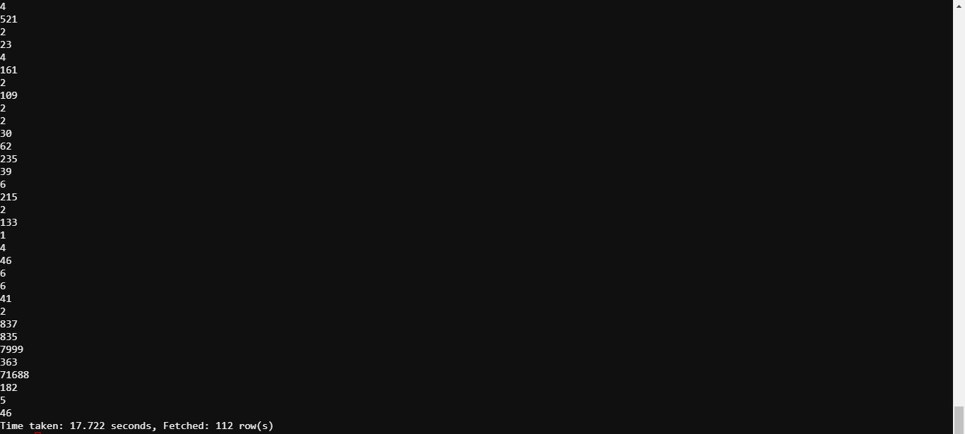

1. Find out the number of adults based on income and workclass. Note the time taken for getting the result

select count(age) as no_of_adults from test_tia13.census_data where age>=18 group by income, workclass;

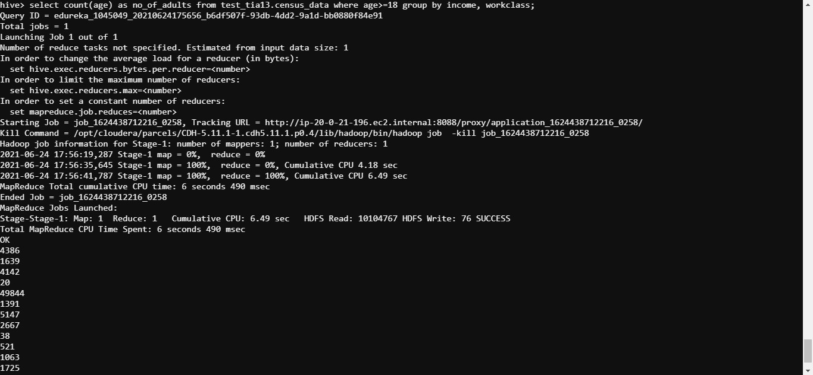

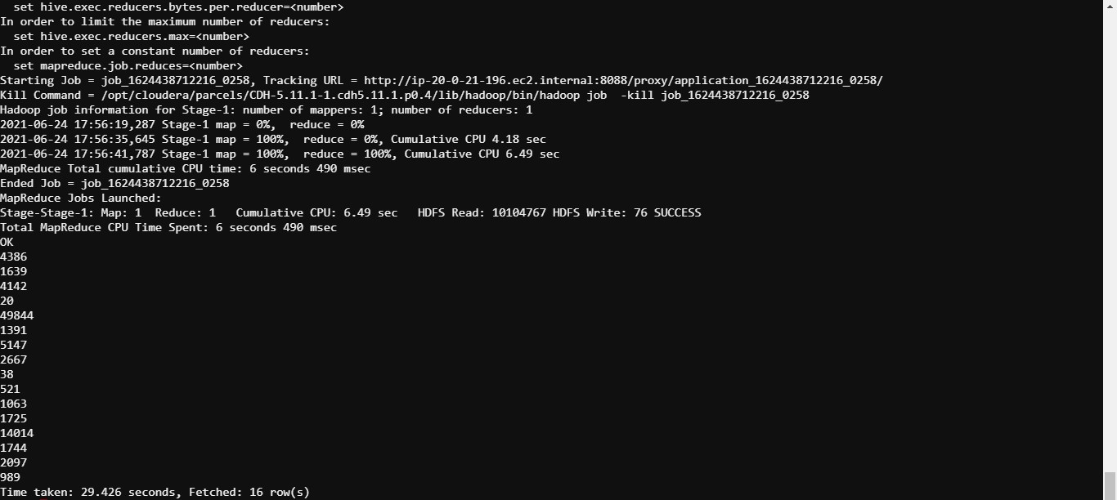

select count(age) as no_of_adults from test_tia13.census_data_partitioned where age>=18 group by income, workclass;

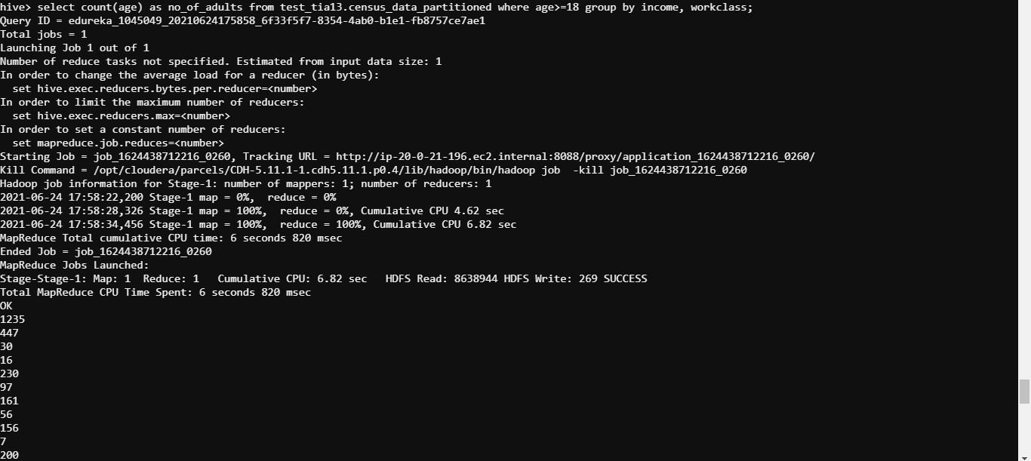

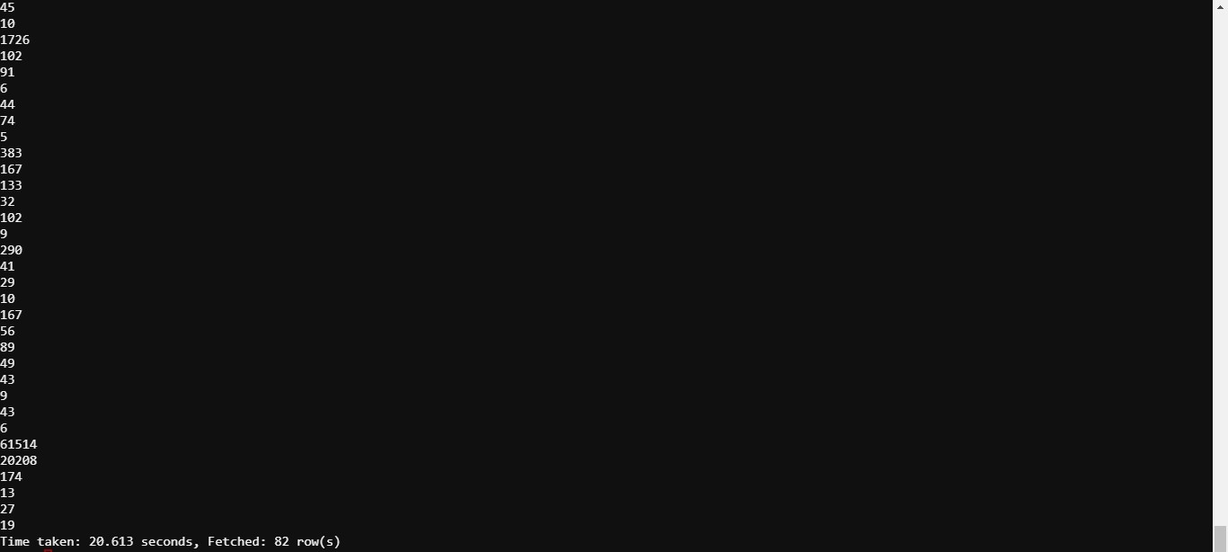

select count(age) as no_of_adults from test_tia13.census_data_ext where age>=18 group by income, workclass;

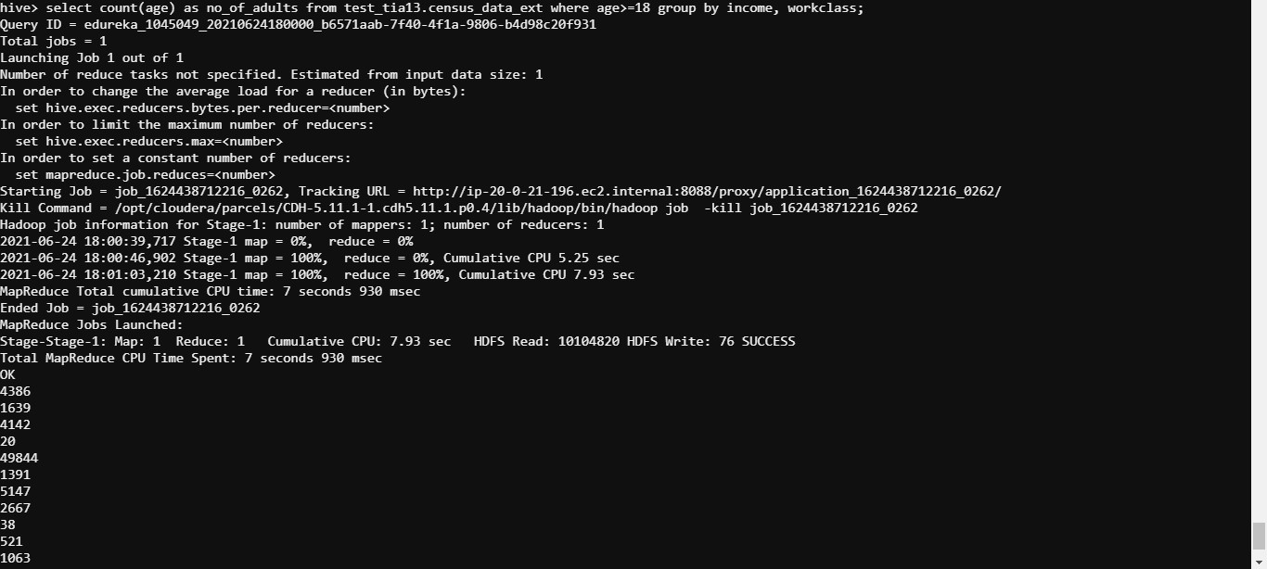

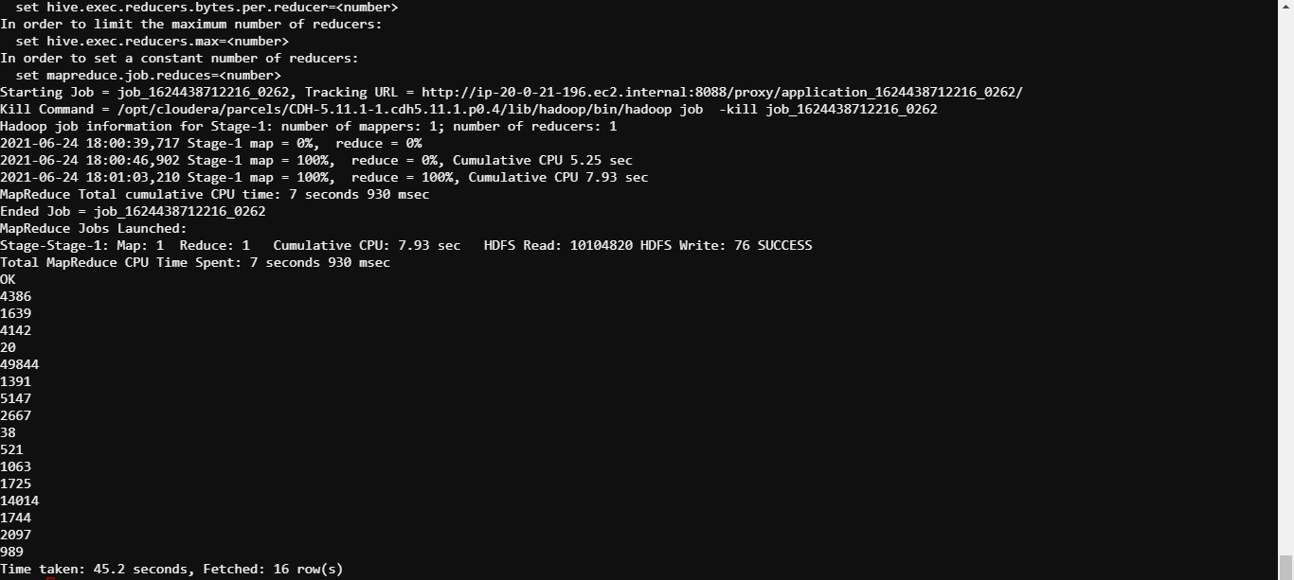

select count(age) as no_of_adults from test_tia13.census_data_ext_partitioned where age>=18 group by income, workclass;

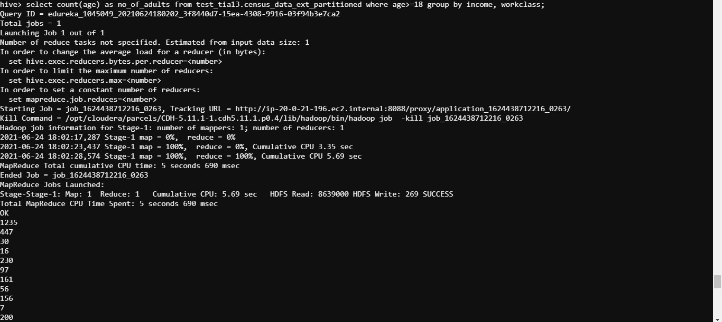

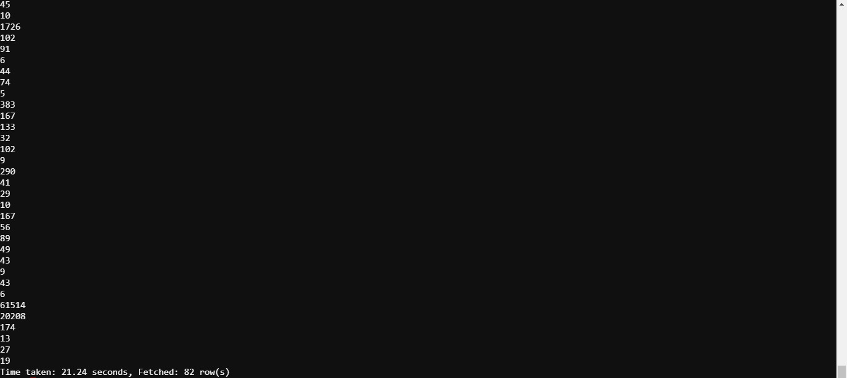

1. Write your observations by comparing the time taken for executing the commands between:
   1. Internal & External Tables

Time taken while working with Internal Tables - 35.798secs, 19.501secs, 29.426secs, 20.613secs;

Avg time taken while working on Internal Tables - 26.3345secs;

Time taken while working with External Tables - 18.238secs, 17.722secs, 45.2secs, 21.24secs;

Avg time taken while working on External Tables - 25.6secs;

Time taken by Internal Tables is more compared to time taken by External Tables.

* 1. Partitioned & Non-partitioned Tables

Time taken while working with Partitioned Tables - 19.501secs, 17.722secs, 20.613secs, 21.24secs;

Avg time taken while working on Partitioned Tables - 19.769secs;

Time taken while working with Non-partitioned Tables - 35.798secs, 18.238secs, 29.426secs, 45.2secs;

Avg time taken while working on Non-partitioned Tables - 32.1655secs;

Time taken by Non-partitioned Tables is more compared to time taken by Partitioned Tables.

8 Delete the internal as well as external tables. Comment on the effect on data and metadata after the deletion is performed for both internal and external tables.

drop table test_tia13.census_data;

drop table test_tia13.census_data_partitioned;

drop table test_tia13.census_data_ext;

drop table test_tia13.census_data_ext_partitioned;

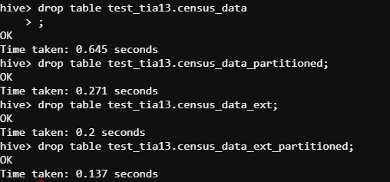

Both data and metadata(schema) gets deleted from the hive server once the tables are dropped in internal tables whereas metadata(schema) gets deleted from the hive server once the tables are dropped in external tables.