Question No 1

Date 30-07-2024

Question Read 2 numbers and display output in form of sum of 2 and 3 is 5.

\*\*\*\*\*\*\*\*\*\*\*\*\*\*\*\*\*\*\*\*\*\*\*\*\*\*\*\*\*\*\*\*\*\*\*\*\*\*\*\*\*\*\*\*\*\*\*\*\*\*\*\*\*\*\*\*\*\*\*\*\*\*\*\*\*\*\*\*\*\*\*\*\*\*\*\*\*\*\*\*\*\*

Author Tia Moncy

Roll No 37

Semester 1

Programme BCA

Question Read 2 numbers and display output in form of sum of 2 and 3 is 5.

#include<stdio.h>

int main()

{

int a,b,s;

printf("enter value for a ");

scanf("%d",&a);

printf("enter value for b ");

scanf("%d",&b);

s=a+b;

printf("sum of %d and %d is %d ",a,b,s);

return 0;

}

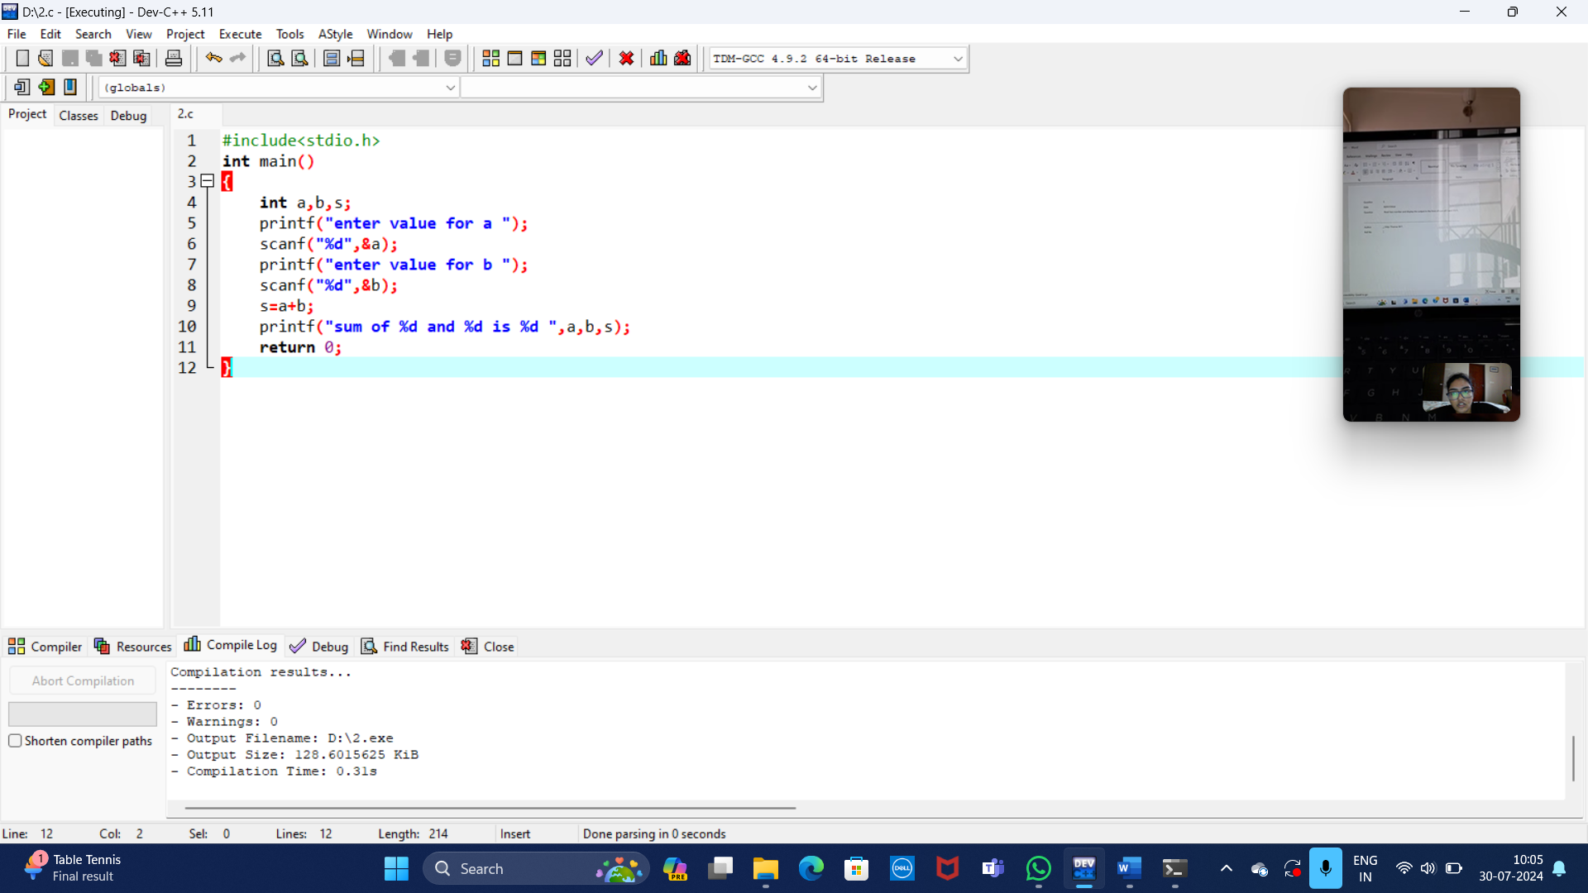

OUTPUT:

