Contents
1.Abstract: 2
2.Introduction: 2
3. Project Objectives: 3
4. Development Methodology 3
5. Development Progress: 3
7. Project Features: 4
8. System Architecture: 4
10. Game Rules 5
11. Level and Target System 5
12. User Interface 6
14. How to Use the Game 6
15. Output 7
16. Limitations 7
17. Conclusion 8

WATER JUG GAME
Java Swing Project Documentation

1.Abstract:

The Water Jug Game is a Java-based interactive puzzle game developed using Java Swing and Object-Oriented Programming concepts. The main objective of the game is to obtain a specific target amount of water by using two jugs with different capacities. The player can perform basic operations such as filling a jug, emptying a jug, and transferring water from one jug to another while following the limitations of the jug capacities. The system provides a graphical user interface that displays the current water level, target amount, selected level, and move count. Different target levels are provided to make the game more interactive and challenging. The transfer operation calculates the maximum possible amount of water that can be moved based on the available water in the source jug and the remaining capacity of the destination jug. The system also includes move validation, reset functionality, win-condition checking, and a completion message when the required target is achieved. The project demonstrates the practical application of Java, Java Swing, Object-Oriented Programming, event handling, GUI components, and basic game-state management. It provides an easy to use environment for understanding problem solving and logical decision making through an interactive puzzle game.
The Water Jug Game contains two water jugs: Jug A with a capacity of 4 liters and Jug B with a capacity of 3 liters. Initially, both jugs are empty. The player performs operations such as Fill, Empty, and Transfer to obtain the target amount of water. The game contains multiple levels with different target values. The documented levels use targets of 2L, 1L, and 3L. The application provides an interactive GUI, move counting, level/target selection, water-level display, move validation, win detection, completion messages, reset functionality, and next-level progression.

2.Introduction:

The Water Jug Game is a Java-based interactive puzzle game developed as a project for the Software Development I course. The project is based on the classic Water Jug puzzle, where the main objective is to measure a required target amount of water by filling, emptying, and transferring water between two jugs while following the game rules. The application was developed using Java Swing for the graphical user interface. Object-Oriented Programming concepts were used to organize the different components of the system. The game uses two jugs with capacities of 4 liters and 3 liters. The project was developed incrementally, with different functionalities implemented and tested during different development weeks. GitHub can be used to store the source code and track project progress.

3. Project Objectives:

1.To develop an interactive Water Jug Game using Java.
2.To create a simple and user-friendly graphical user interface.
3.To allow users to fill, empty, and transfer water between two jugs.
4.To display the current amount of water in each jug.
5.To validate operations according to the rules of the puzzle.
6.To prevent invalid operations.
7.To count valid game moves.
8.To provide different target levels.
9.To detect successful completion of a level.
10.To provide reset and next-level functionality.
11.To apply Object-Oriented Programming concepts.
12.To use GitHub for source-code management and project progress tracking.

4. Development Methodology

The project was developed using the Incremental Development Model. The complete software was divided into smaller development increments. Each increment focused on a specific part of the system. After completing and testing one part, the next functionality was added.
This approach made it easier to develop, test, debug, and improve the Water Jug Game step by step.

5. Development Progress:

Week 1 : Project requirements and objectives will be identified. The rules, features, and scope of the Water Jug Game will be analyzed and documented.
Week 2 :The overall system design and game flow will be planned. The GUI layout and class structure will be prepared.
Week 3 : The development environment will be set up, and the basic project structure will be created using Java and Swing.
Week 4 : The graphical user interface, including water jug representations, buttons, labels, and control panels, will be designed and implemented.
Week 5 : The functionality for filling, emptying, and transferring water between jugs will be developed and integrated into the system.
Week 6 : The game logic will be implemented to track water levels and validate user actions according to the game rules.
Week 7 : Different game levels and target water quantities will be added to increase interactivity and challenge.
Week 8 : Winning conditions, move counting, and game completion messages will be implemented.
Week 9 :The application will be tested thoroughly to identify and fix bugs, ensuring smooth gameplay and user experience.
Week 10 :Final documentation, project report, screenshots, and presentation slides will be prepared for project submission and demonstration.

6. System Requirements:

1. Hardware Requirements:
Processor , RAM, Storage, Keyboard and mouse, Monitor.
2. Software Requirements:
Windows operating system , Java Development Kit (JDK), NetBeans IDE , GitHub account or access to the project repository

7. Project Features:

1. Main Menu / Game Start — The application provides a starting interface from which the user can begin the game.
2.Two Water Jugs — The game contains Jug A (4L) and Jug B (3L).
3. Fill Operation — The selected jug can be filled to its maximum capacity.
4. Empty Operation — The selected jug can be emptied to 0L.
5. Transfer Operation — Water can be transferred from one jug to the other until the source is empty or the destination is full.
6. Water-Level Display — The current water amount is shown using the GUI progress bars.
7. Level/Target Selection — The game provides target values for different levels.
8. Move Counter — Valid operations are counted as game moves.
9. Reset — The game can return to its initial state.
10. Win Detection — The system checks whether the required target amount has been obtained and displays a success message.

8. System Architecture:

The project follows a modular architecture. The GUI and game logic are organized so that different responsibilities can be handled by separate methods/classes.
Main logical components include:
1.Main game class — starts the application and creates the GUI.
2.Game panel / GUI — displays jugs, controls, levels, target, move count and status.
3.Game-state logic — maintains the current water level of each jug.
4.Operation logic — performs fill, empty and transfer operations.
5.Win-condition logic — checks the current state against the selected target.
6.Reset/level logic — restores the initial state and manages level progression.

9. Project Structure:
The project can be organized into Java classes/modules for the GUI, game state, operations, and win checking. The exact class names may vary according to the final source-code version.
Typical responsibilities are:
• WaterJugGame / main class — starts the program.
• GamePanel / GUI class — handles the Swing interface.
• Game-state variables — store current water levels and move count.
• Operation methods — implement fill, empty and transfer.
• checkWin(int current, int target) — checks whether the required amount has been reached.
• JPanel — organizes different parts of the interface.
The current water level of each jug is updated after every valid operation.

10. Game Rules

The Water Jug Game follows these basic rules:
1. Jug A has a maximum capacity of 4 liters.
2. Jug B has a maximum capacity of 3 liters.
3. A jug cannot contain more water than its capacity.
4. A jug can be filled to its maximum capacity.
5. A jug can be emptied completely.
6. During transfer, water moves until the source becomes empty or the destination becomes full.
7. The player wins when the required target amount is obtained according to the level condition.

11. Level and Target System

The game includes multiple target levels.
• Level 1 — Target: 2L
• Level 2 — Target: 1L
• Level 3 — Target: 3L
The selected target is stored by the game and compared with the current jug amount. The target is therefore a central part of the win condition.

12. User Interface

The graphical user interface was developed using Java Swing.
The main interface contains:
• Game title
• Level selection
• Target display
• Jug A water-level display
• Jug B water-level display
• Fill controls
• Empty controls
• Transfer controls
• Move counter
• Reset/next-level controls
• Status or winning message
The GUI allows the user to play the game without using command-line input.

13. How to Download the Project from GitHub
A user can download the project from the GitHub repository.
Step 1: Open the GitHub repository.
Step 2: Click the Code button.
Step 3: Select Download ZIP.
Step 4: Extract the downloaded ZIP file.
The extracted folder contains the project files.

14. How to Use the Game

Step 1 — Start the application.
Step 2 — Select a game level/target.
Step 3 — Observe the initial water levels of both jugs.
Step 4 — Use Fill to fill a selected jug.
Step 5 — Use Empty to remove all water from a selected jug.
Step 6 — Use Transfer to move water between the two jugs.
Step 7 — Continue operations until the required target is obtained.
Step 8 — When the target is reached, the game displays the winning/completion message.

15. Output
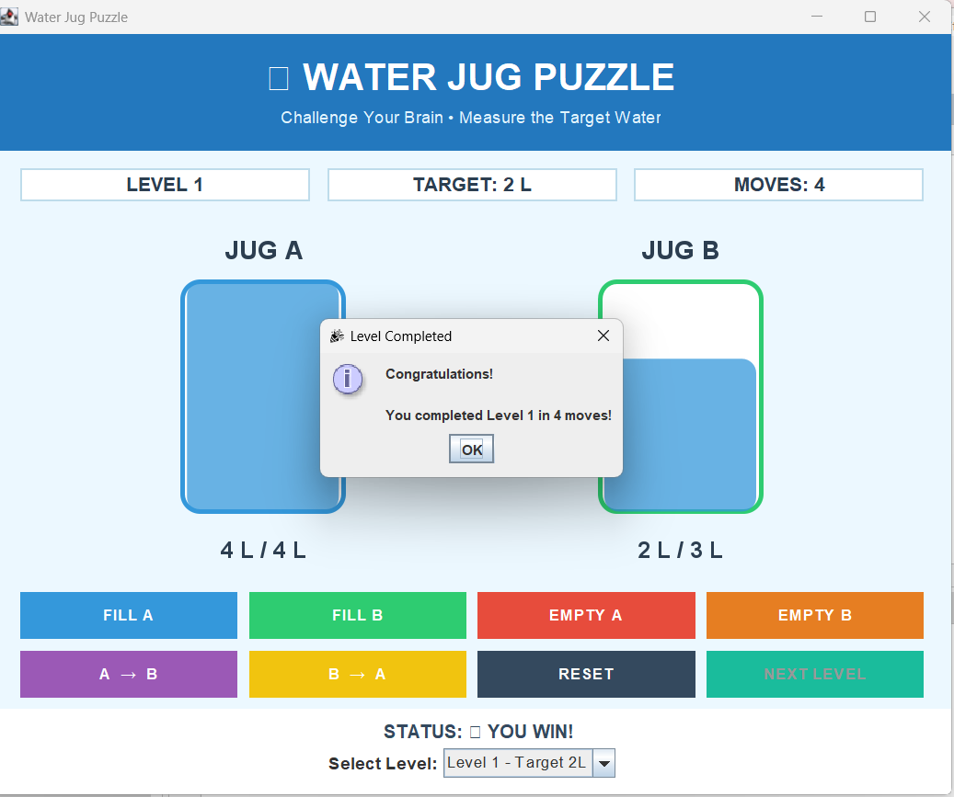

16. Limitations

The current version of the Water Jug Game has some limitations:
- The game uses fixed jug capacities of 4 liters and 3 liters.
- The number of available target levels is limited.
- The game is designed for a single player.
- There is no online multiplayer functionality.
- Player scores and game progress are not permanently stored.
- The application does not use a database.
- Advanced animations and visual effects are limited.
- The game is designed as a desktop-based Java Swing application.
- The game does not currently provide sound effects.
- The available game operations and rules are limited to the predefined game logic.

17. Conclusion

The Water Jug Game project provided practical experience in Java software development and Object-Oriented Programming. The system was developed step by step, starting from project planning and GUI development and continuing with jug operations, transfer logic, validation, level/target selection, move counting, win detection, reset functionality, testing and final improvements. The application demonstrates how Java Swing, OOP concepts, GUI components, event handling and game logic can be combined to develop a complete interactive puzzle game.

