Teisha Soans

A068

86062300017

Practical-1 Infrastructure as a service using AWS

Date: 20/07/24

Task 2: Implement Ubuntu machine using AWS ec2 and execute the Linux commands

Step 1: Search for EC2

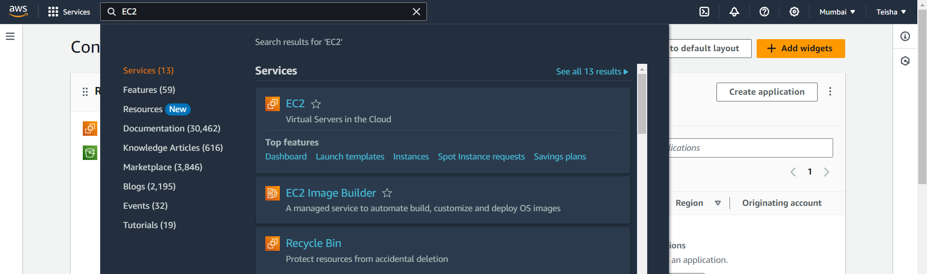

Step 2: Start making your server by clicking on launch instance

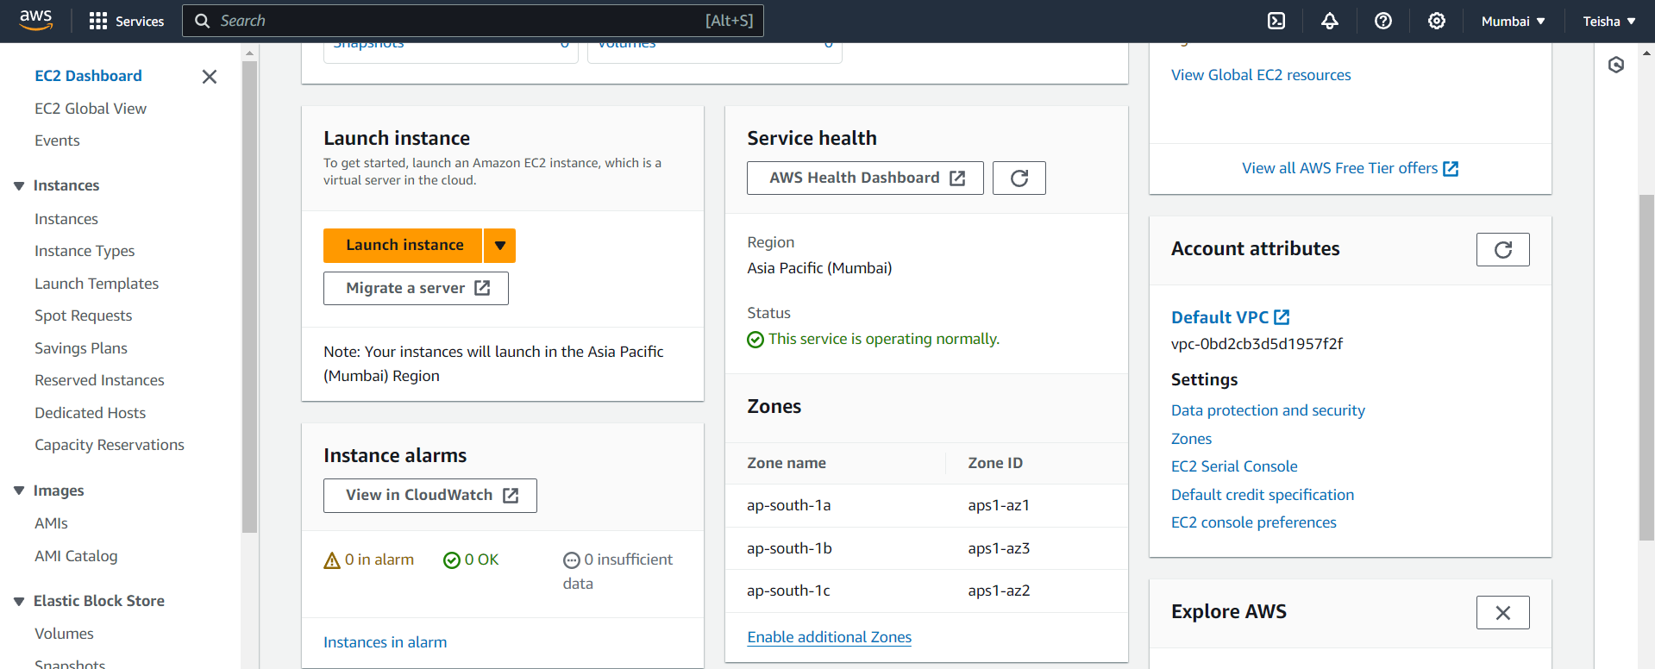

Step 3: Name your instance, I have chosen to name it Server_1_20/07/24

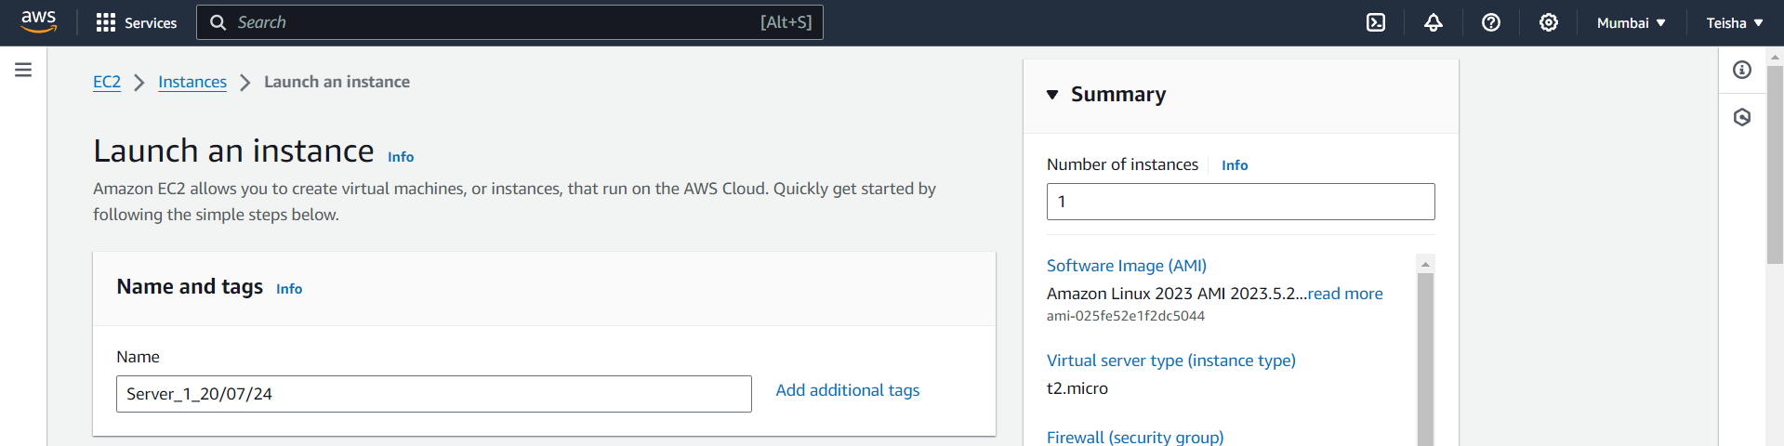

Step 4: Click on Ubuntu for the application and the 24.04 LTS for the AMI

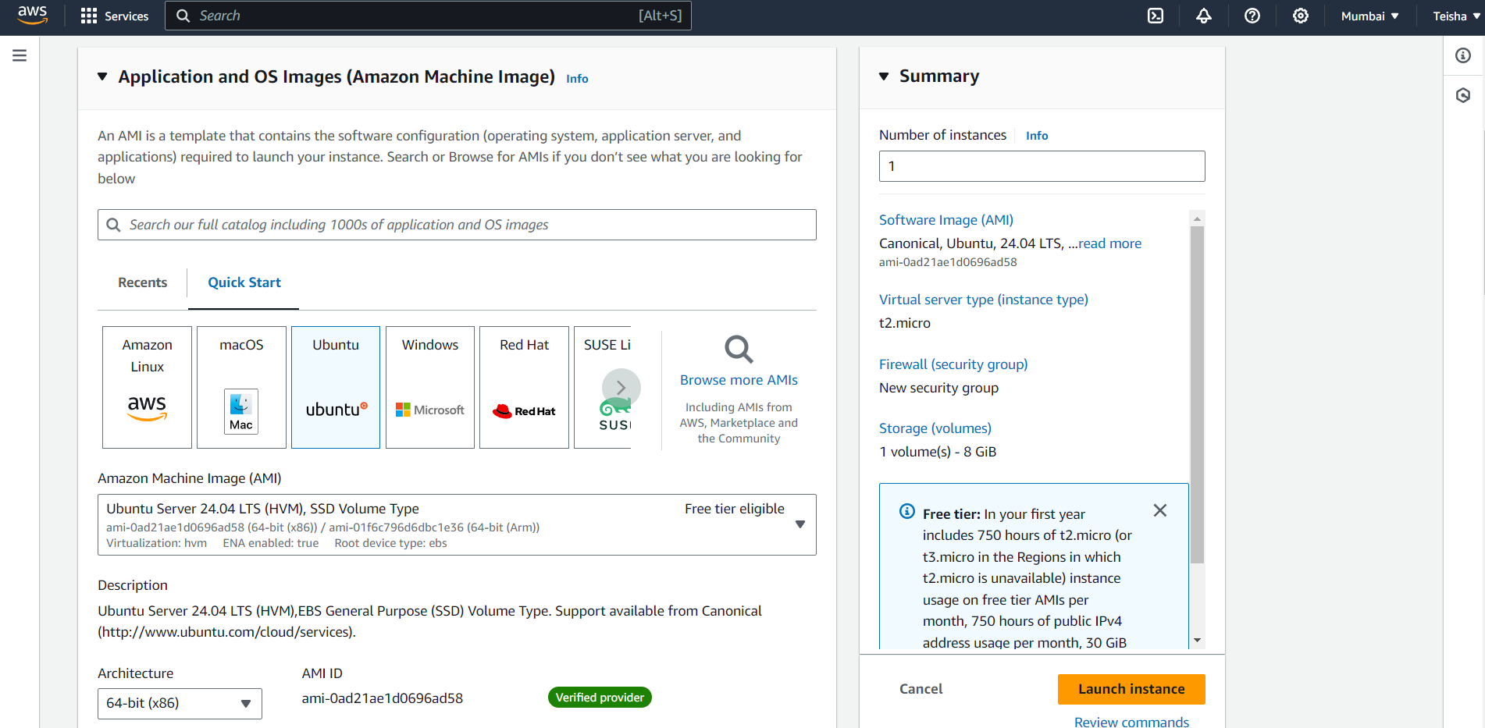

Step 5: Choose your instance type as t2.micro

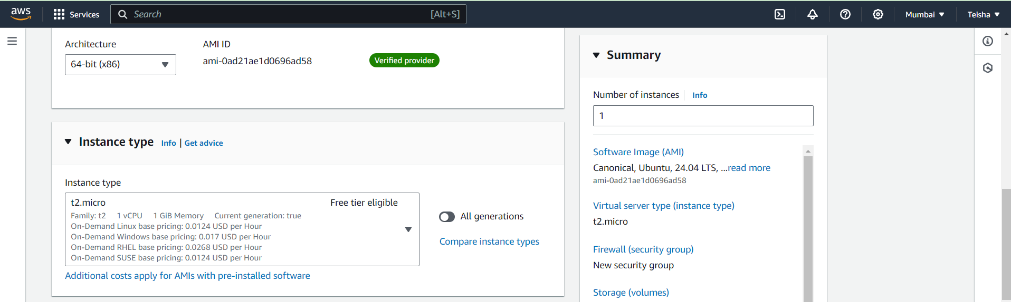

Step 6: Now we will have to create a key pair login

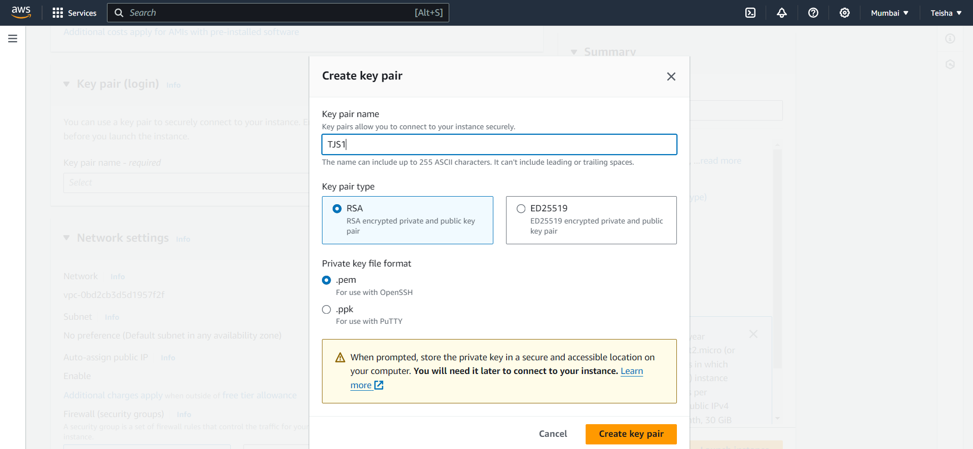

Step 7: Now we will not change anything else and launch the instance

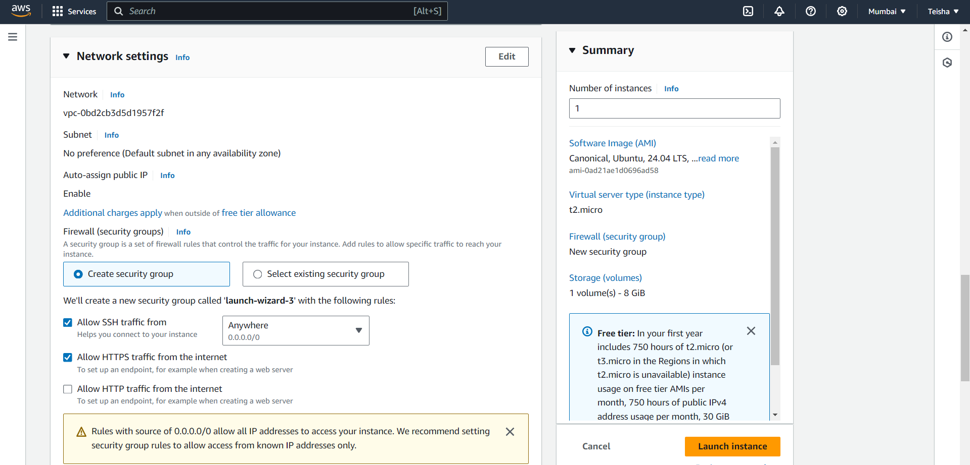

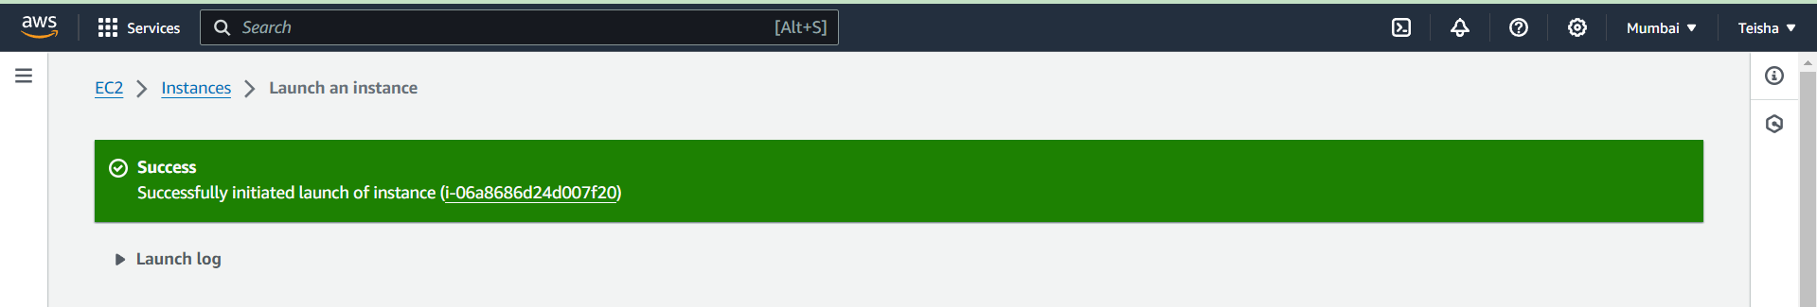

Step 8: Finally we have implemented the Ubuntu machine using AWS

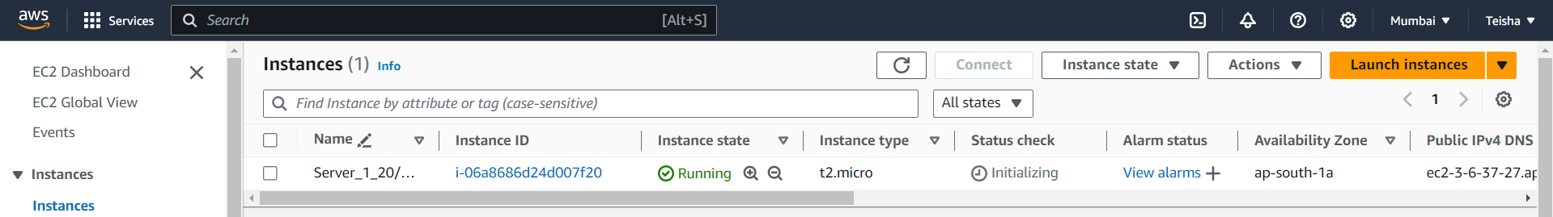

Executing 5 Linux commands:

Step 9: We now connect the instance in order to run the Linux commands, first we will click on connect

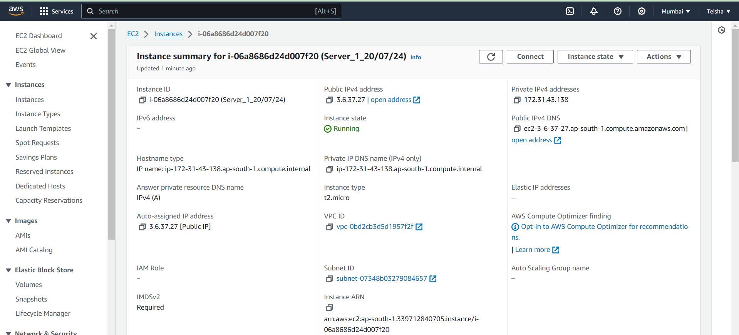

Step 10: Now we will execute the commands

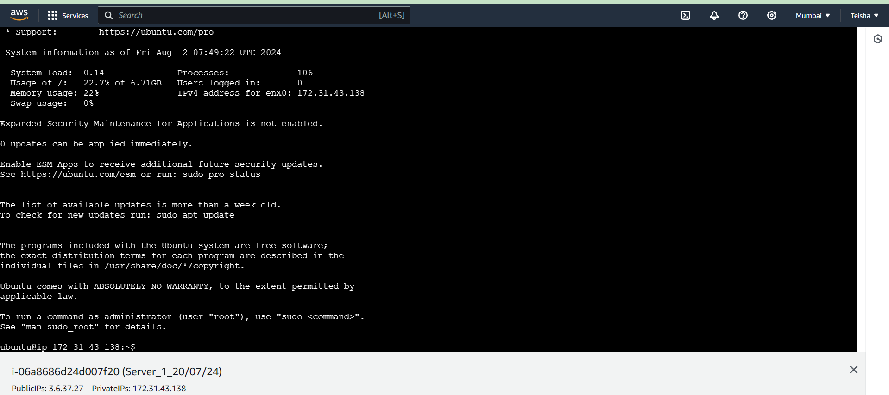

Step 11: This is the final 5 commands implemented

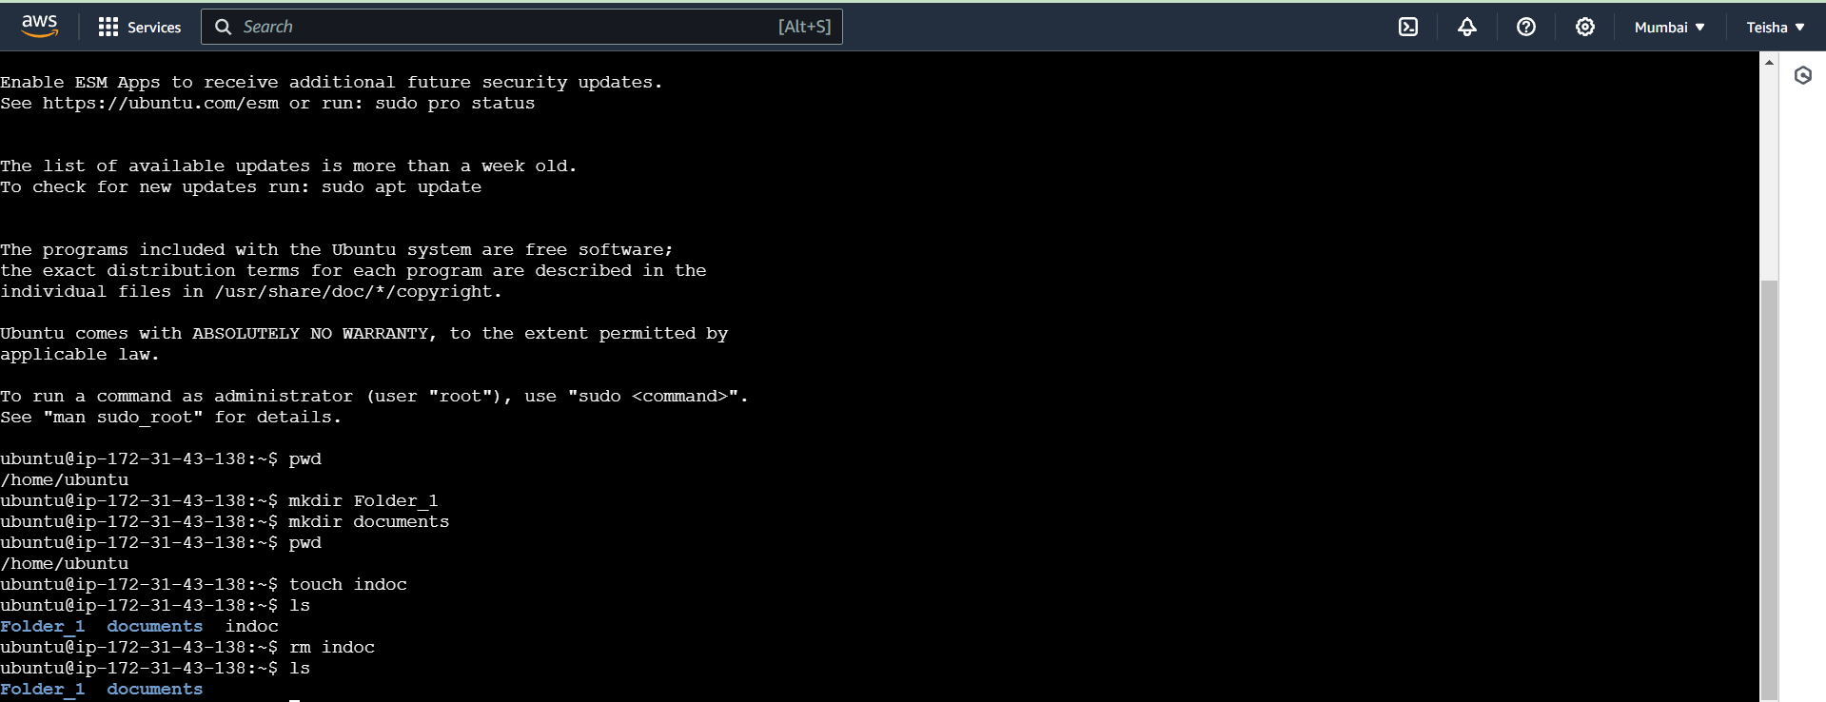

Step 12: Once done we will terminate the instance

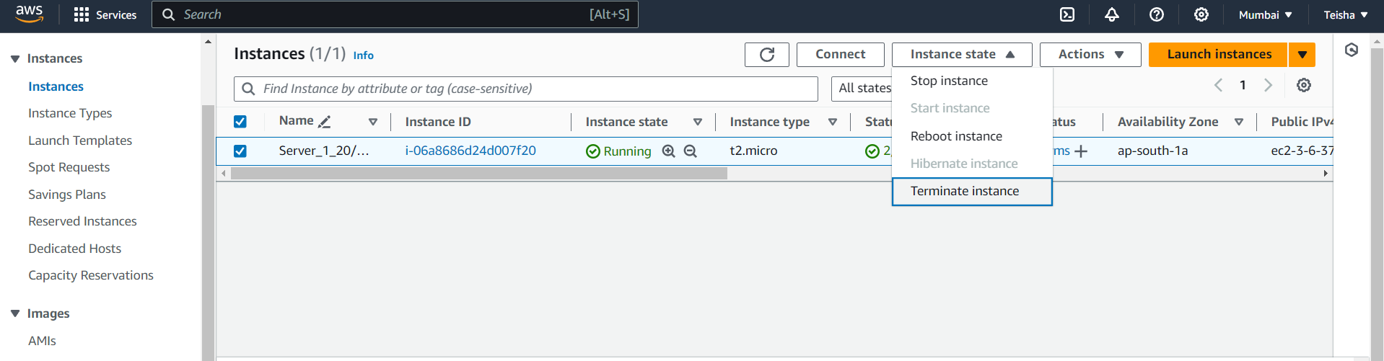

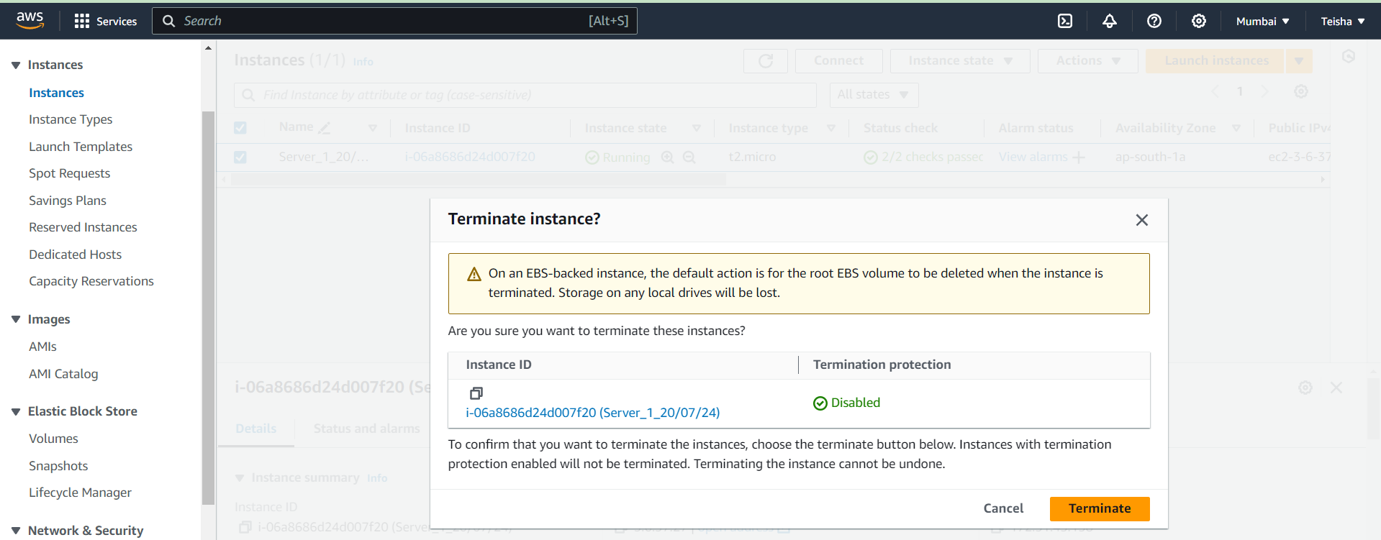

Task 1. Implement the windows machine using AWS ec2

Same as Ubuntu steps