Teisha Soans

A068

86062300017

Practical-2 Storage As Service Using AWS

Task 1: Implementing S3 for uploading a video

Step 1: Search for S3

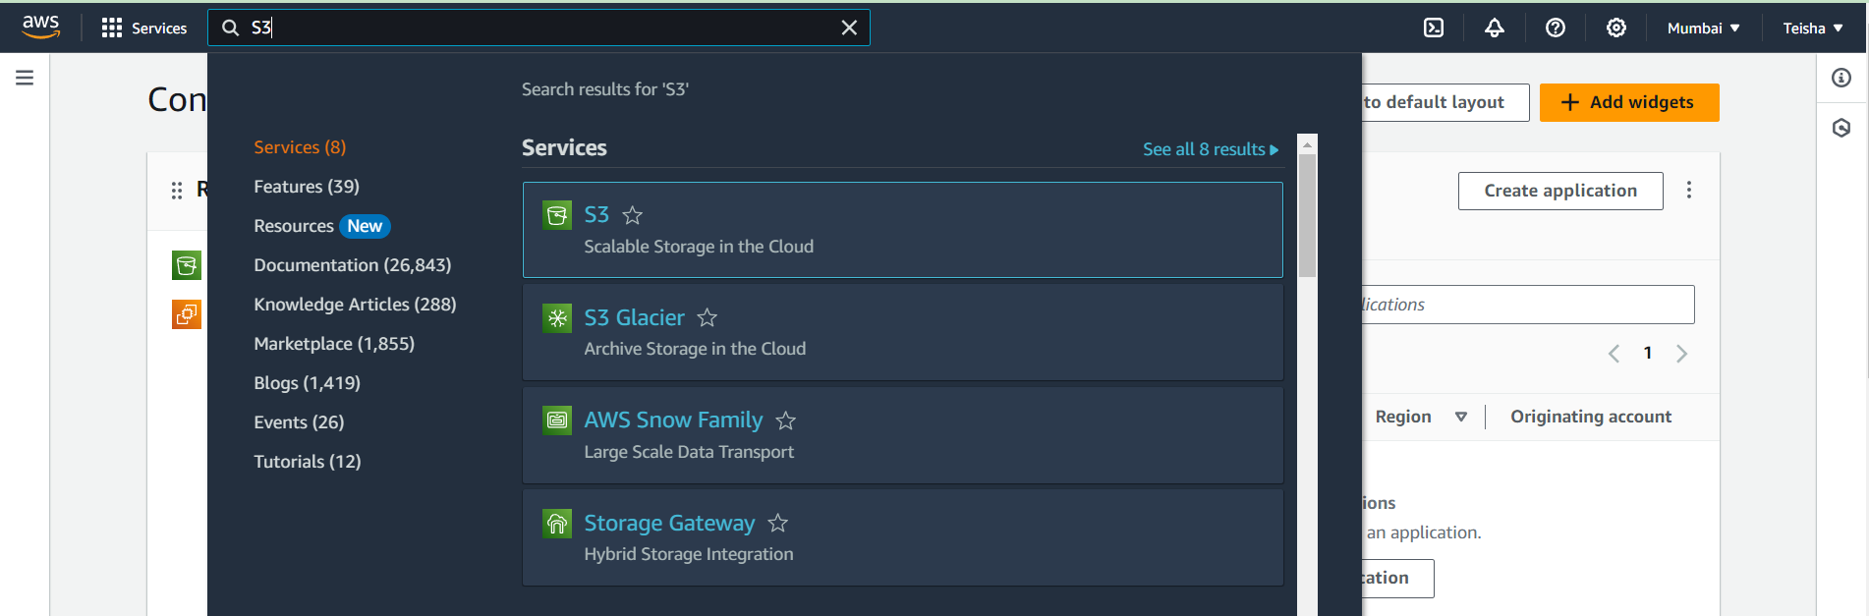

Step 2: Create a Bucket

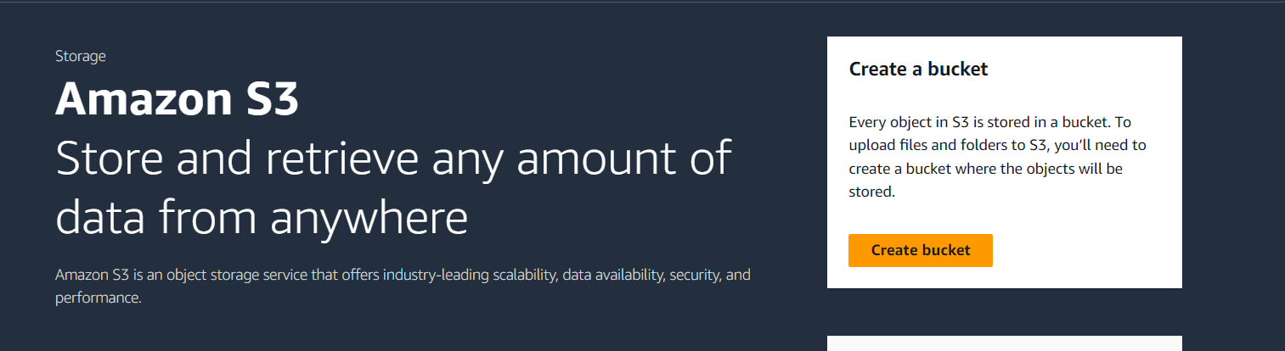

Step 3: Name your Bucket

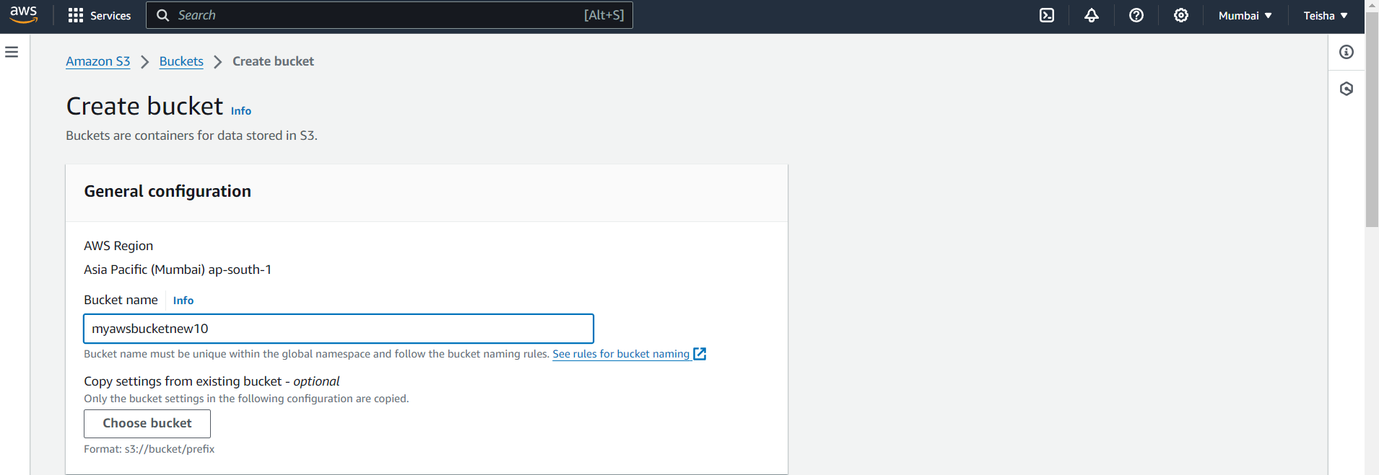

Step 4: ACLs Disabled

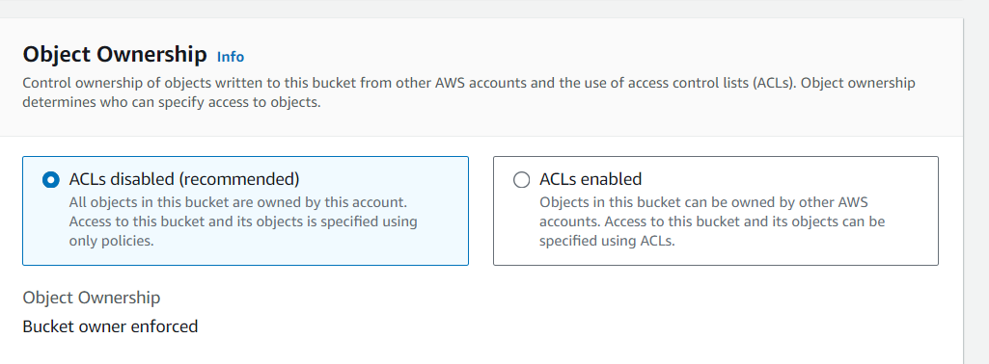

Step 5: Block all public access and disable bucket versioning

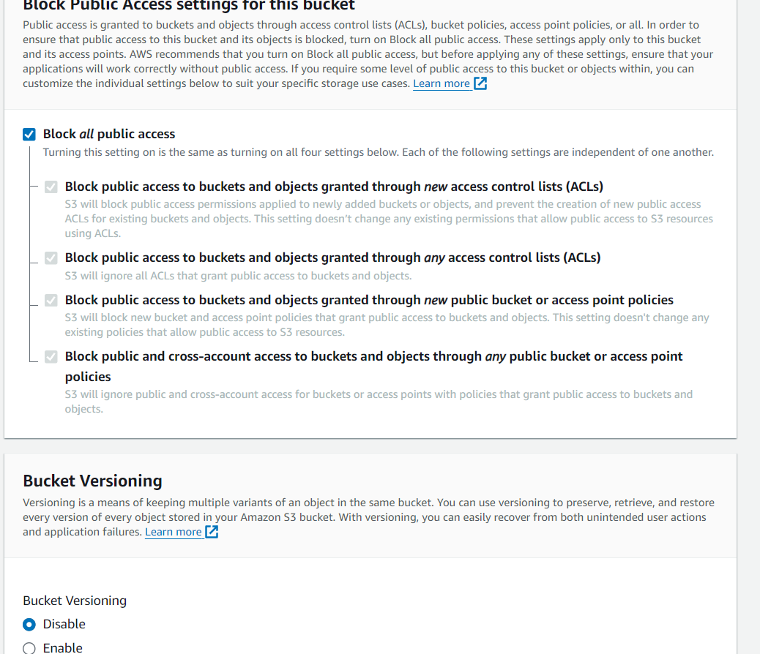

Step 6: Finally create your bucket

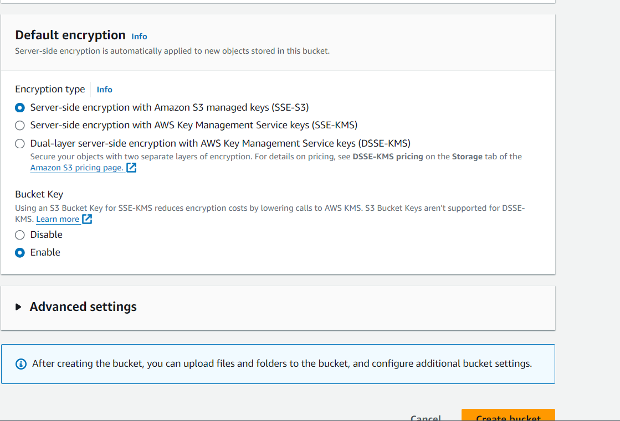

Step 7: Now we will add a folder to the bucket by clicking on the bucket name 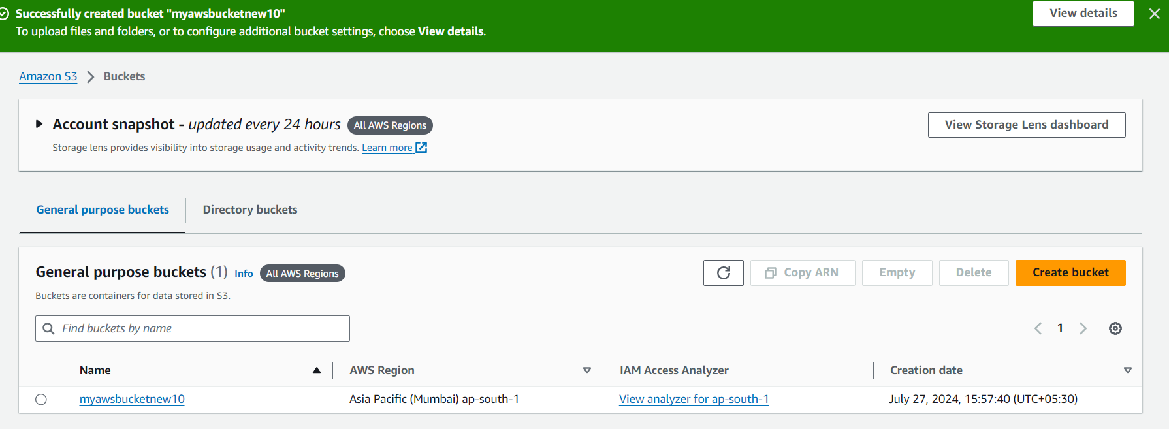Step 7: Next we click on create a folder 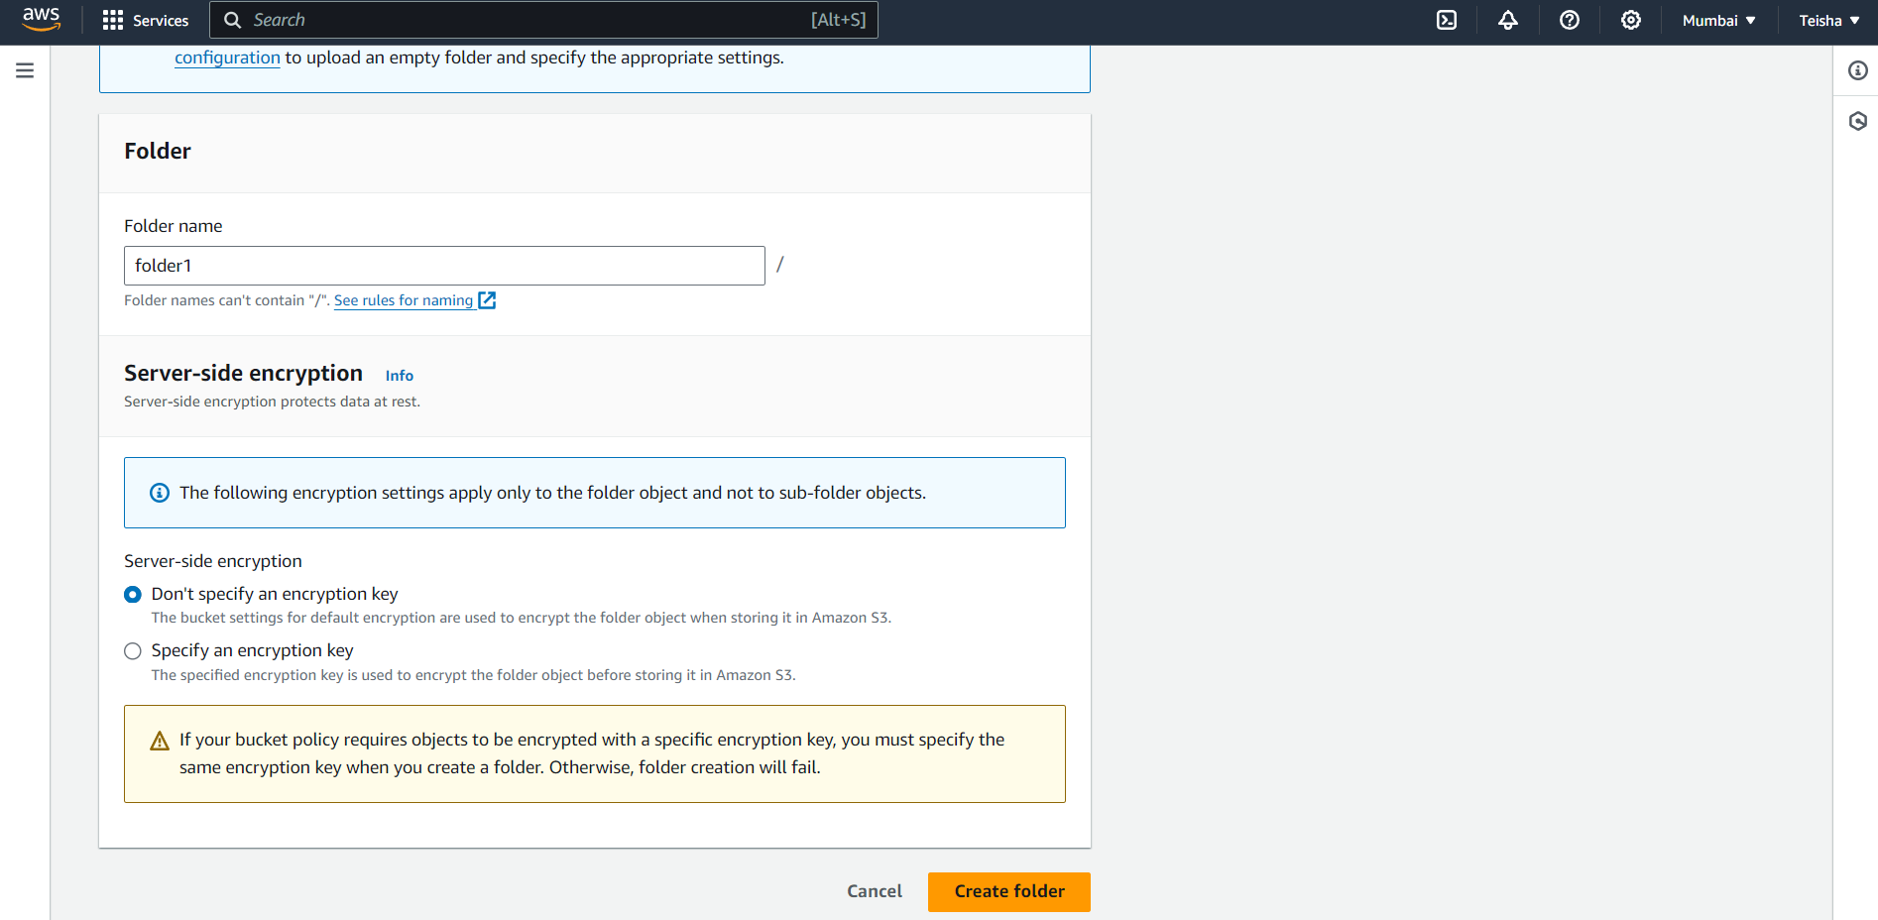

Step 8: Now our next step will be to click on upload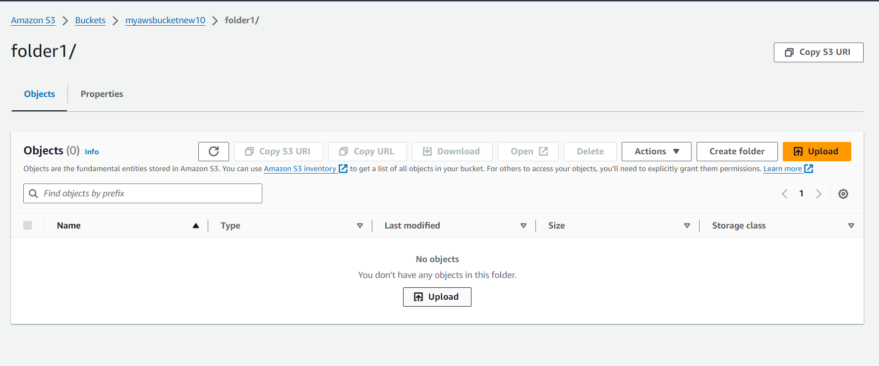

Step 9: Now we will upload the required video and check for the status

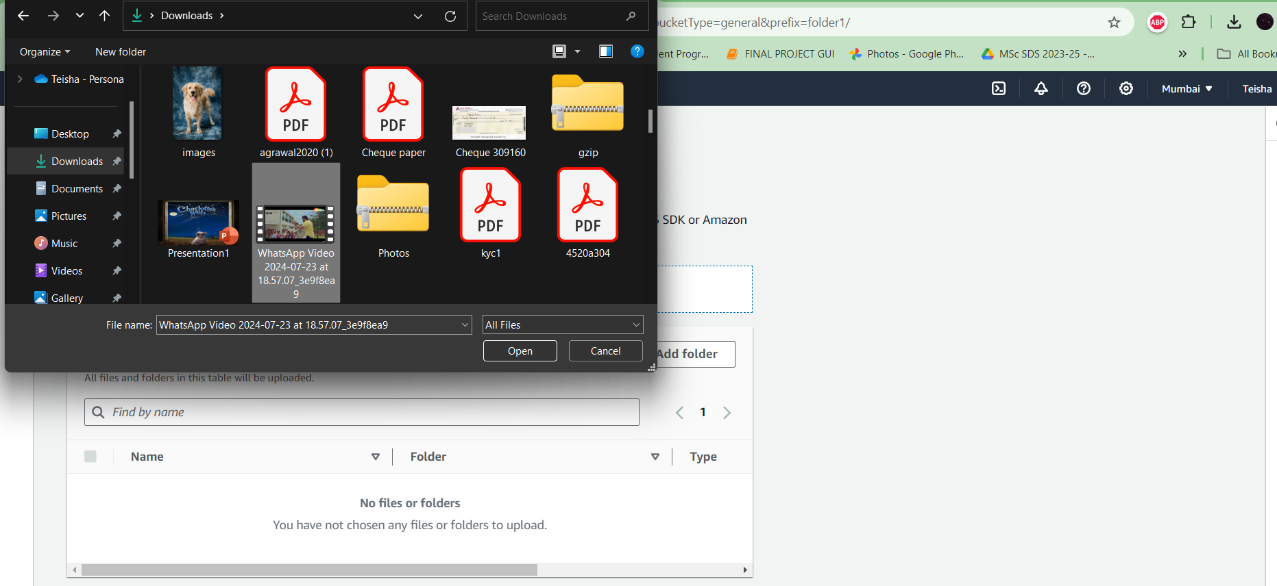 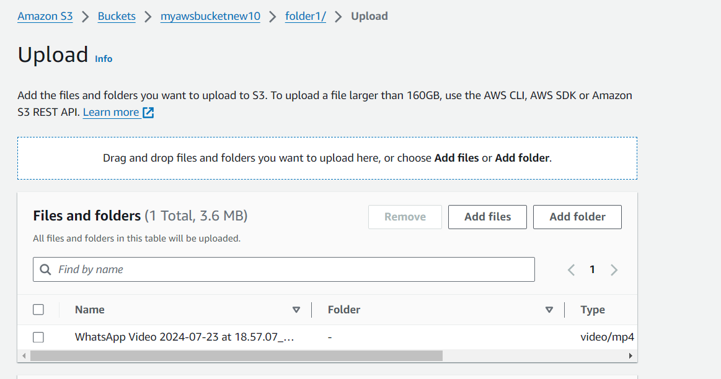

Step 10: Finally we check if it has succeeded and then get the object overview

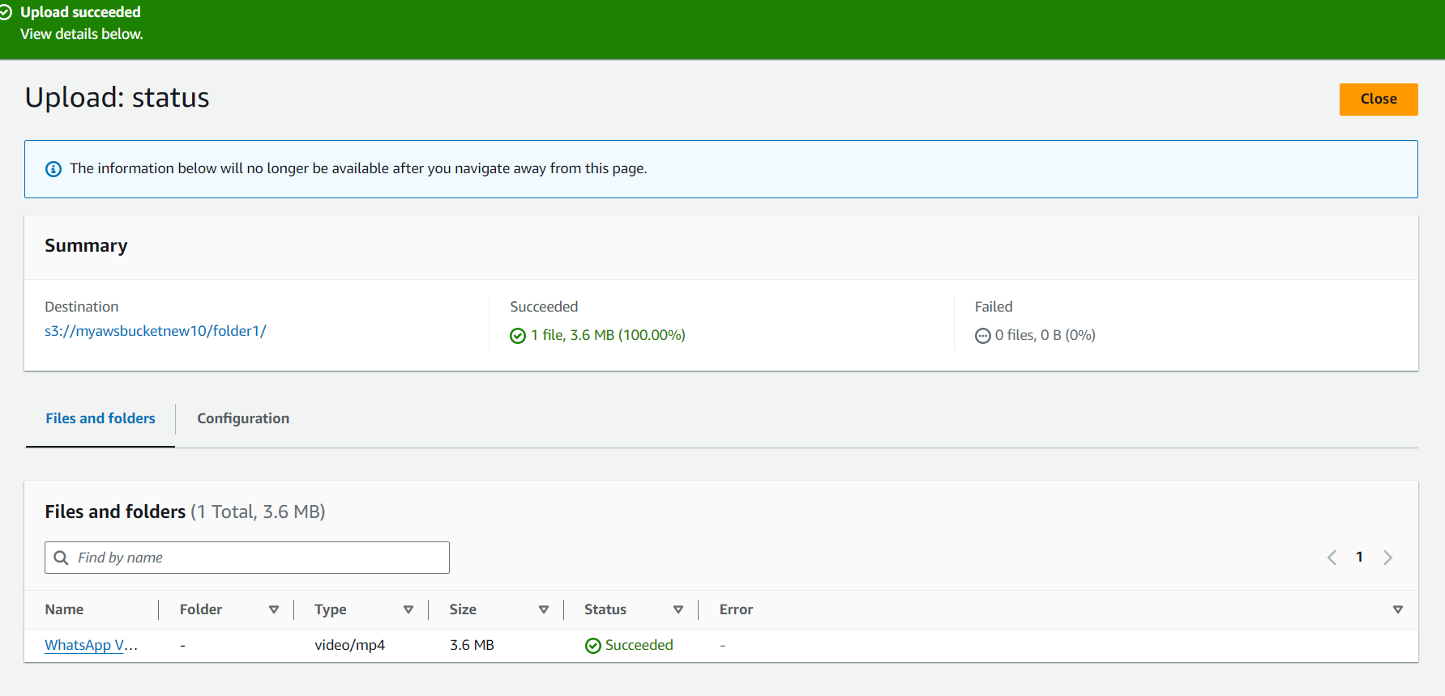 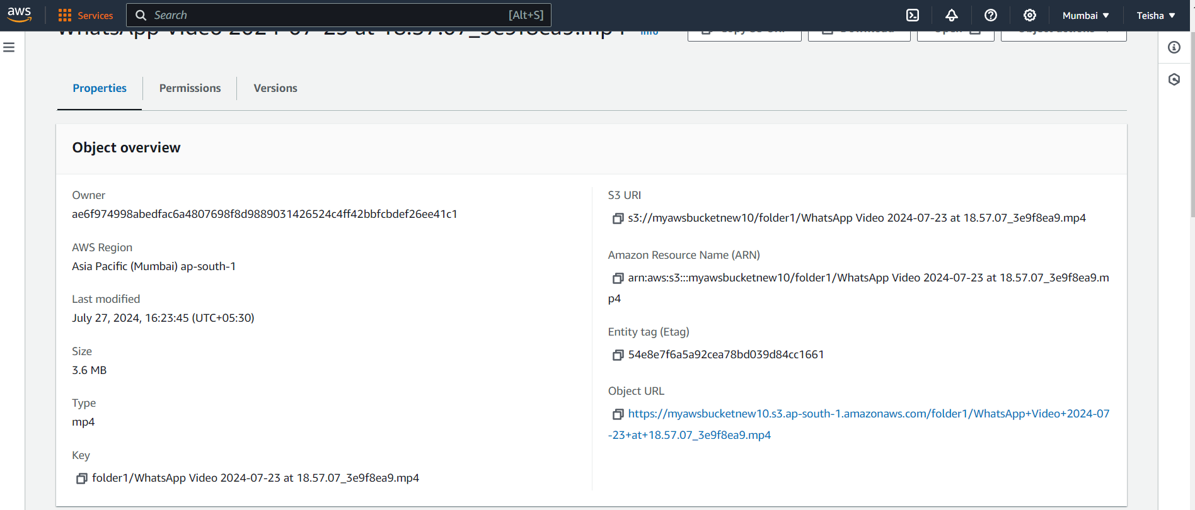

Task 2: Implementing S3 for uploading a static website

Step 1: Since we have already created a bucket before we will just upload the static website on the created bucket

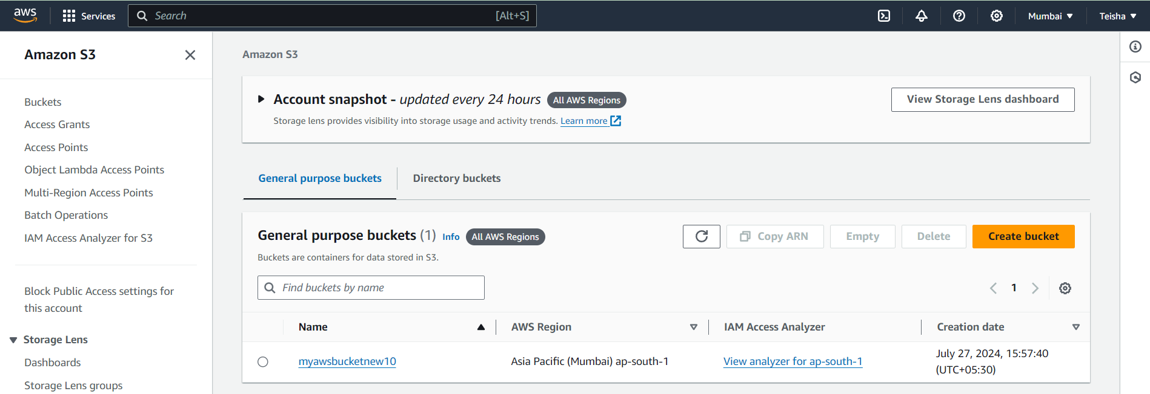

Step 2: Select on the bucket and the folder1 in it

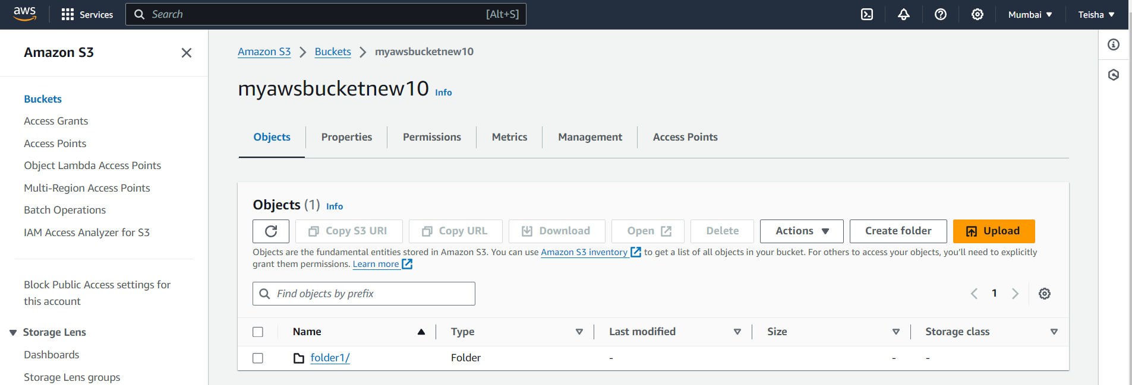

Step 3: Our next step will be to upload our static website in the folder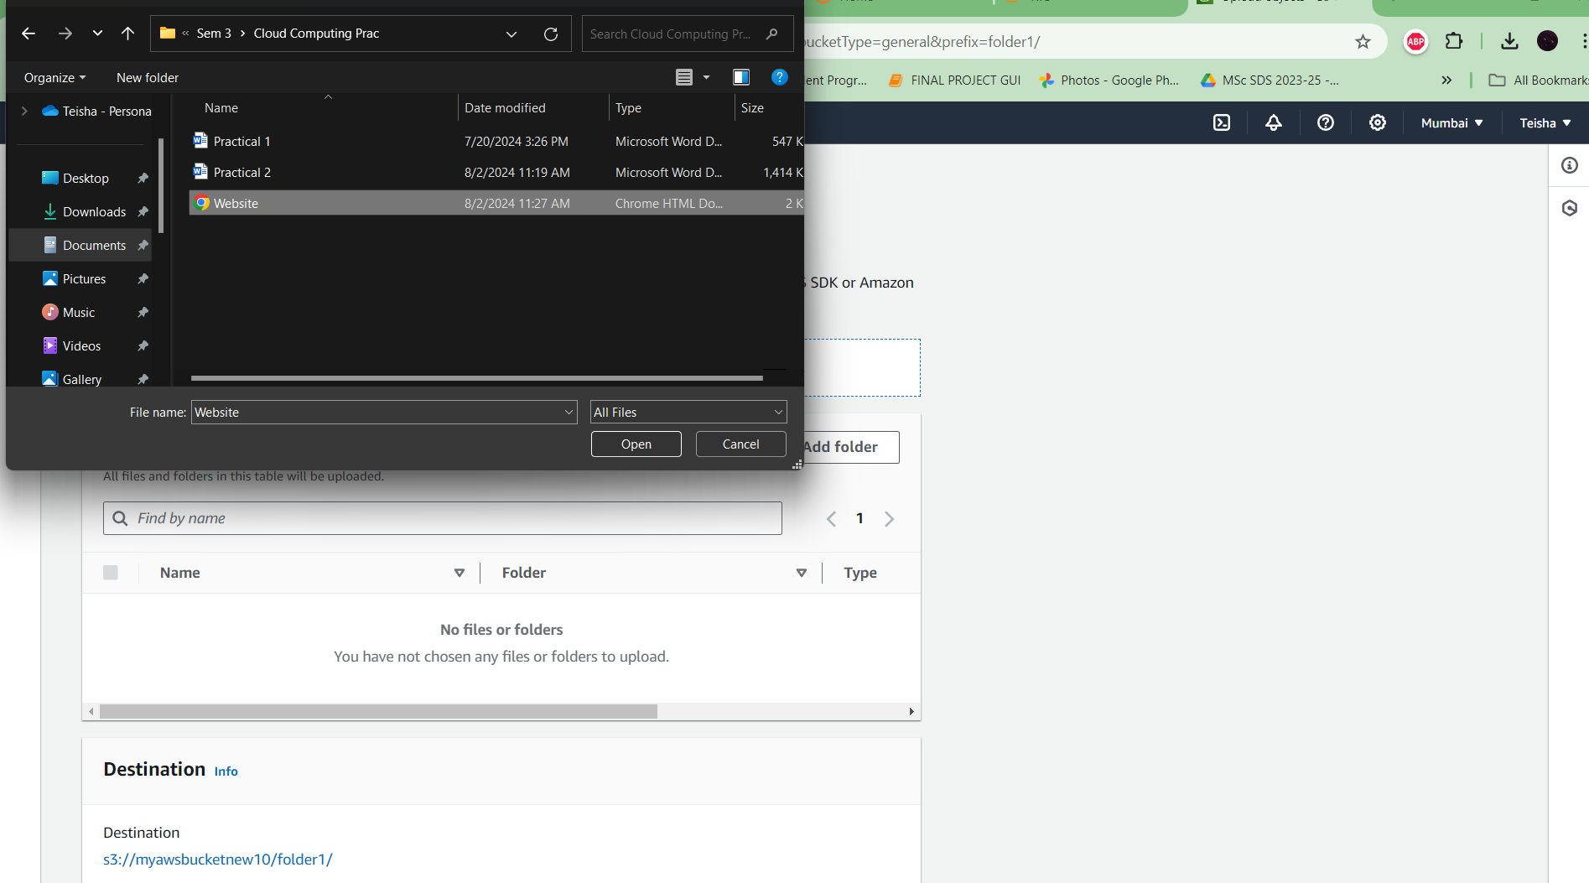

Step 4: Our next step will be to upload our static website in the folder

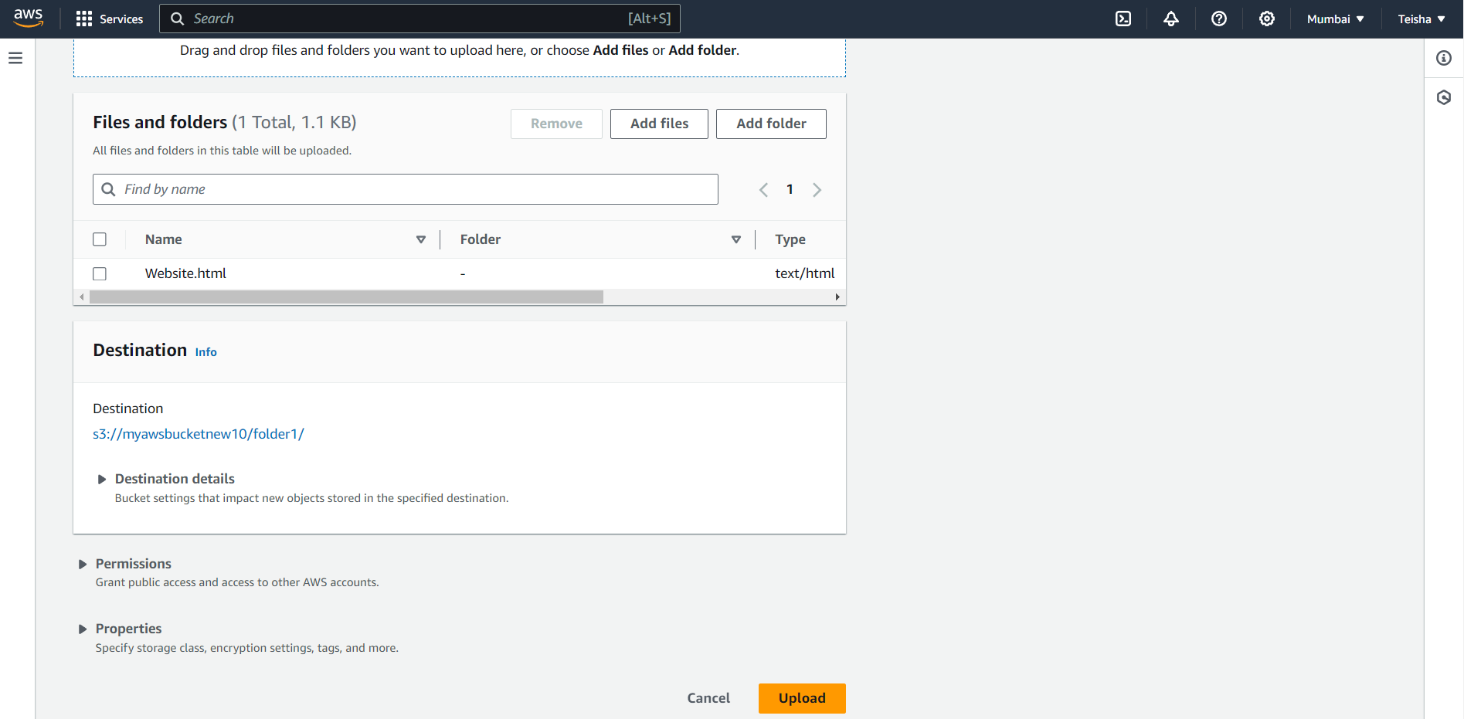

Step 5: After the success of the upload we will check the overview of the same

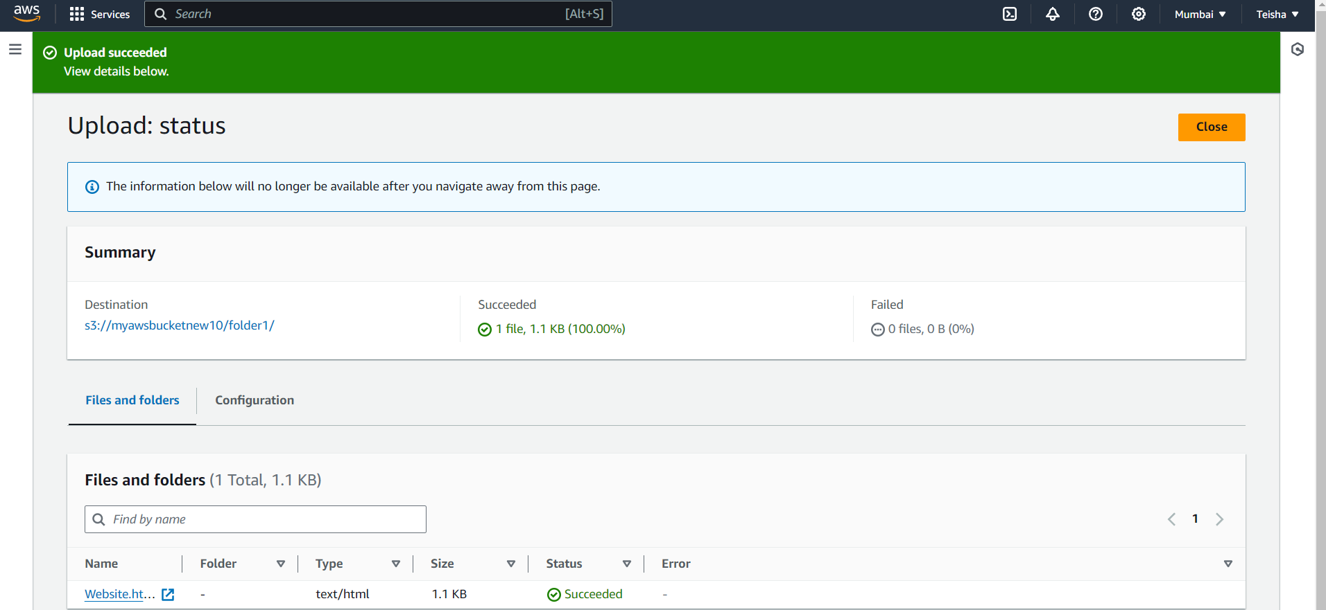

Step 6: Finally we have successfully uploaded our static website

