Teisha Soans

A068

86062300017

Practical-3 : Identity Access Management

Task 1: Create and Implement policies IAM user for accessing any 4 services from the aws user and group.

Step 1: Search for IAM on the AWS console

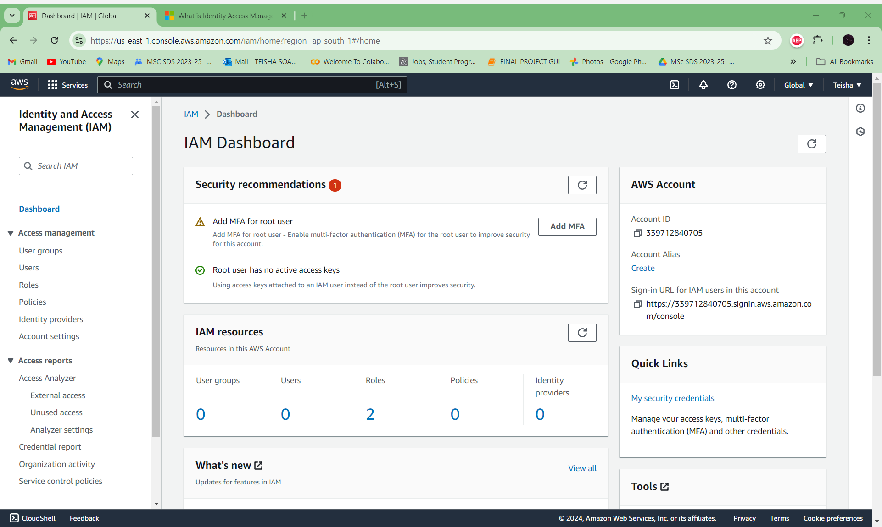

Step 2: Go to users to create a new user

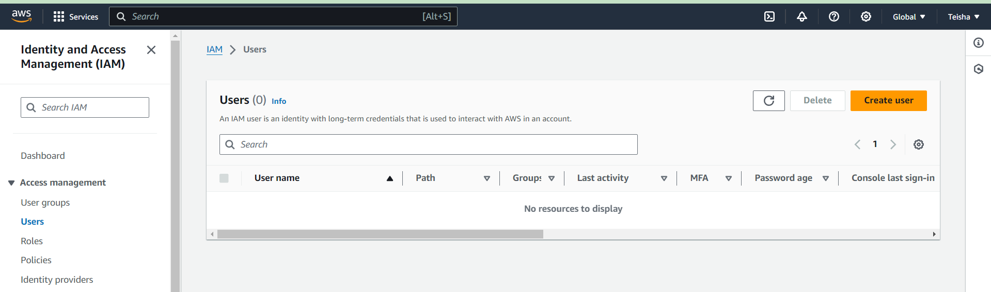

Step 3: Name your user before moving to the next step

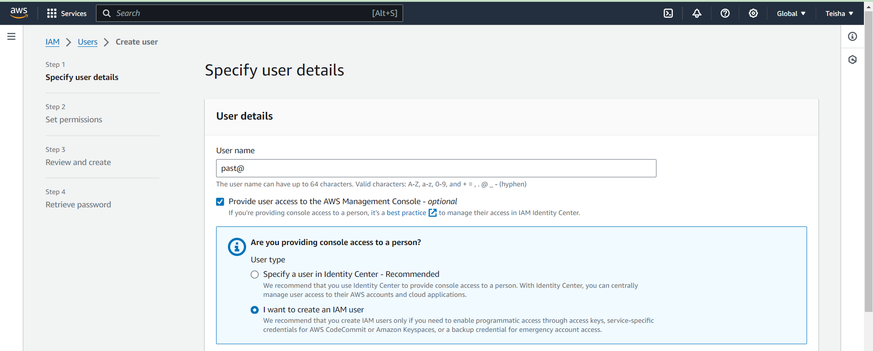

Step 4: You can either customize your own password or use the autogenerated one and then move ahead

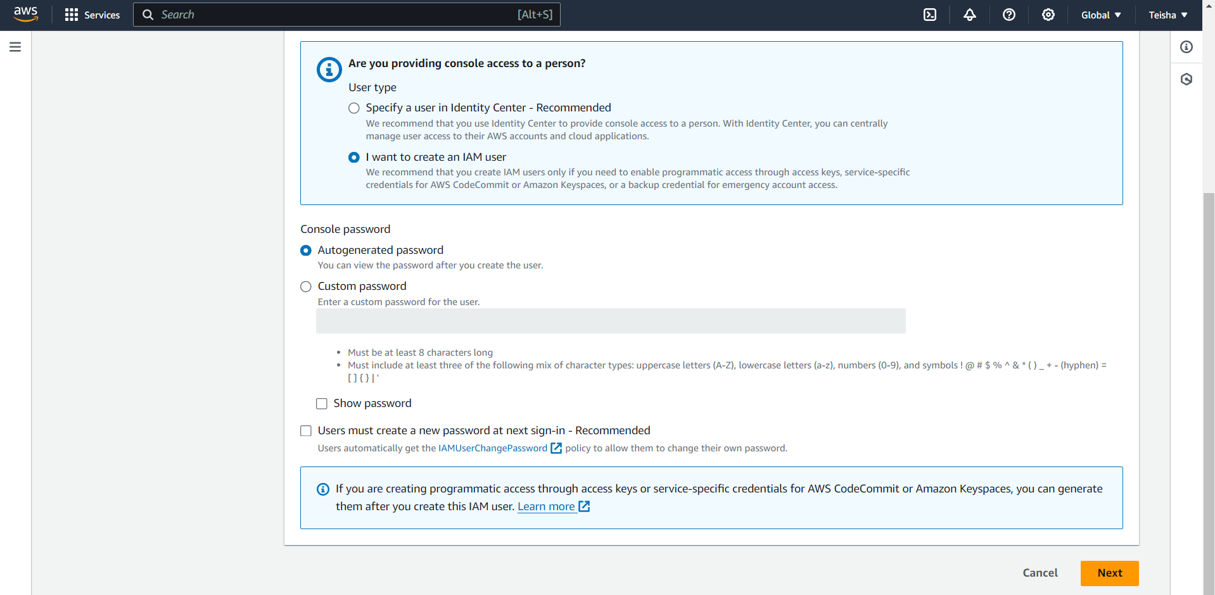

Step 5: We now want to create a policy for our user

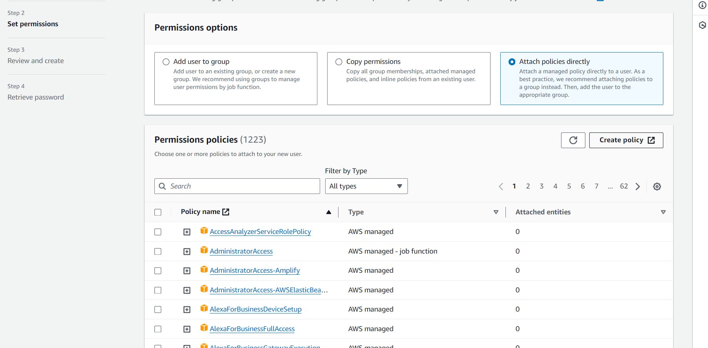

Step 6: After selecting Create Policy we choose the service we want i.e. S3 and select all resources

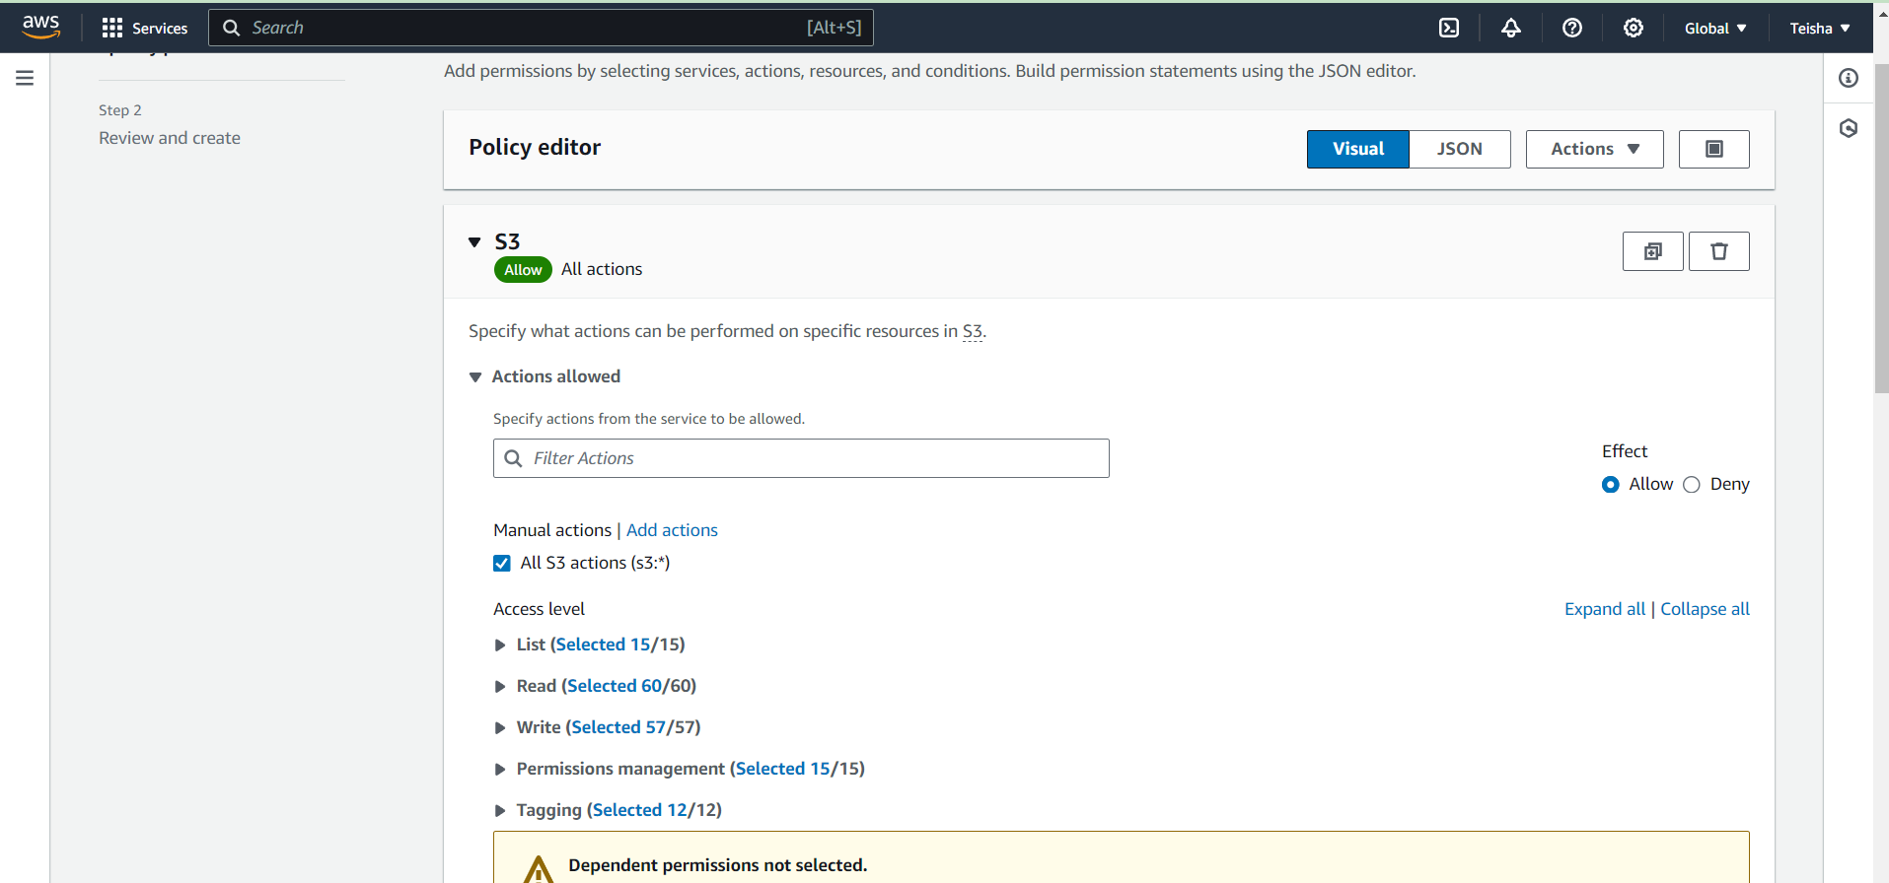

Step 7: Similarly after we select add permissions we choose the 2nd service as EC2

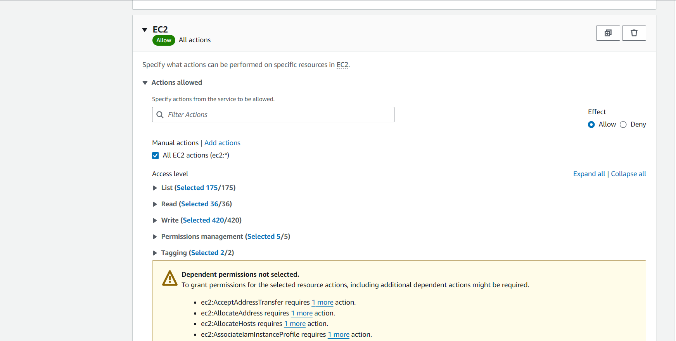

Step 8: Next we add RDS service

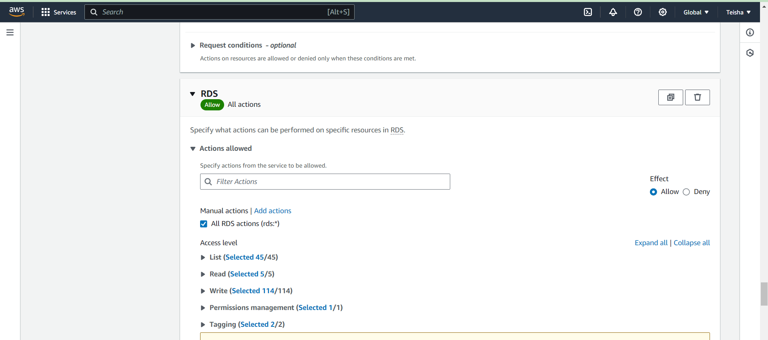

Step 9: Finally we add the 4th service i.e. Lambda

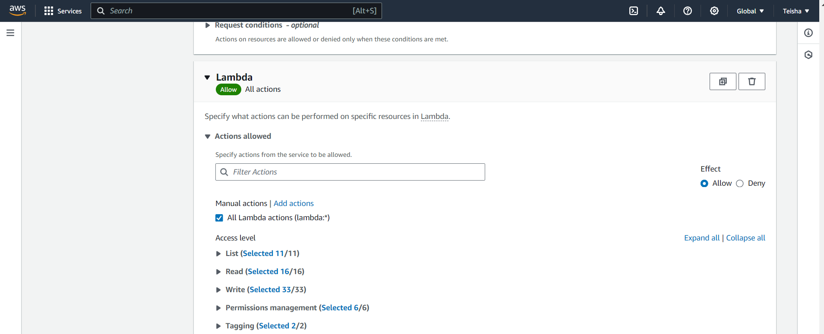

Step 10: Then we click on the next button and name our policy and give an appropriate description

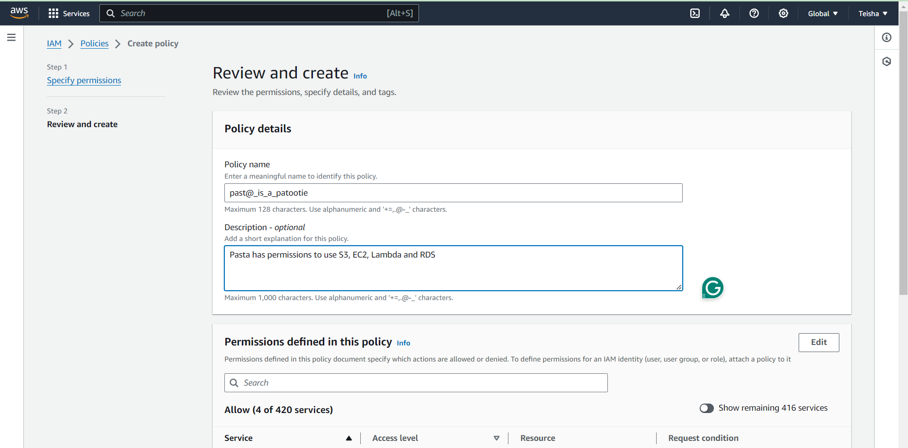

Step 11: Finally our policy is created

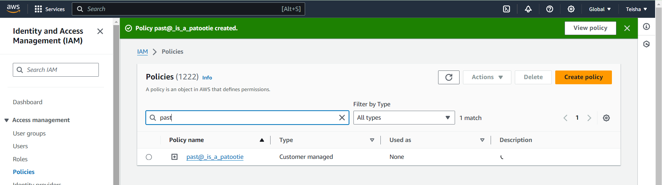

Step 12: Now we attach the policy to the user

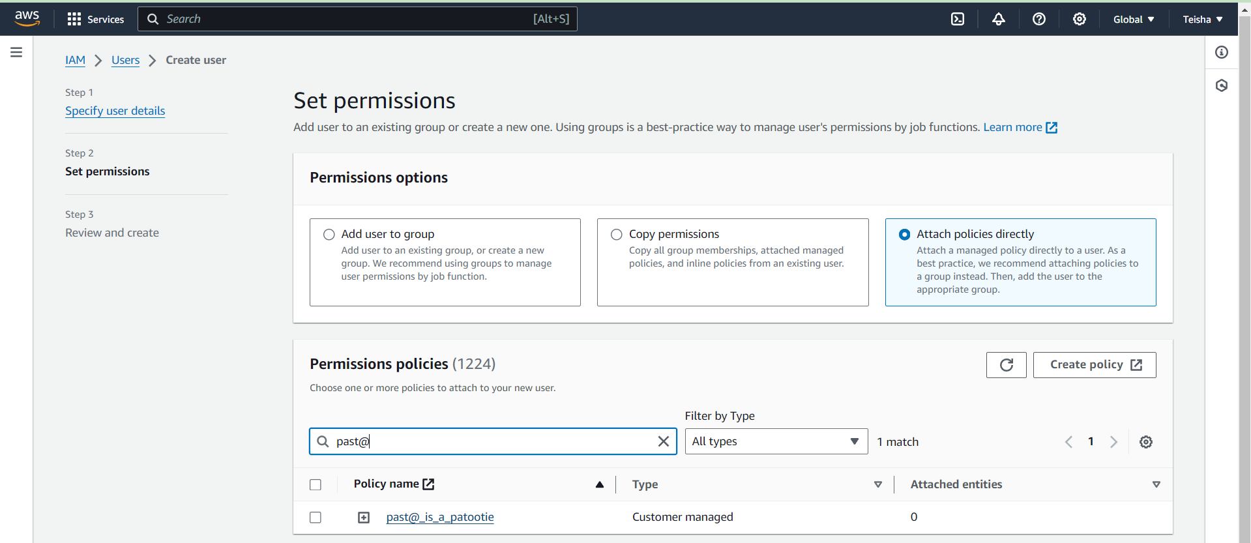

Step 13: Finally review the user details and the permissions along with the policy

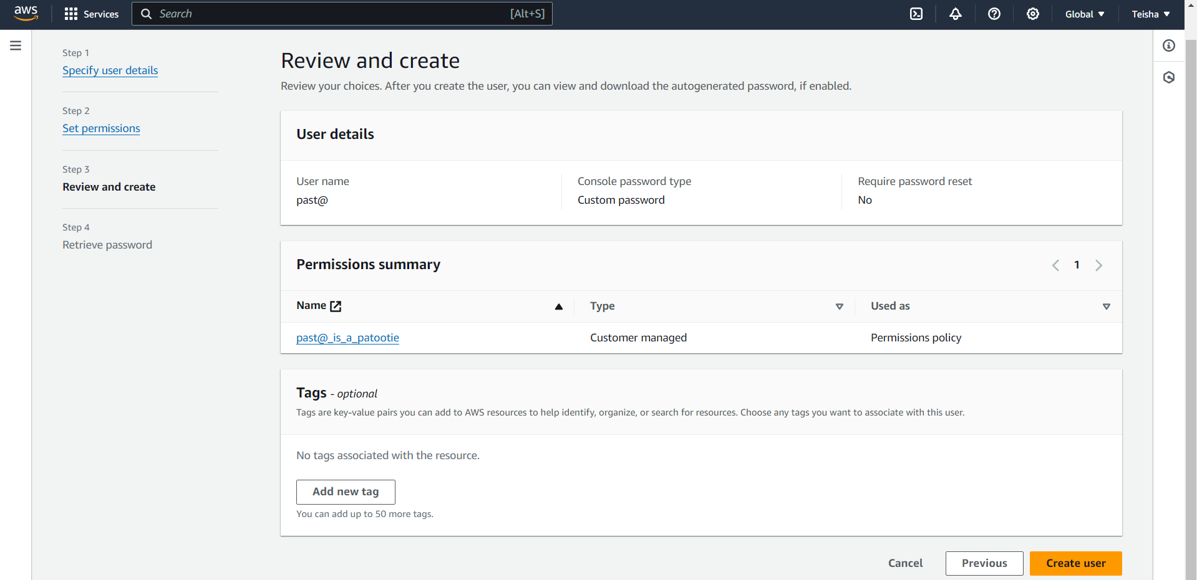

Step 14: Your user is now ready after clicking on Create User

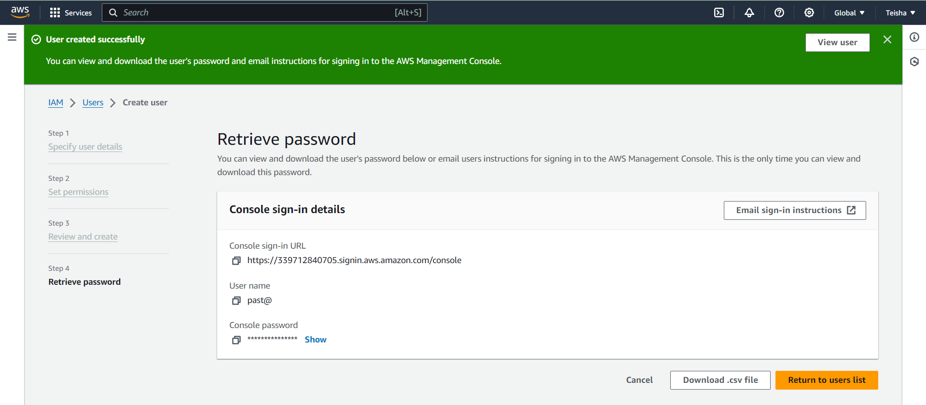

Step 15: Now we check our user details

