Teisha Soans

A068

86062300017

Practical-5 : Platform as a service using AWS

Task 1: Implement paas using elastic beanstalk for Python

1. We’ll be using Elastic Beanstalk - Python

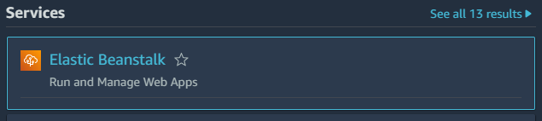

1. There will be the steps

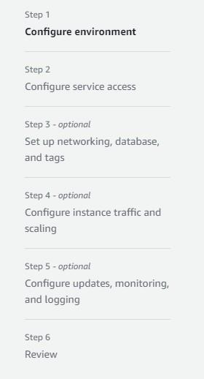

1. Fill in the details

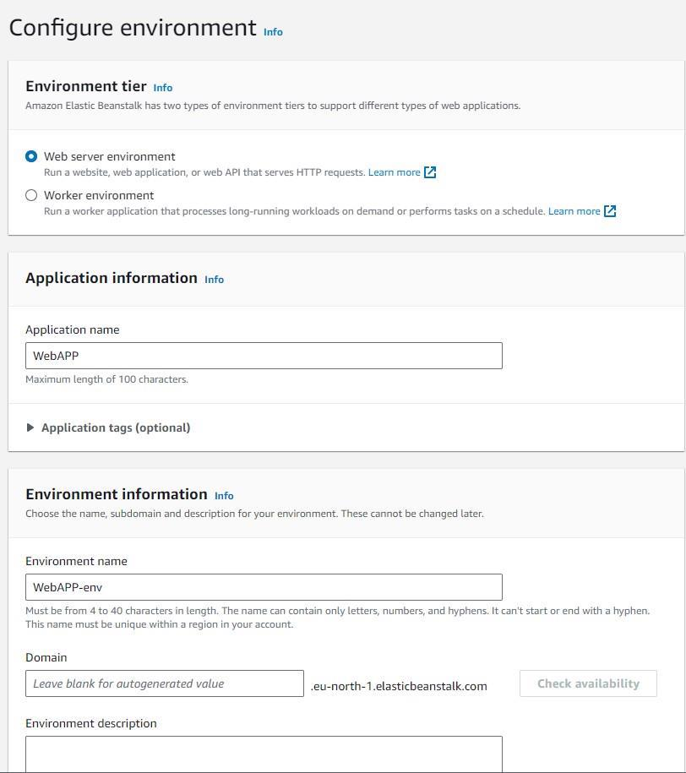

1. Select the platform

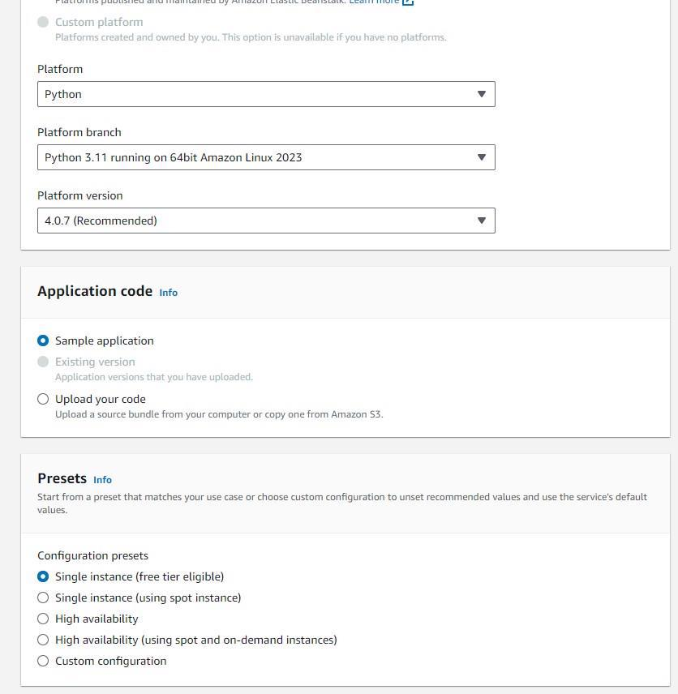

1. Go to the IAM services -> Create role

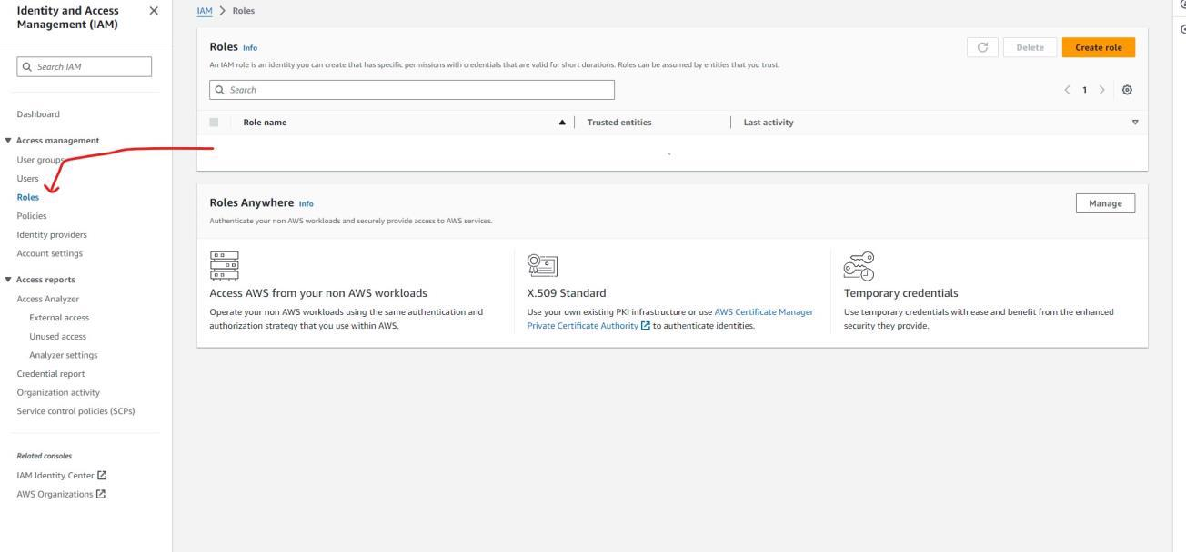

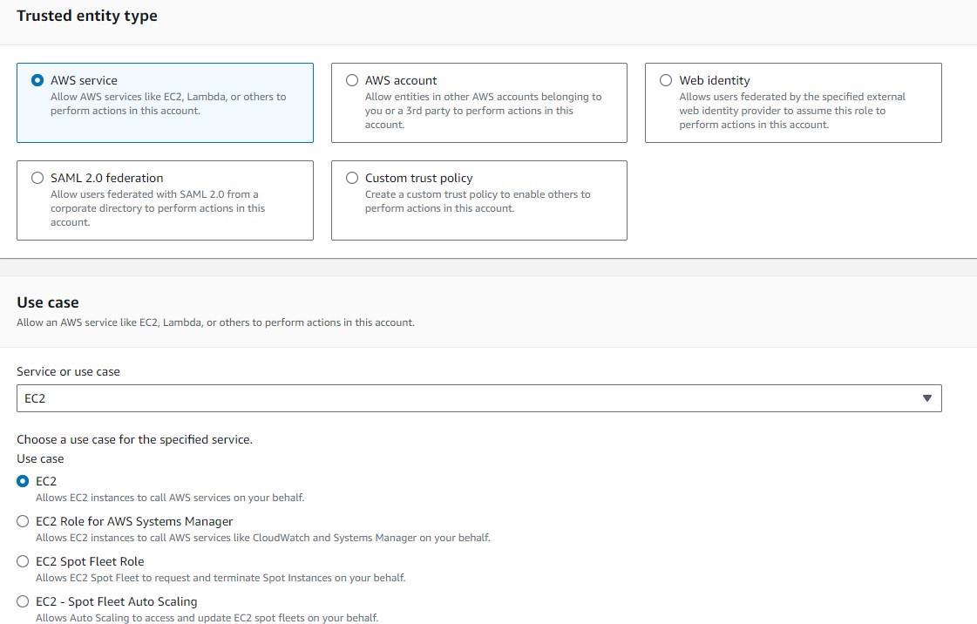

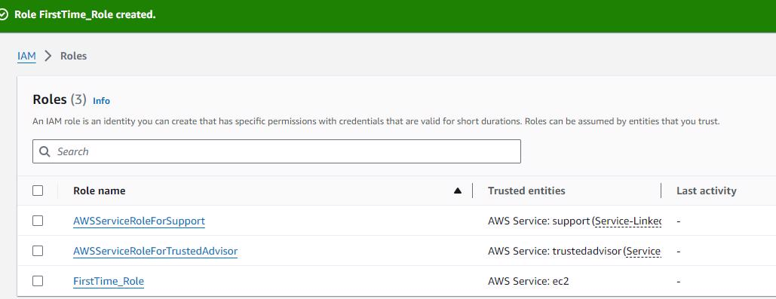

1. Create new service role, and select the EC instance profile

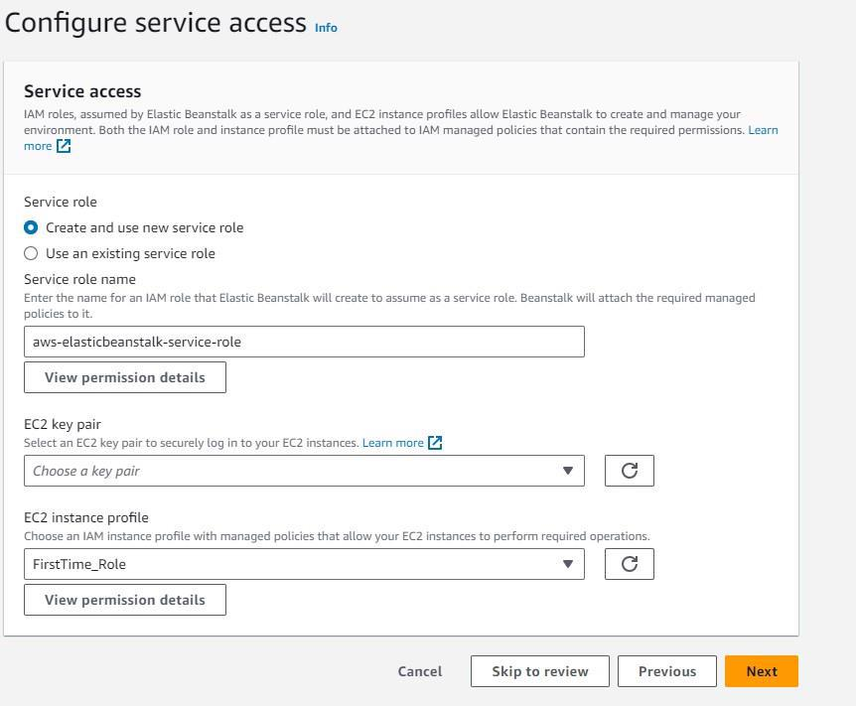

1. Set up network and database

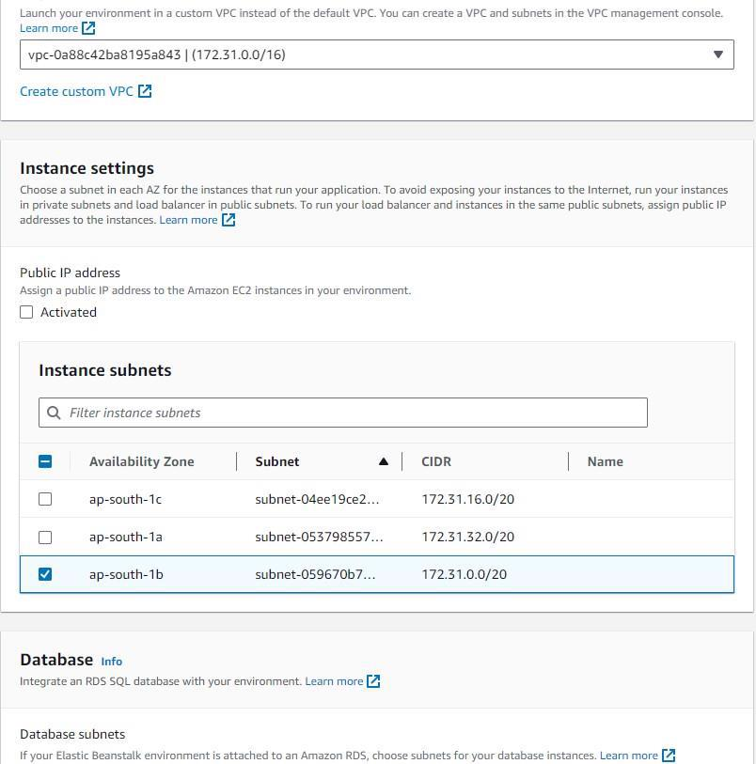

1. Keep the settings default

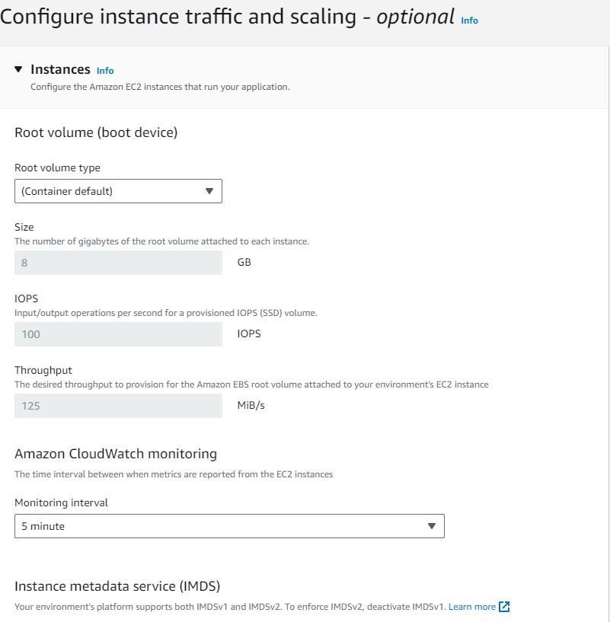

1. Keep the settings default

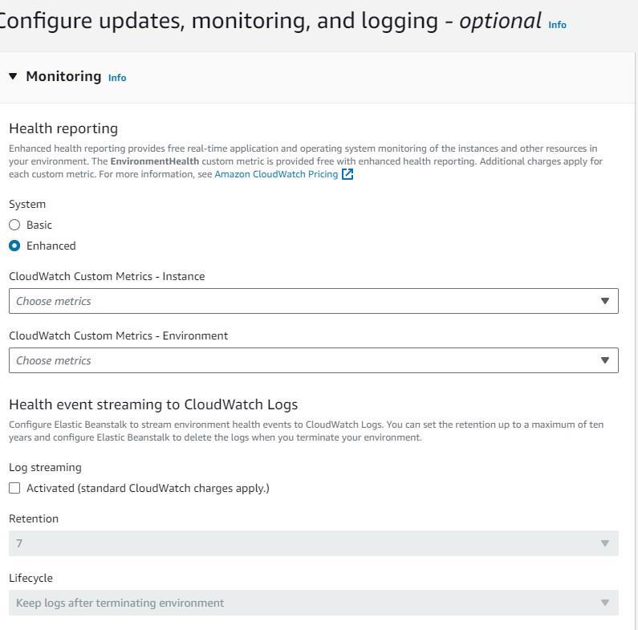

1. Review and submit.
2. The environment will start launching

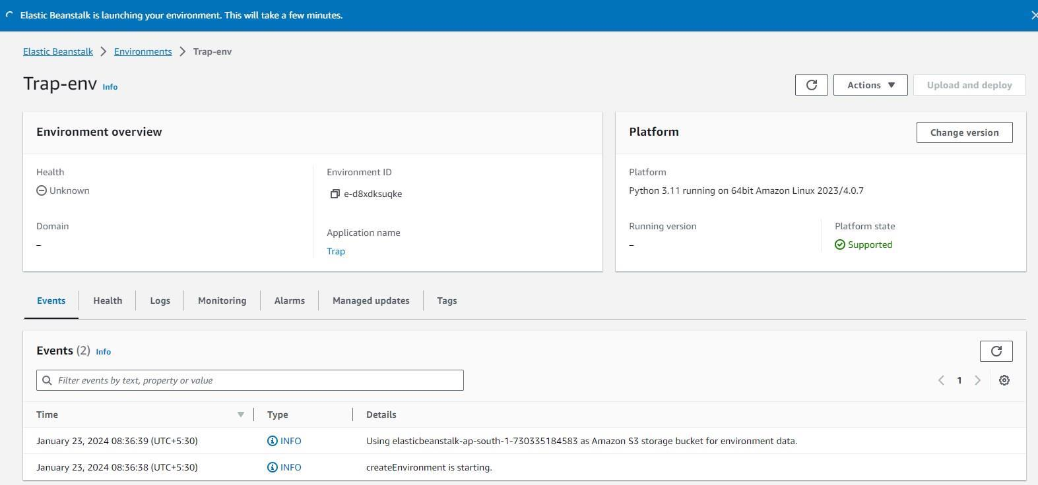

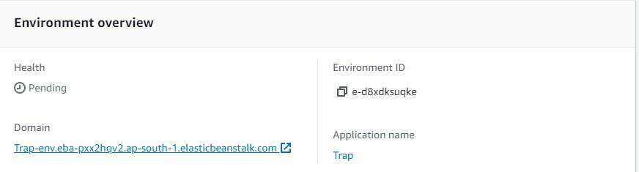

1. The webapp is launched!

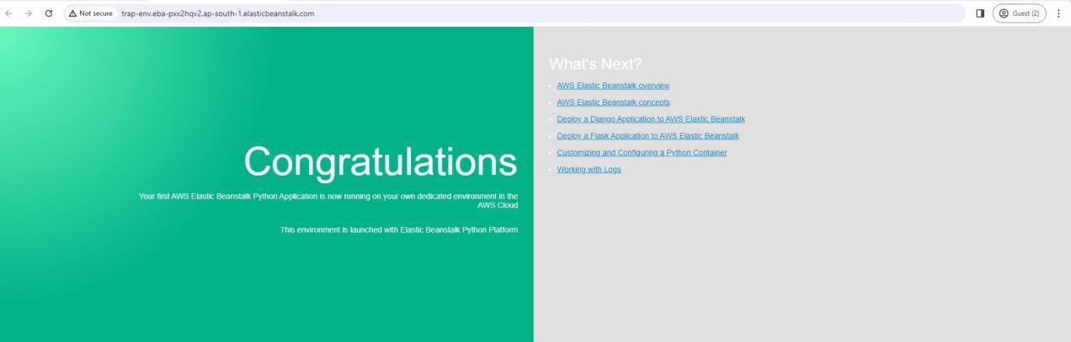

Task 2: Implement paas using elastic beanstalk for Java

1. We’ll be using Elastic Beanstalk - Java



1. There will be the steps



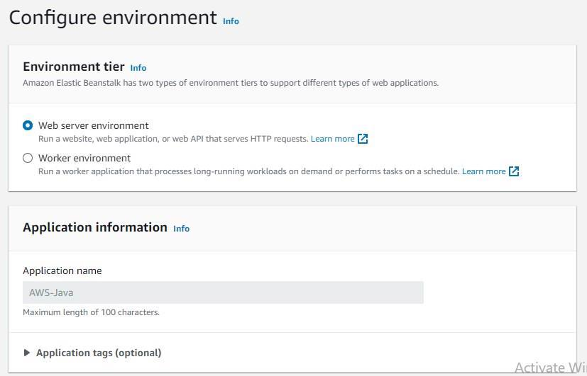

1. Select the platform



1. Go to the IAM services -> Create role







1. Create new service role, and select the EC instance profile

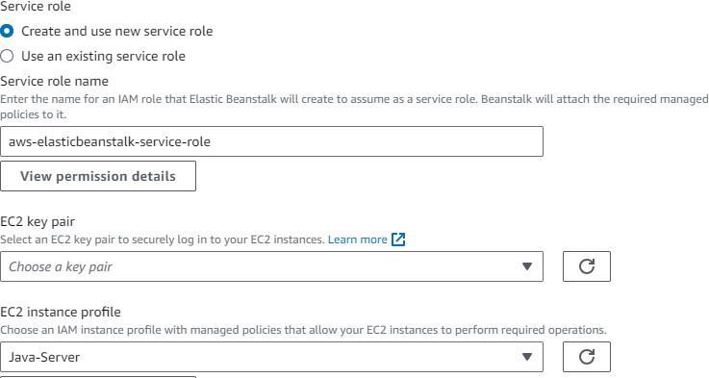

1. Set up network and database



1. Keep the settings default



1. Keep the settings default



1. Review and submit!
2. The environment will start launching

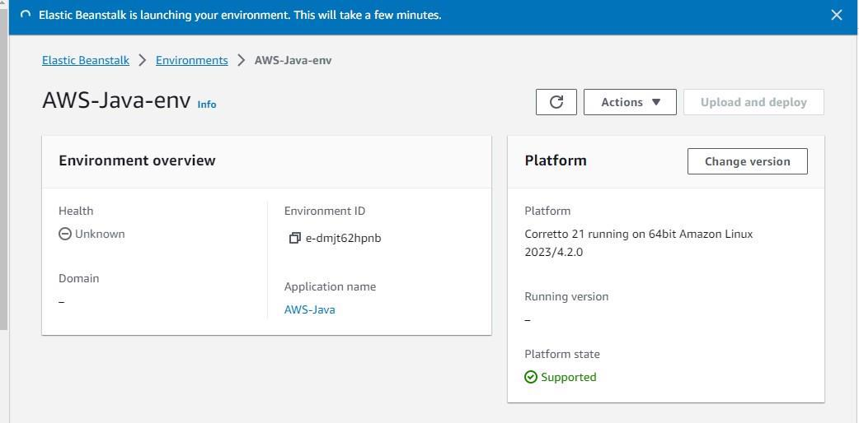

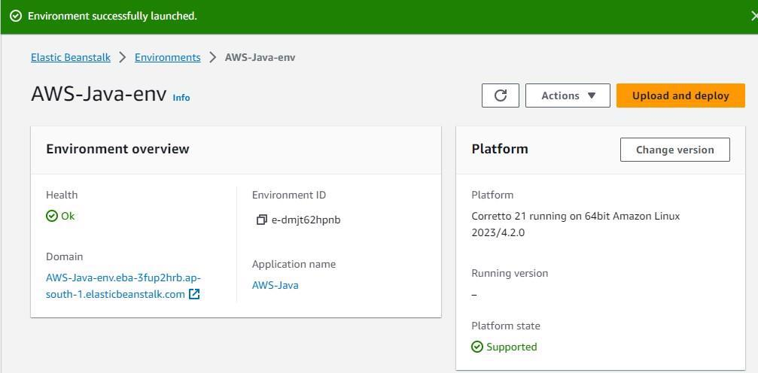

1. The webapp is launched!

