Teisha Soans

A068

86062300017

Practical-6 . Installing UBUNTU AND WINDOWS using VMWARE

1. Click on the link provided below. Now select the version you want to download and click on “Go to downloads”. [https.//customerconnect.vmware.com/en/downloads/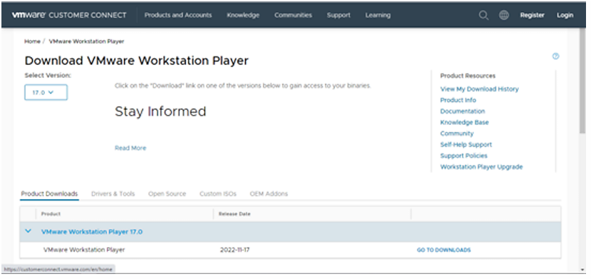](https://customerconnect.vmware.com/en/downloads/)
2. Now, Click on download now

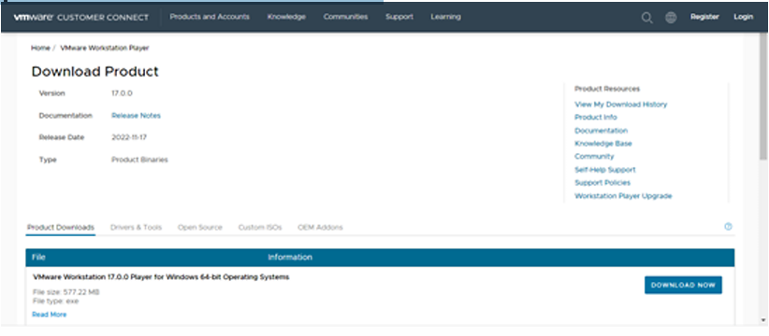

1. Open the (.exe) file and install it.
2. Open the link below and download the Ubuntu ISO file. [https.//ubuntu.com/download/desktop](https://ubuntu.com/download/desktop)

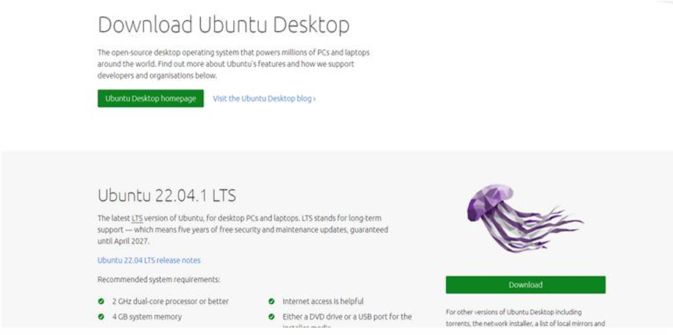

1. Open the installed VMware application

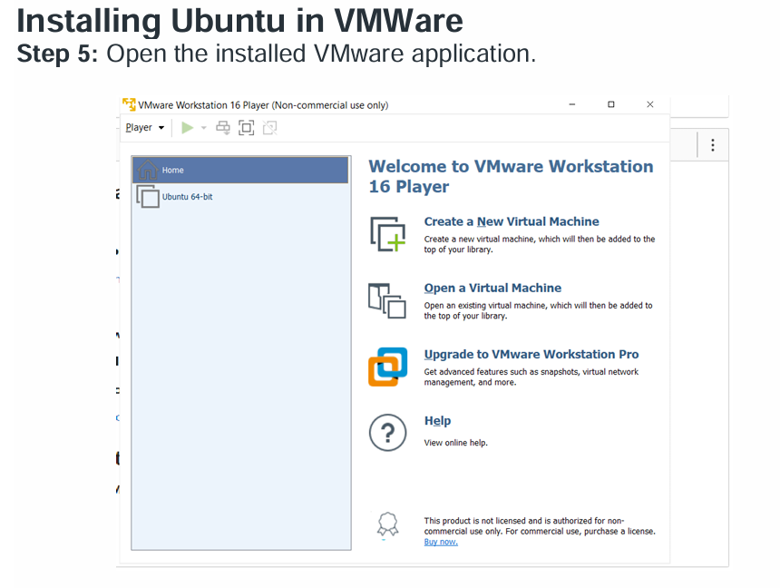

1. Click on “Create new virtual machine”. Browse the ISO file that has been downloaded and select it.

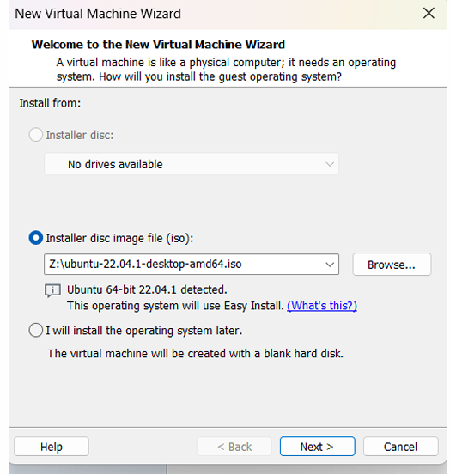

1. Enter all the details >> click on next. Personalization of Virtual Machine.

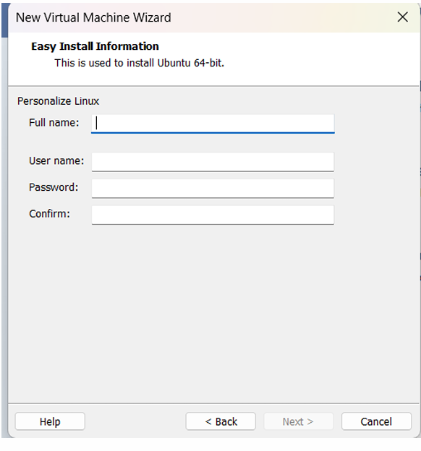

1. Enter Virtual machine name >> click on next.

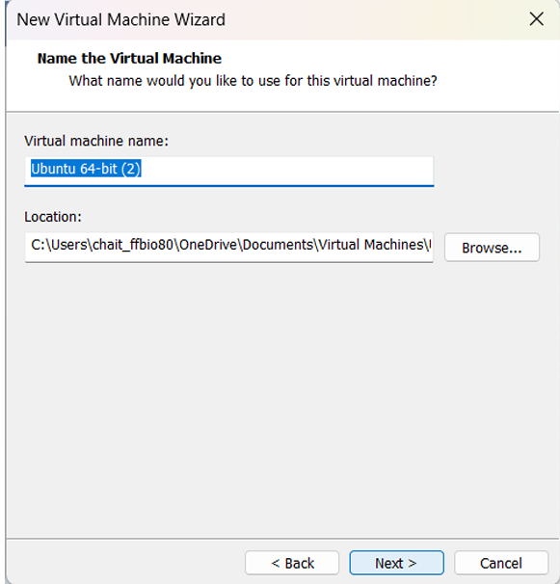

1. Specify disk capacity >> click on next.

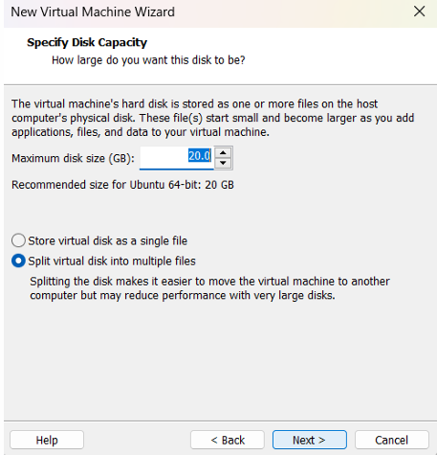

1. If needed customize the hardware and click on finish

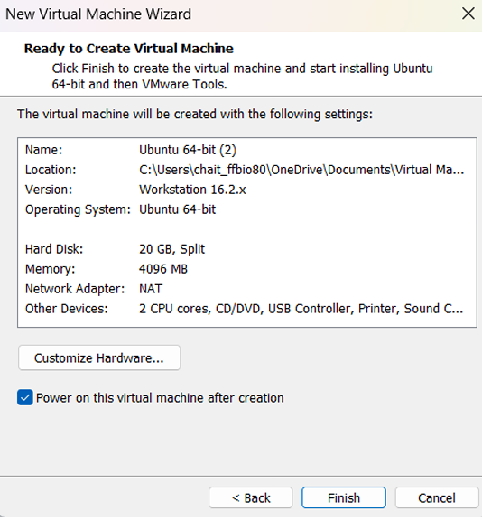

1. Ubuntu has been successfully installed in VMWare. Now open VMware and click on ubuntu-64 which appears on the left panel. (If not directly opened). Select the language and click on next. Select the Normal or Minimal installation based on your requirements.

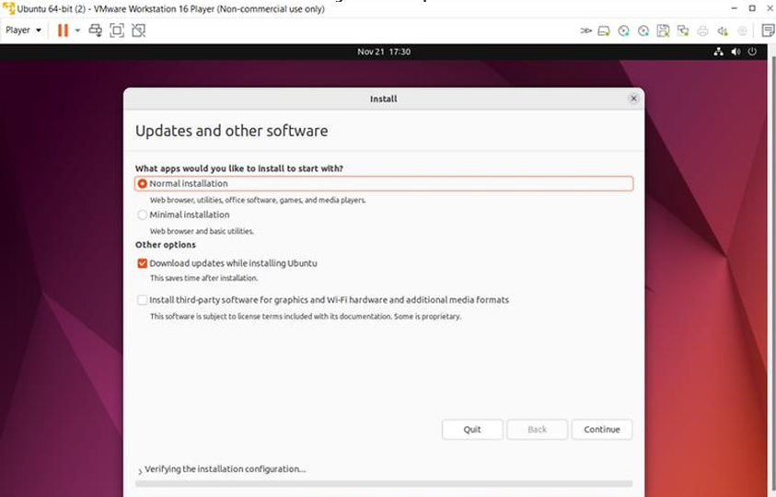

1. Select Installation type >> Erase disk and install Ubuntu (This will not delete your windows data) >> Click on install now.

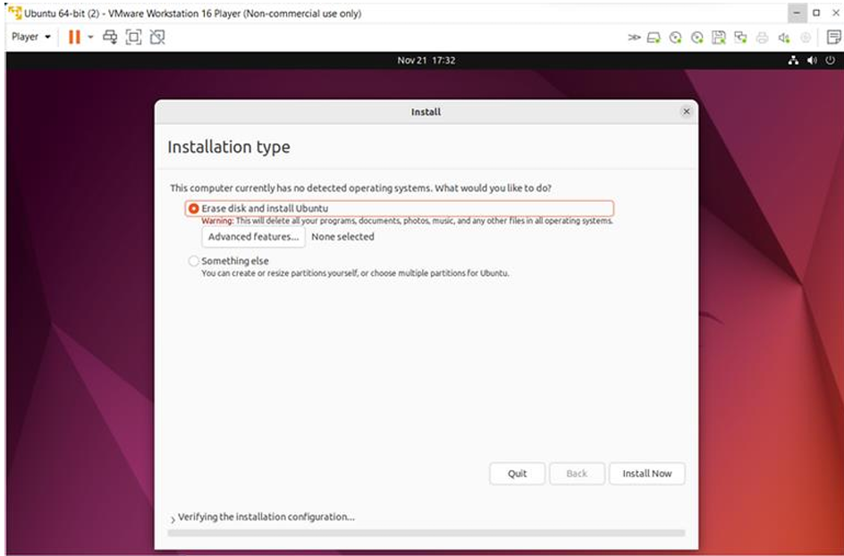

Installing Windows in VMWare

1. Similarly for windows just **install windows 7 in place of Ubuntu (repeat s from 5th )**