Teisha Soans

A068

86062300017

Practical-7 : Virtualisation using MOBAXTERM

Task 1: Using Ubuntu Instance

1. Create EC2 insatnce on AWS for Ubuntu

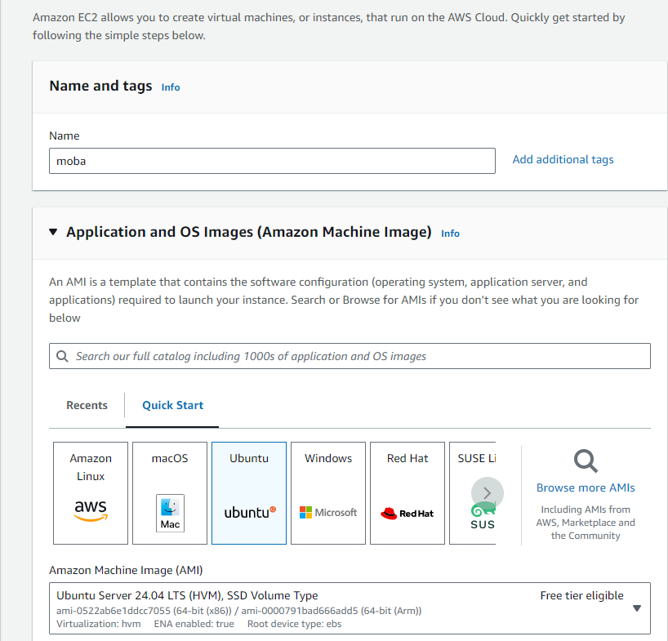

1. Create a new key pair and launch the instance.
2. Connect the instance once ready and copy the public IP address
3. Open MOBAXTERM and click on Session

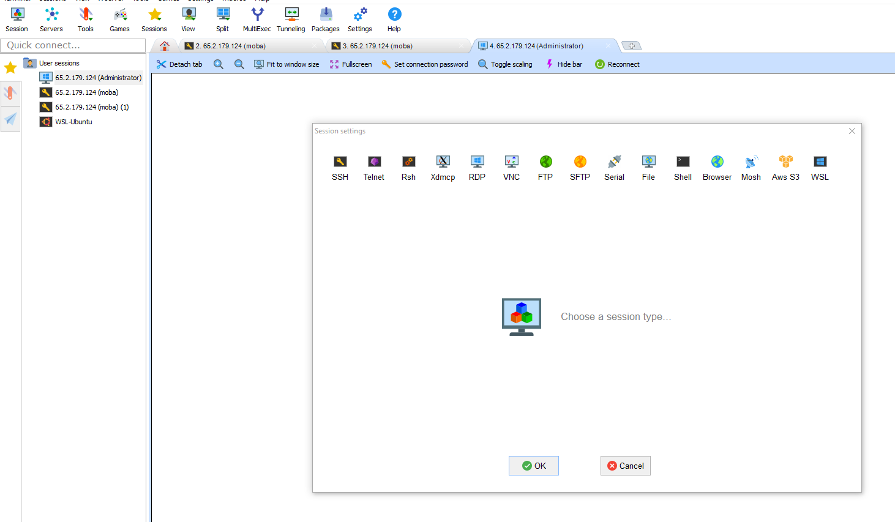

1. Select SSH and insert public IP address in remote host

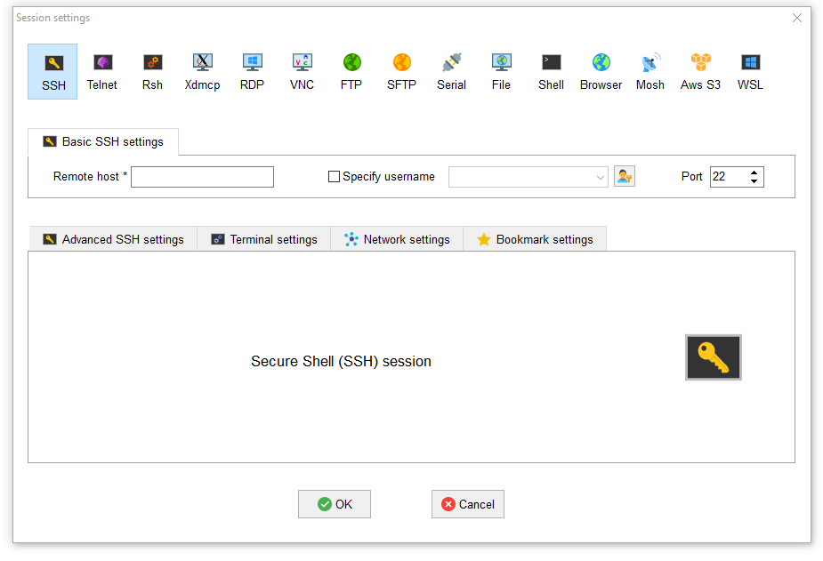

1. Choose specify username and insert instance’s name
2. Select Advanced SSH settings

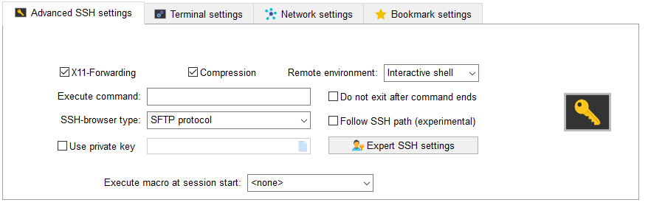

1. Select use private key and attach the new key pair file created and press okay

Task 2: Using Windows

1. Create an EC2 instance with windows server
2. Create new key pair and launch the instance.
3. While connecting the instance open the RDP client section for Username and password

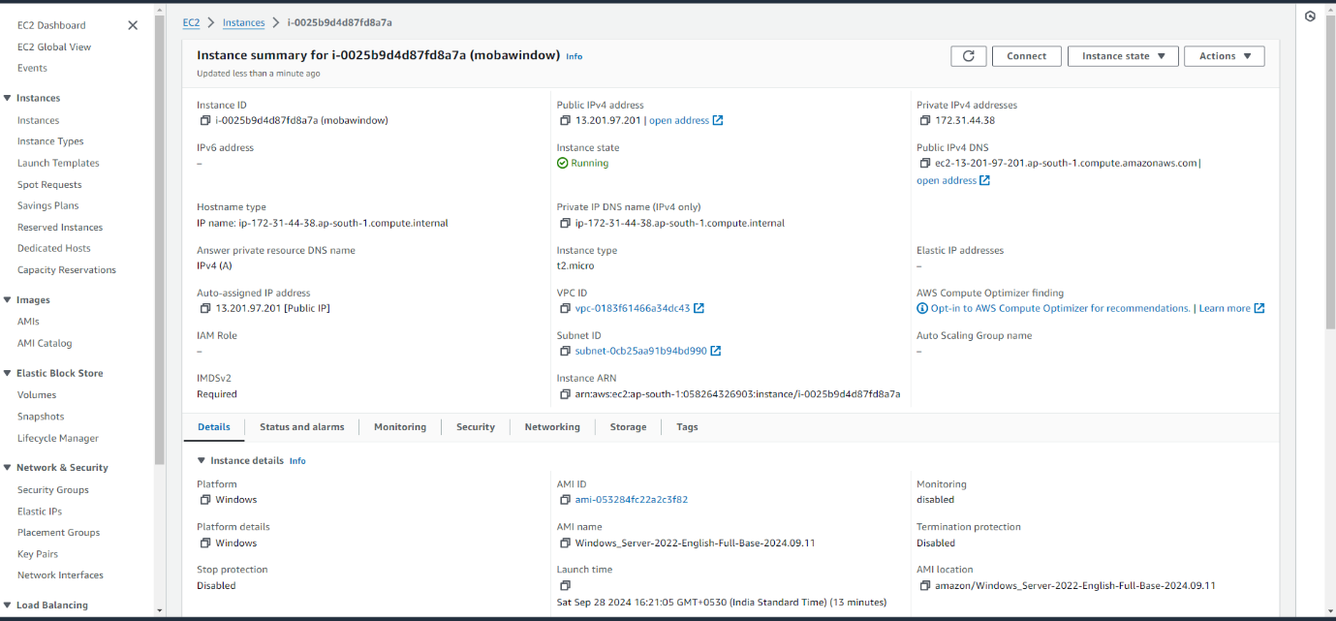

1. Open mobaxterm and Select Sessions>RDP

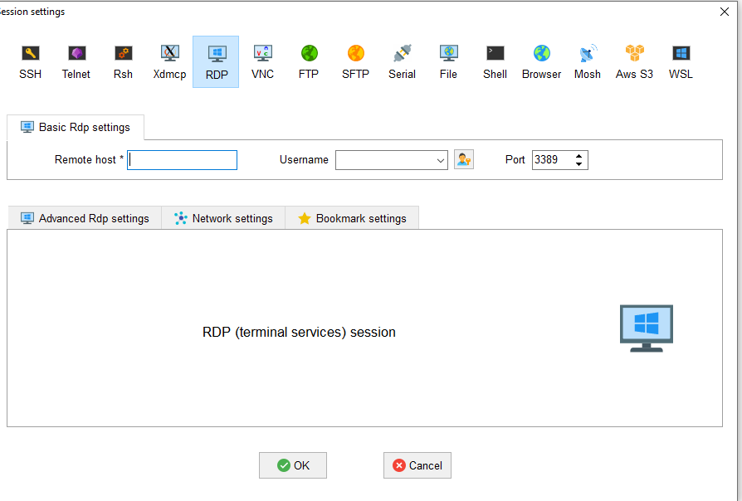

1. Copy the Public IP address and username from Window instance :

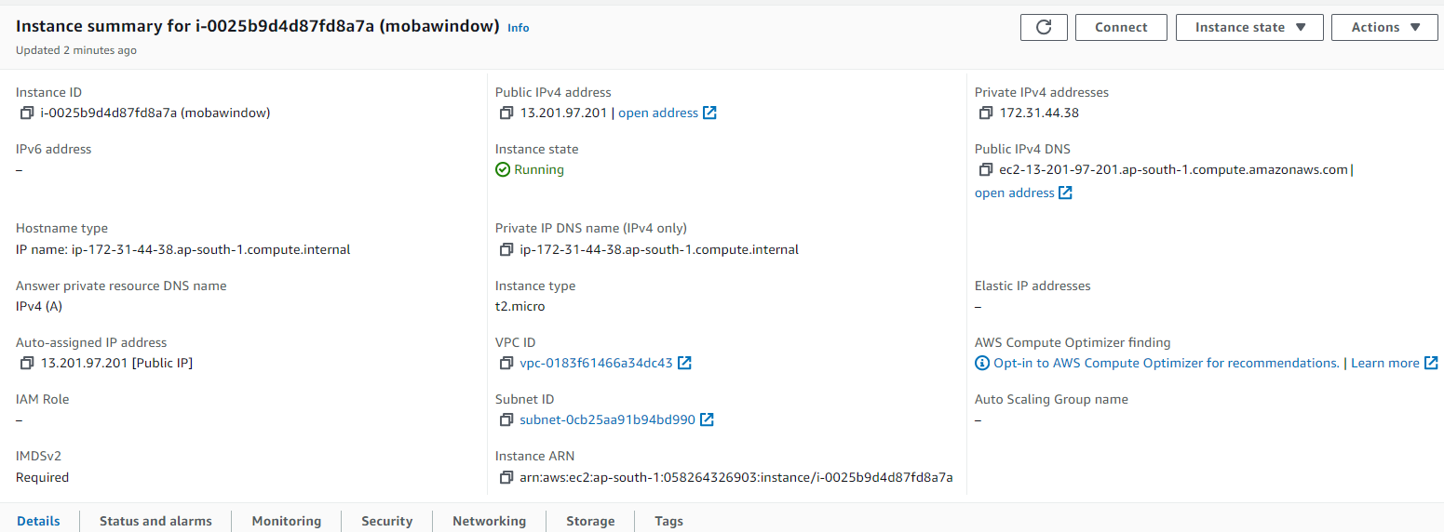

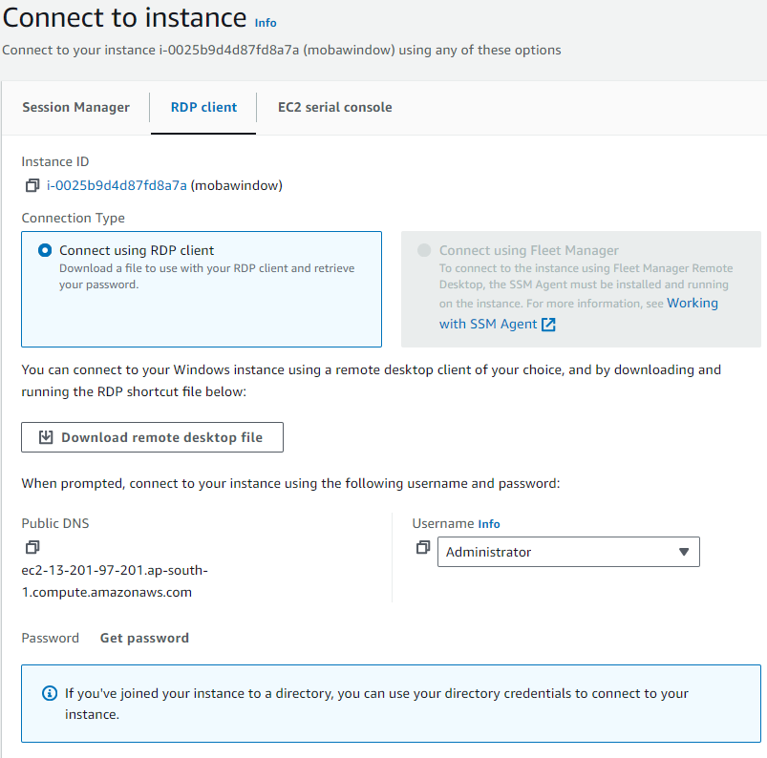

1. Now we need to decrypt the password by uploading the key pair file created.

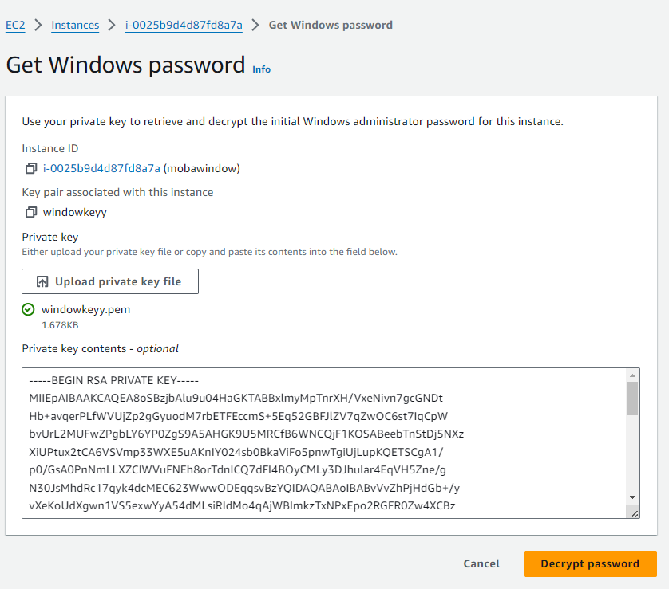

1. The password is decrypted
2. And now after entering the password the Virtual environment is created.