Teisha Soans

A068

86062300017

Practical-8 : AMAZON SAGEMAKER

1. Creating IAM ROLE and assigning sagemaker permission

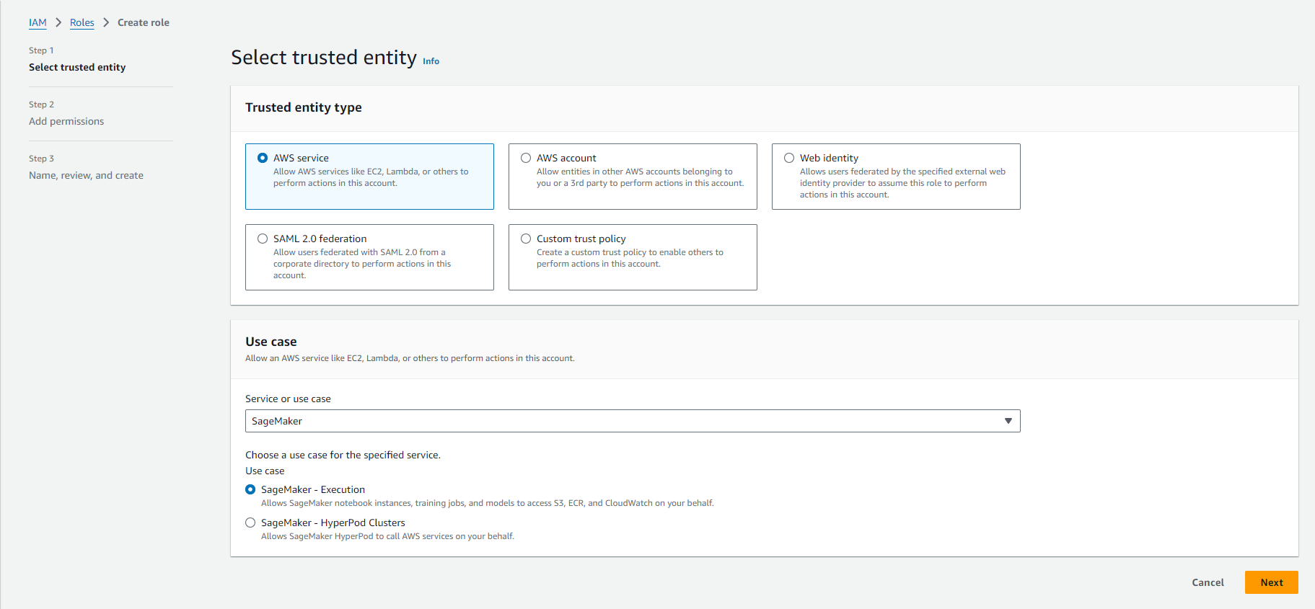

1. IAM Role is created.

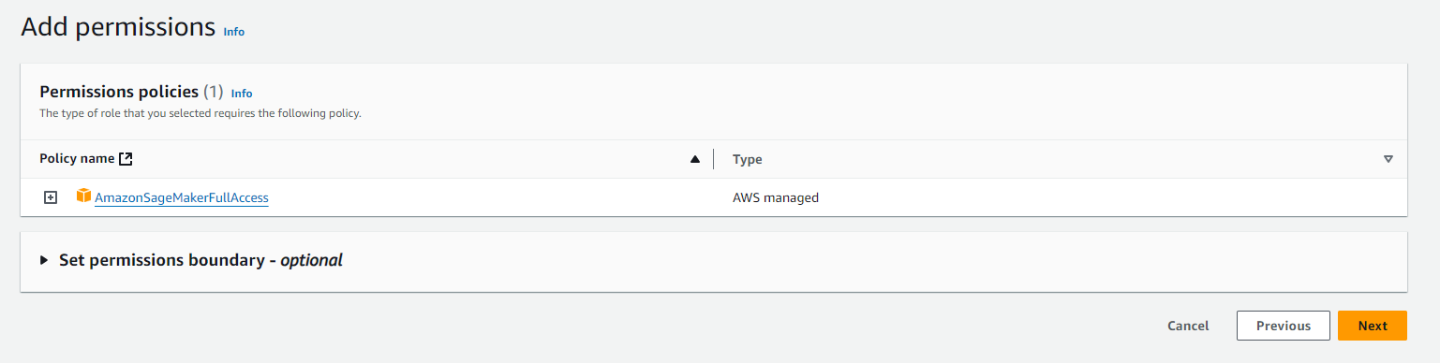

1. Creating s3 bucket named mygroup2

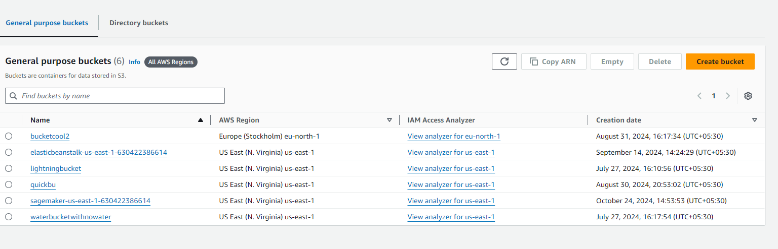

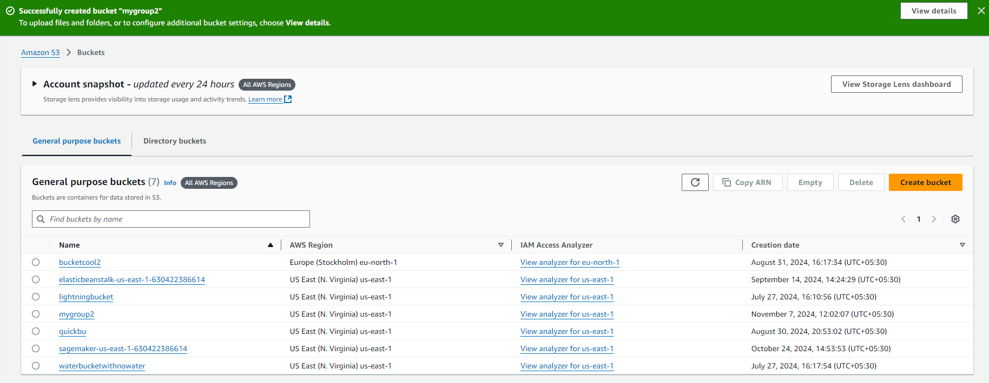

1. open Amazon SageMaker console
2. Select Notebook instances and click create notebook instances
3. Here we will assign the IAM role created earlier i.e fraud_detection

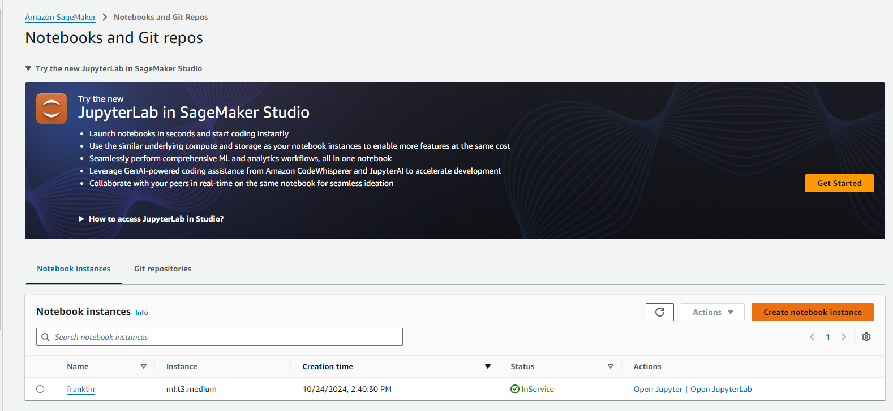

1. Create a Jupiter Notebook

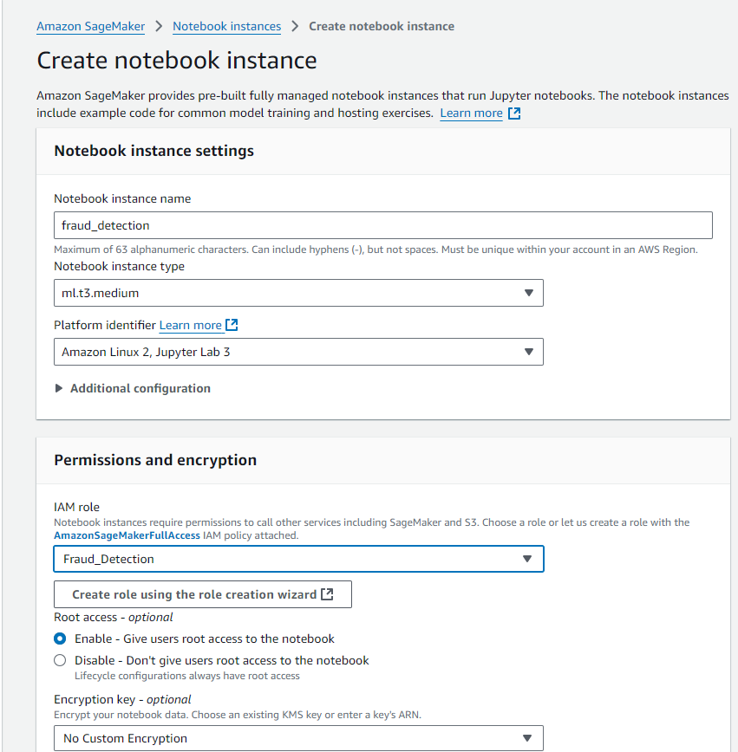

1. Notebook is created

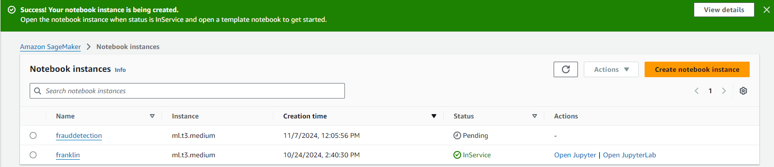

1. Open Jupyter or JupyterLab according to the interface needed.
2. Go to File menu->Choose New-> Notebook.
3. Select Kernel as ‘conda_python3’

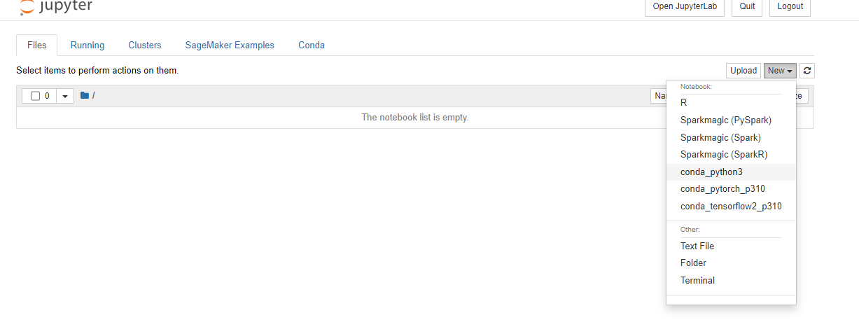

1. Deploying the model (Here it is stored in s3 bucket that we had created)

