DATA ANALYTICS PROJECT
Supply Chain Delivery
& Profitability Analysis
DataCo e-commerce operations: exploratory analytics, root-cause analysis and late-delivery prediction
172,765  Total Orders | 94,523  Late Deliveries | 54.71%  Late Delivery % | 74%  Model Accuracy

Item | Detail
Period covered | January 2015 – January 2018
Dataset | DataCo Smart Supply Chain (180,519 records × 53 columns raw)
Tools | Python, pandas, NumPy, Matplotlib, Seaborn, scikit-learn, imbalanced-learn
Methods | EDA, KPI design, bottleneck detection, root-cause drill-down, Random Forest with SMOTE

Contents
1. Executive Summary 1
2. Business Context & Objectives 1
Core Business Problem 1
Analytical Objectives 1
3. Data Preparation & Key Performance Indicators 1
3.1 Dataset and cleaning 1
3.2 Key performance indicators 1
4. Profitability Analysis 1
4.1 Profitability Distribution 1
4.2 Delay Distribution & Profit vs. Delay Days 1
5. Bottleneck Detection 1
6. Root Cause Analysis 1
7. Time-Based Delay Patterns 1
8. Machine Learning Model Results 1
Class Imbalance Handling (SMOTE) 1
Random Forest Classifier – Test Set Performance (34,553 records) 1
9. Strategic Recommendations 1
9.1 Suggested KPI Targets 1
10. Conclusion 1
11. Methodological Notes & Limitations 1

1. Executive Summary
This report presents a comprehensive analysis of the delivery operations of a global e-commerce company managing end-to-end order fulfilment across multiple regions. The analysis covers 172,765 non-cancelled orders from January 2015 through January 2018, and focuses on identifying the drivers of chronic late deliveries, quantifying their relationship with profitability, and establishing a data-driven framework for improvement.
The headline finding is stark: 54.71% of all analyzed orders are delivered late. Total profit across profitable orders reached $7.5M, and orders that were delayed account for about $2.1M of profit, which is used here as a “profit at risk” indicator. A Random Forest model achieved 74% accuracy in identifying orders at risk of being late.

Key Finding | Metric
Overall Late Delivery Rate | 54.71%
On-Time Delivery Rate | 45.29%
Total Orders Analyzed | 172,765
Total Profit (profitable orders) | $7.5M
Profit at Risk (delayed orders) | $2.1M
Predictive Model Accuracy (Random Forest) | 74%

2. Business Context & Objectives
The company operates a global e-commerce platform selling products across categories including sporting goods, fitness equipment, outdoor gear, footwear and apparel across multiple international regions.

Core Business Problem
Actual shipping times frequently deviate from scheduled delivery windows. This erodes customer trust, exposes profitable orders to disruption, and makes it hard to give buyers reliable commitments at the point of purchase.

Analytical Objectives
- Understand the current state of delivery performance across all dimensions (region, mode, time, segment).
- Quantify the relationship between delays and order profitability.
- Identify the primary operational bottlenecks driving late deliveries.
- Build a predictive model to flag high-risk orders early.
- Deliver actionable recommendations to improve on-time delivery and profitability.

3. Data Preparation & Key Performance Indicators

3.1 Dataset and cleaning
Item | Value
Original records / columns | 180,519 / 53
Duplicate records | 0
Records after cleaning | 172,765
Columns after cleaning | 20 (plus derived fields)
Analysis period | 2015-01-01 to 2018-01-31

- Dropped identifying, redundant, fully missing and single-value columns (for example Product Description, which was entirely missing).
- Removed orders with Delivery Status “Shipping canceled”, since they do not reflect delivery performance.
- Created Order Processing Time (shipping date − order date), Delay (processing time − scheduled days), Is_Delayed (Delay > 0), and month, day and hour fields.
- Created a Profitability Flag (Profit, Loss, Break even) from Order Profit Per Order.

3.2 Key performance indicators
The following KPIs were computed directly from the cleaned dataset to establish a performance baseline.
172,765  Total Orders | 94,523  Late Deliveries | 54.71%  Late Delivery % | 45.29%  On-Time Delivery %

$7.5M  Total Profit (profitable orders) | $2.1M  Profit at Risk (delayed orders) | 3 days  90th Percentile Delay | $22.03  Avg Order Profit

Late Delivery Rate at 54.71% | More than half of all orders arrive late. This is not an edge-case problem; it is the default experience for the majority of orders.
$2.1M Profit at Risk | Orders that experienced delays account for $2.1M of profit (the sum of Order Profit Per Order for delayed orders). This is a proxy for exposed volume, not a causal estimate of loss.
90th Percentile Delay = 3 Days | Even the more extreme cases are contained within 3 days of lateness, which suggests the problem is systemic and process-driven rather than catastrophic.

IMPORTANT DEFINITION
The dataset also contains a source field, Late_delivery_risk (98,977 late vs 73,788 on time). The 54.71% KPI uses the derived Is_Delayed measure, while the model predicts Late_delivery_risk. The two are related but not identical, and should be reconciled before production use.

4. Profitability Analysis

4.1 Profitability Distribution
Order-level profitability was classified into three tiers based on Order Profit Per Order. While 80.66% of orders are profitable, the 18.69% loss-making share is a meaningful drag and justifies a separate pricing and discount review.
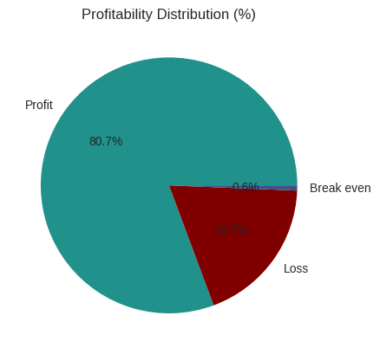
Figure 1. Profitability distribution (%).
Profitability class | Orders | Share
Profit | 139,354 | 80.66%
Loss | 32,295 | 18.69%
Break even | 1,116 | 0.65%

4.2 Delay Distribution & Profit vs. Delay Days
The delay distribution shows that 31.0% of all orders arrive exactly 1 day late, the single largest cohort. Combined, orders delayed by 1 to 4 days account for 54.7% of all order volume, directly matching the overall late delivery rate.
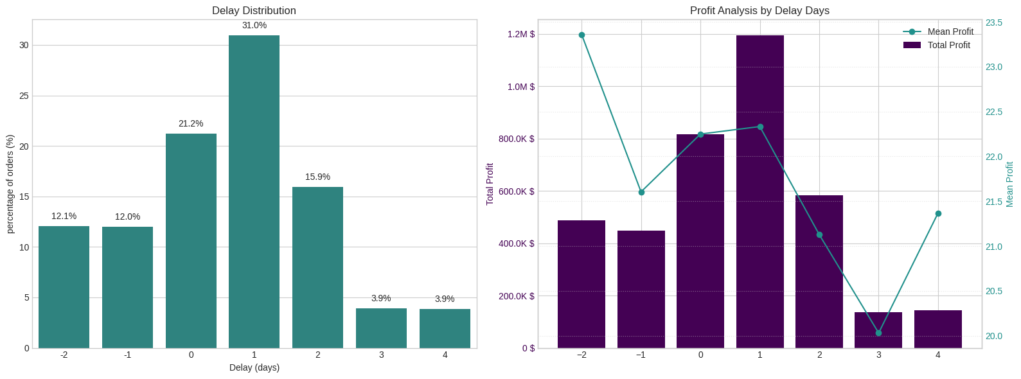
Figure 2. Delay distribution (left) and profit analysis by delay days (right).
Delay (days) | Share of orders | Mean profit / order | Total profit
−2 | 12.08% | $23.36 | $487.6K
−1 | 11.99% | $21.60 | $447.6K
0 | 21.21% | $22.25 | $815.4K
1 | 30.97% | $22.33 | $1.195M
2 | 15.95% | $21.13 | $582.1K
3 | 3.92% | $20.03 | $135.7K
4 | 3.88% | $21.37 | $143.1K

A critical observation: mean profit per order remains stable at roughly $20–$23 across all delay levels. The profitability exposure is therefore driven by the volume of delayed orders, not by individual order economics, which makes systemic throughput improvement the highest-leverage intervention.

5. Bottleneck Detection
Delay percentage was computed across six key operational dimensions. The charts below show where the fulfilment process breaks down most severely.
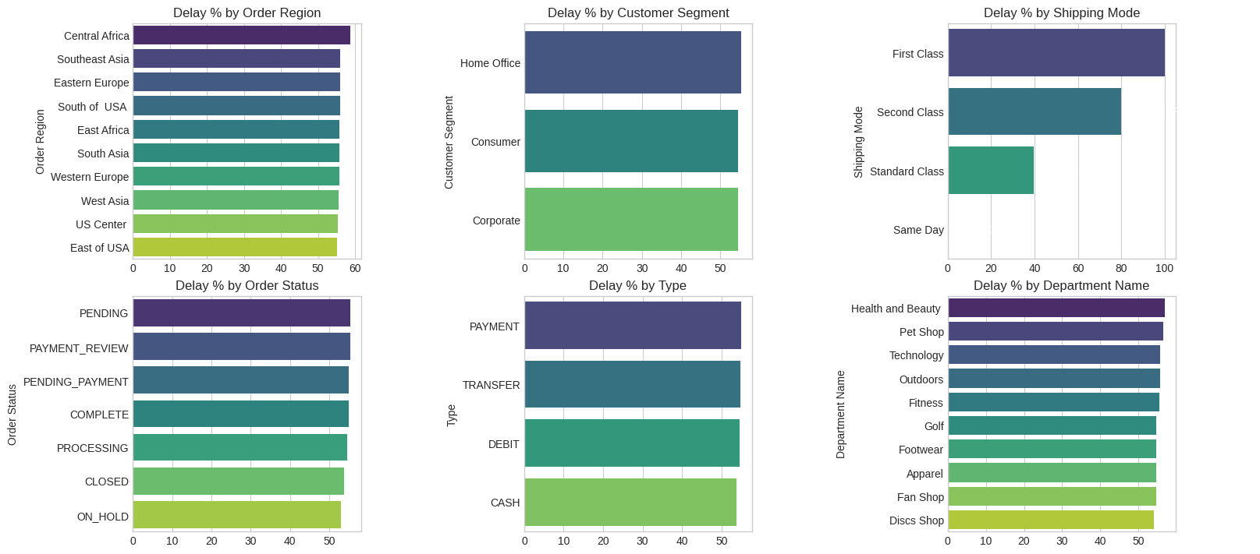
Figure 3. Bottleneck detection: delay % by category (top 10 categories per panel).
Shipping Mode is the #1 Lever | First Class: 100% delay rate. Second Class: 79.8%. Standard Class: 39.8%. Same Day: 0%. Mode assignment logic is the most impactful single variable to examine.
Regional Spread is Narrow | Central Africa leads at 58.7%, but regions cluster in a narrow mid-50% band. This points to a company-wide pattern rather than a localized logistics failure.
Customer Segments Nearly Identical (54.5–55.4%) | Consumer, Corporate and Home Office customers all experience similar delay rates (Home Office 55.36%, Consumer 54.64%, Corporate 54.46%).
Health & Beauty (56.9%) and Pet Shop (56.6%) Lead by Department | These departments marginally outpace others in delay rate, warranting an inventory and carrier audit for these product categories.
Payment and Order Status Signals | PENDING, PAYMENT_REVIEW and PENDING_PAYMENT are among the higher-delay order statuses, and PAYMENT and TRANSFER payment types are elevated relative to CASH.

6. Root Cause Analysis
Central Africa was selected for deep-dive root-cause analysis as the highest-delay region (58.7%). The chart below ranks the top 10 driver factors by delay percentage within this region.
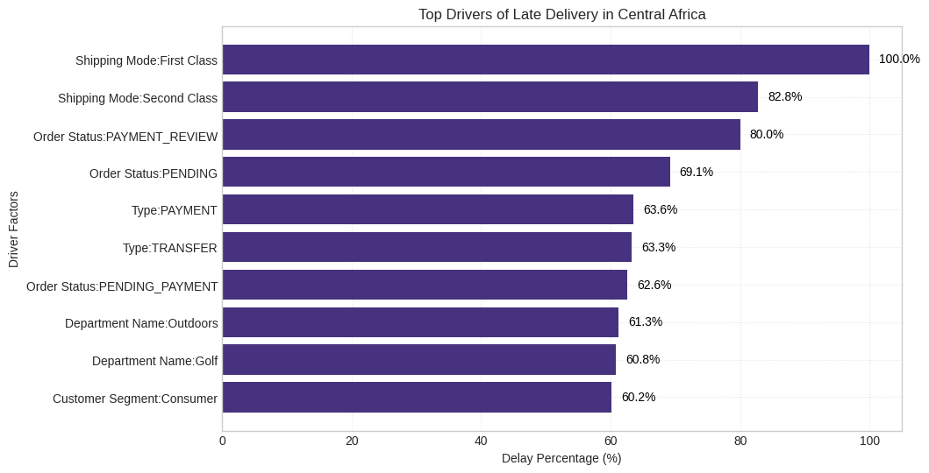
Figure 4. Top drivers of late delivery in Central Africa.
Driver level in Central Africa | Delay rate
Shipping Mode: First Class | 100.0%
Shipping Mode: Second Class | 82.8%
Order Status: PAYMENT_REVIEW | 80.0%
Order Status: PENDING | 69.1%
Type: PAYMENT | 63.6%
Type: TRANSFER | 63.3%
Order Status: PENDING_PAYMENT | 62.6%
Department: Outdoors | 61.3%
Department: Golf | 60.8%
Customer Segment: Consumer | 60.2%

Shipping mode remains the strongest single separator, while payment and order-status states and selected departments also show high delay rates. These are diagnostic associations, not proof of causality.

7. Time-Based Delay Patterns
Three temporal dimensions were analyzed: month of year, day of week and hour of day. While delay rates are relatively stable across all dimensions (roughly 52–57%), specific peaks highlight opportunities for targeted capacity planning.
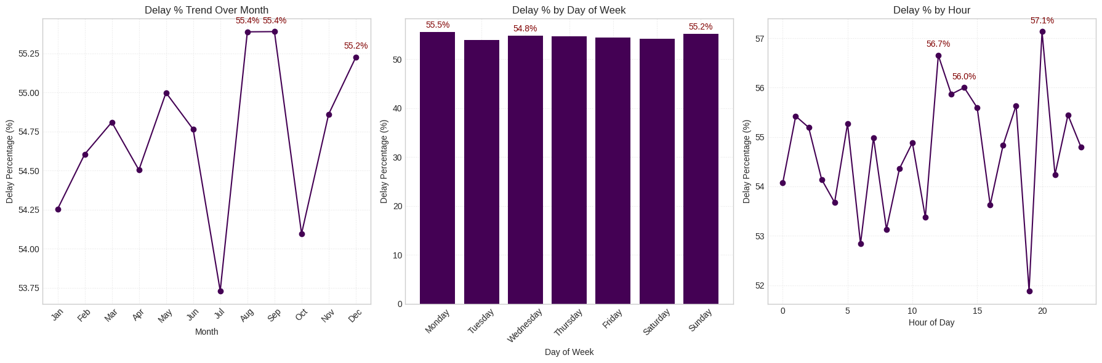
Figure 5. Delay % by month, day of week and hour of day.
Peak Delay Months: Aug & Sep (55.4%) and Dec (55.2%) | August and September are the highest months, with December close behind. July is a notable low point (about 53.7%), confirming that seasonal variation is plannable.
Day-of-Week Variance is Minimal | Monday (55.5%) and Sunday (55.2%) are the peak days, but the spread across the week is less than 1 percentage point. Day of week is not a meaningful lever for intervention.
Intra-Day Peaks: Hour 20 (57.1%), Hour 12 (56.7%), Hour 14 (56.0%) | Evening orders at hour 20 have the highest delay rate, possibly reflecting processing cut-off windows. Midday peaks may point to bottlenecks during high-volume hours.

8. Machine Learning Model Results
A supervised classification model was built to predict whether an individual order will be delivered late (Late_delivery_risk = 1). Inputs were Type, scheduled shipment days, Category Name, Customer Segment, Department Name, Order Region, Shipping Mode, order month and order hour. The pipeline used frequency encoding of categorical variables, a stratified train/test split (138,212 / 34,553), SMOTE oversampling to address class imbalance, and a Random Forest classifier.

Class Imbalance Handling (SMOTE)
Split | Class 0 (On-time) | Class 1 (Late)
Before SMOTE (train) | 59,030 | 79,182
After SMOTE (train) | 79,182 | 79,182

Random Forest Classifier – Test Set Performance (34,553 records)
Metric | Class 0 (On-time) | Class 1 (Late) | Overall (Weighted)
Precision | 0.68 | 0.79 | 0.74
Recall | 0.73 | 0.75 | 0.74
F1-score | 0.70 | 0.77 | 0.74
Support | 14,758 | 19,795 | 34,553

74% Overall Accuracy | The model correctly classifies nearly 3 in 4 orders, a useful foundation for an order-level late-delivery alert system.
Higher Precision on Late Orders (0.79) | When the model predicts an order will be late, it is correct about 79% of the time, which is enough to trigger targeted interventions without excessive false alarms.
Recall for Late Orders at 0.75 | The model captures 75% of actual late orders. The remaining 25% miss rate is acceptable for a first-generation alert system, with clear room for improvement.
Class 0 Harder to Predict (Precision 0.68) | On-time deliveries share many characteristics with late ones given the systemic nature of delays, making them harder to distinguish.

9. Strategic Recommendations
Based on the findings across all analytical dimensions, the following prioritized actions are recommended. Priorities reflect the strength of the observed signal, not guaranteed causal impact.
CRITICAL | 1. Immediately Audit First Class & Second Class Shipping Capacity  First Class has a 100% delay rate and Second Class 79.8%, which contradicts what these modes promise. Conduct a carrier SLA audit. Until resolved, consider repricing or adjusting the delivery promise to reflect actual performance.

HIGH | 2. Deploy the Predictive Alert System  The Random Forest model (74% accuracy, 79% precision on late orders) is suitable for a production pilot. Integrate it into order management to flag high-risk orders at confirmation and trigger proactive customer communication and priority handling.

HIGH | 3. Resolve Payment Processing Bottlenecks  Orders in PAYMENT_REVIEW (80.0% in Central Africa) and PENDING_PAYMENT show elevated delay rates. Introduce automated escalation for stalled payment reviews and review order-release rules.

MEDIUM | 4. Develop Seasonal Surge Capacity Plans  August, September (55.4%) and December (55.2%) are peak delay months. Build pre-season capacity plans including temporary logistics partnerships, inventory pre-positioning and adjusted delivery promise windows.

MEDIUM | 5. Default to Standard Class for Eligible Orders  Standard Class achieves a 39.8% delay rate, far lower than First and Second Class. Re-evaluate shipping-mode assignment logic, particularly in regions and departments with poor premium-mode performance.

MEDIUM | 6. Investigate High-Delay Departments in Central Africa  Outdoors (61.3%) and Golf (60.8%) show elevated delay rates in Central Africa. Conduct a warehouse-level audit of stock availability, pick-and-pack times and carrier assignment.

LOW | 7. Reduce Loss-Making Order Share (18.7%)  The loss-making share warrants a separate pricing and discount review. Combine it with the delay analysis to see whether discounted orders are disproportionately late.

LOW | 8. Continuously Retrain the Predictive Model  Retrain the model periodically. Explore adding carrier-level data and warehouse utilization features, and target a recall improvement above 80% on late orders.

9.1 Suggested KPI Targets
Priority Area | Current State | Target State
Late Delivery Rate | 54.71% | < 30% within 12 months
First Class On-Time Rate | 0% | > 80%
Second Class On-Time Rate | 20.2% | > 60%
Predictive Model Accuracy | 74% | > 82% (enhanced model)
Loss-Making Orders | 18.7% | < 12%
Profit at Risk | $2.1M | Reduce by 40%

These are management targets for planning purposes, not forecasts, and should be validated against operational feasibility and service-level commitments.

10. Conclusion
This analysis surfaces a clear picture: a global e-commerce operation where the majority of orders (54.71%) miss their scheduled delivery windows, with about $2.1M of profit tied to delayed orders.
The drivers are identifiable and addressable. Shipping-mode performance (First Class at 100% late, Second Class at 79.8%) is the dominant operational signal. Payment and order-status friction forms a secondary bottleneck, seasonal volume spikes call for better planning, and geographic differences, while present, are secondary to the company-wide pattern.
A Random Forest model trained on readily available order features already achieves 74% accuracy in identifying at-risk orders, providing a practical baseline for an alerting pilot.
FINAL TAKEAWAY
Establish the delivery baseline, act first on the strongest bottleneck signals, investigate the process states behind them, plan for seasonal peaks, and use predictive alerts to intervene before high-risk orders become late.

11. Methodological Notes & Limitations
- The business KPI uses Is_Delayed (Delay > 0); the model target is the source field Late_delivery_risk. Their late-order counts differ and should be reconciled.
- The $2.1M “profit at risk” is the sum of Order Profit Per Order for delayed orders. It is a proxy for exposure, not a causal estimate of profit lost to delay.
- Bottleneck and root-cause results are observational; a high delay rate does not prove a category causes delay.
- Frequency encoding was computed before the train/test split, which can leak information. For production, fit encodings on training data only.
- No hyperparameter tuning, cross-validation, threshold optimization or calibration was performed; metrics reflect a baseline configuration.
- Data ends in January 2018 and excludes cancelled orders; findings describe that historical, non-cancelled population.

