
Predictive Modelling for TechScape
Machine Learning | MDSAA 2021/22



Group 60
António Fonseca - r2018…
João Carvalho - r20181122
Lucas Lopes - r2018…
Mariana Ferreira - r20181071
Tiago Oom - r20181077

Professors: Roberto Henriques, Carina Albuquerque and Lara Oliveira

Index

1. Introduction 2
2. Data preparation 2
3. Dataset exploration 2
3.1. Descriptive statistics 2
3.2. Coherence checking 3
3.3. Missing values 3
3.4. Outliers 3
4. Feature engineering 3
5. Feature selection 3
6. Model training 3
6.1. Data partition 3
6.2. Data preprocessing 3
6.3. Models 3
7. Model deployment 3
8. Discussion 3
9. Conclusions 3
10. References 3
11. Appendices 3

Index

1. Introduction 2
2. Data preparation 2
3. Dataset exploration 3
3.1. Descriptive statistics 3
3.2. Coherence checking 3
3.3. Missing values 3
3.4. Outliers 3
4. Feature engineering 3
5. Feature selection 3
6. Model training 3
6.1. Data partition 3
6.2. Data preprocessing 3
6.3. Models 3
7. Model deployment 3
8. Discussion 3
9. Conclusions 3
10. References 3
11. Appendices 3

Introduction
(Introduzir o tema, objetivos e metodologia)

Data preparation
(Dataset inicial e alteração nos tipos de variáveis)

Dataset exploration

Descriptive statistics
(Análise das estatísticas descritivas e dos gráficos)

Coherence checking
(Explicar o raciocínio)

Missing values
(Explicar que não há)

Outliers
(Metodologia adotada para lidar com outliers)

Feature engineering
(Explicar a criação das novas variáveis e alterações noutras para garantir a coerência e valores não omissos)

Feature selection
(Processo de decidir as variáveis, explicar o raciocínio do k-folds)
Proceeding to the feature selection part of our project, we first decided to check for any univariate variable in the dataset as it would be pointless to keep it since it wouldn´t provide any relevant information to our model.
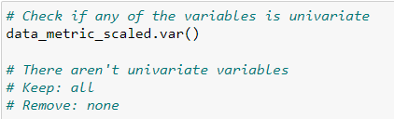
The next step would be to check for any pair/subset of variables that were too much correlated with each other as including any correlated variables in the model would harm its performance. Note that it is only possible to evaluate the correlations among the metric variables.
We acknowledge that this step should only be done for the training dataset and not for the whole dataset. However, we performed a Stratified K-Fold to estimate our model (as will be explained further ahead in this paper), and so, it wouldn´t be practical to check the correlation matrix for each different training set. Furthermore, the feature selection is an iterative process and so if any doubt would arise about if a variable should or not be kept in the model we would try the different possible combinations of variables to keep and check which ones would give better results.
The correlation matrix is shown below.
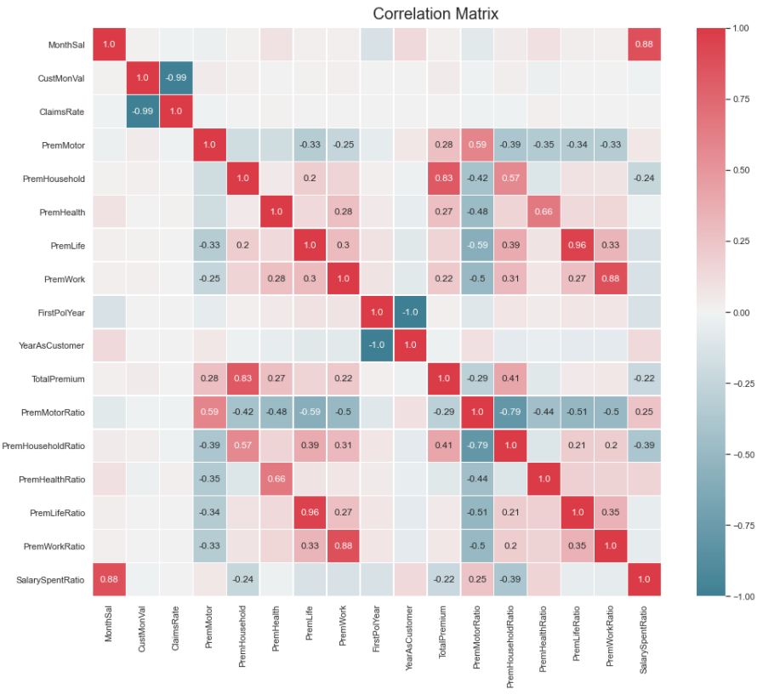
The problematic pairs of variables were identified and pointed out as follows:
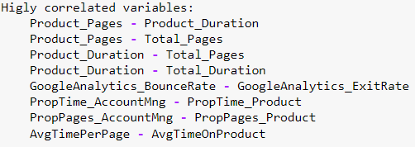

Then we perform seven more procedures for feature selection ( regarding only the metric features ) :
- Lasso regression
- Decision tree (criterion=’entropy’)
- Decision tree (criterion=gini)
- Recursive Feature Selection
- Backward Elimination
- Forward Selection
- Select From Model

However, for these, we used a Stratified 10-fold to reduce the possible bias caused by a specific split of data. So, each one of the previous mentioned algorithms was performed 10 times in 10 different training data set where the data was normalized taking into account only that specific training data. This way we obtained an overall view of the results of the most important features as shown below.
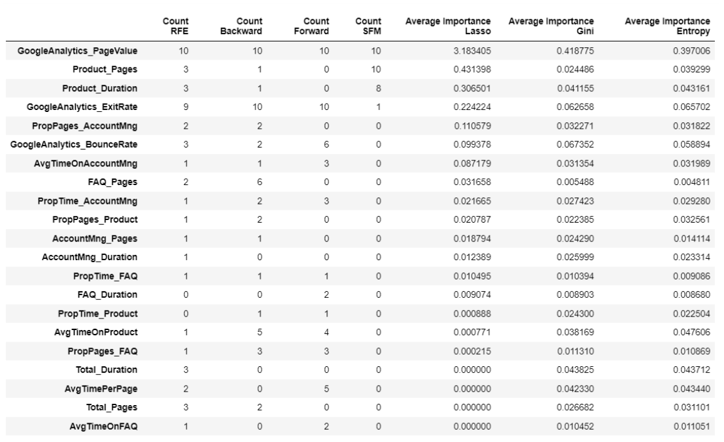
For the categorical features, we applied the exact same procedure but with only one algorithm:
- Chi-Square test for feature selection
The overall results are shown below:
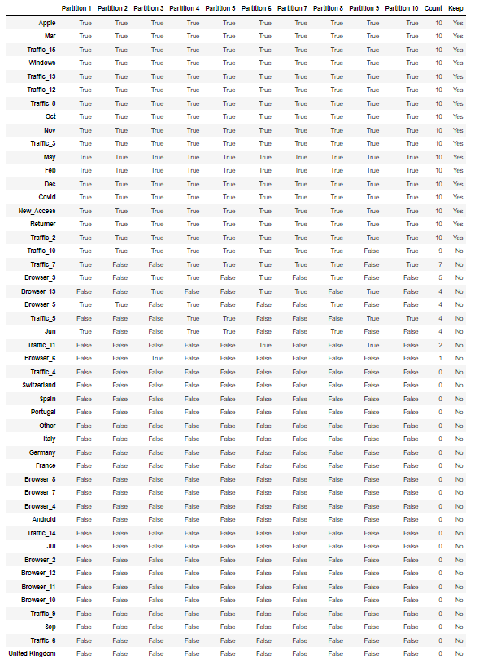

Then the variables we decided to keep were:

Model training

Data partition
(Explicar o objetivo do k-folds)

Data preprocessing
(Tratamento do train depois da partição)

Models
(Desenvolvimento dos modelos)

7. Model deployment
(Implementação do melhor)

8. Discussion
(Discussão dos resultados – comparação de vários modelos?)

9. Conclusions
(Contextualização dos resultados no problema e limitações)

10. References

11. Appendices

