Lab1

- To compile the program do the commands:
- make tmeas
- make
- To run the program do the command: ./myprogam ?(number of iterations)
- To clean everything do: make clean

If number of iterations isn’t specified, the predefined number is 100000.

Every step of the lab has been completed (code is correctly commented for easier understanding) being that, after each run, the values of the measured times are appended to the file “results.txt”, each line following the structure nº of iterations followed by the time took by the arithmetic operation loop followed by the time took by the printing loop.

The makefile specifies the includes directory (inc) in the compilation process as well as includes the library directory (lib).

By consulting “results.txt”, the run times for various runs are already present and, some conclusions can be taken:
- Run times for runs with low number of iterations are very random, being that many aspects can affect the values (Using the values in the results file, anything lower than 100000000 can have big fluctuations).
- Run times for runs with high number of iterations show more of a linear increase in time, being that the last runs (1 billion iterations) has 10x the iterations of the previous one (100 million iterations) and around 10x the time taken for both loops which is the expected result from the experiment.

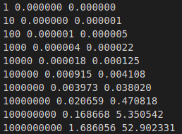

fig.1 – Results.txt

Tiago Araújo Castro

